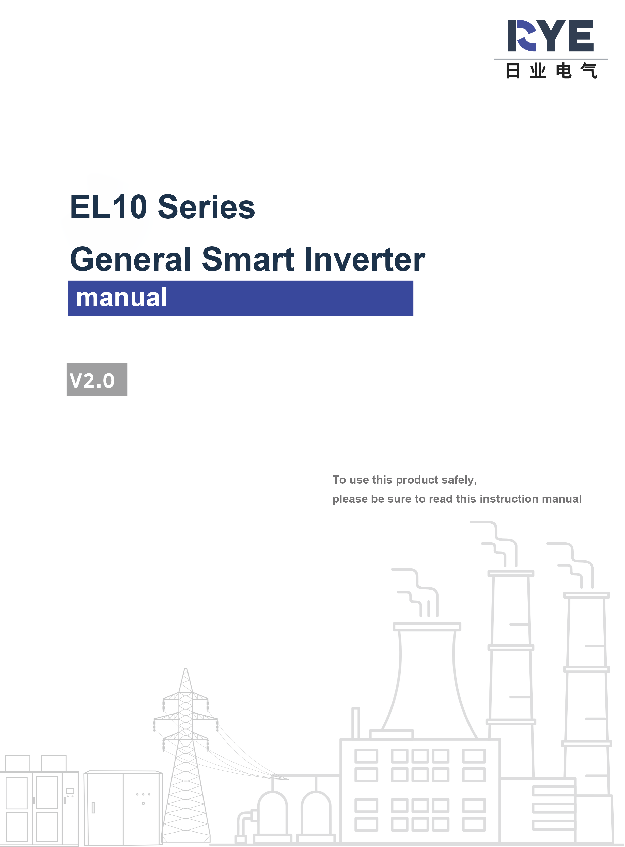

Preface

Product Introduction
The EL10 is a compact general-purpose inverter designed with a streamlined structure, featuring rich hardware and software configurations. It is characterized by its flexibility, ease of use, and reliability. Primarily used for speed control of three-phase AC asynchronous motors, it finds wide application in industries such as food and beverage, logistics packaging, textiles, and woodworking machinery. Please refer to the following figure for the product appearance.
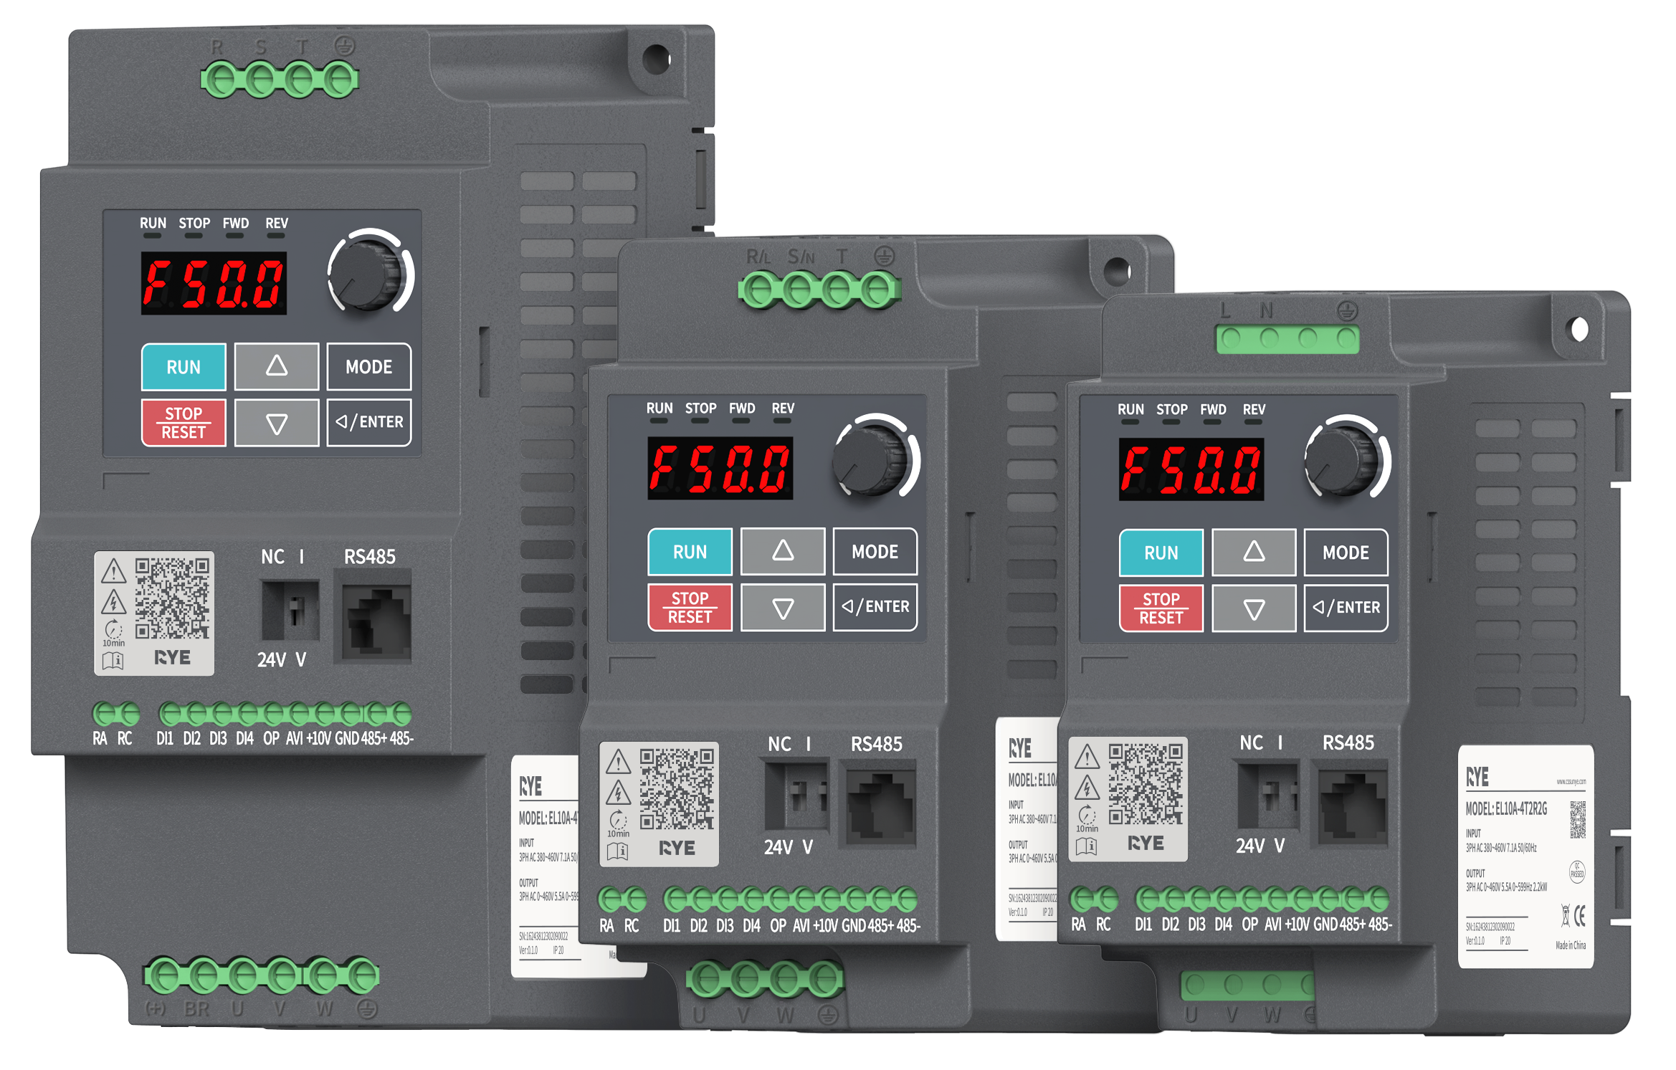
This manual introduces the installation, wiring, commissioning, and trial operation procedures, including installation dimensions, mechanical installation, electrical installation, commissioning and trial operation, fault handling, function code table, and peripheral electrical components.

Version Change Record
Revision Date | Release Version | Change Content
2024–03 | 1.0 | First Release
2024-07 | 2.0 | Add CAN Communication Related Content

Warranty Statement
- Under normal use conditions, if the product malfunctions or is damaged, we provide warranty service within the warranty period. After the warranty period, repair fees will be charged.
- Within the warranty period, the following situations causing product damage will incur repair fees.
- Damage caused by not operating the product according to the manual.
- Damage caused by fire, water, or abnormal voltage.
- Damage caused by using the product for non-standard functions.
- Damage caused by using the product beyond its specified range.
- Product secondary damage caused by force majeure (natural disasters, earthquakes, lightning strikes).
Service fees are calculated according to the manufacturer's uniform standards; if there is a contract, the contract takes precedence. For detailed warranty information, please refer to the 'Product Warranty Card'.

Safety Precautions
Safety Statement
- This chapter explains the safety precautions necessary for the correct use of this product. Before using this product, please read the product manual and correctly understand the relevant safety precaution information. Failure to comply with the matters specified in the safety precautions may result in death, serious injury, or equipment damage.
- The 'Danger' and 'Caution' items in the manual do not represent all safety precautions but serve as a supplement to all safety precautions.
- This product should be used in an environment that meets the design specification requirements; otherwise, it may cause malfunctions. Functional abnormalities or component damages caused by non-compliance with these regulations are not covered under the product quality warranty.
- Personal injury accidents, property losses, etc., resulting from non-compliance with the contents of this manual or improper operation of the product will not be subject to any legal liability on our part.
Safety Definitions
In this manual, safety precautions are divided into the following two categories:
Danger: Hazards caused by failure to operate as required, which may result in serious injury or even death;
Caution: Hazards caused by failure to operate as required, which may result in moderate injuries, minor injuries, or equipment damage;
Please read this chapter carefully when installing, commissioning, and maintaining this system, and strictly follow the safety precautions outlined in this chapter. The company shall not be liable for any injuries or losses resulting from non-compliance with these instructions.
Usage Phase | Safety Level | Matters
Before Installation | Danger | If you find that the control system is water-damaged, parts are missing, or components are damaged upon unpacking, do not install!  Do not install if the packing list does not match the actual items!
Before Installation | Caution | Handle with care during transportation; otherwise, there is a risk of damaging the equipment!  Do not use inverters that are damaged or have missing parts, as there is a risk of injury!  Do not touch the components of the control system with your hands; otherwise, there is a risk of electrostatic damage!
When installing | Danger | Install on metal or other flame-retardant materials; keep away from flammable objects. Otherwise, it may cause a fire!  Do not loosen the mounting screws of the equipment components at will, especially those marked in red!
When installing | Caution | Do not allow wire ends or screws to fall into the drive; otherwise, it can cause damage to the drive!  Install the drive in a location with minimal vibration and avoid direct sunlight.  When two or more inverters are installed in the same cabinet, pay attention to their installation positions to ensure good heat dissipation.
When wiring | Danger | Installation must be performed by a qualified electrical engineer; otherwise, danger may occur!  A circuit breaker must be installed between the inverter and the power supply; otherwise, a fire may break out!  Before wiring, ensure that the power supply is in a zero-energy state; otherwise, there is a risk of electric shock!  Properly ground the inverter according to standards; otherwise, there is a risk of electric shock!
When wiring | Caution | Never connect the input power to the inverter's output terminals (U, V, W). Pay attention to the markings on the wiring terminals and do not connect them incorrectly! Otherwise, it may cause damage to the drive!  Never connect the braking resistor directly across the DC bus (+), (-) terminals; otherwise, a fire may occur!  Please refer to the manual for the recommended wire gauge; otherwise, an accident may occur!
Before Powering On | Caution | Ensure that the voltage level of the input power supply matches the rated voltage level of the inverter; Check if the wiring positions on the power input terminals (R, S, T) and output terminals (U, V, W) are correct; Also, check for any short circuits in the peripheral circuits connected to the drive and ensure that all connections are secure, otherwise, this may cause damage to the drive!  No dielectric strength tests are required for any part of the inverter as it has already been tested at the factory; otherwise, accidents may occur!
Before Powering On | Danger | The inverter must be covered with its cover before powering on; otherwise, electric shock may occur!  Wiring of all peripheral accessories must follow the guidance in this manual, and be connected according to the circuit connection methods provided herein; otherwise, accidents may occur!
After power-on | Danger | Do not open the cover after power-on. Otherwise, there is a risk of electric shock!  Do not touch any input or output terminals of the inverter. Otherwise, there is a risk of electric shock!
After power-on | Caution | If parameter identification is required, be aware of the danger of injury from the rotating motor; otherwise, accidents may occur!  Do not arbitrarily change the parameters set by the inverter manufacturer; otherwise, equipment damage may result!
During operation | Danger | Non-professional technicians should not test signals during operation; otherwise, personal injury or equipment damage may occur!  Do not touch the cooling fan or discharge resistor to check the temperature, as it may cause burns!
During operation | Caution | While the inverter is running, avoid dropping anything into the equipment, as it can cause damage to the device!  Do not use contactors to control the start and stop of the drive, as it can cause damage to the equipment!
During maintenance | Danger | Personnel who have not received professional training must not perform repairs or maintenance on the inverter, as it can result in personal injury or equipment damage!  Do not perform maintenance or repair on the equipment while it is energized, as there is a risk of electric shock!  Confirm that the input power to the inverter has been disconnected for 10 minutes before performing maintenance or repair on the drive, otherwise residual charges in the capacitors can cause harm to personnel!  All plug-in modules must be inserted or removed when the power is off!  After replacing the inverter, parameter settings and checks must be performed.
Contents

Preface 1
Product Introduction 1
Version Change Record 1
Warranty Statement 1
Safety Precautions 2
Chapter One Product Information 7
1. Naming Rules 7
1.1 Nameplate 7
Chapter Two Selection Overview 8
Chapter 3 Product Specifications 9
3.1. Electrical Specifications 9
3.2. Technical Specifications 10
3.3. Custom Functions 10
3.4. Environmental Specifications 10
Chapter 4 Optional Accessories 12
4.1control panel 12
4.2Cable 13
4.3 Peripheral Electrical Components 14
Chapter 5 Mechanical Installation 16
5.1 Overall Dimensions 16
5.2 Installation Requirements 16
5.3 Storage, Handling, and Unpacking 19
5.4 Installation 20
Chapter 6 Electrical Installation 23
6.1 Electrical Wiring Diagram 23
6.2 Main Circuit Terminal Description 25
6.3 Control Circuit Terminal Description 26
Chapter 7 Display and Operation 29
7.1 Introduction to Display and Operation 29
7.2 Display 30
7.3 Operation 33
Chapter Eight parameter overview table 35
8.1 F0 group - Basic Function Group 35
8.2 F1 Group - Start/Stop Control Parameters 37
8.3 F2 group - VF control parameters 38
8.4 F4 Group - First Motor Parameters 38
8.5 F5 Group - Input Terminals 39
8.6 F6 group - output terminals 40
8.7 F7 Group - Auxiliary Functions and Keyboard Display 41
8.8 F8 Group - Communication Parameters 43
8.9 F9 Group - Fault and Protection 44
8.10 FA Group-PID Function 45
8.11 FD Group - Multi-Speed and Simple PLC Function 46
8.12 U0 Group - Fault Record Parameters 48
8.13 U1 Group - Status Monitoring Parameters 50
8.14 L2 Group - Optimized Control Parameters 50
8.15 L4 Group - Brake Function Parameters 50
8.16 L5 Group - Sleep Wake Function Parameters 50
8.17 L6 Group - Counting 50
8.18 L7 Group - AI Multi-point Curve Setting 50
8.19 LD Group - MODBUS Address Mapping Function Settings 51
Chapter 9 Parameter Group Description 52
9.1 F0 group basic function codes 52
9.2 F1 Group Start/Stop Control Parameters 56
9.3 F2 Group VF Control Parameters 63
9.4 Parameters for the first motor in group F4 64
9.5 F5 Group Input Terminals 65
9.6 F6 Group Output Terminals 74
9.7 F7 Group Auxiliary Functions and Keyboard Display 76
9.8 Communication parameters for F8 group 80
9.9 F9 group fault and protection parameters 82
9.10 FA Group PID Function 92
9.11 FD group multi-speed and simple PLC functions 98
9.12 U0 Group Fault Record Parameters 100
9.13 U1 Group Status Monitoring Parameters 102
9.14 L2 Group Optimization Control Parameters 103
9.15 L4 Group Brake Function Parameters 104
9.16 L5 Group Sleep and Wake-up Function Parameters 104
9.17 L6 group count 106
9.18 L7 Group AI Multi-point Curve Setting 106
9.19 LD Group MODBUS Address Mapping Function Setup 107
Chapter 10 Basic Configuration and Function Application 110
10.1 Basic Inverter Applications 110
10.2 Motor Commissioning Method 118
10.3 Input and Output Terminal Description 119
10.4 Control Performance 120
10.5 Application Control 138
10.6 Faults and Protection 149
Chapter 11 Fault Diagnosis and Countermeasures 160
11.1 Fault Handling 160
11.2 Warning handling 165

Chapter One Product Information

Naming Rules
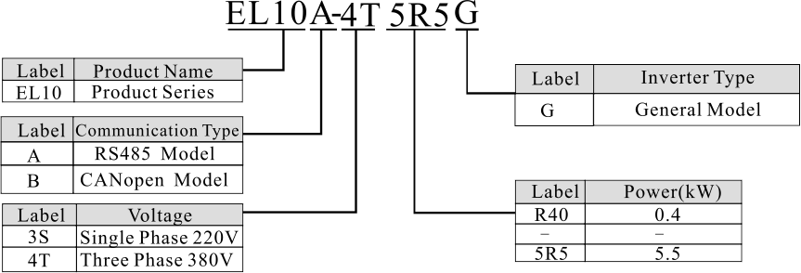
Figure 1-1 Example of Three-Phase 5.5kW Product Model

Nameplate
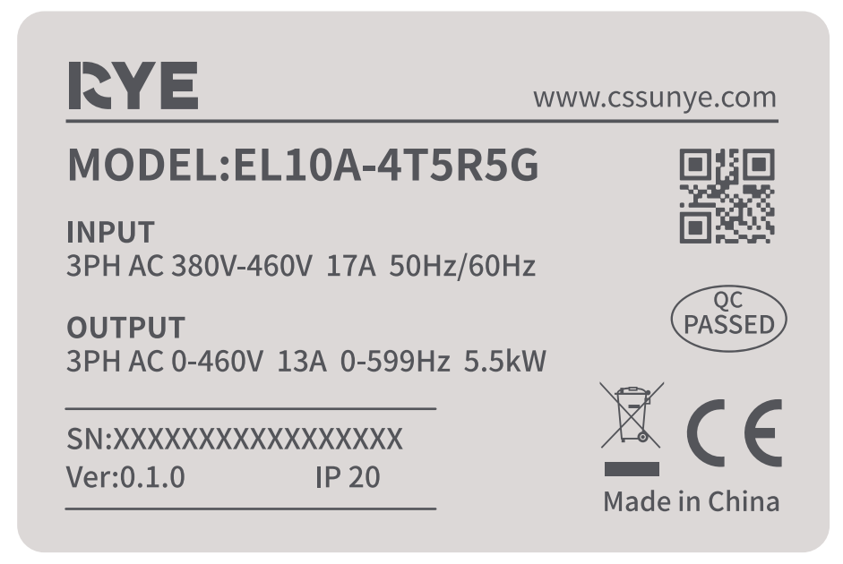
Figure 1-2 Example of Three-Phase 5.5kW Nameplate

Chapter Two Selection Overview
Table 2-1 EL10 Inverter Model and Basic Specifications RS485 Model
External Structure | Inverter Model | Input Voltage (V) | Input Current (A) | Output Current (A) | Suitable Motor (kW)
C0 | EL10A-3SR40G | Single Phase 200V～240V  Range: ±10% | 6.5 | 2.7 | 0.4
C0 | EL10A-3SR75G | Single Phase 200V～240V  Range: ±10% | 9.3 | 4.2 | 0.75
C0 | EL10A-3S1R5G | Single Phase 200V～240V  Range: ±10% | 15.7 | 7.5 | 1.5
C1 | EL10A-3S2R2G | Single Phase 200V～240V  Range: ±10% | 24.0 | 11.0 | 2.2
C1 | EL10A-4TR75G | Three-phase 380V～460V  Range: ±10% | 3.2 | 2.5 | 0.75
C1 | EL10A-4T1R5G | Three-phase 380V～460V  Range: ±10% | 5.0 | 4.2 | 1.5
C1 | EL10A-4T2R2G | Three-phase 380V～460V  Range: ±10% | 7.1 | 5.5 | 2.2
C2 | EL10A-4T4R0G | Three-phase 380V～460V  Range: ±10% | 10.0 | 9.0 | 4.0
C2 | EL10A-4T5R5G | Three-phase 380V～460V  Range: ±10% | 17.0 | 13.0 | 5.5
Table 2-2 CANopen Models
External Structure | Inverter Model | Input Voltage (V) | Input Current (A) | Output Current (A) | Suitable Motor (kW)
C0 | EL10B-3SR40G | Single Phase 200V～240V  Range: ±10% | 6.5 | 2.7 | 0.4
C0 | EL10B-3SR75G | Single Phase 200V～240V  Range: ±10% | 9.3 | 4.2 | 0.75
C0 | EL10B-3S1R5G | Single Phase 200V～240V  Range: ±10% | 15.7 | 7.5 | 1.5
C1 | EL10B-3S2R2G | Single Phase 200V～240V  Range: ±10% | 24.0 | 11.0 | 2.2
C1 | EL10B-4TR75G | Three-phase 380V～460V  Range: ±10% | 3.2 | 2.5 | 0.75
C1 | EL10B-4T1R5G | Three-phase 380V～460V  Range: ±10% | 5.0 | 4.2 | 1.5
C1 | EL10B-4T2R2G | Three-phase 380V～460V  Range: ±10% | 7.1 | 5.5 | 2.2
C2 | EL10B-4T4R0G | Three-phase 380V～460V  Range: ±10% | 10.0 | 9.0 | 4.0
C2 | EL10B-4T5R5G | Three-phase 380V～460V  Range: ±10% | 17.0 | 13.0 | 5.5

Chapter 3 Product Specifications

Electrical Specifications

220V1φ
Table 3-1 EL10 Single-Phase Inverter Electrical Specifications
Model EL10A(B)-3S□□□G |  | R40 | R75 | 1R5 | 2R2
Applicable Motor Power (kW) |  | 0.4 | 0.75 | 1.5 | 2.2
Applicable Motor Power (HP) |  | 0.5 | 1.0 | 2.0 | 3.0
Output | Rated Output Capacity (kVA) | 1 | 1.6 | 2.9 | 4.2
Output | Rated Output Current (A) | 2.7 | 4.2 | 7.5 | 11.0
Output | Maximum Output Voltage (V) | Corresponding Input Voltage
Output | Output Frequency Range (Hz) | 0.1Hz~599Hz
Output | Carrier Frequency (kHz) | 2kHz~6kHz (Default 4kHz)
Input | Input Current (A) | 6.5 | 9.3 | 15.7 | 24.0
Input | Rated Voltage, Frequency | Single Phase 200V~240V, 50/60Hz
Input | Permissible Input Voltage Variation Range | ±10% (180V~264V)
Input | Permissible Power Supply Frequency Variation | ±5% (47Hz~63Hz)
Cooling Method |  | Forced Air Cooling
Gross Weight (kg) |  | 0.6 | 0.6 | 0.6 | 0.7

380V3φ
Table 3-2 EL10 Three-Phase Inverter Electrical Specifications
Model EL10A(B)-4T□□□G |  | R75 | 1R5 | 2R2 | 4R0 | 5R5
Applicable Motor Power (kW) |  | 0.75 | 1.5 | 2.2 | 4 | 5.5
Applicable Motor Power (HP) |  | 1 | 2 | 3 | 5.5 | 7.5
Output | Rated Output Capacity (kVA) | 2 | 3.3 | 4.4 | 7.4 | 10.4
Output | Rated Output Current (A) | 2.5 | 4.2 | 5.5 | 9 | 13
Output | Maximum Output Voltage (V) | Corresponding Input Voltage
Output | Output Frequency Range (Hz) | 0.1Hz~599Hz
Output | Carrier Frequency (kHz) | 2kHz~6kHz (Default 4kHz)
Input | Input Current (A) | 3.2 | 4.3 | 7.1 | 10 | 17
Input | Rated Voltage, Frequency | Three-phase power supply 380V~460V, 50/60Hz
Input | Permissible Input Voltage Variation Range | ±10% (342V~506V)
Input | Permissible Power Supply Frequency Variation | ±5% (47Hz~63Hz)
Cooling Method |  | Forced Air Cooling
Gross Weight (kg) |  | 0.7 | 0.7 | 0.7 | 1.2 | 1.2

Technical Specifications
Table 3-3 EL10 Inverter Technical Specifications
Item |  |  | Specification
Control  Features | Control Method |  | V/F Control
Control  Features | Output Frequency Resolution |  | Panel control: 0.01Hz below 10Hz; 0.1Hz above 10Hz  Communication control: 0.01Hz  Analog setting: Maximum frequency × ±0.1%
Control  Features | Overload Capacity |  | 150% of rated output current for 60 seconds, 180% for 3 seconds
Control  Features | Prohibited Frequency Setting |  | 0.1~599.0Hz Set 4 Points
Control  Features | Acceleration/Deceleration Time |  | 0.1~600 Seconds (4 Segments of Acceleration/Deceleration Time Can Be Set Independently)
Control  Features | Stall Prevention |  | Set According to Motor Load Characteristics, at 20~200% of Driver Rated Current
Control  Features | DC Braking |  | Braking Current: 0~100% of Rated Current, Braking Time: 0~60 Seconds
Control  Features | V/F Curve |  | General V/F Curve Setting, 1.5 Power Curve Setting, 2 Power Curve Setting
Operation  Features | Frequency Setting Signal | Panel Operation | Panel VR Setting
Operation  Features | Frequency Setting Signal | External Signal | External Terminal: UP/DOWN Frequency, Jog Operation,  AVI/ACI: 0~+10VDC/4~20mA/0~20mA  Serial Communication Port: Standard models support RS485, extended models support CANopen
Operation  Features | Operation  Set Signal | Panel Operation | Set by RUN, STOP keys
Operation  Features | Operation  Set Signal | External Signal | MI1, MI2, MI3 two/three-wire control, jog operation, serial communication (RS485)
Operation  Features | Input Terminal Functions |  | 16-segment speed (including main speed) default speed switching, acceleration/deceleration prohibition command, 4-segment acceleration/deceleration switching, external counting, fault reset, incremental/decremental terminal set frequency, jog operation, etc.
Operation  Features | Output Terminal Functions |  | Operation indication, frequency arrival indication, zero-speed indication, counter arrival indication, fault indication, overheating warning, emergency stop, etc.
Human-  Machine Interface | Communication/Bus |  | EL10A supports RS485 communication; EL10B supports CANopen and RS485
Human-  Machine Interface | Analog Input |  | 1 AI channel
Human-  Machine Interface | Digital Input |  | 4 DI channels
Human-  Machine Interface | Digital Output |  | 1 Normally Open Relay Output [EL10A]
Human-  Machine Interface | Digital Output |  | 1 Normally Closed Relay Output [EL10B]
Human-  Machine Interface | Digital Operation Panel |  | Includes 6 function keys, a 4-digit 7-segment LED display, 4 LED status indicators, can set frequency, display actual output frequency, output current, parameter browsing, modification settings and parameter locking, fault display, can perform start, stop, reset, forward/reverse
Human-  Machine Interface | Backend Software |  | Supports inverter parameter operation and virtual oscilloscope function;  Through the virtual oscilloscope, graphical monitoring of the inverter's internal state can be achieved;
Protection Functions |  |  | Undervoltage, Overvoltage, Overcurrent, IGBT Overtemperature, Inverter Overload, Motor Overload, Detection Line Abnormality, PID Disconnection, Parameter Reading Abnormality, Parameter Password Error, Communication Abnormality, Communication Timeout, DEB Abnormality, Excessive Slip Difference, Output Phase Loss, External Terminal Abnormality, External Interruption Operation, etc.

Custom Functions
Table 3-4 EL10 Inverter Custom Functions
Item | Specification
Acceleration/Deceleration Curves | Linear, S-Curve (Initial Arcs Can Be Set Separately)
Built-in PID | Built-in PID, Achieving Process Control in Specific Situations
Operation Command Channel | Three Channels: Operation Panel, External Terminals, Communication Setting (Can Be Switched via Parameters)
Frequency Jump Function | Skip certain frequency bands to avoid resonance points.
Energy consumption braking | Reduce bus voltage surge through energy dissipation
Multi-speed operation | Achieve 16-speed switching via external terminals
Automatic voltage adjustment | Automatically maintain constant output voltage when grid voltage changes
Overvoltage and overcurrent stall prevention | Automatically limit current and voltage during operation to prevent frequent overcurrent and overvoltage trips
Rapid current limiting function | Minimize overcurrent as much as possible to allow the inverter to stably transition under extreme conditions
Energy-saving operation | Energy-saving operation to improve work efficiency
Continuous Operation During Momentary Power Interruption | Maintaining normal operation of the inverter for a short period during a momentary power outage by compensating for voltage drops through certain methods

Environmental Specifications
Table 3-5 EL10 Inverter Environmental Specifications

Item | Specification
Installation Location | Below an altitude of 1000m, indoors (no corrosive gases, liquids, or dust), derated use above 1000m
Ambient Temperature | -10°C to +40°C (except for naturally cooled models, when installed side-by-side, the operating temperature limit is 40°C, derated use required above 40°C, maximum usage temperature is 50°C)
Storage Temperature | -20°C to +60°C
humidity | below 95%RH (no condensation)
vibration | complies with IEC60068-2-6
protection class | IP20
degree of contamination | 2
Cooling Method | forced air cooling

Chapter 4 Optional Accessories
Table 4-1 EL10 Inverter Optional Accessories
name | internal model | function | notes
external LED panel | KPL-LED1 | LED control panel, for parameter display, setting, and copying | /
external LED panel | CM800-JP-09-04 | LED Keyboard Mounting Base | /
external LED panel | Network Cable 1* | Extension Cable for Operation Panel, Supports RJ45 Terminal | /
DIN Rail Installation | None | EL10 Rail Installation Accessories | Please refer to Figure 2-8 for rail size diagram and purchase accordingly.
Cable/Wire Terminal | None | Connection between the driver and the power grid, motor, or other peripheral electrical equipment | Please refer to the recommendations and requirements in Section 4-2 and purchase accordingly.
Peripheral Electrical Components | None | Peripheral electrical equipment to be used with the driver | Please refer to the recommendations and requirements in Section 4-3 and purchase accordingly.
1* cable length optional, please consult sales for purchase.

4.1control panel
Table 4-2 EL10 Inverter Control Panel
Model | Description | Appearance
KPL-LED1 | LED control panel, for parameter display, setting, and copying. | 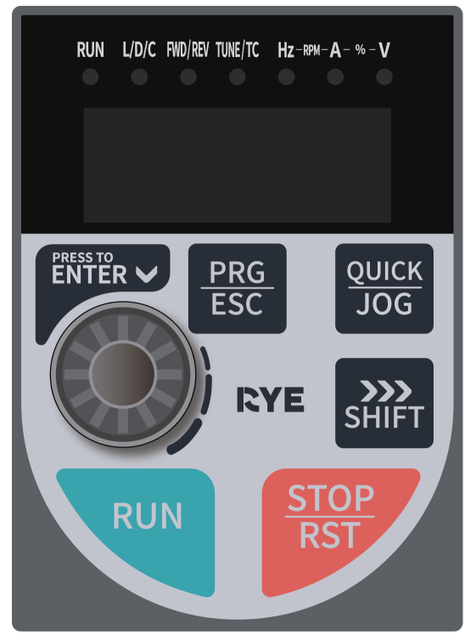
Figure 4-1 Control Panel Dimensions (Unit: mm)
Figure 4-2 Mounting Bracket Dimensions and Recommended Cutout Dimensions (Unit: mm)

4.2Cable

Main Circuit Cable
For the selection of power cable size, please follow the regulations and requirements of each country or region. IEC cable selection is based on:
- Compliance with EN60204-1 and IEC60364-5-52 standards.
- Use PVC copper conductor cables.
- 40°C ambient temperature, 70°C cable surface temperature. (Note: If the ambient temperature exceeds 40°C, please contact the manufacturer)
- Symmetrical cable with copper mesh shielding.
If the recommended cable specifications for peripheral devices or options exceed the cable specifications applicable to the product, please contact us. To meet EMC standard requirements, it is essential to use cables with a shield. Shielded cables are available in two types: three-phase conductors and four-phase conductors, as shown in the figure below. When the conductive performance of the shielding layer of a three-phase conductor shielded cable does not meet the requirements, an additional separate PE line should be added. Alternatively, a four-phase conductor shielded cable can be used, one of which is a PE line. To effectively suppress radio frequency interference, the shielding layer of the shielded cable should be composed of coaxial copper braiding. To enhance shielding effectiveness and conductivity, the braid density of the shielding layer should be greater than 90%.
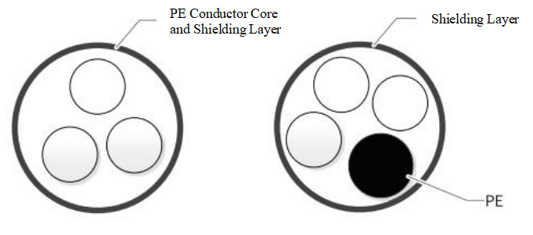
Figure 4-3 Recommended Power Cable Types

Control Circuit Wiring
To ensure that IO signal lines are not affected by strong external interference noise, it is recommended to use shielded cables with a shielding layer, and to achieve a reliable 360° connection at both ends of the shielding layer using signal shielding brackets with the equipment. Different analog signals should use separate shielded wires; digital signal lines are recommended to use shielded twisted pairs.
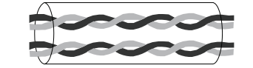
Figure 4-4 Schematic Diagram of Shielded Twisted Pair
Refer to the table below for the cross-sectional area of main circuit/control circuit wiring and recommended terminal lug models:
Table 4-3 Recommended Wire Gauge and Terminal Lug Models for EL10 Inverter
Frame Number | Inverter Model | RST/UVW/Ground Recommended Wires and Terminal Lugs |  | Control Circuit Wires  （mm²） | Control Circuit Terminal Lug Model
Frame Number | Inverter Model | Wire (mm²) | Terminal Lug Model | Control Circuit Wires  （mm²） | Control Circuit Terminal Lug Model
C0 | EL10A(B)-3SR40G | 1 | E1010 | 0.5 | E0510
C0 | EL10A(B)-3SR75G | 2.5 | E2510 | 0.5 | E0510
C0 | EL10A(B)-3S1R5G | 2.5 | E2510 | 0.5 | E0510
C1 | EL10A(B)-3S2R2G | 4 | E4012 | 0.5 | E0510
C1 | EL10A(B)-4TR75G | 0.75 | E7512 | 0.5 | E0510
C1 | EL10A(B)-4T1R5G | 0.75 | E7512 | 0.5 | E0510
C1 | EL10A(B)-4T2R2G | 1 | E1012 | 0.5 | E0510
C2 | EL10A(B)-4T4R0G | 2.5 | E2512 | 0.5 | E0510
C2 | EL10A(B)-4T5R5G | 2.5 | E2512 | 0.5 | E0510

Peripheral Electrical Components

Circuit Breakers and Fuses
- The current rating of the circuit breaker must be between 2 to 4 times the rated input current of the inverter
- Fuses with specifications lower than those listed in the table below are permitted
Table 4-4 Recommended Circuit Breaker and Fuse Specifications for EL10 Inverters
Frame Number | Inverter Model | Rated Input Current (A) | Recommended Semiconductor Fuse Rating (A) | Recommended Circuit Breaker Rating (A)
C0 | EL10A(B)-3SR40G | 6.5 | 15 | 15
C0 | EL10A(B)-3SR75G | 9.3 | 20 | 20
C0 | EL10A(B)-3S1R5G | 15.7 | 40 | 30
C1 | EL10A(B)-3S2R2G | 24 | 50 | 50
C1 | EL10A(B)-4TR75G | 3.2 | 10 | 10
C1 | EL10A(B)-4T1R5G | 4.3 | 10 | 10
C1 | EL10A(B)-4T2R2G | 7.1 | 15 | 15
C2 | EL10A(B)-4T4R0G | 10 | 20 | 20
C2 | EL10A(B)-4T5R5G | 17 | 40 | 40

EMC filter
To ensure that this product meets the requirements of EN/IEC 61800-3 standards, an external EMC filter is required. Please purchase according to the rated input current of this product. For brand and model recommendations, please consult after-sales service:
Table 4-5 Recommended EMC Filter Specifications for EL10 Inverter
Frame Number | Inverter Model | Rated Input Current (A) | Recommended EMC Filter Rating (A)
C0 | EL10A(B)-3SR40G | 6.5 | 10
C0 | EL10A(B)-3SR75G | 9.3 | 10
C0 | EL10A(B)-3S1R5G | 15.7 | 20
C1 | EL10A(B)-3S2R2G | 24 | 30
C1 | EL10A(B)-4TR75G | 3.2 | 5
C1 | EL10A(B)-4T1R5G | 4.3 | 5
C1 | EL10A(B)-4T2R2G | 7.1 | 10
C2 | EL10A(B)-4T4R0G | 10 | 20
C2 | EL10A(B)-4T5R5G | 17 | 20

Input Reactor
- Improve the power factor on the input side;
- Eliminate higher harmonics on the input side to prevent damage to other equipment due to voltage waveform distortion;
- Eliminate input current imbalance caused by power supply phase imbalance;
- Reduce the thermal stress and lifespan impact on the rectifier bridge and bus capacitor when a large-capacity power grid is equipped with a small-capacity inverter (usually at a ratio of 10), due to the low grid impedance. When the above four requirements are present, an input reactor can be selected, and the recommended specifications for the input reactor are as follows:
Table 4-6 Recommended Input Reactor Specifications for EL10 Inverter
Frame Number | Power Grid | Inverter Model | Recommended Rated Current of Input Reactor (A) | Maximum Continuous Input Current of Inverter (A) | Recommended Inductance of Input Reactor (mH) 3~5% impedance
C0 | Single-phase 220V | EL10A(B)-3SR40G | 6.5 | 9.75 | 3
C0 | Single-phase 220V | EL10A(B)-3SR75G | 9.3 | 13.95 | 1.5
C0 | Single-phase 220V | EL10A(B)-3S1R5G | 15.7 | 23.55 | 1.25
C1 | Single-phase 220V | EL10A(B)-3S2R2G | 24 | 36 | 0.8
C1 | Three-phase 380V | EL10A(B)-4TR75G | 3.2 | 4.8 | 10
C1 | Three-phase 380V | EL10A(B)-4T1R5G | 4.3 | 6.45 | 9
C1 | Three-phase 380V | EL10A(B)-4T2R2G | 7.1 | 10.65 | 6
C2 | Three-phase 380V | EL10A(B)-4T4R0G | 10 | 15 | 4
C2 | Three-phase 380V | EL10A(B)-4T5R5G | 17 | 25.5 | 2

Output Reactor
Installing an output reactor on the driver output side can reduce excessive dV/dt, thereby reducing the voltage stress on the motor windings, protecting the motor windings, lowering the motor temperature, and extending the motor's service life. Whether to configure an output reactor on the driver output side can be determined based on specific circumstances. The transmission line between the inverter and the motor should not be too long; if the cable is too long, its distributed capacitance will be large, making it prone to generating higher harmonic currents. When the application environment has higher harmonic requirements for the power grid, an optional reactor can be selected; if there are no special requirements, it does not need to be selected.
Table 4-7 Recommended Output Reactor Specifications for EL10 Inverter
Frame Number | Inverter Model | Recommended Output Reactor Rated Current (A) | Inverter Maximum Continuous Output Current (A) | Recommended Output Reactor Inductance (mH) 3~5% impedance
C0 | EL10A(B)-3SR40G | 2.7 | 4.05 | 12
C0 | EL10A(B)-3SR75G | 4.2 | 6.3 | 7.5
C0 | EL10A(B)-3S1R5G | 7.5 | 11.25 | 2.5
C1 | EL10A(B)-3S2R2G | 11 | 16.5 | 2
C1 | EL10A(B)-4TR75G | 2.5 | 3.75 | 25
C1 | EL10A(B)-4T1R5G | 4.2 | 6.3 | 8
C1 | EL10A(B)-4T2R2G | 5.5 | 8.25 | 7
C2 | EL10A(B)-4T4R0G | 9 | 13.5 | 4
C2 | EL10A(B)-4T5R5G | 13 | 19.5 | 2

4.3.5Ferrite Core and Ferrite Clamp
The ferrite core can be installed on the input side or output side of the driver, as close to the driver as possible. Installing the ferrite core on the input side can improve the driver's EMI performance on the power grid. Installing the ferrite core on the output side is mainly used to reduce interference from the driver to external devices, while also reducing bearing current.
For leakage current issues and other signal line interference problems that exist in some application scenarios, ferrite cores or ferrite clamps can be selected for suppression.
- Amorphous Ferrite Core: Has a very high permeability within 1 MHz, which is highly effective for suppressing driver interference, but it is slightly more expensive.
- Ferrite Beads: Perform well in frequency bands above 1 MHz, effective in suppressing interference on various signal lines for low-power drivers, and have a low cost.
Please decide whether to select ferrite cores or beads based on the actual on-site debugging situation.

Chapter 5 Mechanical Installation
  - Overall Dimensions
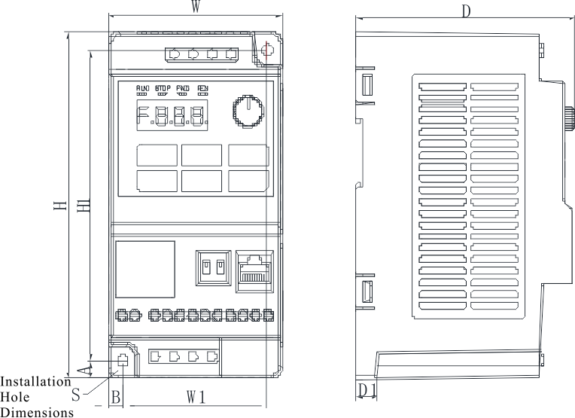
Figure 5-1 Schematic Diagram of C0 Appearance and Installation Dimensions
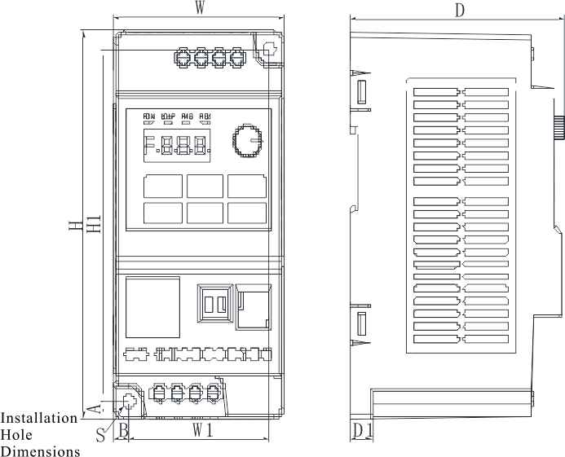
Figure 5-2 Schematic Diagram of C1 Appearance and Installation Dimensions
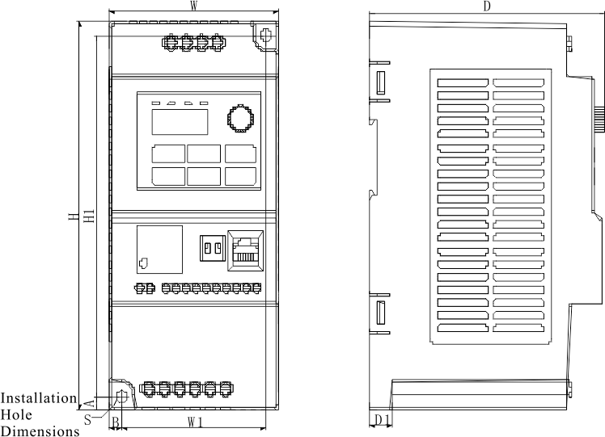
Figure 5-3 Schematic Diagram of C2 Appearance and Installation Dimensions
Table 5-1 Appearance and Installation Hole Position Dimensions of EL10-C0 to C2 (Unit: mm)
Dimensions  Structure | W | W1 | H | H1 | D | D1 | A | B | Mounting Hole Diameter S (mm) | Gross Weight (Kg)
C0 | 69.0 | 57.5 | 133.0 | 119.5 | 104.0 | 11.5 | 7.0 | 6.0 | Φ4.5 | 0.6
C1 | 73.0 | 60.0 | 143.0 | 130.0 | 105.0 | 11.5 | 6.8 | 6.5 | Φ5.5 | 0.7
C2 | 84.5 | 72.0 | 180.0 | 167.5 | 117.5 | 12.0 | 6.3 | 6.3 | Φ5.5 | 1.2
  - Installation Requirements
    - Installation Environment
(1) Ambient Temperature: -10°C to +40°C (for side-by-side installation, the operating temperature limit is 40°C; operation above 40°C requires derating, with a maximum usage temperature of 50°C).
(2) Install the inverter on a fire-resistant surface, ensuring there is sufficient cooling space around it, then mount it vertically on the mounting bracket using screws.
(3) Install in a location that is not prone to vibration, where vibration does not exceed 0.6g, and pay special attention to keeping away from stamping machines and similar equipment.
(4) Avoid installing in areas exposed to direct sunlight, high humidity, or where water droplets may fall.
(5) Avoid installing in areas where the air contains corrosive, flammable, or explosive gases.
(6) Avoid installing in areas with oil contamination, excessive dust, or metal particles.
    - installation space
Depending on the power rating of the inverter, the surrounding installation space and spacing will vary slightly when installing the inverter.
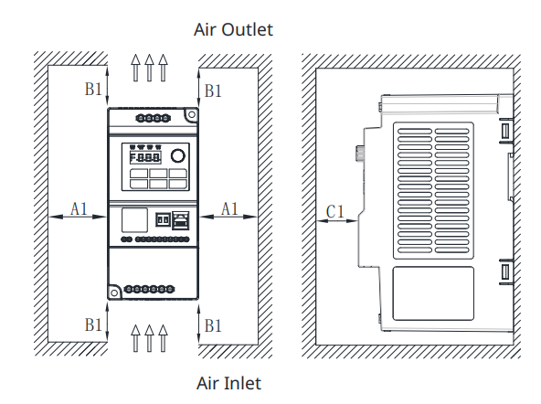
Figure 5-4 Installation Diagram for C0～C2 Models (Single Unit Installation)
Table 5-2 Installation Space Requirements for 0.4～5.5kW (Single Unit Installation)
Installation Space Requirements
Power Rating | Dimensional Requirements (Unit: mm)
0.4kW | A1≥20 | B1≥80 | C1≥80
0.75kW | A1≥20 | B1≥80 | C1≥80
1.5kW | A1≥20 | B1≥80 | C1≥80
2.2kW | A1≥20 | B1≥80 | C1≥80
4.0kW | A1≥20 | B1≥80 | C1≥80
5.5kW | A1≥20 | B1≥80 | C1≥80
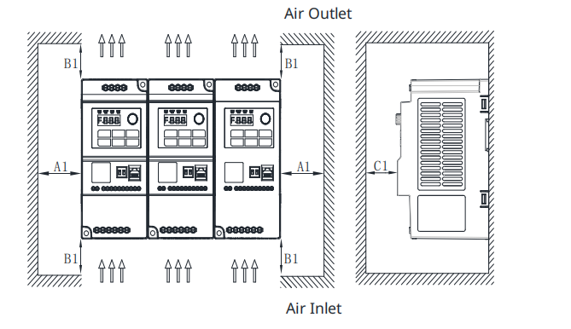
Figure 5-5 Installation Diagram for C0～C2 Models (Side-by-Side Installation)
Table 5-3 Installation Space Requirements for 0.4～5.5kW (Side-by-Side Installation)
Installation Space Requirements
Power Rating | Dimensional Requirements (Unit: mm)
0.4kW | A1≥20 | B1≥100 | C1≥80
0.75kW | A1≥20 | B1≥100 | C1≥80
1.5kW | A1≥20 | B1≥100 | C1≥80
2.2kW | A1≥20 | B1≥100 | C1≥80
4.0kW | A1≥20 | B1≥120 | C1≥80
5.5kW | A1≥20 | B1≥120 | C1≥80
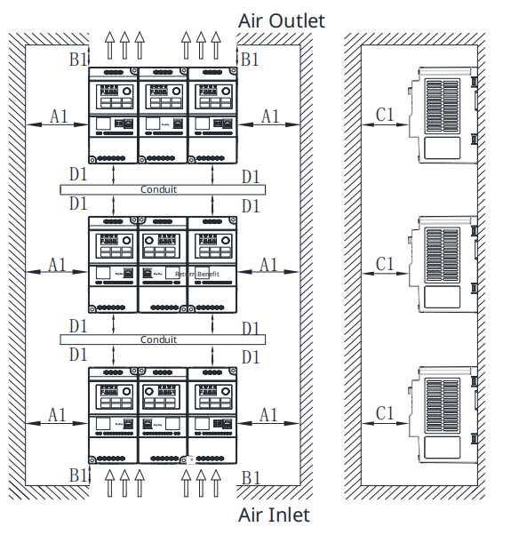
Figure 5-6 Installation Diagram for C0～C2 Models (Vertical Side-by-Side Installation)

Table 5-4 Installation Space Requirements for 0.4～5.5kW (Vertical Side-by-Side Installation)
Installation Space Requirements
Power Rating | Dimensional Requirements (Unit: mm)
0.4kW | A1≥20 | B1≥100 | C1≥80 | D1≥80
0.75kW | A1≥20 | B1≥100 | C1≥80 | D1≥80
1.5kW | A1≥20 | B1≥100 | C1≥80 | D1≥80
2.2kW | A1≥20 | B1≥100 | C1≥80 | D1≥80
4.0kW | A1≥20 | B1≥120 | C1≥80 | D1≥80
5.5kW | A1≥20 | B1≥120 | C1≥80 | D1≥80
    - Note on Model Installation
Please install the inverter vertically to facilitate heat dissipation upwards, but do not invert it. When there are many inverters in the cabinet, it is best to install them side by side, aligning the top of the machines when installed side by side. For occasions where installation is required vertically, please refer to the installation diagram in Figure 5-6 to prevent overheating of the upper equipment due to heat from the lower equipment.
Follow the installation space requirements as shown in Tables 5-2, 5-3, and 5-4 to ensure adequate cooling space for the inverter, but also consider the cooling conditions of other components within the cabinet during layout.
Note:
This series of inverters should be installed in a vertical upward position; installation in any other orientation such as lying down, on its side, or upside down is prohibited.
    - Installation Tools
Table 5-5 Mechanical Installation Tools Table
Tool Name | Description
Electric Drill and Drill Bits | Used for drilling mounting holes on the installation surface when mechanically installing equipment.
Phillips and Slotted Screwdrivers | Used for tightening or loosening screws during inverter installation.
Tape Measure | Used for measuring the installation dimensions of the inverter and verification during installation.
Gloves | Wear gloves during inverter installation to prevent static electricity.
Mounting Rail (see Fig. 5-7 for optional accessories) | When installing the inverter inside a cabinet, use the mounting rail to secure the inverter within the cabinet.
Screw | Secure the inverter to the mounting surface.

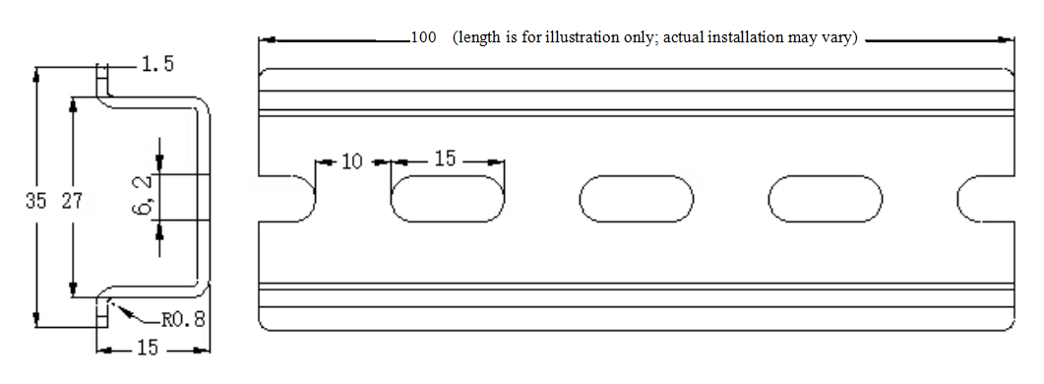
Figure 5-7 Rail Dimension Diagram (Unit: mm)
The accessories and quantities required for mechanical installation are listed in the table below:
Table 5-6 Optional Accessories List
Installation Method | Screw Specifications | Quantity | Description
wall-mounted installation | Purchase according to the size of the mounting holes and the application scenario | 2 | For securing the device to the wall
Cabinet Installation | (Refer to Figure 5-7 for rail dimensions) Please purchase or customize as needed | 1 | For securing the device to the rail bracket
Wiring Tools
When wiring the main circuit terminals, consider the size of the terminals and select appropriate tools to connect and secure them. Detailed requirements for wiring installation tools are listed in the table below.
Table 5-7 Main Circuit Terminal Wiring Installation Tool Requirements
Inverter Frame Number | Required Tools
C0~C2 | Slotted screwdriver, Phillips screw, wire stripper, crimping pliers
  - Storage, Handling, and Unpacking
    - Storage
When storing long-term, try to maintain the integrity of the product packaging, or use covering measures to ensure the equipment is not affected by the environment.
(1) Do not expose the inverter to harsh environments such as dust, sunlight, corrosion, flammable gases, oils, moisture, and vibration.
(2) The storage temperature for this product should be maintained between -20°C and +60°C, and the ambient temperature should not change drastically.
(3) For inverter products stored for a long time, it is necessary to power them on at least once every 6 months. The power-on time should be at least 5 hours to prevent the degradation of electrolytic capacitors. At the same time, the input voltage must be slowly increased to the rated value using a variac. If there are any questions, please consult the manufacturer's technical support.
    - Handling Before Unpacking

Transportation Precautions:
For the EL10 series models, the product is small in size and light in weight, allowing for manual handling. However, handle with care when lifting and placing.
    - Packaging Verification
Upon receiving the goods, please verify that the delivery note matches the actual items, and check if the packaging is the original factory packaging and if there is any damage. If any items are missing or damaged, please contact the shipping company immediately for handling. Do not connect the device if the product is damaged; wait for a professional to confirm the electrical safety before proceeding. For assistance, please consult the manufacturer's technical support.
    - Packing List
The product is packaged in a cardboard box. The specific packing list is as follows:
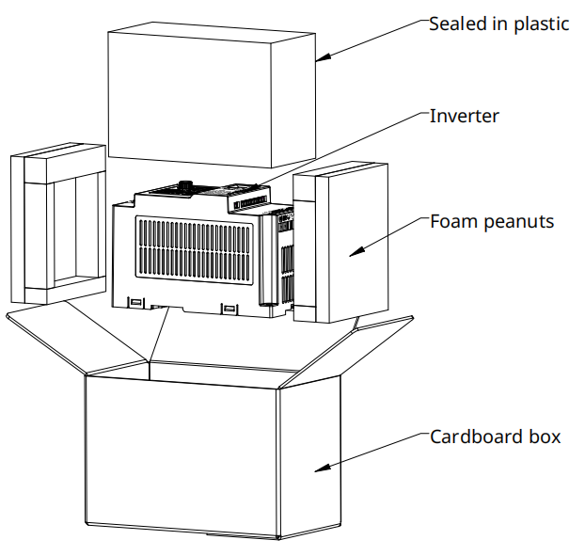
Figure 5-8 Packing List
    - Unpackaging
Instructions for unpacking are as follows:
(1) Remove the lid of the box.
(2) Remove all packing materials.
(3) Take out the device.
(4) Cut open the plastic film on the device.
(5) Ensure there are no signs of damage to the product.
(6) Dispose of or recycle packaging according to local regulations.
    - Description
For C0～C2 models, the equipment is relatively small in size and light in weight, allowing for manual handling;
For C0～C2 models, wall-mounted installation and recessed installation are supported.
  - Installation
Precautions Before Installation
Before installing the inverter into the control cabinet, check the cabinet design to ensure there is sufficient installation space and cooling space. When performing installation work, ensure that the installation location has sufficient strength to support the weight of the equipment.
When performing installation work, cover the top of the equipment with cloth or paper to prevent metal shavings, oil, water, etc., from entering the equipment during drilling. If foreign objects enter the equipment, it may cause equipment failure. After completing the work, remove the covering cloth or paper to avoid affecting the machine's cooling.
The installation area must ensure that the equipment has sufficient cooling space, and consider the heat dissipation of other components in the cabinet. For details, please refer to the 'Single Equipment Installation', 'Side-by-Side Installation', and 'Vertical Side-by-Side Installation' sections in Chapter 5.2.2 'Installation Space'.
When using mounting brackets, the material of the brackets must be flame-retardant.
For applications in environments with metal dust, it is recommended to use an enclosed installation cabinet to ensure that the equipment is isolated from metal dust. Note that fully sealed cabinets must have adequate cooling space.
Tighten all screws to the specified torque; otherwise, there may be a risk of fire or electric shock.
Do not place flammable or explosive items near the equipment.
    - Wall-mounted Installation Method
Refer to Chapter 5.1 for the location and diameter of the wall-mounted installation holes and overall dimensions.
Installation Procedures
Use a Phillips screwdriver to secure the two screws at the upper right and directly below the inverter (recommended screws are M4, M5 cross-recessed screws; length specifications should be determined by the customer based on the actual installation scenario).
Figure 5-9 Wall-mounted Installation
Note:
When installing the inverter using the wall-mounted method, both the upper right and lower left screws must be secured simultaneously. Do not fix only one screw on the device, as this may cause the fixed part to fall off and damage due to uneven force over long-term operation.
When disassembling, use a Phillips screwdriver to remove the two mounting screws on the inverter and then remove the inverter.
    - Rail Mounting Method
When installing the inverter using the rail mounting method, purchase DIN rail mounting accessories (optional). For detailed information, refer to Table 5-5 “Mechanical Installation Tools.”
Use a slotted screwdriver to gently pry out the rail clip slightly as shown in the following figure:
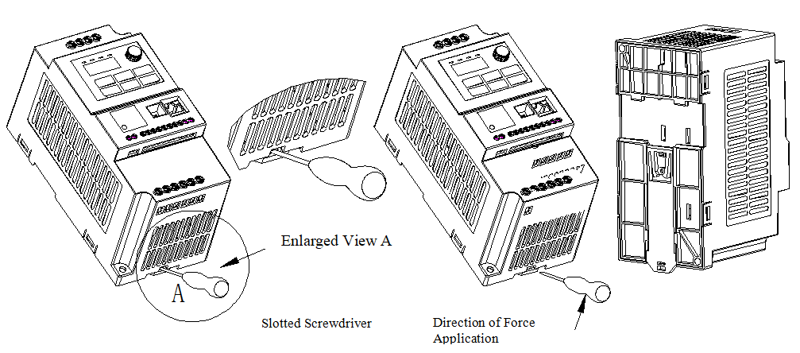
Figure 5-10 Rail Mounting Diagram 1
Scenario 1
If the rail has not yet been installed in the cabinet, follow the instructions in “Figure 5-11 Rail Mounting Diagram 2” to install the entire unit in the direction shown, secure the clips in place, then press the product onto the rail as indicated by the arrow in “Figure 5-12 Rail Mounting Diagram 3,” and finally press the rail clips upward to lock them onto the rail, completing the rail installation.
Figure 5-11 Rail Installation Diagram 2
Figure 5-12 Rail Installation Diagram 3
Scenario 2
If the rail has been installed in the cabinet, first support the entire unit as shown in 'Figure 5-13 Rail Installation Diagram 4', then press the bottom of the unit firmly in the direction of the arrow (left image of Figure 5-13) towards the lower left until the rail clicks into the unit's clips. After it is properly seated, push the rail clip up to the limit to lock it onto the rail, completing the rail installation.
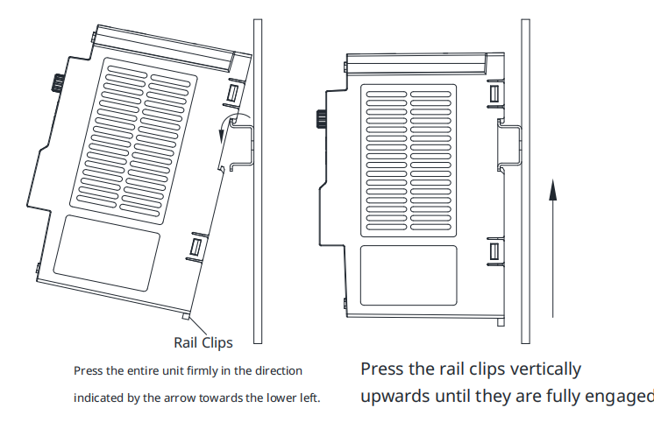
Figure 5-13 Rail Installation Diagram 4
Disassembly
When performing control circuit wiring, ensure that the machine has been powered off for more than 10 minutes.
Use a slotted screwdriver to gently pry out the rail clip slightly so that it is no longer locking onto the rail, then pull the unit diagonally upwards to remove it from the rail.
If choosing rail mounting, it is recommended to use Installation Method 1.

Chapter 6 Electrical Installation
  - Electrical Wiring Diagram
    - RS485 Model
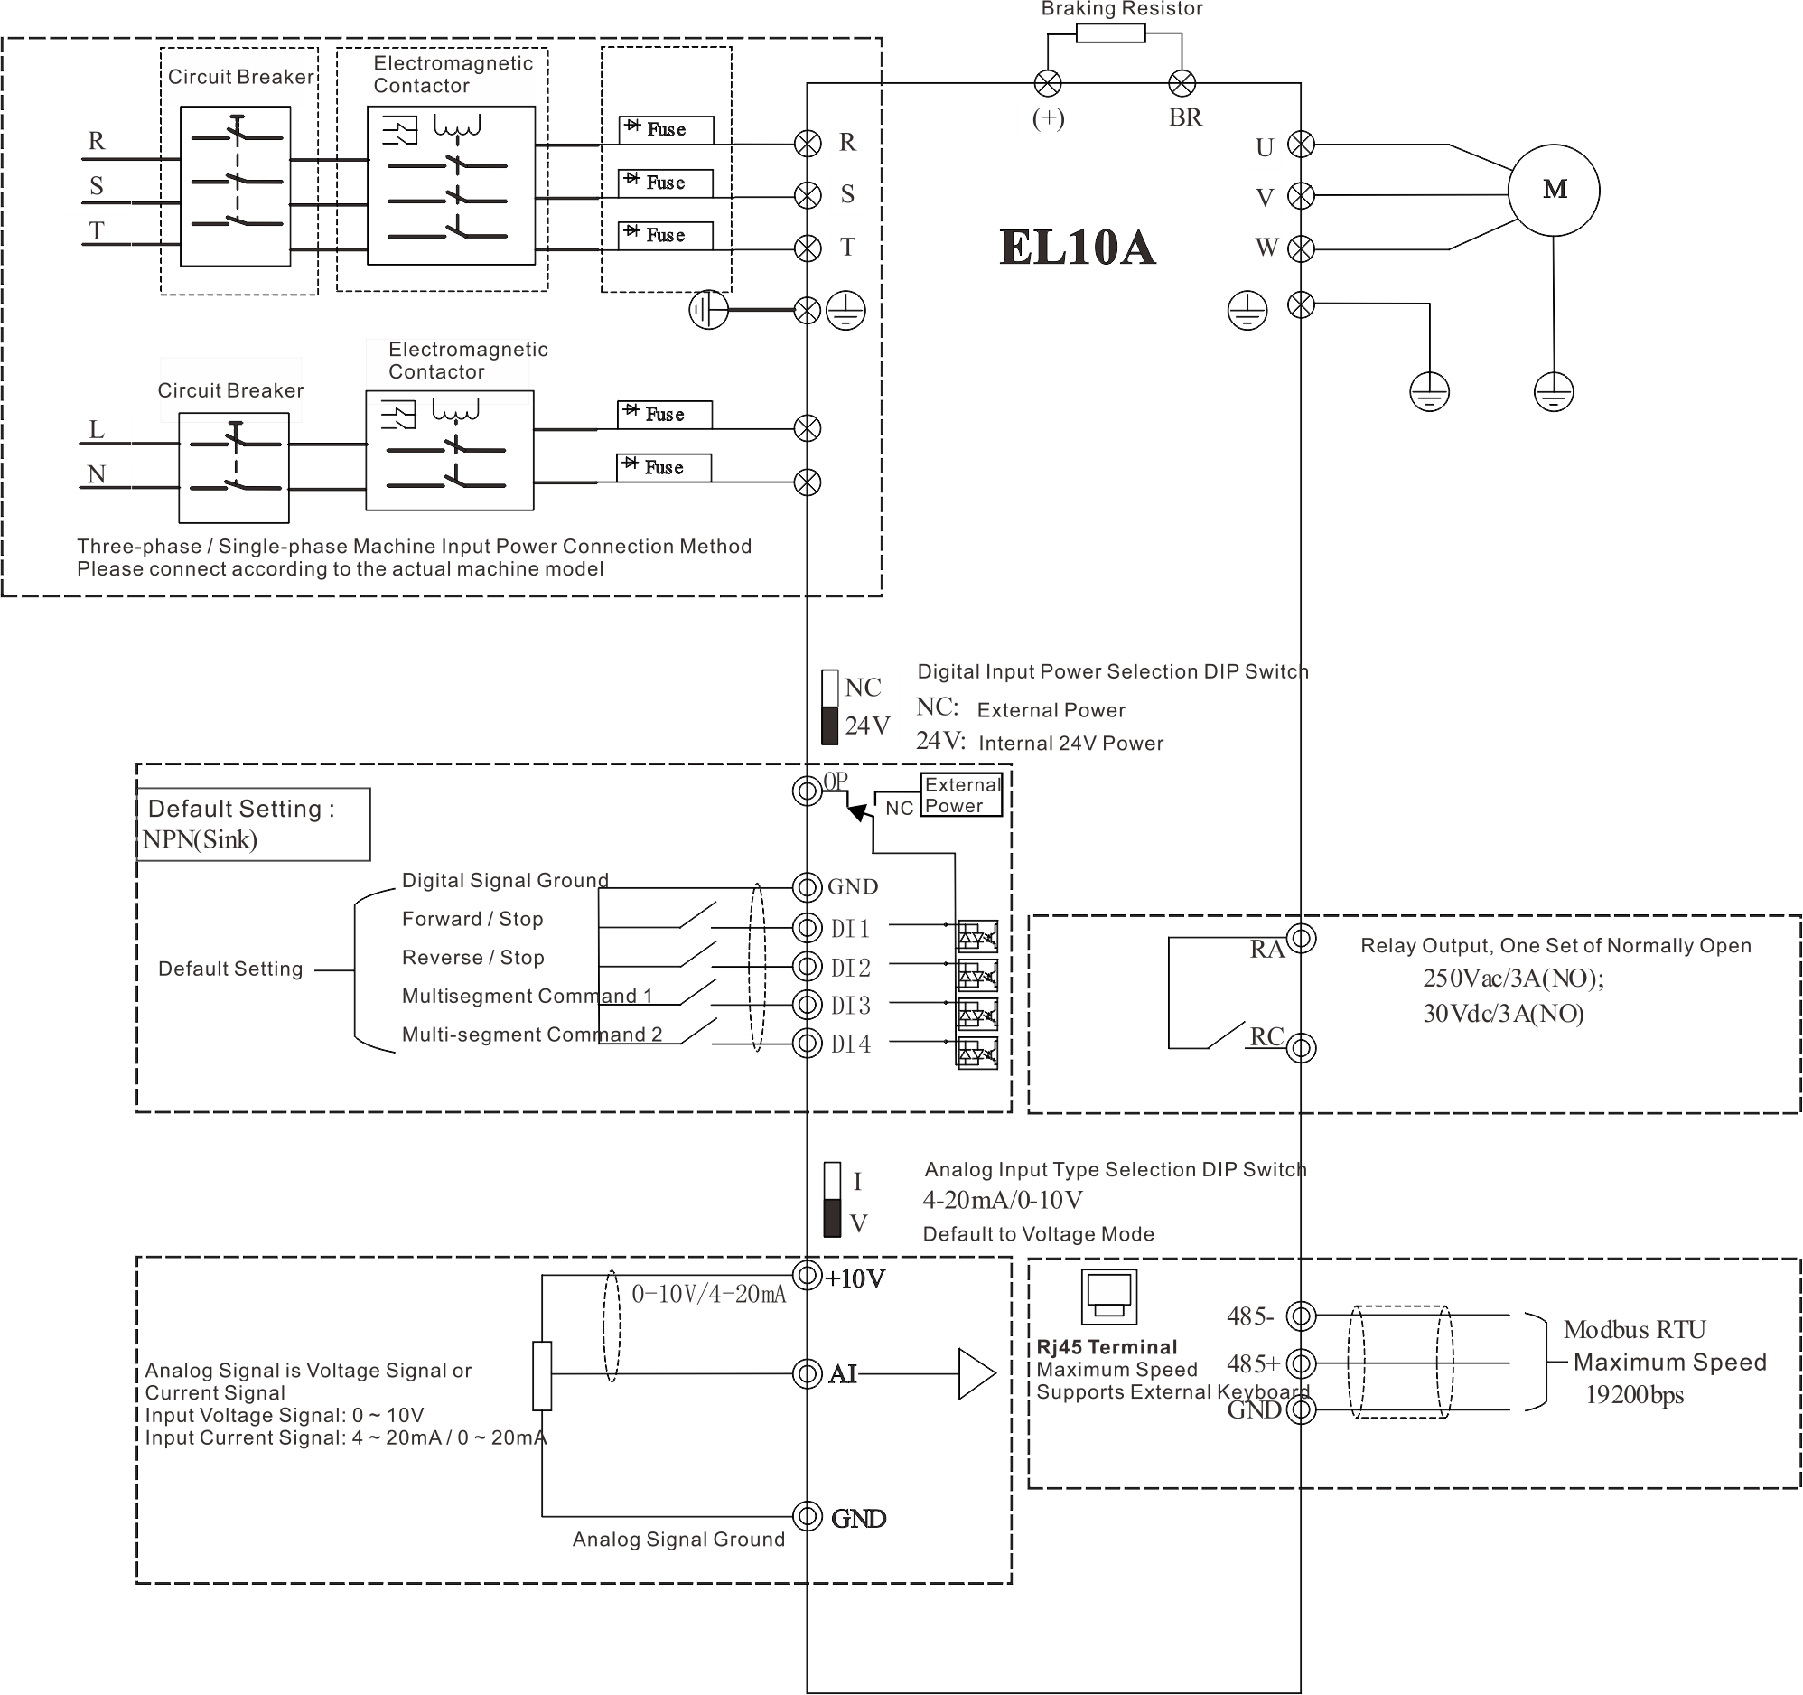
Figure 6-1 Three-phase/Single-phase Power Input Terminal Wiring Diagram

    - CANopen Model
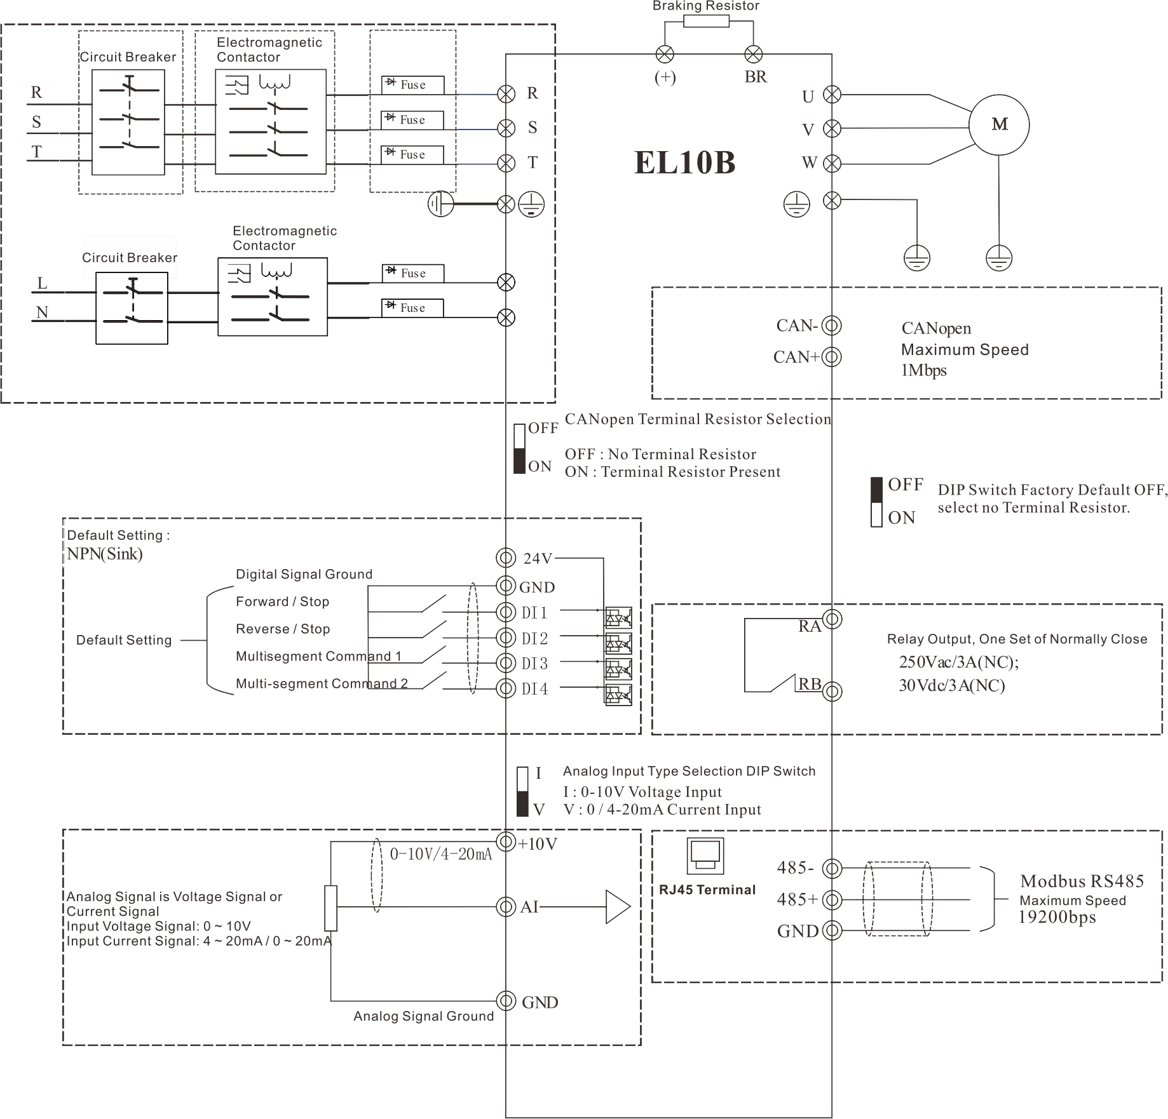
Figure 6-2 Three-phase/Single-phase Power Input Terminal Wiring Diagram

  - Main Circuit Terminal Description
    - main circuit terminals

Output Terminals

Input Terminals

Output Terminals

Input Terminals

Figure 6-3 EL10 Inverter Main Circuit Terminal Layout

Table 6-1 Main Circuit Terminal Marking Description
Terminal Marking | name | Description
R, S, T | Three-phase Power Input Terminals | AC Input Three-phase Power Connection Points
R/L, S/N | C1 Frame Three-phase/Single-phase Power Compatible Input Terminals | AC Input Three-phase/Single-phase Power Connection Points
(+), BR | Braking Resistor Connection Terminals | Reserved for 4.0kW/5.5kW models with brake unit, not currently supported.
U, V, W | Inverter Output Terminals | Connect to Three-phase Motor
 | Grounding Terminal | Grounding
    - Wiring Precautions
Inverter Output Side U, V, W
Capacitors or surge absorbers must not be connected to the inverter's output side, as this can cause frequent protection trips or even damage the inverter.
When the motor cable is too long, electrical resonance can easily occur due to the influence of distributed capacitance, leading to motor insulation failure or significant leakage current, which can trigger overcurrent protection at the grounding terminal:
The grounding terminal must be reliably grounded; otherwise, it may lead to abnormal operation or damage to the equipment.
Do not share the grounding terminal with the power neutral (N) terminal.
  - Control Circuit Terminal Description
    - Control Circuit Terminal
The control circuit terminal layout is shown below:
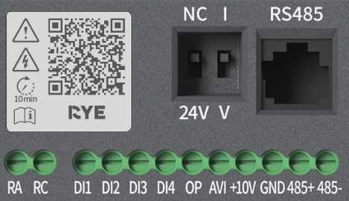
Figure 6-4 Control Circuit Terminal Layout [EL10A]
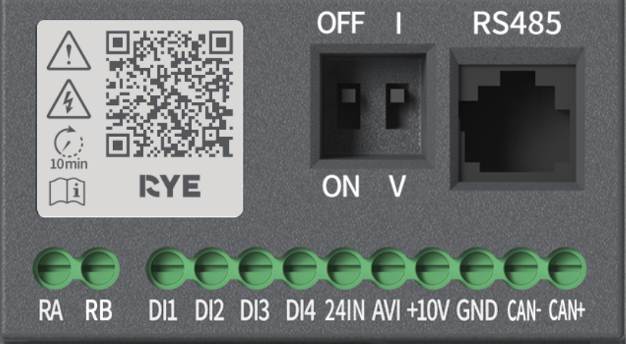
Figure 6-5 Control Circuit Terminal Layout [EL10B]
    - Terminal/DIP Switch Function Description
Table 6-2 EL10 Inverter Control Terminal/DIP Switch Function Description
Category | Terminal/DIP Switch Symbol | Terminal/DIP Switch Name | Function Description
Power Input | OP | Terminal for switching between internal and external power supply for DI with NC/24V DIP switch [EL10A] | When the DIP switch is set to NC, no wiring is required at the OP terminal, and the internal power supply is used for DI;  When the DIP switch is set to 24V, the OP terminal must be connected to an external 24V power supply to power the input DI
Power Selection | NC/24V | Internal/External Power Supply Selection
Power Input | 24IN | External 24V Power Supply Input [EL10B] | [EL10B] model supports only external power supply mode
Analog Input | AVI | Analog Input | Input Range: DC0～10V/0～20mA/4～20mA, Customer Configurable, Input Impedance: 57kΩ±5% when voltage input, 500Ω when current input
Analog Input Power Supply | +10V | Analog Input Power Supply | Internal Precision Power Supply for Analog Input Function
Analog Input Selection | I/V | Voltage and Current Analog Input Selection Switching | Set to I for AVI Input as Current Analog Signal;  Set to V for AVI Input as Voltage Analog Signal
Digital Input | DI1 | Digital Input 1 | Optocoupler Isolated, Bipolar Input Compatible  Input Impedance: 3kΩ  DI1～DI4 voltage range when level input: 9～30V
Digital Input | DI2 | Digital Input 2
Digital Input | DI3 | Digital Input 3
Digital Input | DI4 | Digital Input 4
Communication  Interface | 485+ | Modbus Communication Interface | RS485 Positive [EL10A]
Communication  Interface | 485- | Modbus Communication Interface | RS485 Negative [EL10A]
Communication  Interface | CAN+ | CAN Communication Interface | CAN Signal Positive [EL10B]
Communication  Interface | CAN- | CAN Communication Interface | CAN Signal Negative [EL10B]
Relay Output | RA-RC | Normally Open [EL10A] | Single-channel Relay Output Capability:  250Vac/3A;  30Vdc/3A
Relay Output | RA-RB | Normally Closed [EL10B]
RJ45 | RS485 | External Keyboard Interface | External keyboard, parameter copy keyboard interface, can be extended using standard network cable
    - Wiring Precautions
AI Analog Input Terminal:
Due to the susceptibility of weak analog voltage signals to external interference, shielded cables are generally required, and the wiring distance should be as short as possible, not exceeding 20m, as shown in Figure 3-5. In situations where analog signals are severely interfered with, a filter capacitor or ferrite core should be added on the side of the analog signal source.
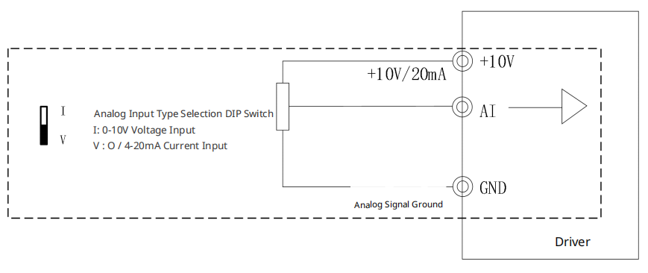
Figure 6-6 Schematic Diagram of Analog Input Terminal Wiring
Version A DI Digital Input Terminals:
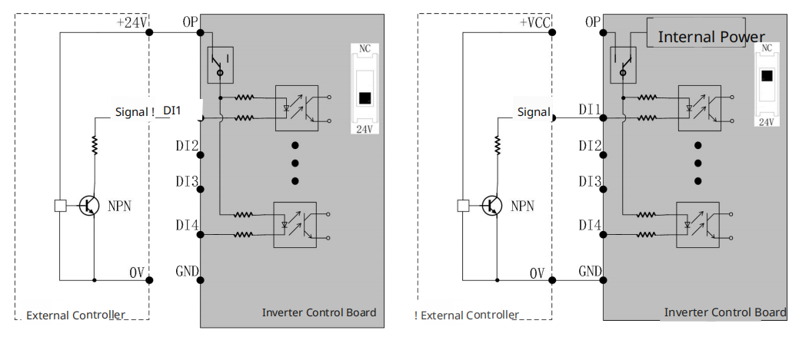
Figure 6-7 Wiring Diagrams for Digital Input Terminals in Two Different Modes
Note: When the DIP switch is set to 24V, the external terminal OP signal must be connected to an external 24V power supply. When the DIP switch is set to NC, the OP can be left open, and the inverter's GND terminal must be connected to the external controller's GND.
Version B DI Digital Input Terminals:

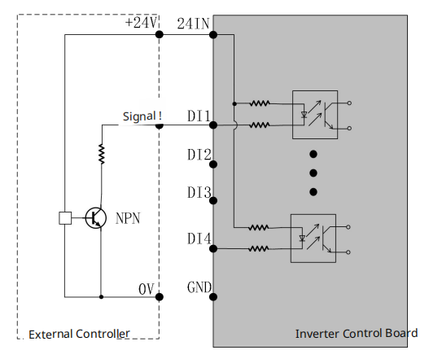
Figure 6-8 Wiring Diagram for EL10B Digital Input Terminals
Note: The EL10B can only use an external power supply for DI.
When using an external power supply, the voltage range for standard IO ports (DI1～DI4) should be 9～30V, and shielded cables are generally required. The wiring distance should be as short as possible, not exceeding 20 meters. When using active drive mode, necessary filtering measures must be taken to address power supply crosstalk. It is recommended to use contact control method.

Chapter 7 Display and Operation
  - Introduction to Display and Operation
The driver operation and display area is divided into four sections. Please refer to the following figure and table for the functions of each section:
1
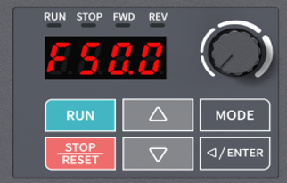
2
4
Figure 7-1 Operation and Display Partition Diagram
Table 7-1 Functions of Each Section in Operation and Display
Section | function | Button/Display Schematic | Corresponding Function
Driver Status Display Area | Indicates the current operating status of the inverter. Refer to the table below for details. |  | Operation Status Indicator Light  On: Running  Off: Not Running  Flashing: Accelerating
Driver Status Display Area |  |  | Stop Status Indicator Light  On: Stopped  Off: Not Stopped  Flashing: Stopping Process
Driver Status Display Area |  |  | Forward Rotation Status Indicator Light  On: Forward Running  Off: Not Forward Running  Flashing: Switching from Forward to Reverse
Driver Status Display Area |  |  | Reverse Rotation Status Indicator Light  On: Reverse Running  Off: Not Reverse Running  Flashing: Switching from Reverse to Forward
Driver Status Display Area |  | All Lights Flashing Synchronously | Fault/Warning Status Indicator
Main Display Area | Can display the driver's function codes, frequency, current, voltage, fault status, etc. | Refer to the table below for the display codes and actual data correspondence
Frequency Setting Knob | Adjust the driver output frequency | 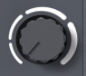 | When VR is used as the frequency command source (default VR), turning the frequency command clockwise increases the frequency, and turning it counterclockwise decreases the frequency.
Button area | Switching display interfaces, parameter settings, and inverter control |  | - For operation when the digital keypad is used as the running command source.
Button area |  |  | - For stopping operations when the inverter status is running and the running command source is the digital keypad.  - For reset operations when the inverter status is fault (only for resettable faults/warnings).  - When the running command is not from the digital keypad, the effectiveness of the STOP button for stopping operations depends on the selection of parameter F7-19.
Button area |  |  | - When the monitoring interface displays frequency (F interface) and the frequency command source is the digital keypad, this is used to increase the frequency operation.  - When the monitoring interface displays forward/reverse rotation (FWD/REV interface) and the operation command source is the digital keypad, this is used to switch to forward rotation.  - In the parameter setting interface, this is used to increase the current parameter group, parameter members, and parameter values.
Button area |  |  | - When the monitoring interface displays frequency (F interface) and the frequency command source is the digital keypad, this is used to decrease the frequency operation.  - When the monitoring interface displays forward/reverse rotation (FWD/REV interface) and the operation command source is the digital keypad, this is used to switch to reverse rotation.  - In the parameter setting interface, this is used to decrease the current parameter group, parameter members, and parameter values.
Button area |  |  | - When in the Monitoring Interface (F H U A FWD/REV interface), used to switch display content.  FHUAFWD/REVFH…  - When in the Parameter Setting interface, used to return to the previous menu level.
Button area |  |  | - When in the Monitoring Interface (F H U A FWD/REV interface), used to switch from the monitoring interface to the parameter setting interface.  - Parameter Members  - When in the parameter content modification interface, a short press is used to increment (adjust cursor position), and a long press is used to write parameters.
  - Display
    - Comparison of Display Codes and Actual Data
Table 7-2 Comparison Table of Display Codes and Actual Data
LED Display | Actual Data | LED Display | Actual Data | LED Display | Actual Correspondence
 | 0 |  | 1 |  | 2
 | 3 |  | 4 |  | 5
 | 6 |  | 7 |  | 8
 | 9 |  | A |  | b
 | C |  | d |  | E
 | F |  | U |  | H
 | L |  | - |  | c
 | h |  | n |  | o
 | P |  | r |  | t
 | u |  | J |  | y
    - Function Display Item Description
Serial Number | Display Item | Description
1 |  | Display the inverter's current setting frequency
2 |  | Display the inverter's current output frequency
3 |  | Display the output current from the inverter to the motor
4 |  | Display the count value
5 |  | Display the actual output frequency of the inverter
6 |  | Display the DC bus voltage value of the inverter
7 |  | Display the output voltage value of the inverter
8 |  | Display the power factor angle of the inverter output
9 |  | Display the output power of the inverter
10 |  | Display the motor speed
11 |  | Display the segment speed being executed in multi-speed operation
12 |  | Display the ripple of the DC bus voltage
13 |  | Display the PID feedback value
14 |  | Display the signal value of the AVI analog input terminal
15 |  | Display digital output ON/OFF status
16 |  | Display digital input ON/OFF status
17 |  | Display inverter power module IGBT temperature
18 |  | Display function code parameter loading operation
19 |  | Display fault codes (flashing display)
20 |  | Display warning codes (flashing display)
  - Operation
    - Page selection
Press MODE key Press MODE key Press MODE key
Press MODE key Press MODE key Press MODE key
Note: In page selection mode, press ENTER key to enter parameter setting.
    - parameter setting
Press ENTER key Press ENTER key Press ENTER key
Note: In parameter setting mode, press MODE key to return to the previous page.
    - direction setting
press MODE key press MODE key press MODE key
press up key press down key Press MODE key
    - frequency setting
press down key press up key

Chapter Eight parameter overview table
function code symbols are explained as follows:
“☆”: indicates that the inverter parameter can be modified during both stop and operation
“★”: indicates that the inverter parameter cannot be modified while in operation
“○”: indicates that the parameter is a manufacturer parameter and cannot be changed by the user
“●”: indicates the actual detection value of the inverter or the manufacturer's fixed value, which cannot be changed
“T”: indicates that the parameter will adjust the display on the 4-digit LED panel, including decimal point shifting, with the maximum set value limited to 9999; if it exceeds the LED keyboard display range, it is recommended to use a higher-level machine or communication panel for setting.
The communication address in the function parameter table is written in hexadecimal.

F0 group - Basic Function Group
Function Code | name | Content | Default Value | Change | Communication Address
F0-00 | Product Model | Product Model: Input Voltage, Power, Number of Input Voltage Phases | Model Confirmation | ●/T | 0000
F0-01 | Light/Heavy Load Selection | 1: Heavy Load | 1 | ● | 0001
F0-02 | Rated Current | 0.00A～655.35A | Model Confirmation | ● | 0002
F0-03 | Control Mode | 0: Speed Mode | 0 | ● | 0003
F0-04 | Speed Mode Selection | 0: VF Control | 0 | ● | 0004
F0-05 | Operation Command Source Selection | 0: Digital Keypad  1: External Terminal Input  2: RS485 Communication Input  3: CANopen Input (Supported by Extended Models) | 0 | ★ | 0005
F0-06 | Frequency Source Selection | 0: Digital Keypad  1: RS485 Communication  2: Analog Input  3: External Up/Down Input  6: CANopen Input (Supported by Extended Models)  7: Keypad VR Setting  9: PID  10: Digital Terminal Multi-Speed  11: Simple PLC Multi-Speed | 7 | ★ | 0006
F0-07 | Auxiliary Frequency Source | 0: Disabled  1: Digital Keypad  2: RS485 Communication  3: Analog Input  6: CANopen Input (Supported by Extended Models)  7: Keypad VR Setting | 0 | ★ | 0007
F0-08 | Frequency Source Superposition Selection | 0: Main Frequency + Auxiliary Frequency  1: Main Frequency - Auxiliary Frequency  2: Auxiliary Frequency - Main Frequency | 0 | ★ | 0008
F0-09 | Forward/Reverse Prohibition Selection | 0: Forward/Reverse Enabled  1: Reverse Prohibited  2: Forward Prohibited | 0 | ★ | 0009
F0-10 | Upper Limit Frequency | 0.00Hz～599.00Hz | 599.00Hz | ☆/T | 000A
F0-11 | Lower Limit Frequency | 0.00Hz～599.00Hz | 0.00Hz | ☆/T | 000B
F0-12 | Speed Curve Time Unit | 0: Acceleration/Deceleration Unit is 0.01s  1: Acceleration/Deceleration Unit is 0.1s | 0 | ★ | 000C
F0-13 | Acceleration Time 1 | 0.00s～600.00s | Model Confirmation | ☆/T | 000D
F0-14 | Deceleration Time 1 | 0.00s～600.00s | Model Confirmation | ☆/T | 000E
F0-15 | Carrier Frequency | 2kHz～6kHz | 4kHz | ★ | 000F
F0-16 | Carrier Reduction Method | 0: Reduce Carrier Based on Current and Temperature  1: Reserved  2: Same as Setting 0 but Does Not Modify Overcurrent Stall Threshold | 0 | ☆ | 0010
F0-18 | Parameter Management Settings | 0: No Function  1: Parameter Write Protection  5: Reset kWH Display  7: Reset CAN Slave (Supported by Extended Models)  9: Reset to 50Hz factory value | 0 | ★ | 0012
F0-19 | Parameter setting frequency command value | 0.00Hz～599.00Hz | 50.00Hz | ☆/T | 0013

F1 Group - Start/Stop Control Parameters
Function Code | name | Content | Default Value | Change | Communication Address
F1-00 | Startup speed tracking | 0: No action  1: Track from maximum frequency  2: Track startup frequency  3: Track from minimum frequency | 0 | ☆ | 0100
F1-02 | Abnormal restart method | 0: Stop operation  1: Track current speed  2: Minimum frequency for tracking | 0 | ☆ | 0102
F1-03 | Speed tracking maximum current | 20%～200% | 100% | ☆ | 0103
F1-04 | Voltage increase rate | 1%～200% | 100% | ☆ | 0104
F1-05 | Start frequency | 0.00Hz～599.00Hz | 0.50Hz | ★/T | 0105
F1-06 | Start hold time | 0.00s～600.00s | 0.00s | ☆/T | 0106
F1-07 | Startup Hold Frequency | 0.00Hz～599.00Hz | 0.00Hz | ☆/T | 0107
F1-08 | Braking Current Level | 0%～100% | 0% | ☆ | 0108
F1-09 | Startup Braking Time | 0.0s～60.0s | 0.0s | ☆ | 0109
F1-10 | DC Braking Ratio Coefficient | 0～65535 | 2000 | ☆/T | 010A
F1-11 | DC Braking Integral Coefficient | 0～65535 | 100 | ☆/T | 010B
F1-12 | Stopping Method | 0: Deceleration Stop  1: Free Stop | 0 | ☆ | 010C
F1-13 | Deceleration Method | 0: Deceleration Method 0  1: Deceleration Method 1  2: Deceleration Method 2 | 0 | ★ | 010D
F1-14 | Maximum Flux Braking Current | 0～2500 | 1000 | ☆ | 010E
F1-15 | 1-4 Segment Acceleration/Deceleration Switching Points | 0.00Hz～599.00Hz | 0.00Hz | ☆/T | 010F
F1-16 | S Acceleration Time 1 | 0.00s～25.00s | 0.20s | ☆ | 0110
F1-17 | S Acceleration Time 2 | 0.00s～25.00s | 0.20s | ☆ | 0111
F1-18 | S Deceleration Time 1 | 0.00s～25.00s | 0.20s | ☆ | 0112
F1-19 | S Deceleration Time 2 | 0.00s～25.00s | 0.20s | ☆ | 0113
F1-20 | Automatic Acceleration and Deceleration Selection | 0: Linear Acceleration and Deceleration  1: Automatic Acceleration and Linear Deceleration  2: Linear Acceleration and Automatic Deceleration  3: Automatic Acceleration and Deceleration  4: Linear Acceleration and Deceleration, with Suppression of Automatic Acceleration and Deceleration | 0 | ☆ | 0114
F1-21 | Automatic Acceleration and Deceleration Kp | 0～65535 | 200 | ☆/T | 0115
F1-22 | Automatic Acceleration and Deceleration Ki | 0.000～65.535 | 0.400 | ☆/T | 0116
F1-23 | Abnormal Shutdown Method | 0: Free Stop  1: According to First Deceleration Time  2: According to Second Deceleration Time  3: According to Third Deceleration Time  4: According to Fourth Deceleration Time  5: According to System Deceleration Time  6: Automatic Deceleration | 0 | ☆ | 0117
F1-24 | Braking Start Time | 0.0s～60.0s | 0.0s | ☆ | 0118
F1-25 | Braking Start Frequency | 0.00Hz～599.00Hz | 0.00Hz | ☆/T | 0119
F1-26 | Stop Holding Time | 0.00s～600.00s | 0.00s | ☆/T | 011A
F1-27 | Stop Holding Frequency | 0.00Hz～599.00Hz | 0.00Hz | ☆ | 011B
F1-29 | Instantaneous Power Failure Restart Method | 0: Stop operation  1: Track current speed  2: Minimum frequency for tracking | 0 | ☆ | 011D
F1-30 | Allowed Power Failure Time | 0.0s～20.0s | 2.0s | ☆ | 011E
F1-31 | Base Lockout Interruption Time | 0.0s～5.0s | 0.5s | ☆ | 011F
F1-32 | Instant Stop Prevention (dEb) Recovery Threshold  Value | 0.0～200.0V | 40.0/20.0V | ☆ | 0120
F1-33 | Instant Stop Prevention (dEb) Action Bias Threshold | 0.0～200.0 | 40.0 | ☆ | 0121
F1-34 | Instant Stop Prevention (dEb) Deceleration Selection | 0: No action  1: Enable, No Recovery  2: Enable, Recovery | 0 | ☆ | 0122
F1-35 | Instantaneous stop (dEb) recovery time | 0.0s～25.0s | 3.0s | ☆ | 0123

F2 group - VF control parameters
Function Code | name | Content | Default Value | Change | Communication Address
F2-00 | V/F voltage selection | 0: General V/F curve  1: 1.5th power V/F curve  2: 2nd power V/F curve | 0 | ★ | 0200
F2-01 | Torque compensation gain | 0～10 | 1 | ☆ | 0201
F2-02 | Torque compensation filter time | 0.001s～10.000s | 0.500s | ☆/T | 0202
F2-04 | Motor Multi-Point VF Frequency Point 1 | 0.00Hz～599.00Hz | 0.50Hz | ★/T | 0204
F2-05 | Motor Multi-Point VF Voltage Point 1 | 0.0V～480.0V | 2.0/1.0V | ★ | 0205
F2-06 | Motor Multi-Point VF Frequency Point 2 | 0.00Hz～599.00Hz | 1.50Hz | ★/T | 0206
F2-07 | Motor Multi-Point VF Voltage Point 2 | 0.0V～480.0V | 10.0/5.0V | ★ | 0207
F2-08 | Motor Multi-Point VF Frequency Point 3 | 0.00Hz～599.00Hz | 3.00Hz | ★/T | 0208
F2-09 | Motor Multi-Point VF Voltage Point 3 | 0.0V～480.0V | 22.0/11.0V | ★ | 0209
F2-10 | Slip Compensation Filter Time | 0.001s～9.999s | 0.100s | ☆ | 020A
F2-11 | Slip Compensation Gain | 0.00～10.00 | 0.00 | ☆ | 020B
F2-13 | Maximum Slip Limit Value | 0.00Hz～200.00Hz | 20.00Hz | ☆/T | 020D
F2-14 | Oscillation Suppression Gain | 0～9999 | 1000 | ☆ | 020E

F4 Group - First Motor Parameters
Function Code | name | Content | Default Value | Change | Communication Address
F4-00 | Motor Type Selection | 0: Induction Motor | 0 | ● | 0400
F4-02 | Motor Maximum Frequency | 0.00Hz～599.00Hz | 50.00Hz | ★/T | 0402
F4-03 | Motor Rated Frequency | 0.00Hz～599.00Hz | 50.00Hz | ★/T | 0403
F4-04 | Motor Rated Voltage | 0.0V～510.0V | 380.0/220.0V | ★ | 0404
F4-05 | Motor Rated Power | 0.00kW～655.35kW | Model Confirmation | ★/T | 0405
F4-06 | Motor Poles | 2～20 | Model Confirmation | ★ | 0406
F4-07 | Motor Rated Current | 0.00A～655.35A | Model Confirmation | ★/T | 0407
F4-08 | Motor Rated Speed | 0rpm～65535rpm | Model Confirmation | ★/T | 0408
F4-10 | Motor No-load Current | 0.00A～F4-07 | Model Confirmation | ★/T | 040A
F4-11 | Motor Stator Resistance | 0.000Ω～65.535Ω | Model Confirmation | ★/T | 040B

F5 Group - Input Terminals
Function Code | name | Content | Default Value | Change | Communication Address
F5-00 | DI1 Terminal Function Selection | 0: No Function  1: Multi-speed 1  2: Multi-speed 2  3: Multi-speed 3  4: Multi-speed 4  5: Fault Reset  6: Jogging  7: Speed Pause  8: 1-2 Segment Acceleration/Deceleration Switching  9: 3-4 Segment Acceleration/Deceleration Switching  10: External Fault (F1-20)  11: Base Blockade  12: Stop Output  13: Automatic Acceleration and Deceleration Prohibited  15: AI Input Frequency Command  18: Forced Stop (F1-20)  19: External Command for Frequency Increase  20: External Command for Frequency Decrease  21: PID Function Prohibited  22: Clear Counter  23: Input Count  24: External Forward Jogging  25: External Reverse Jogging  28: External Fault Free Stop  40: Motor Free Stop  49: Inverter Enable  53: CANopen Quick Stop  70: Auxiliary Frequency Prohibition  71: PID Prohibition, Zero Output  72: PID Prohibition, Maintain Output  73: PID Gain is 0  74: PID Feedback Reversal | 0 | ★ | 0500
F5-01 | DI2 Terminal Function Selection |  | 0 | ★ | 0501
F5-02 | DI3 Terminal Function Selection |  | 1 | ★ | 0502
F5-03 | DI4 Terminal Function Selection |  | 2 | ★ | 0503
F5-08 | Terminal Command Mode | 0: No Function  1: 2-Wire Mode 1  2: 2-Wire Mode 2  3: 3-Wire Mode  4: 2-Wire Mode 1/Fast Start  5: 2-Wire Mode 2/Fast Start  6: 3-Wire Fast Start | 1 | ★ | 0508
F5-09 | UP/DOWN Mode Selection | 0: System Acceleration/Deceleration Time  1: F5-10 Fixed Acceleration/Deceleration  2: F5-10 Pulse Signal  3: Curve  4: Step Acceleration/Deceleration | 0 | ☆ | 0509
F5-10 | UP/DOWN Rate of Change | 0.001Hzms～1.000Hzms | 0.001Hzms | ☆ | 050A
F5-15 | DI Terminal Logic | 0～65535 | 0 | ☆ | 050F
F5-16 | DI Terminal Response Time | 0.000s～9.999s | 0.005s | ☆ | 0510
F5-17 | Virtual/Real DI Terminal Selection | 0～65535 | 0 | ☆ | 0511
F5-18 | Virtual Terminal Status Setting | 0～65535 | 0 | ☆ | 0512
F5-19 | External Operation Selection | 0: Invalid  1: Run if there is an operation command | 0 | ☆ | 0513
F5-20 | AI Signal Type Selection | 0: 0-10V Input Selection  1: 0-20mA Input Selection  2: 4-20mA Input Selection | 0 | ☆ | 0514
F5-21 | AI Function Selection | 0: No Function  1: Frequency Setting  4: PID Target Value  5: PID Feedback Value  6: PTC Thermistor Input  11: PT100 Thermistor Value  12: Auxiliary Frequency Setting  13: PID Offset | 1 | ☆ | 0515
F5-22 | AI Input Bias | -100.0%～100.0% | 0.0% | ☆ | 0516
F5-23 | AI Bias Mode Selection | 0: No Bias  1: Below Bias = Bias  2: Above Bias = Bias  3: Absolute Bias Centered  4: Bias Centered | 0 | ☆ | 0517
F5-24 | AI Gain | -500.0%～500.0% | 100.0% | ☆/T | 0518
F5-25 | AI Filter Time | 0.00s～20.00s | 0.01s | ☆ | 0519
F5-38 | Analog Frequency Negative Value Reversal | 0: Forward/Reverse by Operation Source  1: Forward/Reverse by Bias | 0 | ☆ | 0526
F5-42 | 4-20mA Wire Break Action | 0: Do Not Detect Wire Break  1: Maintain pre-disconnection frequency  2: Decelerate to 0Hz  3: Immediate stop on fault | 0 | ☆ | 052A
F5-43 | 4-20mA open circuit threshold | 0.00mA～4.00mA | 2.00mA | ☆ | 052B

F6 group - output terminals
Function Code | name | Content | Default Value | Change | Communication Address
F6-00 | RLY terminal function selection | 0: No Function  1: Inverter running  2: Reached set speed  3: Reached frequency 1  4: Reached frequency 2  5: Zero speed command running  6: Zero speed command  9: Inverter Ready  10: Low Voltage Warning  11: Fault Indication  12: Brake Release  13: Overheat Warning  14: Braking Unit Activation  15: PID Deviation Warning  16: Excessive Slip  17: Set Count Value Reached  18: Final Count Value Reached  19: Base Blockade  20: Fault Output  21: Overvoltage  22: Overcurrent Stall Prevention  23: Overvoltage Stall Prevention  24: Operation Source Not Digital Keypad  25: Forward Command  26: Reverse Command  29: Higher than F6-08 speed value  30: Lower than F6-08 speed value  33: Zero operation output frequency  34: Zero output frequency  35: Fault option 1  36: Fault option 2  37: Fault option 3  38: Fault option 4  40: Reached set frequency  42: Mechanical brake release  44: Low current output  45: UVW electromagnetic switch enable  46: dEb action output  51: RS485 control output  53: Simple PLC completes cycle  67: Analog level arrival output | 11 | ☆ | 0600
F6-04 | Effective Logic of DO Terminal | 0～65535 | 0 | ☆ | 0604
F6-05 | Source of AI for DO Output | 0: AI1 | 0 | ☆ | 0605
F6-06 | Upper Limit Value of AI for DO Output | -100.00%～100.00% | 50.00% | ☆/T | 0606
F6-07 | Lower Limit Value of AI for DO Output | -100.00%～100.00% | 10.00% | ☆/T | 0607
F6-08 | DO Action Frequency | 0.00Hz～599.00Hz | 0.00Hz | ☆/T | 0608
F6-09 | Motor Zero Speed Judgment Threshold | 0rpm～65535rpm | 0rpm | ☆/T | 0609
F6-27 | Frequency Arrival 1 Detection Value | 0.00Hz～599.00Hz | 50.00Hz | ☆/T | 061B
F6-28 | Frequency Arrival 1 Amplitude | 0.00Hz～599.00Hz | 2.00Hz | ☆/T | 061C
F6-29 | Frequency Arrival 2 Detection Value | 0.00Hz～599.00Hz | 50.00Hz | ☆/T | 061D
F6-30 | Frequency Arrival 2 Amplitude | 0.00Hz～599.00Hz | 2.00Hz | ☆/T | 061E

F7 Group - Auxiliary Functions and Keyboard Display
Function Code | name | Content | Default Value | Change | Communication Address
F7-00 | JOG Frequency Setting | 0.00Hz～599.00Hz | 6.00Hz | ☆/T | 0700
F7-01 | JOG Acceleration Time | 0.00s～600.00s | 10.00s | ☆/T | 0701
F7-02 | JOG Deceleration Time | 0.00s～600.00s | 10.00s | ☆/T | 0702
F7-03 | Acceleration Time 2 | 0.00s～600.00s | Model Confirmation | ☆/T | 0703
F7-04 | Deceleration Time 2 | 0.00s～600.00s | Model Confirmation | ☆/T | 0704
F7-05 | Acceleration Time 3 | 0.00s～600.00s | Model Confirmation | ☆/T | 0705
F7-06 | Deceleration Time 3 | 0.00s～600.00s | Model Confirmation | ☆/T | 0706
F7-07 | Acceleration Time 4 | 0.00s～600.00s | Model Confirmation | ☆/T | 0707
F7-08 | Deceleration Time 4 | 0.00s～600.00s | Model Confirmation | ☆/T | 0708
F7-09 | Jump Frequency 1 Upper Limit | 0.00Hz～599.00Hz | 0.00Hz | ☆/T | 0709
F7-10 | Jump Frequency 1 Lower Limit | 0.00Hz～599.00Hz | 0.00Hz | ☆/T | 070A
F7-11 | Jump Frequency 2 Upper Limit | 0.00Hz～599.00Hz | 0.00Hz | ☆/T | 070B
F7-12 | Jump Frequency 2 Lower Limit | 0.00Hz～599.00Hz | 0.00Hz | ☆/T | 070C
F7-13 | Jump Frequency 3 Upper Limit | 0.00Hz～599.00Hz | 0.00Hz | ☆/T | 070D
F7-14 | Jump Frequency 3 Lower Limit | 0.00Hz～599.00Hz | 0.00Hz | ☆/T | 070E
F7-15 | Jump Frequency 4 Upper Limit | 0.00Hz～599.00Hz | 0.00Hz | ☆/T | 070F
F7-16 | Jump Frequency 4 Lower Limit | 0.00Hz～599.00Hz | 0.00Hz | ☆/T | 0710
F7-17 | Fan Control Method | 0: Fan Runs Continuously  1: Stop 1 Minute After Shutdown  2: Stop with Inverter  3: Start at 50°C  4: Fan Starts During Operation, Stops Below 48°C When Stopped, Continues Running Above 50°C | 4 | ☆ | 0711
F7-19 | Keyboard STOP Key Enable | 0: Disabled  1: Enabled | 0 | ☆ | 0713
F7-20 | Startup Screen Selection | 0: Set Frequency Display  1: Output Frequency Display  2: User-Defined Display  3: Output Current Display  4: Direction of Operation Display | 0 | ☆ | 0714
F7-21 | User-defined Display Selection | 0: Display the inverter output current to the motor (I) (Unit: Amp)  1: Display the count value (c) (Unit: CNT)  2: Display the actual inverter output frequency (f) (Unit: Hz)  3: Display the inverter DC bus voltage value (DCbus voltage) (U) (Unit: VDC)  4: Display the inverter output voltage value (E) (Unit: VAC)  5: Display the inverter output power factor angle (n) (Unit: deg)  6: Display the inverter output power (P) (Unit: kW)  7: Display the motor speed, in rpm (r) (Unit: Krpm) (thousand revolutions per minute)  8: Display the segment number (d) being executed in multi-speed operation  9: Display the DC bus voltage ripple (u) (Unit: VDC)  10: Display AVI analog input terminal signal value (C) (unit: %)  11: Display PID feedback value (b) (unit: %)  12: Display digital output ON/OFF status (o)  13: Display digital input ON/OFF status (J)  14: Display inverter power module (IGBT) temperature (t) (unit: ºC) | 3 | ☆ | 0715
F7-26 | Cumulative number of startups | 0～65535 | 0 | ●/T | 071A
F7-27 | Cumulative startup days | 0～65535 | 0 | ●/T | 071B
F7-28 | Cumulative running minutes | 0～1439 | 0 | ● | 071C
F7-29 | Cumulative operating days | 0～65535 | 0 | ● | 071D
F7-30 | Cumulative Running Minutes | 0～65535 | 0 | ●/T | 071E
F7-31 | Motor Running Time | 0min～1439min | 0min | ● | 071F
F7-32 | Motor Running Days | 0～65535 | 0 | ● | 0720
F7-33 | Password Input | 0～65535 | 0 | ☆/T | 0721
F7-34 | Password Setting | 0～65535 | 0 | ☆/T | 0722
F7-35 | Automatic Energy Saving Setting | 0: Disabled  1: Enabled | 0 | ☆ | 0723
F7-36 | Energy Saving Gain | 10～1000 | 100 | ☆ | 0724
F7-37 | Automatic Voltage Regulation | 0: Enable AVR Function  1: Disable AVR Function  2: Disable AVR During Deceleration | 0 | ☆ | 0725
F7-38 | Current Display Filtering | 0.001s～65.535s | 0.100s | ☆/T | 0726
F7-39 | Display Filter Time | 0.001s～65.535s | 0.100s | ☆/T | 0727
F7-40 | Soft Start Switch Delay Time | 0～65535 | 7000 | ☆ | 0728
F7-41 | Operating Frequency Deviation Deadband | 0.00～599.00 | 0.00 | ☆/T | 0729
F7-42 | Output Phase Sequence Switching | 0: Output according to command direction.  1: Output opposite to command direction | 0 | ☆ | 072A
F7-52 | W-sec Low Byte | 0.0～6553.5 | 0.0 | ●/T | 0734
F7-53 | W-sec high byte | 0.0～6553.5 | 0.0 | ●/T | 0735
F7-54 | W-hrs | 0.0～6553.5 | 0.0 | ●/T | 0736
F7-55 | KWh low byte | 0.0～6553.5 | 0.0 | ●/T | 0737
F7-56 | KWh high byte | 0.0～6553.5 | 0.0 | ●/T | 0738
F7-57 | Machine model version | 0.00～655.35 | 10.10 | ● | 0739
F7-58 | Software Version | 0.00～655.35 | \ | ● | 073A
F7-59 | Software Release Date | 0～65535 | \ | ● | 073B
F7-61 | Enhanced Parameter Display Selection | 0～1 | 1 | ☆ | 073D

F8 Group - Communication Parameters
Function Code | name | Content | Default Value | Change | Communication Address
F8-00 | Baud Rate Setting | 4.8kbps～19.2kbps | 19.2kbps | ☆ | 0800
F8-01 | Communication Data Format | 1：7,N,2forASCII  2：7,E,1forASCII  3：7,O,1forASCII  4：7,E,2forASCII  5：7,O,2forASCII  6：8,N,1forASCII  7：8,N,2forASCII  8：8,E,1forASCII  9：8,O,1forASCII  10：8,E,2forASCII  11：8,O,2forASCII  12：8,N,1forRTU  13：8,N,2forRTU  14：8,E,1forRTU  15：8,O,1forRTU  16：8,E,2forRTU  17:8,O,2forRTU | 12 | ☆ | 0801
F8-02 | Communication Address | 1～254 | 1 | ☆ | 0802
F8-03 | Response Delay | 0.0ms～200.0ms | 2.0ms | ☆ | 0803
F8-04 | Communication Timeout Time | 0.0s～100.0s | 0.0s | ☆ | 0804
F8-05 | Communication Error Handling | 0: Warning and Continue Running  1: Warning and Decelerate to Stop  2: Warning and Free Stop  3: No Warning | 3 | ☆ | 0805
F8-06 | Communication Given Frequency | 0.00Hz～599.00Hz | 50.00Hz | ●/T | 0806
F8-07 | Communication Decoding Method | 0: Use 20XX  1: Use 60XX | 1 | ☆ | 0807
F8-14 | CANopen Node Address | 0~127 | 0 | ★ | 080E
F8-15 | CAN Bus Communication Rate | 0: 1Mbps  1：500kbps  2：250kbps  3：125kbps  4：100kbps  5：50kbps | 0 | ★ | 080F
F8-18 | CANopen warning record | 0~65535 | 0 | ● | 0812
F8-19 | CiA402 protocol selection | 0: Disabled  1: Enabled | 0 | ☆ | 0813
F8-20 | CANopen communication status | 0：node reset state  1：communication reset state  2：reset complete state  3: Pre-operational state  4: Operational state  5: Stop state | 0 | ● | 0814
F8-21 | CiA operational status | 0: Power-on incomplete state  1: Prohibited operation state  2: Pre-excitation state  3: Excitation state  4: Operation permitted state  5: No function  6: No function  7: Quick action stop state  8: No function  9: No function  10: No function  11: No function  12: No Function  13: Trigger Error Action Status  14: Error State | 0 | ● | 0815
F8-22 | CANopen Index Reset | 0~65535 | 65535 | ★ | 0816

F9 Group - Fault and Protection
Function Code | name | Content | Default Value | Change | Communication Address
F9-00 | Protection Control Bit | 0～65535 | 0 | ☆ | 0900
F9-01 | Motor Overload Selection | 0: Constant Torque Output Motor  1: Variable Torque Output Motor  2: No Motor Overload Protection | 2 | ☆ | 0901
F9-02 | Motor Overload Time | 30.0s～600.0s | 60.0s | ☆ | 0902
F9-03 | Overvoltage Stall Mode | 0: Overvoltage Stall Mode 0  1: Overvoltage Stall Mode 1 | 1 | ☆ | 0903
F9-04 | Overvoltage Stall Threshold | 0.0V～900.0V | 760.0/380.0V | ☆ | 0904
F9-05 | Overvoltage Stall Deceleration Time | 0.00s～655.35s | 600.00s | ☆/T | 0905
F9-06 | Undervoltage Fault Auto Clear | 0: Disabled  1: Enabled | 0 | ☆ | 0906
F9-08 | Acceleration OC Stall Threshold | 0%～200% | 150% | ☆ | 0908
F9-09 | Overcurrent Stall Limit Threshold | 0%～100% | 100% | ☆ | 0909
F9-10 | Constant Speed OC Stall Threshold | 0%～200% | 150% | ☆ | 090A
F9-11 | Constant Speed OC Acceleration/Deceleration Selection | 0: System Acceleration/Deceleration Time  1: First Acceleration and Deceleration Time  2: Second Acceleration and Deceleration Time  3: Third Acceleration and Deceleration Time  4: Fourth Acceleration and Deceleration Time  5: Automatic Acceleration and Deceleration Time | 0 | ☆ | 090B
F9-12 | Input Phase Loss Action Selection | 0: Alarm and Decelerate to Stop  1: Alarm and Free Stop | 0 | ☆ | 090C
F9-13 | Input Phase Loss Filter Time | 0.00s～600.00s | 0.20s | ☆/T | 090D
F9-14 | Input Phase Loss Voltage Threshold | 0.0V～320.0V | 60.0/30.0V | ☆ | 090E
F9-15 | Output Phase Loss Action Selection | 0: Warning and Continue Running  1: Warning and Decelerate to Stop  2: Warning and Free Stop  3: No Warning | 3 | ☆ | 090F
F9-16 | Output Phase Loss Detection Time | 0.000s～65.535s | 0.100s | ☆/T | 0910
F9-17 | Output Phase Loss Current Threshold | 0.00%～100.00% | 7.00% | ☆/T | 0911
F9-18 | Output Phase Loss Braking Time | 0.000s～65.535s | 0.000s | ☆/T | 0912
F9-22 | Low Current Setting Threshold | 0.0%～100.0% | 0.0% | ☆ | 0916
F9-23 | Low Current Detection Time | 0.00s～360.00s | 0.00s | ☆/T | 0917
F9-24 | Low Current Action Method | 0: No Function  1: Alarm and Free Stop  2: Alarm and Second Deceleration Stop  3: Alarm and Continue Running | 0 | ☆ | 0918
F9-25 | Excessive Slip Detection Value | 0.0%～100.0% | 0.0% | ☆ | 0919
F9-26 | Excessive Slip Detection Time | 0.0s～10.0s | 1.0s | ☆ | 091A
F9-27 | Excessive Slip Action Selection | 0: Warning and Continue Running  1: Warning and Decelerate to Stop  2: Warning and Free Stop  3: No Warning | 0 | ☆ | 091B
F9-36 | Over Torque Selection 1 | 0: No Detection  1: Constant Speed Detection Continue Running  2: Constant Speed Detection Stop Running  3: Running Detection Continue Running  4: Running Detection Stop Running | 0 | ☆ | 0924
F9-37 | Over Torque Threshold 1 | 10%～250% | 120% | ☆ | 0925
F9-38 | Over-torque time 1 | 0.1s～60.0s | 0.1s | ☆ | 0926
F9-46 | Abnormal start count | 0～10 | 0 | ☆ | 092E
F9-47 | Abnormal restart reset time | 0.0s～6000.0s | 60.0s | ☆/T | 092F
F9-48 | PTC action selection | 0: Warning and continue running  1: Warning and Decelerate to Stop  2: Warning and Free Stop  3: No Warning | 0 | ☆ | 0930
F9-49 | PTC Threshold | 0.0%～100.0% | 50.0% | ☆ | 0931
F9-50 | PT Detection Threshold 1 | 0.000V～10.000V | 5.000V | ☆/T | 0932
F9-51 | PT Detection Threshold 2 | 0.000V～10.000V | 7.000V | ☆/T | 0933
F9-52 | PT Voltage 1 Protection Frequency | 0.00Hz～599.00Hz | 0.00Hz | ☆/T | 0934
F9-53 | PT Operation Delay Time | 0s～6000s | 60s | ☆ | 0935
F9-57 | Output Phase Loss Threshold 2 | 0.00%～100.00% | 2.00% | ☆/T | 0939
F9-58 | Overvoltage Stall Recovery Threshold | 0.0V～900.0V | 630.0/315.0V | ☆ | 093A

FA Group-PID Function
Function Code | name | Content | Default Value | Change | Communication Address
FA-00 | PID Feedback Type Selection | 0: No Function  1: Negative Feedback Analog Input  4: Positive Feedback Analog Input  7: Negative Feedback Communication Input  8: Positive Feedback Communication Input | 0 | ☆ | 0A00
FA-01 | PID Setpoint Source Selection | 0: Frequency Command  1: Parameter FA-02  2: RS485 Communication  3: Analog Input  4: CANopen (Extended Model) | 0 | ☆ | 0A01
FA-02 | PID Setpoint Value | -100.00%～100.00% | 50.00% | ☆/T | 0A02
FA-03 | PID Setpoint Change Time | 0.00s～655.35s | 0.00s | ☆/T | 0A03
FA-04 | PID Feedback Filter Time | 0.1s～300.0s | 5.0s | ☆ | 0A04
FA-05 | Proportional Coefficient 1 | 0.00%～99.99% | 8.00% | ☆ | 0A05
FA-06 | Integral Time 1 | 0.00s～99.99s | 0.15s | ☆ | 0A06
FA-07 | Differential Time 1 | 0.00s～1.00s | 0.00s | ☆ | 0A07
FA-08 | Proportional Coefficient 2 | 0.00～99.99 | 8.00 | ☆/T | 0A08
FA-09 | Integral Time 2 | 0.00s～99.99s | 0.15s | ☆/T | 0A09
FA-10 | Differential Time 2 | 0.00s～1.00s | 0.00s | ☆ | 0A0A
FA-11 | PID Series/Parallel Selection | 0: Kp, Kp*Ki, Kp*Kd  1: Kp, Ki, Kd | 1 | ☆ | 0A0B
FA-12 | PID Control Execution Cycle | 0～1 | 0 | ☆ | 0A0C
FA-13 | PID Parameter Switching Conditions | 0: No Function  1: Switch based on output frequency  2: Switch based on PID deviation | 0 | ☆ | 0A0D
FA-14 | PID Parameter Switching Error 1 | 0.00%～100.00% | 10.00% | ☆/T | 0A0E
FA-15 | PID Parameter Switching Error 2 | 0.00%～100.00% | 40.00% | ☆/T | 0A0F
FA-16 | Allow PID Reverse Delay | 0.0s～999.9s | 0.0s | ☆ | 0A10
FA-17 | PID Direction Change Selection | 0: Disabled  1: Enabled | 0 | ☆ | 0A11
FA-18 | Feedback Suppression Deviation Rate | 0%～100% | 10% | ☆ | 0A12
FA-19 | Feedback Suppression Gain | 0～1000 | 800 | ☆ | 0A13
FA-20 | PID Compensation Selection | 0: Parameter Setting  1: Analog Input | 0 | ☆ | 0A14
FA-21 | PID Compensation Value | -99.9～99.9 | 0.0 | ☆ | 0A15
FA-22 | PID Deviation Deadband Limit | 0.00%～99.99% | 0.06% | ☆ | 0A16
FA-23 | PID Control Deviation Limit | 0.00%～99.99% | 0.00% | ☆ | 0A17
FA-24 | Integral Separation Level | 0.00%～99.99% | 0.00% | ☆ | 0A18
FA-25 | Integral Upper Limit | 0.00%～100.00% | 100.0% | ☆/T | 0A19
FA-26 | Wake-up Integral Limit | 0.0%～200.0% | 50.0% | ☆ | 0A1A
FA-27 | Main Auxiliary Reverse Cut-off Frequency | 0.0%～100.0% | 10.0% | ☆ | 0A1B
FA-28 | PID Output Positive Limit | 0.0%～100.0% | 100.0% | ☆ | 0A1C
FA-29 | PID Output Negative Limit | 0.00%～100.0% | 100.0% | ☆ | 0A1D
FA-30 | PID Output Frequency Reference | 0～1 | 0 | ☆ | 0A1E
FA-31 | PID Output Filter Time | 0.0s～2.5s | 0.0s | ☆ | 0A1F
FA-32 | Soft Start-PID Switching Value | 0.00%～99.99% | 5.00% | ☆ | 0A20
FA-33 | Soft Start Frequency | 0.00Hz～599.00Hz | 0.00Hz | ☆/T | 0A21
FA-34 | Soft Start Acceleration Time | 0.00s～600.00s | 3.00s | ☆/T | 0A22
FA-35 | No Load Current | 0.00A～655.35A | 0.00A | ☆/T | 0A23
FA-36 | Soft Start Acceleration Step | 0.00s～600.00s | 0.10s | ☆/T | 0A24
FA-49 | Feedback Abnormality Detection Time | 0.0s～999.9s | 0.0s | ☆ | 0A31
FA-50 | Feedback Disconnection Action Selection | 0: Warning and continue running  1: Fault and Decelerate to Stop  2: Fault and Free Stop  3: Run at Frequency Before Disconnection | 0 | ☆ | 0A32
FA-51 | PID Feedback Abnormal Deviation | 1.0%～50.0% | 10.0% | ☆ | 0A33
FA-52 | Abnormal Deviation Detection Time | 0.1s～300.0s | 5.0s | ☆ | 0A34
FA-53 | PID Control Flag | 0～65535 | 2 | ☆ | 0A35

FD Group - Multi-Speed and Simple PLC Function
Function Code | name | Content | Default Value | Change | Communication Address
FD-00 | Multi-Speed 0 | -100.00%～100.00% | 0.00% | ☆/T | 0D00
FD-01 | Multi-Speed 1 | -100.00%～100.00% | 0.00% | ☆/T | 0D01
FD-02 | Multi-Speed 2 | -100.00%～100.00% | 0.00% | ☆/T | 0D02
FD-03 | Multi-Speed 3 | -100.00%～100.00% | 0.00% | ☆/T | 0D03
FD-04 | Multi-Speed 4 | -100.00%～100.00% | 0.00% | ☆/T | 0D04
FD-05 | Multi-Speed 5 | -100.00%～100.00% | 0.00% | ☆/T | 0D05
FD-06 | Multi-Speed 6 | -100.00%～100.00% | 0.00% | ☆/T | 0D06
FD-07 | Multi-Speed 7 | -100.00%～100.00% | 0.00% | ☆/T | 0D07
FD-08 | Multi-Speed 8 | -100.00%～100.00% | 0.00% | ☆/T | 0D08
FD-09 | Multi-Speed 9 | -100.00%～100.00% | 0.00% | ☆/T | 0D09
FD-10 | Multi-Speed 10 | -100.00%～100.00% | 0.00% | ☆/T | 0D0A
FD-11 | Multi-Speed 11 | -100.00%～100.00% | 0.00% | ☆/T | 0D0B
FD-12 | Multi-Speed 12 | -100.00%～100.00% | 0.00% | ☆/T | 0D0C
FD-13 | Multi-Speed 13 | -100.00%～100.00% | 0.00% | ☆/T | 0D0D
FD-14 | Multi-Speed 14 | -100.00%～100.00% | 0.00% | ☆/T | 0D0E
FD-15 | Multi-Speed 15 | -100.00%～100.00% | 0.00% | ☆/T | 0D0F
FD-16 | PLC Operation Mode | 0: Stop at End of Operation  1: Hold at End of Operation  2: Continuous Operation | 0 | ☆ | 0D10
FD-17 | PLC Power Failure Memory Selection | 0: No Memory on Power Failure/Shutdown  1: Memory on Power Failure  2: Memory on Shutdown  3: Memory on Power Failure/Shutdown | 0 | ☆ | 0D11
FD-18 | PLC Operation Time Unit | 0: Second  1: Hour | 0 | ☆ | 0D12
FD-19 | Multi-Speed 0 Command Setting | 0: Function Code FD-00 Setting  1: AI  2: VR  3: Function Code F0-19 Setting | 0 | ☆ | 0D13
FD-20 | PLC Segment 00 Operation Time | 0.0~6553.5 | 0.0 | ☆/T | 0D14
FD-21 | PLC Segment 00 Acceleration/Deceleration Settings | 0~3 | 0 | ☆ | 0D15
FD-22 | PLC Segment 01 Operation Time | 0.0~6553.5 | 0.0 | ☆/T | 0D16
FD-23 | PLC Segment 01 Acceleration/Deceleration Settings | 0~3 | 0 | ☆ | 0D17
FD-24 | PLC Segment 02 Operation Time | 0.0~6553.5 | 0.0 | ☆/T | 0D18
FD-25 | PLC Segment 02 Acceleration/Deceleration Settings | 0~3 | 0 | ☆ | 0D19
FD-26 | PLC Segment 03 Operation Time | 0.0~6553.5 | 0.0 | ☆/T | 0D1A
FD-27 | PLC Segment 03 Acceleration/Deceleration Settings | 0~3 | 0 | ☆ | 0D1B
FD-28 | PLC Segment 04 Operation Time | 0.0~6553.5 | 0.0 | ☆/T | 0D1C
FD-29 | PLC Segment 04 Acceleration/Deceleration Settings | 0~3 | 0 | ☆ | 0D1D
FD-30 | PLC Segment 05 Operation Time | 0.0~6553.5 | 0.0 | ☆/T | 0D1E
FD-31 | PLC Segment 05 Acceleration/Deceleration Settings | 0~3 | 0 | ☆ | 0D1F
FD-32 | PLC Segment 06 Operation Time | 0.0~6553.5 | 0.0 | ☆/T | 0D20
FD-33 | PLC Segment 06 Acceleration/Deceleration Settings | 0~3 | 0 | ☆ | 0D21
FD-34 | PLC Segment 07 Operation Time | 0.0~6553.5 | 0.0 | ☆/T | 0D22
FD-35 | PLC Segment 07 Acceleration/Deceleration Settings | 0~3 | 0 | ☆ | 0D23
FD-36 | PLC Segment 08 Operation Time | 0.0~6553.5 | 0.0 | ☆/T | 0D24
FD-37 | PLC Segment 08 Acceleration/Deceleration Settings | 0~3 | 0 | ☆ | 0D25
FD-38 | PLC Segment 09 Operation Time | 0.0~6553.5 | 0.0 | ☆/T | 0D26
FD-39 | PLC Segment 09 Acceleration/Deceleration Settings | 0~3 | 0 | ☆ | 0D27
FD-40 | PLC Segment 10 Operation Time | 0.0~6553.5 | 0.0 | ☆/T | 0D28
FD-41 | PLC Segment 10 Acceleration/Deceleration Settings | 0~3 | 0 | ☆ | 0D29
FD-42 | PLC Segment 11 Operation Time | 0.0~6553.5 | 0.0 | ☆/T | 0D2A
FD-43 | PLC Segment 11 Acceleration/Deceleration Settings | 0~3 | 0 | ☆ | 0D2B
FD-44 | PLC Segment 12 Operation Time | 0.0~6553.5 | 0.0 | ☆/T | 0D2C
FD-45 | PLC Segment 12 Acceleration/Deceleration Settings | 0~3 | 0 | ☆ | 0D2D
FD-46 | PLC Segment 13 Operation Time | 0.0~6553.5 | 0.0 | ☆/T | 0D2E
FD-47 | PLC Segment 13 Acceleration/Deceleration Settings | 0~3 | 0 | ☆ | 0D2F
FD-48 | PLC Segment 14 Operation Time | 0.0~6553.5 | 0.0 | ☆/T | 0D30
FD-49 | PLC Segment 14 Acceleration/Deceleration Settings | 0~3 | 0 | ☆ | 0D31
FD-50 | PLC Segment 15 Operation Time | 0.0~6553.5 | 0.0 | ☆/T | 0D32
FD-51 | PLC Segment 15 Acceleration/Deceleration Settings | 0~3 | 0 | ☆ | 0D33
FD-52 | PLC Current Work Step | 0~15 | 0 | ● | 0D34
FD-53 | PLC Operation Time High Byte | 0~65535 | 0 | ● | 0D35
FD-54 | PLC Operation Time Low Byte | 0~65535 | 0 | ● | 0D36

U0 Group - Fault Record Parameters
Function Code | name | Content | Default Value | Change | Communication Address
U0-00 | Fault Record 1 | 0～65535 | 0 | ● | 1000
U0-01 | Fault Record 2 | 0～65535 | 0 | ● | 1001
U0-02 | Fault Record 3 | 0～65535 | 0 | ● | 1002
U0-03 | Fault Record 4 | 0～65535 | 0 | ● | 1003
U0-04 | Fault Record 5 | 0～65535 | 0 | ● | 1004
U0-05 | Fault Record 6 | 0～65535 | 0 | ● | 1005
U0-06 | Fault Record 7 | 0～65535 | 0 | ● | 1006
U0-07 | Fault Record 8 | 0～65535 | 0 | ● | 1007
U0-08 | Fault Record 9 | 0～65535 | 0 | ● | 1008
U0-09 | Fault Record 10 | 0～65535 | 0 | ● | 1009
U0-10 | Fault Output 1 | 0～65535 | 0 | ☆ | 100A
U0-11 | Fault Output 2 | 0～65535 | 0 | ☆ | 100B
U0-12 | Fault Output 3 | 0～65535 | 0 | ☆ | 100C
U0-13 | Fault Output 4 | 0～65535 | 0 | ☆ | 100D
U0-14 | Fault 1-Motor Speed | -32767rpm～32767rpm | 0rpm | ● | 100E
U0-15 | Fault 1-Reserved
U0-16 | Fault 1-Input Terminal | 0～65535 | 0 | ● | 1010
U0-17 | Fault 1-Output Terminal | 0～65535 | 0 | ● | 1011
U0-18 | Fault 1 - Inverter Status | 0～65535 | 0 | ● | 1012
U0-19 | Fault 1 - Frequency Command Hz | 0.00Hz～655.35Hz | 0.00Hz | ● | 1013
U0-20 | Fault 1 - Output Frequency | 0.00Hz～599.00Hz | 0.00Hz | ●/T | 1014
U0-21 | Fault 1 - Output Voltage | 0.0V～6553.5V | 0.0V | ● | 1015
U0-22 | Fault 1 - DC Voltage | 0.0V～6553.5V | 0.0V | ● | 1016
U0-23 | Fault 1-Output Current | 0.00A～655.35A | 0.00A | ● | 1017
U0-24 | Fault 1-IGBT Temperature | -3276.7℃～3276.7℃ | 0.0℃ | ● | 1018
U0-25 | Fault 1-Reserved
U0-26 | Fault 2-Output Frequency | 0.00Hz～599.00Hz | 0.00Hz | ●/T | 101A
U0-27 | Fault 2-Direct Current Voltage | 0.0V～6553.5V | 0.0V | ● | 101B
U0-28 | Fault 2-Output Current | 0.00A～655.35A | 0.00A | ● | 101C
U0-29 | Fault 2-IGBT Temperature | -3276.7℃～3276.7℃ | 0.0℃ | ● | 101D
U0-30 | Fault 3-Output Frequency | 0.00Hz～599.00Hz | 0.00Hz | ●/T | 101E
U0-31 | Fault 3-Direct Current Voltage | 0.0V～6553.5V | 0.0V | ● | 101F
U0-32 | Fault 3-Output Current | 0.00A～655.35A | 0.00A | ● | 1020
U0-33 | Fault 3-IGBT Temperature | -3276.7℃～3276.7℃ | 0.0℃ | ● | 1021
U0-34 | Fault 4-Output Frequency | 0.00Hz～599.00Hz | 0.00Hz | ●/T | 1022
U0-35 | Fault 4 - DC Voltage | 0.0V～6553.5V | 0.0V | ● | 1023
U0-36 | Fault 4 - Output Current | 0.00A～655.35A | 0.00A | ● | 1024
U0-37 | Fault 4 - IGBT Temperature | -3276.7℃～3276.7℃ | 0.0℃ | ● | 1025
U0-38 | Fault 5 - Output Frequency | 0.00Hz～599.00Hz | 0.00Hz | ●/T | 1026
U0-39 | Fault 5 - DC Voltage | 0.0V～6553.5V | 0.0V | ● | 1027
U0-40 | Fault 5 - Output Current | 0.00A～655.35A | 0.00A | ● | 1028
U0-41 | Fault 5-IGBT Temperature | -3276.7℃～3276.7℃ | 0.0℃ | ● | 1029
U0-42 | Fault 6-Output Frequency | 0.00Hz～599.00Hz | 0.00Hz | ●/T | 102A
U0-43 | Fault 6-Direct Current Voltage | 0.0V～6553.5V | 0.0V | ● | 102B
U0-44 | Fault 6-Output Current | 0.00A～655.35A | 0.00AL | ● | 102C
U0-45 | Fault 6-IGBT Temperature | -3276.7℃～3276.7℃ | 0.0℃ | ● | 102D
U0-46 | Days of Fault 1 Occurrence | 0～65535 | 0 | ●/T | 102E
U0-47 | Minutes of Fault 1 Occurrence | 0～1439 | 0 | ● | 102F
U0-48 | Days of Fault 2 Occurrence | 0～65535 | 0 | ●/T | 1030
U0-49 | Minutes of Fault 2 Occurrence | 0～1439 | 0 | ● | 1031
U0-50 | Days of Fault 3 Occurrence | 0～65535 | 0 | ●/T | 1032
U0-51 | Minutes of Fault 3 Occurrence | 0～1439 | 0 | ● | 1033
U0-52 | Days of Fault 4 Occurrence | 0～65535 | 0 | ●/T | 1034
U0-53 | Minutes of Fault 4 Occurrence | 0～1439 | 0 | ● | 1035
U0-54 | Days of Fault 5 Occurrence | 0～65535 | 0 | ●/T | 1036
U0-55 | Minutes of Fault 5 Occurrence | 0～1439 | 0 | ● | 1037
U0-56 | Days of Fault 6 Occurrence | 0～65535 | 0 | ●/T | 1038
U0-57 | Minutes of Fault 6 Occurrence | 0～1439 | 0 | ● | 1039

U1 Group - Status Monitoring Parameters
Function Code | name | Content | Default Value | Change | Communication Address
U1-00 | DI Terminal Status | 0～65535 | 0 | ● | 1100
U1-01 | DO Terminal Status | 0～65535 | 0 | ● | 1101
U1-02 | Frequency Command (Read-Only) | 0.00Hz～599.00Hz | 50.00Hz | ●/T | 1102
U1-03 | External Frequency Record | 0.00Hz～599.00Hz | 60.00Hz | ●/T | 1103
U1-04 | PID Feedback Value | -200.00～200.00 | 0.00 | ●/T | 1104
U1-05 | KP Gain Monitoring Value | 0.00%～99.99% | 0.00% | ● | 1105
U1-06 | KI Gain Monitoring Value | 0.00s～100.00s | 0.05s | ●/T | 1106
U1-07 | KD Gain Monitoring Value | 0.00～1.00 | 0.00 | ● | 1107

L2 Group - Optimized Control Parameters
Function Code | name | Content | Default Value | Change | Communication Address
L2-17 | Braking Resistor Activation Voltage | 700.0V～900.0V | 740.0/370.0V | ☆ | 1811
L2-18 | Undervoltage Protection Value | 250.0V～440.0V | 360.0/180.0V | ☆ | 1812
L2-19 | Zero Speed Operation Selection | 0: Wait for Output  1: Zero Speed Output  2: Output at Minimum Frequency | 0 | ★ | 1813
L2-23 | Overmodulation Gain | 80～120 | 100 | ☆ | 1817

L4 Group - Brake Function Parameters
Function Code | name | Content | Default Value | Change | Communication Address
L4-00 | Brake Frequency | 0.00～599.00Hz | 0.00 | ☆/T | 1A00

L5 Group - Sleep Wake Function Parameters
Function Code | name | Content | Default Value | Change | Communication Address
L5-00 | Sleep Mode Reference Selection | 0: PID Command Arrival  1: PID Feedback Arrival | 0 | ★ | 1B00
L5-01 | Sleep Threshold | 0.00Hz～599.00Hz | 0.00Hz | ☆/T | 1B01
L5-02 | Wake Threshold | 0.00Hz～599.00Hz | 0.00Hz | ☆/T | 1B02
L5-03 | Sleep Delay | 0.0s～999.9s | 0.0s | ☆ | 1B03
L5-04 | Wake Delay | 0.00s～600.00s | 0.00s | ☆/T | 1B04

L6 Group - Counting
Function Code | name | Content | Default Value | Change | Communication Address
L6-00 | Final Count Value Setting | 0～65500 | 0 | ☆/T | 1C00
L6-01 | Intermediate Count Value Setting | 0～65500 | 0 | ☆/T | 1C01
L6-02 | Count Reached E.F Enable | 0: Count Reached, No EF  1: Count Reached, EF | 0 | ☆ | 1C02

L7 Group - AI Multi-point Curve Setting
Function Code | name | Content | Default Value | Change | Communication Address
L7-00 | AI Curve Selection | 0: General Curve  1: AI Three-Point Curve | 0 | ☆ | 1D00
L7-01 | AI1 Minimum Point Input Value | 0.00～20.00 | 0.00 | ☆ | 1D01
L7-02 | AI1 Minimum Point Percentage | 0.00%～100.00% | 0.00% | ☆/T | 1D02
L7-03 | AI1 Mid-Point Input Value | 0.00～20.00 | 5.00 | ☆ | 1D03
L7-04 | AI1 Mid-Point Percentage | 0.00%～100.00% | 50.00% | ☆/T | 1D04
L7-05 | AI1 Maximum Point Input Value | 0.00～20.00 | 10.00 | ☆ | 1D05
L7-06 | AI1 Maximum Point Percentage | 0.00%～100.00% | 100.00% | ☆/T | 1D06

LD Group - MODBUS Address Mapping Function Settings
Function Code | name | Content | Default Value | Change | Communication Address
LD-00 | MODBUS Address Mapping Function Enable | 0000h~FFFFh | 0000h | ☆ | 3300
LD-01 | Control Word Mapping Address | 0000h~FFFFh | 2000h | ☆ | 3301
LD-02 | Forward Operation Command | 0000h~FFFFh | 0001h | ☆ | 3302
LD-03 | Reverse Operation Command | 0000h~FFFFh | 0002h | ☆ | 3303
LD-04 | Forward Jog Command | 0000h~FFFFh | 0003h | ☆ | 3304
LD-05 | Reverse Jog Command | 0000h~FFFFh | 0004h | ☆ | 3305
LD-06 | Stop Command | 0000h~FFFFh | 0005h | ☆ | 3306
LD-07 | Stop Command 2 | 0000h~FFFFh | 0005h | ☆ | 3307
LD-08 | Fault Reset Command | 0000h~FFFFh | 0007h | ☆ | 3308
LD-09 | Jog Stop Command | 0000h~FFFFh | 0005h | ☆ | 3309
LD-10 | Frequency Command Mapping Address | 0000h~FFFFh | 2001h | ☆ | 330A
LD-11 | Fault Code Mapping Address | 0000h~FFFFh | 2100h | ☆ | 330B
LD-12 | Status Word Mapping Address | 0000h~FFFFh | 2101h | ☆ | 330C
LD-13 | Forward Operation Value | 0000h~FFFFh | 0001h | ☆ | 330D
LD-14 | Reverse Operation Value | 0000h~FFFFh | 0002h | ☆ | 330E
LD-15 | Stop Status Value | 0000h~FFFFh | 0003h | ☆ | 330F
LD-16 | Fault Status Value | 0000h~FFFFh | 0004h | ☆ | 3310
LD-17 | Given Frequency Mapping Address | 0000h~FFFFh | 2102h | ☆ | 3311
LD-18 | Output Frequency Mapping Address | 0000h~FFFFh | 2103h | ☆ | 3312
LD-19 | Output Current Mapping Address | 0000h~FFFFh | 2104h | ☆ | 3313
LD-20 | Bus Voltage Mapping Address | 0000h~FFFFh | 2105h | ☆ | 3314
LD-21 | Output Voltage Mapping Address | 0000h~FFFFh | 2106h | ☆ | 3315
LD-22 | Output Power Mapping Address | 0000h~FFFFh | 2206h | ☆ | 3316
LD-23 | DI Status Mapping Address | 0000h~FFFFh | 2210h | ☆ | 3317
LD-24 | DO Status Mapping Address | 0000h~FFFFh | 2211h | ☆ | 3318
LD-25 | AI1 Mapping Address | 0000h~FFFFh | 220Bh | ☆ | 3319
LD-26 | AI2 Mapping Address (Reserved) | 0000h~FFFFh | 220Ch | ☆ | 331A
LD-27 | Motor speed mapping address | 0000h~FFFFh | 210Ch | ☆ | 331B
LD-28 | Torque feedback mapping address (reserved) | 0000h~FFFFh | 2227h | ☆ | 331C
LD-29 | Torque setpoint mapping address (reserved) | 0000h~FFFFh | 2228h | ☆ | 331D

Chapter 9 Parameter Group Description
  - F0 group basic function codes
F0-00 | Product Model | Range: 0～65535 | Factory value: determined by model
For user viewing only, not to be modified.
The model code meanings are shown in Table 9-1.
Table 9-1 Product Model List
Product Model | Inverter Status | Product Model | Meaning
2100 | 220V single-phase input, 0.4kW
2101 | 220V single-phase input, 0.75kW | 4301 | 380V three-phase input, 0.75kW
2102 | 220V single-phase input, 1.5kW | 4302 | 380V three-phase input, 1.5kW
2103 | 220V single-phase input, 2.2kW | 4303 | 380V three-phase input, 2.2kW
 |  | 4304 | 380V three-phase input, 4kW
 |  | 4305 | 380V three-phase input, 5.5kW

F0-01 | Light/Heavy Load Selection | Range: 1～1 | Factory setting: 1
Default value 1: Heavy load, non-modifiable.
This series of inverters only provides heavy load models.
F0-02 | Rated Current | Range: 0.00～655.35 | Factory value: determined by model
For user viewing only, not to be modified.
Note: The machine is equipped with a 4-digit LED panel, which automatically adjusts the decimal place according to the current value and decimal position to facilitate 4-digit LED display.
F0-03 | Control Mode | Range: 0～0 | Factory setting: 0
0: Speed Mode
F0-04 | Speed Mode Selection | Range: 0～2 | Factory setting: 0
0: VF Control
This function code is used to select the required control method.
F0-05 | Operation Command Source Selection | Range: 0～3 | Factory setting: 0
This function code is used to select the input channel for the inverter control command.
Inverter control commands include: start, stop, forward, reverse, jog, etc.
0: Digital Keypad.
Select this command channel to control the inverter's operation and stop through the RUN, STOP, etc., buttons on the built-in keypad of the machine.
1: External Terminal Input
Select this command channel to control the inverter through digital input terminals.
2: RS485 Communication Input
Select this command channel to send commands to the inverter via RS485 communication, controlling the inverter to perform actions such as start and stop.
3: CANopen Input (Supported by Extended Models)
Select this command channel to send control commands to the inverter using the CANopen protocol.
F0-06 | Frequency Source Selection | Range: 0～11 | Factory setting: 7
This function code is used to set the main frequency source.
0: Digital Keypad, i.e., parameter F0-19 setting, panel UP/DOWN can modify the frequency setting.
The frequency value can be set through the keyboard, either by setting the frequency value at the 'Fxx.xxHz' display on the main interface using the UP/DOWN keys; or by entering the F0-19 parameter setup screen to modify the current parameter value, which also changes the current frequency command.
Note: This parameter address does not support continuous writing of frequency commands via communication. If you need to set the frequency command via communication, refer to the setting F0-06=1 (RS485 communication).
1: RS485 Communication
To set the frequency value via RS485 communication, the external device must be connected to the inverter's 485+ and 485- terminals, after which the frequency can be set through the communication method. For details, refer to the 'MODBUS Communication Protocol'.
2: Analog Input
Set the frequency value through an analog signal. The frequency value can be set through the analog input channel on the inverter. The analog input function needs to be set to 'frequency setting' (set through F5-21, default setting is frequency command).
3: External Up/Down Input
Set the frequency value through DI terminals by setting the F5 group DI terminal functions to 19, 20 (external command for frequency increase, external command for frequency decrease), then adjust the frequency value using the corresponding DI terminals.
4: Reserved.
5: Reserved.
6: CANopen Input (Supported by Extended Models)
Set the frequency value through CANopen communication; the external system uses the CANopen protocol to communicate with the inverter and set its frequency value.
7: Panel VR setting (default value)
8: Reserved
9: PID
The frequency setpoint comes from process PID control. The PID function can be configured using the FA group function codes; the output of the PID controller serves as the inverter's frequency setpoint. For details, refer to the introduction of the 'PID function' in the FA group.
10: Digital Terminal Multi-Speed
Set the frequency value through DI terminals. The F5 group 'input terminals' and FD group 'multi-speed and simple PLC functions' function codes can be used to set speed segments and the correspondence between DI input signals and speed segments. Please refer to the descriptions of these two groups of function codes for more details.
11: Simple PLC Multi-Speed
Through the 'multi-speed and simple PLC functions' function codes, the inverter can be set to automatically operate according to the preset acceleration/deceleration time, frequency, and running time.
F0-07 | Auxiliary Frequency Source | Range: 0～7 | Factory setting: 0
This function code is used to select the auxiliary frequency source.
0: Disabled
Disable auxiliary frequency function.
1: Digital keypad as set by parameter F0-19; the panel UP/DOWN keys can modify the frequency setting.
The frequency value can be set through the keyboard, either by setting the frequency value at the 'Fxx.xxHz' display on the main interface using the UP/DOWN keys; or by entering the F0-19 parameter setup screen to modify the current parameter value, which also changes the current frequency command.
Note: This parameter address does not support continuous writing of frequency commands via communication. If you need to set the frequency command via communication, refer to the setting F0-06=1 (RS485 communication).
2: RS485 Communication
To set the frequency value via RS485 communication, the external device must be connected to the inverter's 485+ and 485- terminals, after which the frequency can be set through the communication method. For details, refer to the 'MODBUS Communication Protocol'.
3: Analog Input
Set the frequency value through an analog signal. The frequency value can be set through the analog input channel on the inverter. The analog input function needs to be set to 'frequency setting' (set through F5-21, default setting is frequency command).
4: External Up/Down input
Set the frequency value through DI terminals by setting the F5 group DI terminal functions to 19, 20 (external command for frequency increase, external command for frequency decrease), then adjust the frequency value using the corresponding DI terminals.
5: Reserved.
6: CANopen Input (Supported by Extended Models)
Set the frequency value through CANopen communication; the external system uses the CANopen protocol to communicate with the inverter and set its frequency value.
7: Panel VR setting
Note:
- The auxiliary frequency source can only be modified when the inverter is stopped;
- The main and auxiliary frequency function selection can only be modified when the inverter is stopped.
- The main frequency and auxiliary frequency should not be set to the same source if possible.
- When digital inputs (F5-00~F5-04, LC-00~LC-02) are configured to force the auxiliary frequency to 0, the auxiliary frequency output function will be disabled.
- If the result of subtracting the auxiliary frequency from the main frequency is negative, negative frequency input must be allowed (set F5-38 to 1) to reverse; otherwise, the output frequency will be 0. Additionally, pay attention to the setting of the main-auxiliary reversal cutoff frequency (FA-27) to avoid limiting the desired reverse output.
F0-08 | Frequency Source Superposition Selection | Range: 0～2 | Factory setting: 0
0: Main Frequency + Auxiliary Frequency
The actual set frequency of the inverter is the sum of the main frequency and the auxiliary frequency.
1: Main Frequency - Auxiliary Frequency
The actual set frequency of the inverter is the main frequency minus the auxiliary frequency.
2: Auxiliary Frequency - Main Frequency
The actual set frequency of the inverter is the auxiliary frequency minus the main frequency.
F0-09 | Forward/Reverse Prohibition Selection | Range: 0～2 | Factory setting: 0
0: Forward/Reverse Enabled
Allows the inverter to rotate forward and reverse.
1: Reverse Prohibited
The inverter can only rotate forward, not reverse.
2: Forward Prohibited
The inverter can only rotate reverse, not forward.
F0-10 | Upper Limit Frequency | Range: 0.00～599.00Hz | Factory setting: 599.00Hz
This function code is used to set the maximum frequency that the inverter can output.
F0-11 | Lower Limit Frequency | Range: 0.00～F0-10 | Factory setting: 0.00Hz
This function code is used to set the lower limit frequency of the inverter. When the inverter starts running, it begins at the start frequency. During operation, if the given frequency is less than the lower limit frequency, the inverter will continue to run at the lower limit frequency until the inverter stops or 0Hz is given or the given frequency exceeds the lower limit frequency.
F0-12 | Speed Curve Time Unit | Range: 0～1 | Factory setting: 0
Used to set the precision of the acceleration and deceleration time unit.
0: Acceleration and deceleration unit is 0.01 seconds
1: Acceleration and deceleration unit is 0.1 seconds
By default, this function code is 0, at which point the acceleration and deceleration time is in two decimal places, with a maximum value of 600.00 seconds. If longer acceleration and deceleration times are required, this function code can be changed to 1, at which point the acceleration and deceleration time becomes one decimal place, with a maximum value of 6000.0 seconds, to meet the need for longer acceleration and deceleration times.
F0-13 | Acceleration Time 1 | Range: 0.00～600.00 seconds or 0.0～6000.0 seconds | Factory setting:Model determined
F0-14 | Deceleration Time 1 | Range: 0.00～600.00 seconds or 0.0～6000.0 seconds | Factory setting:Model determined
Acceleration time refers to the time it takes for the inverter to accelerate from zero frequency to the acceleration and deceleration reference frequency (determined by F4-02), see t1 in Figure 9-1.
Deceleration time refers to the time required for the inverter to decelerate from the acceleration/deceleration reference frequency (determined by F4-02) to zero frequency, see t2 in Figure 9-1.
This series of inverters provides 4 sets of acceleration/deceleration times, which users can switch between using digital input terminals DI.
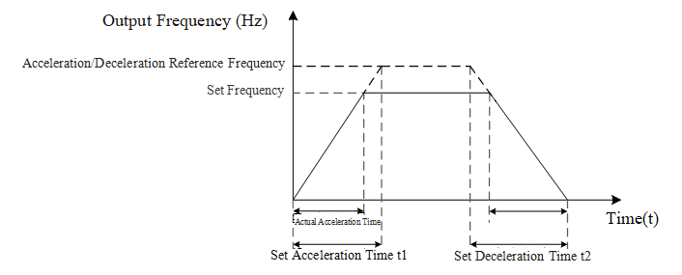
Figure 9-1 Acceleration/Deceleration Time
Note: The machine is equipped with a 4-digit LED panel, which automatically adjusts the decimal place according to the current value and decimal position to facilitate 4-digit LED display.
F0-15 | Carrier Frequency | Range: 2～6kHz | Factory Setting: 4kHz
This function code is used to adjust the carrier frequency of the inverter. By adjusting the carrier frequency, motor noise can be reduced, mechanical system resonance points can be avoided, ground leakage current can be decreased, and interference generated by the inverter can be reduced. When the carrier frequency is low, the higher harmonic components of the output current increase, leading to increased motor losses and temperature rise. When the carrier frequency is high, motor losses decrease, and motor temperature rise decreases, but inverter losses increase, inverter temperature rise increases, and interference increases. Adjusting the carrier frequency will affect the performance shown in Table 9-2:
Table 9-2 Effects of High and Low Carrier Frequencies
Carrier Frequency | Low->High
Motor Noise | High->Low
Output Current Waveform | Poor->Good
Motor Temperature Rise | High->Low
Inverter Temperature Rise | Low->High
Leakage Current | Low->High
External Radiated Interference | Low->High
The default carrier frequency for the EL10 model is 4K. Although users can modify it as needed, they should note that if the carrier frequency is set higher than the factory setting, it will lead to an increase in the inverter heat sink temperature rise. At this time, users need to derate the inverter, otherwise there is a risk of overheating alarms.
F0-16 | Carrier Reduction Method | Range: 0～2 | Factory setting: 0
This function code is used to set the inverter's carrier frequency reduction method.
0: Reduce Carrier Based on Current and Temperature
When the inverter output current is too high or the module temperature is too high, it will automatically reduce the inverter carrier frequency, and at the same time, it will also automatically lower the overcurrent stall prevention level.
1: Reserved.
2: Same as setting 0, but the overcurrent stall prevention threshold remains unchanged.
F0-18 | Parameter Management Settings | Range: 0～13 | Factory setting: 0
0: No Function
1: Parameter Write Protection
After entering 1, most function codes will be locked and cannot be modified; only parameter management (F0-18) and password input (F7-33) can be modified. This value will be written to EEPROM and remains effective even after power loss. Only by setting parameter management (F0-18) to 0 can other parameter values be modified.
5: Reset kWH Display
The inverter's energy consumption statistics can be reset.
7: Reset CAN Slave
Reset CAN Slave
9: Reset to 50Hz factory value
Function codes can be restored to factory settings, which will reset the function codes to their default values. If a password has been set on the inverter (via F7-34), the password must be removed (via F7-33) before restoring factory settings.
1）When parameter management is set to 6 or 7, the control board needs to be repowered after setting completion.
2）If the frequency command source is the digital keypad, and parameter management is set to 7, to achieve reverse operation, the analog frequency negative value must also be reversed.
(F5-38) set to 1 (allow negative frequency input, positive frequency forward, negative frequency reverse, digital keypad and external terminals cannot control forward/reverse).
  - F1 Group Start/Stop Control Parameters
F1-00 | Startup speed tracking | Range: 0～3 | Factory setting: 0
This function code sets the speed tracking method.
Speed tracking is applicable for punch presses, fans, and other high-inertia load applications.
When using the free stop (i.e., inertial stop) method to stop, or when the inverter suddenly stops due to a fault, the motor will decelerate under the influence of friction. If the motor has a large inertia, it will take a longer time to come to a complete stop. If the inverter starts directly while the motor has not completely stopped, it may cause significant impact. The speed tracking function can obtain the motor's speed and then control the motor to run to the set frequency based on this speed. This not only shortens the time required for re-starting but also avoids excessive impact.
0: No action
Speed tracking function is off.
1: Track from the maximum output frequency
Upon restart, track the speed downward from the maximum output frequency until the motor speed is detected, then control the motor to run at the set frequency.
2: Track startup frequency
Upon restart, track the speed from the given frequency at startup, ultimately controlling the motor to run at the set frequency.
3: Track from the minimum output frequency
Upon restart, track the speed from the minimum frequency until the motor speed is detected, then control the motor to run at the set frequency.
F1-02 | Abnormal restart method | Range: 0～2 | Factory setting: 0
This function code sets the abnormal restart method.
When an abnormality occurs, the inverter usually stops running until the fault is reset and a run command is received, after which it will restart. The abnormal restart function can automatically clear faults and control the inverter to restart when a fault occurs, achieving the purpose of continuous motor operation. When the number of automatic fault clearance attempts reaches the set value, it will no longer automatically clear the fault and restart. The number of abnormal start attempts can be set through function code F9-46.
0: Stop operation
In the event of an abnormality, the machine stops; after fault reset, the inverter does not automatically restart.
1: Track current speed
During abnormal restart, speed tracking starts from the current speed, and once the speed is tracked, the motor is controlled to run at the set frequency.
2: Minimum frequency for tracking
During abnormal restart, speed tracking starts from the minimum frequency, and once the speed is tracked, the motor is controlled to run at the set frequency.
F1-03 | Speed Tracking Maximum Current% | Range: 20%～200% | Factory Value: 100%
The inverter starts speed tracking only when the output current exceeds the set value of this function code. The larger the set value of this function code, the faster the tracking speed, but setting it too high may cause overcurrent or overload faults.
F1-04 | Voltage increase rate | Range: 1～200 | Factory Value: 100
This function code sets the voltage increase rate during speed tracking. Under normal circumstances, this function code does not need to be changed and should be kept at its default value.
F1-05 | Start frequency | Range: 0～599.00Hz | Factory Value: 0.50Hz
This function code is used to set the start frequency. If the start frequency is higher than the lower limit frequency, the inverter will start running from the start frequency.
Note: The machine is equipped with a 4-digit LED panel, which will display one less decimal place, i.e., 20.00 will be displayed as 20.0; this does not affect communication.
F1-06 | Start hold time | Range: 0.00～600.00 seconds | Factory setting: 0.00 seconds
F1-07 | Startup Hold Frequency | Range: 0～599.00Hz | Factory setting: 0.00Hz
In applications such as cranes and elevators, to improve reliability or positioning accuracy, it is often necessary to run at a certain frequency for a period of time before continuing to accelerate to the set frequency, and when stopping, to run at a certain frequency for a period of time before decelerating to zero speed. The frequency hold function can achieve these objectives. The frequency hold function includes start-up frequency hold and stop frequency hold. The start-up frequency hold function is shown in Figure 9-2, where F1-06 is the start-up hold time and F6-07 is the start-up hold frequency, which can be used to set the start-up frequency hold function.
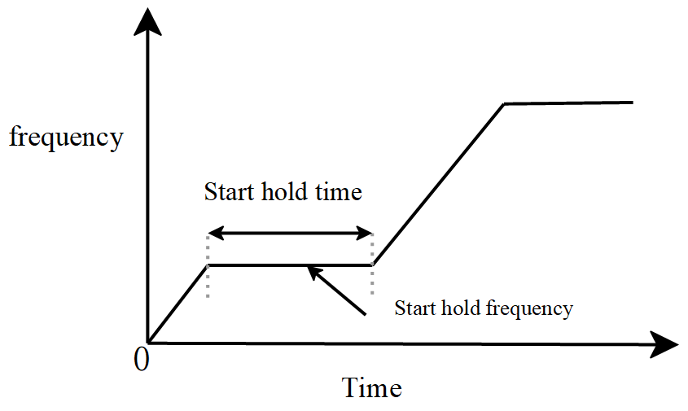
Figure 9-2 Start Frequency Hold Function
Note: The machine is equipped with a 4-digit LED panel, which automatically adjusts the decimal place according to the current value and decimal position to facilitate 4-digit LED display.
F1-08 | Braking Current Level | Range: 0～100% | Factory Value: 0%
F1-09 | Startup Braking Time | Range: 0.0～60.0 seconds | Factory Value: 0.0 seconds
F1-10 | DC Braking Ratio Coefficient | Range: 0～65535 | Factory Value: 2000
F1-11 | DC Braking Integral Coefficient | Range: 0～65535 | Factory Value: 100
When the inverter starts, if the motor is still rotating, it may cause significant impact. To avoid this situation, the motor can be braked first until it stops rotating, then start from the start frequency. By activating the DC braking function, DC current is injected into the motor windings to produce a braking torque that stops the motor from rotating. The start DC braking function is shown in Figure 9-3.
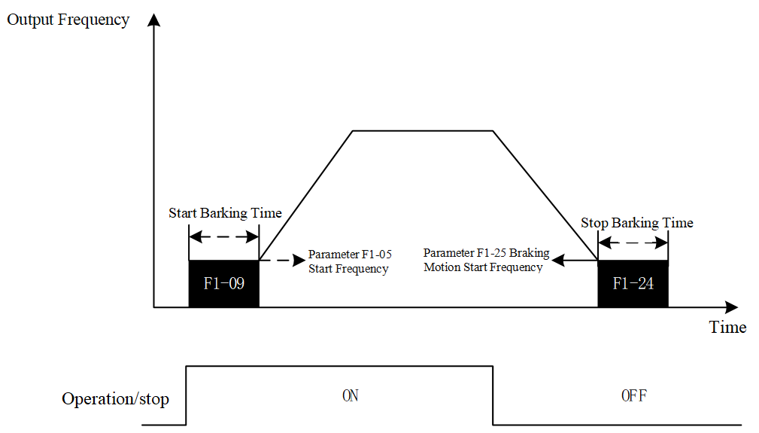
Figure 9-3 DC/Stop Braking Function
If the start braking time is not zero, the DC braking function during startup is effective. The inverter starts by first applying the set braking current for DC braking, then after the set start braking time, it begins to run up to the set frequency. The greater the braking current, the greater the braking force.
F1-08 Braking Current Size, used to set the magnitude of the DC braking current during startup and stop, the unit is %, based on the motor's rated current as the reference value.
F1-09 Start Braking Time, used to set the duration of the DC braking at startup. When the start braking time is set to zero, the DC braking at startup is ineffective.
The parameters of the current PI regulator can be adjusted using F1-10 DC Braking Proportional Coefficient and F1-11 DC Braking Integral Coefficient.
Note: The machine is equipped with a 4-digit LED panel, which automatically adjusts the decimal place according to the current value and decimal position to facilitate 4-digit LED display.
F1-12 | Stopping Method | Range: 0～1 | Factory setting: 0
0: Deceleration Stop
Decelerate and stop; the inverter decelerates according to the set deceleration time, until it reaches 0 or the minimum output frequency (start frequency F1-05), then stops output.
1: Free Stop
After the stop command becomes effective, the inverter immediately terminates output.
F1-13 | Deceleration Method | Range: 0～2 | Factory setting: 0
This function code is used to set the deceleration method. When the motor decelerates, it may feed energy back to the inverter, thus raising the bus voltage. If the bus voltage is too high, it can cause an overvoltage fault. Choosing an appropriate deceleration method can reduce the likelihood of an overvoltage fault occurring.
0: No function
Normal deceleration or stop without performing regenerative energy suppression.
1: Deceleration Method 1
During deceleration, the inverter will automatically adjust the deceleration curve based on the overvoltage stall threshold (F9-04) and the bus voltage.
2: Deceleration Method 2
During the deceleration process, when the bus voltage is too high, deceleration mode 2 will be activated, and the inverter will automatically adjust the output frequency and output voltage to achieve the purpose of consuming regenerative energy.
F1-14 | Maximum Flux Braking Current | Range: 0～2500 | Factory Value: 1000
This function code is used for setting the maximum current for flux braking, where 0-2500 represents 0-2.5 times the rated current of the inverter.
This current setting determines the peak current of the inverter's output current, with 1000 representing 1.0 times the rated current. If the rated current of the inverter is 5.50A (F0-02), then the peak value of the maximum current for flux braking is 5.50A.
F1-15 | 1-4 Segment Acceleration/Deceleration Switching Points | Range: 0～599.00Hz | Factory setting: 0.00Hz
If it is necessary to switch the acceleration/deceleration time during operation, this can be achieved by modifying the function code. When the current frequency is less than the switching frequency, the motor adjusts speed according to acceleration/deceleration time 4; when the current frequency is greater than the switching frequency, the motor adjusts speed according to acceleration\deceleration time 1. The 1-4 segment acceleration/deceleration switching function is shown in Figure 9-4.
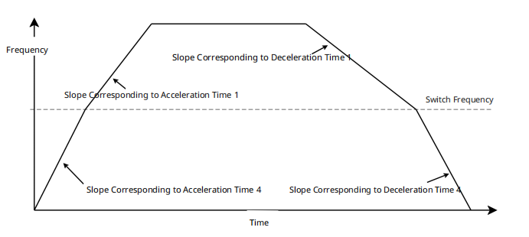
Figure 9-4 1-4 Segment Acceleration/Deceleration Frequency Switching Points
Note: The machine is equipped with a 4-digit LED panel, which automatically adjusts the decimal place according to the current value and decimal position to facilitate 4-digit LED display.
F1-16 | S Acceleration Time 1 | Range: 0.00～25.00 seconds | Factory Setting: 0.20 seconds
F1-17 | S Acceleration Time 2 | Range: 0.00～25.00 seconds | Factory Setting: 0.20 seconds
F1-18 | S Deceleration Time 1 | Range: 0.00～25.00 seconds | Factory Setting: 0.20 seconds
F1-19 | S Deceleration Time 2 | Range: 0.00～25.00 seconds | Factory Setting: 0.20 seconds
There are two modes of speed curve: normal acceleration/deceleration mode and S-curve acceleration/deceleration mode. When all four function codes are zero, the speed curve operates in normal acceleration/deceleration mode; otherwise, it operates in S-curve acceleration/deceleration mode.
In general acceleration and deceleration modes, the slope of acceleration and deceleration will undergo sudden changes at the start or end of the process, causing significant variations in motor torque within a short period, which can impact both the motor and the load. To reduce this impact, S-curve acceleration and deceleration mode can be used. Under this mode, the slope of the speed curve is continuous, thereby reducing torque shock. Figure 9-5 shows the frequency and acceleration waveforms during general acceleration and deceleration, where it can be seen that the acceleration is discontinuous and sudden changes occur. In contrast, the acceleration in Figure 9-6, which illustrates S-curve acceleration and deceleration, changes continuously, thus adopting an S-curve can mitigate the impact caused by sudden changes in torque.
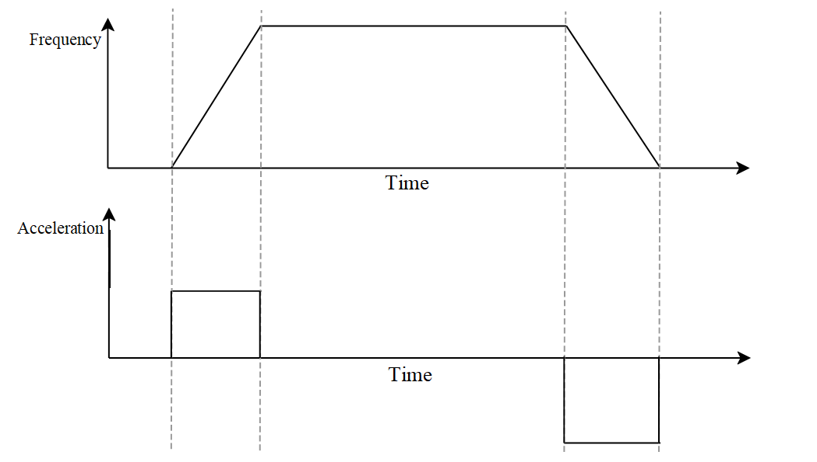
Figure 9-5 Normal Acceleration/Deceleration Mode
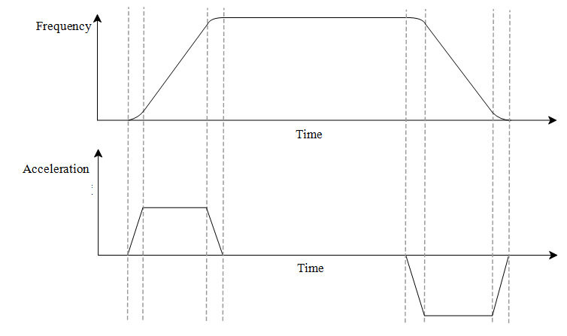
Figure 9-6 S Acceleration/Deceleration Mode
In S acceleration/deceleration mode, the total acceleration and deceleration time will be longer. When accelerating from zero to the maximum operating frequency, the total acceleration time = set acceleration time + (S acceleration time 1)/2 + (S acceleration time 2)/2, the total deceleration time = set deceleration time + (S deceleration time 3)/2 + (S deceleration time 4)/2. As shown in Figure 9-7, in the figure below, S1 represents S acceleration time 1, S2 represents S acceleration time 2, S3 represents S deceleration time 3, and S4 represents S deceleration time 4.
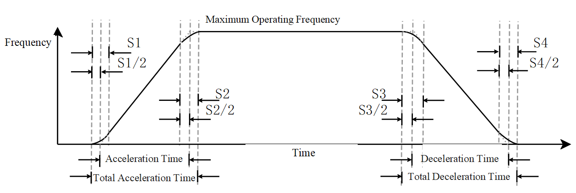
Figure 9-7 S Acceleration/Deceleration Mode Time
Note: The machine is equipped with a 4-digit LED panel, which automatically adjusts the decimal place according to the current value and decimal position to facilitate 4-digit LED display.
F1-20 | Automatic Acceleration and Deceleration Selection | Range: 0～4 | Factory setting: 0
This function code is used to set the automatic acceleration and deceleration mode. In practical applications, the setting of acceleration and deceleration times is influenced by factors such as load conditions and motor inertia, and may require multiple adjustments to determine. If the acceleration time is too short, it may cause excessive acceleration current, leading to overcurrent; If the deceleration time is too short, it may result in excessively high bus voltage, causing overvoltage. The automatic acceleration and deceleration function can automatically adjust the acceleration and deceleration times based on actual conditions, simplifying the debugging process.
0: Linear Acceleration and Deceleration
Both automatic acceleration and automatic deceleration functions are turned off.
1: Automatic Acceleration and Linear Deceleration
The automatic acceleration function is enabled, while the automatic deceleration function is disabled.
2: Linear Acceleration and Automatic Deceleration
Automatic acceleration function is off, automatic deceleration function is on.
3: Automatic Acceleration and Deceleration
Both automatic acceleration and automatic deceleration functions are on.
4: Linear Acceleration and Deceleration, with Suppression of Automatic Acceleration and Deceleration
Default linear acceleration and deceleration; when the current is too high, the automatic acceleration function is activated; when the bus voltage is too high, the automatic deceleration function is activated; in other cases, both automatic acceleration and automatic deceleration functions are off.
F1-21 | Automatic Acceleration and Deceleration Kp | Range: 0～65535 | Factory setting: 200
F1-22 | Automatic Acceleration and Deceleration Ki | Range: 0～655.35 | Factory setting: 0.400
When the automatic acceleration and deceleration functions are enabled, the acceleration and deceleration slopes are adjusted via a PI controller; the above two function codes are used to set the parameters of the PI controller.
Note 1: The machine comes with a 4-digit LED panel, F1-21 will limit the maximum value to 9999, communication settings do not affect this.
Note: The machine is equipped with a 4-digit LED panel, which automatically adjusts the decimal place according to the current value and decimal position to facilitate 4-digit LED display.
F1-23 | Selection of Shutdown Method in Case of External Abnormal Input | Range: 0～6 | Factory setting: 0
This function code is used to set the shutdown method in case of an abnormal condition. When the digital input terminal is set to external fault or forced shutdown function, if the terminal receives a valid level, the inverter will stop according to the method set by this parameter.
0: Free Stop
The inverter immediately stops output and enters free stop mode.
1: According to First Deceleration Time
Decelerate according to deceleration time 1.
2: According to Second Deceleration Time
Decelerate according to deceleration time 2.
3: According to Third Deceleration Time
Decelerate according to deceleration time 3.
4: According to Fourth Deceleration Time
Decelerate according to deceleration time 4.
5: According to System Deceleration Time
Decelerate according to the currently set deceleration time.
6: Automatic Deceleration
The inverter automatically adjusts the deceleration time.
F1-24 | Braking Start Time | Range: 0.0～60.0 seconds | Factory Value: 0.0 seconds
F1-25 | Braking Start Frequency | Range: 0.00～599.00 Hz | Factory setting: 0.00Hz
The above function codes are used to set the stop DC braking function. When the inverter stops, there may be instances where the motor does not come to a complete stop. To prevent this, the stop DC braking function can be used to apply DC braking to the motor after it stops, ensuring that the motor does not rotate after shutdown.
If the stop braking time is not zero, the stop DC braking function is effective. The inverter decelerates to the braking start frequency and then begins DC braking, stopping output after the set stop braking time. The greater the braking current, the greater the braking force.
F1-08 Braking Current Size, used to set the magnitude of the DC braking current during startup and stop, the unit is %, based on the motor's rated current as the reference value.
F1-24 Stop Braking Time, used to set the duration of the stop DC braking. If DC braking is required during stopping, F1-12 Motor Stop Method must be set to deceleration stop for the stop DC braking function to be effective. When the stop braking time is set to zero, the stop DC braking function is disabled.
F1-25 Braking Start Frequency, this function code sets the start frequency for stopping DC braking. When the inverter decelerates to the frequency value set by this function code, DC braking begins.
Note: The machine is equipped with a 4-digit LED panel, which automatically adjusts the decimal place according to the current value and decimal position to facilitate 4-digit LED display.
F1-26 | Stop Holding Time | Range: 0.00～600.0 seconds | Factory setting: 0.00 seconds
F1-27 | Stop Holding Frequency | Range: 0.00～599.00Hz | Factory setting: 0.00Hz
In applications such as elevators and cranes, to improve reliability or positioning accuracy, it is necessary to maintain a certain frequency for a period of time before stopping at zero speed. This is the stop frequency hold function. The stop frequency hold function is shown in Figure 9-8, F1-26 Stop Hold Time and F1-27 Stop Hold Frequency can be used to set the stop frequency hold function.
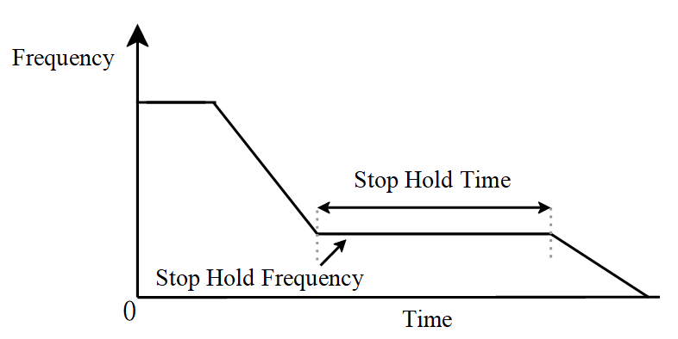
Figure 9-8 Stop Hold Frequency and Time
Note: The machine is equipped with a 4-digit LED panel, which automatically adjusts the decimal place according to the current value and decimal position to facilitate 4-digit LED display.
F1-29 | Instantaneous Power Failure Restart Method | Range: 0～2 | Factory setting: 0
In general, when power is lost, the inverter will stop due to undervoltage, and even if the power returns to normal within a short time, the inverter will not restart automatically. The instantaneous power failure restart function allows the inverter to continue outputting during a brief power outage and recovery, achieving the purpose of preventing the motor from stopping.
0: Stop operation
In the event of an instantaneous power failure, operation stops and cannot be restarted automatically.
1: Track current speed
The inverter starts from the frequency before the power failure and performs speed tracking downwards. Once the motor frequency is detected, it accelerates from the detected motor frequency to the set frequency. This option is recommended when the motor inertia is large.
2: Minimum frequency for tracking
The inverter starts tracking upwards from the lowest frequency. Once the motor frequency is detected, it accelerates from the detected motor frequency to the set frequency. This option is recommended when the motor inertia is small.
F1-30 | Allowed Power Failure Time | Range: 0.0～20.0seconds | Factory Value: 2.0 seconds
When the power outage duration is less than the set value of this function code, automatic restart according to the settings of F1-29 is allowed; when the power outage duration exceeds the set time of this function code, automatic restart will no longer occur.
F1-31 | Base Lockout Interruption Time | Range: 0.0～5.0seconds | Factory Value: 0.5 seconds
When an external controller detects an abnormal condition, it may be necessary for the inverter to immediately stop output. At this time, the base blocking function of the inverter can be used. Upon receiving a base blocking signal, the inverter immediately stops PWM output. After the base blocking signal is removed, the inverter waits for the time set by this function code before restarting. In addition, if the inverter stop mode is Free Stop, after stopping, it is necessary to wait for the time set by this function code before running again (the interval between two runs).
F1-32 | Instant Stop Without Stopping (dEb) Recovery Threshold | Range: 0.0～200.0 | Factory Value: 40.0/20.0
F1-33 | Instant Stop Without Stopping (dEb) Recovery Threshold | Range: 0.0～200.0 | Factory Value: 40.0
F1-34 | Instant Stop Without Stopping (dEb) Recovery Threshold | Range: 0～4 | Factory setting: 0
F1-35 | Instant Stop Without Stopping (dEb) Recovery Threshold | Range: 0.0～25.0 seconds | Factory Value: 3.0 seconds
When the grid voltage drops, the inverter may shut down due to undervoltage. Uncontrolled abnormal shutdowns can cause significant impact, leading to system damage and serious consequences. The Instant Stop Without Stopping function (also known as KEB, Kinetic Energy Backup, or dEb, Deceleration Energy Backup function) can, in such cases, allow the motor to decelerate in a controlled manner, reducing the impact on the system.
F1-32 Instant Stop No Stop (dEb) Recovery Threshold
This function code is used to set the dEb recovery voltage. By default, dEb recovery voltage = dEb action voltage + (F1-32 setting value).
F1-33 Instant Stop No Stop (dEb) Action Bias Threshold
This function code is used to set the dEb action voltage. By default,
For 220V models, dEb action voltage = undervoltage protection value + 30V + (F1-33 setting value)
For 380V models, dEb action voltage = undervoltage protection value + 60V + (F1-33 setting value)
F1-34 Instant Stop No Stop (dEb) Deceleration Selection
This function code is used to set the deceleration mode during instant stop no stop.
0: No action
When the grid voltage dips, the inverter does not reduce speed; it may shut down due to undervoltage.
1: Enable, No Recovery
When the grid voltage dips and reaches the DEB action voltage, the inverter controls the motor to decelerate. When the grid voltage returns to normal, it continues to control the motor to decelerate to zero before shutting down.
2: Enable, Recovery
When the grid voltage dips and reaches the DEB action voltage, the inverter controls the motor to decelerate. When the grid voltage returns to normal, it maintains the current frequency for a period (F1-35) before accelerating back to the target frequency.
F1-35 Instantaneous Stop No Shutdown (DEB) Recovery Time
This parameter is used to set the time during which the inverter maintains operation at the current frequency after power recovery. After this time, the inverter accelerates back to the given frequency.
  - F2 Group VF Control Parameters
This function code can be used to adjust the VF control mode.
F2-00 | V/F voltage selection | Range:0～2 | Factory Value:0
This function code is used to set the voltage curve type. This inverter provides multiple voltage curves and allows for custom voltage curves to meet different operating conditions.
0: General V/F Curve (Multi-Segment VF Curve)
The multi-segment (custom) V/F curve is shown in Figure 9-9, defined by F2-04～F2-09 and F4-03 and F4-04, as illustrated below. In Figure 9-9, f1, f2, f3, and fb represent the motor multi-point VF frequency points 1, 2, 3, and the rated frequency, respectively, while V1, V2, V3, and Vb represent the motor multi-point VF voltage points 1, 2, 3, and the rated voltage, respectively.
Caution: Under normal conditions, V1<V2<V3<Vb, f1<f2<f3<fb. Setting the voltage too high at low frequencies may cause the motor to overheat or even burn out, and the inverter may experience overcurrent or overvoltage protection.
Figure 9-9 Typical V/F Curve
1: 1.5th power V/F curve
The output voltage of the inverter is proportional to the 1.5 power of the frequency.
2: 2nd power V/F curve
The output voltage of the inverter is proportional to the square of the frequency.
F2-01 | Torque compensation gain | Range:0～10 | Factory setting:1
F2-02 | Torque compensation filter time | Range: 0.001～10.000 seconds | Factory setting:0.500
The above two function codes apply to VF control mode.
F2-01 Torque compensation gain, used to adjust the torque compensation level. By adjusting the output voltage, the motor's load-carrying capacity can be adjusted. The greater the torque compensation gain, the better the load-carrying capacity, but the output current will increase. If set too high, it may cause overcurrent faults; reducing the torque compensation gain will correspondingly degrade the load-carrying capacity.
F2-02 Torque Compensation Filter Time, used to adjust the filter time for torque compensation. Setting the filter time too large ensures stable control, but degrades control response. When the filter time is too small, the response is faster, but it may lead to instability. Adjust according to actual conditions.
Note: The machine is equipped with a 4-digit LED panel, which automatically adjusts the decimal place according to the current value and decimal position to facilitate 4-digit LED display.
F2-04 | Motor Multi-Point VF Frequency Point 1 | Range: 0.00～599.00Hz | Factory Value: 0.50Hz
F2-05 | Motor Multi-Point VF Voltage Point 1 | Range: 0.0～480.0V | Factory Value: 2.0V/1.0V
F2-06 | Motor Multi-Point VF Frequency Point 2 | Range: 0.00～599.00Hz | Factory Value: 1.50Hz
F2-07 | Motor Multi-Point VF Voltage Point 2 | Range: 0.0～480.0V | Factory Value: 10.0V/5.0V
F2-08 | Motor Multi-Point VF Frequency Point 3 | Range: 0.00～599.00Hz | Factory Value: 3.00Hz
F2-09 | Motor Multi-Point VF Voltage Point 3 | Range: 0.0～480.0V | Factory Value: 22.0V/11.0V
The above function codes are used to set the voltage curve, please refer to function code F2-00.
Note: The machine is equipped with a 4-digit LED panel, which automatically adjusts the decimal place according to the current value and decimal position to facilitate 4-digit LED display.
F2-10 | Slip Compensation Filter Time | Range: 0.001～9.999 seconds | Factory Value: 0.100 seconds
F2-11 | Slip Compensation Gain | Range: 0.00～10.00 | Factory Value: 0.00
F2-10 Slip Compensation Filter Time, used to set the filter time for slip compensation. The larger the value of this function code, the slower the compensation response; the smaller the value, the faster the response, but it may lead to system instability. Adjust according to actual conditions.
F2-11 Slip Compensation Gain, used to set the gain for slip compensation. By modifying the slip compensation gain, the motor speed accuracy can be improved.
When using VF control: Under electric load conditions, if the motor speed is lower than the actual speed, the slip compensation gain can be appropriately increased; conversely, it should be decreased; Under generator load conditions, if the motor speed is higher than the actual speed, the slip compensation gain can be appropriately increased; conversely, it should be decreased.
F2-13 | Maximum Slip Limit Value | Range: 0.00～200.00Hz | Factory Setting: 20.00Hz
This function code is used to set the maximum slip.
Note: The machine is equipped with a 4-digit LED panel, which automatically adjusts the decimal place according to the current value and decimal position to facilitate 4-digit LED display.
F2-14 | Oscillation Suppression Gain | Range: 0～9999 | Factory Value: 1000
When using VF control to drive an asynchronous motor, there may be vibration issues. If the vibration is severe, it can lead to a fault shutdown, preventing normal operation. Adjusting this function code can improve the oscillation condition. The greater the oscillation suppression gain, the better the oscillation suppression effect, but the dynamic performance of the motor will decrease. Conversely, the poorer the vibration suppression effect, the better the dynamic performance of the motor. In actual use, you can adjust this function code according to actual needs.
  - Parameters for the first motor in group F4
F4-00 | Motor Type Selection | Range: 0～0 | Factory setting: 0
This parameter is used to set the motor type: (Read-only)
0: Induction Motor (Currently, EL10 only supports induction motors)
F4-02 | Motor Maximum Frequency | Range: 0.00～599.00Hz | Factory Value: 50.00Hz
F4-03 | Motor Rated Frequency | Range: 0.00～599.00Hz | Factory Value: 50.00Hz
F4-04 | Motor Rated Voltage | Range: 0.0～510.0V | Factory Value: 380.0V/220.0V
The above parameters are used to set the rated frequency, rated voltage, and maximum operating frequency of the induction motor;
Note, changing the F4-02 parameter will affect the motor's acceleration and deceleration rates. The current acceleration/deceleration time parameter corresponds to the time it takes for the motor to accelerate/decelerate from zero speed to the highest frequency.
F4-05 | Motor Rated Power | Range: 0.00～655.35kW | Factory value: determined by model
This parameter is used to set the rated power of the induction motor.
F4-06 | Motor Poles | Range: 2～20 | Factory value: 4
This parameter is a read-only parameter used to display the number of poles of the induction motor. Based on the rated frequency (F4-03) and rated speed (F4-08) entered by the user, this parameter value is automatically calculated. This parameter equals twice the number of pole pairs of the motor.
F4-07 | Motor Rated Current | Range: 0.00A～655.35A | Factory value: determined by model
This parameter is used to set the rated current of the induction motor.
F4-08 | Motor Rated Speed | Range: 0～65535rpm | Factory value: 1410rpm
This parameter is used to set the rated speed of the induction motor, in units of rpm (revolutions per minute). The inverter software will automatically calculate the number of poles of the induction motor based on this parameter and the rated frequency (F4-03).
F4-10 | Motor No-load Current | Range: 0.00A～F4-07 | Factory value: determined by model
This parameter is used to set the no-load current value of the induction motor.
F4-11 | Motor Stator Resistance | Range: 0.000～655.35Ω | Factory value: determined by model
This parameter is used to set the stator resistance of the induction motor.
The unit of this parameter is Ω.
Note: The machine comes with a 4-digit LED panel; F4-02, F4-03, F4-05, F4-07, F4-11 will display one less decimal place, i.e., 20.00 displays as 20.0, F8-08 is limited to 9999, communication is unaffected.
  - F5 Group Input Terminals
The EL10 series inverter is equipped with 4 multi-function digital input terminals.
F5-00 | DI1 Terminal Function Selection | Range: 0～94 | Factory setting: 0
F5-01 | DI2 Terminal Function Selection | Range: 0～94 | Factory setting: 0
F5-02 | DI3 Terminal Function Selection | Range: 0～94 | Factory setting: 1
F5-03 | DI4 Terminal Function Selection | Range: 0～94 | Factory Value: 2
The above function codes are used to set the functions corresponding to the digital multi-function input terminals, as shown in Table 9-3. The IO 23 function can only be set in MI4.
Table 9-3 Functions Corresponding to Digital Multi-function Input Terminals
Set Value | function | Description
0 | No Function | The inverter does not process digital terminal signals.
1 | Multi-Speed 1 | A total of 16 speed settings can be achieved through the combination of states of the four digital input terminals; see the detailed combinations below.
2 | Multi-Speed 2
3 | Multi-Speed 3
4 | Multi-Speed 4
5 | Fault Reset | External Fault Reset function. This is the same as the RESET key on the digital keypad.
6 | Jog Operation | Jog operation, where the jog operation set frequency, acceleration/deceleration time refer to F7-00, F7-01, F7-02.
7 | Speed Hold | During the inverter's acceleration or deceleration process, if the external terminal function is selected as Speed Hold and the terminal status is valid, the inverter maintains the current speed. If the terminal status is invalid, the inverter continues to accelerate or decelerate to the set value.
8 | 1-2 Segment Acceleration/Deceleration Switching | First and Second Acceleration/Deceleration Time Switching, default uses the first and fourth acceleration/deceleration times, which can be switched through the first and fourth acceleration/deceleration switching frequency (F1-15). By selecting a multifunctional input terminal, the terminal status can be switched to achieve the first and second acceleration/deceleration time switching.
9 | 3-4 Segment Acceleration/Deceleration Switching | Third and Fourth Acceleration/Deceleration Time Switching, by selecting a multifunctional input terminal, the terminal status can be switched to achieve the third and fourth acceleration/deceleration time switching.
10 | External Fault | External Fault Input (ExternalFault), when a valid state is detected on the multifunctional digital terminal, the inverter will decelerate and stop according to the emergency or forced shutdown deceleration method (F1-23). The digital keypad will display EF until the external terminal status returns to normal. After fault reset (RESET), the inverter can resume operation.
11 | Base Block | Base Block (BaseBlock) Input, when the multifunctional digital terminal status is detected as valid, the inverter immediately stops output, the motor freely decelerates to a stop, and B.B is displayed on the digital keypad.
12 | Stop Output | Output Stop, when the set multifunctional digital terminal is detected as valid, the inverter will immediately stop output, the motor freely decelerates to a stop, and the inverter enters output wait mode until the input IO signal returns to normal, at which point the inverter restarts to the current set frequency.
13 | Prohibit Automatic Acceleration and Deceleration | To cancel automatic acceleration and deceleration settings, set the automatic acceleration and deceleration (F1-20) to non-linear acceleration and deceleration. Switching the state of the multifunctional input IO port can achieve switching between automatic acceleration and deceleration and linear acceleration and deceleration modes.
15 | AI input frequency command | Speed command from AI, when the set multifunctional input terminal status is valid, the inverter's frequency command source is forcibly set to AI, and when other AI command sources are set, AI1 has the highest priority.
18 | Emergency stop | Forced shutdown, when the set multifunctional input terminal status is valid, the inverter will decelerate and shut down according to the emergency or forced shutdown deceleration method (F1-23).
19 | External frequency increase command | Frequency increment command, the frequency command source (F0-06=3) needs to be set to external UP/DOWN terminals, when the set multifunctional input terminal status is valid, the inverter's frequency setting will increase by one unit, if the input terminal remains continuously valid, the frequency command will incrementally increase to the maximum frequency command value according to the external terminal UP/DOWN key mode (F5-09) and the external terminal UP/DOWN key acceleration/deceleration rate (F5-10) settings.
20 | Frequency decrease external command | Frequency decrement command, requires setting the frequency command source (F0-06=3) to external UP/DOWN terminals. When the configured multi-function input terminal status is active, the inverter's frequency setting will decrease by one unit. If the input terminal remains continuously active, the frequency command will decrement to the minimum frequency command value according to the settings for the external terminal UP/DOWN key mode (F5-09) and the external terminal UP/DOWN key acceleration/deceleration rate (F5-10).
21 | PID function disabled | PID function cancellation, when the configured multi-function input terminal status is active, the PID function is disabled.
22 | Clear counter | Counter Reset: When the set multifunctional input terminal status is valid, the inverter will reset the current count display value. The inverter will resume counting when the input terminal status switches to invalid.
23 | Input Count (only MI4 is valid) | When the input terminal status is valid once, the count value displayed on the digital keypad will automatically increment by 1. The zero-reset judgment value of the count is determined by the last count value reaching the setting (L6-00).
24 | External Forward Jog | Set the operation command source to external terminals (F0-05=1). When the set multifunctional input terminal status is valid, the inverter will perform forward jog operation.
25 | External Reverse Jog | Set the operation command source to external terminals (F0-05=1), when the set multifunctional input terminal status is valid, the inverter will perform reverse jog operation.
28 | External Fault Free Stop | Emergency stop, when the set multifunctional input terminal status is valid, the inverter immediately stops output and displays EF1 on the digital keypad, the motor freely decelerates to a stop. When the external input terminal status returns to normal, fault reset must be performed through RESET before it can continue to operate.
38 | Prohibit Writing to EEPROM | Prohibit writing to EEPROM, when the set multifunctional input terminal status is valid, some parameter modifications cannot be saved to EEPROM and will not be retained after power loss.
40 | Motor Free Stop | Forced free run stop, during inverter operation, when the set multifunctional input terminal status is valid, the inverter immediately stops output, and the motor freely stops.
49 | Inverter Enable | Inverter Enable, by default, inverter enable is effective, allowing the inverter to control start and stop; without enable, operation commands are invalid. If enable fails during inverter operation, the motor freely decelerates to a stop. Switching the set multifunctional input terminal status can switch the inverter enable state; once the multifunctional input terminal is configured as the inverter enable, only setting the multifunctional input terminal status to valid can start the inverter.
53 | CANopen Quick Stop Trigger (Supported by Extended Models) | CANopen Quick Stop Trigger, when controlled via CANopen, if the configured multi-function input terminal is effective, the inverter's operating state is forcibly switched to quick stop.
70 | Auxiliary Frequency Forced to 0 | Auxiliary Frequency Forced to 0, when the auxiliary frequency function is enabled (auxiliary frequency source F0-07 is not 0), if the configured multi-function input terminal is effective, the auxiliary frequency is forced to 0. If PID is the main frequency, PID will continue to operate.
71 | PID Function Disabled, PID Output Forced to 0 | PID Function Disabled, PID Output Forced to 0, when the auxiliary frequency function is enabled (auxiliary frequency source F0-07 is not 0) and the PID function is used, if the configured multi-function input terminal is effective, the PID function stops, the integral value is reset to zero, and the PID output is cleared.
72 | PID function disabled, PID maintains current output level | PID function disabled, PID maintains previous output value, auxiliary frequency function enabled (auxiliary frequency source F0-07 is not 0), and when using the PID function, if the set multifunctional input terminal is effective, the PID function stops, and PID maintains the previous output.
73 | Force PID integral gain to 0 | Force PID integral gain to 0, integral action does not occur, if the set multifunctional input terminal is effective, the PID continues to operate, but the integrator stops working, and the integrator output is cleared.
74 | Invert PID feedback | Invert PID feedback, if the set multifunctional input terminal is effective, the PID feedback value sign is reversed, if the PID feedback is positive, it is converted to negative, if the PID feedback is negative, it is converted to positive.
Note:
- All digital input terminals are trigger-effective, meaning that after each power-up, the terminal status must switch from invalid to valid for the inverter to recognize the terminal input status as valid. If the terminal input status remains valid before and after power-up, the inverter will consider the terminal input status invalid (except for the power-up operation command, i.e., after selecting F5-19, the valid state upon power-up will run the inverter).
- When 2/3-wire control is selected (F5-08 is not 0), digital input terminals DI1 and DI2 are forced to forward and reverse input, and other functions cannot be selected. To select other functions for DI1 and DI2, F5-08 must be set to 0.
- Before changing the function of a digital terminal, ensure that the corresponding terminal status has been reset to an invalid state to guarantee that the previously selected function is already invalid when selecting the next function.
Multi-Speed/Multi-Point Position 1, 2, 3, 4 Function Description (Set Value to 1/2/3/4):
4 multi-speed command terminals can be combined into 16 states, these 16 states correspond to 16 command set values. Taking the default configuration as an example (F5-02=1, F5-03=2, F5-04=3, F5-05=4, F5-16=0 low level effective), the relationship between DI status and multi-speed mapping is shown in Table 9-4 or Figure 9-10.
Table 9-4 DI Status and Multi-Speed Mapping Relationship
DI6 | DI5 | DI4 | DI3 | Frequency Setting | Corresponding Function Code
H | H | H | H | Multi-Speed 0 | FD-00
H | H | H | L | Multi-Speed 1 | FD-01
H | H | L | H | Multi-Speed 2 | FD-02
H | H | L | L | Multi-Speed 3 | FD-03
H | L | H | H | Multi-Speed 4 | FD-04
H | L | H | L | Multi-Speed 5 | FD-05
H | L | L | H | Multi-Speed 6 | FD-06
H | L | L | L | Multi-Speed 7 | FD-07
L | H | H | H | Multi-Speed 8 | FD-08
L | H | H | L | Multi-Speed 9 | FD-09
L | H | L | H | Multi-Speed 10 | FD-10
L | H | L | L | Multi-Speed 11 | FD-11
L | L | H | H | Multi-Speed 12 | FD-12
L | L | H | L | Multi-Speed 13 | FD-13
L | L | L | H | Multi-Speed 14 | FD-14
L | L | L | L | Multi-Speed 15 | FD-15
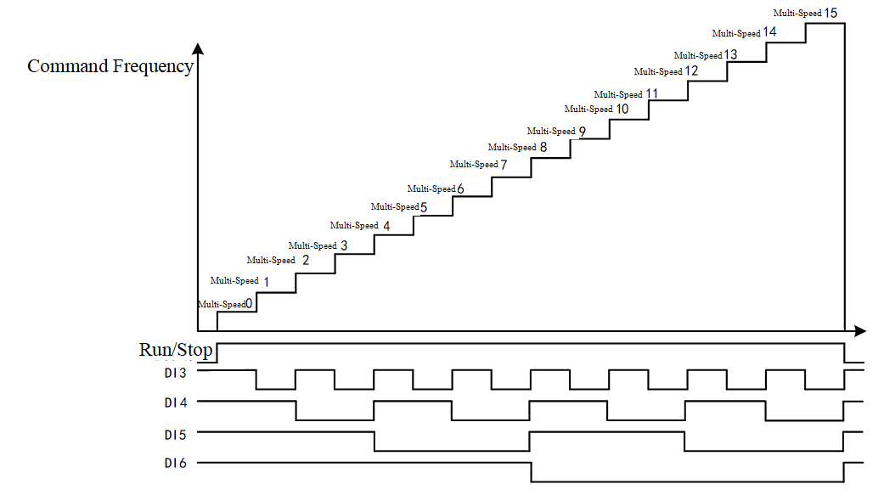
Figure 9-10 DI Corresponding to Multi-Speed
Speed Hold Function Description (Set Value to 7): When this function is invalid, normal acceleration and deceleration will occur; When this function is effective, maintain the current frequency unchanged, as shown in Figure 9-11.
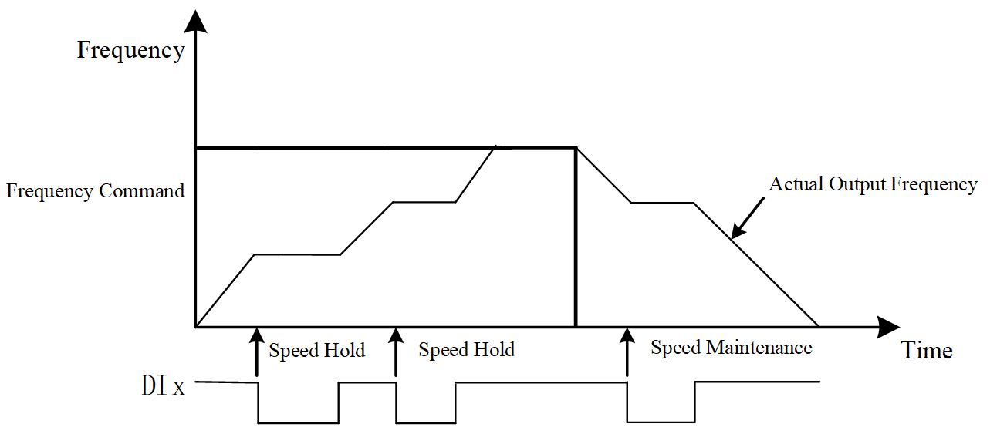
Figure 9-11 Speed Holding Function Diagram
External Fault Free Stop Function (set value 28) Description:
When this function is ineffective, the inverter operates normally; When this function is effective, the inverter reports an external fault and immediately stops running; it needs to be reset before it can be restarted, as shown in Figure 9-12.
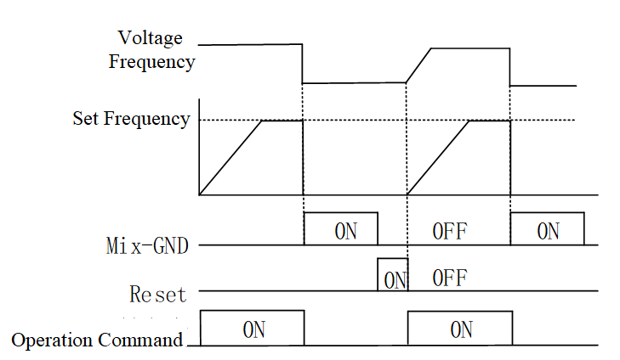
9-12 External Fault Free Stop Function
Manual and Automatic Mode Enable Function (set values 41, 42) Description:
The manual and automatic mode enable functions can switch between manual and automatic modes, as shown in Table 9-5.
Table 9-5 Manual and Automatic Mode Enable Functions
Manual mode enable function | Automatic mode enable function | Inverter operation mode
Invalid | Invalid | Stop operation
Valid | Invalid | Manual mode
Invalid | Valid | Automatic mode
Valid | Valid | Stop operation

F5-08 | Terminal Command Mode | Range: 0～6 | Factory setting: 1
This function code is used to set the terminal command method.
0: No Function
1: 2-Wire Mode 1
2: 2-Wire Mode 2
3: 3-Wire Mode
4: 2-Wire Mode 1/Fast Start
5: 2-Wire Mode 2/Fast Start
6: 3-Wire Fast Start
Table 9-6 shows the wiring diagram for the terminal command method.
Table 9-6 Wiring diagram for the terminal command method
Terminal command method (F5-08) | External terminal wiring diagram
1: 2-Wire Mode 1 | 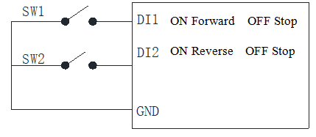
2: 2-Wire Mode 2 | 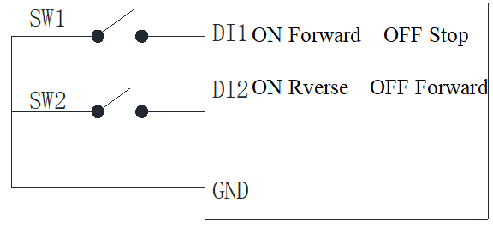
3: 3-Wire Mode | 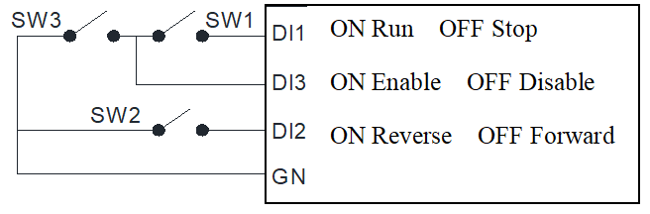
4: 2-Wire Mode 1/Fast Start | Same as Mode 1
5: 2-Wire Mode 2/Fast Start | Same as Mode 2
6: 3-Wire Fast Start | Same as Mode 3
Note: When set to quick start mode, the inverter will immediately respond to the start command. During shutdown, there will be a significant voltage on the inverter output terminals.
F5-09 | UP/DOWN Mode Selection | Range: 0～4 | Factory setting: 0
F5-10 | UP/DOWN Rate of Change | Range: 0.001～1.000Hz/ms | Factory Value: 0.001
This function code is used to set the UP/DOWN mode.
0: System Acceleration/Deceleration Time
When the external UP/DOWN signal is valid, the inverter accelerates or decelerates according to the normal acceleration/deceleration time (F0-13, F0-14, F7-03～F7-08).
1: Constant Speed
When the external UP/DOWN signal is valid, the inverter accelerates or decelerates according to the UP/DOWN change rate (F5-10).
2: Step Acceleration/Deceleration (1step/pulse)
When the external UP/DOWN signal generates a valid pulse, the inverter performs a step acceleration or deceleration once according to the UP/DOWN change rate (F5-10).
3: When the exponential curve external UP/DOWN signal is valid, the inverter accelerates or decelerates according to the exponential curve.
4: Step acceleration/deceleration (1 step/100 ms)
When the external UP/DOWN signal is valid, the inverter changes its speed in steps every 100 ms according to the UP/DOWN rate (F5-10).
F5-15 | DI Terminal Logic | Range: 0～65535 | Factory setting: 0
This function code can be used to set the effective logic level of the DI terminals. The table below lists the effective logic control bits for each DI terminal. If the corresponding control bit is 0, the effective logic level remains unchanged; if the corresponding control bit is 1, the effective logic level is inverted. The effective logic control bits for DI terminals are shown in Table 9-7.
Table 9-7 Valid Logic Control Bits for DI Terminal
Second digit from the right: Hexadecimal 0～F |  |  |  | First digit from the right: Hexadecimal 0～F
Reserved | Reserved | Reserved | Reserved | DI4 | DI3 | DI2 | DI1
Fourth digit from the right: Hexadecimal 0～F |  |  |  | Third digit from the right: Hexadecimal 0～F
Reserved | Reserved | Reserved | Reserved | Reserved | Reserved | Reserved | Reserved

F5-16 | DI Terminal Response Time | Range: 0.000s～30.000s | Factory Setting: 0.005s
This function code is used to set the sensitivity of the DI terminal. If the DI terminal experiences false triggering due to interference, this parameter can be increased to enhance the DI terminal's resistance to interference, but the sensitivity of the DI terminal will also decrease accordingly.
F5-17 | Virtual/Real DI Terminal Selection | Range: 0～65535 | Factory setting: 0
This function code can be used to set whether the DI terminal signal comes from an actual terminal or a virtual terminal. Table 9-8 lists the virtual/actual control bits for each DI terminal. If the corresponding control bit is 0, the actual terminal is selected; if the corresponding control bit is 1, the virtual terminal is selected. Virtual terminal signals are set through F5-18.
Table 9-8 Virtual/Actual DI Terminal Selection
Second digit from the right: Hexadecimal 0～F |  |  |  | First digit from the right: Hexadecimal 0～F
Reserved | Reserved | Reserved | Reserved | DI4 | DI3 | DI2 | DI1
Fourth digit from the right: Hexadecimal 0～F |  |  |  | Third digit from the right: Hexadecimal 0～F
Reserved | Reserved | Reserved | Reserved | Reserved | Reserved | Reserved | Reserved

F5-18 | Virtual Terminal Status Setting | Range: 0～65535 | Factory setting: 0
This function code can be used to set the virtual DI terminal signals. Table 9-8 lists the control bits for each virtual DI terminal signal. If the corresponding signal control bit is 0, the corresponding virtual terminal signal is invalid; if the corresponding signal control bit is 1, the corresponding virtual terminal signal is valid.
Table 9-9 Virtual Terminal Status Settings
Second digit from the right: Hexadecimal 0～F |  |  |  | First digit from the right: Hexadecimal 0～F
Reserved | Reserved | Reserved | Reserved | DI4 | DI3 | DI2 | DI1
Fourth digit from the right: Hexadecimal 0～F |  |  |  | Third digit from the right: Hexadecimal 0～F
Reserved | Reserved | Reserved | Reserved | Reserved | Reserved | Reserved | Reserved

F5-19 | External Operation Selection | Range: 0～1 | Factory setting: 0
This function code is used to set the response to external terminal command signals when the inverter is powered on and during fault reset.
0: Invalid
When power is applied or a fault reset occurs, if there is a terminal operation command, the inverter does not run until the terminal command signal is canceled; it will only run after receiving the terminal operation command again.
1: Run if there is an operation command
When power is applied or a fault reset occurs, if there is a terminal operation command, the inverter runs.
F5-20 | AI1 Signal Type Selection | Range: 0～1 | Factory setting: 0
This function code is used to set the AI1 signal type.
0: 0-10V Input Selection
Voltage signal input, input range is 0-10V.
1: 0-20mA Input Selection
Current signal input, input range is 0-20mA.
2: 4-20mA Input Selection
Current signal input, input range is 0-20mA.
F5-21 | AI Function Selection | Range: 0～20 | Factory setting: 1
This function code is used to set the AI1 function, as shown in Table 9-9 for analog input function selection:
Table 9-9 Analog Input Function Selection
Set Value | function | Description
0 | No Function | AI terminal has no function
1 | Frequency Setting | When setting the frequency, it is necessary to set the frequency source (F0-06) to 2.
4 | PID target value | When setting the PID target value, it is necessary to set the PID feedback terminal (FA-00 not equal to 0), and there are two other cases:  1. When the PID target value source (FA-01) is set to 0 (by frequency setting), parameters F5-21, F5-27, or F5-33 should be set to 1 or 4. If both 1 and 4 are set in the analog input simultaneously, AI is given priority as the PID target value.  2. When the PID target value source (FA-01) is set to 3 (by external analog input). The PID target value will be displayed in percentage form through parameter FA-02 (PID target value setting) (precision 0.01%).
5 | PID Feedback Value | When used as PID feedback, set the PID feedback selection (FA-00) to 1 or 4, and the feedback value will be displayed in percentage form (accuracy 0.01%) through U1-04 (communication setting PID feedback value).
6 | PTC Thermistor Input | An external PTC thermistor must be connected to detect whether the motor is overheating.
11 | PT100 Thermistor Value | An external PT100 thermistor must be connected to detect whether the motor is overheating.
12 | Auxiliary Frequency Setting | When used as an auxiliary frequency input, set the auxiliary frequency source (F0-07) to 3 (from external analog input).
13 | PID Offset | When used as a PID compensation amount, set the PID feedback selection (FA-00 not equal to 0) to be valid, set the PID compensation selection (FA-20) to 1 (from external analog input), and the intelligent start frequency command (FA-33) to 0. The change in the analog input compensation amount can be displayed in percentage form (accuracy 0.1%) in parameter FA-21 (PID compensation).

F5-22 | AI1 Input Bias | Range: -100.0%～100.0% | Factory Value: 0.0
This function code is used to set the analog input value corresponding to the 0 point of the AI1 input signal.
F5-23 | AI1 Bias Mode Selection | Range: 0～4 | Factory setting: 0
This function code is used to set the AI1 bias mode. Properly setting the bias mode can reasonably process the input signal to reduce the impact of noise.
0: No Bias
1: Below Bias = Bias
2: Above Bias = Bias
3: Absolute Bias Centered
4: Bias Centered
The diagrams showing various bias modes for AI1 are illustrated in Figures 9-13 to 9-17, where Bias represents bias, set through F5-22, and Gain represents gain, set through F5-24. The horizontal axis in the figures represents the input signal, and the vertical axis represents the signal after bias processing. The bias mode can be selected based on requirements.
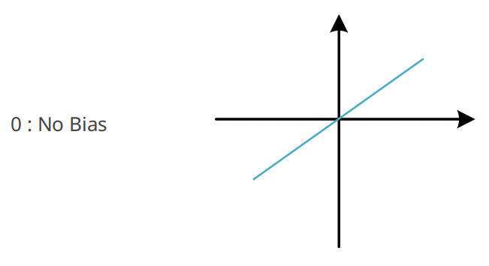
Fig. 9-13 No Bias
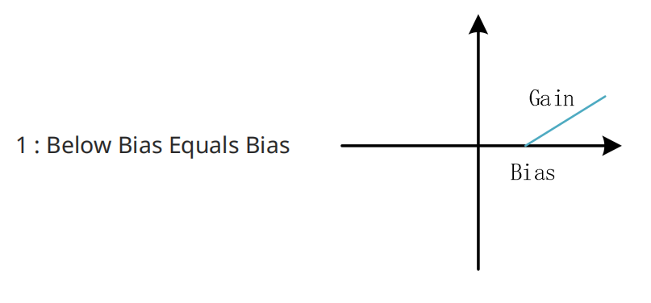
Fig. 9-14 Below Bias = Bias
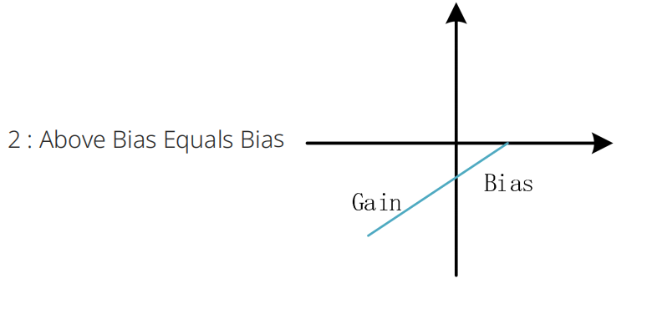
Fig. 9-15 Above Bias = Bias
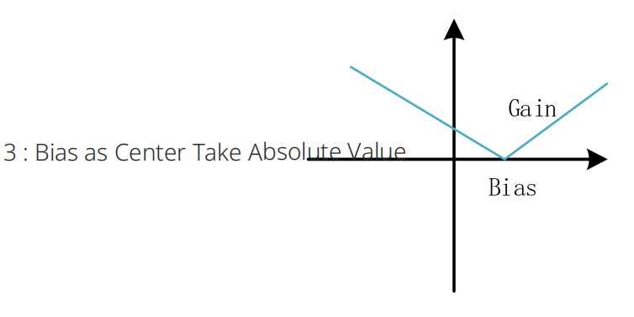
Fig. 9-16 Bias as Center Absolute Value
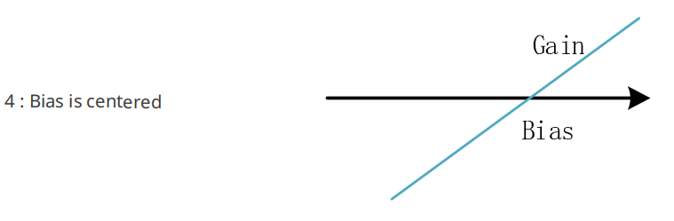
Fig. 9-17 Bias as Center
F5-24 | AI1 Gain | Range: -500.0% to 500.0% | Factory Setting: 100.0%
This function code is used to set the AI1 signal gain. The AI1 signal gain can proportionally adjust the analog input signal; refer to F5-23 for gain settings.
Note: The machine is equipped with a 4-digit LED panel, which automatically adjusts the decimal place according to the current value and decimal position to facilitate 4-digit LED display.
F5-25 | AI1 Filter Time | Range: 0.00 to 20.00 seconds | Factory Setting: 0.01 second
The inverter software uses a digital low-pass filter to remove noise signals contained in the analog input signals at the control terminals; this parameter sets the time constant of the digital low-pass filter. The larger this parameter value, the better the filtering effect, but the greater the signal delay, and the control response performance deteriorates; the smaller the setting value, the faster the control response, but the poorer the noise filtering effect, which may lead to unstable control. When selecting the optimal setting value, it can be determined based on a compromise between control stability and response delay.
F5-38 | Analog Frequency Negative Value Reversal | Range: 0～1 | Factory setting: 0
This function code is used to set whether the analog signal can control the inverter direction.
0: Forward/Reverse by Operation Source
Negative frequency input from the analog input signal is not allowed; forward and reverse actions are controlled by the keyboard or external terminals.
1: Forward/Reverse by Bias
Negative frequency input from the analog input signal is allowed; positive frequency results in forward rotation, and negative frequency results in reverse rotation; at this time, the keyboard and external terminals cannot control forward and reverse rotation.
The condition for an analog signal to input negative frequency is:
1. Set F5-38 to 1;
2. Set bias mode (F5-23) to 4 (bias centered);
3. The corresponding analog input gain is less than 0, making the calculated input frequency negative. This parameter can control whether the inverter reverses.
F5-42 | 4-20mA Wire Break Action | Range: 0～3 | Factory setting: 0
This function code is used to set the handling method when an analog input current signal break is detected, effective when the analog type is selected as 4-20mA input.
0: Do Not Detect Wire Break
Do not perform break detection.
1: Maintain pre-disconnection frequency
After detecting a break, continue running and display a break warning.
2: Decelerate to 0Hz
After detecting a break, reduce the frequency to zero speed while displaying a break warning.
3: Immediate stop on fault
After detecting a break, immediately stop running and report a break fault.
F5-43 | 4-20mA open circuit threshold | Range: 0.00mA～4.00mA | Factory Value: 2.00mA
This function code is used to set the threshold for detecting an open circuit in the analog input current signal; if the value is below this threshold, an open circuit is detected.
  - F6 Group Output Terminals
This series of inverters is equipped with 1 multifunctional relay output terminal.
F6-00 | RLY terminal function selection | Range: 0～76 | Factory Value: 11
The selection of multifunctional output terminal functions is shown in Table 9-10:
Table 9-10 Selection of Multifunctional Output Terminal Functions
Set Value | function | Description
0 | No Function | Disable Multifunctional Digital Output Function
1 | Inverter Running | When the inverter is running, this terminal outputs a valid signal.
2 | Reach Set Frequency | When the inverter reaches the set frequency, and the deviation between the output frequency and the set frequency is within a certain range (±2Hz), this terminal outputs a valid signal.
3 | Arrival Frequency 1 Detection Value | When the inverter output frequency deviates from the Arrival Frequency 1 Detection Value (F6-27) by less than the Arrival Frequency 1 Amplitude (F6-28), this terminal is valid.
4 | Arrival Frequency 2 Detection Value | When the inverter output frequency deviates from the Arrival Frequency 2 Detection Value (F6-29) by less than the Arrival Frequency 2 Amplitude (F6-30), this terminal is valid.
5 | Zero Speed Command Operation | During inverter operation, when the frequency command is 0, this terminal is valid.
6 | Zero Speed Command Operation (Including STOP) | When the inverter frequency command is 0 (including when the inverter is stopped), this terminal is valid.
9 | Inverter Ready | When there are no inverter faults (including during shutdown and operation), this terminal is active.
10 | Low Voltage Warning | When the inverter experiences DC bus undervoltage (including during shutdown and operation, and when the DC bus voltage is below the low voltage threshold L2-18), this terminal is active.
11 | Fault Indication | When the inverter has a fault (excluding undervoltage during shutdown, B.B. fault, dEb fault), this terminal is active.
12 | Brake Release | When the inverter operating frequency is not 0 or greater than the motor zero speed threshold (F6-09), this terminal is active.
13 | Overtemperature Warning | When the inverter detects an IGBT over-temperature warning, this terminal outputs a valid signal.
14 | Software brake action indication | When the inverter's discharge resistor switch operates, this terminal outputs a valid signal.
15 | PID feedback abnormality | When the inverter detects that the deviation between the PID setpoint and feedback exceeds the set threshold (FA-51) and duration (FA-52), this terminal outputs a valid signal.
16 | Excessive slip | When the inverter detects an excessive slip fault, this terminal outputs a valid signal.
17 | Count value does not reset to zero | When the inverter executes an external counter, if the count value equals the parameter L6-01 setting, this terminal outputs a valid signal. If the parameter L6-01 setting > parameter L6-00 setting, this terminal output is invalid.
18 | Count value resets to zero | When the inverter executes the external counter, if the count value equals the set value of parameter L6-00, this terminal outputs a valid signal.
19 | Base block state | When the inverter enters base block (B.B.) and stops output, this terminal outputs a valid signal.
20 | Warning indication | When the inverter detects a warning, this terminal outputs a valid signal.
21 | Overvoltage warning | When the inverter detects that the bus voltage exceeds the set overvoltage warning threshold (0.9 times the overvoltage threshold, no warning state is output), this terminal outputs a valid signal.
22 | Overcurrent stall warning | When the inverter detects an overcurrent stall prevention warning, this terminal outputs a valid signal.
23 | Overvoltage Stall Warning | When the inverter detects an overvoltage stall prevention warning, this terminal outputs a valid signal.
24 | Inverter Operation Source | When the inverter operation command source is not the keyboard (F0-05 is not 0), this terminal outputs a valid signal.
25 | Forward Command | When the inverter's operation direction command is forward, this terminal outputs a valid signal.
26 | Reverse Command | When the inverter's operation direction command is reverse, this terminal outputs a valid signal.
29 | Over Frequency | When the actual output frequency of the inverter is greater than the DO action frequency (F6-08), this terminal outputs a valid signal.
30 | Under Frequency | When the actual output frequency of the inverter is less than the DO action frequency (F6-08), this terminal outputs a valid signal.
33 | Zero Frequency Operation | When the inverter is operating and the output frequency is zero, this terminal is active.
34 | Output Zero Frequency (including STOP) | When the inverter's output frequency is zero or it is stopped, this terminal is active.
35 | Fault Output Selection 1 | When the inverter encounters a fault set by U0-10, this terminal is active.
36 | Fault Output Selection 2 | When the inverter encounters a fault set by U0-11, this terminal is active.
37 | Fault Output Selection 3 | When the inverter encounters a fault set by U0-12, this terminal is active.
38 | Fault Output Selection 4 | When the inverter encounters a fault set by U0-13, this terminal is active.
40 | Reach Target Frequency | When the inverter output frequency reaches the set frequency (including stop and frequency command is 0), this terminal output is valid.
42 | Mechanical brake release | It needs to be used in conjunction with setting parameters DO action frequency (F6-08) and holding brake frequency (L4-00). When the brake release is detected, this terminal output is valid.
44 | Output undercurrent | When the inverter experiences undercurrent (the undercurrent action method is selected by parameter F9-24, which may not report an undercurrent fault or warning), this terminal output is valid.
45 | UVW electromagnetic switch enable | It needs to be used in conjunction with configuring the digital input terminal as 49 (inverter enable). When the inverter status enable terminal is active, the output terminal is valid.
46 | dEB action | During the inverter deceleration process, when dEB action occurs, the output terminal is effective.
51 | RS485 control output | RS-485 (Modbus) control output, which controls the output terminals based on the status of the corresponding data bits of RS-485. The RS-485 and digital output port mapping table is as follows:
  terminal | parameter setting | attribute | index
  RLY1 | F6-00=51 | RW | 2640 data bit 0
53 | simple PLC completes cycle | When the simple PLC completes one cycle, it outputs a pulse signal with a width of 250ms.
67 | analog input threshold reached output | The inverter's multi-function output terminal operates when the analog input is between the high threshold and low threshold. Parameter F6-05 selects the analog input channel for comparison (for the EL10 series, there is only one AI channel, so keep the default setting). Parameter F6-06 sets the high threshold for analog input comparison (default 50%). Parameter F6-07 sets the low threshold for analog input comparison (default 10%). The multi-function output terminal operates when the analog input > Parameter F6-06; The multi-function output terminal stops output when the analog input < Parameter F6-07.

F6-04 | Effective Logic of DO Terminal | Range: 0～65535 | Factory setting: 0
This function code can be used to set different DO terminal active logic levels. The table below lists the active logic control bits for each DO terminal. If the corresponding control bit is 0, the active logic level remains unchanged; if the corresponding control bit is 1, the active level is inverted. See Table 9-11.
Table 9-11 DO Terminal Effective Logic Control Bits
Bit4 | Bit4 | Bit2 | Bit1 | Bit0
Reserved | Reserved | Reserved | Reserved | RLY1

F6-05 | Source of AI for DO Output | Range: 0～4 | Factory setting: 0
F6-05 DO Output AI Source
0: AI (EL10 has only one AI)
F6-06 | Upper Limit Value of AI for DO Output | Range: -100.00% to 100.00% | Factory Value: 50.00%
F6-07 | Lower Limit Value of AI for DO Output | Range: -100.00% to 100.00% | Factory Value: 10.00%
When the multi-function digital output terminals (F6-00 to F6-03) are configured as 67 (analog input threshold reached output), the corresponding multi-function digital output status is valid when the analog input signal of F6-05 exceeds F6-06; if the analog input signal is less than F6-07, the corresponding multi-function digital output status is invalid. Note that the set value of F6-06 should be greater than the set value of F6-07.
Note: The machine is equipped with a 4-digit LED panel, which automatically adjusts the decimal place according to the current value and decimal position to facilitate 4-digit LED display.
F6-08 | DO Action Frequency | Range: 0.00Hz～599.00Hz | Factory setting: 0.00Hz
F6-08 DO Action Frequency
When the actual output frequency of the inverter is greater than the DO action frequency (F6-08), if the output terminal function is set to 29, this terminal output is valid. When the actual output frequency of the inverter is less than the DO action frequency (F6-08), if the output terminal function is set to 30, this terminal output is valid.
Note: The machine is equipped with a 4-digit LED panel, which automatically adjusts the decimal place according to the current value and decimal position to facilitate 4-digit LED display.
F6-09 | Motor Zero Speed Judgment Threshold | Range: 0rpm～65535rpm | Factory Value: 0rpm
This parameter defines the motor zero-speed judgment threshold. When the motor speed is below the value set for this parameter, the multi-function output terminal set to 43 will output effectively. The motor zero-speed judgment function is shown in Figure 9-12.
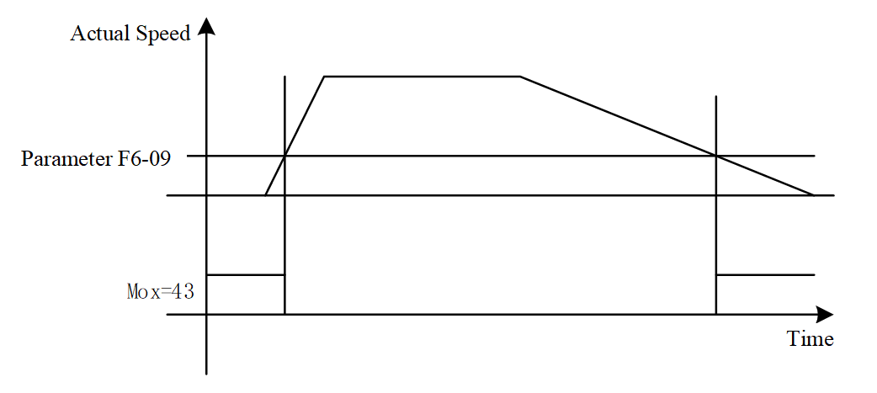
Figure 9-12 Motor Zero-Speed Judgment Function
In open-loop control mode, estimated speed calculation is used;
Note: The machine is equipped with a 4-digit LED panel, with a maximum value limit of 9999; communication/master computer does not affect this.
F6-27 | Frequency Arrival 1 Detection Value | Range: 0.00Hz～599.00Hz | Factory Value: 50.00Hz
F6-28 | Frequency Arrival 1 Amplitude | Range: 0.00Hz～599.00Hz | Factory setting: 2.00Hz
F6-29 | Frequency Arrival 2 Detection Value | Range: 0.00Hz～599.00Hz | Factory Value: 50.00Hz
F6-30 | Frequency Arrival 2 Amplitude | Range: 0.00Hz～599.00Hz | Factory setting: 2.00Hz
Two DO output frequency threshold values can be set, including Frequency Reach 1 detection value (F6-27) and Frequency Reach 2 detection value (F6-29). Two DO output frequency judgment width threshold values can be set, including Frequency Reach 1 amplitude (F6-28) and Frequency Reach 2 amplitude (F6-30). When the inverter output speed (frequency) reaches the set DO output frequency threshold range, the corresponding multi-function output terminal, if set to 3 or 4 (parameter F6-00), will output effectively.
Note: The machine is equipped with a 4-digit LED panel, which automatically adjusts the decimal place according to the current value and decimal position to facilitate 4-digit LED display.
  - F7 Group Auxiliary Functions and Keyboard Display
F7-00 | JOG Frequency Setting | Range: 0.00～599.00Hz | Factory Setting: 6.00Hz
F7-01 | JOG Acceleration Time | Range: 0.00～600.00 seconds | Factory Setting: 10.00 seconds
F7-02 | JOG Deceleration Time | Range: 0.00～600.00 seconds | Factory Setting: 10.00 seconds
The above parameters are used to set the jogging operation frequency, the time to accelerate from 0.00Hz to the jogging operation frequency, and the time to decelerate from the jogging operation frequency to 0.00Hz. During jogging operation, when a jogging command is received, the inverter controls the motor to accelerate to the jogging frequency according to the jogging acceleration time. When the jogging command is removed, depending on the stop method, the inverter controls the motor to decelerate and stop according to the jogging deceleration time or adopts other stopping methods.
F7-03 | Acceleration Time 2 | Range: 0.00～600.00 seconds or 0.0～6000.0 seconds | Factory value: determined by model
F7-04 | Deceleration Time 2 | Range: 0.00～600.00 seconds or 0.0～6000.0 seconds | Factory value: determined by model
F7-05 | Acceleration Time 3 | Range: 0.00～600.00 seconds or 0.0～6000.0 seconds | Factory value: determined by model
F7-06 | Deceleration Time 3 | Range: 0.00～600.00 seconds or 0.0～6000.0 seconds | Factory value: determined by model
F7-07 | Acceleration Time 4 | Range: 0.00～600.00 seconds or 0.0～6000.0 seconds | Factory value: determined by model
F7-08 | Deceleration Time 4 | Range: 0.00～600.00 seconds or 0.0～6000.0 seconds | Factory value: determined by model
Note: The machine is equipped with a 4-digit LED panel, which automatically adjusts the decimal place according to the current value and decimal position to facilitate 4-digit LED display.
For details on function codes F7-03 to F7-08, please refer to F0-13, F0-14.
F7-09 | Jump Frequency 1 Upper Limit | Range: 0.00～599.00Hz | Factory Value: 0.00
F7-10 | Jump Frequency 1 Lower Limit | Range: 0.00～599.00Hz | Factory Value: 0.00
F7-11 | Jump Frequency 2 Upper Limit | Range: 0.00～599.00Hz | Factory Value: 0.00
F7-12 | Jump Frequency 2 Lower Limit | Range: 0.00～599.00Hz | Factory Value: 0.00
F7-13 | Jump Frequency 3 Upper Limit | Range: 0.00～599.00Hz | Factory Value: 0.00
F7-14 | Jump Frequency 3 Lower Limit | Range: 0.00～599.00Hz | Factory Value: 0.00
F7-15 | Jump Frequency 4 Upper Limit | Range: 0.00～599.00Hz | Factory Value: 0.00
F7-16 | Jump Frequency 4 Lower Limit | Range: 0.00～599.00Hz | Factory Value: 0.00
When the motor operates near the mechanical resonance point of the load, it may cause mechanical resonance of the load, thereby degrading control performance; in severe cases, it may damage the load. To avoid resonance, the skip frequency function can be used to make the motor bypass the mechanical resonance point. When the set frequency is within the skip frequency range, the actual operating frequency will run at the skip frequency boundary closest to the set frequency. By setting the skip frequency, the inverter can bypass the mechanical resonance point of the load. The frequency hopping function is shown in Figure 9-19. This inverter can set 4 frequency hopping points. If two adjacent hopping frequencies are set to the same value, this function will not work at that frequency.
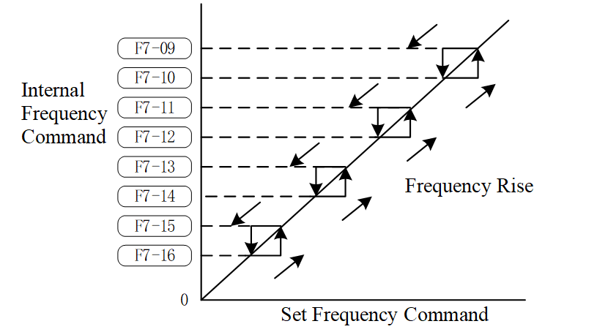
Figure 9-19 Frequency Hopping Points
Parameters F7-09 to F7-16 are used to set prohibited frequency settings. The inverter's frequency setting will skip these frequency ranges, but the frequency output remains continuous. These eight parameters have no size limitations and can be combined. The setting value of parameter F7-09 does not need to be greater than the setting value of parameter F7-10, the setting value of parameter F7-11 does not need to be greater than the setting value of parameter F7-12, the setting value of parameter F7-13 does not need to be greater than the setting value of parameter F7-14, and the setting value of parameter F7-15 does not need to be greater than the setting value of parameter F7-16. Parameters F7-09 to F7-16 can be set according to user needs, with no greater than or less than relationships between them. These parameters define the frequency range in which the inverter is prohibited from operating. This function can be used to prevent resonance caused by the natural frequency of the mechanical system. This function ensures that the inverter does not continuously operate at the resonant frequency of the mechanical system or load system, or other frequencies where operation is prohibited, thus avoiding resonance at each frequency point. Four zones are available for use. The frequency command (F) can still be set within the prohibited operating frequency range; in this case, the output frequency (H) will be limited to the lower limit of the prohibited operating frequency range. When the inverter is accelerating or decelerating, the output frequency may still pass through the prohibited operating frequency range.
Note: The machine is equipped with a 4-digit LED panel, which automatically adjusts the decimal place according to the current value and decimal position to facilitate 4-digit LED display.
F7-17 | Fan Control Method | Range: 0～4 | Factory value: 4
0: After power-on, the fan runs continuously.
1: The fan starts when the inverter is running and stops 1 minute after the inverter stops.
2: The fan operates according to the inverter's running status; it starts when the inverter is running and stops when the inverter stops.
3: When the module temperature > 50°C, the fan starts; when the module temperature < 48°C and the inverter has stopped running, the fan stops.
4: The fan starts when the inverter is running and continues to run after the inverter stops until the module temperature < 48°C, at which point the fan stops; if the temperature is > 50°C, the fan remains on.
F7-19 | Keyboard STOP Key Enable | Range: 0～1 | Factory setting: 0
0: The built-in keyboard STOP button can control shutdown only when the operation command source selection parameter F0-05=0. In other cases, the keyboard STOP button is ineffective.
1: Regardless of whether the operation command source selection is 0, the built-in keyboard STOP button can always control shutdown.
F7-20 | Startup Screen Selection | Range: 0～4 | Factory setting: 0
0: Set Frequency Display
1: Output Frequency Display
2: User-Defined Display
3: Output current display.
4: Direction of Operation Display
F7-21 | User-defined Display Selection | Range: 0～61 | Factory setting: 3
0: Display the inverter output current to the motor (I) (Unit: Amp)
1: Display the count value (c) (Unit: CNT)
2: Display the actual inverter output frequency (f) (Unit: Hz)
3: Display the inverter DC bus voltage value (DCbus voltage) (U) (Unit: VDC)
4: Display the inverter output voltage value (E) (Unit: VAC)
5: Display the inverter output power factor angle (n) (Unit: deg)
6: Display the inverter output power (P) (Unit: kW)
7: Display the motor speed, in rpm (r) (Unit: Krpm) (thousand revolutions per minute)
8: Display the segment number (d) being executed in multi-speed operation
9: Display the DC bus voltage ripple (u) (Unit: VDC)
10: Display AVI analog input terminal signal value (C) (unit: %)
11: Display PID feedback value (b.) (unit: %)
12: Display digital output ON/OFF status (o)
13: Display digital input ON/OFF status (J)
14: Display inverter power module (IGBT) temperature (t) (unit: ºC)
Note: The machine is equipped with a 4-digit LED panel, which automatically adjusts the decimal place according to the current value and decimal position to facilitate 4-digit LED display.
F7-26 | Cumulative number of startups | Range: 0～65535 | Factory setting: 0
F7-27 | Cumulative startup days | Range: 0～65535 | Factory setting: 0
F7-28 | Cumulative running minutes | Range: 0～1439 | Factory setting: 0
F7-29 | Cumulative operating days | Range: 0～65535 | Factory setting: 0
F7-30 | Cumulative Running Minutes | Range: 0～65535 | Factory setting: 0
The above parameters are used to display the inverter's accumulated start-up and operation information.
F7-31 | Motor Running Time | Range: 0～1439min | Factory setting: 0min
F7-32 | Motor Running Days | Range: 0～65535 | Factory setting: 0
The above parameters are used to display the motor's accumulated running time.
Note: The machine is equipped with a 4-digit LED panel, which automatically adjusts the decimal place according to the current value and decimal position to facilitate 4-digit LED display.
F7-33 | Password Input | Range: 0～65535 | Factory setting: 0
F7-34 | Password Setting | Range: 0～65535 | Factory setting: 0
F7-34 supports user-defined password for keyboard lock. After setting, the keyboard will be locked, and other parameters cannot be modified. To unlock, enter the corresponding password in F7-33.
Note: The machine is equipped with a 4-digit LED panel, which automatically adjusts the decimal place according to the current value and decimal position to facilitate 4-digit LED display.
F7-35 | Automatic Energy Saving Setting | Range: 0～1 | Factory setting: 0
F7-36 | Energy Saving Gain | Range: 10～1000 | Factory Value: 100
Using an inverter to drive a motor is primarily aimed at energy conservation. Under the same torque output conditions, the voltage and current output by the inverter can vary, and different scenarios correspond to different output powers of the inverter. If a combination of voltage and current can be selected to reduce the output power of the inverter, the goal of energy conservation is achieved.
During operation, the inverter continuously calculates the output power and adjusts the output voltage based on the output power to achieve the minimum output power or maintain it near the minimum value. The entire process occurs without external intervention and can be performed automatically, hence it can be referred to as the 'automatic energy-saving' function. To ensure that the acceleration and deceleration performance is not affected by the automatic energy-saving function, this function is disabled during acceleration and deceleration and only activated during steady-speed operation.
F7-37 | Automatic Voltage Regulation | Range: 0～4 | Factory setting: 0
When the bus voltage changes, the output voltage may also change, which can affect the motor control performance. The bus voltage compensation function (Automatic Voltage Regulation function, AVR) can compensate for output voltage variations caused by changes in bus voltage, making the motor control performance more stable.
0: Enable AVR Function
With the AVR function enabled, the inverter calculates the output voltage based on the bus voltage, ensuring that the output voltage does not fluctuate with changes in bus voltage.
1: Disable AVR Function
With AVR function disabled, the inverter does not calculate output voltage based on bus voltage; the output voltage will fluctuate with the bus voltage, leading to fluctuations in motor current.
2: Disable AVR During Deceleration
The AVR function is disabled during deceleration but enabled in other states. Disabling the AVR function during deceleration can shorten the deceleration time.
F7-42 | Output Phase Sequence Switching | Range: 0～1 | Factory setting: 0
0: Output according to the command direction normally.
1: Output frequency opposite to the command direction; forward rotation changes to reverse rotation, and reverse rotation changes to forward rotation for the same frequency command.
Note: The output phase sequence switching and forward/reverse rotation prohibition selection can be used together; however, if the prohibited rotation direction setting matches the direction after phase sequence switching, the output phase sequence switching function will not be effective.
F7-52 | W-sec Low Byte | 0.0～6553.5 | 0.0
F7-53 | W-sec high byte | 0.0～6553.5 | 0.0
F7-54 | W-hrs | 0.0～6553.5 | 0.0
F7-55 | KWh low byte | 0.0～6553.5 | 0.0
F7-56 | KWh high byte | 0.0～6553.5 | 0.0
This parameter is used to display the cumulative operating output energy of the inverter.
Note: The machine comes with a 4-digit LED panel, and the maximum display value is limited to 9999.
F7-57 | Machine model version | Range: 0.00～655.35 | Factory setting: 10.10
This parameter indicates the series type of the inverter.
F7-58 | Software Version | Range: 0.00～655.35 | Factory value: determined by model
F7-59 | Software Release Date | Range: 0～65535 | Factory value: determined by model
The above parameters are used to display the software version and release date information of the inverter, read-only.
F7-61 | Enhanced Parameter Display Selection | Range: 0～1 | Factory setting: 1
0: Display only 18 function parameter groups, i.e., F0-FF groups, U0-U1 groups.
1: Default display of 31 function parameter groups, i.e., F0～FF groups, U0～U1 groups, H0～H3 groups, L0～L8 groups.
  - Communication parameters for F8 group
F8-00 | Baud Rate Setting | Range: 4.8kbps～19.2kbps | Factory setting: 19.2kbps
This parameter configures the baud rate for Modbus communication on the inverter's RS485 terminal. This parameter can only be set to one of the following values; otherwise, it will be forced to 9.6 kbps. The current standard model of EL10 supports up to 19200 baud rate.
Setting range:
4.8: 4800 bps
9.6: 9600 bps
19.2: 19200 bps
F8-01 | Communication Data Format | Range: 1～17 | Factory value: 12
This parameter configures the data format for Modbus communication on the inverter's RS485 terminal.
1：7,N,2forASCII
2：7,E,1forASCII
3：7,O,1forASCII
4：7,E,2forASCII
5：7,O,2forASCII
6：8,N,1forASCII
7：8,N,2forASCII
8：8,E,1forASCII
9：8,O,1forASCII
10：8,E,2forASCII
11：8,O,2forASCII
12: 8,N,1 for RTU (factory default value)
13：8,N,2forRTU
14：8,E,1forRTU
15：8,O,1forRTU
16：8,E,2forRTU
17:8,O,2forRTU
F8-02 | Communication Address | Range: 1～254 | Factory setting: 1
This parameter configures the address of the inverter as a slave during Modbus communication on the RS485 terminal.
F8-03 | Response Delay | Range: 0.0 ms～200.0 ms | Factory value: 2.0 ms
This parameter sets the response delay time for Modbus communication on the inverter's RS485 terminal, generally no change is required.
F8-04 | Communication Timeout Time | Range: 0.0s～100.0s | Factory Value: 0.0s
This parameter sets the Modbus communication timeout time for the inverter's RS485 terminal, generally no need to change.
F8-05 | Communication Error Handling | Range: 0～3 | Factory setting: 3
This parameter sets the handling method after the Modbus communication timeout for the inverter's RS485 terminal.
0: Warning and Continue Running
1: Warning and Decelerate to Stop
2: Warning and Free Stop
3: No Warning
F8-06 | Communication Given Frequency | Range: 0.00Hz～599.00Hz | Factory Value: 50.00Hz
This parameter is read-only, used to display the given frequency under Modbus communication for the inverter's RS485 terminal.
Note: The machine is equipped with a 4-digit LED panel, which automatically adjusts the decimal place according to the current value and decimal position to facilitate 4-digit LED display.
F8-07 | Communication Decoding Method | Range: 0～1 | Factory setting: 1
Read/Write Permission: User Set
Valid Range: 0: Use Decoding Method 1
1: Use Decoding Method 2
Table 9-12
Communication Decoding Methods |  | Decoding Method 1 | Decoding Method 2
Control Source | Digital Keypad | No Effect, Control Source: Digital Keypad Button Control
Control Source | external terminals | No effect, control: controlled by external terminals
Control Source | RS-485 | The reference address range is 2000h~20FFh | The reference address range is 6000h~60FFh
Control Source | CANopen (extended support) | Custom Protocol One | Custom Protocol Two
Control Source | Communication Card (Reserved) | The reference address range is 2000h~20FFh | The reference address range is 6000h~60FFh

F8-14 | CANopen Node Address | Range: 0～127 | Factory setting: 0
This parameter configures the address of the inverter as a slave when CANopen communication over the CAN bus is used.
F8-15 | CANopen bus communication rate | Range: 0~5 | Factory setting: 0
This parameter configures the baud rate for CAN bus communication.
Valid range:
0: 1Mbps
1：500kbps
2：250kbps
3：125kbps
4：100kbps
5：50kbps
F8-18 | CANopen warning record | Range: 0~65535 | Factory setting: 0
This parameter is read-only and records CANopen-related warnings during inverter operation.
F8-19 | CiA402 protocol selection | Range: 0~1 | Factory setting: 0
Read/Write Permission: User Set
Valid range:
0: Do not use CiA402 protocol
1: Use CiA402 protocol (60xx)
Note: When not using the CiA402 protocol, the CANopen decoding method is set by F8-07.
F8-20 | CANopen communication status | Range: 0~5 | Factory setting: 0
This parameter is read-only and is used to display the communication status of CANopen during inverter operation.
Valid range:
0：node reset state
1：communication reset state
2：reset complete state
3: Pre-operational state
4: Operational state
5: Stop state
F8-21 | CiA402 operating status | Range: 0~14 | Factory setting: 0
This parameter is read-only and is used to display the operating status of the CiA402 protocol during inverter operation.
Valid range:
0: Power-on incomplete state
1: Prohibited operation state
2: Pre-excitation state
3: Excitation state
4: Operation permitted state
5~6: No function
7: Quick action stop state
8~12: No function
13: Trigger Error Action Status
14: Error State
F8-22 | CANopen Index Reset | Range: 0~65535 | Factory value: 65535
This parameter is used to reset CANopen index data.
  - F9 group fault and protection parameters
F9-01 | Motor Overload Selection | Range: 0～2 | Factory Value: 2
F9-02 | Motor Overload Time | Range: 30.0～600.0 seconds | Factory value: 60.0 seconds
Function Code F9-01 is used to set the overload protection mode.
0: Constant Torque Output Motor (Independent Cooling)
1: Variable Torque Output Motor (Coaxial Cooling)
2: No Motor Overload Protection
Function Code F9-02 is used to set the overload protection time when the motor current reaches 150% of the rated current. By setting an appropriate inverse-time curve, the operating time of the motor under overload conditions can be made less than the set motor overload protection time, thereby achieving overload protection for the motor and preventing damage due to overheating. When the overload time reaches the motor overload protection time, an overload fault (E022) will be reported. This function is not enabled by default; if it needs to be activated, set F9-01 to 0 or 1.
When F9-01 is set to 0, the overload protection curve for the motor is shown in Figure 9-20. Here, T equals the set value of parameter F9-02, and “motor current percentage” refers to the ratio of the inverter output current to the motor rated current. When the motor fan is independently controlled, this inverse-time curve can be selected. In this case, the fan speed is independent of the motor speed, so the cooling capacity does not decrease as the motor speed decreases, and the inverse-time curve is also independent of the motor operating speed.
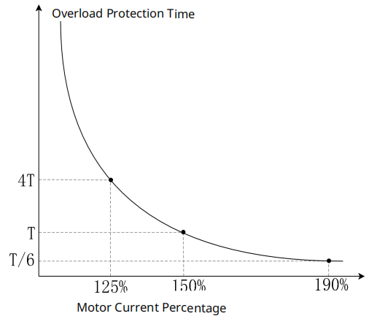
Figure 9-20 Inverse-Time Curve 1
When F9-01 is set to 1, the overload protection curve for the motor is shown in Figure 9-21. Among them, the “speed coefficient” is a function of the motor speed; when the motor speed exceeds the rated speed, the speed coefficient equals 1; when the motor speed is below the rated speed, the speed coefficient = 1/(0.4 + 0.6 * motor speed / motor rated speed).
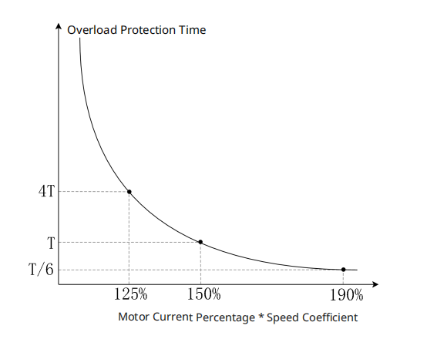
Figure 9-21 Inverse Time Curve 2
When the motor uses coaxial cooling (the fan is connected to the motor shaft), the fan speed is the same as the motor speed, and a decrease in motor speed will reduce the fan's cooling capacity. In this case, it is recommended to set F9-01 to 1, so that the inverse time curve adjusts according to the motor speed, reducing the motor's overload capability as the speed decreases to prevent overheating due to reduced fan cooling capacity. When the motor speed is zero, the fan stops rotating, at this time the speed factor is 2.5, and the corresponding overload curve is shown in Figure 9-22. From Figure 9-22, it can be seen that when the current reaches 60% of the motor's rated current, the motor will report an overload fault after running for T time.
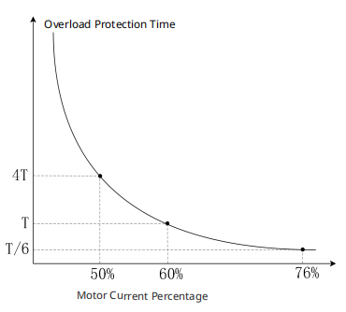
Figure 9-22 Inverse Time Curve 3
F9-03 | Overvoltage Stall Mode | Range: 0～1 | Factory setting: 1
This function code is used to set the overvoltage stall prevention mode. When the motor decelerates, energy feedback may cause the bus voltage to rise. If the bus voltage is too high, it can lead to an overvoltage fault. By reducing the deceleration ramp, the increase in bus voltage can be suppressed, thus avoiding shutdown due to overvoltage.
0: Overvoltage Stall Mode 0
If the inverter detects that the bus voltage is higher than the set value of F9-04, the inverter will stop decelerating (the output frequency remains unchanged) until the bus voltage falls below the set value of F9-58, at which point the inverter will resume deceleration.
1: Overvoltage Stall Mode 1
During the deceleration process, dynamically adjust the speed curve to prevent overvoltage faults due to excessively high bus voltage.
It should be noted that when the overvoltage stall prevention function is activated, the inverter's deceleration time will exceed the set time. If automatic adjustment of the deceleration time is not allowed, this function must be disabled. To prevent overvoltage, the following measures can be taken:
  - Reasonably increase the deceleration time;
  - Install a braking resistor to dissipate the motor's feedback energy.
F9-04 | Overvoltage Stall Threshold | Range: 0.0～900.0V | Factory setting: 760.0V/380.0V
This function code is used to set the overvoltage stall threshold. When the setting value is 0.0, the overvoltage stall prevention function is disabled. When the inverter is equipped with a braking unit and connected to a braking resistor, it is recommended to use this setting. When the setting value is not 0.0, the overvoltage stall prevention function is effective. This parameter can be set according to the power supply and load conditions. If set too low, it may prolong the deceleration time. If the setting value exceeds the overvoltage protection point, the overvoltage stall prevention function is considered disabled.
F9-08 | Overcurrent Slip Limiting Threshold During Acceleration | Range: 0%～200% | Factory Value: 150%
F9-09 | Overcurrent Stall Limit Threshold | Range: 0%～100% | Factory Value: 100%
Generally speaking, the faster the acceleration, the greater the torque current required. If the acceleration is too fast, it may result in excessive motor current. To protect the motor and inverter, current limiting is necessary. The overcurrent slip prevention function during acceleration prevents overcurrent conditions caused by excessively fast acceleration. The principle of the overcurrent slip prevention function during acceleration is not complicated. When the current exceeds the set value, the inverter stops accelerating. Once the current drops below the set value, the inverter resumes acceleration, as shown in Figure 9-23.
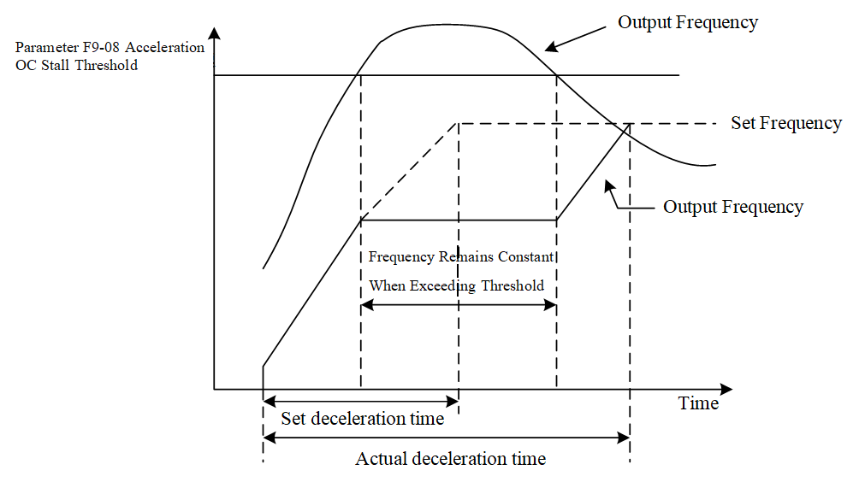
Figure 9-23 OC Stall Process
F9-08 Acceleration Overcurrent Stall Threshold
This function code is used to set the acceleration overcurrent stall prevention threshold, in units of %, based on the inverter's rated current. When the inverter accelerates, if the output current exceeds the value set by F9-08, the inverter will stop accelerating. When the current falls below the value set by F9-08, the inverter resumes acceleration to the set frequency.
F9-09 Overcurrent Stall Limit Threshold
This function code is used to set the acceleration overcurrent stall prevention threshold during field weakening. When the motor operating frequency is greater than the rated frequency, the acceleration overcurrent stall prevention threshold equals the F9-08 set value × the F9-09 set value. For example: If F9-08=150%, F9-09=80%, when the motor operating frequency exceeds the rated frequency, the acceleration overcurrent flux loss prevention threshold is: F9-08 setting × F9-09 setting = 150% × 80% = 120%.
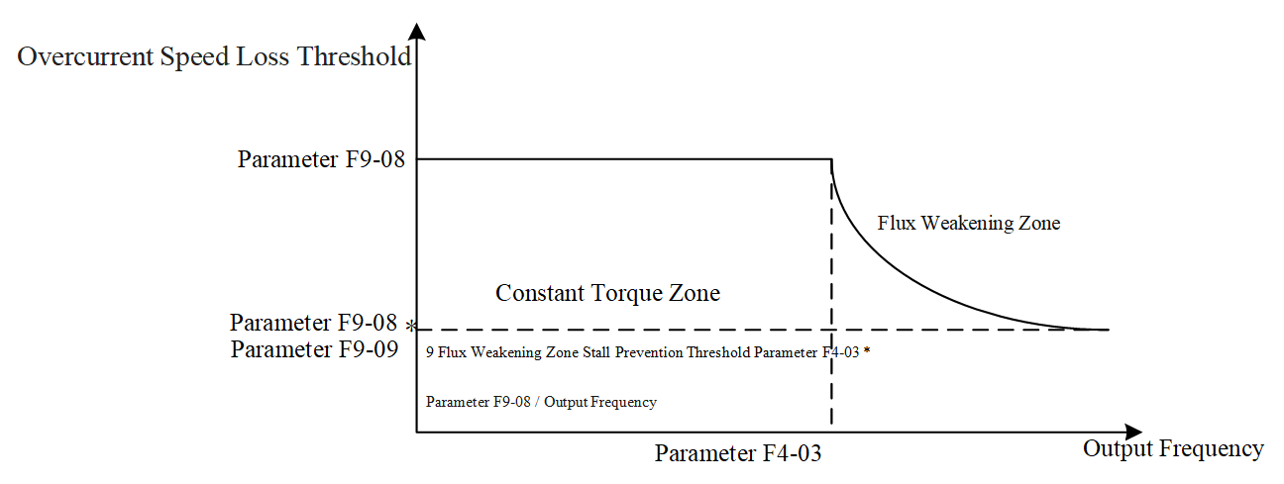
Figure 9-24 Acceleration Overcurrent Flux Loss Prevention Threshold During Field Weakening
Note that when the acceleration overcurrent flux loss prevention function activates, the inverter's acceleration time will be longer than the set time.
F9-10 | Overcurrent Flux Loss Prevention Threshold During Constant Speed | Range: 0～200% | Factory Value: 150%
F9-11 | Overcurrent Acceleration/Deceleration Selection During Constant Speed | Range: 0～5 | Factory setting: 0
The above two function codes are used to set the overcurrent flux loss prevention function during operation. Generally, the larger the motor load, the greater the motor current. If the motor load is too high, it can lead to excessive motor current. If the motor load exceeds the motor's capacity, it may even result in loss of control. The stall overcurrent prevention function during operation can prevent the aforementioned situations of excessive current or loss of control. The principle of the stall overcurrent prevention function during operation is shown in Figure 9-25. When the motor current exceeds the set value, the inverter begins to decelerate until the current drops below the allowable value, at which point the motor reaccelerates to the set frequency.

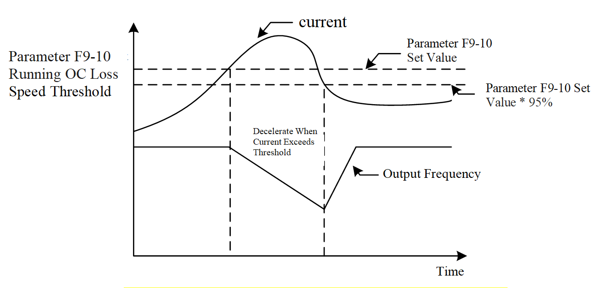
Figure 9-25 Stall Overcurrent Prevention Function During Operation
F9-10 Constant Speed Stall Overcurrent Threshold
This function code is used to set the stall overcurrent prevention threshold during operation, with units in %, based on the inverter's rated current. When the inverter is running, if the output current exceeds the F9-10 set value, the inverter will decelerate according to the acceleration/deceleration time selected by F9-11 to prevent motor stall. When the output current is below 95% of the set value in F9-10, the inverter will re-accelerate to the set frequency according to the acceleration/deceleration time selected in parameter F9-11.
F9-11 Constant Speed Overcurrent Stall Acceleration/Deceleration Selection
This function code is used for overcurrent acceleration/deceleration selection during constant speed operation.
0: System Acceleration/Deceleration Time
1: First acceleration/deceleration time (F0-13F0-14)
2: Second acceleration/deceleration time (F7-03F7-04)
3: Third acceleration/deceleration time (F7-05F7-06)
4: Fourth acceleration/deceleration time (F7-07F7-08)
5: Automatic Acceleration and Deceleration Time
F9-12 | Input Phase Loss Action Selection | Range: 0～1 | Factory setting: 0
F9-13 | Input Phase Loss Filter Time | Range: 0.00～600.00 seconds | Factory Setting: 0.20 seconds
F9-14 | Input Phase Loss Voltage Threshold | Range: 0.0～320.0V | Factory setting: 60.0V/30.0V
If the power supply is not correctly connected to the inverter or if there is an abnormality in the power supply, an input phase loss fault may occur. When an input phase loss occurs, the inverter bus voltage may fluctuate significantly, causing fluctuations in motor torque or speed, and also affecting the lifespan of the bus capacitor. The input phase loss detection function can detect whether an input phase loss fault has occurred and promptly take protective measures.
F9-12 Input Phase Loss Action Selection
This function code is used to set the inverter action when an input phase loss occurs.
0: Alarm and Decelerate to Stop
1: Alarm and Free Stop
F9-13 Input Phase Loss Filter Time
This function code is used to set the low-pass filter time required for phase loss detection, which generally does not need to be modified.
Note: The machine is equipped with a 4-digit LED panel, which automatically adjusts the decimal place according to the current value and decimal position to facilitate 4-digit LED display.
F9-14 Input Phase Loss Voltage Threshold
This function code is used to set the voltage threshold required for phase loss detection, which generally does not need to be modified.
F9-15 | Output Phase Loss Action Selection | Range: 0～3 | Factory setting: 3
F9-16 | Output Phase Loss Detection Time | Range: 0.000 to 65.535 seconds | Factory Value: 0.100 seconds
F9-17 | Output Phase Loss Current Threshold | Range: 0.00 to 100.00% | Factory Value: 7.00%
F9-18 | Output Phase Loss Braking Time | Range: 0.000 to 65.535 seconds | Factory Value: 0.000 seconds
When there is an abnormal connection between the motor and the inverter, output phase loss may occur. During output phase loss, the current in the disconnected phase of the motor is zero. To maintain operation, the current in the remaining phases generally increases, and the speed and torque will also experience significant fluctuations, which can potentially damage the motor and inverter. Output phase loss detection can identify phase loss conditions in the motor and take appropriate actions.
F9-15 Output Phase Loss Action Selection
This function code is used to set the inverter's action during output phase loss.
0: Warning and Continue Running
1: Warning and Decelerate to Stop
2: Warning and Free Stop
3: No Warning
F9-16 Output Phase Loss Detection Time
This function code is used to set the output phase loss detection time during operation, generally no modification is required.
F9-17 Output Phase Loss Current Threshold
This function code is used to set the output phase loss current detection threshold, generally no modification is required.
F9-18 Output Phase Loss Braking Time
This function code is used for output phase loss judgment at startup. If the set value is not zero, the output phase loss judgment will be performed at startup.
The following introduces four scenarios.
Example 1: F9-18=0, no pre-operation output phase loss detection. As shown in Figure 9-26, during the operation of the inverter, if any phase output current is less than the threshold set by F9-17 and exceeds the time set by F9-16, the inverter will begin to execute the action set by F9-15.
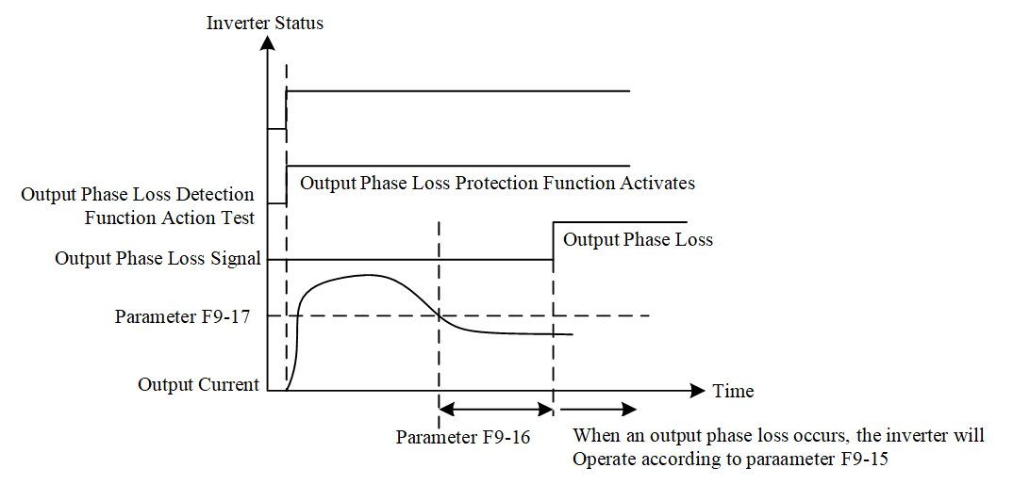
Figure 9-26 F9-18=0
Example 2: The inverter is in a stopped state, F9-18=0 and F1-09≠0. As shown in Figure 9-27, when starting, the inverter begins DC braking according to the settings of F1-08 and F1-09; during this period, output phase loss detection is not performed. After DC braking is completed, the inverter starts running and performs output phase loss detection as described in Case 1.
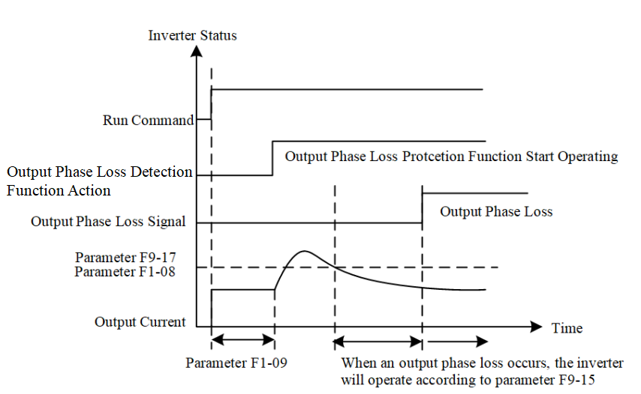
Figure 9-27 F9-18=0 and F1-09≠0
Example 3: The inverter is in a stopped state, F9-18≠0 and F1-09≠0. When starting, it first performs DC braking according to the time set by F9-18, then performs DC braking according to the time set by F1-09. During the time set by F9-18, the DC braking current is 20 times the value set by F9-57; During the time set by F1-09, the DC braking current is the value set by F1-08. Total DC braking time = Value set by F9-18 + Value set by F1-09.
Example 9-1: F9-18 ≠ 0 and F1-09 ≠ 0 (no output phase loss detected at startup), as shown in Figure 9-28.
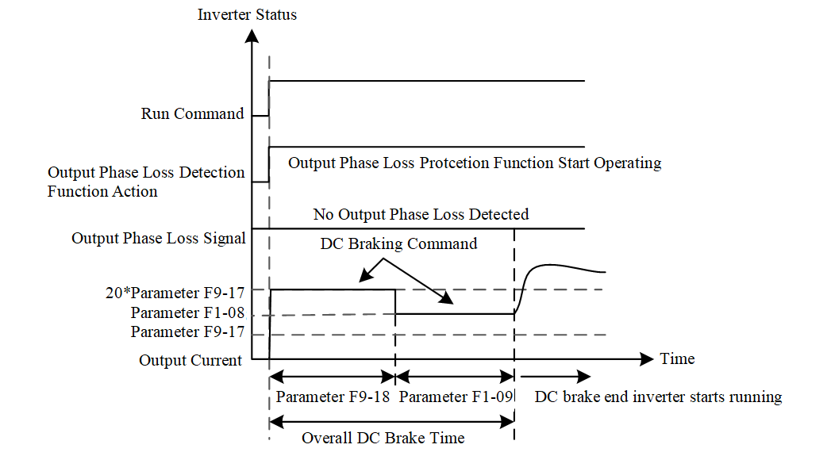
Figure 9-28 F9-18 ≠ 0 and F1-09 ≠ 0 (no output phase loss detected at startup)
Example 9-2: F9-18 ≠ 0 and F1-09 ≠ 0, output phase loss detected at startup. As shown in Figure 9-29, if an output phase loss occurs within the time set by F9-18, the inverter will begin to execute the action set by F9-15 after half of the time set by F9-18 has elapsed.
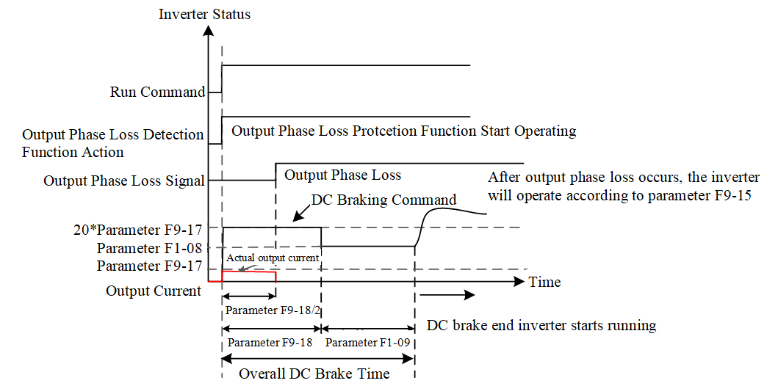
Figure 9-29 F9-18≠0 and F1-09≠0, (output phase loss detected at startup)
Example 4: The inverter is in a stopped state, F9-18≠0 and F1-09=0, during startup, DC braking is performed according to the time set by parameter F9-18, with the DC braking current being 20 times the value set by F9-57.
Example 4-1: F9-18≠0 and F1-09=0 (no output phase loss detected at startup), as shown in Figure 9-30.
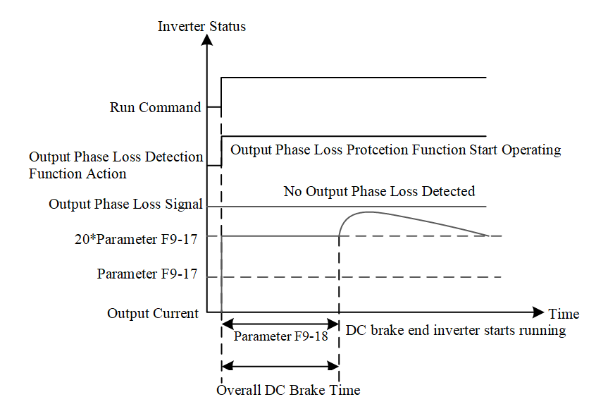
Figure 9-30 F9-18≠0 and F1-09=0 (No output phase loss detected at startup)
Example 4-2: F9-18≠0 and F1-09=0, output phase loss detected at startup. As shown in Figure 9-31, if an output phase loss occurs within the time set by F9-18, after half of the time set by F9-18 has passed, the inverter begins to execute the action set by F9-15.
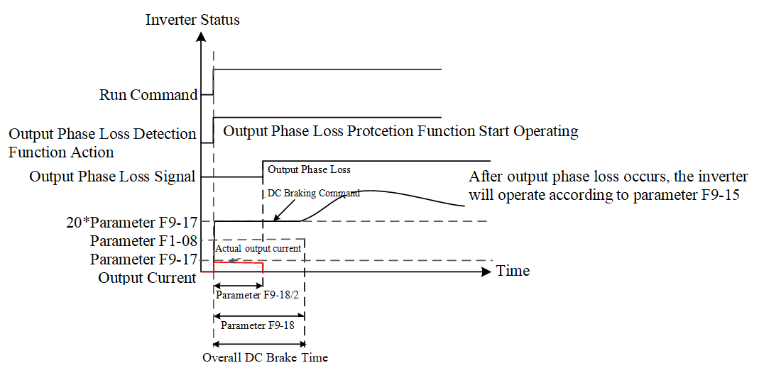
Figure 9-31 F9-18≠0 and F1-09=0 (Output phase loss detected at startup)
Note: The machine is equipped with a 4-digit LED panel, and F9-16---F9-18 will automatically adjust the decimal places based on the current value and decimal point to facilitate display on the 4-digit LED.
No Output Phase Loss Detected
F9-22 | Low Current Setting Threshold | Range: 0.0～100.0% | Factory Value: 0.0%
F9-23 | Low Current Detection Time | Range: 0.00～360.00 seconds | Factory setting: 0.00 seconds
F9-24 | Low Current Action Method | Range: 0～3 | Factory setting: 0
Low current protection is designed to prevent the inverter or motor from operating at low current levels for extended periods. A current lower than normal values generally will not damage the inverter or motor, but it may cause system abnormalities due to the motor's inability to deliver the desired torque.
F9-22 Low Current Set Threshold
F9-23 Low Current Detection Time
The above two function codes are used to set the low current detection conditions. F9-22 Low Current Set Threshold is expressed as a percentage, based on the inverter's rated current. When the inverter output current is less than the F9-22 set value and persists for longer than the time set by F9-23, a low current fault is detected, and the inverter will take subsequent actions according to the F9-24 Low Current Action Mode.
F9-24 Low Current Operation Mode
0: No Function
Low current protection function is off, low current setting threshold (F9-22) and low current detection time (F9-23) are both invalid.
1: Fault and Free Stop
When the low current protection condition is met, report a low current fault and stop freely.
2: Fault and Second Deceleration Stop
When the low current protection condition is met, report a low current fault and decelerate to stop according to the second deceleration time.
3: Alarm and Continue Running
When the low current protection condition is met, issue a low current warning but do not stop.
F9-25 | Excessive Slip Detection Value | Range: 0.0～100.0% | Factory Value: 0.0%
F9-26 | Excessive Slip Detection Time | Range: 0.0～10.0 seconds | Factory value: 1.0 seconds
F9-27 | Excessive Slip Action Selection | Range: 0～3 | Factory setting: 0
Slip is the difference between the synchronous speed of an induction motor and its actual speed; generally speaking, the greater the load torque, the greater the slip. If excessive slip occurs, it may be due to an overload or other abnormal conditions, so timely action should be taken.
F9-25 Excessive Slip Detection Value
F9-26 Excessive Slip Detection Time
The above two function codes are used to set the conditions for detecting excessive slip. F9-25 Excessive Slip Detection Value is in units of %, based on the rated slip of the motor. When the actual slip of the induction motor exceeds the set value of F9-25 and persists for longer than the time set by F9-26, an over-slip fault is considered to have occurred, and the inverter will take subsequent actions according to the setting of F9-27 Excessive Slip Action Selection.
F9-27 Slip Exceedance Action Selection
0: Warning and Continue Running
When the slip exceedance detection conditions are met, issue a slip exceedance warning without stopping the machine.
1: Fault and Decelerate to Stop
When the slip exceedance detection conditions are met, report a slip exceedance fault, decelerate, and stop the machine.
2: Fault and Free Stop
When the slip exceedance detection conditions are met, report a slip exceedance fault and free stop the machine.
3: No Warning
Do not perform slip exceedance fault detection.
F9-36 | Over Torque Selection 1 | Range: 0～4 | Factory setting: 0
F9-37 | Over Torque Threshold 1 | Range: 10～250% | Factory Value: 120%
F9-38 | Over-torque time 1 | Range: 0.1～60.0 seconds | Factory Value: 0.1 second
The above function codes are used to set up the over-torque detection function. The inverter issues a warning or shuts down when it detects excessive torque, protecting the motor and the inverter.
F9-36 Over Torque Selection 1
0: No Detection
1: Constant Speed Detection Continue Running
During constant speed operation, if the motor experiences over-torque, a warning is issued but operation continues.
2: Constant Speed Detection Stop Running
During constant speed operation, if the motor experiences over-torque, an over-torque fault is reported and operation stops.
3: Running Detection Continue Running
During operation, if the motor experiences over-torque, a warning is issued but operation continues.
4: Running Detection Stop Running
During operation, if the motor experiences over-torque, an over-torque fault is reported and operation stops.
F9-37 Over Torque Threshold 1
F9-38 Over Torque Time 1
When the inverter output current exceeds F9-37 (unit %, based on the rated current of the inverter) and persists for more than the time set by F9-38, the inverter will determine subsequent actions according to F9-36. As shown in Figure 9-32, when F9-36 is 1 or 3, if over-torque is detected, the inverter will display an over-torque warning but will continue to operate until the output current drops below 95% of the F9-37 set value, after which the warning will be cleared. As shown in Figure 9-33, when F9-36 is 2 or 4, if over-torque is detected, the inverter will report an over-torque fault and stop running until the fault is reset, allowing it to resume operation.
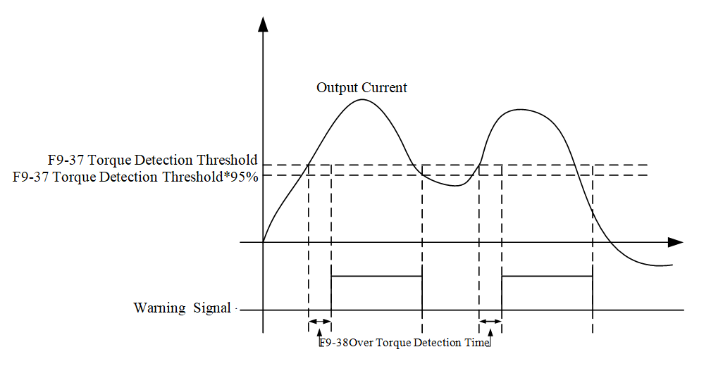
Figure 9-32 Over Torque Detection Schematic 1
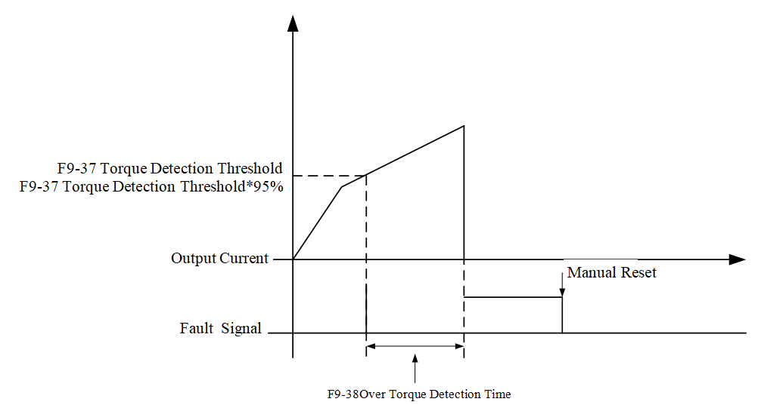
Figure 9-33 Over Torque Detection Schematic 2
F9-46 | Abnormal start count | Range: 0～10 | Factory setting: 0
F9-47 | Abnormal restart reset time | Range: 0.0～6000.0 seconds | Factory Value: 60.0
When an abnormality (overcurrent and overvoltage) occurs, the inverter will generally stop running until the fault is reset and a run command is received, after which it will restart. The automatic restart function can automatically clear faults after they occur and control the inverter to restart, achieving continuous motor operation. After a fault occurs, if the number of automatic restart attempts is not zero, the inverter fault will be cleared, and speed search will be performed, followed by controlling the motor to run to the set frequency. If the number of retries after an anomaly is zero, the fault will not be cleared, and the inverter will remain in a shutdown state.
F9-46 Retry Count After Anomaly
This function code is used to set the number of automatic retries after an anomaly. If set to zero, the inverter will not automatically restart after an anomaly. When automatically restarting after an anomaly, the inverter will start according to the settings in F1-02. If the number of anomalies exceeds the value set in F9-46, the fault will not automatically reset. It must be manually reset and a new run command received before operation can continue.
F9-47 Reset Time After Retry
After a retry following an anomaly, if no further anomalies occur within the time set by this function code, the retry count for F9-46 will be reset to its set value.
Note: The machine is equipped with a 4-digit LED panel. F9-47 will automatically adjust the decimal places based on the current value and the number of decimal places to facilitate display on the 4-digit LED.
F9-48 | PTC action selection | Range: 0～3 | Factory setting: 0
F9-49 | PTC Threshold | Range: 0.0～100.0% | Factory setting: 50.0%
F9-50 | PT Detection Threshold 1 | Range: 0.000～10.000V | Factory setting: 5.000V
F9-51 | PT Detection Threshold 2 | Range: 0.000～10.000V | Factory setting: 7.000V
F9-52 | PT Voltage 1 Protection Frequency | Range: 0.00～599.00Hz | Factory setting: 0.00Hz
F9-53 | PT Operation Delay Time | Range: 0～6000 seconds | Factory setting: 60 seconds
By obtaining the motor temperature through a sensor, the motor can be protected based on its temperature. When the motor temperature exceeds a certain value, the motor operation will stop to prevent overheating damage. Thermistors are typically used to measure motor temperature, with common types being PTC resistors and PT100 resistors.
F9-48 PTC Action Selection
This function code is used to set the inverter action when PTC overheating occurs.
0: Warning and continue running
When motor overheating is detected, a motor overheat warning is issued, and the inverter continues to operate.
1: Fault and Decelerate to Stop
When motor overheating is detected, a motor overheat fault is issued, and the inverter decelerates and stops.
2: Fault and Free Stop
When motor overheating is detected, a motor overheat fault is issued, and the inverter performs a free stop.
3: No Warning
No PTC detection is performed.
F9-49 PTC Threshold
This function code is used to set the PTC overheating detection threshold, with the unit being %, and the reference value being the maximum analog input value. When using the PTC overheating detection function, the corresponding analog input terminal must be set to voltage signal input, and the function of this analog input terminal is “Thermistor PTC Input.”When the feedback voltage reaches the set value of F9-49, the inverter will operate according to the method set in F9-48.
F9-50 PT Detection Threshold 1
F9-51 PT Detection Threshold 2
The above two function codes are used to set the PT100 over-temperature detection threshold.
F9-52 PT Protection Frequency
F9-53 PT Action Delay Time
The above two function codes are used to set the inverter's action after detecting PT100 over-temperature. When using the PT100 over-temperature detection function, the corresponding analog input terminal must be set to voltage signal input. The function of this analog input terminal is “PT100 Value”. When the feedback voltage is less than the set value of F9-50, the motor operates normally; When the feedback voltage is between the set values of F9-50 and F9-51, the inverter will run to the frequency set by F9-52 after the time set by F9-52. When the feedback voltage exceeds the set value of F9-51, the inverter will operate according to the method set by F9-48.
Note: The machine comes with a 4-digit LED panel. F9-50---F9-52 will automatically adjust the decimal places based on the current value and decimal position to facilitate display on the 4-digit LED.
F9-57 | DC braking output phase loss threshold 2 | Range: 0.00%～100.00% | Factory setting: 2.00%
This function code is used to set the current threshold for output phase loss detection during startup. For details, refer to F9-15 to F9-18.
Note: The machine is equipped with a 4-digit LED panel, which automatically adjusts the decimal place according to the current value and decimal position to facilitate 4-digit LED display.
F9-58 | Overvoltage Stall Recovery Threshold | Range: 0.0V～900.0V | Factory Value: 630.0V/315V
This function code is used to set the overvoltage stall prevention recovery threshold, please refer to F9-03 for details. When this parameter is for 220V models, the internal system will add 40V as the overvoltage stall recovery threshold.
For 380V models, overvoltage stall threshold = F9-58
For 220V models, overvoltage stall threshold = F9-58 + 40V
  - FA Group PID Function
The PID principle block diagram is shown in Figure 9-34:

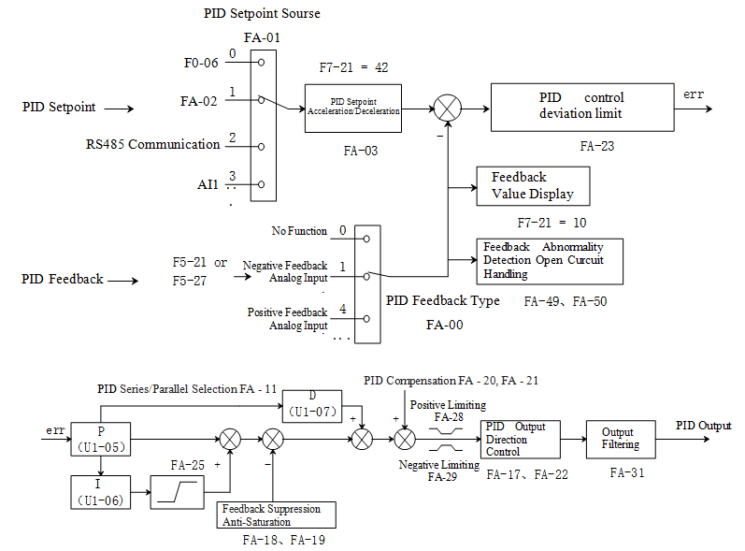
Figure 9-34 PID Principle Block Diagram
FA-00 | PID Feedback Type Selection | Range: 0～8 | Factory setting: 0
0: No Function
1: Negative Feedback Analog Input
2: Reserved
3: Reserved
4: Positive Feedback Analog Input
5: Reserved
6: Reserved
7: Negative Feedback Communication Input (Parameter Address U1-04)
8: Positive Feedback Communication Input (Parameter Address U1-04)
Positive Feedback: If the feedback value is less than the PID setpoint, the inverter output frequency increases.
Negative Feedback: If the feedback value is less than the PID setpoint, the inverter output frequency decreases.
To set an analog signal as the feedback input, you need to configure the related functions of F5-21, setting it to PID feedback signal (=5).
FA-01 | PID Setpoint Source Selection | Range: 0～4 | Factory setting: 0
0: Frequency Command
1: Parameter FA-02
2: RS485 Communication
3: Analog Input
4: CANopen (Supported on Extended Models)
This parameter selects the channel for the PID target value.
FA-02 | PID Setpoint Value | Range: -100.00% to 100.00% | Factory Value: 50.00%
When FA-01 (PID Setpoint Source) is set to 1, this parameter must be configured. This parameter is a relative value, where 100% corresponds to the maximum feedback value of the controlled system.
Note: The machine is equipped with a 4-digit LED panel, which automatically adjusts the decimal place according to the current value and decimal position to facilitate 4-digit LED display.
FA-03 | PID Setpoint Change Time | Range: 0.00s to 655.35s | Factory Value: 0.00
The time required for the PID setpoint (parameter FA-02) to change from 0.0% to 100.0%. When the PID setpoint changes, the actual setpoint does not respond immediately but changes linearly over the given time to prevent sudden changes in the setpoint.
Note: The machine is equipped with a 4-digit LED panel, which automatically adjusts the decimal place according to the current value and decimal position to facilitate 4-digit LED display.
FA-04 | PID Feedback Filter Time | Range: 0.1s～300.0s | Factory Value: 5.0
Filter the PID feedback value; this parameter helps reduce the impact of disturbances on the feedback but may degrade the response performance of the closed-loop control process.
FA-05 | Proportional Coefficient 1 | Range: 0.00～99.99 | Factory Value: 8.00
The speed at which the deviation decreases depends on the proportional coefficient; the larger the proportional coefficient, the faster the deviation decreases. However, an excessively large proportional coefficient can cause significant overshoot and oscillation, reducing stability, especially in systems with large lag. Reducing the proportional coefficient decreases the possibility of system oscillation but slows down the response speed. When executing 2ms enhanced PID control (parameter FA-12=0), the number of decimal places for this parameter can be selected by parameter FA-53 bit 1, 0: 1 decimal place, 1: 2 decimal places.
FA-06 | Integral Time 1 | Range: 0.00s～99.99s | Factory Value: 0.15
This parameter determines the strength of the integral action of the PID controller. The smaller the integral time, the stronger the integral action, which helps reduce overshoot, decrease oscillation, and make the system more stable, but the elimination of static error in the system will become slower.
FA-07 | Differential Time 1 | Range: 0.00s～1.00s | Factory Value: 0.00
This parameter determines the strength of the PID controller's response to the rate of change of the error. The longer the differential time, the stronger the adjustment. When this parameter is set appropriately, it can reduce overshoot and shorten the adjustment time. Differential action amplifies noise interference; therefore, excessive differential control is detrimental to the system's ability to resist interference. Additionally, when there is no change in the input, the output of the differential action is zero. Therefore, differential control is often combined with the other two control laws to form a PD controller or a PID controller.
FA-08 | Proportional Coefficient 2 | Range: 0.00～99.99 | Factory Value: 8.00
Same as parameter FA-05, no further details here
FA-09 | Integral Time 2 | Range: 0.00s～99.99s | Factory Value: 0.15
Same as parameter FA-06, no further details here
FA-10 | Differential Time 2 | Range: 0.00s～1.00s | Factory Value: 0.00
Same as parameter FA-07, no further details here
FA-11 | PID Series/Parallel Selection | Range: 0～1 | Factory setting: 1
0: Series, traditional PID control architecture
1: Parallel, which means separating proportional control, integral control, and derivative control, allowing users to adjust P, I, D controllers separately according to application needs; parallel-type PID is selected by default.
The block diagram of PID series control is shown in Figure 9-35:
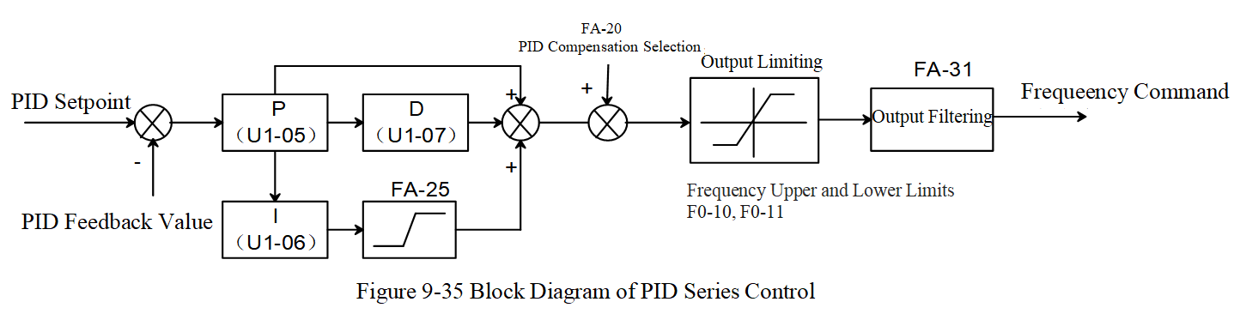
Figure 9-35 Block Diagram of PID Series Control
The block diagram of PID parallel control is shown in Figure 9-36:
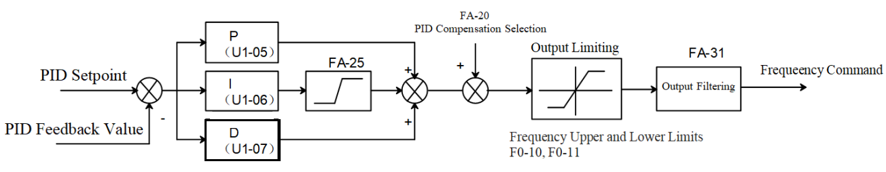
Figure 9-36 Block Diagram of PID Parallel Control
FA-12 | PID Control Execution Cycle | Range: 0～1 | Factory setting: 0
0: Perform 2ms enhanced PID control
1: Perform 1ms traditional PID control
FA-12=0, the user selects to execute process PID control once every 2ms cycle, the PID output frequency reference base can be set according to parameter FA-30, choosing either 100.00% corresponding to the maximum output frequency or 100.00% corresponding to the auxiliary frequency. For example, if the user enables the main and auxiliary frequency function (assuming the selection of main frequency + auxiliary frequency, parameter F0-07=1, F0-08=0), and sets the PID output frequency reference to the auxiliary frequency (FA-30=1), and the keyboard sets the auxiliary frequency to 40Hz, then the maximum PID output frequency will be 40Hz.
When FA-12=1, the user selects a 1ms cycle to execute process PID control once, where 100.00% PID output corresponds to the maximum output frequency, and there is no auxiliary frequency option for the reference benchmark.
Additionally, the enhanced PID option (FA-12=0) supports soft start and automatic switching of two sets of PID parameters based on output frequency or deviation, while the traditional PID option (FA-12=1) does not have these functions.
In some application scenarios, one set of PID parameters cannot meet the requirements of the entire operation process. In such cases, parameter FA-13 can be used to activate the switching between two sets of PID parameters, with related parameters being FA-13 to FA-15.
FA-13 | PID Parameter Switching Conditions | Range: 0～2 | Factory setting: 0
0: Use the first set of PID parameters FA-05~FA-07
1: Automatically adjust based on output frequency. Use the first set of PID parameters FA-05~FA-07 when operating at or below the minimum frequency F2-04, use the second set of PID parameters FA-08~FA-10 when operating at the maximum frequency F4-02, and use a linear interpolation value of the two sets of PID parameters when the operating frequency is between F2-04 and F4-02.
2: Automatically switch based on the deviation between setpoint and feedback. Use the first set of PID parameters FA-05~FA-07 when the absolute value of the deviation between setpoint and feedback is less than PID parameter switching deviation 1 (parameter FA-14). Use the second set of PID parameters FA-08~FA-10 when the absolute value of the deviation between setpoint and feedback is greater than PID parameter switching deviation 2 (parameter FA-15). When the absolute value of the given and feedback deviation varies between FA-14 and FA-15, the PID parameters are the linear interpolation values of two sets of PID parameters.
When FA-13=1, the PI parameter adjustment diagram is shown in Figure 9-37:
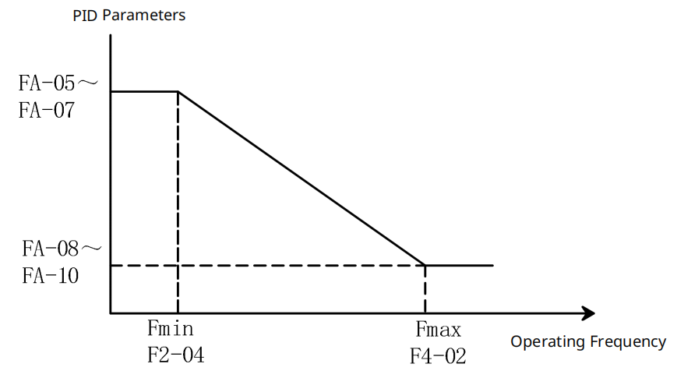
Figure 9-37 PI Parameter Adjustment Diagram
When FA-13=2, the PI parameter adjustment diagram is shown in Figure 9-38:
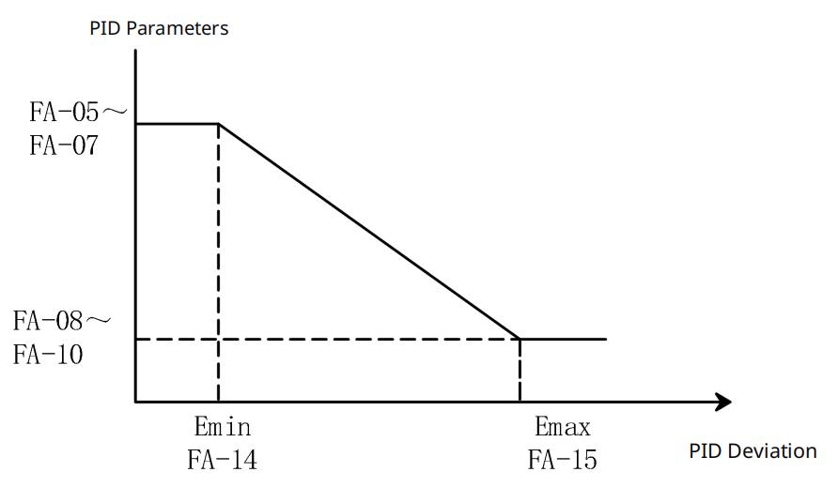
Figure 9-38 PI Parameter Adjustment Diagram
FA-14 | PID Parameter Switching Error 1 | Range: 0.00%～100.00% | Factory Value: 10.00
FA-15 | PID Parameter Switching Error 2 | Range: 0.00%～100.00% | Factory Value: 40.00
FA-16 | Allow PID Reverse Delay | Range: 0.0s～999.9s | Factory Value: 0.0
When parameter FA-16≠0, the reverse function after startup is enabled. For example, setting FA-16=2.0 means that during the start-up period of 0 to 2 seconds, PID control is not allowed to change the direction of operation (parameter FA-17=0), and after 2 seconds of start-up, PID control is automatically allowed to change the direction of operation (parameter FA-17 will be automatically updated to 1).
Note: The machine is equipped with a 4-digit LED panel, which automatically adjusts the decimal place according to the current value and decimal position to facilitate 4-digit LED display.
FA-17 | PID Direction Change Selection | Range: 0～1 | Factory setting: 0
0: Cannot Change Running Direction
1: Can Change Running Direction
FA-18 | Feedback Suppression Deviation Rate | Range: 0%～100% | Factory Value: 10%
Parameters FA-18 and FA-19 are only valid when performing 2ms enhanced PID control (Parameter FA-12 = 0).
FA-19 | Feedback Suppression Gain | Range: 0～1000 | Factory Value: 800
When the setpoint and feedback deviation are in opposite directions, parameters FA-18 and FA-19 provide feedback suppression anti-integral windup functionality to quickly exit the saturation state and respond rapidly to external inputs, avoiding prolonged controller output saturation and improving the controller's response capability. The controller performs anti-integral windup suppression based on the relationship between the feedback suppression deviation rate (Parameter FA-18) and the 100ms deviation rate.
FA-20 | PID Compensation Selection | Range: 0～1 | Factory setting: 0
0: Parameter Setting
1: Analog Input
When FA-20=0, the PID compensation value (parameter FA-21) must be set.
FA-21 | PID Compensation Value | Range: -99.9%～99.9% | Factory Value: 0.0
The reference for this parameter is the maximum output frequency F4-02. Example: If the maximum output frequency parameter F4-02=50.00Hz, and FA-21 is 10.0%, the PID compensation will increase the output frequency by 5.00Hz.
FA-22 | PID Deviation Deadband Limit | Range: 0.00%～99.99% | Factory Value: 0.06
When the PID control output exceeds FA-22, the PID regulation output becomes effective; otherwise, the PID regulator is inhibited, preventing the actuator from oscillating when the PID output is small.
FA-23 | PID Control Deviation Limit | Range: 0.00%～99.99% | Factory Value: 0.00
This parameter determines the level at which the deviation between the feedback and setpoint signals causes the PID regulation to stop, maintaining the previous output value. PID regulation output is only executed when the deviation between the feedback value and the setpoint exceeds the PID control deviation limit FA-23. Properly setting this parameter can adjust the accuracy and stability of the PID system, as shown in Figure 9-39.
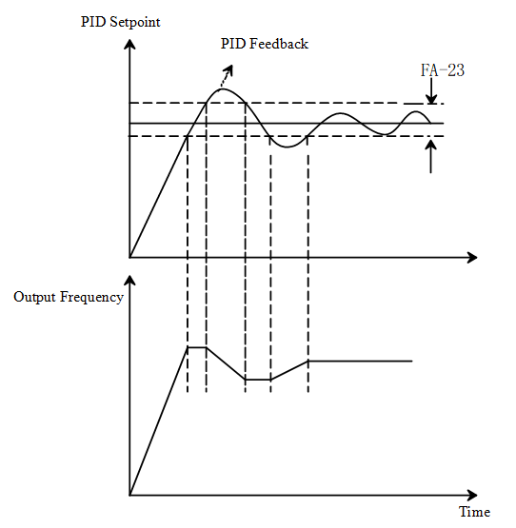
Figure 9-39 Schematic Diagram of PID Control Deviation Limit
FA-24 | Integral Separation Level | Range: 0.00%～99.99% | Factory Value: 0.00
When the PID feedback overshoot is large at startup, integral separation can be enabled to reduce overshoot, with the parameter benchmark being the PID deviation.
When FA-24≠0, the integral separation function is activated, and it only operates once at startup. When the deviation between the setpoint and the feedback value exceeds the parameter FA-24, integral separation occurs to prevent excessive overshoot due to integral action; When the deviation is less than parameter FA-24, the integral action takes effect to eliminate steady-state error.
FA-25 | Integral Upper Limit | Range: 0.00%～100.00% | Factory value: 100.0
This parameter is the upper limit of integration, with the reference being the maximum output frequency F4-02. When the integral value is too large, if the load suddenly changes, the inverter's response speed slows down, which may cause motor slippage or mechanical damage; at this time, the parameter FA-25 can be appropriately reduced.
Note: The machine is equipped with a 4-digit LED panel, which automatically adjusts the decimal place according to the current value and decimal position to facilitate 4-digit LED display.
FA-26 | Wake-up Integration Limit | Range: 0.0%～200.0% | Factory value: 50.0
This parameter is the upper limit of wake-up integration, used to reduce the reaction time from sleep to wake-up, with the reference being the maximum output frequency F4-02.
FA-27 | Main Auxiliary Reverse Cut-off Frequency | Range: 0.0%～100.0% | Factory Value: 10.0
In some cases, only when the PID output frequency is negative (i.e., the inverter is running in reverse), can the PID possibly bring the setpoint and feedback to the same state; however, excessive reverse frequency is not allowed in certain situations. Parameter FA-27 is used to determine the upper limit of the reverse frequency. The reference base for this parameter is the maximum output frequency F4-02.
Note: The machine is equipped with a 4-digit LED panel, which automatically adjusts the decimal place according to the current value and decimal position to facilitate 4-digit LED display.
FA-28 | PID Output Positive Limit | Range: 0.00%～100.00% | Factory value: 100.0
This parameter is the upper limit value of the PID control output command, with the reference base being the maximum output frequency F4-02.
FA-29 | PID Output Negative Limit | Range: 0.00%～100.00% | Factory value: 100.0
When PID output reversal is allowed, the PID output will be negative, at which point the output will be limited to the value set by parameter FA-29, and it should be used in conjunction with parameter FA-17.
FA-30 | PID Output Frequency Reference | Range: 0～1 | Factory setting: 0
0: PID control output 100.00% corresponds to maximum output frequency F4-02
1: PID control output 100.00% corresponds to auxiliary frequency (if the auxiliary frequency command changes, the PID output frequency will also change)
This parameter is only valid when the main and auxiliary frequency function is enabled.
FA-31 | PID Output Filter Time | Range: 0.0s～2.5s | Factory Value: 0.0
This parameter is used to set the low-pass filter time for PID control output; the larger the parameter value, the greater the PID output filtering, and the slower the change in output frequency. Improper setting of parameter FA-31 may affect the response speed of the inverter and even cause system oscillation.
FA-32 | Soft Start-PID Switching Value | Range: 0.00%～99.99% | Factory value: 5.00
This parameter is based on the deviation between the PID setpoint and feedback values.
FA-33 | Soft Start Frequency | Range: 0.00Hz～599.00Hz | Factory Value: 0.00
When parameter FA-33 ≠ 0, the soft start function is enabled.
Note: The machine is equipped with a 4-digit LED panel, which automatically adjusts the decimal place according to the current value and decimal position to facilitate 4-digit LED display.
FA-34 | Soft Start Acceleration Time | Range: 0.00s～600.00s | Factory Value: 3.00
Time to Accelerate from Start to Soft Start Frequency FA-33
Note: The machine is equipped with a 4-digit LED panel, which automatically adjusts the decimal place according to the current value and decimal position to facilitate 4-digit LED display.
FA-35 | No-load Current | Range: 0.00A～655.35A | Factory Value: 0.00A
When parameter FA-35 ≠ 0 and the inverter output current exceeds FA-35, it starts at the soft start frequency (parameter FA-33) and the soft start acceleration step (parameter FA-36), until the soft start acceleration time (parameter FA-34) is reached, then normal PID control begins.
Note: The machine is equipped with a 4-digit LED panel, which automatically adjusts the decimal place according to the current value and decimal position to facilitate 4-digit LED display.
FA-36 | Soft Start Acceleration Step | Range: 0.00s～600.00s | Factory Value: 0.10
PID Soft Start is shown in Figure 9-40. When the startup PID feedback overshoot is significant, soft start can be used to reduce the feedback overshoot. The soft start function only activates once during startup. When soft start is enabled, it will first start according to the soft start frequency FA-33 and acceleration time FA-34. When the PID deviation is less than parameter FA-32, it switches back to normal PID control (when switching from soft start to PID control, the soft start frequency is used as the PID integral value to avoid discontinuity in frequency).
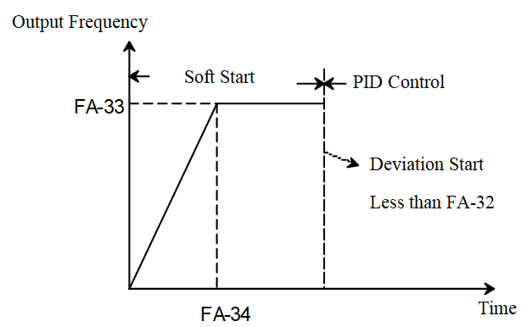
Figure 9-40 Schematic Diagram of PID Soft Start
PID Abnormality Detection
Parameters related to PID abnormality detection processing are FA-49~FB-53. When the AIx signal type parameters F5-20, F5-26, or F5-32 = 2 (i.e., selecting 4~20mA analog input), the settings for parameters FA-49 and FA-50 are valid.
Note: The machine is equipped with a 4-digit LED panel, which automatically adjusts the decimal place according to the current value and decimal position to facilitate 4-digit LED display.
FA-49 | Feedback Abnormality Detection Time | Range: 0.0s～999.9s | Factory Value: 0.0
This parameter is used to detect possible abnormalities or extremely slow responses in the feedback analog quantity; FA-49 = 0 means no detection. When the analog signal sample value is below the 4~20mA open circuit threshold (parameter F5-43) and the duration exceeds FA-49, the feedback analog signal is abnormal, and the inverter performs abnormal action handling according to the setting of parameter FA-50, with the operation panel displaying an “AFE” prompt.
FA-50 | Feedback Disconnection Action Selection | Range: 0～3 | Factory setting: 0
0: Warning and Continue Running
1: Fault and Decelerate to Stop
2: Fault and Free Stop
3: Warning and running at the frequency before the open circuit
FA-51 | PID Feedback Abnormal Deviation | Range: 1.0%～50.0% | Factory Value: 10.0
When the deviation between the setpoint and feedback signal exceeds the threshold (parameter FA-51) and the duration exceeds the deviation abnormality detection time FA-52, a PID deviation abnormality occurs. If the function selection of output terminals F6-00~F6-03 is 15, the output terminal will indicate a PID deviation warning.
FA-52 | Abnormal Deviation Detection Time | Range: 0.1s～300.0s | Factory Value: 5.0
FA-53 | PID Control Flag | Range: 0000H～FFFFH | Factory Value: 2
PID control flag (bits 0~2 valid)
bit0: PID reverse action selection, 0: PID reverse according to PID calculation value, 1: reverse according to parameter F0-09;
bit1: PID parameter Kp decimal point position selection, 0: 1 decimal place, 1: 2 decimal places;
bit2: 0: no function, 1: when the main and auxiliary frequency function is enabled, the integral upper limit base value is the auxiliary frequency.
  - FD group multi-speed and simple PLC functions
This inverter can set 16 speed segments, specific configurations can refer to the relevant descriptions of F5-00 to F5-07.
FD-00 | Multi-Speed 0 | -100.00%～100.00% | 0.00%
FD-01 | Multi-Speed 1 | -100.00%～100.00% | 0.00%
FD-02 | Multi-Speed 2 | -100.00%～100.00% | 0.00%
FD-03 | Multi-Speed 3 | -100.00%～100.00% | 0.00%
FD-04 | Multi-Speed 4 | -100.00%～100.00% | 0.00%
FD-05 | Multi-Speed 5 | -100.00%～100.00% | 0.00%
FD-06 | Multi-Speed 6 | -100.00%～100.00% | 0.00%
FD-07 | Multi-Speed 7 | -100.00%～100.00% | 0.00%
FD-08 | Multi-Speed 8 | -100.00%～100.00% | 0.00%
FD-09 | Multi-Speed 9 | -100.00%～100.00% | 0.00%
FD-10 | Multi-Speed 10 | -100.00%～100.00% | 0.00%
FD-11 | Multi-Speed 11 | -100.00%～100.00% | 0.00%
FD-12 | Multi-Speed 12 | -100.00%～100.00% | 0.00%
FD-13 | Multi-Speed 13 | -100.00%～100.00% | 0.00%
FD-14 | Multi-Speed 14 | -100.00%～100.00% | 0.00%
FD-15 | Multi-Speed 15 | -100.00%～100.00% | 0.00%
The multi-speed setting values are relative values, ranging from -100.0% to 100.0%, which are percentages relative to the maximum frequency and can be used as a frequency source.
FD-16 | PLC Operation Mode | 0: Stop at End of Operation  1: Hold at End of Operation  2: Continuous Operation | 0
There are three operating modes for PLC:
0: Stop at End of Operation
The inverter automatically stops after completing all steps; to restart, a new start command must be given.
1: Hold at End of Operation
After completing all steps, the inverter automatically maintains the last step frequency until a stop command is received.
2: Continuous Operation
After completing all steps, the inverter automatically starts the next cycle until a stop command is received.
FD-17 | PLC Power Failure Memory Selection | 0: No Memory on Power Failure/Shutdown  1: Memory on Power Failure  2: Memory on Shutdown  3: Memory on Power Failure/Shutdown | 0
PLC power failure memory refers to remembering the operating step and running time of the PLC before a power failure, and resuming operation from the remembered step and time when power is restored. Choosing not to remember means that each power-up will restart the PLC process from the initial segment.
PLC stop memory refers to recording the current operating step and running time of the PLC at the time of shutdown, and resuming operation from the remembered step and time upon the next start. Choosing not to remember means that each start will restart the PLC process from the initial segment.
FD-18 | PLC Operation Time Unit | 0: Second  1: Hour | 0
The user can select an appropriate time unit based on the duration of operation; changing this setting will affect the PLC's runtime for each segment.
FD-19 | Multi-Speed 0 Command Setting | 0: Function Code FD-00 Setting  1: AI  2: VR  3: Function Code F0-19 Setting | 0
For multi-speed level 0 command setting, in addition to selecting FD-00, there are multiple other options available, facilitating switching between multi-speed levels and other setting methods.
FD-20 | PLC Segment 00 Operation Time | 0.0~6553.5 | 0.0
FD-21 | PLC Segment 00 Acceleration/Deceleration Settings | 0~3 | 0
FD-22 | PLC Segment 01 Operation Time | 0.0~6553.5 | 0.0
FD-23 | PLC Segment 01 Acceleration/Deceleration Settings | 0~3 | 0
FD-24 | PLC Segment 02 Operation Time | 0.0~6553.5 | 0.0
FD-25 | PLC Segment 02 Acceleration/Deceleration Settings | 0~3 | 0
FD-26 | PLC Segment 03 Operation Time | 0.0~6553.5 | 0.0
FD-27 | PLC Segment 03 Acceleration/Deceleration Settings | 0~3 | 0
FD-28 | PLC Segment 04 Operation Time | 0.0~6553.5 | 0.0
FD-29 | PLC Segment 04 Acceleration/Deceleration Settings | 0~3 | 0
FD-30 | PLC Segment 05 Operation Time | 0.0~6553.5 | 0.0
FD-31 | PLC Segment 05 Acceleration/Deceleration Settings | 0~3 | 0
FD-32 | PLC Segment 06 Operation Time | 0.0~6553.5 | 0.0
FD-33 | PLC Segment 06 Acceleration/Deceleration Settings | 0~3 | 0
FD-34 | PLC Segment 07 Operation Time | 0.0~6553.5 | 0.0
FD-35 | PLC Segment 07 Acceleration/Deceleration Settings | 0~3 | 0
FD-36 | PLC Segment 08 Operation Time | 0.0~6553.5 | 0.0
FD-37 | PLC Segment 08 Acceleration/Deceleration Settings | 0~3 | 0
FD-38 | PLC Segment 09 Operation Time | 0.0~6553.5 | 0.0
FD-39 | PLC Segment 09 Acceleration/Deceleration Settings | 0~3 | 0
FD-40 | PLC Segment 10 Operation Time | 0.0~6553.5 | 0.0
FD-41 | PLC Segment 10 Acceleration/Deceleration Settings | 0~3 | 0
FD-42 | PLC Segment 11 Operation Time | 0.0~6553.5 | 0.0
FD-43 | PLC Segment 11 Acceleration/Deceleration Settings | 0~3 | 0
FD-44 | PLC Segment 12 Operation Time | 0.0~6553.5 | 0.0
FD-45 | PLC Segment 12 Acceleration/Deceleration Settings | 0~3 | 0
FD-46 | PLC Segment 13 Operation Time | 0.0~6553.5 | 0.0
FD-47 | PLC Segment 13 Acceleration/Deceleration Settings | 0~3 | 0
FD-48 | PLC Segment 14 Operation Time | 0.0~6553.5 | 0.0
FD-49 | PLC Segment 14 Acceleration/Deceleration Settings | 0~3 | 0
FD-50 | PLC Segment 15 Operation Time | 0.0~6553.5 | 0.0
FD-51 | PLC Segment 15 Acceleration/Deceleration Settings | 0~3 | 0
When the runtime for the Nth segment of the PLC is set to greater than 0, that step will be executed; otherwise, it will be skipped directly. For the acceleration/deceleration settings of the Nth segment of the PLC, you can choose the acceleration/deceleration time for the corresponding step.
The acceleration/deceleration time setting values correspond to the respective acceleration/deceleration as shown in Table 9-13.
Table 9-13 Acceleration/Deceleration Setting Table
Set Value | Corresponding Acceleration/Deceleration | Corresponding Parameters
0 | Acceleration/Deceleration 1 | F0-13F0-14
1 | Acceleration/Deceleration 2 | F7-03F7-04
2 | Acceleration/Deceleration 3 | F7-05F7-06
3 | Acceleration/Deceleration 4 | F7-07F7-08

FD-52 | PLC Current Work Step | 0~15 | 0
FD-53 | PLC Operation Time High Byte | 0~65535 | 0
FD-54 | PLC Operation Time Low Byte | 0~65535 | 0
Parameter PLC current step records the sequence number of the current step being executed by the PLC, while PLC runtime records the time value that the PLC has been running.
Note: After the inverter completes all steps, it can be configured to output a signal indicating the completion of one cycle. When the PLC operation mode is set to stop after a single run or hold after a single run, the signal will only be output once. For continuous operation, the signal will be output each time a cycle is completed.
  - U0 Group Fault Record Parameters
The fault record function logs the names of faults that occur in the inverter, along with the power-on time, frequency, torque, voltage, current, and temperature of power devices at the moment of the fault, providing reference information for subsequent fault diagnosis.
The current inverter software supports recording the fault codes of the last 10 faults, the power-on times at the moment of the last 6 faults, and physical quantity information.
Only faults that cause the inverter to shut down after they occur are recorded; undervoltage faults during shutdown are not recorded.
Fault record information is stored in EEPROM, and it automatically updates and writes fault information into EEPROM each time a fault occurs.
U0-00 | Fault Record 1 | Range: 0～65535 | Factory setting: 0
U0-01 | Fault Record 2 | Range: 0～65535 | Factory setting: 0
U0-02 | Fault Record 3 | Range: 0～65535 | Factory setting: 0
U0-03 | Fault Record 4 | Range: 0～65535 | Factory setting: 0
U0-04 | Fault Record 5 | Range: 0～65535 | Factory setting: 0
U0-05 | Fault Record 6 | Range: 0～65535 | Factory setting: 0
U0-06 | Fault Record 7 | Range: 0～65535 | Factory setting: 0
U0-07 | Fault Record 8 | Range: 0～65535 | Factory setting: 0
U0-08 | Fault Record 9 | Range: 0～65535 | Factory setting: 0
U0-09 | Fault Record 10 | Range: 0～65535 | Factory setting: 0
The above parameters are used to record the fault codes of the last 10 faults of the inverter. The smaller the fault record number (the minimum value is 1), the closer the corresponding fault is to the present. For example, the most recent fault will always be displayed in U0-00, and each subsequent fault will increment the count of all previous faults by 1. If the number of faults exceeds 6 or 10, the earliest fault record information will be overwritten. For the fault codes corresponding to fault types, please refer to the fault table.
U0-10 | Fault Output 1 | Range: 0～65535 | Factory setting: 0
U0-11 | Fault Output 2 | Range: 0～65535 | Factory setting: 0
U0-12 | Fault Output 3 | Range: 0～65535 | Factory setting: 0
U0-13 | Fault Output 4 | Range: 0～65535 | Factory setting: 0
When the inverter fails, and the set values of parameters U0-10 to U0-13 match the fault codes, you can enable the corresponding RLY1/RLY2 and DO1/DO2 outputs by setting F6-00 to F6-03 to 35 to 38. The four fault outputs can operate independently without affecting each other.
U0-14 | Fault 1-Motor Speed | Range: -32767 to 32767 r/min | Factory setting: 0
U0-15 | Fault 1-Reserved
U0-16 | Fault 1-Input Terminal | Range: 0～65535 | Factory setting: 0
U0-17 | Fault 1-Output Terminal | Range: 0～65535 | Factory setting: 0
U0-18 | Fault 1 - Inverter Status | Range: 0～65535 | Factory setting: 0
U0-19 | Fault 1 - Frequency Command | Range: 0.00 to 655.35 Hz | Factory Value: 0.00
U0-20 | Fault 1 - Output Frequency | Range: 0.00 to 599.99 Hz | Factory Value: 0.00
U0-21 | Fault 1 - Output Voltage | Range: 0.0 to 6553.5 V | Factory Value: 0.0
U0-22 | Fault 1 - DC Voltage | Range: 0.0 to 6553.5 V | Factory Value: 0.0
U0-23 | Fault 1-Output Current | Range: 0.0 to 655.35 A | Factory Value: 0.00
U0-24 | Fault 1-IGBT Temperature | Range: -3276.7 to 3276.7 °C | Factory Value: 0.0
U0-25 | Fault 1-Reserved
The above parameters are used to record the inverter's relevant information during the most recent fault.
U0-26 | Fault 2-Output Frequency | Range: 0.00～599.00Hz | Factory Value: 0.00
U0-27 | Fault 2-Direct Current Voltage | Range: 0.0 to 6553.5 V | Factory Value: 0.0
U0-28 | Fault 2-Output Current | Range: 0.00～655.35A | Factory Value: 0.00
U0-29 | Fault 2-IGBT Temperature | Range: -3276.7 to 3276.7 °C | Factory Value: 0.0
The above parameters are used to record the inverter's relevant information during the second-to-last fault.
U0-30 | Fault 3-Output Frequency | Range: 0.00 to 599.99 Hz | Factory Value: 0.00
U0-31 | Fault 3-Direct Current Voltage | Range: 0.0 to 6553.5 V | Factory Value: 0.0
U0-32 | Fault 3-Output Current | Range: 0.0 to 655.35 A | Factory Value: 0.00
U0-33 | Fault 3-IGBT Temperature | Range: -3276.7 to 3276.7 °C | Factory Value: 0.0
The above parameters are used to record the inverter's relevant information during the third-to-last fault.
U0-34 | Fault 4-Output Frequency | Range: 0.00 to 599.99 Hz | Factory Value: 0.00
U0-35 | Fault 4 - DC Voltage | Range: 0.0 to 6553.5 V | Factory Value: 0.0
U0-36 | Fault 4 - Output Current | Range: 0.0 to 655.35 A | Factory Value: 0.00
U0-37 | Fault 4 - IGBT Temperature | Range: -3276.7 to 3276.7 °C | Factory Value: 0.0
The above parameters are used to record the inverter's relevant information during the fourth-to-last fault.
U0-38 | Fault 5 - Output Frequency | Range: 0.00 to 599.99 Hz | Factory Value: 0.00
U0-39 | Fault 5 - DC Voltage | Range: 0.0 to 6553.5 V | Factory Value: 0.0
U0-40 | Fault 5 - Output Current | Range;0.0～655.35A | Factory Value: 0.00
U0-41 | Fault 5-IGBT Temperature | Range: -3276.7 to 3276.7 °C | Factory Value: 0.0
The above parameters are used to record the inverter's relevant information during the fifth-to-last fault.
U0-42 | Fault 6-Output Frequency | Range: 0.00 to 599.99 Hz | Factory Value: 0.00
U0-43 | Fault 6-Direct Current Voltage | Range: 0.0 to 6553.5 V | Factory Value: 0.0
U0-44 | Fault 6-Output Current | Range: 0.0 to 655.35 A | Factory Value: 0.00
U0-45 | Fault 6-IGBT Temperature | Range: -3276.7 to 3276.7 °C | Factory Value: 0.0
The above parameters are used to record the inverter's relevant information during the sixth-to-last fault.
U0-46 | Days of Fault 1 Occurrence | Range: 0～65536 days | Factory setting: 0
U0-47 | Minutes of Fault 1 Occurrence | Range: 0～1439 minutes | Factory setting: 0
U0-48 | Days of Fault 2 Occurrence | Range: 0～65536 days | Factory setting: 0
U0-49 | Minutes of Fault 2 Occurrence | Range: 0～1439 minutes | Factory setting: 0
U0-50 | Days of Fault 3 Occurrence | Range: 0～65536 days | Factory setting: 0
U0-51 | Minutes of Fault 3 Occurrence | Range: 0～1439 minutes | Factory setting: 0
U0-52 | Days of Fault 4 Occurrence | Range: 0～65536 days | Factory setting: 0
U0-53 | Minutes of Fault 4 Occurrence | Range: 0～1439 minutes | Factory setting: 0
U0-54 | Days of Fault 5 Occurrence | Range: 0～65536 days | Factory setting: 0
U0-55 | Minutes of Fault 5 Occurrence | Range: 0～1439 minutes | Factory setting: 0
U0-56 | Days of Fault 6 Occurrence | Range: 0～65536 days | Factory setting: 0
U0-57 | Minutes of Fault 6 Occurrence | Range: 0～1439 minutes | Factory setting: 0
The above parameters are used to record the time elapsed since the inverter control board was powered on at each fault occurrence, regardless of whether the inverter is running.
Note: The machine is equipped with a 4-digit LED panel, which automatically adjusts the decimal place according to the current value and decimal position to facilitate 4-digit LED display.
  - U1 Group Status Monitoring Parameters
U1-00 | DI Terminal Status | Range: 0～65536 | Factory setting: 0
This parameter is read-only and is used to display the status of the inverter's DI terminals. The relationship between each bit and the DI terminal is shown in Table 9-14.
Table 9-14 DI Terminal Status
Bit0 | Bit1 | Bit2 | Bit3 | Bit4 | Bit5 | Bit6 | Bit7
DI1 | DI2 | DI3 | DI4 | Reserved | Reserved | Reserved | Reserved
Bit8 | Bit9 | Bit10 | Bit11 | Bit12 | Bit13 | Bit14 | Bit15
Reserved | Reserved | Reserved | Reserved | Reserved | Reserved | Reserved | Reserved

U1-01 | DO Terminal Status | Range: 0～65535 | Factory setting: 0
This parameter is read-only and is used to display the status of the inverter's DO terminals. The relationship between each bit and the DO terminal is shown in Table 9-15.

Table 9-15 DO Terminal Status
Bit0 | Bit1 | Bit2 | Bit3 | Bit4 | Bit5 | Bit6 | Bit7
RLY1 | Reserved | Reserved | Reserved | Reserved | Reserved | Reserved | Reserved
Bit8 | Bit9 | Bit10 | Bit11 | Bit12 | Bit13 | Bit14 | Bit15
Reserved | Reserved | Reserved | Reserved | Reserved | Reserved | Reserved | Reserved

U1-02 | Frequency Command | Range: 0～599.00Hz | Factory Value: 50.00
This parameter is used for reading and writing the frequency command from the keypad. When the frequency source is selected as the digital keypad, this parameter stores the frequency command value at the time of inverter fault.
U1-03 | External Frequency Record | Range: 0～599.00Hz | Factory Value: 60.00
This parameter is read-only. When the frequency source is selected as external terminals, this parameter stores the frequency command value at the time of inverter fault.
U1-04 | PID Feedback Value | Range: -200.00～200.00 | Factory Value: 0.00
This parameter is typically read-only and is used to display the PID feedback value. However, when the PID feedback type is selected as communication (FA-00=7 or 8), this parameter can be written to set the PID feedback value.
U1-05 | KP Gain Monitoring Value | Range: 0.00 to 100.00% | Factory Value: 0.00
U1-06 | KI Gain Monitoring Value | Range: 0.00～100.00s | Factory Value: 0.00
U1-07 | KD Gain Monitoring Value | Range: 0.00～1.00 | Factory Value: 0.00
The above parameters are read-only and used to display the PID proportional, integral, and differential gain values.
Note: The machine is equipped with a 4-digit LED panel, which automatically adjusts the decimal place according to the current value and decimal position to facilitate 4-digit LED display.
  - L2 Group Optimization Control Parameters
L2-17 | Braking Resistor Activation Voltage | Range: 700.0～900.0V for 380V models  Range: 350.0～450.0V for 220V models | Factory Value: 740.0V/370.0V
This parameter sets the DC bus voltage threshold when the braking unit is activated. Users can select an appropriate braking resistor to achieve optimal deceleration characteristics. This parameter can be modified during operation.
L2-18 | Undervoltage Protection Value | Range: 250.0～440.0V for 380V models  Range: 125.0～220.0V for 220V models | Factory Value: 360.0V/180.0V
This parameter sets the inverter's DC bus undervoltage threshold. When the DC bus voltage is lower than this value, an undervoltage fault will be triggered, causing the inverter to stop output and the motor to enter free stop.
L2-19 | Zero Speed Operation Selection | Range: 0～2 | Factory setting: 0
0: Wait for Output
When the control mode is VF, the output waits, and the inverter enters a waiting state (no voltage output on U, V, W);
In other control modes, zero-speed operation is performed.
1: Zero-speed Operation
The inverter enters the running state, but the actual output is zero;
2: Output at Minimum Frequency
The inverter operates according to the set values of Multi-point VF Frequency Point 1 (F2-04) and Multi-point VF Voltage Point 1 (F2-05).
  - L4 Group Brake Function Parameters
L4-00 | Brake Frequency | Range: 0.00～599.00Hz | Factory Value: 0.00
This function code is used to set the brake frequency.
Note: The machine is equipped with a 4-digit LED panel, which automatically adjusts the decimal place according to the current value and decimal position to facilitate 4-digit LED display.
  - L5 Group Sleep and Wake-up Function Parameters
These parameters are mainly used to implement sleep and wake-up functions in constant pressure water supply applications. During the sleep period, the inverter stops running. After a wake-up delay within the sleep zone, the inverter starts running again, ending the sleep mode.
The sleep and wake-up functions require setting parameters such as sleep threshold, sleep delay, wake-up threshold, and wake-up delay. In general, the wake-up frequency (L5-02) should be set greater than or equal to the sleep frequency (L5-01). When the sleep frequency is 0, the sleep and wake-up functions are invalid.
Sleep and wake-up are divided into three cases:
(1) Frequency command (without using process PID, parameter FA-00=0, only valid in VF control, i.e., VF sleep and wake-up)
After the output frequency reaches the sleep frequency (parameter L5-01), the inverter maintains operation at the sleep frequency and begins the sleep delay (parameter L5-03). After the delay time has elapsed, it stops directly at 0Hz. When the frequency command reaches the wake-up frequency (parameter L5-02), after the wake-up delay (parameter L5-04), the inverter starts to accelerate to the set frequency according to the preset acceleration time. The frequency command sleep and wake-up process is shown in Figure 9-41.
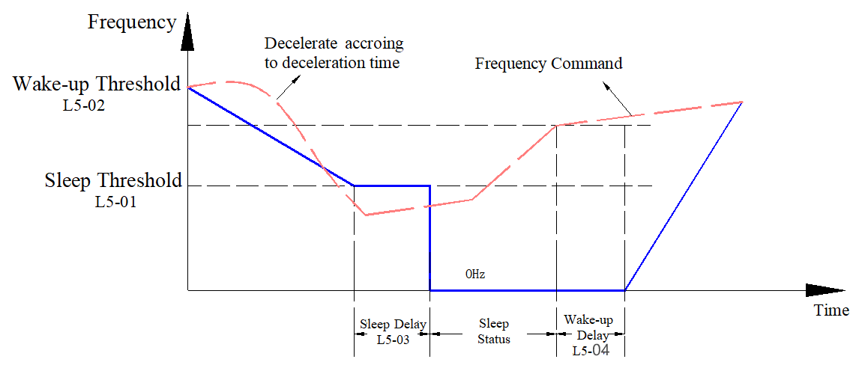
Figure 9-41 Schematic Diagram of Frequency Command Sleep and Wake-up
(2) PID Output Frequency Command (Use process PID, parameter FA-00≠0 and parameter L5-00=0, i.e., PID sleep and wake-up)
When the PID output frequency command reaches the sleep frequency (parameter L5-01), the inverter begins to sleep. After the sleep delay (parameter L5-03) has elapsed, it stops directly at 0Hz. If the sleep delay time has not been reached, the output frequency remains at the lower limit frequency (parameter F0-11, and F0-11≠0) or the minimum output frequency (parameter F2-04, if the lower limit frequency F0-11=0), waiting for the sleep time to reach before entering the sleep state. When the PID output frequency command reaches the wake-up frequency (parameter L5-02), the inverter starts the wake-up delay (parameter L5-04). After the delay time has elapsed, the inverter begins to accelerate to the PID output frequency setpoint according to the preset acceleration time. The PID output frequency command sleep and wake-up process is shown in Figure 9-42.
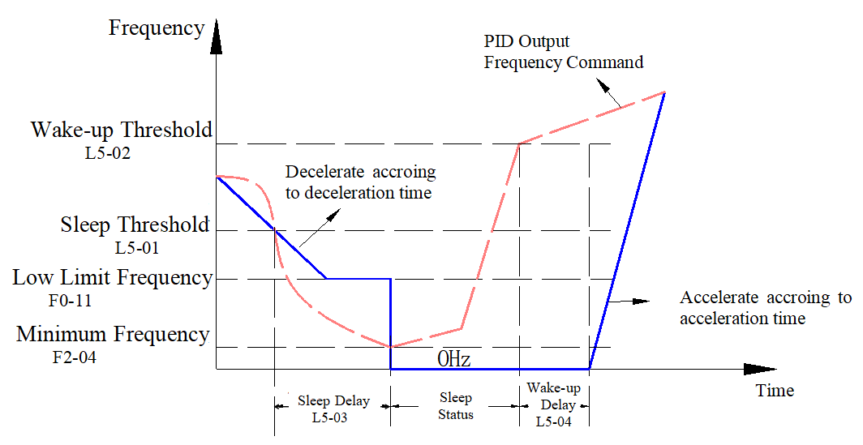
Figure 9-42 Schematic Diagram of PID Output Frequency Command Sleep and Wake-Up
(3) PID feedback value (using process PID, parameter FA-00 ≠ 0 and parameter L5-00 = 1, also for PID sleep and wake-up)
When the PID feedback value reaches the sleep threshold (parameter L5-01), the inverter begins to enter sleep mode. After the sleep delay (parameter L5-03) has elapsed, it stops directly at 0 Hz. If the sleep delay time has not been reached, the output frequency remains at the lower limit frequency (parameter F0-11, and F0-11≠0) or the minimum output frequency (parameter F2-04, if the lower limit frequency F0-11=0), waiting for the sleep time to reach before entering the sleep state. When the PID feedback value reaches the wake-up threshold (parameter L5-02), the inverter starts the wake-up delay (parameter L5-04). After the delay time has elapsed, the inverter begins to accelerate to the PID output frequency setting according to the set acceleration time. The PID feedback value sleep and wake-up process is shown in Figure 9-43:
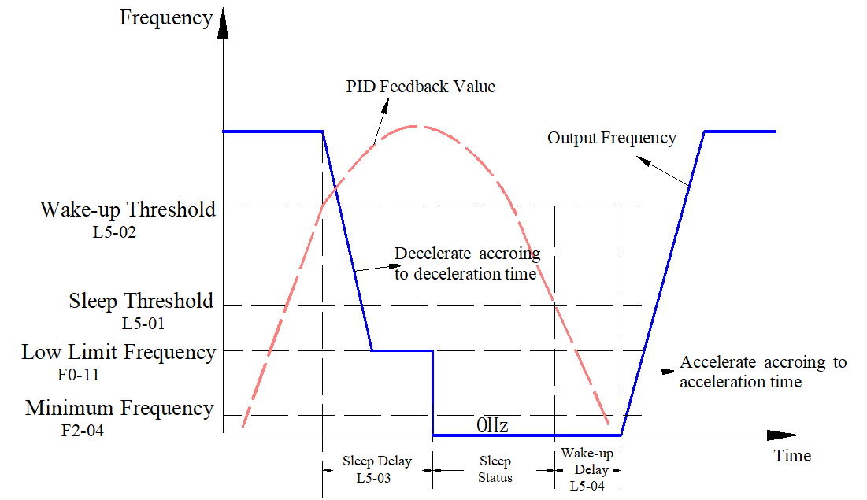
Figure 9-43 Schematic Diagram of PID Feedback Value Sleep and Wake-Up
When the sleep function (the above cases 2 and 3) is controlled by the PID setpoint and feedback value, the inverter frequency source must be selected as PID (parameter F0-06=9)
L5-00 | Sleep Mode Reference Selection | Range: 0～1 | Factory setting: 0
0: PID Command Arrival
1: PID Feedback Arrival
When parameter L5-00=0, the units of parameters L5-01 and L5-02 automatically change to frequency, and the setting range automatically changes to 0.00~599.00Hz.
When parameter L5-00=1, parameters L5-01 and L5-02 units automatically change to percentage, and the reference base becomes the percentage of feedback, with the setting range automatically changing to 0.00~200.00%.
L5-01 | Sleep Threshold | Range: 0.00Hz～599.00Hz | Factory value:0.00
During inverter operation, when the set frequency is less than the sleep frequency (parameter L5-01, L5-00=0), or the PID negative feedback value is greater than the sleep threshold (parameter L5-01, L5-00=1), the inverter begins to enter sleep mode. After the sleep delay (parameter L5-03) has elapsed, it stops directly at 0Hz.
Note: The machine is equipped with a 4-digit LED panel, which automatically adjusts the decimal place according to the current value and decimal position to facilitate 4-digit LED display.
L5-02 | Wake Threshold | Range: 0.00Hz～599.00Hz | Factory value:0.00
If the inverter is in sleep mode and the current operating command is valid, when the set frequency is greater than the wake-up frequency (parameter L5-02, L5-00=0), or the PID negative feedback value is less than the wake-up threshold (parameter L5-02, L5-00=1), after the wake-up delay (L5-04), the inverter starts to accelerate according to the set acceleration time to the PID output frequency setting.
Note: The machine is equipped with a 4-digit LED panel, which automatically adjusts the decimal place according to the current value and decimal position to facilitate 4-digit LED display.
L5-03 | Sleep Delay | Range: 0.0s～999.9s | Factory value:0.0
L5-04 | Wake-up delay | Range: 0.00s～600.00s | Factory value:0.00
  - L6 group count
L6-00 | Final Count Value Setting | Range: 0～65500 | Factory setting: 0
This function code is used for counting functions and can set the final count value (maximum value).
When L6-00 is 0, the counting function is disabled. When L6-00 is not 0, the counting function is active. The counter's input point can be triggered by multifunction terminal DI4 (digital input function set to 23 for input counting), as shown in Figure 9-44. When the count reaches the L6-00 set value, the inverter can send a final count reached signal through the digital output terminal.
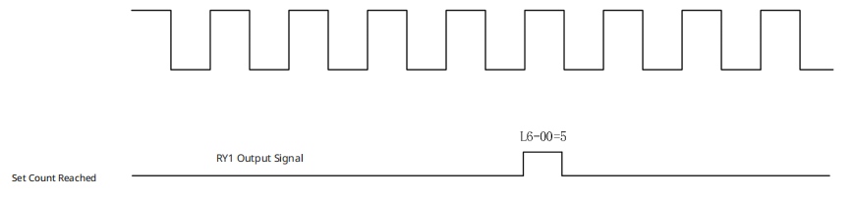
Figure 9-44 Final Count Value Setting Diagram
L6-01 | Intermediate Count Value Setting | Range: 0～65500 | Factory setting: 0
This function code is used for counting functions and can set the intermediate (set) count value. This function code must be used in conjunction with the final count value setting (L6-00).
As shown in Figure 9-45, when the count value increases to the set value of L6-01, the inverter can issue a signal indicating that the set count has been reached through digital output terminals, and continue counting until the final count value.
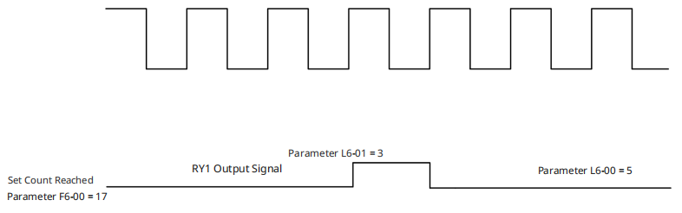
Figure 9-45 Schematic Diagram of Intermediate Count Value Setting
L6-02 | Count Reached E.F Enable | Range: 0～1 | Factory setting: 0
This function code is used to set the inverter's action when the count is reached.
0: Count reached, no EF;
When the count is reached, the inverter continues to run.
1: Count reached, EF;
When the count is reached, the inverter stops running and indicates an external fault.
  - L7 Group AI Multi-point Curve Setting
L7-00 | AI Curve Selection | Range: 0～1 | Factory setting: 0
This function code is used to set the AI curve adjustment method.
0: General Curve
The setting value is 0, all analog input signals are calculated using bias and gain.
1: AI1 Three-point Curve
Set value to 1, AI1 uses the frequency and voltage/current correspondence method (parameters L7-01 to L7-06) for calculation, other analog input signals use the bias and gain method for calculation.
L7-01 | AI1 Minimum Point Input Value | Range: 0.00～20.00 | Factory Value: 0.00
L7-02 | AI1 Minimum Point Percentage | Range: 0.00%～100.00% | Factory Value: 0.00
L7-03 | AI1 Mid-Point Input Value | Range: 0.00～20.00 | Factory value: 5.00
L7-04 | AI1 Mid-Point Percentage | Range: 0.00 to 100.00% | Factory Value: 50.00
L7-05 | AI1 Maximum Point Input Value | Range: 0.00～20.00 | Factory Value: 10.00
L7-06 | AI1 Maximum Point Percentage | Range: 0.00 to 100.00% | Factory Value: 100.00
The above function codes are used to adjust the AI1 input signal using a three-point curve, which is effective when the AI1 curve is set to a three-point curve.
L7-01, L7-03, and L7-05 are the actual input voltage or current values. If the input signal type is 0-10V, entering 1.00 represents 1V; If the input type is 0-20mA or 4-20mA, entering 5.00 represents 5mA. Note that when setting, L7-01 < L7-03 < L7-05 must be satisfied. L7-02, L7-04, and L7-05 are the numerical values corresponding to the respective input values entered into the inverter, with units in %. 100% represents the maximum value; for example, if the analog input function is set to input frequency, 100% corresponds to the maximum frequency (F4-02). When the AI1 input type is 0-10V and used as a frequency command, the curve relationships corresponding to different settings of L7-01 to L7-06 are shown in Figure 9-46.
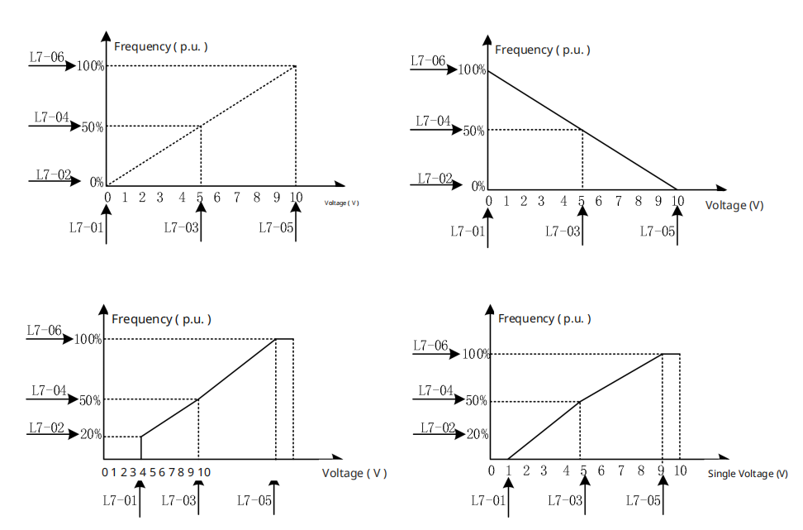
Figure 9-46 AI1 Multi-point Curve
Note: The machine comes with a 4-digit LED panel. L7-04 and L7-06 will automatically adjust the decimal places based on the current value and the number of decimal places to facilitate display on the 4-digit LED.
  - LD Group MODBUS Address Mapping Function Setup
The EL10 series inverter supports the Modbus address mapping function, allowing users to set the Modbus communication addresses for control words, status words, and other commonly used variables through this function, significantly enhancing the compatibility of the inverter's Modbus communication. The steps to configure the Modbus address mapping function are as follows:
- First, set function code F0-18 to 2, then set it to 6688;
- Set function code F7-61 to 4, and the 'Modbus Address Mapping' function codes for the LD group will be displayed;
- Set function code LD-00 to 1 to enable the Modbus address mapping function.
After enabling the address mapping function, the corresponding function codes can be used to set the Modbus communication addresses for the respective variables.
The following introduces the steps for mapping addresses of commonly used variables:
Frequency command address mapping: Set the function code LD-10 “frequency command mapping address” to the desired address. After setting, write the corresponding value to the address set by LD-10 to modify the given frequency. Similarly, after setting, read the value of the address set by LD-10 to obtain the current given frequency.
The setup steps for mapping addresses of other variables are similar to those described above.
LD-00 | MODBUS Address Mapping Function Enable | Range: 0000h~FFFFh | Factory setting: 0000h
This function code is used to enable or disable the Modbus address mapping function.
0: Modbus address mapping function disabled
Setting the value to 0 disables this function.
Non-zero value: Modbus address mapping function enabled.
LD-01 | Control Word Mapping Address | Range: 0000h~FFFFh | Factory Value: 2000h
LD-02 | Forward Operation Command | Range: 0000h~FFFFh | Factory Value: 0001h
LD-03 | Reverse Operation Command | Range: 0000h~FFFFh | Factory Value: 0002h
LD-04 | Forward Jog Command | Range: 0000h~FFFFh | Factory Value: 0003h
LD-05 | Reverse Jog Command | Range: 0000h~FFFFh | Factory Value: 0004h
LD-06 | Stop Command | Range: 0000h~FFFFh | Factory Value: 0005h
LD-07 | Stop Command 2 | Range: 0000h~FFFFh | Factory Value: 0005h
LD-08 | Fault Reset Command | Range: 0000h~FFFFh | Factory Value: 0007h
LD-09 | Jog Stop Command | Range: 0000h~FFFFh | Factory Value: 0005h
Control Word Mapping Address: Set the function code LD-01 “Control Word Mapping Address” to the desired address, and set the function codes LD-02 to LD-09 to the desired values. After setting, write the values set in LD-02 to LD-09 to the control word mapping address set in LD-01 to achieve the corresponding control command. For example, set the function code LD-01 to 4000h, and set LD-02 “Forward Operation Command” to 0001h, then write 0001h to address 4000h to control the motor to run forward.
LD-10 | Frequency Command Mapping Address | Range: 0000h~FFFFh | Factory Value: 2001h
Frequency command address mapping: Set the function code LD-10 “frequency command mapping address” to the desired address. After setting, write the corresponding value to the address set by LD-10 to modify the given frequency. Similarly, after setting, read the value of the address set by LD-10 to obtain the current given frequency.
LD-12 | Status Word Mapping Address | Range: 0000h~FFFFh | Factory Value: 2101h
LD-13 | Forward Operation Value | Range: 0000h~FFFFh | Factory Value: 0001h
LD-14 | Reverse Operation Value | Range: 0000h~FFFFh | Factory Value: 0002h
LD-15 | Stop Status Value | Range: 0000h~FFFFh | Factory Value: 0003h
LD-16 | Fault Status Value | Range: 0000h~FFFFh | Factory Value: 0004h
Status Word Address Mapping: Set the function code LD-12 “Status Word Mapping Address” to the desired address, and set the function codes LD-13~LD-16 to the desired values. After setting, the value read from the address set by LD-12 under the corresponding status should match the values set by LD-13~LD-16. For example, set the function code LD-12 to 4101h, and set the function code LD-13 “Forward Operation Value” to 0001h. When the motor is in forward operation, reading the address 4101h will yield the value 0001h.
LD-11 | Fault Code Mapping Address | Range: 0000h~FFFFh | Factory Value: 2100h
LD-17 | Given Frequency Mapping Address | Range: 0000h~FFFFh | Factory Value: 2102h
LD-18 | Output Frequency Mapping Address | Range: 0000h~FFFFh | Factory Value: 2103h
LD-19 | Output Current Mapping Address | Range: 0000h~FFFFh | Factory Value: 2104h
LD-20 | Bus Voltage Mapping Address | Range: 0000h~FFFFh | Factory Value: 2105h
LD-21 | Output Voltage Mapping Address | Range: 0000h~FFFFh | Factory Value: 2106h
LD-22 | Output Power Mapping Address | Range: 0000h~FFFFh | Factory Value: 2206h
LD-23 | DI Status Mapping Address | Range: 0000h~FFFFh | Factory Value: 2210h
LD-24 | DO Status Mapping Address | Range: 0000h~FFFFh | Factory Value: 2211h
LD-25 | AI1 Mapping Address | Range: 0000h~FFFFh | Factory Value: 220Bh
LD-26 | AI2 Mapping Address (Reserved) | Range: 0000h~FFFFh | Factory Value: 220Ch
LD-27 | Motor speed mapping address | Range: 0000h~FFFFh | Factory Value: 210Ch
LD-28 | Torque feedback mapping address (reserved) | Range: 0000h~FFFFh | Factory Value: 2227h
LD-29 | Torque setpoint mapping address (reserved) | Range: 0000h~FFFFh | Factory Value: 2228h
For other states, physical quantity address mapping: Set the corresponding function code to the required address. After setting, read out the address value of the set parameter to obtain the corresponding physical quantity value.
Table 9-16 Units and Decimal Places for Physical Quantities
Parameter Address | Parameter Content | Default Decimal Point (Position) | Default Unit
LD-11 | Fault Code Mapping Address | None | None
LD-17 | Given Frequency Mapping Address | 2 | Hz
LD-18 | Output Frequency Mapping Address | 2 | Hz
LD-19 | Output Current Mapping Address | 2 | A
LD-20 | Bus Voltage Mapping Address | 1 | V
LD-21 | Output Voltage Mapping Address | 1 | V
LD-22 | Output Power Mapping Address | 1 | Kw
LD-23 | DI Status Mapping Address | None | None
LD-24 | DO Status Mapping Address | None | None
LD-25 | AI1 Mapping Address | 2 | %
LD-27 | Motor speed mapping address | 0 | RPM
Note: Decimal positions for physical data are not currently supported.

Chapter 10 Basic Configuration and Function Application
  - Basic Inverter Applications

Operation Command Settings
Operation commands are used to control the inverter's start, stop, forward/reverse rotation, jog operation, etc. Operation commands are divided into three types: keyboard, terminal, and communication. Parameter F0-05 is used to select the operation command method.
Table 10-1 Operation Command Setting Related Parameters
Function Code | Function Code Definition | Value Range | Factory Value | Description
F0-05 | Operation Command Source Selection | 0: Digital Keypad  1: External Terminal Input  2: RS485 Communication Input  3: CANopen Input (Supported by Extended Models) | 0 | Select the input channel for the inverter control command. Inverter control commands include: start, stop, forward, reverse, jog, etc.  0: Digital Keypad  Selecting this command channel allows control commands to be input via the RUN, STOP, etc., buttons on the keyboard, suitable for initial debugging.  1: External Terminal Input  Select this command channel to input control commands through the inverter's DI terminals. The DI terminal control commands can be set according to different scenarios, such as start/stop, forward/reverse, jogging, two/three-wire mode, multi-speed functions, etc., suitable for most applications.  2, 3: Communication command channel  Communication methods include RS485, CANopen (extended support).  Select this command channel to input control commands via remote communication, suitable for long-distance control or centralized control of multiple device systems.
Set operation instructions through the 'keyboard'
When F0-05 is set to 0, use the keyboard buttons 'RUN', 'STOP', etc., to give the inverter operation commands.
Press the “RUN” button to start the inverter; you will see the indicator light above the “RUN” button light up.
When the inverter is running, press the “STOP” button to shut it down. Before shutdown, the “RUN” button indicator light will flash until the shutdown is complete, at which point the flashing will stop and the indicator light above the “STOP” button will light up.
Set operation commands through external terminals
When F0-05 is set to 1, operation commands are given to the inverter through DI terminals to control its start and stop.
Parameter F5-08 sets the terminal command method, with a total of 6 methods as shown in Table 10-2:
Table 10-2 Terminal Command Method Setting Parameters
Function Code | Function Code Definition | Value Range | Factory Value | Description
F5-08 | Operation Command Source Selection | 0: No Function  1: 2-Wire Mode 1  2: 2-Wire Mode 2  3: 3-Wire Mode  4: 2-Wire Mode 1/Fast Start  5: 2-Wire Mode 2/Fast Start  6: 3-Wire Fast Start | 1 | Select different terminal combinations to set the inverter's operating mode.
2-wire Mode 1
F5-08=1, set to commonly used 2-wire Mode 1.
The DI1 terminal is used for forward operation, and the DI2 terminal is used for reverse operation. Connect the forward operation switch to the DI1 terminal and the reverse operation switch to the DI2 terminal.
Table 10-32 Parameters Related to 2-wire Mode 1
Function Code | Function Code Definition | Set Value | Description
F5-08 | Terminal Command Mode | 1 | 2-wire Mode 1
F5-00 | DI1 Terminal Function Selection | 0 | When F5-08 is changed to 1, the DI1 terminal defaults to forward operation.
F5-01 | DI2 Terminal Function Selection | 0 | When F5-08 is changed to 1, the DI2 terminal defaults to reverse operation.
F0-05 | Operation Command Source Selection | 1 | External Terminal Input
Table 10-42 2-wire Mode 1
SW1 | SW2 | Run Command
1 | 0 | Forward Operation
0 | 1 | Reverse Operation
1 | 1 | Stop
0 | 0 | Stop
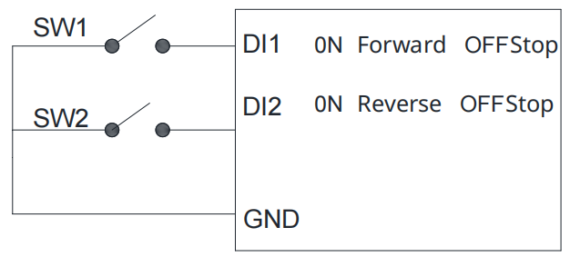
Figure 10-1 Two-wire Operation Mode 1
2-wire Mode 2
F5-08=2, set to 2-wire Mode 2.
The DI1 terminal is used to control the run command, and the DI2 terminal is used to control the forward/reverse direction.
Table 10-5 Parameters Related to Two-Wire Mode 2
Function Code | Function Code Definition | Set Value | Description
F5-08 | Terminal Command Mode | 2 | 2-wire Mode 2
F5-00 | DI1 Terminal Function Selection | 0 | Default is to control the run command
F5-01 | DI2 Terminal Function Selection | 0 | Default is to control the forward/reverse direction
F0-05 | Operation Command Source Selection | 1 | External Terminal Input
Table 10-6 Two-Wire Mode 2
SW1 | SW2 | Run Command
1 | 0 | Forward Operation
1 | 1 | Reverse Operation
0 | 1 | Stop
0 | 0 | Stop
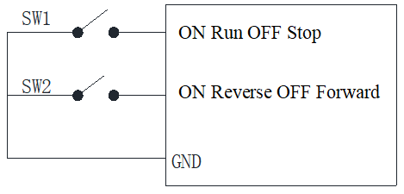
Figure 10-2 Two-Wire Operation Mode 2
Three-wire
F5-08=3, set to three-wire mode.
The DI1 terminal is used to control the run command, the DI2 terminal is used to control the forward/reverse direction, and the DI3 terminal is used to control the run enable.
Table 10-7 Parameters Related to Three-Wire Mode
Function Code | Function Code Definition | Set Value | Description
F5-08 | Terminal Command Mode | 3 | Three-wire
F5-00 | DI1 Terminal Function Selection | 0 | Default is to control the run command
F5-01 | DI2 Terminal Function Selection | 0 | Default is to control the forward/reverse direction
F5-02 | DI3 Terminal Function Selection | 0 | Default is the run enable terminal
F0-05 | Operation Command Source Selection | 1 | External Terminal Input
Table 10-8 Three-Wire Mode
SW1 | SW2 | SW3 | Run Command
1 | 0 | 1 | Forward Operation
1 | 1 | 1 | Reverse Operation
x | x | 0 | Stop
0 | x | x | Stop
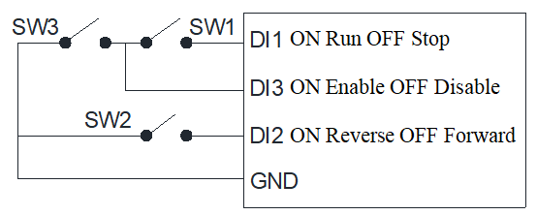
Figure 10-3 Three-Wire Operation Mode
Set operation commands through communication
When F0-05 is set to 2 or 3, send operation commands to the inverter via communication to control its start and stop.
This series supports multiple communication methods: 485, CANopen. According to the communication protocol, relevant parameters need to be set in the F8 group to match the corresponding serial port protocol.
The following uses 485 communication as an example to explain the process of sending operation commands via communication.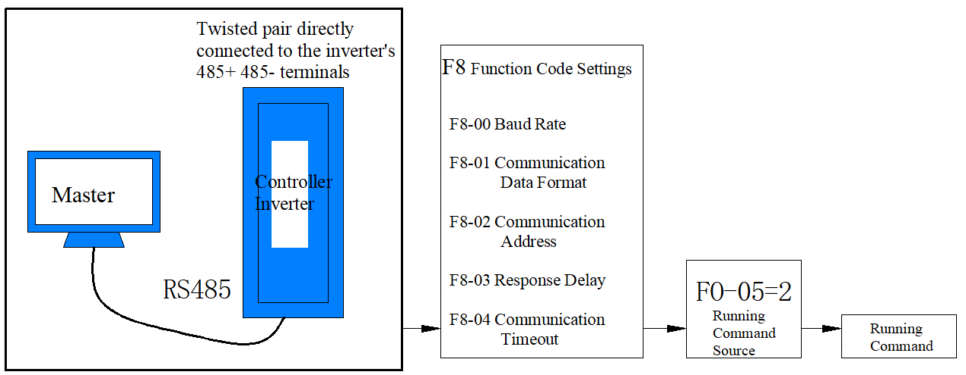
Figure 10-4 Schematic diagram of communication for setting operation commands
Application example: Communication control for forward operation of the inverter. Send write command data “0106200000120207”. The data is in hexadecimal, and the meaning of each data bit is shown in the table below. For more communication addresses and commands, see Appendix B.
Table 10-9 Instruction Data Bit Meaning
Data | Meaning
01 | Inverter Communication Address
06 | Write Command
2000 | Control Command Communication Address
0012 | Forward Operation Command
0207 | CRC Checksum Low Byte, High Byte
Complete Data Transmission Process:
Master Sends: 0106200000120207
Slave Responds: 0106200000120207

Frequency Command Setting
The inverter is equipped with two frequency setting channels, named the main frequency source and the auxiliary frequency source. These can operate independently, switch at any time, or even be combined using a set calculation method to meet different control requirements on site.
Main Frequency Source Selection
The inverter's main frequency source has 11 options, including digital keypad, RS485 communication, analog input, external Up/Down, CANopen, PID, multi-speed, etc., which can be selected through F0-06.

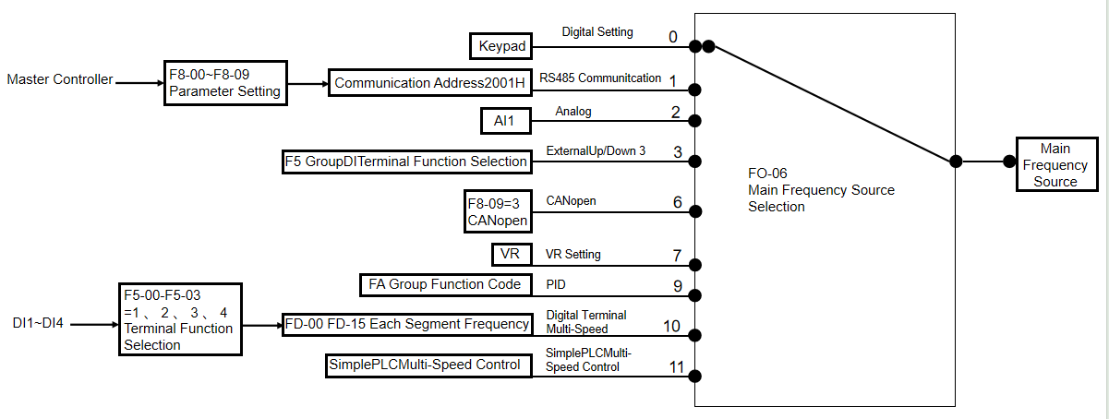
Figure 10-5 Main Frequency Source Diagram
From the different frequency sources shown in the figure, it can be seen that the operating frequency of the inverter can be determined by function codes, can also be adjusted manually at any time, can also be set using an analog signal, can also be given using multi-speed terminal commands, can also be regulated in a closed loop by an internal PID controller through external feedback signals; or can be controlled via communication from a higher-level machine.
The figure above provides the relevant function code numbers for setting each frequency source. When setting, refer to the detailed description of the corresponding function code.
Usage Method with Auxiliary Frequency Setting
There are 7 types of auxiliary frequency sources, which are selected by setting F0-07.

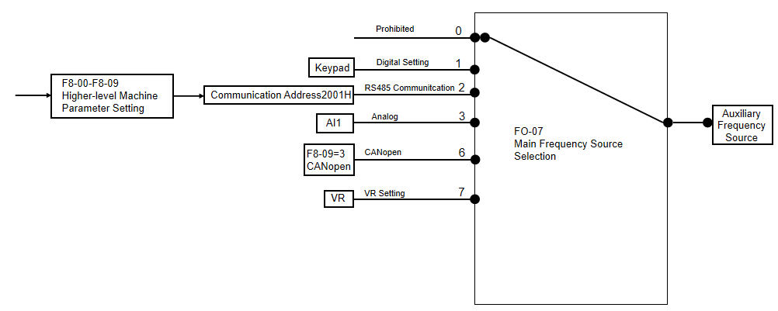

Figure 10-6 Auxiliary Frequency Source Diagram
In actual use, the relationship between the target frequency and the main and auxiliary frequency sources is set through F0-08.

Start/Stop Methods
Startup Methods
The inverter's startup modes include direct start and speed tracking start, which are selected through function parameter F1-00.
Direct Start
F1-00=0, direct start method, suitable for most small inertia loads, the frequency curve during the start-up process is shown in the following figure. The 'DC braking' function before startup is applicable to the drive of elevators and lifting loads; The 'startup frequency' is suitable for equipment drives that require torque shock at startup, such as concrete mixer equipment.
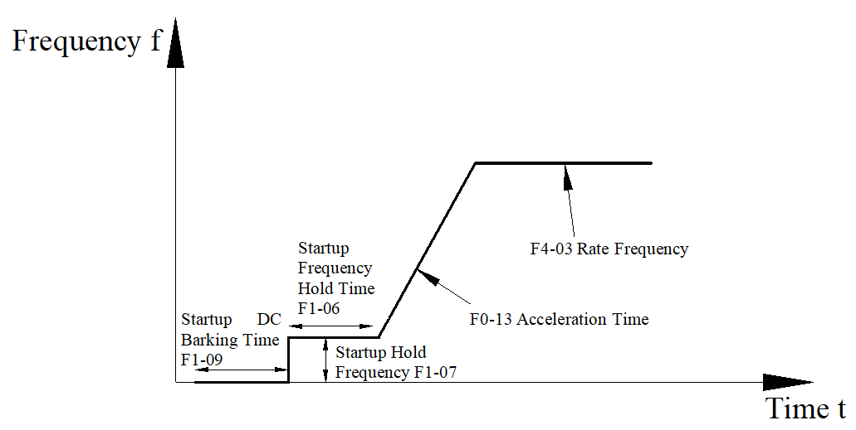
Figure 10-7 Schematic Diagram of Direct Start with DC Braking
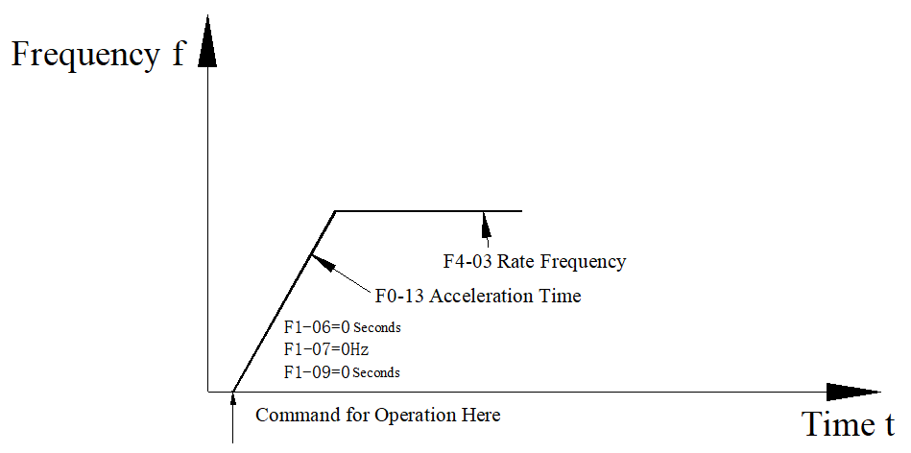
Figure 10-8 Schematic Diagram of Direct Start Without DC Braking
Speed Tracking Start
F1-00≠0, for speed tracking start, speed tracking is suitable for punch presses, fans, and other high-inertia load applications.
First, look at the startup curve process when F1-00=0:
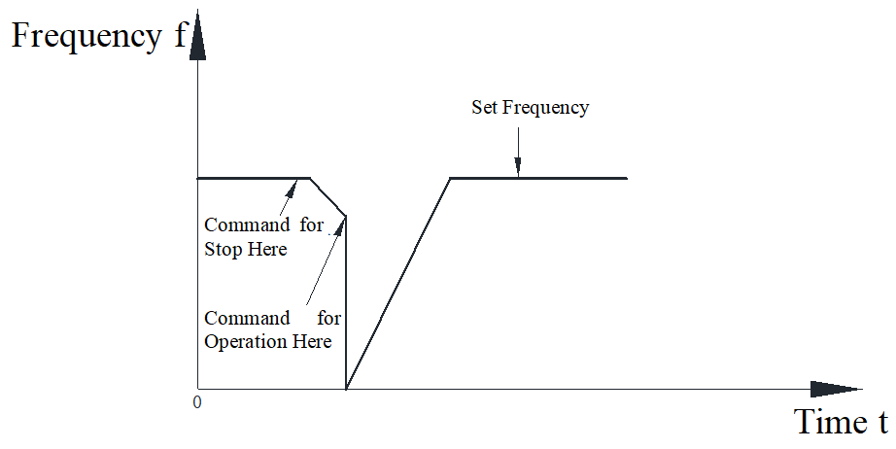
Figure 10-9 Startup Curve When Speed Search Function is Disabled
After a stop command is given, the inverter decelerates to a stop. If a run command is given before the frequency reduces to zero, the frequency accelerates from zero to the set frequency.
When F1-00=1, it is a start from the maximum frequency, and the frequency curve during the start-up process is as follows:
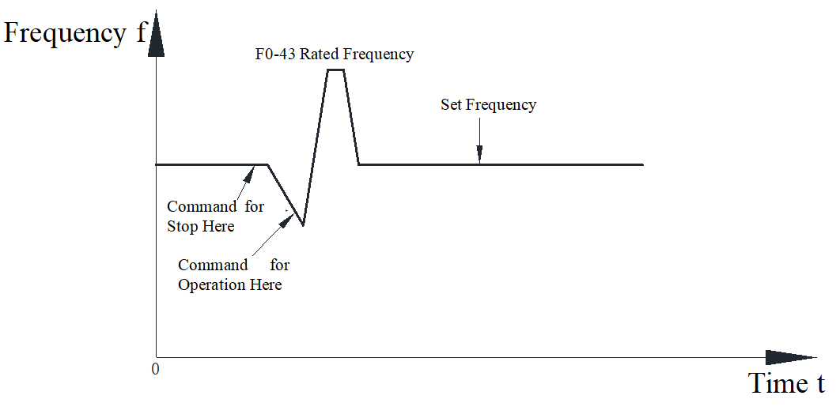
Figure 10-10 Start tracking from maximum frequency
After a stop command is given, the inverter decelerates to a stop. If the frequency has not reduced to zero and a run command is given again, the frequency directly decreases from the rated frequency to the set frequency.
When F1-00=2, it indicates starting tracking from the current frequency. The frequency curve during the start-up process is as follows:
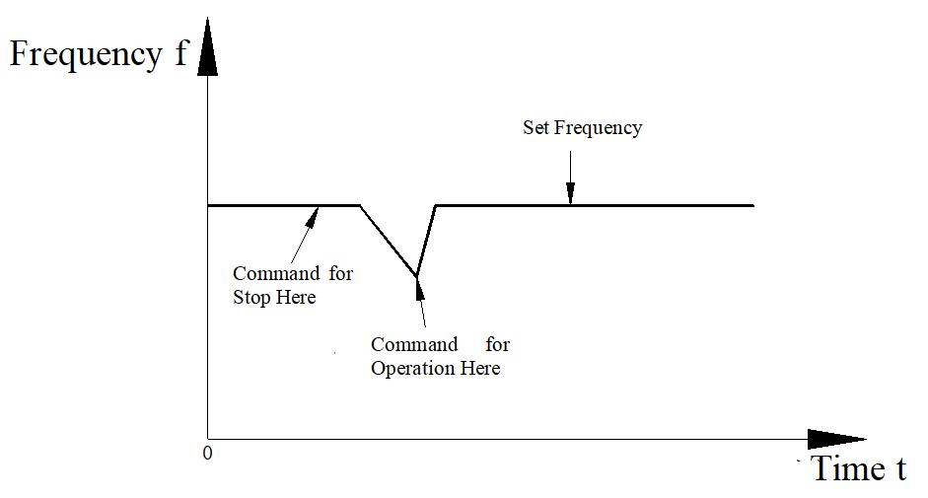
Figure 10-11 Start tracking from current frequency
After a stop command is given, the inverter decelerates to a stop. If the frequency has not reduced to zero and a run command is given again, the frequency directly reaches the set frequency. When F1-00=3, it indicates starting tracking from the minimum frequency. The frequency curve during the start-up process is as follows:

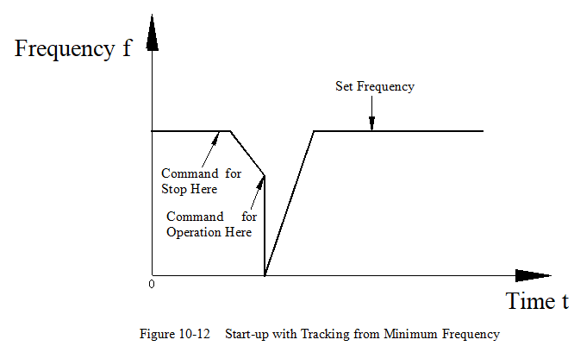
Figure 10-12 Start-up with Tracking from Minimum Frequency
This start-up process is consistent when F1-00=0.
Shutdown Methods
The inverter has two shutdown modes: deceleration stop and free stop, selected by function code F1-12.
Deceleration Shutdown
F1-12=0 for deceleration shutdown; after the shutdown command becomes effective, the inverter reduces the output frequency according to the deceleration time, and stops when the frequency reaches 0.
The frequency curve is shown in the following figure:
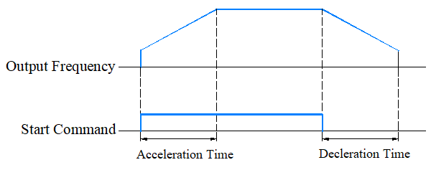
Figure 10-13 Deceleration Shutdown Output Frequency Curve
Free Shutdown
After the shutdown command becomes effective, the inverter immediately terminates output, and the motor stops freely according to mechanical inertia.
The frequency curve is shown in the following figure:
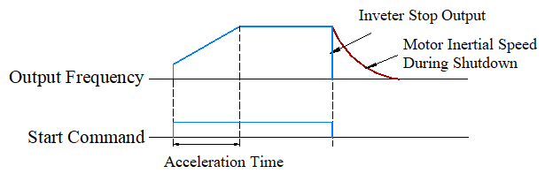
Figure 10-14 Free Stop Output Frequency Curve
Acceleration and Deceleration Time Settings
Acceleration time refers to the time required for the inverter to accelerate from zero frequency to F4-03 (rated frequency) base frequency. Deceleration time refers to the time required for the inverter to decelerate from F4-03 (rated frequency) base frequency to zero frequency.
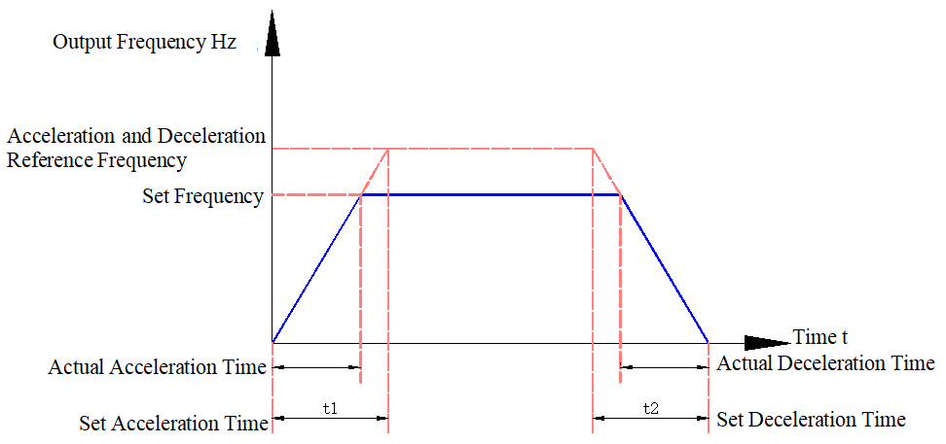
Figure 10-15 Acceleration and Deceleration Time Diagram
The EL10 provides four sets of acceleration and deceleration times, which users can switch between using digital input terminals DI (terminal input functions 8, 9). The four sets of acceleration and deceleration times are set through the following function codes:
First set: F0-13F0-14 Second set: F7-03F7-04
Third set: F7-05F7-06 Fourth set: F7-07F7-08
Application Examples:
Taking DI3 and DI4 as input switching terminals as an example, the following are the setup steps.
- Set parameters F5-02 and F5-03 to select DI3 and DI4 terminals as input switching terminals.
Table 10-10 Input Terminal Control for Acceleration/Deceleration Switching
Function Code | Function Code Definition | Set Value | Description
F5-02 | DI3 Terminal Function Selection | 8 | 1-2 Segment Acceleration/Deceleration Switching
F5-03 | DI4 Terminal Function Selection | 9 | 3-4 Segment Acceleration/Deceleration Switching
- By setting four groups of acceleration/deceleration parameters, set the corresponding acceleration/deceleration times.
Table 10-11 Input Terminal Settings for Acceleration/Deceleration Times
DI4 Terminal Status | DI3 Terminal Status | Acceleration and Deceleration Time Settings
OFF | OFF | First Group Acceleration/Deceleration Time F0-13, F0-14
OFF | ON | Second Group Acceleration/Deceleration Time F7-03, F7-04
ON | OFF | Third Group Acceleration/Deceleration Time F7-05, F7-06
ON | ON | Fourth Group Acceleration/Deceleration Time F7-07, F7-08
- When setting F0-12 (Speed Curve Time Unit), the decimal point position of the four acceleration and deceleration time groups will change, and the corresponding acceleration and deceleration times will also change. This should be noted during actual use.
- Setting F1-20 (Automatic Acceleration and Deceleration Selection) chooses the inverter's acceleration and deceleration method.
0: Linear Acceleration and Deceleration
1: Automatic Acceleration, Linear Deceleration
2: Linear Acceleration, Automatic Deceleration
3: Automatic Acceleration and Deceleration
4: Linear Acceleration and Deceleration, with Suppression of Automatic Acceleration and Deceleration

  - Motor Commissioning Method

Asynchronous Motor VF Control Commissioning Method
This section will introduce them together. The list of parameters related to asynchronous motor VF commissioning is shown in Table 10-12.
Table 10-12 Parameters Related to Asynchronous Motor VF Commissioning
Parameter Number | Parameter Name
F4-03 | Motor Rated Frequency
F4-04 | Motor Rated Voltage
F2-04 | Motor Multi-Point VF Frequency Point 1
F2-05 | Motor Multi-Point VF Voltage Point 1
F2-06 | Motor Multi-Point VF Frequency Point 2
F2-07 | Motor Multi-Point VF Voltage Point 2
F2-08 | Motor Multi-Point VF Frequency Point 3
F2-09 | Motor Multi-Point VF Voltage Point 3
F2-10 | Slip Compensation Filter Time
F2-11 | Slip Compensation Gain
F2-14 | Oscillation Suppression Gain
F3-29 | Torque compensation filter time
F7-37 | Automatic Voltage Regulation

10.2.1.1 Basic Settings
Basic settings for asynchronous motor VF commissioning mainly include motor nameplate parameter settings, as shown in Figure 10-16.
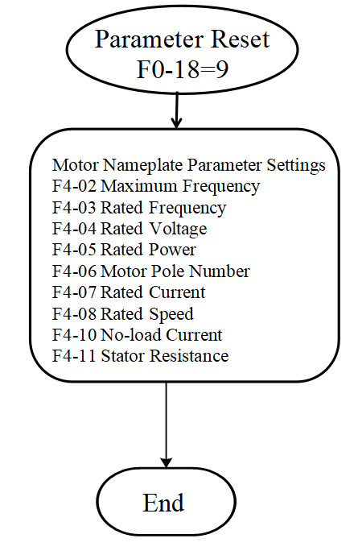
Figure 10-16 Basic Settings for Asynchronous Motor VF Commissioning
The basic settings steps for VF are as follows:
(1) Parameter reset; Set parameter F0-18 to 9 to restore the inverter parameters to factory settings.
(2) Set motor nameplate parameters; set the parameters as shown in Table 10-13 according to the motor nameplate:
Table 10-13 Motor Nameplate Parameters
Parameter Number | Parameter Name
F4-00 | IM (Induction/Asynchronous Motor)
F4-02 | Maximum Frequency
F4-03 | Motor Rated Frequency
F4-04 | Motor Rated Voltage
F4-05 | Motor Rated Power
F4-06 | Motor Poles
F4-07 | Motor Rated Current
F4-08 | Motor Rated Speed
F4-10 | Motor No-load Current
F4-11 | Motor Stator Resistance
(3) Set the VF curve and compensation points (slip compensation, torque compensation, oscillation suppression, etc.).
Note: The number of poles of the motor is automatically calculated based on the rated frequency and rated speed, and the user only needs to confirm whether it is correct.

10.2.1.2 No-load Testing
After basic settings are completed, no-load testing can be conducted. Control the motor to run at different frequencies; if the motor vibrates, the F2-14 “Oscillation Suppression Gain” can be increased.

10.2.1.3 Full-load Testing
After no-load testing is completed, load testing can be performed. If the motor's load capacity is insufficient, try increasing the F2-01 “Torque Compensation Gain”. Under full load conditions, if the actual motor speed is lower than the set speed, try increasing the F2-11 “Slip Compensation Gain”; conversely, if the actual motor speed is higher than the set speed, try decreasing the F2-11 “Slip Compensation Gain”.
  - Input and Output Terminal Description

Digital Input Terminal Function (DI)
The EL10 series inverter is equipped with 4 multifunctional digital input terminals, where MI4 can be set to equal 23 (counting input). Each DI terminal can select any one of the DI terminal functions.
Table 10-14 List of DI Terminal Function Parameters
F5-00 | DI1 Terminal Function Selection | Range: 0～94 | Factory setting: 0
F5-01 | DI2 Terminal Function Selection | Range: 0～94 | Factory setting: 0
F5-02 | DI3 Terminal Function Selection | Range: 0～94 | Factory setting: 0
F5-03 | DI4 Terminal Function Selection | Range: 0～94 | Factory setting: 0
For detailed instructions on selecting DI terminal functions, refer to Parameter Group F5 “Table 9-3 Digital Multifunctional Input Terminal Corresponding Functions”

Digital Output Terminal Function (DO)
The EL10 series inverter is equipped with one multifunctional relay output terminal.
Table 10-15 List of DO Terminal Function Related Parameters
F6-00 | RLY terminal function selection | Range: 0～76 | Factory Value: 11
F6-04 | Effective Logic of DO Terminal | Range: 0～65535 | Factory setting: 0
F6-05 | Source of AI for DO Output | 0: AI (EL10 has only one AI) | Factory setting: 0
F6-06 | Upper Limit Value of AI for DO Output | -100.00%～100.00% | 50.00
F6-07 | Lower Limit Value of AI for DO Output | -100.00%～100.00% | 10.00
F6-08 | DO Action Frequency | 0.00～599.00Hz | 0.00
For detailed instructions on selecting DO terminal functions, refer to Parameter Group F6 “Table 2-10 Digital Multifunctional Output Terminal Corresponding Function Selection”

Analog Input Terminal Function (AI)
The EL10 series inverter is equipped with 1 AI terminal.
Table 10-16 AI Terminal Function Selection Parameter List
F5-21 | AI1 Function Selection | Range: 0～20 | Factory setting: 1
For detailed instructions on DO terminal function selection, refer to parameter group F6 “Table 10-9 Analog Input Function Selection”
  - Control Performance

Setting of the V/F Curve
This inverter has built-in multiple V/F curves and can customize V/F curves to meet different load conditions. When F2-00=0, it is a multi-segment V/F curve, as shown in Table 10-17. Among them, V1<V2<V3, F1<F2<F3. When F2-00=1, the inverter output voltage is proportional to the 1.5 power of the frequency. When F2-00=2, the inverter output voltage is proportional to the square of the frequency.
Table 10-17 V/F Curve Setting Parameters
Parameter | Function Definition | Default Value | Setting Range | Parameter Description
F2-00 | V/F voltage selection | 0 | 0: General V/F curve  1: 1.5th power V/F curve  2: 2nd power V/F curve | Multi-Segment (Custom) V/F Curve, define multi-segment V/F curves according to F2-04～F2-09 and F4-03 and F4-04, as shown in the following figure.  In the figure, f1, f2, f3, and fb are the motor multi-point VF frequency points 1, 2, 3, and rated frequency, respectively, and V1, V2, V3, and Vb are the motor multi-point VF voltage points 1, 2, 3, and rated voltage, respectively.  Caution: Under normal conditions, V1<V2<V3<Vb, f1<f2<f3<fb. Setting the voltage too high at low frequencies may cause the motor to overheat or even burn out, and the inverter may experience overcurrent or overvoltage protection.
F2-04 | Motor Multi-Point VF  Frequency Point 1 | 0.50Hz | 0.00~599.00Hz
F2-05 | Motor Multi-Point VF  Voltage point 1 | 2.0V/1.0V | 0.0~480.0V
F2-06 | Motor Multi-Point VF  Frequency point 2 | 1.50Hz | 0.00~599.00Hz
F2-07 | Motor Multi-Point VF  Voltage point 2 | 10.0V/5.0V | 0.0~480.0V
F2-08 | Motor Multi-Point VF  Frequency point 3 | 3.00Hz | 0.00~599.00Hz
F2-09 | Motor Multi-Point VF  Voltage point 3 | 22.0V/11.0V | 0.0~480.0V
F4-03 | Motor Rated Frequency | 50.00Hz | 0.00~599.00Hz
F4-04 | Motor Rated Voltage | 380.0V/220.0V | 0.0~510.0V

Torque compensation
Torque compensation is a commonly used stage in motor control, which can be used to improve load-carrying capacity and enhance control performance. The torque compensation function in this section can be used for the VF control of asynchronous motors (available only in VF mode). Based on the operating status of the motor (such as motor speed), the torque compensation amount is calculated. This compensation amount is then multiplied by a certain gain, passed through a low-pass filter, and added to the output voltage as a voltage compensation value to achieve the purpose of torque compensation. Relevant parameters are shown in Table 1018.
Table 10-18 Torque Compensation Related Parameters
Parameter | Function Definition | Default Value | Setting Range | Parameter Description
F2-01 | Torque compensation gain | 1 | 0~10 | This parameter is used to adjust the torque compensation level. By adjusting the output voltage, the motor's load-carrying capacity can be adjusted. The greater the torque compensation gain, the better the load-carrying capacity, but the output current will increase. If set too high, it may cause overcurrent faults; reducing the torque compensation gain will correspondingly degrade the load-carrying capacity.
F2-02 | Torque Filter Time | 0.500s | 0.001~10.000s | This parameter is used to adjust the filter time for torque compensation. A larger filter time setting results in more stable control, but the control response becomes slower. When the filter time is too small, the response is faster, but it may lead to instability. Adjust according to actual conditions.

Slip Compensation
Slip compensation is a commonly used stage in asynchronous motor control. Due to the existence of slip, the speed of an induction motor is often not equal to the synchronous speed. If slip is not compensated, it may result in insufficient accuracy in the speed control of the induction motor. Reasonable slip compensation can improve the speed accuracy of the induction motor. Based on the mathematical model of the motor, the slip is calculated using information such as motor current and voltage. By adding the slip to the synchronous speed, slip compensation is achieved. Since the calculated slip may have errors, the slip compensation gain can be increased to adjust it. Additionally, the calculated slip usually contains noise, which can be eliminated or reduced using a low-pass filter. The relevant parameters are shown in Table 10-19.
Table 10-19 Slip Compensation Related Parameters
Parameter | Function Definition | Default Value | Setting Range | Parameter Description
F2-10 | Slip Compensation Filter Time | 0.100s | 0.001~9.999s | This parameter is used to set the filter time for slip compensation. The larger the value of this function code, the slower the compensation response; the smaller the value, the faster the response, but it may lead to system instability. Adjust according to actual conditions.
F2-11 | Slip Compensation Gain | 0.00 | 0.00~10.00 | This parameter is used to set the gain for slip compensation. By adjusting the slip compensation gain, the motor speed accuracy can be improved. When using VF control: Under electric load conditions, if the motor speed is lower than the actual speed, the slip compensation gain can be appropriately increased; otherwise, it should be decreased. Under generator load conditions, if the motor speed is higher than the actual speed, the slip compensation gain can be appropriately increased; conversely, it should be decreased.

Parameter Management Settings
Parameter management settings are achieved through a function code parameter setting to implement write protection, value reset, parameter reset, read-only parameter modification, program reset, and other operations. Currently, parameter management settings are performed through function code F0-18, as shown in Table 10-20.
Table 10-20 Parameter Management Settings
Parameter | Function Definition | Default Value | Setting Range | Parameter Description
F0-18 | Parameter Management | 0 | 0: No Function  1: Parameter Write Protection  5: Reset kWH Display  7: Reset CAN Slave (Extended Model)  9: Reset to 50Hz factory value  10: Reset to 60Hz Factory Value | 0: No Function;  1: After entering 1, most function codes will be locked and cannot be modified; only parameter management (F0-18) and password input (F7-33) can be modified. This value is written to EEPROM and remains effective after power loss. Only by setting parameter management (F0-18) to 0 can other parameter values be modified;  5: Can reset the inverter's energy statistics to zero;  7: Reset CAN Slave (Extended Model);  9: To restore factory settings for function codes, reset the function codes to their default values. If a password has been set on the inverter (via F7-34), the password must be removed (via F7-33) before restoring factory settings.
Precautions:
- When parameter management setting values are 7, 9, or 10, power must be cycled to the control board after setting completion.
- If the frequency command source is the digital keypad knob, set parameter management to 7. To achieve reverse operation, simultaneously set the analog frequency negative value reversal (F5-38) to 1 (allowing negative frequency input, positive frequency forward rotation, negative frequency reverse rotation; the digital keypad and external terminals cannot control forward/reverse rotation).

Command Source Setting
Users can select the frequency source (F0-06) and operation command source (F0-05) through function code settings to ensure the inverter operates normally under different input command methods. Relevant parameters are shown in Table 10-21.
Table 10-21 Command Source Setting Parameters
Parameter | Function Definition | Default Value | Setting Range | Parameter Description
F0-06 | Frequency Command Source Selection | 0 | 0: Digital Keypad or Parameter F0-19 Setting  1: RS485 Communication  2: Analog Input  3: External Up/Down Input  4: Reserved.  5: Reserved.  6: CANopen Input (Supported by Extended Models)  7: Panel VR setting (default value)  9: PID  10: Digital Terminal Multi-Speed  11: PLC Multi-Speed | 0: Set the frequency value using the up and down keys on the keypad, or set the frequency command value by setting the value of parameter F0-19.  1: Set the frequency value via RS485 communication; the external device must be connected to the inverter's 485+ and 485-, and then the frequency can be set through communication. For details, refer to the MODBUS Communication Protocol.  2: Set the frequency value via an analog signal. The frequency value can be set through the analog input on the inverter, and the analog input function must be set to 'Frequency Setting' (set through F5-21).  3: Set the frequency value through DI terminals, set the F5 group DI terminal function selection to 19, 20 (external command for frequency increase, external command for frequency decrease), then adjust the frequency value through the corresponding DI terminals.  6: Set the frequency value through CANopen communication; use the CANopen protocol to communicate with the inverter and set its frequency value. (Supported by extended models)  7: VR setting, the panel has built-in VR setting for frequency commands.  9: The frequency setpoint comes from process PID control. The PID function can be configured using the FA group function codes; the output of the PID controller serves as the inverter's frequency setpoint. For details, refer to the introduction of the 'PID function' in the FA group.  10: Set the frequency value through DI terminals. The F5 group 'input terminals' and FD group 'multi-speed and simple PLC functions' function codes can be used to set speed segments and the correspondence between DI input signals and speed segments. Please refer to the descriptions of these two groups of function codes for more details.  11: PLC multi-speed, set the frequency value and acceleration/deceleration method for each segment through multi-segment parameters, configure the internal program to automatically run according to the set time, frequency, and acceleration.
F0-05 | Operation Command Source Selection | 0 | 0: Digital Keypad  1: External Terminal Input  2: RS485 Communication Input  3: CANopen Input | 0: Select this command channel to control the inverter's operation and stop through the RUN, STOP, etc., buttons on the keyboard.  1: Select this command channel to control the inverter via digital input terminals.  2: Select this command channel to send commands to the inverter through RS485 communication, controlling the inverter to start, stop, etc.  3: Select this command channel for the master device to send control commands to the inverter using the CANopen protocol.
Precautions:
- The command source can only be modified when the inverter is stopped;
- At the same time, configure the digital inputs (F5-00~F5-04) as multi-speed commands as the frequency source, and configure the analog input (F5-21) as the frequency command source. Priority order: Multi-speed > Analog input frequency source > Frequency command source selection input (F0-06);
- When digital inputs (F5-00~F5-04) are used as operation command sources, the priority order is: digital inputs > operation command source selection (F0-05).

Stopping Method
Users can select different normal stopping methods, such as deceleration stop and free-run stop, according to actual application scenarios through function codes. The inverter can modify the stopping method during operation. After the inverter receives a shutdown command, it reduces the output frequency according to the selected stopping method and then stops the output. The two stopping methods are shown in Figure 10-17:
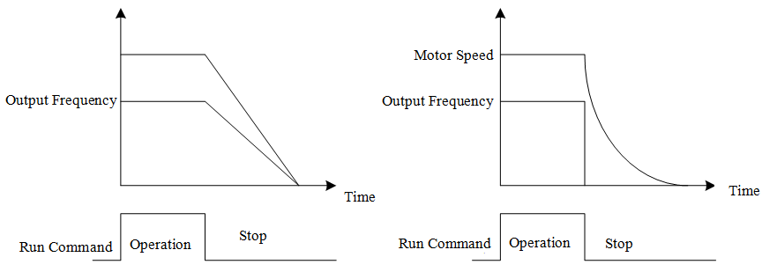
Figure 10-17 Stopping Method Diagram
Relevant parameters are shown in Table 10-22:
Table 10-22 Relevant Parameters Table
Parameter | Function Definition | Default Value | Setting Range | Parameter Description
F1-12 | Stopping Method | 0 | 0: Deceleration Stop  1: Free Stop | 0: Deceleration stop, the inverter decelerates according to the set deceleration time until it reaches 0 or the motor multi-point VF frequency point 1 (F2-04), after which it stops the drive output;  1: Free Stop, when the inverter receives a shutdown command, it immediately stops output, and the motor freely decelerates to a stop according to the load inertia.
Precautions:
- When mechanical stopping is required, and the motor needs to stop immediately to prevent personal injury or material waste, it is recommended to set it to deceleration stop. The length of the deceleration time should be determined based on the characteristics of the site commissioning.
- When mechanical stopping occurs, if the load inertia is very small and there are no requirements for the motor stopping time, or if the motor running unloaded has no impact, and the load inertia is relatively large, it is recommended to set it to free stop, such as in applications like fans and presses.

Forward/Reverse Prohibition Selection
In some application scenarios, the motor can only operate in one direction; if it runs in the opposite direction to the predetermined direction, it may cause equipment damage or other unknown losses. The motor's operating direction can be limited through software settings. When the motor phase sequence is connected incorrectly, the desired motor rotation direction can be switched by adjusting the inverter output drive phase sequence without changing the actual wiring order. The forward/reverse prohibition selection diagram is shown in Figure 10-18:
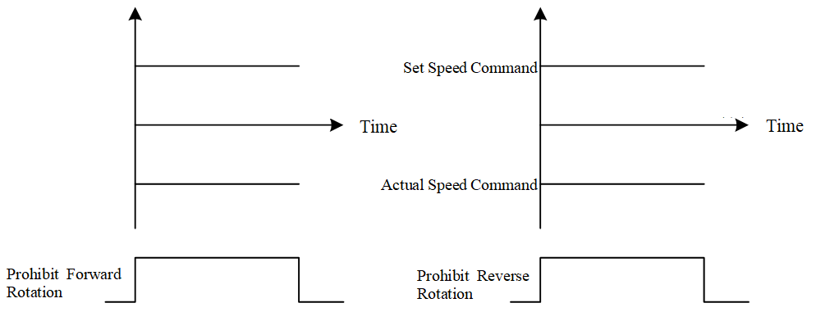
Figure 10-18 Forward/Reverse Prohibition Selection Diagram

The phase sequence switching diagram is shown in Figure 10-19:
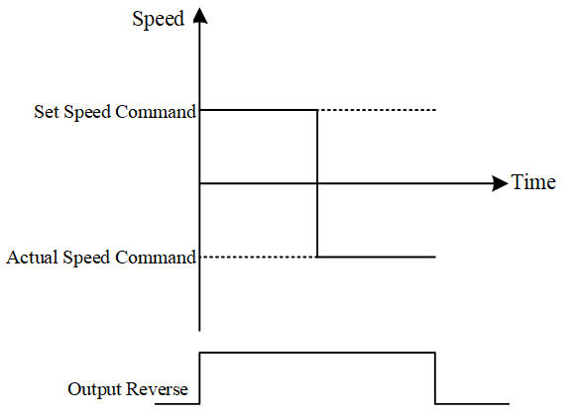
Figure 10-19 Phase Sequence Switching Diagram
The relevant parameters are shown in Table 10-23:
Table 10-23 Forward/Reverse Prohibition Parameters
Parameter | Function Definition | Default Value | Setting Range | Parameter Description
F0-09 | Forward/Reverse Prohibition Selection | 0 | 0: Forward/Reverse Enabled  1: Reverse Prohibited  2: Forward Prohibited | Setting value 0: Normal output according to command direction;  Setting value 1: Only forward rotation regardless of set direction;  Setting value 2: Only reverse rotation regardless of set direction;
F7-42 | Output Phase Sequence Switching | 0 | 0~1 | 0: Output according to the command direction normally.  1: Output frequency opposite to the command direction; forward rotation changes to reverse rotation, and reverse rotation changes to forward rotation for the same frequency command.  Note: The output phase sequence switching and forward/reverse rotation prohibition selection can be used together; however, if the prohibited rotation direction setting matches the direction after phase sequence switching, the output phase sequence switching function will not be effective.
Precautions:
- Do not modify the forward/reverse rotation prohibition selection while the inverter is running;
- Do not modify the output phase sequence switching while the inverter is running;
The output phase sequence switching and forward/reverse rotation prohibition selection can be used together; however, if the prohibited rotation direction setting matches the direction after phase sequence switching, the output phase sequence switching function will not be effective.

Auxiliary frequency function
In some application scenarios, without changing the main frequency command, the auxiliary frequency command can be used to correct the main frequency command, as shown in Table 10-24.
Table 10-24 Parameters related to the auxiliary frequency function
Parameter | Function Definition | Default Value | Setting Range | Parameter Description
F0-07 | Auxiliary Frequency Source | 0 | 0: Disabled  1: Digital Keypad  2: RS485 Communication  3: Analog Input  6: CANopen input (supported by extended models)  7: VR setting | 0: Prohibited; disable the auxiliary frequency function.  1: Set the frequency value using the up/down keys on the keyboard, or set the frequency command value by setting parameter F0-19.  2: RS485 communication; To set the frequency value via RS485 communication, the external device must be connected to the inverter's 485+ and 485- terminals, after which the frequency can be set through the communication method. For details, refer to the 'MODBUS Communication Protocol'.  3: Analog Input; set the frequency value through an analog signal. The frequency value can be set via the analog input channel on the inverter, and the analog input function can be configured as 'Auxiliary Frequency Setting' (set through F5-21, F5-27, or F5-33).  4: External Up/Down input; Set the frequency value through DI terminals by setting the F5 group DI terminal functions to 19, 20 (external command for frequency increase, external command for frequency decrease), then adjust the frequency value using the corresponding DI terminals.  6: CANopen input; Select this command channel to allow external control commands to be sent to the inverter using the CANopen protocol.  7: VR setting, the panel has built-in VR setting for frequency commands.
F0-08 | Frequency Source Superposition Selection | 0 | 0: Main Frequency + Auxiliary Frequency  1: Main Frequency - Auxiliary Frequency  2: Auxiliary Frequency - Main Frequency | 0: Main Frequency + Auxiliary Frequency; the actual set frequency of the inverter is the sum of the main frequency and the auxiliary frequency.  1: Main Frequency - Auxiliary Frequency; The actual set frequency of the inverter is the main frequency minus the auxiliary frequency.  2: Auxiliary Frequency - Main Frequency; The actual set frequency of the inverter is the auxiliary frequency minus the main frequency.
Precautions:
1. The auxiliary frequency source can only be modified when the inverter is stopped;
2. The main and auxiliary frequency function selection can only be modified when the inverter is stopped;
3. The main frequency and auxiliary frequency cannot be set to the same source;
4. When digital inputs are configured as auxiliary frequency disabled (F5-00~F5-04), the auxiliary frequency output function will be disabled;
5. If the result of the main and auxiliary frequency subtraction is negative, negative frequency input must be allowed (set F5-38 to 1) to reverse, otherwise the output frequency will be 0. Additionally, pay attention to the setting of the main and auxiliary reverse stop frequency (FA-27) to avoid the desired reverse output being limited.

Energy Feedback Suppression
When the motor decelerates, the inverter may return energy, causing the bus voltage to rise. If the bus voltage is too high, it can lead to overvoltage faults. Energy feedback suppression can increase motor losses, reduce energy feedback, thereby lowering the probability of overvoltage faults, and also allow the motor to decelerate more quickly.
During deceleration, increasing the motor's magnetic field/magnetic flux/excitation current can increase motor losses and reduce the energy returned to the inverter. This function has two implementation forms, 'Overvoltage Energy Suppression' and 'Traction Energy Control (TEC)'. “Overvoltage Energy Suppression,” will decelerate according to the set deceleration time; the actual fastest deceleration time will not be less than the set deceleration time. “Traction Energy Control” automatically adjusts the output frequency and output voltage based on the inverter's capability to accelerate the consumption of regenerative energy; the deceleration time is the result of automatic adjustment by the inverter. Relevant parameters are shown in Table 10-25.
Table 10-25 Parameters Related to Regenerative Energy Suppression
Parameter | Function Definition | Default Value | Setting Range | Parameter Description
F1-13 | Deceleration Method | 0 | 0~2 | 0: No function; normal deceleration or stop without regenerative energy suppression.  1: Deceleration Mode 1; During deceleration, the inverter will automatically adjust the deceleration curve based on the F9-04 overvoltage stall threshold and the bus voltage.  2: Deceleration Method 2; During deceleration, when the bus voltage is too high, Deceleration Method 2 will be activated, and the inverter will automatically adjust the output frequency and output voltage to achieve the purpose of accelerating the consumption of regenerative energy.
F1-14 | Maximum Flux Braking Current | 1000 | 0~2500 | Limits the maximum current during traction energy control; this parameter can be modified during operation.

Zero Speed Operation Selection
Selects the operating mode of the inverter when the given frequency is less than the minimum output frequency of the motor. This function determines the operating mode of the inverter when the given frequency is less than the minimum output frequency of the motor. At this time, there are three operating modes of the inverter:
- Output waiting, which means not working, with no output on the UVW three phases;
- Zero-speed operation, which means running at a given frequency of zero;
- Operating at the minimum frequency means running at the given frequency as the minimum frequency.
Zero-speed operation selection parameters are shown in Table 10-26.
Table 10-26 Zero-speed Operation Selection Parameters
Parameter | Function Definition | Default Value | Setting Range | Parameter Description
L2-19 | Zero Speed Operation Selection | 0 | 0: Wait for Output  1: Zero Speed Output  2: Output at Minimum Frequency | 0: When the control mode is VF, output waits, and the inverter enters a waiting state (no voltage output on UVW), while zero-speed operation is performed under other control modes.  1: The inverter enters an operating state, but the actual output is zero;  2: The inverter operates according to the set values of multi-point VF frequency point 1 (F2-04) and multi-point VF voltage point 1 (F2-05).

Frequency Command Processing
Process the frequency command sent from the application layer to the drive layer to ensure it remains within a reasonable range. When the given frequency is greater than the allowed maximum frequency, the given frequency is set to the maximum frequency. When the given frequency is less than the allowed minimum frequency, the given frequency is set to the minimum frequency or zero according to the operating mode. The parameters related to frequency setting processing are shown in Table 10-27.
Table 10-27 Parameters Related to Frequency Setting Processing
Parameter | Function Definition | Default Value | Setting Range | Parameter Description
L2-19 | Zero Speed Operation Selection | 0 | 0: Wait for Output  1: Zero Speed Output  2: Output at Minimum Frequency | When the given frequency is less than the 'Minimum Motor Output Frequency Setting', the output mode is determined by this parameter.
F0-10 | Upper Limit Frequency | 599.00Hz | 0.0~599.00Hz | The upper limit of the given frequency, which must be set higher than the 'Lower Limit Frequency' parameter.
F0-11 | Lower Limit Frequency | 0.00Hz | 0.0~599.00Hz | The lower limit of the given frequency, which, together with the 'Minimum Motor Output Frequency Setting', determines the lower limit value of the given frequency. When setting, this parameter must be lower than the 'Upper Limit Frequency' parameter.

Frequency command limit
If the frequency command received by the inverter exceeds the value set by the parameter “Maximum Motor Frequency,” the frequency command will be modified to the value set by the parameter “Maximum Motor Frequency.” Refer to Table 10-28 for related parameters.
Table 10-28 Frequency Command Limit Related Parameters
Parameter | Function Definition | Default Value | Setting Range | Parameter Description
F4-02 | Motor Maximum Frequency | 50.00 or 60.0 Hz | 0.00~599.00Hz | This parameter is used to set the maximum operating frequency of the inverter. If the input frequency command exceeds this parameter setting, the frequency command will be modified to this value. This parameter cannot be modified during operation.

Speed curve
There are two modes of speed curve: normal acceleration/deceleration mode and S-curve acceleration/deceleration mode. When all four function codes are zero, the speed curve operates in normal acceleration/deceleration mode; otherwise, it operates in S-curve acceleration/deceleration mode.
In general acceleration and deceleration modes, the slope of acceleration and deceleration will undergo sudden changes at the start or end of the process, causing significant variations in motor torque within a short period, which can impact both the motor and the load. To reduce this impact, S-curve acceleration and deceleration mode can be used. Under this mode, the slope of the speed curve is continuous, thereby reducing torque shock. Figure 10-20 shows the frequency and acceleration waveforms during normal acceleration and deceleration. It can be seen that the acceleration is discontinuous and may exhibit sudden changes. In contrast, the acceleration during S-curve acceleration and deceleration, as shown in Figure 10-21, is continuously variable, thus using an S-curve can reduce the impact caused by sudden torque changes.
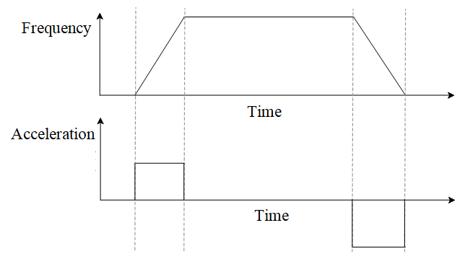
Figure 10-20 General Acceleration/Deceleration Mode
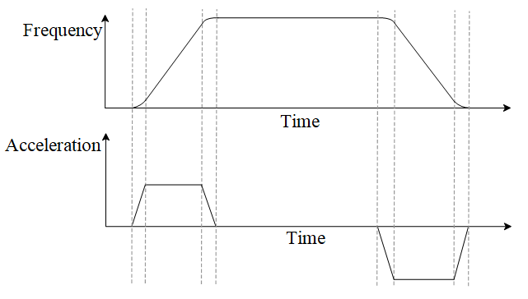
Figure 10-21 S Acceleration/Deceleration Mode
In S acceleration/deceleration mode, the total acceleration and deceleration time will be longer. When accelerating from zero to the maximum operating frequency, the total acceleration time = set acceleration time + (S acceleration time 1)/2 + (S acceleration time 2)/2, the total deceleration time = set deceleration time + (S deceleration time 3)/2 + (S deceleration time 4)/2. As shown in Figure 10-22, S1 represents S acceleration time 1, S2 represents S acceleration time 2, S3 represents S deceleration time 3, and S4 represents S deceleration time 4.
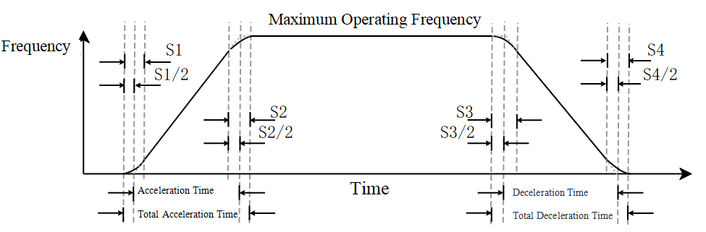
Figure 10-22 S Acceleration/Deceleration Time
Related parameters are shown in Table 10-29:
Table 10-29 Speed Curve Related Parameters
Parameter | Function Definition | Default Value | Setting Range | Parameter Description
F1-16 | S Acceleration Time 1 | 0.2s | 0.00~25.00s (when F0-12=0) or 0.0~250.0s (when F0-12=1) | The above parameters are used to set the S acceleration/deceleration time.
F1-17 | S Acceleration Time 2 | 0.2s | 0.00~25.00s (when F0-12=0) or 0.0~250.0s (when F0-12=1)
F1-18 | S Deceleration Time 1 | 0.2s | 0.00~25.00s (when F0-12=0) or 0.0~250.0s (when F0-12=1)
F1-19 | S Deceleration Time 2 | 0.2s | 0.00~25.00s (when F0-12=0) or 0.0~250.0s (when F0-12=1)
F0-12 | Speed Curve Time Unit | 0 | 0: Unit 0.01 seconds  1: Unit 0.1 seconds | This parameter is used to set the unit of time for the speed curve.

Frequency Jump Function
When operating near the mechanical resonance point of the load, it may cause mechanical resonance of the load, thereby degrading control performance, and in severe cases, it may damage the load. To avoid resonance, the skip frequency function can be used to make the motor bypass the mechanical resonance point. When the set frequency is within the skip frequency range, the actual operating frequency will run at the skip frequency boundary closest to the set frequency. By setting the skip frequency, the inverter avoids the mechanical resonance point of the load. This inverter can set 4 skip frequency points. If two adjacent skip frequencies are set to the same value, this function will not work at that frequency. The frequency hopping function is shown in Figure 10-23, and the relevant parameters are listed in Table 10-30.
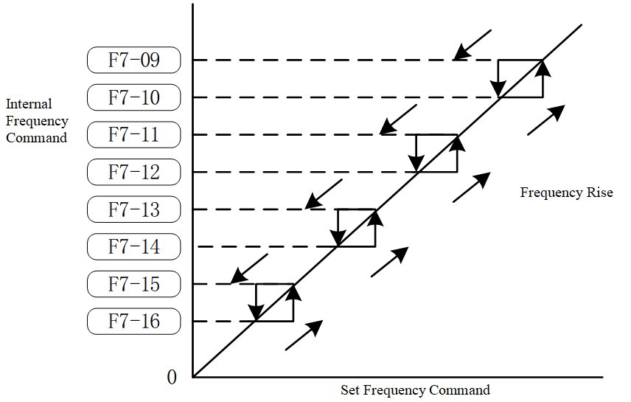
Figure 10-23 Frequency Hopping Function
Table 10-30 Parameters for Frequency Hopping Function
Parameter | Function Definition | Default Value | Setting Range | Parameter Description
F7-09 | Jump Frequency 1 Upper Limit | 0.00Hz | 0.00~599.00Hz | These eight parameters are used to set prohibited frequency settings. The inverter's frequency setting will skip these frequency ranges, but the output frequency remains continuous. There are no size limitations for these eight parameters, and they can be combined. The setting value of parameter F7-09 does not need to be greater than the setting value of parameter F7-10, the setting value of parameter F7-11 does not need to be greater than the setting value of parameter F7-12, the setting value of parameter F7-13 does not need to be greater than the setting value of parameter F7-14, and the setting value of parameter F7-15 does not need to be greater than the setting value of parameter F7-16. Parameters F7-09 to F7-16 can be set according to user needs, with no greater than or less than relationships between them. These parameters define the frequency range in which the inverter is prohibited from operating. This function can be used to prevent resonance caused by the natural frequency of the mechanical system. This function ensures that the inverter does not continuously operate at the resonant frequency of the mechanical system or load system, or other frequencies where operation is prohibited, thus avoiding resonance at each frequency point. Four zones are available for use. The frequency command (F) can still be set within the prohibited operating frequency range; in this case, the output frequency (H) will be limited to the lower limit of the prohibited operating frequency range. When the inverter is accelerating or decelerating, the output frequency may still pass through the prohibited operating frequency range.
F7-10 | Jump Frequency 1 Lower Limit | 0.00Hz | 0.00~599.00Hz
F7-11 | Jump Frequency 2 Upper Limit | 0.00Hz | 0.00~599.00Hz
F7-12 | Jump Frequency 2 Lower Limit | 0.00Hz | 0.00~599.00Hz
F7-13 | Jump Frequency 3 Upper Limit | 0.00Hz | 0.00~599.00Hz
F7-14 | Jump Frequency 3 Lower Limit | 0.00Hz | 0.00~599.00Hz
F7-15 | Jump Frequency 4 Upper Limit | 0.00Hz | 0.00~599.00Hz
F7-16 | Jump Frequency 4 Lower Limit | 0.00Hz | 0.00~599.00Hz

Automatic Acceleration and Deceleration
In practical applications, the setting of acceleration and deceleration times is influenced by factors such as load conditions and motor inertia, and may require multiple adjustments to determine. If the acceleration time is too short, it may cause excessive acceleration current, leading to overcurrent; If the deceleration time is too short, it may result in excessively high bus voltage, causing overvoltage. The automatic acceleration and deceleration function can automatically adjust the acceleration and deceleration times based on actual conditions, simplifying the commissioning process.
The automatic acceleration and deceleration function consists of two parts: automatic acceleration and automatic deceleration. The automatic acceleration function allows the motor to accelerate to the set frequency at the fastest possible acceleration time while ensuring a smooth start-up current and preventing stalling. The automatic deceleration function can reduce the motor speed to the set frequency or stop operation in the shortest time possible, ensuring that overvoltage does not occur even without a braking resistor. The automatic acceleration and deceleration functions can be individually enabled or disabled to meet different requirements, as shown in Table 10-31.
Table 10-31 Automatic Acceleration and Deceleration Parameters
Parameter | Function Definition | Default Value | Setting Range | Parameter Description
F1-20 | Automatic Acceleration and Deceleration Selection | 0 | 0: Linear Acceleration and Deceleration  1: Automatic acceleration with linear deceleration;  2: Linear acceleration with automatic deceleration;  3: Automatic acceleration and deceleration;  4: Linear Acceleration and Deceleration, with Suppression of Automatic Acceleration and Deceleration | 0: Linear acceleration and deceleration; both automatic acceleration and deceleration functions are disabled.  1: Automatic acceleration with linear deceleration; automatic acceleration function is enabled, and automatic deceleration function is disabled.  2: Linear acceleration and automatic deceleration; automatic acceleration function is off, and automatic deceleration function is on.  3: Automatic acceleration and deceleration; both automatic acceleration and deceleration functions are on.  4: Linear acceleration and deceleration, with automatic acceleration and deceleration suppression; when the current is too high, the automatic acceleration function is on; when the bus voltage is too high, the automatic deceleration function is on; in other cases, both automatic acceleration and deceleration functions are off.
F1-21 | Automatic Acceleration and Deceleration Kp | 200 | 0~65535 | When the automatic acceleration and deceleration function is on, it is used to set the PI regulator parameters to adjust the acceleration and deceleration slope.
F1-22 | Automatic Acceleration and Deceleration Ki | 0.400 | 0~65.535

Overcurrent Stall

10.4.16.1 Overcurrent Stall During Acceleration
Generally speaking, the faster the acceleration, the greater the torque current required. If the acceleration is too fast, it may result in excessive motor current. To protect the motor and inverter, current must be limited; the overcurrent stall during acceleration function can prevent overcurrent conditions caused by too rapid acceleration.
The principle of overcurrent flux loss during acceleration is shown in Figure 10-24. When the current exceeds the set value, the inverter stops accelerating until the current drops below the set value, at which point the inverter resumes acceleration.
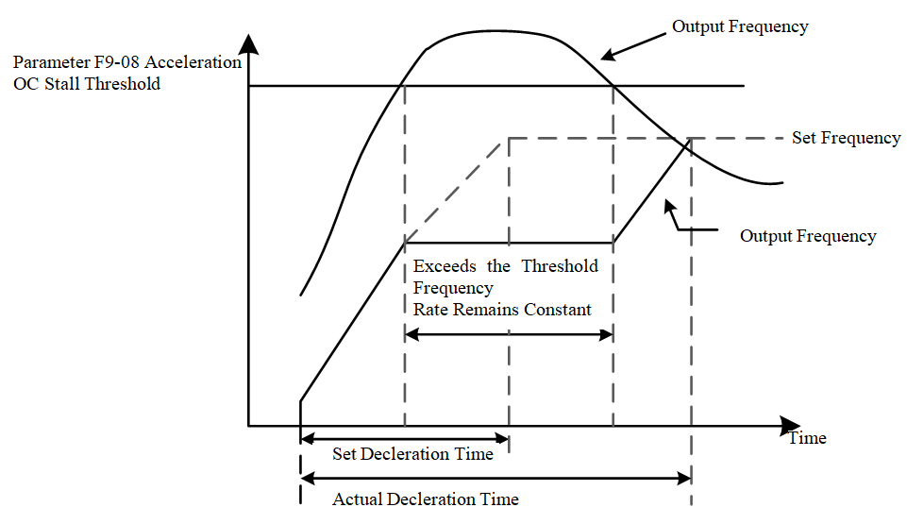
Figure 10-24 Overcurrent Flux Loss During Acceleration
For the overcurrent flux loss prevention level in the weak magnetic region, refer to the description of parameter F9-09; the protection curve is shown in Figure 10-32.
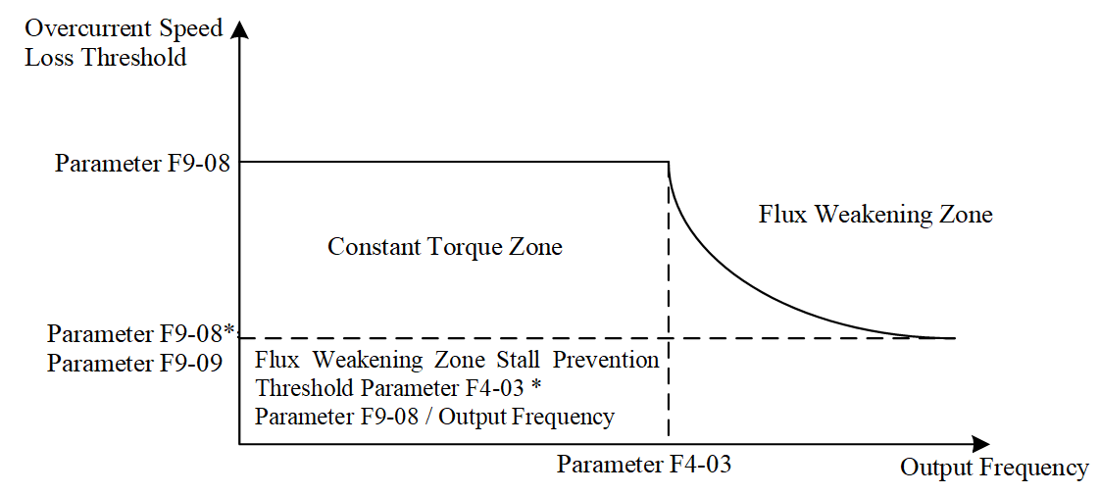
Figure 10-25 Current Loss Stall in Weak Magnetic Region
When overcurrent flux loss prevention is activated, the inverter's acceleration time will be longer than the set time. If the stall state occurs due to insufficient motor capacity or operation under factory settings, reduce the setting value of parameter F9-08.
If the acceleration time cannot be extended due to this function, it needs to be disabled to prevent overcurrent. The following measures can be taken:
  - Appropriately increase the acceleration time;
  - Set parameter F1-20 Automatic Acceleration and Deceleration selection to 1, 3, or 4 for automatic acceleration.
Related parameters are shown in Table 10-32:
Table 10-32 Overcurrent Stall Parameters During Acceleration
Parameter | Function Definition | Default Value | Setting Range | Parameter Description
F9-08 | Overcurrent (OC) During Acceleration  Stall Threshold | 150% | 0~200% | This parameter is used to set the overcurrent stall prevention threshold during acceleration, expressed as a percentage, based on the rated current of the inverter. When the inverter accelerates, if the output current exceeds the value set by F9-08, the inverter will stop accelerating. When the current falls below the value set by F9-08, the inverter resumes acceleration to the set frequency.
F9-09 | Overcurrent Stall  Limit Threshold | 100% | 0~100% | This parameter is used to set the overcurrent stall prevention threshold during acceleration when weakening the magnetic field. When the motor operating frequency is greater than the rated frequency, the acceleration overcurrent stall prevention threshold equals the F9-08 set value × the F9-09 set value.

10.4.16.2 Overcurrent Stall During Constant Speed
Generally, if the motor load is greater, the motor current will also be greater. If the motor load is too high, it can lead to excessive motor current. If the motor load exceeds the motor's capacity, it may even result in loss of control. The constant speed stall overcurrent function can prevent the aforementioned issues of excessive current or loss of control.
The principle of the constant speed overcurrent stall function is shown in Figure 10-26, and the relevant parameters are listed in Table 10-33. When the motor current exceeds the set value, the inverter begins to decelerate until the current drops below the allowable value, at which point the motor reaccelerates to the set frequency.
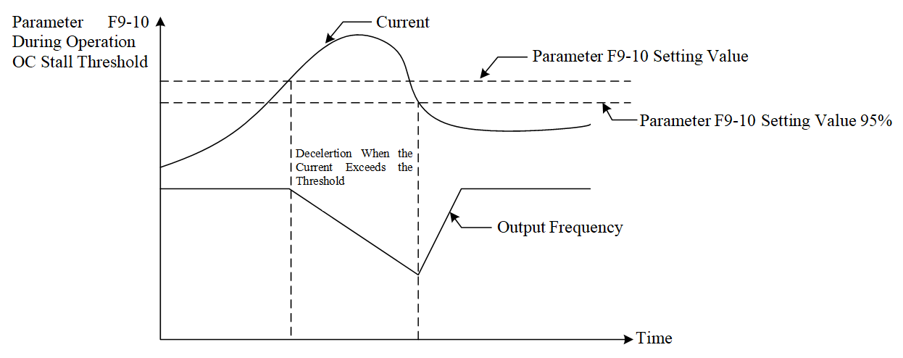
Figure 10-26 Constant Speed Overcurrent Stall
Table 10-33 Overcurrent Stall Parameters During Operation
Parameter | Function Definition | Default Value | Setting Range | Parameter Description
F9-10 | Overcurrent Stall Threshold at Constant Speed | 150% | 0~200% | This parameter is used to set the overcurrent stall prevention threshold during constant speed operation, with units in %, based on the rated current of the inverter. When the inverter is running, if the output current exceeds the F9-10 set value, the inverter will decelerate according to the acceleration/deceleration time selected by F9-11 to prevent motor stall. When the output current is below 95% of the set value in F9-10, the inverter will re-accelerate to the set frequency according to the acceleration/deceleration time selected in parameter F9-11.
F9-11 | Overcurrent Stall Acceleration/Deceleration Selection at Constant Speed | 0 | 0: System acceleration/deceleration time;  1: First acceleration/deceleration time;  2: Second acceleration/deceleration time;  3: Third acceleration/deceleration time;  4: Fourth acceleration/deceleration time;  5: Automatic acceleration/deceleration time. | This parameter is used to select the acceleration/deceleration time for overcurrent stall action.

Overvoltage Stall
When the motor decelerates, it may feed energy back to the inverter, causing the inverter's bus voltage to rise. If the bus voltage becomes too high, it may lead to an overvoltage fault. The overvoltage stall function adjusts the slope of the speed curve to avoid overvoltage as much as possible.
When an overvoltage on the bus is detected, the motor deceleration slope is reduced; if the bus voltage is not too high, it maintains the normal deceleration slope or decelerates at the maximum deceleration slope. In this way, the bus voltage can be kept within a reasonable range during motor deceleration, avoiding overvoltage conditions.
There are several methods to implement overvoltage stall; Figure 10-27 shows one method where, when the bus voltage reaches the overvoltage detection level, the inverter stops decelerating, causing the bus voltage to start dropping. Once it drops to the overvoltage recovery level, the inverter resumes deceleration.
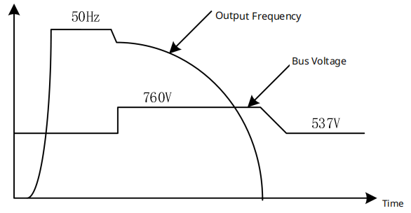
Figure 10-27 Overvoltage Stall Prevention Method 1
When overvoltage stall prevention is activated, the inverter's deceleration time will be longer than the set time. If automatic adjustment of the deceleration time is not allowed, this function must be disabled. To prevent overvoltage, the following measures can be taken:
1. Appropriately increase the deceleration time;
2. Install a braking resistor to dissipate the motor's feedback energy.
Figure 10-28 shows another implementation method. During motor deceleration, the inverter's deceleration slope is controlled to ensure that the bus voltage does not exceed the set value. Relevant parameters are shown in Table 10-34.
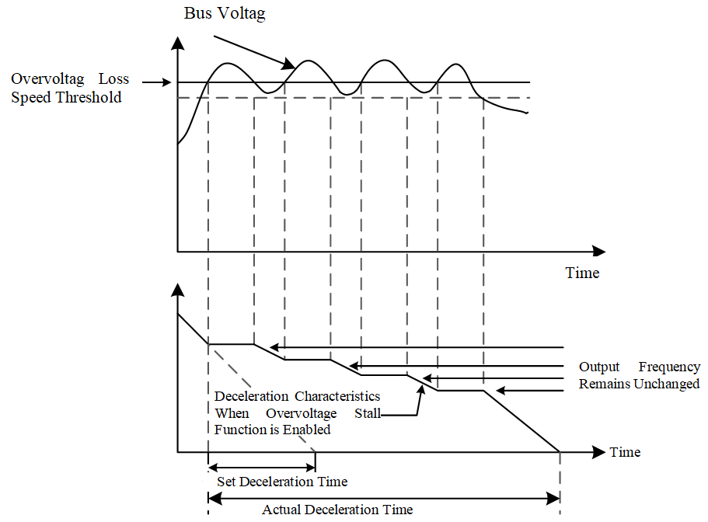
Figure 10-28 Overvoltage Stall Prevention Method 2
Table 10-34 Overvoltage Stall Related Parameters
Parameter | Function Definition | Default Value | Setting Range | Parameter Description
F9-03 | Overvoltage Stall Mode | 0 | 0: Overvoltage Stall Mode 0  1: Overvoltage Stall Mode 1 | 0: Overvoltage stall mode 0; If the inverter detects that the bus voltage is higher than the set value of F9-04, the inverter will stop decelerating (the output frequency remains unchanged) until the bus voltage falls below the set value of F9-58, at which point the inverter will resume deceleration.  1: Overvoltage stall mode 1; During the deceleration process, dynamically adjust the speed curve to prevent overvoltage faults due to excessively high bus voltage.
F9-04 | Overvoltage Stall Threshold | 760.0V/380.0V | 0.0~900.0V/0.0~450.0V | When the set value is 0.0, the overvoltage stall prevention function is disabled. When the inverter is equipped with a braking unit and connected to a braking resistor, it is recommended to use this setting. When the setting value is not 0.0, the overvoltage stall prevention function is effective. This parameter can be set according to the power supply and load conditions. If set too low, it may prolong the deceleration time. If the setting value exceeds the overvoltage protection point, the overvoltage stall prevention function is considered disabled.
F9-05 | Overvoltage Stall Deceleration Time | 600.00 | 0.00~655.35 | Overvoltage Stall Deceleration Time

PID function
The PID principle block diagram is shown in Figure 10-29:

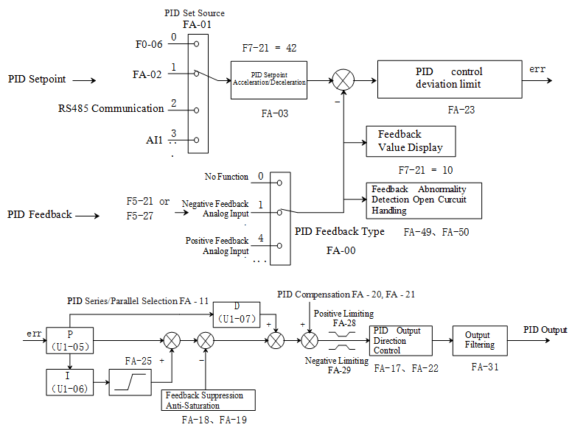
Figure 10-29 PID Principle Block Diagram
The PID series control block diagram is shown in Figure 10-30:
Figure 10-30 PID Series Control Block Diagram
The PID parallel control block diagram is shown in Figure 10-31:
Figure 10-31 PID Parallel Control Block Diagram
The related parameters are shown in Table 10-35:
Table 10-35 PID Function Related Parameters
Parameter | Function Definition | Default Value | Setting Range | Parameter Description
FA-00 | PID Feedback Type Selection | 0 | 0: No Function  1: Negative Feedback Analog Input  4: Positive Feedback Pulse Input  7: Negative Feedback Communication Input  8: Positive Feedback Communication Input | Positive Feedback: If the feedback value is less than the PID setpoint, the inverter output frequency increases;  Negative Feedback: If the feedback value is less than the PID setpoint, the inverter output frequency decreases.
FA-01 | PID Setpoint Source Selection | 0 | 0: Frequency Command  1: Parameter FA-02  2: RS485 Communication  3: Analog Input  4: CANopen | This parameter selects the channel for the PID target setting.
FA-02 | PID Setpoint Value | 50.00% | -100.00%～100.00% | When FA01 (PID Setpoint Source) is set to 1, this parameter must be configured. This parameter is a relative value, where 100% corresponds to the maximum feedback value of the controlled system.-
FA-03 | PID Setpoint Change Time | 0.00s | 0.00s～655.35s | The time required for the PID setpoint (parameter FA-02) to change from 0.0% to 100.0%. When the PID setpoint changes, the actual setpoint does not respond immediately but changes linearly over the given time to prevent sudden changes in the setpoint.
FA-04 | PID Feedback Filter Time | 5.0s | 0.1s～300.0s | Filter the PID feedback value; this parameter helps reduce the impact of disturbances on the feedback but may degrade the response performance of the closed-loop control process.
FA-05 | Proportional Coefficient 1 | 8.00% | 0.00%～99.99% | The speed at which the deviation decreases depends on the proportional coefficient; the larger the proportional coefficient, the faster the deviation decreases. However, an excessively large proportional coefficient can cause significant overshoot and oscillation, reducing stability, especially in systems with large lag. Reducing the proportional coefficient decreases the possibility of system oscillation but slows down the response speed. When executing 2ms enhanced PID control (parameter FA-12=0), the number of decimal places for this parameter can be selected by parameter FA-53 bit 1, 0: 1 decimal place, 1: 2 decimal places.
FA-06 | Integral Time 1 | 0.05s | 0.00s～99.99s | This parameter determines the strength of the integral action of the PID controller. The smaller the integral time, the stronger the integral action, which helps reduce overshoot, decrease oscillation, and make the system more stable, but the elimination of static error in the system will become slower.
FA-07 | Differential Time 1 | 0.00s | 0.00s～1.00s | This parameter determines the strength of the PID controller's response to the rate of change of the error. The longer the differential time, the stronger the adjustment. When this parameter is set appropriately, it can reduce overshoot and shorten the adjustment time. Differential action amplifies noise interference; therefore, excessive differential control is detrimental to the system's ability to resist interference. Additionally, when there is no change in the input, the output of the differential action is zero. Therefore, differential control is often combined with the other two control laws to form a PD controller or a PID controller.
FA-08 | Proportional Coefficient 2 | 20.00 | 0.00～99.99 | Same as parameter FA-05, no further details here
FA-09 | Integral Time 2 | 0.08s | 0.00s～99.99s | Same as parameter FA-06, no further details here
FA-10 | Differential Time 2 | 0.00s | 0.00s～1.00s | Same as parameter FA-07, no further details here
FA-11 | PID Series/Parallel Selection | 1 | 0: Kp, Kp*Ki, Kp*Kd  1: Kp, Ki, Kd | 0: Series, traditional PID control architecture  1: Parallel, which means separating proportional control, integral control, and derivative control, allowing users to adjust P, I, D controllers separately according to application needs; parallel-type PID is selected by default.
FA-12 | PID Control Execution Cycle | 0 | 0: Perform 2ms enhanced PID control  1: Perform 1ms traditional PID control | FA-12=0, the user selects to execute process PID control once every 2ms cycle, the PID output frequency reference base can be set according to parameter FA-30, choosing either 100.00% corresponding to the maximum output frequency or 100.00% corresponding to the auxiliary frequency. For example, if the user enables the main and auxiliary frequency function (assuming the selection of main frequency + auxiliary frequency, parameter F0-07=1, F0-08=0), and sets the PID output frequency reference to the auxiliary frequency (FA-30=1), and the keyboard sets the auxiliary frequency to 40Hz, then the maximum PID output frequency will be 40Hz. When FA-12=1, the user selects a 1ms cycle to execute process PID control once, where 100.00% PID output corresponds to the maximum output frequency, and there is no auxiliary frequency option for the reference benchmark. Additionally, the enhanced PID option (FA-12=0) supports soft start and automatic switching of two sets of PID parameters based on output frequency or deviation, while the traditional PID option (FA-12=1) does not have these functions.
FA-13 | PID Parameter Switching Conditions | 0 | 0: No Function  1: Switch based on output frequency  2: Switch based on PID deviation | 0: Use the first set of PID parameters FA-05~FA-07  1: Automatically adjust based on output frequency. Use the first set of PID parameters FA-05~FA-07 when operating at or below the minimum frequency F2-04, use the second set of PID parameters FA-08~FA-10 when operating at the maximum frequency F4-02, and use a linear interpolation value of the two sets of PID parameters when the operating frequency is between F2-04 and F4-02.  2: Automatically switch based on the deviation between setpoint and feedback. Use the first set of PID parameters FA-05~FA-07 when the absolute value of the deviation between setpoint and feedback is less than PID parameter switching deviation 1 (parameter FA-14). Use the second set of PID parameters FA-08~FA-10 when the absolute value of the deviation between setpoint and feedback is greater than PID parameter switching deviation 2 (parameter FA-15). When the absolute value of the given and feedback deviation varies between FA-14 and FA-15, the PID parameters are the linear interpolation values of two sets of PID parameters.
FA-14 | PID Parameter Switching Error 1 | 10.00% | 0.00%～100.00%
FA-15 | PID Parameter Switching Error 2 | 40.00% | 0.00%～100.00%
FA-16 | Allow PID Reverse Delay | 0.0s | 0.0s～999.9s | When parameter FA-16≠0, the reverse function after startup is enabled. For example, setting FA-16=2.0 means that during the start-up period of 0 to 2 seconds, PID control is not allowed to change the direction of operation (parameter FA-17=0), and after 2 seconds of start-up, PID control is automatically allowed to change the direction of operation (parameter FA-17 will be automatically updated to 1).
FA-17 | PID Direction Change Selection | 0 | 0: Disabled  1: Enabled | 0: Cannot Change Running Direction  1: Can Change Running Direction
FA-18 | Feedback Suppression Deviation Rate | 10% | 0%～100% | When the setpoint and feedback deviation are in opposite directions, parameters FA-18 and FA-19 provide feedback suppression anti-integral windup functionality to quickly exit the saturation state and respond rapidly to external inputs, avoiding prolonged controller output saturation and improving the controller's response capability. The controller performs anti-integral windup suppression based on the relationship between the feedback suppression deviation rate (Parameter FA-18) and the 100ms deviation rate.
FA-19 | Feedback Suppression Gain | 800 | 0～1000
FA-20 | PID Compensation Selection | 0 | 0: Parameter Setting  1: Analog Input | When FA-20=0, the PID compensation value (parameter FA-21) must be set.
FA-21 | PID Compensation Value | 0.0 | -99.9～99.9 | The reference for this parameter is the maximum output frequency F4-02. Example: If the maximum output frequency parameter F4-02=50.00Hz, and FA-21 is 10.0%, the PID compensation will increase the output frequency by 5.00Hz.
FA-22 | PID Deviation Deadband Limit | 0.06% | 0.00%～99.99% | When the PID control output exceeds FA-22, the PID regulation output becomes effective; otherwise, the PID regulator is inhibited, preventing the actuator from oscillating when the PID output is small.
FA-23 | PID Control Deviation Limit | 0.00% | 0.00%～99.99% | This parameter determines the level at which the deviation between the feedback and setpoint signals causes the PID regulation to stop, maintaining the previous output value. PID control output is only executed when the deviation between the feedback value and the setpoint exceeds the PID control deviation limit FA-23. Properly setting this parameter can adjust the accuracy and stability of the PID system. The functional diagram is as follows:  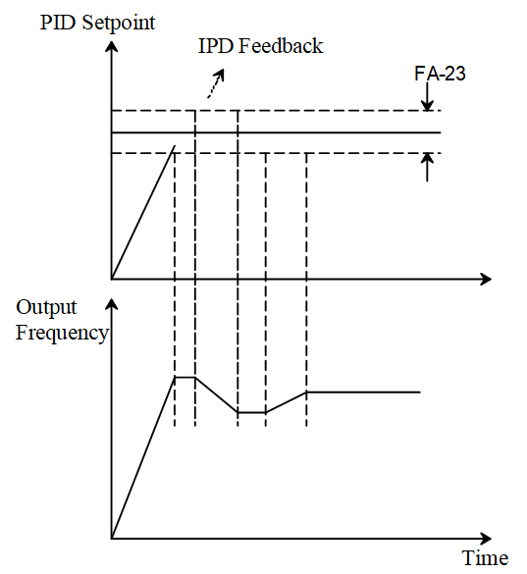
FA-24 | Integral Separation Level | 0.00% | 0.00%～99.99% | When the PID feedback overshoot is large at startup, integral separation can be enabled to reduce overshoot, with the parameter benchmark being the PID deviation. When FA-24≠0, the integral separation function is activated, and it only operates once at startup. When the deviation between the setpoint and the feedback value exceeds the parameter FA-24, integral separation occurs to prevent excessive overshoot due to integral action; When the deviation is less than parameter FA-24, the integral action takes effect to eliminate steady-state error.
FA-25 | Integral Upper Limit | 100.0% | 0.00%～100.00% | This parameter is the upper limit of integration, with the reference being the maximum output frequency F4-02. When the integral value is too large, if the load suddenly changes, the inverter's response speed slows down, which may cause motor slippage or mechanical damage; at this time, the parameter FA-25 can be appropriately reduced.
FA-26 | Wake-up Integral Limit | 50.0% | 0.0%～200.0% | This parameter is the upper limit of wake-up integration, used to reduce the reaction time from sleep to wake-up, with the reference being the maximum output frequency F4-02.
FA-27 | Main Auxiliary Reverse Cut-off Frequency | 10.0% | 0.00%～100.00% | In some cases, only when the PID output frequency is negative (i.e., the inverter is running in reverse), can the PID possibly bring the setpoint and feedback to the same state; however, excessive reverse frequency is not allowed in certain situations. Parameter FA-27 is used to determine the upper limit of the reverse frequency. The reference base for this parameter is the maximum output frequency F4-02.
FA-28 | PID Output Positive Limit | 100.0% | 0.00%～100.00% | This parameter is the upper limit value of the PID control output command, with the reference base being the maximum output frequency F4-02.
FA-29 | PID Output Negative Limit | 100.0% | 0.00%～100.00% | When PID output reversal is allowed, the PID output will be negative, at which point the output will be limited to the value set by parameter FA-29, and it should be used in conjunction with parameter FA-17.
FA-30 | PID Output Frequency Reference | 0 | 0～1 | 0: PID control output 100.00% corresponds to maximum output frequency F4-02;  1: PID control output 100.00% corresponds to auxiliary frequency (if the auxiliary frequency command changes, the PID output frequency will also change).
FA-31 | PID Output Filter Time | 0.0s | 0.0s～2.5s | This parameter is used to set the low-pass filter time for PID control output; the larger the parameter value, the greater the PID output filtering, and the slower the change in output frequency. Improper setting of parameter FA-31 may affect the response speed of the inverter and even cause system oscillation.
FA-32 | Soft Start-PID Switching Value | 5.00% | 0.00%～100.00% | This parameter is based on the deviation between the PID setpoint and feedback value.
FA-33 | Soft Start Frequency | 0.00Hz | 0.00Hz～599.00Hz | When parameter FA-35 ≠ 0 and the inverter output current exceeds FA-35, it starts at the soft start frequency (parameter FA-33) and the soft start acceleration step (parameter FA-36), until the soft start acceleration time (parameter FA-34) is reached, then normal PID control begins.
FA-34 | Soft Start Acceleration Time | 3.00s | 0.00s～600.00s
FA-35 | No Load Current | 0.00A | 0.00A～655.35A
FA-36 | Soft Start Acceleration Step | 0.10s | 0.00s～600.00s
FA-49 | Feedback Abnormality Detection Time | 0.0s | 0.0s～999.9s | This parameter is used to detect possible abnormalities or extremely slow responses in the feedback analog quantity; FA-49 = 0 means no detection. When the analog signal sample value is below the 4~20mA open circuit threshold (parameter F5-43) and the duration exceeds FA-49, the feedback analog signal is abnormal, and the inverter performs abnormal action handling according to the setting of parameter FA-50, with the operation panel displaying an “AFE” prompt.
FA-50 | Feedback Disconnection Action Selection | 0 | 0: Alarm and continue running;  1: Alarm and decelerate to stop;  2: Alarm and free stop;  3: Run at the frequency before disconnection. | Used to set the handling method for feedback disconnection faults
FA-51 | PID Feedback Abnormal Deviation | 10.0% | 1.0%～50.0% | When the deviation between the setpoint and feedback signal exceeds the threshold (parameter FA-51) and the duration exceeds the deviation abnormality detection time FA-52, a PID deviation abnormality occurs. If the function selection of output terminals F6-00~F6-03 is 15, the output terminal will indicate a PID deviation warning.
FA-52 | Abnormal Deviation Detection Time | 5.0s | 0.1s～300.0s
FA-53 | PID Control Flag | 2 | 0～65535 | PID control flag (bits 0~2 valid)  bit0: PID reverse action selection, 0: PID reverse according to PID calculation value, 1: Reverse according to parameter F0-09.  bit1: PID parameter Kp decimal point position selection, 0: 1 decimal place, 1: 2 decimal places.  bit2: 0: no function, 1: when the main and auxiliary frequency function is enabled, the integral upper limit base value is the auxiliary frequency.
  - Application Control
    - Jog Operation
Jog operation is a common function of inverters, often used during equipment debugging or when precise adjustments are needed. During jog operation, after receiving the jog command, the inverter controls the motor to accelerate to the jogging frequency according to the jog acceleration time. When the jog command is removed, depending on the stopping method, the inverter controls the motor to decelerate and stop according to the jog deceleration time or uses other stopping methods. Relevant parameters are shown in Table 10-36.
Table 10-36 Jog Operation Related Parameters
Parameter | Function Definition | Default Value | Setting Range | Parameter Description
F7-00 | JOG Frequency Setting | 6.00Hz | 0.00~599.00Hz | The above parameters are used to set the jogging operation frequency, the time to accelerate from 0.00Hz to the jogging operation frequency, and the time to decelerate from the jogging operation frequency to 0.00Hz. During jogging operation, when a jogging command is received, the inverter controls the motor to accelerate to the jogging frequency according to the jogging acceleration time. When the jogging command is removed, depending on the stop method, the inverter controls the motor to decelerate and stop according to the jogging deceleration time or adopts other stopping methods.
F7-01 | JOG Acceleration Time | 10.00s | 0.00~600.00s or 0.0~6000.0s
F7-02 | JOG Deceleration Time | 10.00s | 0.00~600.00s or 0.0~6000.0s
F0-12 | Speed Curve Time Unit | 0 | 0: Acceleration/Deceleration Unit 0.01 seconds  1: Acceleration/Deceleration Unit 0.1 seconds | This parameter is used to set the unit of time for the speed curve.
    - Fan Control
Inverters are typically equipped with fans. When the fan operates, it can accelerate air circulation, thereby reducing the internal temperature of the inverter. Relevant parameters are shown in Table 10-37. The fan operation status can be determined by the inverter's operating status, module temperature, etc. Currently, several different fan operation modes are provided, which can be selected according to needs.
Table 10-37 Fan Control Related Parameters
Parameter | Function Definition | Default Value | Setting Range | Parameter Description
F7-17 | Fan Control Method | 4 | 0: Fan Runs Continuously  1: Stop 1 Minute After Shutdown  2: Stop with Inverter  3: Start at 50°C  4: Fan Starts During Operation, Stops Below 48°C When Stopped, Continues Running Above 50°C | 0: After power-on, the fan runs continuously.  1: The inverter runs the fan, which is turned off 1 minute after the inverter stops.  2: The fan operates according to the inverter's running status; it starts when the inverter is running and stops when the inverter stops.  3: When the module temperature > 50°C, the fan starts; when the module temperature < 48°C and the inverter has stopped running, the fan stops.  4: The inverter runs the fan, which is turned off when the module temperature drops below 48°C after the inverter stops, and continues to run if the temperature rises above 50°C.
    - Base Block
When the external controller detects an abnormal condition, it may be necessary for the inverter to stop immediately; at this time, the base blocking function of the inverter needs to be used. When a base blocking signal is received, the inverter stops PWM output. After the base blocking signal is removed, the inverter resumes operation after a certain delay (which can be set through parameters). Additionally, if the inverter's stopping method is free stop, after stopping, it is necessary to wait for the time set by this function code before it can run again, as shown in Table 10-38.
Table 10-38 Base Blocking Related Parameters
Parameter | Function Definition | Default Value | Setting Range | Parameter Description
F1-31 | Base Lockout Interruption Time | 0.5s | 0.0~5.0s | Used to set the waiting time from when the inverter stops output to when it restarts.
    - Bus Voltage Compensation
When the bus voltage changes, the output voltage may also change, which can affect the motor control performance. The bus voltage compensation function (Automatic Voltage Regulation function, AVR) can compensate for output voltage variations caused by changes in bus voltage, making the motor control performance more stable.
When the bus voltage increases, appropriately reduce the output duty cycle; when the bus voltage decreases, appropriately increase the output duty cycle. This maintains a constant output voltage. In actual use, the duty cycle calculated by the control algorithm can be multiplied by the reciprocal of the bus voltage reference value and the actual value to achieve this. The parameters related to bus voltage compensation are shown in Table 10-39.
Table 10-39 Parameters Related to Bus Voltage Compensation
Parameter | Function Definition | Default Value | Setting Range | Parameter Description
F7-37 | Automatic Voltage Regulation | 0 | 0: Enable AVR function;  1: Disable AVR function;  2: Disable AVR during deceleration. | 0: AVR function enabled, the inverter calculates the output voltage based on the bus voltage, ensuring that the output voltage does not fluctuate with changes in bus voltage.  1: AVR function is off, the inverter does not calculate the output voltage based on the bus voltage, the output voltage will fluctuate with the bus voltage fluctuations, which can lead to fluctuations in motor current.  2: The AVR function is turned off during deceleration but remains on in other states. Turning off the AVR function during deceleration can shorten the deceleration time.
    - Frequency Hold
In applications such as elevators and cranes, to improve reliability, it is often necessary to run at a certain frequency for a period of time before continuing to accelerate to the set frequency when starting, and to run at a certain frequency for a period of time before decelerating to zero speed when stopping. The above can be achieved through the frequency hold function.
The frequency holding function includes start-up holding and stop holding, which process the speed curve during start-up and stop, respectively. As shown in Figure 10-32, the parameters for start-up holding frequency, start-up holding time, stop holding frequency, and stop holding time can be adjusted to meet different requirements.
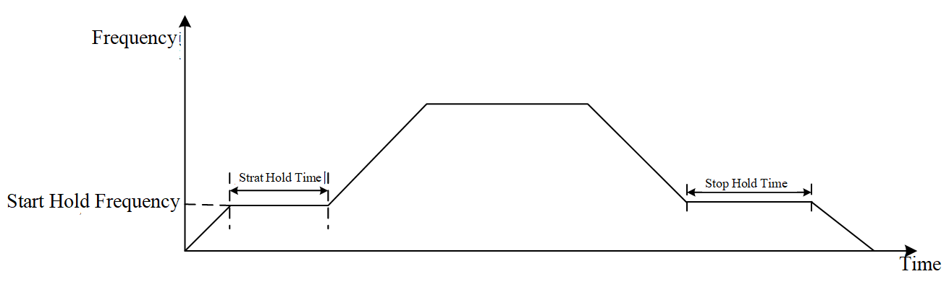
Figure 10-32 Frequency Holding
Frequency holding related parameters are shown in Table 10-40:
Table 10-40 Frequency Holding Related Parameters
Parameter | Function Definition | Default Value | Setting Range | Parameter Description
F1-06 | Start hold time | 0.00s | 0.00~600.00s | F1-06 start-up holding time and F6-07 start-up holding frequency can be set to configure the start-up frequency holding function.
F1-07 | Startup Hold Frequency | 0.00s | 0.00~599.00Hz
F1-26 | Stop Holding Time | 0.00s | 0.00~600.00s | F1-26 stop holding time and F1-27 stop holding frequency can be set to configure the stop frequency holding function.
F1-27 | Stop Holding Frequency | 0.00s | 0.00~599.00Hz
    - Start/Stop DC Braking
When the inverter starts, if the motor is still rotating, it may cause significant impact. To avoid this situation, the motor can be braked first until it stops rotating before starting again. The start DC braking function generates braking torque by injecting DC current into the motor windings, as shown in Figure 10-33.
When the inverter stops, the motor may not come to a complete stop. To prevent this, the stop DC braking function can be used to brake the motor after stopping, ensuring that the motor does not rotate after stopping. The stop DC braking function injects DC current into the motor windings during stopping to generate braking torque, achieving the purpose of braking. Starting DC braking is typically used in situations such as fans, where the motor may still be rotating when the inverter starts. In this case, starting DC braking can be used to stop the motor before restarting. Stopping DC braking can ensure that the motor stops during shutdown.
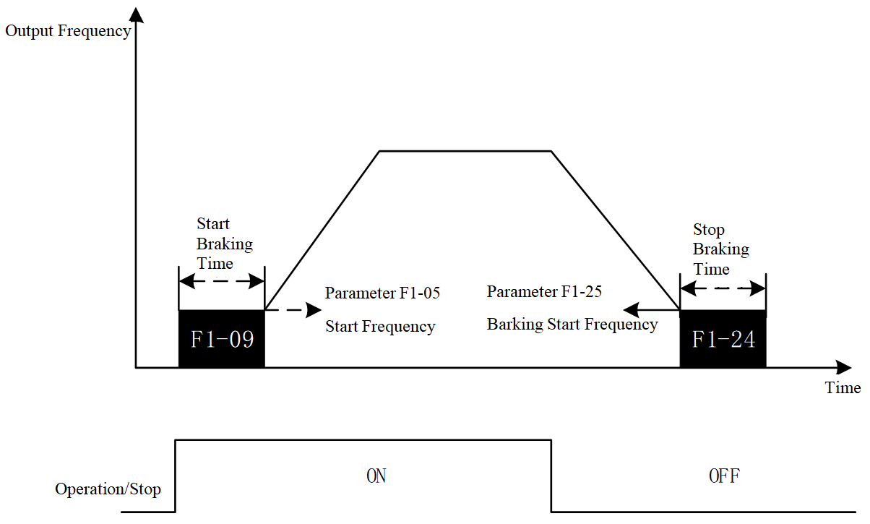
Figure 10-33 Start/Stop DC Braking
Parameters related to start/stop DC braking are shown in Table 10-41:
Table 10-41 Start/Stop DC Braking
Parameter | Function Definition | Default Value | Setting Range | Parameter Description
F1-08 | Braking Current Level | 0 | 0~100% | Used to set the magnitude of the start and stop DC braking current, expressed as a percentage of the motor's rated current.
F1-09 | Startup Braking Time | 0.0 | 0.0~60.0s | Used to set the duration of the start DC braking. If the start braking time is set to zero, start DC braking is disabled.
F1-10 | DC Braking Ratio Coefficient | 2000 | 0~65535 | Use F1-10 DC brake ratio coefficient and F1-11 DC brake integral coefficient to adjust the current PI regulator parameters.
F1-11 | DC Braking Integral Coefficient | 100 | 0~65535
F1-24 | Braking Start Time | 0.0s | 0.0~60.0s | This parameter sets the duration of the DC brake during stopping. To perform DC braking when stopping, the parameter F1-12 motor stop method must be set to deceleration stop for this function to be effective. When the stop brake time is set to 0.0, DC braking during stop is invalid.
F1-25 | Braking Start Frequency | 0.0Hz | 0.00~599.00Hz | This parameter is used to set the starting frequency for stop DC braking. When the inverter decelerates to the frequency value set by this function code, DC braking begins.
    - Instantaneous power failure restart
Generally, when power is lost, the inverter will shut down due to undervoltage, and even if the power returns to normal within a short time, the inverter will not restart automatically. The instantaneous power failure restart function can automatically restart the inverter when power is briefly interrupted and then restored, ensuring the motor does not stop rotating.
After an under-voltage fault occurs, if the bus voltage returns to normal within a certain period (which can be set via parameters), the inverter will perform speed search and then control the motor to run at the set frequency. If the bus voltage does not return to normal within the specified time, the inverter will shut down. Parameters related to the instantaneous power failure restart function are shown in Table 10-42.
Table 10-42 Instantaneous Power Failure Restart
Parameter | Function Definition | Default Value | Setting Range | Parameter Description
F1-29 | Instantaneous Power Failure Restart Method | 0 | 0: Stop operation;  1: Speed tracking starts from the frequency before the power failure;  2: Speed tracking starts from the minimum output frequency. | 0: Stop operation; in case of instantaneous power failure, stop operation, cannot restart automatically.  1: Track at current speed; The inverter starts from the frequency before the power failure and tracks downward. Once the motor frequency is detected, it accelerates from the detected motor frequency to the set frequency. This option is recommended when the motor inertia is large.  2: Track at minimum frequency; The inverter starts tracking upward from the lowest frequency. Once the motor frequency is detected, it accelerates from the detected motor frequency to the set frequency. This option is recommended when the motor inertia is small.
F1-30 | Allowed Power Failure Time | 2.0s | 0.0~20.0s | When the power outage duration is less than the set value of this function code, automatic restart according to the settings of F1-29 is allowed; when the power outage duration exceeds the set time of this function code, automatic restart will no longer occur.
    - Continuous Operation During Momentary Power Interruption
When the grid voltage drops, the inverter may shut down due to undervoltage. Uncontrolled abnormal shutdowns can cause significant impact, leading to system damage and serious consequences. The function of not stopping during instantaneous power failure can, in this situation, allow the motor to decelerate in a controlled manner, reducing the impact on the system.
When a grid voltage sag (bus voltage below a certain value) is detected, the ride-through function starts working, adjusting the deceleration ramp to put the motor into a generating state, feeding energy back to the inverter, preventing the bus voltage from dropping rapidly, thus avoiding shutdown of the inverter due to undervoltage. The ride-through parameters are shown in Table 10-43.

Table 10-43 Ride-through Parameters
Parameter | Function Definition | Default Value | Setting Range | Parameter Description
F1-32 | Instant Stop Without Stopping (dEb) Recovery Threshold | 40.0V/20.0V | 0.0~200.0V | This parameter is used to set the dEb recovery voltage value. By default, dEb recovery voltage = dEb action voltage + (F1-32 setting value).
F1-33 | Instant Stop Prevention (dEb) Action Bias Threshold | 40.0V | 0.0~200.0V | This parameter is used to define the voltage value at which dEb starts to act. By default, the dEb activation voltage = undervoltage protection value + 60V + (F1-33 setting value).
F1-34 | Instant Stop Prevention (dEb) Deceleration Selection | 0 | 0: No action  1: Enable, no recovery;  2: Enable, recovery; | 0: When the grid voltage drops, the inverter does not decelerate, and the inverter may stop due to undervoltage.  1: When the grid voltage drops, upon reaching the dEb action voltage, the inverter controls the motor to decelerate. When the grid voltage returns to normal, it continues to control the motor to decelerate to zero, then stops.  2: When the grid voltage drops, upon reaching the dEb action voltage, the inverter controls the motor to decelerate. When the grid voltage returns to normal, it maintains the current frequency operation for a period (F1-35) before accelerating back to the target frequency.
F1-35 | Instantaneous stop (dEb) recovery time | 3.0s | 0.0~25.0s | This parameter is used to set the time during which the inverter maintains operation at the current frequency after power recovery. After this period ends, the inverter accelerates again to the given frequency.
L2-18 | Undervoltage Protection Value | 360.0V/180.0V | 250.0~440.0V | A voltage below this level will trigger under-voltage protection.
    - Degree Tracking
Speed tracking is applicable for punch presses, fans, and other high-inertia load applications. In control modes with an encoder, when F1-00 is set to a non-zero value, the inverter will automatically start speed tracking based on the speed feedback from the encoder. When using the free stop (i.e., inertial stop) method to stop, or when the inverter suddenly stops due to a fault, the motor will decelerate under the influence of friction. If the motor has a large inertia, it will take a longer time to come to a complete stop. If the inverter starts directly while the motor has not completely stopped, it may cause significant impact. The speed tracking function can obtain the motor's speed and then control the motor to run to the set frequency based on this speed. This not only shortens the time required for re-starting but also avoids excessive impact.
Speed tracking related parameters are shown in Table 10-44:
Table 10-44 Speed Tracking Related Parameters
Parameter | Function Definition | Default Value | Setting Range | Parameter Description
F1-00 | Startup speed tracking | 0 | 0: No action;  1: Track from maximum frequency;  2: Frequency tracking during startup;  3: Tracking from the minimum frequency. | 0: Speed tracking function disabled.  1: Tracking from the maximum output frequency; Upon restart, track the speed downward from the maximum output frequency until the motor speed is detected, then control the motor to run at the set frequency.  2: Upon restart, track the speed from the given frequency at startup, ultimately controlling the motor to run at the set frequency.  3: Upon restart, track the speed from the minimum frequency, and after tracking the motor speed, control the motor to run at the set frequency.
F1-03 | Speed tracking maximum current | 100% | 20~200% | The inverter starts speed tracking only when the output current exceeds this setting. The larger this parameter is set, the faster the tracking speed, but setting it too high may cause overcurrent or overload faults.
    - Abnormal Restart
After an abnormality occurs, the inverter usually stops operating until the fault is reset and a run command is received, at which point it will restart. The Abnormal Restart function can automatically clear faults and control the inverter to restart when a fault occurs, ensuring the motor does not stop running. Relevant parameters are shown in Table 10-45.
After a fault occurs, if the number of abnormal restart attempts (F9-46) is not zero, the inverter fault will be cleared, and a speed search will be performed before controlling the motor to operate at the set frequency. If the number of retries after an anomaly is zero, the fault will not be cleared, and the inverter will remain in a shutdown state.
Table 10-45 Parameters Related to Abnormal Restart
Parameter | Function Definition | Default Value | Setting Range | Parameter Description
F1-02 | Abnormal restart method | 0 | 0: Stop operation;  1: Track at current speed;  2: Track minimum frequency. | 0: Shut down after an abnormality, the inverter does not automatically restart after fault reset.  1: When an abnormality occurs and the system restarts, it performs speed tracking from the current speed. After tracking the speed, it controls the motor to run to the set frequency.  2: When an abnormality occurs and the system restarts, it performs speed tracking from the minimum frequency. After tracking the speed, it controls the motor to run to the set frequency.
F9-46 | Abnormal Restart Count | 0 | 0~10 | This parameter is used to set the number of automatic restarts after an abnormality. If set to zero, the inverter will not automatically restart after an abnormality. When automatically restarting after an anomaly, the inverter will start according to the settings in F1-02. If the number of abnormalities exceeds the value set in F9-46, the fault will not automatically reset. It must be manually reset and a new operation command received before it can continue running.
F9-47 | Abnormal restart reset time | 60.0s | 0.0~6000.0s | After a retry following an anomaly, if no further anomalies occur within the time set by this function code, the retry count for F9-46 will be reset to its set value.
    - Vibration suppression
When using VF control to drive an asynchronous motor, vibration issues may occur. If the vibration is severe, it can lead to shutdowns, preventing normal operation. Therefore, in designing the VF control algorithm, vibration suppression functionality is generally a necessary component, and some self-tuning algorithms also require vibration suppression functions.
By appropriately adjusting the given frequency based on the motor's operating status, the purpose of vibration suppression can be achieved. Relevant parameters are shown in Table 10-46. The vibration suppression effect can be adjusted through the parameter 'Oscillation Suppression Gain.' The greater the 'Oscillation Suppression Gain,' the better the vibration suppression effect, but the dynamic performance of the motor will decrease. Conversely, the poorer the vibration suppression effect, the better the dynamic performance of the motor. In actual use, this parameter can be adjusted according to specific requirements.
Table 10-46 Vibration Suppression Parameters
Parameter | Function Definition | Default Value | Setting Range | Parameter Description
F2-14 | Oscillation Suppression Gain | 1000 | 0~9999 | If oscillation occurs when the motor is under VF control, this parameter value can be adjusted to improve the oscillation condition. The greater the oscillation suppression gain, the better the oscillation suppression effect, but the dynamic performance of the motor will decrease; conversely, the poorer the vibration suppression effect, the better the dynamic performance of the motor.
    - Braking Unit Control
When the motor operates in generator mode and feeds energy back to the inverter, the bus voltage of the inverter will rise. If not controlled, it may trigger an overvoltage fault, preventing the inverter from continuing to operate. The braking unit can dissipate the energy fed back by the motor, thus avoiding excessively high bus voltage. When using this function, an external braking resistor must be connected to the inverter. When the bus voltage is detected to be higher than the set voltage, the braking unit operates. At this time, the braking resistor is equivalent to being connected in parallel with the bus capacitor, thereby releasing the energy stored in the capacitor and reducing the bus voltage to achieve the purpose of limiting the bus voltage. The control parameters related to the braking unit are shown in Table 10-47:

Table 10-47 Control Parameters Related to the Braking Unit
Parameter | Function Definition | Default Value | Setting Range | Parameter Description
L2-17 | Braking Resistor Activation Voltage | 740.0V/370.0V | 700.0~900.0V 380V models  350.0~450.0V 220V models | This parameter is used to set the turn-on voltage of the braking unit. Users can select an appropriate braking resistor to achieve optimal deceleration characteristics.
    - Automatic Energy Saving
Using an inverter to drive a motor is primarily aimed at energy conservation. Under the same torque output conditions, there are various scenarios for the voltage and current output by the inverter. Different scenarios correspond to different output powers of the inverter. If a combination of voltage and current can be selected to reduce the output power of the inverter, the goal of energy conservation is achieved.
While running, the inverter continuously calculates the output power and adjusts the output voltage based on the output power to minimize it or keep it near the minimum value. The entire process occurs without external intervention and can be performed automatically, hence it is referred to as the 'automatic energy-saving' function. To ensure that the acceleration and deceleration performance is not affected by the automatic energy-saving function, this feature is disabled during acceleration and deceleration, and only activated during steady-speed operation. Parameters related to automatic energy-saving are shown in Table 10-48:
Table 10-48 Parameters Related to Automatic Energy Saving
Parameter | Function Definition | Default Value | Setting Range | Parameter Description
F7-35 | Automatic Energy Saving Setting | 0 | 0: Disabled  1: Enabled | After the automatic energy-saving function is enabled, the voltage will be output normally during acceleration and deceleration. During constant-speed operation, the output voltage will be automatically adjusted based on the load condition. When the load is small, the output voltage will automatically decrease, thus achieving the purpose of energy saving.
F7-36 | Energy Saving Gain | 100% | 10~1000% | When F7-35 is set to 1, this parameter can be used to adjust the energy-saving gain. The factory setting value is 100%. If the energy-saving effect is unsatisfactory, F7-36 can be reduced; if the motor oscillates, F7-36 should be increased.
    - Sleep and Wake-up
The sleep and wake-up functions are used to achieve constant pressure water supply applications. The inverter stops running during the sleep period. After the wake-up delay within the sleep zone, the inverter starts running again, ending the sleep state. The sleep and wake-up functions require setting parameters such as sleep threshold, sleep delay, wake-up threshold, and wake-up delay. In general, the wake-up frequency (L5-02) should be set greater than or equal to the sleep frequency (L5-01). When the sleep frequency is 0, the sleep and wake-up functions are invalid.
Sleep and wake-up are divided into three cases:
(1) Frequency command (without using process PID, parameter FA-00=0, only valid in VF control, i.e., VF sleep and wake-up)
After the output frequency reaches the sleep frequency (parameter L5-01), the inverter maintains operation at the sleep frequency and begins the sleep delay (parameter L5-03). After the delay time has elapsed, it stops directly at 0Hz.
When the frequency command reaches the wake-up frequency (parameter L5-02), after the wake-up delay (parameter L5-04), the inverter begins to accelerate to the set frequency according to the preset acceleration time.
This process is shown in Figure 10-34:
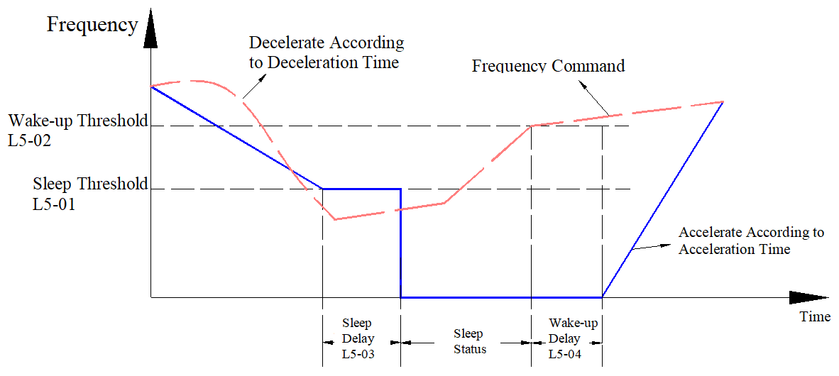
Figure 10-34 Frequency Command
(2) PID Output Frequency Command (Use process PID, parameter FA-00≠0 and parameter L5-00=0, i.e., PID sleep and wake-up)
When the PID output frequency command reaches the sleep frequency (parameter L5-01), the inverter begins to sleep. After the sleep delay (parameter L5-03) has elapsed, it stops directly at 0Hz. If the sleep delay time has not been reached, the output frequency remains at the lower limit frequency (parameter F0-11, and F0-11≠0) or the minimum output frequency (parameter F2-04, if the lower limit frequency F0-11=0), waiting for the sleep time to reach before entering the sleep state.
When the PID output frequency command reaches the wake-up frequency (parameter L5-02), the inverter starts the wake-up delay (parameter L5-04). After the delay time has elapsed, the inverter begins to accelerate to the PID output frequency setpoint according to the preset acceleration time.
This process is shown in Figure 10-35:
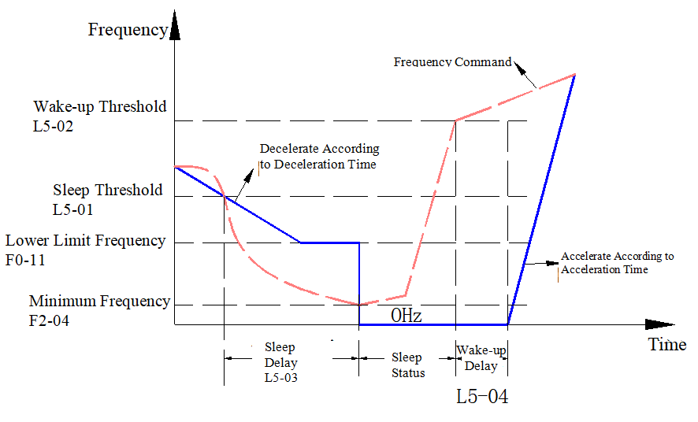
Frequency Command
Figure 10-35 PID Output Frequency Command
(3) PID feedback value (using process PID, parameter FA-00 ≠ 0 and parameter L5-00 = 1, also for PID sleep and wake-up)
When the PID feedback value reaches the sleep threshold (parameter L5-01), the inverter begins to enter sleep mode. After the sleep delay (parameter L5-03) has elapsed, it stops directly at 0 Hz. If the sleep delay time has not been reached, the output frequency remains at the lower limit frequency (parameter F0-11, and F0-11≠0) or the minimum output frequency (parameter F2-04, if the lower limit frequency F0-11=0), waiting for the sleep time to reach before entering the sleep state.
When the PID feedback value reaches the wake-up threshold (parameter L5-02), the inverter starts the wake-up delay (parameter L5-04). After the delay time has elapsed, the inverter begins to accelerate to the PID output frequency setpoint according to the preset acceleration time.
This process is shown in Figure 10-36:
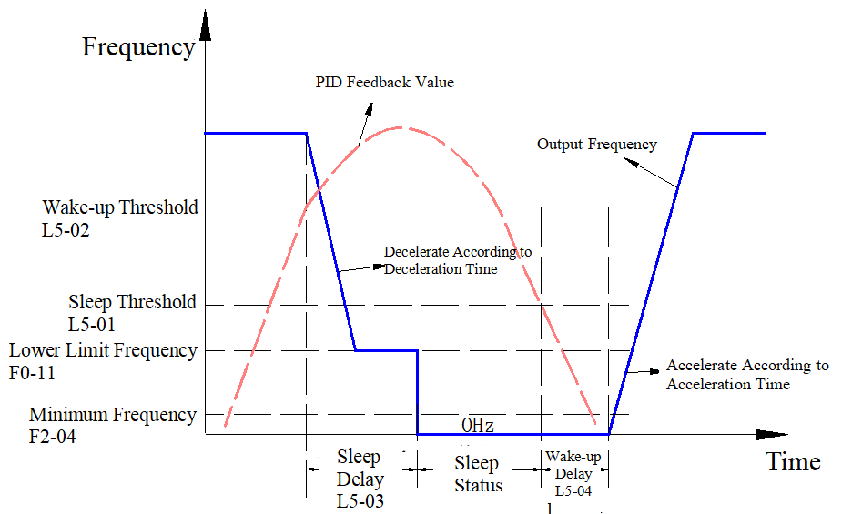
Figure 10-36 PID Feedback Value
When the sleep function (the above cases 2 and 3) is controlled by the PID setpoint and feedback value, the inverter frequency source must be selected as PID (parameter F0-06=9)
Parameters related to the sleep and wake-up functions are shown in Table 10-49:
Table 10-49 Parameters Related to Sleep and Wake-Up Functions
Parameter | Function Definition | Default Value | Setting Range | Parameter Description
L5-00 | Sleep Mode Reference Selection | 0 | 0: PID Command Arrival  1: PID Feedback Arrival | When parameter L5-00=0, the units of parameters L5-01 and L5-02 automatically change to frequency, and the setting range automatically changes to 0.00~599.00Hz. When parameter L5-00=1, parameters L5-01 and L5-02 units automatically change to percentage, and the reference base becomes the percentage of feedback, with the setting range automatically changing to 0.00~200.00%.
L5-01 | Sleep Threshold | 0.00Hz | 0.00Hz~599.00Hz | During inverter operation, when the set frequency is less than the sleep frequency (parameter L5-01, L5-00=0), or the PID negative feedback value is greater than the sleep threshold (parameter L5-01, L5-00=1), the inverter begins to enter sleep mode. After the sleep delay (parameter L5-03) has elapsed, it stops directly at 0Hz.
L5-02 | Wake Threshold | 0.00Hz | 0.00Hz~599.00Hz
L5-03 | Sleep Delay | 0.0s | 0.0s~999.9s
    - Monitoring
The monitoring function displays the status and parameter information of the inverter on the display area of the digital keypad. The parameters to be displayed can be selected by setting function code F7-21. The monitoring function-related parameters are shown in Table 10-50:
Also, through the U display interface on the digital keypad, the display can be switched using the up and down keys, and power-on display can be selected via F7-20.
Table 10-50 Monitoring Function-Related Parameters
Parameter | Function Definition | Default Value | Setting Range | Parameter Description
F7-21 | U Interface Display Selection | 3 | 0: Display the inverter output current to the motor (I) (Unit: Amp)  1: Display the count value (c) (Unit: CNT)  2: Display the actual inverter output frequency (f) (Unit: Hz)  3: Display the inverter DC bus voltage value (DCbus voltage) (U) (Unit: VDC)  4: Display the inverter output voltage value (E) (Unit: VAC)  5: Display the inverter output power factor angle (n) (Unit: deg)  6: Display the inverter output power (P) (Unit: kW)  7: Display the motor speed, in rpm (r) (Unit: Krpm) (thousand revolutions per minute)  8: Display the segment number (d) being executed in multi-speed operation  9: DC bus ripple (u) (unit: VDC)  10: Display AVI analog input terminal signal value (C.) (unit: %)  11: Digital output ON/OFF status (o)  12: Digital input ON/OFF status (J)  13: Display the temperature of the inverter's power module (IGBT) (t) (unit: ºC) | This parameter can be used to change the U interface display parameters of the LED during shutdown or operation.
    - Address Mapping Example
The address mapping function primarily enhances the compatibility of the inverter's Modbus communication. The following are several common operation examples:
Example 1: Mapping method to control inverter operation, stop, and fault reset
Control word mapping address: LD-01=4000H
Forward run command: LD-02=1
Reverse run command: LD-03=2
Forward jog command: LD-04=3
Reverse jog command: LD-05=4
Stop command: LD-06=5
Stop command 2: LD-07=6
Fault reset command: LD-08=7
Jog stop command: LD-09=8
Forward Operation
11:41:19.464 Send data 0x0106400000015DCA
11:41:19.479 Receive data 0x0106400000015DCA
Motor running forward
Reverse Operation
11:42:28.272 Send data 0x0106400000021DCB
11:42:28.287 Receive data 0x0106400000021DCB
Motor running in reverse
Forward jog
11:43:02.591 Send data 0x010640000003DC0B
11:43:02.607 Receive data 0x010640000003DC0B
Motor forward jog
Reverse jog
11:43:43.903 Send data 0x0106400000049DC9
11:43:43.918 Receive data 0x0106400000049DC9
Motor reverse jog
Stop
11:44:42.871 Send data 0x0106400000055C09
11:44:42.886 Receive Data 0x0106400000055C09
Motor Stops Running
Stop 2
11:50:08.389 Send Data 0x0106400000061C08
11:50:08.404 Receive Data 0x0106400000061C08
Motor Stops Running
Fault Reset
11:51:15.150 Send Data 0x010640000007DDC8
11:51:15.165 Receive Data 0x010640000007DDC8
Fault Reset
Jog Stop
11:55:32.690 Send Data 0x0106400000089DCC
11:55:32.706 Receive Data 0x0106400000089DCC
Motor Stops Running
Example 2: Frequency Command Setting via Mapping Method
Frequency Command Mapping Address: LD-10=4001H
Set Frequency [15Hz]
13:19:25.367 Send Data 0x0106400105DCCF03
13:19:25.383 Receive Data 0x0106400105DCCF03
Set Frequency [0Hz]
13:19:48.969 Send Data 0x010640010000CDCA
13:19:48.987 Receive Data 0x010640010000CDCA
Example 3: Fault Code Reading via Mapping Method
Fault Code Mapping Address: LD-11=4100H
Fault Code (Original MODBUS Address Reading)
13:27:17.228 Send Data 0x0103210000018E36
13:27:17.244 Receive Data 0x01030200363852
Fault Code Reading via Mapping Method
13:27:21.877 Send Data 0x0103410000019036
13:27:21.892 Receive Data 0x01030200363852
Example 4: Obtaining Inverter Status Information via Mapping Method
Status Word Mapping Address: LD-12=4101H
Forward Operation Value: LD-13=1
Reverse Operation Value: LD-14=2
Stop Status Value: LD-15=3
Fault Status Value: LD-16=4
Obtaining Forward Operation via Mapping Method
13:31:25.349 Sending Data 0x010341010001C1F6
13:31:25.364 Receiving Data 0x01030200017984
Obtaining Reverse Operation via Mapping Method
13:33:40.853 Sending Data 0x010341010001C1F6
13:33:40.868 Receiving Data 0x01030200023985
Obtaining Stop Status via Mapping Method
13:34:28.528 Sending Data 0x010341010001C1F6
13:34:28.543 Receive Data 0x0103020003F845
Obtain Fault Status via Mapping Method
13:35:27.724 Send Data 0x010341010001C1F6
13:35:27.740 Receive Data 0x0103020004B987
Example 5: Obtain Given Frequency via Mapping Method
Given Frequency Mapping Address: LD-17=4102H
Given Frequency (Original MODBUS Address Read)
13:57:29.260 Send Data 0x0103210200012FF6
13:57:29.275 Receive Data 0x01030205DCBA8D
Given Frequency Mapping
13:57:54.252 Send Data 0x01034102000131F6
13:57:54.267 Receive Data 0x01030205DCBA8D
Example 6: Obtaining other physical quantities through mapping, such as motor current
Output current mapping address: LD-19=4104H
Output current (original MODBUS address read)
14:02:27.534 Sending data 0x010321040001CFF7
14:02:27.549 Receiving data 0x010302011CB81D
Output current mapping
14:02:38.837 Sending data 0x010341040001D1F7
14:02:38.852 Receiving data 0x010302011CB81D
  - Faults and Protection
    - IGBT Overtemperature Protection
When the IGBT temperature exceeds the overtemperature protection point, an IGBT overtemperature fault is reported, and the motor stops running; When the temperature is detected to be below the overtemperature fault temperature but above the overtemperature warning threshold, an overtemperature fault alarm is issued, and the motor can continue to run. IGBT overtemperature protection parameters are shown in Table 10-51:
Table 10-51 IGBT Overtemperature Protection Parameters
Parameter | Function Definition | Default Value | Setting Range | Parameter Description
F9-41 | Overtemperature Warning Threshold | Dependent on the model power | 0.0~110.0℃ | In the inverter specification module, the defined module overtemperature protection point is 95℃, and the module overtemperature warning threshold is 90℃. When the module temperature exceeds the lower value between the module overtemperature warning threshold and the F9-41 set temperature, an IGBT overheating warning (A009) is reported; When the module temperature exceeds the overtemperature protection point, an IGBT high temperature fault (E016) is reported. When an IGBT overtemperature warning occurs, it does not affect the operation of the inverter; at this time, cooling measures can be taken in advance to prevent the inverter from experiencing an overtemperature fault.
    - Low Current Protection
Low current protection is designed to prevent the inverter from operating for extended periods under conditions where the current is below normal levels. Operating below normal current may not cause damage to the inverter, but such abnormal operation can result in the system failing to achieve the expected load-carrying capacity. Relevant parameters are shown in Table 10-52.
Users can determine the undercurrent threshold based on the normal operating current and the duration of low current that the system can tolerate. They can also decide the actions the inverter should take upon detecting low current, such as free stop, deceleration stop, or issuing a warning while the inverter continues to operate normally. The low current warning will automatically clear when the current exceeds the set low current threshold by 1%. Low current protection does not activate when the inverter is in sleep or standby mode.

Table 10-52 Low Current Protection Related Parameters
Parameter | Function Definition | Default Value | Setting Range | Parameter Description
F9-22 | Low Current Setting Threshold | 0.0% | 0.0~100.0% | F9-22 Low Current Set Threshold is expressed as a percentage, based on the inverter's rated current. When the inverter output current is less than the F9-22 set value and persists for longer than the time set by F9-23, a low current fault is detected, and the inverter will take subsequent actions according to the F9-24 Low Current Action Mode.
F9-23 | Low Current Detection Time | 0.00 | 0.00~360.00s
F9-24 | Low Current Action Method | 0 | 0: No Function  1: Alarm and Free Stop;  2: Alarm and Second Deceleration Stop;  3: Alarm and Continue Running. | 0: Low Current Protection Function Disabled, Low Current Set Threshold (F9-22) and Low Current Detection Time (F9-23) are Both Invalid.  1: When Low Current Protection Conditions are Met, Report Low Current Fault and Free Stop.  2: When Low Current Protection Conditions are Met, Report Low Current Fault and Decelerate to Stop According to Second Deceleration Time.  3: When Low Current Protection Conditions are Met, Issue Low Current Warning but Do Not Stop.
    - Motor Overheat Protection
By obtaining the motor temperature through sensors, the motor can be protected based on its temperature. When the motor temperature exceeds a certain value, the motor operation is stopped to prevent overheating damage. Thermistors are commonly used to measure motor temperature; common thermistors include PTC resistors and PT100 resistors. Parameters related to motor overheat protection are shown in Table 10-53.
Table 10-53 Motor Overheat Protection Related Parameters
Parameter | Function Definition | Default Value | Setting Range | Parameter Description
F9-48 | PTC Action  Selection | 0 | 0: Warning and Continue Running  1: Warning and Decelerate to Stop  2: Warning and Free Stop  3: No Warning | This parameter is used to set the inverter action when the PTC temperature exceeds the threshold.
F9-49 | PTC Threshold | 50.0% | 0.0~100.0% | This parameter is used to set the PTC over-temperature detection threshold, expressed as a percentage, with the reference value being the maximum analog input value. When using the PTC overheating detection function, the corresponding analog input terminal must be set to voltage signal input, and the function of this analog input terminal is “Thermistor PTC Input.”When the feedback voltage reaches the set value of F9-49, the inverter will operate according to the method set in F9-48.
F9-50 | PT Detection Threshold 1 | 5.000 | 0.000~10.000V | Used to set the PT100 over-temperature detection threshold.
F9-51 | PT Detection Threshold 2 | 7.000 | 0.000~10.000V | Used to set the PT100 over-temperature detection threshold.
F9-52 | PT Voltage 1  Protection Frequency | 0.00Hz | 0.00~599.00Hz | When using the PT100 over-temperature detection function, the corresponding analog input terminal must be set to voltage signal input. The function of this analog input terminal is “PT100 Value”. When the feedback voltage is less than the set value of F9-50, the motor operates normally; When the feedback voltage is between the set values of F9-50 and F9-51, the inverter will run to the frequency set by F9-52 after the time set by F9-52. When the feedback voltage exceeds the set value of F9-51, the inverter will operate according to the method set by F9-48.
F9-53 | PT Operation Delay Time | 60s | 0~6000s
    - Motor Overload Protection
By setting an appropriate inverse-time curve, the operating time of the motor under overload conditions is made less than the set overload protection time, thereby achieving overload protection for the motor and preventing damage due to overheating. When the overload time reaches the overload protection time, an overload fault will be reported. This function is not enabled by default; if it needs to be activated, the parameter 'Motor Overload Protection Selection' must be set to 0 or 1.
Taking the motor as an example, when F9-01 is 0, the overload protection curve for the motor is shown in Figure 10-37. Here, T equals the set value of parameter F9-02, and “motor current percentage” refers to the ratio of the inverter output current to the motor rated current. When the motor fan is independently controlled, this inverse-time curve can be selected. In this case, the fan speed is independent of the motor speed, so the cooling capacity does not decrease as the motor speed decreases, and the inverse-time curve is also independent of the motor operating speed.
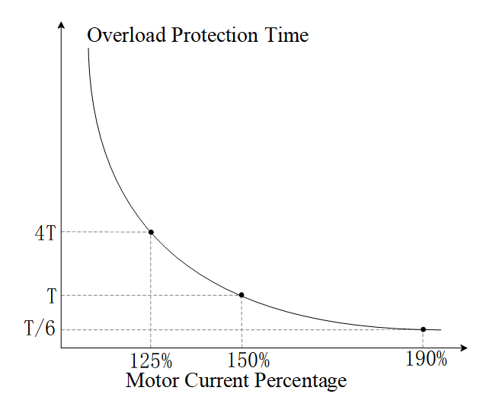
Figure 10-37 Inverse Time Curve 1
When F9-01 is set to 1, the motor overload protection curve is shown in Figure 10-38. Among them, the “speed coefficient” is a function of the motor speed; when the motor speed exceeds the rated speed, the speed coefficient equals 1; when the motor speed is below the rated speed, the speed coefficient = 1/(0.4 + 0.6 * motor speed / motor rated speed).
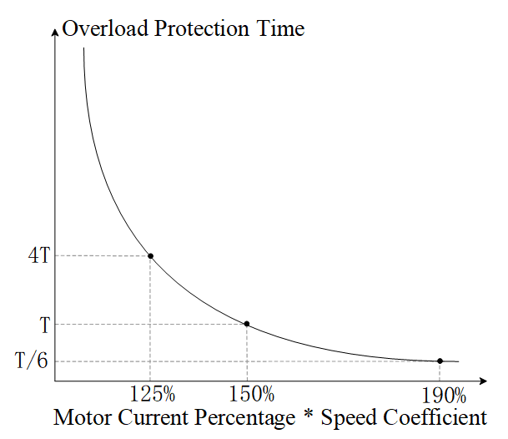
Figure 10-38 Inverse Time Curve 2
When the motor uses coaxial cooling (the fan is connected to the motor shaft), the fan speed is the same as the motor speed, and a decrease in motor speed will reduce the fan's cooling capacity. In this case, it is recommended to set F9-01 to 1, so that the inverse time curve adjusts according to the motor speed, reducing the motor's overload capability as the speed decreases to prevent overheating due to reduced fan cooling capacity. When the motor speed is zero, the fan stops rotating, at which point the speed factor is 2.5, and the corresponding overload curve is shown in Figure 10-39. From Figure 10-39, it can be seen that when the current reaches 60% of the motor's rated current, the motor will report an overload fault after running for T time.
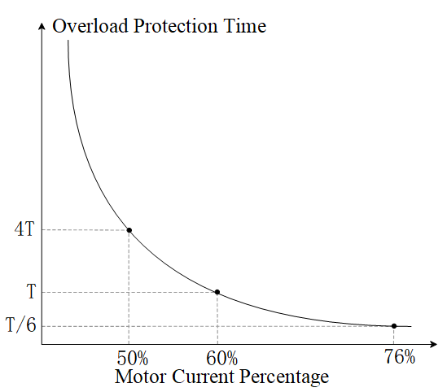
Figure 10-39 Inverse Time Curve 3
The parameters related to motor overload protection are shown in Table 10-54:
Table 10-54 Parameters Related to Motor Overload Protection
Parameter | Function Definition | Default Value | Setting Range | Parameter Description
F9-01 | Motor Overload Selection | 2 | 0: Constant Torque Output Motor  1: Variable Torque Output Motor  2: No Motor Overload Protection | This parameter is used to set the overload protection mode.
F9-02 | Motor Overload Time | 60.0s | 30.0~600.0s | This parameter is used to set the overload protection time when the motor current reaches 150% of the rated current.
    - Fault logging function
The fault record function logs the names of faults that occur in the inverter, along with the power-on time, frequency, torque, voltage, current, and temperature of power devices at the moment of the fault, providing reference information for subsequent fault diagnosis.
The current inverter software supports recording the fault codes of the last 10 faults, the power-on times at the moment of the last 6 faults, and physical quantity information.
Only faults that cause the inverter to shut down after they occur are recorded; undervoltage faults during shutdown are not recorded.
Fault record information is stored in EEPROM, and it automatically updates and writes fault information into EEPROM each time a fault occurs.
Parameters related to the fault logging function are shown in Table 10-56:
Table 10-56 Fault logging parameters
Parameter | Function Definition | Default Value | Setting Range | Parameter Description
U0-00 | Fault Record 1 | 0 | 0～65535 | This set of parameters is used to record the fault codes of the last 10 faults of the inverter. The smaller the fault record number (the minimum value is 1), the closer the corresponding fault is to the present. For example, the most recent fault will always be displayed in U0-00, and each subsequent fault will increment the count of all previous faults by 1. If the number of faults exceeds 6 or 10, the earliest fault record information will be overwritten. For the fault codes corresponding to fault types, please refer to the fault table.
U0-01 | Fault Record 2 | 0 | 0～65535
U0-02 | Fault Record 3 | 0 | 0～65535
U0-03 | Fault Record 4 | 0 | 0～65535
U0-04 | Fault Record 5 | 0 | 0～65535
U0-05 | Fault Record 6 | 0 | 0～65535
U0-06 | Fault Record 7 | 0 | 0～65535
U0-07 | Fault Record 8 | 0 | 0～65535
U0-08 | Fault Record 9 | 0 | 0～65535
U0-09 | Fault Record 10 | 0 | 0～65535
U0-10 | Fault Output 1 | 0 | 0～65535 | When the inverter fails and the setting values of parameters U0-10 to U0-13 match the fault code, the corresponding RLY output can be enabled by setting F6-003 to 35 to 38. The four fault outputs can operate independently without affecting each other.
U0-11 | Fault Output 2 | 0 | 0～65535
U0-12 | Fault Output 3 | 0 | 0～65535
U0-13 | Fault Output 4 | 0 | 0～65535
U0-14 | Fault 1-Motor Speed | 0 | -32767～32767 | Used to record the information of the last 6 faults
U0-15 | Fault 1 - Torque command | 0 | -3276.7～3276.7 | Used to record the information of the last 6 faults
U0-16 | Fault 1-Input Terminal | 0 | 0～65535 | Used to record the information of the last 6 faults
U0-17 | Fault 1-Output Terminal | 0 | 0～65535 | Used to record the information of the last 6 faults
U0-18 | Fault 1 - Inverter Status | 0 | 0～65535 | Used to record the information of the last 6 faults
U0-19 | Fault 1 - Frequency Command | 0.00 | 0.00～655.35Hz | Used to record the information of the last 6 faults
U0-20 | Fault 1 - Output Frequency | 0.00 | 0.00～599.00Hz | Used to record the information of the last 6 faults
U0-21 | Fault 1 - Output Voltage | 0.0 | 0.0～6553.5V | Used to record the information of the last 6 faults
U0-22 | Fault 1 - DC Voltage | 0.0 | 0.0～6553.5V | Used to record the information of the last 6 faults
U0-23 | Fault 1-Output Current | 0.00 | 0.00～655.35A | Used to record the information of the last 6 faults
U0-24 | Fault 1-IGBT Temperature | 0.0 | -3276.7～3276.7℃ | Used to record the information of the last 6 faults
U0-25 | Fault 1 - Capacitor Temperature | 0.0 | -3276.7～3276.7℃ | Used to record the information of the last 6 faults
U0-26 | Fault 2-Output Frequency | 0.00 | 0.00～599.00Hz | Used to record the information of the last 6 faults
U0-27 | Fault 2-Direct Current Voltage | 0.0 | 0.0～6553.5V | Used to record the information of the last 6 faults
U0-28 | Fault 2-Output Current | 0.00 | 0.00～655.35A | Used to record the information of the last 6 faults
U0-29 | Fault 2-IGBT Temperature | 0.0 | -3276.7～3276.7℃ | Used to record the information of the last 6 faults
U0-30 | Fault 3-Output Frequency | 0.00 | 0.00～599.00Hz | Used to record the information of the last 6 faults
U0-31 | Fault 3-Direct Current Voltage | 0.0 | 0.0～6553.5V | Used to record the information of the last 6 faults
U0-32 | Fault 3-Output Current | 0.00 | 0.00～655.35A | Used to record the information of the last 6 faults
U0-33 | Fault 3-IGBT Temperature | 0.0 | -3276.7～3276.7℃ | Used to record the information of the last 6 faults
U0-34 | Fault 4-Output Frequency | 0.00 | 0.00～599.00Hz | Used to record the information of the last 6 faults
U0-35 | Fault 4 - DC Voltage | 0.0 | 0.0～6553.5V | Used to record the information of the last 6 faults
U0-36 | Fault 4 - Output Current | 0.00 | 0.00～655.35A | Used to record the information of the last 6 faults
U0-37 | Fault 4 - IGBT Temperature | 0.0 | -3276.7～3276.7℃ | Used to record the information of the last 6 faults
U0-38 | Fault 5 - Output Frequency | 0.00 | 0.00～599.00Hz | Used to record the information of the last 6 faults
U0-39 | Fault 5 - DC Voltage | 0.0 | 0.0～6553.5V | Used to record the information of the last 6 faults
U0-40 | Fault 5 - Output Current | 0.00 | 0.00～655.35A | Used to record the information of the last 6 faults
U0-41 | Fault 5-IGBT Temperature | 0.0 | -3276.7～3276.7℃ | Used to record the information of the last 6 faults
U0-42 | Fault 6-Output Frequency | 0.00 | 0.00～599.00Hz | Used to record the information of the last 6 faults
U0-43 | Fault 6-Direct Current Voltage | 0.0 | 0.0～6553.5V | Used to record the information of the last 6 faults
U0-44 | Fault 6-Output Current | 0.00 | 0.00～655.35A | Used to record the information of the last 6 faults
U0-45 | Fault 6-IGBT Temperature | 0.0 | -3276.7～3276.7℃ | Used to record the information of the last 6 faults
U0-46 | Days of Fault 1 Occurrence | 0 | 0～65535 | Used to record the information of the last 6 faults
U0-47 | Minutes of Fault 1 Occurrence | 0 | 0～1439 | Used to record the information of the last 6 faults
U0-48 | Days of Fault 2 Occurrence | 0 | 0～65535 | Used to record the information of the last 6 faults
U0-49 | Minutes of Fault 2 Occurrence | 0 | 0～1439 | Used to record the information of the last 6 faults
U0-50 | Days of Fault 3 Occurrence | 0 | 0～65535 | Used to record the information of the last 6 faults
U0-51 | Minutes of Fault 3 Occurrence | 0 | 0～1439 | Used to record the information of the last 6 faults
U0-52 | Days of Fault 4 Occurrence | 0 | 0～65535 | Used to record the information of the last 6 faults
U0-53 | Minutes of Fault 4 Occurrence | 0 | 0～1439 | Used to record the information of the last 6 faults
U0-54 | Days of Fault 5 Occurrence | 0 | 0～65535 | Used to record the information of the last 6 faults
U0-55 | Minutes of Fault 5 Occurrence | 0 | 0～1439 | Used to record the information of the last 6 faults
U0-56 | Days of Fault 6 Occurrence | 0 | 0～65535 | Used to record the information of the last 6 faults
U0-57 | Minutes of Fault 6 Occurrence | 0 | 0～1439 | Used to record the information of the last 6 faults
    - Over Torque Detection
The over torque detection function protects the motor and inverter by limiting the motor torque. When the current exceeds the over torque detection threshold and persists for the set time, the over torque signal is set. When the current falls below 95% of the over torque detection threshold, the over torque signal is cleared. Based on the over torque signal, the inverter will report an over torque fault and stop running, or report an over torque warning and continue running. The parameters related to over torque detection are shown in Table 10-57:
Table 10-57 Over-torque Detection Related Parameters
Parameter | Function Definition | Default Value | Setting Range | Parameter Description
F9-36 | Over Torque Selection 1 | 0 | 0: No Detection  1: Constant speed detection continues running;  2: Constant speed detection stops running;  3: Running detection continues running;  4: Running detection stops running. | 0: No Detection  1: During constant speed operation, if the motor experiences over-torque, an alarm is issued but operation continues.  2: During constant speed operation, if the motor experiences over-torque, an over-torque fault is reported and operation stops.  3: During operation, if the motor experiences over-torque, an alarm is issued but operation continues.  4: During operation, if the motor experiences over-torque, an over-torque fault is reported and operation stops.
F9-37 | Over Torque Threshold 1 | 120 | 10%~250% | When the inverter output current exceeds F9-37 (unit %, based on the rated current of the inverter) and persists for more than the time set by F9-38, the inverter will determine subsequent actions according to F9-36. When F9-36 is set to 1 or 3, if over-torque is detected, the inverter will display an over-torque warning but will continue to operate until the output current drops below 95% of the F9-37 setting, at which point the warning will be cleared. When F9-36 is set to 2 or 4, if over-torque is detected, the inverter will report an over-torque fault and stop running until the fault is reset before it can resume operation.
F9-38 | Over-torque time 1 | 0.1s | 0.0~60.0s
When the inverter output current exceeds F9-37 (unit %, based on the rated current of the inverter) and persists for more than the time set by F9-38, the inverter will determine subsequent actions according to F9-36. As shown in Figure 10-40, when F9-36 is set to 1 or 3, if over-torque is detected, the inverter will display an over-torque warning but will continue to operate until the output current drops below 95% of the F9-37 setting, at which point the warning will be cleared. As shown in Figure 10-41, when F9-36 is 2 or 4, if over-torque is detected, the inverter reports an over-torque fault and stops operation until the fault is reset before it can resume operation.
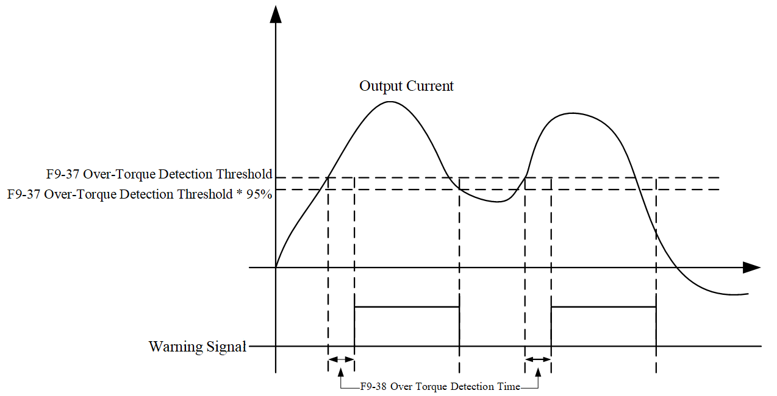
Figure 10-40 Schematic Diagram of Over-Torque Detection
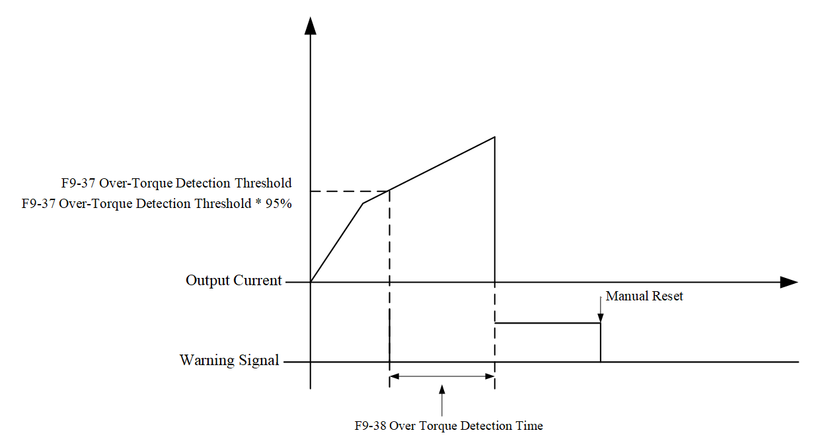
Figure 10-41 Schematic Diagram of Over-Torque Detection
Over-torque handling for Motor 2~4 can refer to the motor, and will not be repeated here.
    - Undervoltage Protection
When the input voltage is too low, the inverter may not operate normally. When undervoltage is detected, the inverter should stop running to avoid abnormal conditions; this is known as undervoltage protection. Relevant parameters are shown in Table 10-58.
Generally, the inverter input voltage detection circuit can indirectly determine whether the input voltage is too low through the bus voltage. When the bus voltage is below the undervoltage protection value, an undervoltage fault is reported. When the bus voltage is above the undervoltage recovery value (undervoltage protection value + 60V for 380V models) (undervoltage protection value + 30V for 220V models), the undervoltage fault is automatically cleared, or it can be cleared after receiving a reset command. Depending on the different operating states of the inverter, undervoltage faults can be categorized as undervoltage during stop (E014), undervoltage during acceleration (E011), undervoltage during deceleration (E012), and undervoltage during constant speed (E013).
Table 10-58 Undervoltage Protection Parameters
Parameter | Function Definition | Default Value | Setting Range | Parameter Description
L2-18 | Undervoltage Protection Value | 360.0V | 300~440.0V | This parameter is used to set the undervoltage protection value. When the inverter bus voltage falls below the undervoltage protection value, an undervoltage fault will be triggered, stopping the output and initiating a free stop. If an undervoltage fault occurs while the inverter is running, the inverter will stop output and initiate a free stop. The fault type depends on the acceleration/deceleration state at the time of the fault, which can be undervoltage during acceleration (E011), undervoltage during deceleration (E012), or undervoltage during constant speed (E013). The undervoltage fault must be cleared by pressing the reset button (STOP). However, if instantaneous stop and restart is set, it will automatically recover. Please refer to the relevant descriptions of parameter F1-29 Instantaneous Power Failure Restart Method (F1-29) and allowable power failure time (F1-30). If the inverter experiences an under-voltage fault during shutdown, it will display under-voltage during shutdown (E014). This fault will not be recorded and can automatically recover when the input voltage exceeds the under-voltage protection value or 60V.
F9-06 | Undervoltage Fault Auto Clear | 0 | 0: Off  1: On | When this parameter is set to 1, under-voltage during acceleration (E011), under-voltage during deceleration (E012), and under-voltage at constant speed (E013) can automatically recover.
    - Output Phase Loss
When there is an abnormal connection between the motor and the inverter, output phase loss may occur. When output phase loss occurs, the current in the disconnected phase of the motor is zero. To maintain motor operation, the current in the remaining phases generally increases, and there will be significant fluctuations in speed and torque, which may cause damage to the motor and inverter. Output phase loss detection can identify phase loss conditions in the motor and take appropriate actions.
When an output phase loss occurs, the current in the disconnected phase of the motor is zero, which can be used to detect the output phase loss. Output phase loss detection can be divided into startup output phase loss detection and operation output phase loss detection. As their names suggest, these methods detect whether an output phase loss has occurred during startup and operation, respectively. After detecting an output phase loss, appropriate actions can be taken as needed to protect the motor and inverter. The parameters related to output phase loss are shown in Table 10-59:
Table 10-59 Parameters Related to Output Phase Loss
Parameter | Function Definition | Default Value | Setting Range | Parameter Description
F9-15 | Output Phase Loss Action Selection | 3 | 0: Warning and continue running;  1: Warning and decelerate to stop;  2: Warning and free stop;  3: No warning. | This parameter is used to set the inverter action when an output phase loss occurs. Setting a value not equal to 3 will enable the output phase loss protection.
F9-16 | Output Phase Loss Deceleration Time | 0.100s | 0.000~65.535s | This parameter is used to set the detection time for output phase loss during operation, generally no modification is required.
F9-17 | Output Phase Loss Current Threshold | 7.00% | 0.00~100.00% | This parameter is used to set the threshold for output phase loss current detection, generally no modification is required.
F9-18 | Output Phase Loss Braking Time | 0.000 | 0.000~65.535s | This parameter is used to determine output phase loss at startup. If the setting is not zero, the inverter will perform an output phase loss check at startup.
The following introduces four scenarios.
Example 1: F9-18=0, no pre-operation output phase loss detection. As shown in Figure 10-42, during inverter operation, if any phase output current is less than the threshold set by F9-17 and exceeds the time set by F9-16, the inverter will begin to execute the action set by F9-15.
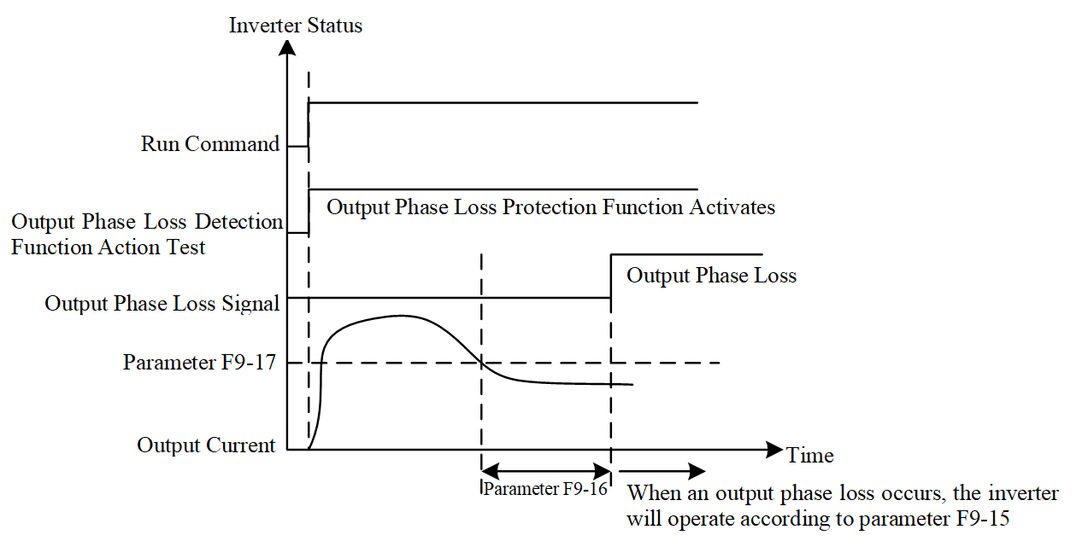
Figure 10-42 F9-18=0
Example 2: The inverter is in a stopped state, F9-18=0 and F1-09≠0. As shown in Figure 10-43, when starting, the inverter begins DC braking according to the settings of F1-08 and F1-09; during this period, output phase loss detection is not performed. After DC braking is completed, the inverter starts running and performs output phase loss detection as described in Case 1.
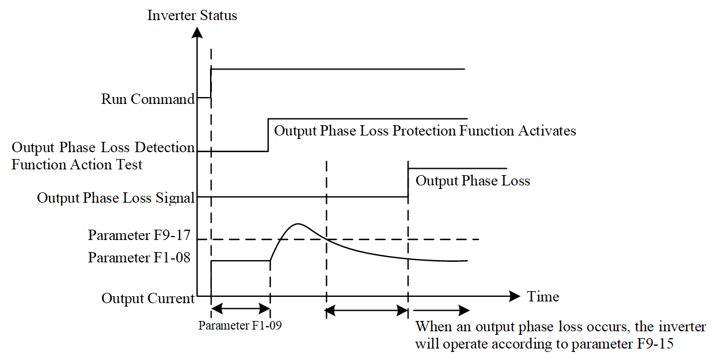
Figure 10-43 F9-18=0 and F1-09≠0
Example 3: The inverter is in a stopped state, F9-18≠0 and F1-09≠0. When starting, it first performs DC braking according to the time set by F9-18, then performs DC braking according to the time set by F1-09. During the time set by F9-18, the DC braking current is 20 times the value set by F9-57; During the time set by F1-09, the DC braking current is the value set by F1-08. Total DC braking time = Value set by F9-18 + Value set by F1-09.
Example 10-1: F9-18≠0 and F1-09≠0 (output phase loss not detected at startup), as shown in Figure 10-44.
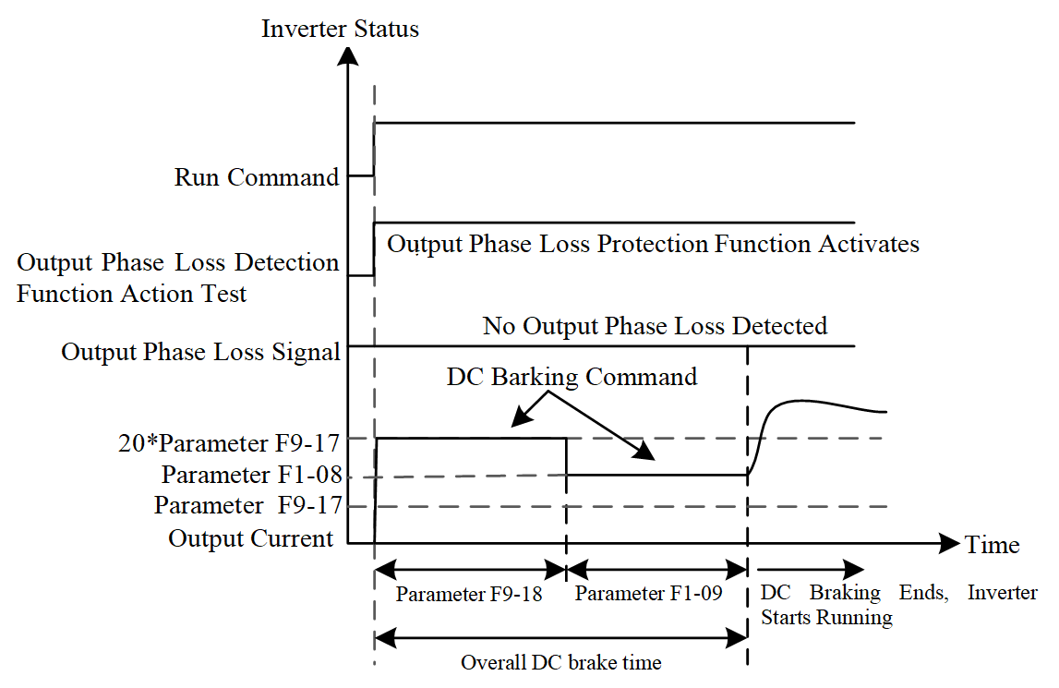
Figure 10-44 F9-18≠0 and F1-09≠0 (output phase loss not detected at startup)
Example 10-2: F9-18≠0 and F1-09≠0, output phase loss detected at startup. As shown in Figure 10-45, if an output phase loss occurs within the time set by F9-18, after half of the F9-18 set time has elapsed, the inverter begins to execute the action set by F9-15.
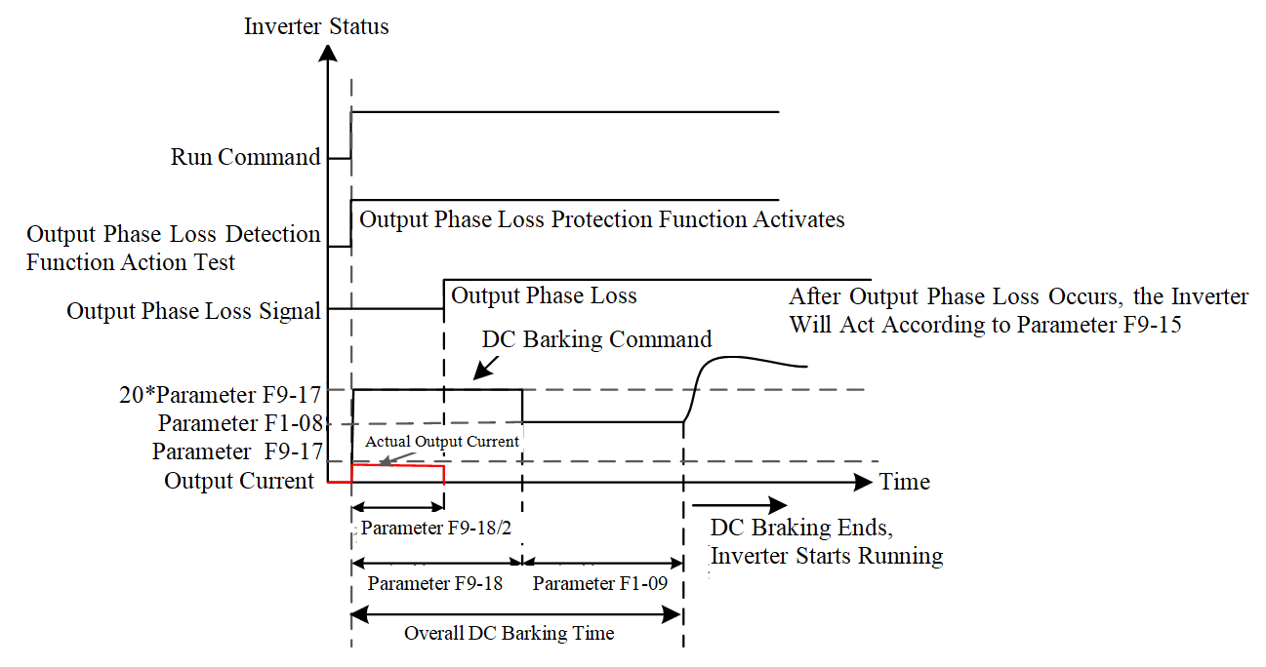
Figure 10-45 F9-18≠0 and F1-09≠0 (Output phase loss detected at startup)
Example 4: The inverter is in a stopped state, F9-18≠0 and F1-09=0, during startup, DC braking is performed according to the time set by parameter F9-18, with the DC braking current being 20 times the value set by F9-57.
Example 4-1: F9-18≠0 and F1-09=0 (No output phase loss detected at startup), as shown in Figure 10-46.
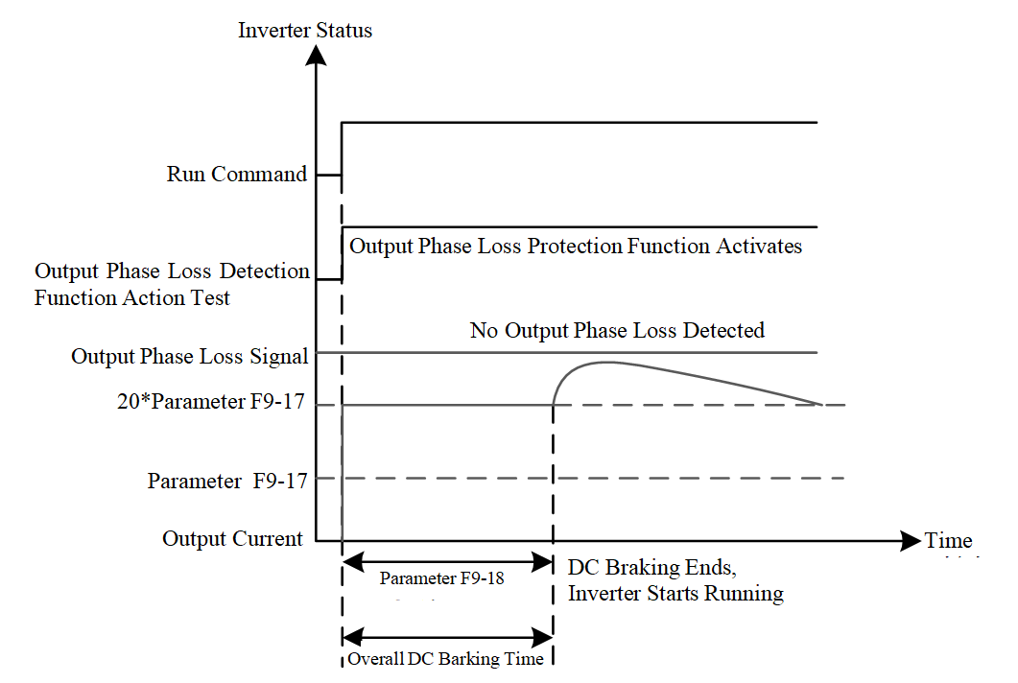
Figure 10-46 F9-18≠0 and F1-09=0 (No output phase loss detected at startup)
Example 4-2: F9-18≠0 and F1-09=0, output phase loss detected at startup. As shown in Figure 10-47, if an output phase loss occurs within the time set by F9-18, the inverter begins to execute the action set by F9-15 after half of the time set by F9-18 has elapsed.
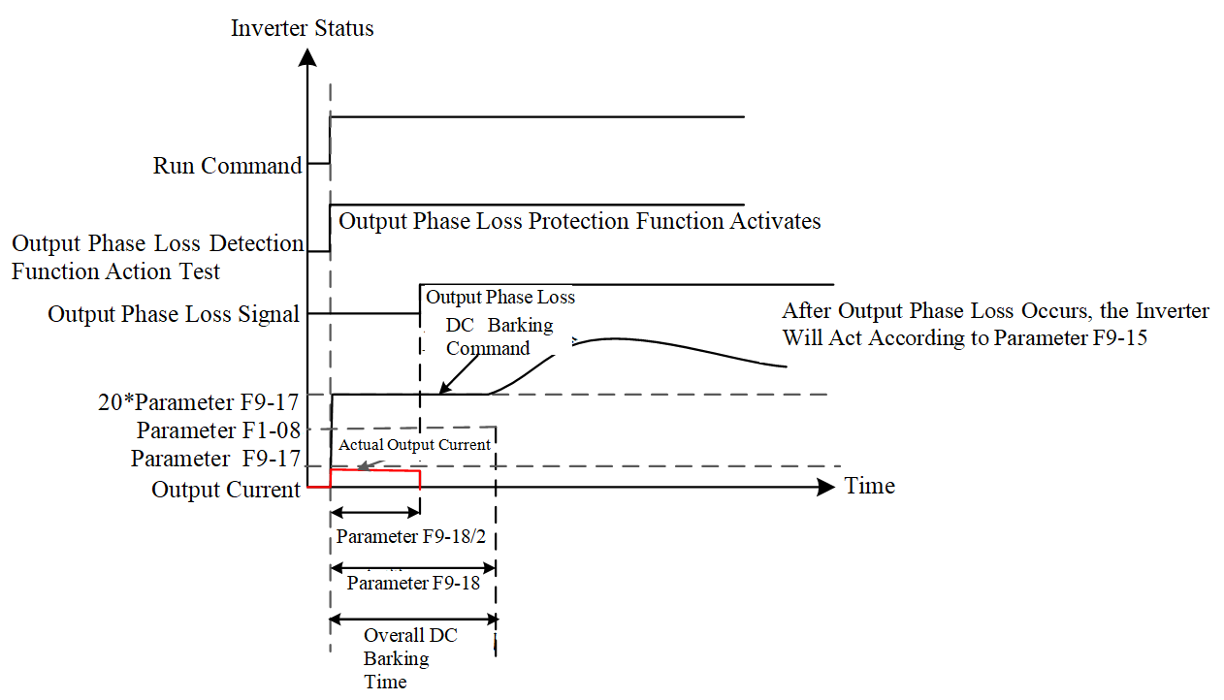
Figure 10-47 F9-18≠0 and F1-09=0 (Output phase loss detected at startup)
    - Input Phase Loss
If the power supply is not correctly connected to the inverter or if there is an abnormality in the power supply, an input phase loss fault may occur. When an input phase loss occurs, the inverter bus voltage may fluctuate significantly, causing fluctuations in motor torque or speed, and also affecting the lifespan of the bus capacitor. The input phase loss detection function can detect whether an input phase loss fault has occurred and promptly take protective measures.
When an input phase loss occurs, if the motor is carrying a heavy load, the bus voltage will fluctuate significantly. By monitoring the fluctuations in the bus voltage, it can be determined whether an input phase loss fault has occurred. When an input phase loss is detected, the system should shut down promptly to prevent damage to the motor or inverter. Parameters related to input phase loss are shown in Table 10-60:
Table 10-60 Parameters Related to Input Phase Loss
Parameter | Function Definition | Default Value | Setting Range | Parameter Description
F9-12 | Input Phase Loss Action Selection | 0 | 0: Warning and deceleration stop;  1: Warning and free stop. | The inverter will perform protective actions for input phase loss based on the setting of parameter F9-12.
F9-13 | Input Phase Loss Filter Time | 0.20s | 0.00~600.00s | This parameter is used to set the low-pass filter time required for phase loss detection, which generally does not need to be modified.
F9-14 | Input Phase Loss Voltage Threshold | 60.0V | 0.0~320.0V | This parameter is used to set the voltage threshold required for phase loss detection, which generally does not need to be modified.

Chapter 11 Fault Diagnosis and Countermeasures

Fault Handling
If a fault occurs during system operation, the inverter will immediately stop output to protect the motor from further damage. At the same time, the inverter will trigger the corresponding fault relay contacts, and the control panel will display the fault code for quick diagnosis of the issue. For each fault code, there are corresponding fault types and common solutions, which can be found in Table 11-1. Please note that the information listed in the table is for reference only and should not be altered arbitrarily. If you cannot resolve the fault, please contact our technical support or product distributor for assistance.
Table 11-1 Fault Alarms and Countermeasures
Fault Number | Fault Name | Fault Description | Possible Causes | Reset Method and Conditions
E001 | Overcurrent During Acceleration | During acceleration, the output current exceeds the inverter's overcurrent threshold. When E001 occurs, the inverter immediately stops output, and the motor will free stop. | 1. The set acceleration time is too short;  2. Poor insulation of motor wiring causing output short circuit;  3. Check if the motor is burned out or has insulation aging;  4. Excessive load;  5. V/F curve setting abnormal;  6. Hardware fault. | Manual reset; after the status disappears, it can be reset after 5 seconds.
E002 | Overcurrent during deceleration | During deceleration or stopping, the output current exceeds the inverter's overcurrent threshold. When E002 occurs, the inverter immediately stops output, and the motor will free stop. | As above | Manual reset; after the status disappears, it can be reset after 5 seconds.
E003 | Overcurrent during constant speed | During constant speed operation, the output current exceeds the inverter's overcurrent threshold. When E003 occurs, the inverter immediately stops output, and the motor will free stop. | As above | Manual reset; after the status disappears, it can be reset after 5 seconds.
E006 | Overcurrent during stop | Overcurrent occurs during stop or hardware circuit abnormality. After E006 occurs, power off and then power on again; if there is a hardware issue, E033, E034, or E035 may appear. | 1. Malfunction due to interference  2. Hardware failure | Manual reset; after the status disappears, it can be reset after 5 seconds.
E007 | Overvoltage during acceleration | The inverter detects an overvoltage on the bus during acceleration. When E007 occurs, the inverter immediately stops output, and the motor will free stop. | 1. Acceleration is too low (e.g., when accelerating downward with a lifting load);  2. The setting for stall prevention is less than the no-load current;  3. Power supply voltage is too high;  4. A capacitor switch in the same power system has operated;  5. The motor is in a generating state;  6. Acceleration time is too short;  7. The motor has a ground short circuit;  8. The connection of the braking resistor or braking unit is incorrect;  9. Malfunction due to interference. | Manual reset; The bus voltage must be below approximately 90% of the overvoltage threshold (810/405V) to reset.
E008 | Overvoltage during deceleration | The inverter detects an excessively high bus voltage during deceleration. When E008 occurs, the inverter immediately stops output, and the motor will free stop. | 1. The deceleration time is too short, causing excessive regenerative energy from the load;  2. As above | Manual reset; The bus voltage must be below approximately 90% of the overvoltage threshold (810/405V) to reset.
E009 | Overvoltage during constant speed | The inverter detects an excessively high bus voltage during constant speed operation. When E009 occurs, the inverter immediately stops output, and the motor will free stop. | 1. Sudden changes in load;  2. As above | Manual reset; The bus voltage must be below approximately 90% of the overvoltage threshold (810/405V) to reset.
E010 | Overvoltage during stop | Overvoltage occurs when the inverter stops. | 1. Supply voltage is too high;  2. Phase-shifting capacitors in the same power system switch;  3. Incorrect wiring of the braking resistor or braking unit;  4. Hardware fault (abnormal voltage sampling circuit);  5. Motor ground short circuit. | Manual reset; The bus voltage must be below approximately 90% of the overvoltage threshold (810/405V) to reset.
E011 | Undervoltage during acceleration | The inverter detects that the bus voltage is below the set value of parameter L2-18 during acceleration. | 1. Power outage occurs;  2. Supply voltage fluctuates;  3. Large capacity motors start;  4. Excessive load;  5. Common DC bus;  6. Whether a DC reactor is installed. | Manual reset; the inverter can be reset when the bus voltage is higher than parameter L2-18+60V.
E012 | Undervoltage during deceleration | The inverter detects that the bus voltage is below the set value of parameter L2-18 during deceleration. | As above | As above
E013 | Undervoltage at constant speed | The inverter detects that the bus voltage is below the set value of parameter L2-18 at constant speed. | As above | As above
E014 | Undervoltage during stop | 1. During stop, the inverter detects that the bus voltage is below the set value of parameter L2-18. | As above | As above
E015 | Input phase loss protection | Power supply input phase loss protection | 1. Input power phase loss occurs;  2. Single-phase power supply input for three-phase models;  3. Power supply voltage fluctuation;  4. The terminal connections of the input power supply are loose;  5. Whether the three-phase power supply input cables have been cut;  6. Unbalanced three-phase input power. | Manual reset
E016 | IGBT temperature too high | The inverter has detected that the IGBT temperature is too high, exceeding 95°C. | 1. Whether the ambient temperature at the site or inside the control cabinet is too high, and whether the ventilation holes of the cabinet are blocked by foreign objects;  2. Whether there are any foreign objects on the heat sink, and whether the fan is rotating;  3. Insufficient ventilation space for the inverter;  4. Whether the load matches the inverter;  5. Long-term operation at 100% or greater than 100% of the rated output. | Manual reset; the IGBT temperature must be below 85°C before resetting.
E021 | Inverter Overload | The output current exceeds the inverter's rated current, 150% of the rated output current for 1 minute. | 1. Excessive load;  2. Acceleration and deceleration times and working cycle time are too short;  3. The voltage in V/F control is too high;  4. The inverter capacity is too small;  5. Overload occurs during low-speed operation;  6. Torque compensation is set too high;  7. Whether the settings for stall prevention are correct;  8. Output phase loss;  9. Speed tracking function parameters are improperly set. | Manual reset; the error can be reset after it disappears for 5 seconds.
E022 | Motor Overload  Protection | Motor overload protection has been activated, and the motor will perform a free stop after activation. | 1. Excessive load;  2. Acceleration and deceleration times and working cycle time are too short;  3. When using a dedicated inverter motor, set parameter F9-01 Motor Overload Protection Selection = 0 for constant torque output motor;  4. The motor overload action value is incorrect;  5. The setting value for maximum motor frequency is too low;  6. Driving multiple motors with one inverter;  7. Whether the settings for stall prevention are correct;  8. Torque compensation is too high;  9. The motor fan operation is abnormal;  10. Unbalanced three-phase impedance of the motor. | Manual reset; the error can be reset after it disappears for 5 seconds.
E024 | Motor overheating | Motor PTC overtemperature warning, when a PTC is installed on the motor and this function is enabled (parameter F5-21/27/33 = 6 Thermistor PTC Input), if the PTC input exceeds the set value of parameter F9-49, it will be processed according to the setting of parameter F9-48. | 1. Motor locked rotor;  2. Excessive load;  3. Ambient temperature too high;  4. Abnormal motor cooling system/fan;  5. Frequent low-speed operation;  6. Acceleration/deceleration time and working cycle time too short;  7. V/F control voltage too high;  8. Whether the set rated current of the motor matches the motor nameplate;  9. Whether the PTC settings and wiring are appropriate;  10. Whether the stall prevention action setting is correct;  11. Three-phase impedance imbalance of the motor;  12. Excessive harmonic content. | Parameter F9-48  0: Warning and Continue Running  1: Fault and Decelerate to Stop  2: Fault and Free Stop  3: No Warning  When parameter F9-48 = 0, it is a warning, and will reset automatically; when parameter F9-48 = 1 or 2, it is a fault, and requires manual reset. It can be reset immediately.
E026 | Over Torque 1 | When the output current exceeds the torque detection value F9-37, and exceeds the over-torque detection time set by parameter F9-38, E026 will be displayed if parameter F9-36 is set to 2 or 4. | 1. Incorrect parameter settings;  2. Mechanical failure;  3. Excessive load;  4. Acceleration/deceleration time or working cycle time is too short;  5. V/F control voltage is too high;  6. Motor capacity is too small;  7. Overload occurs at low speed;  8. Torque compensation is too high;  9. Speed tracking function parameters are improperly set (including instantaneous power loss restart and abnormal restart conditions). | Parameter F9-36  0: No Detection  1: Over-torque detection during constant speed operation; continue running;  2: Over-torque detection during constant speed operation; stop running;  3: Over-torque detection during operation; continue running;  4: Over-torque detection during operation; stop running;  Reset method: When parameter F9-36 is set to 1 or 3, the fault will be automatically cleared when the output current is less than the value of parameter F9-36. When parameter F9-36 is set to 2 or 4, manual reset is required.  Reset condition: Immediate reset is possible.
E028 | Low Current | Low current condition detected | 1. Motor cable disconnection;  2. Improper setting of low current protection function;  3. Load too low. | Parameter F9-24  0: No Function;  1: Error and Free Stop;  2: Error and stop according to second deceleration time;  3: Warning and continue running.  When Parameter F9-24 = 3, it is “Warning”. When the output current exceeds Parameter F9-22 + 0.1A, the warning will be automatically cleared;  When Parameter F9-24 = 1 or 2, it is “Fault”, manual reset required; can be immediately reset.
E031 | Abnormal memory readout | Abnormal EEPROM data readout | Abnormal EEPROM data readout | Manual reset;  Can be immediately reset.
E036 | CC hardware circuit abnormality | CC hardware protection circuit abnormality upon power-up | Hardware fault | Power off required
E037 | OC Hardware Circuit Abnormality | At power-up, the inverter's OC hardware protection circuit is abnormal. | Hardware fault | Power off required
E041 | PID  Open Circuit | PID Feedback Error | 1. Whether the analog feedback value is abnormal;  2. Whether the negative feedback type is set correctly;  3. PID deviation threshold is set too low causing a false alarm. | FA-50 Feedback Signal Open Circuit Handling:  0: Warning and continue running  1: Fault and Decelerate to Stop  2: Fault and Free Stop  3: Alarm and operate at the frequency before the open circuit.
E048 | AI Current Signal Open Circuit | When the 4~20mA open circuit action (parameter F5-42) is selected as 3, the signal type of the AI input terminal is a 4~20mA current signal, and the analog input function is not zero, if the input current signal at this terminal is less than the 4~20mA open circuit threshold (parameter F5-43), an E048 fault will be reported. | Analog Input Current Signal Disconnection | Reset Method: Manual Reset; Reset Condition: When the disconnection fault condition is not met, manual reset can be performed.  Reset Method: Manual Reset; Reset Condition: When the disconnection fault condition is not met, manual reset can be performed.
E049 | External  Fault | External Fault, the inverter decelerates according to the set value of parameter F1-23. | DI Terminal Function = 10 “External Fault”, and the signal is valid | Parameter F1-23  0: Stop with Free Run;  1: Decelerate According to First Deceleration Time;  2: Decelerate According to Second Deceleration Time;  3: Decelerate According to Third Deceleration Time;  4: Decelerate According to Fourth Deceleration Time;  5: System Deceleration (According to Original Deceleration Time)  6: Automatic Deceleration  Manual reset;  After the external fault disappears, manual reset can be performed.
E050 | External Emergency Stop | When the DI terminal function is set to “External Fault Free Stop,” if the terminal signal is valid, the inverter immediately stops output, and the motor freely stops. | DI terminal function = 28 “External Fault Free Stop,” and the signal is valid | Manual Reset; After the “External Fault Free Stop” signal disappears, manual reset can be performed.
E051 | External  Interrupt | When the DI terminal function is set to “Base Block,” the inverter immediately stops output, and the motor freely stops. | DI terminal function = 11 “Base Block,” and the signal is valid | After the “Base Block Signal” disappears, the fault is automatically cleared.
E052 | Password entered incorrectly three times | Password decoding failed three consecutive times | Parameter F7-33 password entry error | Manual reset;  Reset condition requires power off.
E054 | Invalid communication command | Invalid communication command | 1. The communication command sent by the higher-level machine is incorrect;  2. Misoperation due to interference;  3. Communication conditions differ from those of the higher-level machine;  4. Communication cable break or poor contact. | F8-05 Communication Error Handling Method  0: Warning and Continue Running  1: Error and decelerate to stop  2: Error and free stop  3: No warning and continue operation  Reset method: Manual reset;  Reset condition: Can be immediately reset.
E055 | Invalid Communication Address | Invalid Communication Data Address | As above | Reset method: Manual reset;  Reset condition: Can be immediately reset.
E056 | Communication Data Error | Invalid Communication Data Value | As above | Reset method: Manual reset;  Reset condition: Can be immediately reset.
E057 | Communication Write to Read-Only Address | Writing Data to Read-Only Address | As above | Reset method: Manual reset;  Reset condition: Can be immediately reset.
E058 | Modbus Transmission Timeout | Modbus Transmission Timeout | 1. The master device fails to transmit the communication command within the time set in parameter F8-04;  2. Misoperation due to interference;  3. Communication conditions differ from those of the higher-level machine;  4. Communication cable break or poor contact. | Parameter F8-05 Error Handling Method  0: Warning and Continue Running  1: Error and decelerate to stop  2: Error and free stop  3: No warning and continue operation  Reset method: Manual reset;  Reset condition: Can be immediately reset.
E062 | Deceleration Regenerative Braking Action | If parameter F1-34 is not zero, and a power interruption or outage causes the bus voltage to drop below the deceleration regenerative braking action threshold, the deceleration regenerative braking function will activate, causing the motor to begin decelerating and stopping. During this process, the E062 fault will be displayed. | 1. Unstable power supply or power outage;  2. There are other large loads starting in the power system. | Reset Conditions:  Automatic: Select 2 for parameter F1-34; the fault will be automatically cleared after power recovery.  Manual: Select 1 for parameter F1-34; the inverter can be manually reset after decelerating to 0Hz.
E063 | Excessive slip | Slip abnormality, using the maximum slip (parameter F2-13) as the reference. When the inverter output is stable, if the deviation between the set speed and the actual speed exceeds the value set by parameter F9-25, and this condition persists for longer than the time set by parameter F9-26, an E063 fault will occur. The E063 fault only occurs when driving induction motors. | 1. Whether the motor parameters are correct;  2. Excessive load;  3. Whether the settings for parameters F9-25, F9-26, and F2-13 are appropriate. | Parameter F9-27  0: Warning and Continue Running  1: Error and deceleration stop  2: Warning and free stop  3: No Warning  Automatic: Parameter F9-27 = 0 for “Warning”, when the inverter output is stable, and the deviation between the set speed and the actual speed does not exceed the value set in parameter F9-25, the warning is automatically cleared.  Manual: Parameter F9-27 = 1 or 2 for “Fault”, manual reset required.
E064 | Please reset the model code | Incorrect model code setting | Incorrect model code setting | Set product signal F0-00 according to the inverter specification table
E066 | Software overcurrent | Same as E001 | Same as E001 | Same as E001
E079 | U phase overcurrent | U phase short circuit detected before inverter operation | 1. Incorrect motor wiring;  2. Whether poor insulation of the motor wiring causes an output short circuit;  3. Check if the motor is burned out or has insulation aging;  4. Malfunction due to interference  5. The length of the motor cable connection is too long;  6. Hardware fault. | Reset method: Manual reset;  Reset Condition: After the status disappears, it can be reset after 5 seconds.
E080 | V-phase Overcurrent | V-phase short circuit detected before the inverter starts | As above | As above
E081 | W-phase Overcurrent | W-phase short circuit detected before the inverter starts | As above | As above
E082 | U-phase Output Phase Loss | U-phase Output Phase Loss | 1. Imbalance in the three-phase resistance of the motor;  2. Whether there is a problem with the wiring;  3. Whether the motor is a single-phase motor;  4. Whether the current sensor is faulty;  5. Whether the inverter capacity is much larger than the motor capacity. | Parameter F9-15  0: Warning and Continue Running  1: Error and decelerate to stop  2: Error and free stop  3: No Warning  Reset method: Manual reset;  Reset condition: Can be immediately reset.
E083 | V Phase Output Loss | V Phase Output Loss | As above | As above
E084 | W Phase Output Loss | W Phase Output Loss | As above | As above
E087 | Low Frequency Overload Protection | Load Approaching Power Module Limit | Power Module Overload | Reset method: Manual reset;  Reset condition: Can be immediately reset.
E101 | CANopen Disconnection | CANopen Software Disconnection 1 | 1. Communication timeout setting is too short;  2. Misoperation due to interference;  3. Communication cable disconnection, poor contact | Reset method: Manual reset;  Reset Condition: The error can be cleared by sending a reset signal from the higher-level machine.
E102 | CANopen Disconnection | CANopen Software Disconnection 2 | 1. Communication timeout setting is too short;  2. Misoperation due to interference;  3. Communication cable disconnection, poor contact | Reset method: Manual reset;  Reset Condition: The error can be cleared by sending a reset signal from the higher-level machine.
E104 | CANopen Hardware Disconnection | CANopen Hardware Disconnection | 1. Confirm whether the CANopen bus connection is normal;  2. Confirm whether the communication format is correct;  3. Misoperation due to interference;  4. Communication cable break, poor contact; | Reset method: Automatic reset;  Reset condition: CAN bus normally connected
E105 | CANopen index error | CANopen communication index error | Communication index setting error | Reset method: Manual reset  Position;  Reset condition: Reset signal sent by the host computer to clear this error.
E106 | CANopen station number error | CANopen communication station number  Error  (Only supports 1~127) | Communication station number setting error | Reset method: manual reset (parameter F0-18=7);  Reset condition: none
E107 | CANopen memory error | CANopen memory error | CANopen internal memory error | Reset method: Manual reset;  Reset condition: parameter F0-18=7.
E141 | Abnormal current detected before operation | Same as E079 | Same as E079 | Same as E079

Warning handling
For some errors that have a minor impact on the system, the inverter only issues a warning and continues to operate, while displaying the warning name and corresponding warning code on the LCD panel. After the warning reset conditions are met, the warning will be automatically cleared, and the motor will operate normally. The warning codes and corresponding warning handling are shown in Table 4-2.
Table 11-2 Warning codes and warning handling
alarm code | alarm name | Fault Description | Possible Causes | Reset Method and Conditions
A001 | communication command error | RS-485Modbus, invalid communication command | 1. The communication command sent by the higher-level machine is incorrect;  2. Misoperation due to interference and different communication conditions with the higher-level machine;  3. Communication cable break or poor contact. | Parameter F8-05 = 0 sets the alarm to “warning” and continues operation, automatically resetting upon receipt of a correct communication command.
A002 | communication address error | RS-485Modbus, invalid communication data address | As above | As above
A003 | Communication Data Error | RS-485Modbus, invalid communication data value | As above | As above
A004 | inverter cannot process | RS-485Modbus, writing data to read-only address | As above | As above
A005 | communication transmission timeout | RS-485 Modbus, transmission timeout | 1. The master device failed to transmit the communication command within the time specified by parameter F8-04;  2. Misoperation due to interference;  3. Communication conditions differ from those of the higher-level machine;  4. Communication cable break or poor contact. | Parameter F8-05 = 0 indicates 'warning' and continues operation, automatically resetting after receiving the next communication packet.
A007 | Parameter Copy Error 1 | Digital Keypad toDriveCOPY Function Error Warning 1 | 1. Whether new parameters have been added to the inverter software;  2. Misoperation due to interference. | Manual reset
A008 | Parameter Copy Error 2 | Digital Keypad toDriveCOPY Function Error Warning 2 | 1. Whether new parameters have been added to the inverter software;  2. Misoperation due to interference. | Manual reset
A009 | IGBT Overheating Warning | The inverter detects that the IGBT temperature is too high, exceeding the IGBT overheating warning protection level (overheat temperature - 5 degrees, i.e., 95 - 5 = 90 degrees). | 1. Whether the ambient temperature at the site or inside the control cabinet is too high, and whether the ventilation holes of the cabinet are blocked by foreign objects;  2. Whether there are any foreign objects on the heat sink, and whether the fan is rotating;  3. Insufficient ventilation space for the inverter;  4. Whether the load matches the inverter;  5. Long-term operation at 100% or greater than 100% of the rated output. | Automatic Reset; IGBT temperature below 85°C, automatic reset.
A011 | PID Feedback Signal Warning | PID Feedback Signal Loss Warning (For analog feedback signals, this is effective only when the PID function is enabled) | 1. Loose or broken PID feedback wiring;  2. Faulty feedback device;  3. Hardware fault. | Automatic: When parameter FA-50 = 0 or 3, it is “Warning”. The warning will be automatically cleared when the feedback signal exceeds 4mA.  Manual: When parameter FA-50 = 1 or 2, it is “Fault”, requiring manual reset.
A012 | AI (ACI) Current Signal Disconnection | When the 4～20mA disconnection action (parameter F5-42) is set to 1 or 2, and the signal type at the AI input terminal is a 4～20mA current signal, and the analog input function is not zero, if the input current signal at this terminal is less than the 4～20mA disconnection threshold (parameter F5-43), an A012 warning will be issued. | Analog Input Current Signal Disconnection | When the open circuit warning conditions are not met, the warning will be automatically cleared.
A013 | Low Current Warning | If the actual current value is detected to be below the threshold (parameter F9-22), and F9-24 is set to =3, an A013 warning will be issued. | 1: Open Circuit in Output Motor Wires  2: Setting Protection Error  3: Abnormal Current Detection | When the open circuit warning conditions are not met, the warning will be automatically cleared.
A019 | Input  Phase Loss | Inverter Input Phase Loss | 1. Input power phase loss occurs  2. Single-phase power supply input for three-phase models;  3. Power voltage fluctuates;  4. The terminal connections of the input power supply are loose;  5. Whether the three-phase power supply input cables have been cut;  6. Unbalanced three-phase input power. | The warning will be automatically cleared after shutdown.
A020 | Over Torque | Over Torque Warning | 1. Incorrect parameter settings;  2. Mechanical failure;  3. Excessive load;  4. Acceleration/deceleration time and working cycle time are too short;  5. V/F control voltage is too high;  6. Motor capacity is too small;  7. Overload occurs at low speed;  8. Torque compensation is too high;  9. Speed tracking function parameters are improperly set (including instantaneous power loss restart and abnormal restart conditions). | When the output current is less than the value set in parameter F9-37, the A020 warning will be automatically cleared.
A022 | Motor  Overheat | Motor overheating | 1. Motor locked rotor;  2. Excessive load;  3. Ambient temperature too high;  4. Abnormal motor cooling system/fan;  5. Frequent low-speed operation;  6. Acceleration/deceleration time and working cycle time too short;  7. V/F control voltage too high;  8. Is the setting of the motor rated current consistent with the motor nameplate?  9. Whether the PTC settings and wiring are appropriate;  10. Whether the stall prevention action setting is correct;  11. Unbalanced three-phase impedance of the motor  12. Excessive harmonic content. | Parameter F9-48=0 for warning, when the temperature is less than or equal to the set value of parameter F9-49, the A022 warning will be automatically cleared.
A024 | Over slip | Use the maximum slip (parameter F2-13) as the base. When the inverter output is at a steady speed, if F > H or F < H exceeds the level set by parameter F9-25 and lasts longer than the time set by parameter F9-26, an A024 warning will occur. | 1. Whether the motor parameters are correct;  2. Excessive load;  3. Are the settings of parameters F9-25, F9-26, and F2-13 appropriate? | Parameter F9-27=0 for 'warning'. When the inverter output is at a steady speed, and the deviation between the given speed and the actual speed does not exceed the set value of parameter F9-25, the A024 warning will be automatically cleared.
A028 | Output Phase Loss Warning | Inverter Output Phase Loss | 1. Imbalance in the three-phase resistance of the motor;  2. Whether there is a problem with the wiring;  3. Whether the motor is a single-phase motor;  4. Whether the current sensor is faulty;  5. Whether the inverter capacity is much larger than the motor capacity. | If parameter F9-15 is set to 0, the A028 warning will be automatically cleared after the inverter stops.
A030 | Parameter Copy Error Due to Different Models | Digital Keypad toDriveCOPY Function Error Warning 3 | Copying parameters to an inverter of a different model. | Manual reset
A036 | CANopen Software Disconnection | CANopen Software Disconnection 1 | 1. The communication timeout setting is too short;  2. Misoperation due to interference. | Manual reset, send a reset signal from the higher-level machine to clear this error
A037 | CANopen Software Disconnection | CANopen Software Disconnection 2 | 1. The communication timeout setting is too short;  2. Misoperation due to interference.  3. Communication cable break or poor contact. | Manual reset, send a reset signal from the higher-level machine to clear this error
A039 | CANopen Hardware Disconnection | CAN Bus Hardware Disconnection | 1. Confirm whether the communication format is correct;  2. Misoperation due to interference;  3. Communication cable break or poor contact. | Automatic Reset After Warning Clearance
A040 | CANopen index error | CANopen communication index error | Communication index setting error | Manual reset, send a reset signal from the higher-level machine to clear this error
A041 | CANopen station number error | CANopen Communication Station Number Error (Only 1~127 Supported) | Communication station number setting error | Manual Reset, Parameter F0-18=7
A042 | CANopen memory error | CANopen Memory Error | CANopen internal memory error | Manual Reset, Parameter F0-18=7
A044 | CANopen SDO Reception Overflow | CANopen Internal  Stack Buffer Temporary Storage Overflow | Host Sends Too Many SDOs at Once | Manual reset, send a reset signal from the higher-level machine to clear this error
A046 | CANopen Format Error | CANopen Protocol Error | Host Sends Incorrect Communication Packet | Manual reset, send a reset signal from the higher-level machine to clear this error

