Preface
Product Introduction
The CM680 is a newly designed series of high-performance general-purpose inverters, featuring a book-type industrial design that effectively enhances the utilization of installation space. The product is equipped with rich hardware configurations and powerful software performance, supports multiple industrial bus communication protocols, and integrates industry-leading vector control technology. It provides excellent driving performance for various types of motors, along with a wealth of industry-specific functions and macros, enabling applications in automation equipment across industries such as metallurgy, lifting, machine tools, printing, wire drawing, glass, food, fans, and pumps.
This manual introduces the installation, wiring, commissioning, and trial operation procedures of the product, including installation dimensions, mechanical installation, electrical installation, commissioning and trial operation, fault handling, and a brief table of function codes.
More Information
Document Name | Summary
CM680 Series General-Purpose Inverter  Quick Installation and Commissioning Manual | Introduces detailed content on product installation, wiring, commissioning, troubleshooting, function codes, fault codes, etc.
CM680 Series General-Purpose Inverter  Hardware Manual | Introduces the system configuration, technical specifications, components, dimensions, optional accessories (installation accessories, cables, peripheral electrical components), expansion cards, as well as daily maintenance and care guidelines, compliance certifications, and standards related to the product.
CM680 Series General-Purpose Inverter  Installation Manual | Introduces the installation dimensions, space design, detailed installation procedures, wiring requirements, cabling requirements, installation requirements for optional accessories, and common EMC issue resolution suggestions, among other detailed content.
CM680 Series General-Purpose Inverter  Software Manual | Introduces detailed content about the product's function application, communication, fault codes, function codes, etc.
CM680 Series General-Purpose Inverter  Communication Manual | Introduces detailed content about the product communication expansion card's overview, composition, dimensions, installation, electrical connections, communication parameter configuration, fault codes, etc.

Version Change Record
Revision Date | Release Version | Change Content
2023–12 | Ver 1.0 | First release of the manual.
2024–05 | Ver 1.1 | Correction of main circuit terminal dimensions and cable selection, etc.

Warranty Statement
Under normal use conditions, we provide warranty service for any faults or damages that occur within the warranty period. After the warranty period, repair fees will be charged.
During the warranty period, repair costs will be charged for product damage caused by the following situations.
● Damage caused by not operating the product according to the specifications in the manual.
● Damage caused by fire, water, or abnormal voltage.
● Damage caused by using the product for purposes other than its intended functions.
● Damage caused by using the product beyond its specified usage range.
● Secondary damage caused by force majeure (natural disasters, earthquakes, lightning strikes).
Service fees are calculated according to the manufacturer's standard rates; if there is a contract, the terms of the contract take precedence. For detailed warranty information, please refer to the 'Product Warranty Card'.

Safety Precautions

Safety Statement:
●This chapter describes the safety precautions necessary for the correct use of this product. Before using this product, please read the product manual and correctly understand the relevant information about safety precautions. Failure to comply with the matters specified in the safety precautions can lead to death, serious injury, or equipment damage.
●The 'Hazard' and 'Caution' items in the manual do not represent all the safety precautions that should be followed; they only serve as supplements to all safety precautions.
●This product should be used in an environment that meets the design specifications. Otherwise, it may cause malfunctions, and functional abnormalities or component damage due to non-compliance with these regulations are not covered under the product quality warranty.
● Our company will not be held liable for any personal injuries or property damage resulting from failure to comply with the contents of this manual or improper operation of the product.

Definition of Safety Levels:
Hazard: A situation that may result in serious injury or death due to failure to operate as required;
Caution: A situation that may result in moderate injury or minor injury, as well as equipment damage, due to failure to operate as required;
Please read this chapter carefully when installing, commissioning, and maintaining this system, and strictly follow the safety precautions specified in this chapter. Our company will not be responsible for any injuries or losses caused by non-compliance with operating procedures.
Use  Phase | Safety Level | Matters
Before Installation | Hazard | ●If water ingress, missing parts, or damaged components are found when unpacking the control system, do not install!  Do not install if the packing list does not match the actual items!
Before Installation | Caution | ●Handle with care during transportation; otherwise, there is a risk of damaging the equipment!  ●Do not use damaged drives or inverters with missing parts; there is a risk of injury!  ●Do not touch the components of the control system with your hands; otherwise, there is a risk of electrostatic damage!
During Installation | Hazard | ●Install on metal or other fire-resistant materials; keep away from flammable materials. Otherwise, a fire may occur!  ●Do not arbitrarily loosen the mounting screws of equipment components, especially those marked in red!  ●Before performing installation work, ensure that the mechanical strength of the installation location is sufficient to support the weight of the equipment; otherwise, it may lead to mechanical hazards.  ●Strictly prohibit modification of this product and loosening of the mounting screws of product parts and components!
During Installation | Caution | ●Do not allow wire ends or screws to fall into the drive; otherwise, it can cause damage to the drive!  ●Install the drive in a place with minimal vibration and avoid direct sunlight.  ●When two or more inverters are placed in the same cabinet, pay attention to the installation position to ensure good heat dissipation.
When wiring | Hazard | ●Installation must be performed by qualified electrical engineers; otherwise, unexpected hazards may occur!  ●A circuit breaker must be installed between the inverter and the power supply; otherwise, a fire may break out!  ●Before wiring, ensure that the power supply is in a zero-energy state; otherwise, there is a risk of electric shock!  ●Properly ground the inverter according to standards; otherwise, there is a risk of electric shock!
When wiring | Caution | ●Never connect the input power to the inverter's output terminals (U, V, W). Pay attention to the markings on the wiring terminals and do not connect them incorrectly! Otherwise, it can cause damage to the drive!  ●Never connect the braking resistor directly across the DC bus (+), (-) terminals; otherwise, a fire may break out!  ●Please refer to the manual for the recommended wire gauge; otherwise, accidents may occur!
Before Powering On | Caution | ●Ensure that the voltage level of the input power supply matches the rated voltage level of the inverter; Check if the wiring positions on the power input terminals (R, S, T) and output terminals (U, V, W) are correct; Also, check for any short circuits in the peripheral circuits connected to the drive, and ensure that all connections are secure, otherwise, this may cause damage to the drive!  ●No dielectric strength tests are required for any part of the inverter, as this test has already been performed at the factory; otherwise, accidents may occur!
Before Powering On | Hazard | ●The inverter must be covered with its cover before it is powered on; otherwise, electric shock may occur!  ●The wiring of all peripheral accessories must follow the guidance in this manual and be connected according to the circuit connection methods provided herein; otherwise, accidents may occur!
After Power-On | Hazard | ●Do not open the cover after power-on. Otherwise, there is a risk of electric shock!  ●Do not touch any input or output terminals of the inverter. Otherwise, there is a risk of electric shock!
After Power-On | Caution | ●If parameter identification is required, be aware of the danger of injury from the rotating motor; otherwise, accidents may occur!  ●Do not arbitrarily change the parameters set by the inverter manufacturer; otherwise, damage to the equipment may result!
During Operation | Hazard | ●Non-professional technicians should not test signals during operation; otherwise, personal injury or equipment damage may occur!  ●Do not touch the cooling fan or discharge resistor to check the temperature, as it may cause burns!
During Operation | Caution | ●While the inverter is running, avoid dropping anything into the equipment, as it can cause damage to the device!  ●Do not use contactors to control the start and stop of the drive, as it can cause damage to the equipment!
During maintenance | Hazard | ●Personnel who have not received professional training should not perform repairs or maintenance on the inverter, as it can result in personal injury or equipment damage!  ●Do not perform maintenance or repairs on the equipment while it is energized, as there is a risk of electric shock!  ●Confirm that the power supply to the inverter has been disconnected for 10 minutes before performing maintenance or repairs on the drive; otherwise, residual charges on the capacitors can cause injury!  ●All plug-in modules must be inserted or removed only when the power is off!  ●After replacing the inverter, parameter settings and checks must be performed.
When disposing | Caution | ●Dispose of equipment and products according to national regulations and standards to prevent property loss or personal injury!  ●Dispose of and recycle decommissioned equipment and products according to industrial waste management standards to avoid environmental pollution.

Table of Contents
Introduction 1
Safety Precautions 3
1 Product Information 9
1.1 Product Positioning and Features 9
1.2 Naming Rules and Nameplate Markings 10
1.3 Product Models 11
1.4 Technical Data 11
1.4.1 Electrical Parameters 11
1.4.2 Technical Specifications 14
1.5 Component Introduction 16
1.5.1 Overview 16
1.5.2 C2~C4 Product Components 17
1.5.3 C5~C8 Product Components 18
1.5.4 C9~C11 Product Components 19
2 Electrical Design 20
2.1 System Application Wiring 20
2.1.1 System Connection Diagram 20
2.1.2 Electrical Wiring Diagram 22
2.2 Basic Electrical Safety Precautions 24
2.2.1 Selecting Power Isolation Equipment 24
2.2.2 Selecting Main Contactor 24
2.2.3 Selecting Supply Transformer 24
2.2.4 Checking Motor Compatibility 25
2.2.5 Using Permanent Magnet Synchronous Motor 25
2.2.6 Cable Layout Requirements 25
2.3 Main Circuit Wiring 26
2.3.1 Main Circuit Terminal Description 26
2.3.2 Main Circuit Cable Selection 29
2.3.3 Main Circuit Wiring Requirements 31
2.3.4 Terminal Lug Selection 34
2.4 Control Circuit Wiring 35
2.4.1 Control Circuit Terminal Description 35
2.4.2 Control Circuit Terminal Wiring Instructions 37
2.4.3 Control Circuit Wiring Requirements 39
2.5 Communication Connection 41
2.5.1 CANopen Communication 41
2.5.2 Profibus DP Communication 43
2.5.3 Profinet Industrial Ethernet Communication 47
2.5.4 Ethernet/IPIndustrial Ethernet Communication 49
2.5.5 EtherCAT Industrial Ethernet Communication 50
2.6 Grounding 52
2.6.1 Main Circuit Grounding Requirements 52
2.6.2 Control Board Grounding 53
2.6.3 Single Equipment Grounding 54
2.6.4 Multiple Equipment Grounding 56
2.6.5 Cabinet System Grounding 57
2.7 STO Safety Design and Wiring 58
3 Optional Accessories Selection 59
3.1 Overview of Optional Accessories 59
3.2 Peripheral Electrical Components 59
3.2.1 Fuses, Contactors, and Circuit Breakers 60
3.2.2 AC Input Reactor 61
3.2.3 EMC Filter 63
3.2.4 Braking Components 68
3.2.5 Output Reactor 69
3.2.6 Ferrite Cores and Clips 74
3.3 Expansion Card 75
3.3.1 Overview of Expansion Cards 75
3.3.2 Installation of Expansion Cards 75
3.4 PG Card 77
3.4.1 Incremental Encoder Expansion Card 77
3.4.2 Resolver Encoder Expansion Card 79
4 Routine Maintenance and Care 83
4.1 Routine Maintenance 83
4.2 List of Periodic Inspection Items 83
4.3 Lifespan of Wearable Components in the Inverter 84
4.4 Storage of the Inverter 84
5 Compliance with Certifications, Directives, and Standards 85
5.1 Certifications, Directives, and Standards 85
5.2 CE Certification 85
5.2.1 Precautions When Corresponding to European Standards 85
5.2.2 Conditions for Compliance with EMC Directive 85
5.2.3 Conditions for Compliance with LVD Low Voltage Directive 86

Product Information

Product Positioning and Features
The CM680 is a high-performance general-purpose inverter that supports multiple types of motor control algorithms, offering superior performance and support for a wide range of peripherals and industry application macros.
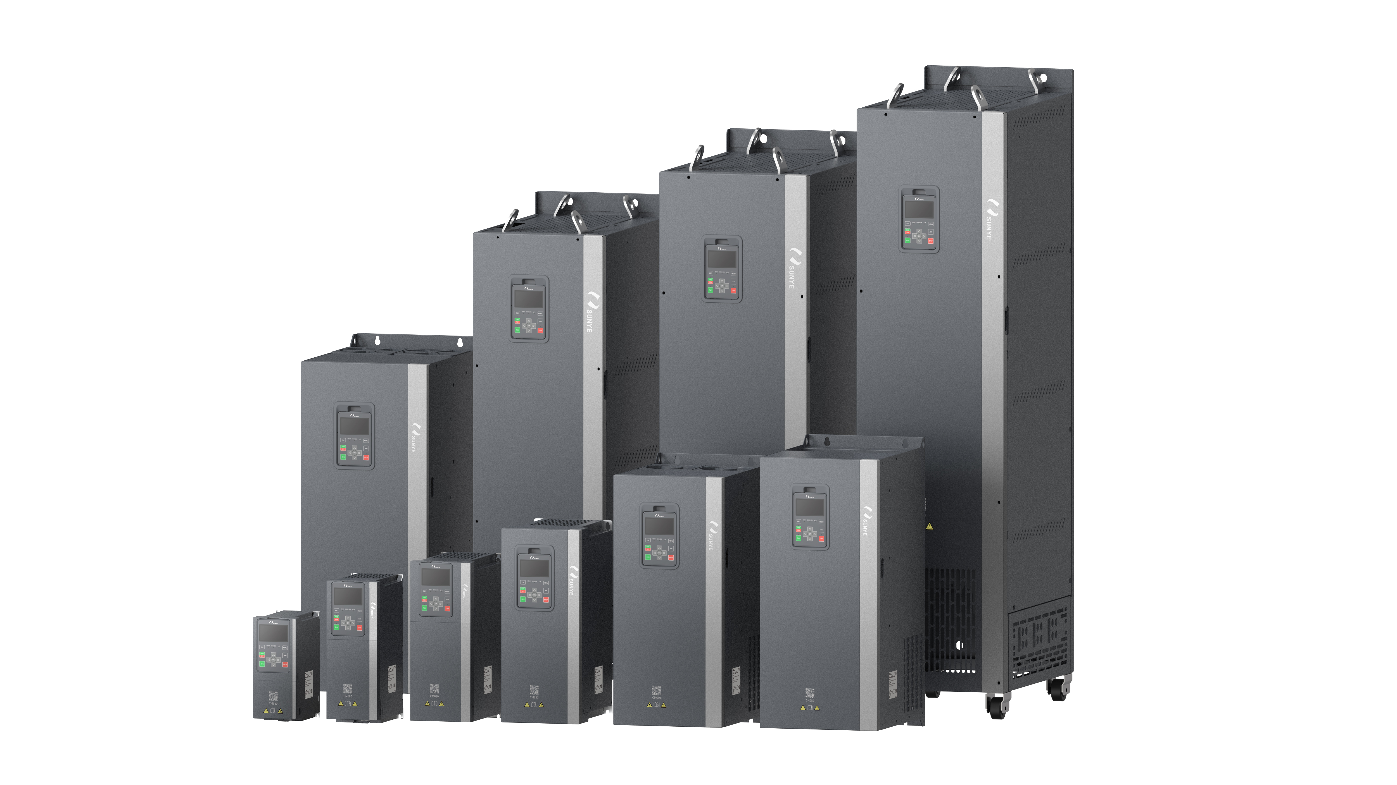
Figure 1-1 Product Appearance
This product has the following features:
- All models have a slim design with vertical airflow and independent cooling channels, allowing multiple inverters to be installed side by side, saving cabinet space.
- It supports the drive of induction motors, permanent magnet synchronous motors, and synchronous reluctance motors, meeting customers' diverse motor needs; Supports multiple bus communication cards including Profibus DP, CANopen, EtherCAT, Profinet, and Ethernet/IP.
- Supports automatic energy-saving control, which outputs the optimal current through energy-saving algorithms to reduce system losses and maximize system efficiency.
- Equipped with an LCD keyboard, parameters are categorized for quick replication, supporting both Chinese and English; upper-level monitoring software for fault monitoring and operational status monitoring; supports STO safety protection function.

Naming Rules and Nameplate Marking

Figure 1-2 Product Model

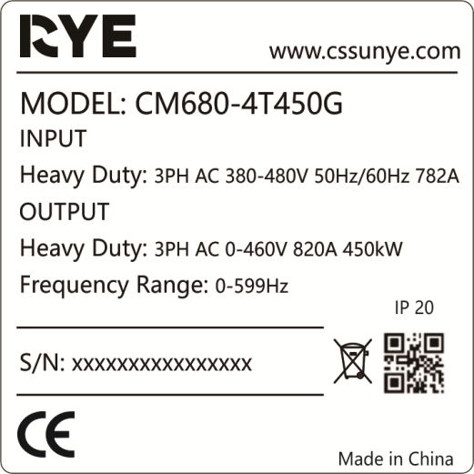
Figure 1-3 Nameplate Marking
Note:
1. Three-phase 380V～480V, models C2～C5 do not support optional DC reactors, while models C6 and above come standard with DC reactors.
2. Three-phase 380V～480V, C2～C4 standard with braking unit, C5～C7 optional braking unit, C8～C11 not available with braking unit.
3. (-L) is an optional output AC reactor, C9～C11 can optionally be equipped with a reactor base.

Product Model
Table 1-1 CM680 Inverter Model and Technical Data
Physical Structure | Inverter Model | Input Voltage | Input Current  （A） | Output Current  （A） | Suitable Motor  （kW）
C2 | CM680-4T4R0GB | Three-phase 380V～480V  Range: -15%～+10% | 11.4 | 9.0 | 4.0
C2 | CM680-4T5R5GB | Three-phase 380V～480V  Range: -15%～+10% | 16.7 | 13.0 | 5.5
C2 | CM680-4T7R5GB | Three-phase 380V～480V  Range: -15%～+10% | 21.0 | 17.0 | 7.5
C3 | CM680-4T011GB | Three-phase 380V～480V  Range: -15%～+10% | 32.0 | 25.0 | 11.0
C3 | CM680-4T015GB | Three-phase 380V～480V  Range: -15%～+10% | 41.0 | 32.0 | 15.0
C4 | CM680-4T018GB | Three-phase 380V～480V  Range: -15%～+10% | 47.0 | 37.0 | 18.5
C4 | CM680-4T022GB | Three-phase 380V～480V  Range: -15%～+10% | 56.0 | 45.0 | 22.0
C4 | CM680-4T030GB | Three-phase 380V～480V  Range: -15%～+10% | 72.0 | 60.0 | 30.0
C5 | CM680-4T037G(B) | Three-phase 380V～480V  Range: -15%～+10% | 88.0 | 75.0 | 37.0
C5 | CM680-4T045G(B) | Three-phase 380V～480V  Range: -15%～+10% | 110.0 | 90.0 | 45.0
C6 | CM680-4T055G(B) | Three-phase 380V～480V  Range: -15%～+10% | 106.0 | 110.0 | 55.0
C6 | CM680-4T075G(B) | Three-phase 380V～480V  Range: -15%～+10% | 139.0 | 152.0 | 75.0
C6 | CM680-4T093G(B) | Three-phase 380V～480V  Range: -15%～+10% | 165.0 | 176.0 | 93.0
C7 | CM680-4T110G(B) | Three-phase 380V～480V  Range: -15%～+10% | 190.0 | 210.0 | 110.0
C7 | CM680-4T132G(B) | Three-phase 380V～480V  Range: -15%～+10% | 230.0 | 253.0 | 132.0
C8 | CM680-4T160G | Three-phase 380V～480V  Range: -15%～+10% | 276.0 | 304.0 | 160.0
C8 | CM680-4T185G | Three-phase 380V～480V  Range: -15%～+10% | 314.0 | 340.0 | 185.0
C9 | CM680-4T200G | Three-phase 380V～480V  Range: -15%～+10% | 346.0 | 380.0 | 200.0
C9 | CM680-4T220G | Three-phase 380V～480V  Range: -15%～+10% | 380.0 | 426.0 | 220.0
C9 | CM680-4T250G | Three-phase 380V～480V  Range: -15%～+10% | 435.0 | 465.0 | 250.0
C10 | CM680-4T280G | Three-phase 380V～480V  Range: -15%～+10% | 478.0 | 520.0 | 280.0
C10 | CM680-4T315G | Three-phase 380V～480V  Range: -15%～+10% | 534.0 | 585.0 | 315.0
C10 | CM680-4T355G | Three-phase 380V～480V  Range: -15%～+10% | 598.0 | 650.0 | 355.0
C11 | CM680-4T400G | Three-phase 380V～480V  Range: -15%～+10% | 672.0 | 725.0 | 400.0
C11 | CM680-4T450G | Three-phase 380V～480V  Range: -15%～+10% | 742.0 | 820.0 | 450.0

Technical Data

Electrical Parameters
Inverter application mode is heavy-duty mode (Type G machine):
Heavy-duty mode is indicated by the uppercase letter G, under which the inverter operates according to the corresponding rated power, rated input current,
rated output current, and overload curve, etc.
Table 1-2 Electrical Parameters (Three-phase 380V~480V) (C2~C3)
Item |  | Specification
Model: CM680-4Txxxx |  | 4R0GB | 5R5GB | 7R5GB | 011GB | 015GB
Physical Structure |  | C2 |  |  | C3
Output | Power (kW) | 4.0 | 5.5 | 7.5 | 011 | 015
Output | Rated Output Current (A) | 9.0 | 13.0 | 17.0 | 25.0 | 32.0
Output | Output Voltage | AC Three-phase 0~460V
Output | Maximum Output Frequency | 599Hz (Can be changed through parameters)
Output | Carrier Frequency | C2: 2kHz~15kHz; C3: 2kHz~10kHz  (Can automatically adjust carrier frequency based on load characteristics)
Output | Overload Capacity | Type G machine 150% rated current 60s
Input | Rated Input Current(A) | 11.4 | 16.7 | 21.0 | 32.0 | 41.0
Input | Rated Voltage Rated Frequency | AC: Three-phase 380~480V, 50/60Hz
Input | Voltage Tolerance Range | -15%~10%
Input | Frequency Tolerance Range | ±5%
Overvoltage Category |  | OVCIII
Pollution Degree |  | PD2
Protection Class |  | IP20 (open type, IP protection class applies to IEC products)
Table 1-3 Electrical Parameters (Three-phase 380V~480V) (C4~C5)
Item |  | Specification
Model: CM680-4Txxxx |  | 018GB | 022GB | 030GB | 037G(B) | 045G(B)
Physical Structure |  | C4 |  |  | C5
Output | Power (kW) | 018 | 022 | 030 | 037 | 045
Output | Rated Output Current (A) | 37.0 | 45.0 | 60.0 | 75.0 | 90.0
Output | Output Voltage | AC Three-phase 0~460V
Output | Maximum Output Frequency | 599Hz (Can be changed through parameters)
Output | Carrier Frequency | C4~C5: 2kHz~10kHz (can be automatically adjusted according to load characteristics)
Output | Overload Capacity | Type G machine 150% rated current 60s
Input | Rated Input Current(A) | 47.0 | 56.0 | 72.0 | 88.0 | 110.0
Input | Rated Voltage Rated Frequency | AC: Three-phase 380~480V, 50/60Hz
Input | Voltage Tolerance Range | -15%~10%
Input | Frequency Tolerance Range | ±5%
Overvoltage Category |  | OVCIII
Pollution Degree |  | PD2
Protection Class |  | IP20 (open type, IP protection class applies to IEC products)
Table 1-4 Electrical Parameters (Three-phase 380V~480V) (C6~C7)
Item |  | Specification
Model: CM680-4Txxxx |  | 055G(B) | 075G(B) | 093G(B) | 110G(B) | 132G(B)
Physical Structure |  | C6 |  |  | C7
Output | Power (kW) | 055 | 075 | 093 | 110 | 132
Output | Rated Output Current (A) | 110.0 | 152.0 | 176.0 | 210.0 | 253.0
Output | Output Voltage | AC Three-phase 0~460V
Output | Maximum Output Frequency | 599Hz (Can be changed through parameters)
Output | Carrier Frequency | C6: 2kHz~10kHz; C7: 2kHz~6kHz  (Can automatically adjust carrier frequency based on load characteristics)
Output | Overload Capacity | Type G machine 150% rated current 60s
Input | Rated Input Current(A) | 106.0 | 139.0 | 165.0 | 190.0 | 230.0
Input | Rated Voltage Rated Frequency | AC: Three-phase 380~480V, 50/60Hz
Input | Voltage Tolerance Range | -15%~10%
Input | Frequency Tolerance Range | ±5%
Overvoltage Category |  | OVCIII
Pollution Degree |  | PD2
Protection Class |  | IP20 (open type, IP protection class applies to IEC products)
Table 1-5 Electrical Parameters (Three-phase 380V~480V) (C8~C9)
Item |  | Specification
Model: CM680-4Txxxx |  | 160G | 185G | 200G | 220G | 250G
Physical Structure |  | C8 |  | C9
Output | Power (kW) | 160 | 185 | 200 | 220 | 250
Output | Rated Output Current (A) | 304.0 | 340.0 | 380.0 | 426.0 | 465.0
Output | Output Voltage | AC Three-phase 0~460V
Output | Maximum Output Frequency | 599Hz (Can be changed through parameters)
Output | Carrier Frequency | C8~C9: 2kHz~6kHz (Can automatically adjust carrier frequency based on load characteristics)
Output | Overload Capacity | Type G machine 150% rated current 60s
Input | Rated Input Current(A) | 276.0 | 314.0 | 346.0 | 380.0 | 435.0
Input | Rated Voltage Rated Frequency | AC: Three-phase 380~480V, 50/60Hz
Input | Voltage Tolerance Range | -15%~10%
Input | Frequency Tolerance Range | ±5%
Overvoltage Category |  | OVCIII
Pollution Degree |  | PD2
Protection Class |  | IP20 (open type, IP protection class applies to IEC products)

Table 1-6 Electrical Parameters (Three-phase 380V~480V) (C10~C11)
Item |  | Specification
Model: CM680-4Txxxx |  | 280G | 315G | 355G | 400G | 450G
Physical Structure |  | C10 |  |  | C11
Output | Power (kW) | 280 | 315 | 355 | 400 | 450
Output | Rated Output Current (A) | 520.0 | 585.0 | 650.0 | 725.0 | 820.0
Output | Output Voltage | AC Three-phase 0~460V
Output | Maximum Output Frequency | 599Hz (Can be changed through parameters)
Output | Carrier Frequency | C10~C11: 2kHz~6kHz (carrier frequency can be automatically adjusted according to load characteristics)
Output | Overload Capacity | Type G machine 150% rated current 60s
Input | Rated Input Current(A) | 478.0 | 534.0 | 598.0 | 672.0 | 742.0
Input | Rated Voltage Rated Frequency | AC: Three-phase 380~480V, 50/60Hz
Input | Voltage Tolerance Range | -15%~10%
Input | Frequency Tolerance Range | ±5%
Overvoltage Category |  | OVCIII
Pollution Degree |  | PD2
Protection Class |  | IP20 (open type, IP protection class applies to IEC products)

Technical Specifications
Table 1-7 Inverter Technical Specifications
Item |  | Specification
Main  Control  Performance | Maximum Output Frequency | 599.00Hz
Main  Control  Performance | Carrier Frequency | 7.5kW and below: 2kHz～15kHz  11kW～93kW: 2kHz～10kHz  110kW～450kW: 2kHz～6kHz  Can automatically adjust carrier frequency based on load characteristics
Main  Control  Performance | Input frequency resolution | Digital setting: 0.01Hz  Analog setting: Maximum frequency × 0.025%
Main  Control  Performance | Control method | Induction Motor: V/F ; VVC ; SVC ; FVC
Main  Control  Performance | Control method | Permanent Magnet Synchronous Motor: SVC ; VVC ; FVC
Main  Control  Performance | Starting torque | SVC 150% ; FVC 180%
Main  Control  Performance | Speed range | 1:200 (SVC)  1:1000 (FVC)
Main  Control  Performance | Speed stability accuracy | SVC: ≤±0.5%  FVC: ≤±0.02%
Main  Control  Performance | Torque response | Torque step response within 20ms
Main  Control  Performance | Torque accuracy | ±10% (SVC)  ±5%(FVC)
Main  Control  Performance | Overload Capacity | 150% Rated Current 60s *
Main  Control  Performance | Torque Boost | Includes automatic torque boost and manual torque boost
Main  Control  Performance | V/F Curve | Multi-point V/F curve; 1.5 power V/F curve; Square V/F curve
Main  Control  Performance | Acceleration/Deceleration Curves | Linear or S-curve acceleration/deceleration method; four sets of acceleration/deceleration times; Acceleration/deceleration time range: 0.00s～600.00s or 0.0s～6000.0s
Main  Control  Performance | DC Braking | Includes start DC braking and stop DC braking, braking time 0.0s～60.0s
Main  Control  Performance | Jog Control | Jog frequency range: 0.00Hz～599.00Hz; Jog acceleration and deceleration time range: 0.00s～600.00s or 0.0s～6000.0s
Main  Control  Performance | Tension Control | Includes four control modes: tension closed-loop speed mode, line speed closed-loop speed mode, tension closed-loop torque mode, tension open-loop torque mode
Main  Control  Performance | Multi-speed Operation | Up to 16 multi-speed operations can be achieved through control terminals
Main  Control  Performance | Built-in PID | Provides options for traditional PID or fuzzy PID control, enhancing the parameter adaptability and robustness of process control systems
Personalized  Function  Ability | Peripheral Safety Self-Check | Safety checks on peripheral devices are performed before operation to promptly identify issues such as grounding and short circuits, improving system reliability
Personalized  Function  Ability | Common DC Bus Function | Can achieve multiple inverters sharing a common DC bus
Personalized  Function  Ability | JOG Key | Can achieve jogging operation through the JOG key on the operation panel
Personalized  Function  Ability | Rapid Current Limiting Function | Built-in rapid current limiting algorithm reduces the probability of overcurrent faults in the inverter
Personalized  Function  Ability | Motor Parameter Identification | Can achieve automatic identification of motor parameters
Personalized  Function  Ability | Automatic Voltage Regulation | When grid voltage changes, it can automatically maintain stable output voltage
Personalized  Function  Ability | Standardized Panel Extension Cable | Customers can use standard network cables to extend the panel themselves
Personalized  Function  Ability | Communication Bus | Supports at least 5 types (Profinet, CANopen, Profibus-DP, EtherCAT, Ethernet/IP)
Personalized  Function  Ability | Supports Expansion Functions | IO Expansion Card; Various Bus Communication Expansion Cards; PG Card (Sine/Cosine, Incremental)
Personalized  Function  Ability | STO | Safe Torque Off in Emergency Situations
Operation | Operation Command Channel | Supports multiple methods for command signal setting: panel setting, control terminal setting, communication setting, etc.
Operation | Frequency Source | Multiple frequency setting sources: panel setting, analog setting, control terminal setting, communication setting, etc.
Operation | Auxiliary Frequency Source | Multiple auxiliary frequency sources: panel setting, analog setting, control terminal setting, communication setting, etc. Flexible implementation of auxiliary frequency fine-tuning, frequency synthesis
Operation | General Terminal | 8*DI (including 1 high-speed), 3*DO (including 1 high-speed), 2*Relay outputs, 3*AI, 2*AO
Operation | Automatic Acceleration and Deceleration | Automatically adjusts acceleration and deceleration time based on load torque
Display and Keyboard Operation | LCD Display | Supports Chinese/English languages
Display and Keyboard Operation | LCD Parameter Copying | Quick parameter copying via the LCD panel
Protection and Optional Accessories | Protection Functions | Motor short-circuit detection, input/output phase loss protection, overcurrent protection, overvoltage protection, undervoltage protection, overheating protection, overload protection, etc.
Protection and Optional Accessories | Optional Accessories | Braking Components
Environment | Usage Location | Indoor, not exposed to direct sunlight, free from dust, corrosive gases, flammable gases, oil mist, water vapor, dripping water, or salt
Environment | Altitude | No derating required for use below 1000m, above 1000m derate by 1% for every 100m increase, maximum operating altitude is 2000m, contact the manufacturer if exceeding 2000m
Environment | Ambient Temperature | －10℃～＋50℃ (derate by 2% for every 1℃ increase when ambient temperature exceeds 40℃)
Environment | Humidity | < 95％RH, no condensation
Environment | Vibration | < 5.9m/s²(0.6g)
Environment | Storage Temperature | －20℃～＋60℃
Environment | Pollution Degree | 2
Environment | Protection Class | IP20
Product  Standard | Product Safety Standard Compliance | IEC61800-5-1:2017
Product  Standard | Product EMC Standard Compliance | IEC61800-3:2018
* For overload operation below 5Hz, derating should be considered.

Component Introduction

Overview
Inverter Structure Types: Models C2 to C4 have a plastic enclosure structure, while models C5 to C11 have a metal enclosure structure.

Components of C2 to C4 Models
Figure 1-4 Component Diagram (C2 to C4)

Components of C5 to C8 Models
Figure 1-5 Component Diagram (C5 to C8)

Components of C9 to C11 Models
Figure 1-6 Component Diagram (C9 to C11)

Electrical Design

System Application Wiring

System Connection Diagram
When using an inverter to control an induction motor to form a control system, various electrical components need to be installed on the input and output sides of the inverter to ensure the safety and stability of the system. For products with three-phase 380V ~ 480V and 4.0kW or higher power, the system configuration is shown in Figure 2-1:
Figure 2-1 System Configuration
Table 2-1 Instructions for Peripheral Electrical Components
Function Section Name | Installation Location | Function Description
Three-phase Input Power | Inverter Input Side | Please supply power according to the rated current specified in this manual. Refer to the specifications table for details.
Air Switch/Circuit Breaker | Inverter Input Side | Disconnects power when overcurrent occurs in downstream equipment
Fast Fuse | Inverter Input Side | Prevents accidents due to short circuits and protects downstream semiconductor devices
Contactor | Inverter Input Side | Inverter power-on and power-off operations. Avoid frequent power-on and power-off operations through contactors (less than twice per minute) or direct start-up operations.
AC Input Reactor | Inverter Input Side | - Improve the power factor on the input side;  - Effectively eliminate higher harmonics on the input side, preventing damage to other equipment caused by voltage waveform distortion;  - Eliminate input current imbalance caused by phase imbalance in the power supply
EMC Input Filter | Inverter Input Side | - Reduce conducted and radiated interference from the inverter to the outside;  - Reduce conducted interference from the power supply to the inverter, enhancing the inverter's immunity to interference.
Built-in EMC | Integrated within the inverter | Reduce conducted and radiated interference from the inverter to the outside;  Note: Models 7.5kW and below only have an EMC selection grounding bolt;  Models 11kW to 450kW can select EMC or VDR grounding through corresponding grounding bolts;
Braking Unit | Some models of the inverter can be equipped with | When the motor decelerates, regenerative energy is dissipated through the braking resistor. Please refer to the manual's braking resistor selection guide to choose an appropriate braking resistor.  Note: For models with B, it is only necessary to select an appropriate braking resistor;  For models with (B), please refer to this manual and contact our company to purchase a braking unit, then select an appropriate braking resistor;  For other models (160kW~450kW), they do not have braking functionality;
DC Reactor | Some models of the inverter come standard with | 1) Improve the power factor on the input side; 2) Effectively eliminate higher harmonics on the input side, preventing damage to other equipment due to voltage waveform distortion
AC Output Reactor | Inverter Output Side | The inverter output side generally contains a significant amount of higher harmonics. When the motor is far from the inverter, there is a large distributed capacitance in the line. A certain harmonic may cause resonance in the circuit, leading to two effects:  - Deterioration of motor insulation performance, which can damage the motor over time.  - Generation of significant leakage current, causing frequent protection trips of the inverter.  Please refer to Table 3-2Inverter Corresponding Cable Length Table to select the appropriatecable type and length from the inverter to the motor
Motor | Drive Output Side | For the drive output side, please select a compatible motor according to recommendations

Electrical Wiring Diagram
Typical wiring is shown in the figure below:
Figure 2-2 4.0-7.5kW Three-Phase Inverter
Figure 2-3 11-132kW Three-Phase Inverter
Note: The CM680 series 11～30kW braking units are built-in; for the CM680 series 37～132kW, the braking unit is an optional feature. If required, please specify when ordering.

Figure 2-4 160kW～450kW Three-Phase Inverter
Note: The CM680 series 160kW～450kW does not have a braking function option.

Basic Electrical Safety Precautions

Selecting Power Isolation Equipment
As standard, the inverter input side is equipped with a main isolation device. Depending on the inverter capacity and selected options, this isolation device can be a disconnect switch or an air circuit breaker.

Select the Main Contactor
Depending on the inverter capacity, you can equip it with a main contactor when ordering.

Select the Supply Transformer
Consider these guidelines
1. Use the following formula to define the transformer's apparent power:
SN(kVA) = 1.6 x total power of the motor shaft (kW)
2. Define the rated voltage of the transformer's secondary winding based on the drive's rated input voltage.
3. Ensure the transformer meets the grid specifications defined for the drive.
● Rated input voltage, allowable voltage variation, and imbalance.
● Rated frequency and allowable variation.
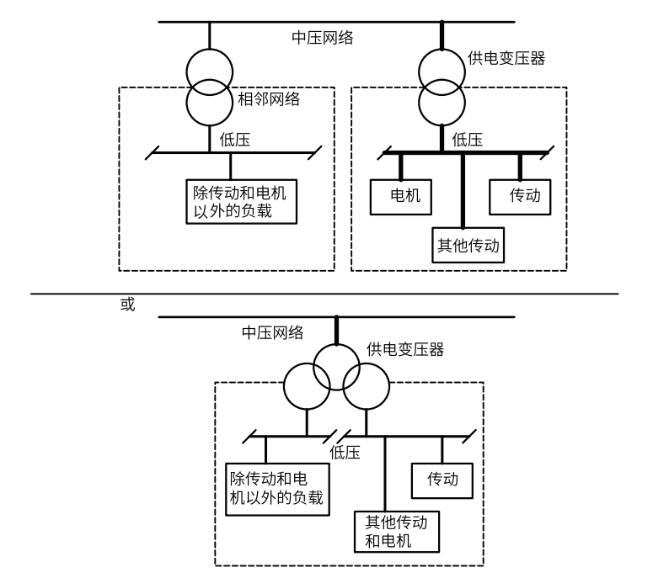
Figure 2-5 Selecting the Supply Transformer

Check the motor compatibility
The inverter can be used with an AC asynchronous induction motor, permanent magnet synchronous motor, or synchronous servo motor. Multiple motors can be connected at once.
Connect multiple induction motors to the inverter.
Based on the AC line voltage and motor load, select the motor capacity and inverter type from the ratings table in the technical data chapter.
Type.

Using a Permanent Magnet Synchronous Motor
The inverter output can only drive one permanent magnet motor.
It is recommended to install a circuit breaker between the permanent magnet synchronous motor and the drive. The circuit breaker can safely disconnect the motor from the drive.
Connection. According to the safety instructions, you must ensure that the motor is shut down and there is no energy feedback to the inverter during maintenance work.

Cable Layout Requirements
1. Signal Wire
a. Signal Wire Cable Requirements
Analog control signal wires should use twisted pair shielded cables, and the cable stripping should be as short as possible (about 57mm).-
b. Signal Wire Layout Requirements
The shielding layer of analog signal wires should preferably be connected to terminal PE or wrapped with insulating tape to prevent interference introduced through connections with other equipment or causing a short circuit.
Given that low-voltage signals are susceptible to strong external electromagnetic interference, signal wires must be routed separately from power circuits (power input, inverter output, and braking resistor connection circuits, etc.), and parallel routing should be avoided as much as possible; if parallel routing is necessary, a distance of at least 50cm should be maintained.
2 Power Cable Requirements
a. Motor Cable Requirements
The distance between the inverter control cabinet and the motor should be as close as possible, and the motor cables should be routed separately from other cables, while avoiding long parallel runs of motor cables alongside other cables to reduce electromagnetic interference generated by the du/dt at the inverter output side. For non-shielded cables, it is recommended that they be routed through a metal box or metal pipe, with both ends of the metal box or metal pipe welded to 16mm^2 (or larger) cable for grounding. For shielded cables, the shielding layer should be 360° grounded at both ends.
b. Input Cable Requirements
It is recommended to use shielded cables for input cables, with the shielding layer grounded 360° at both ends.
For non-shielded cables, it is recommended to route them through a metal box or metal pipe, with both ends of the metal box or metal pipe welded to a 16mm^2 (or larger) cable for grounding.
- Control Cable
Select control cables that comply with national standards (GB/T 5023) or IEC standards (IEC 60227).
If control cables and power cables cross, they should be crossed at a 90-degree angle as much as possible.

Main Circuit Wiring

Main Circuit Terminal Description
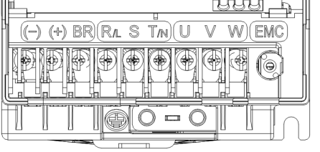
Figure 2-6 4.0~7.5kW Main Circuit Terminal Wiring Diagram

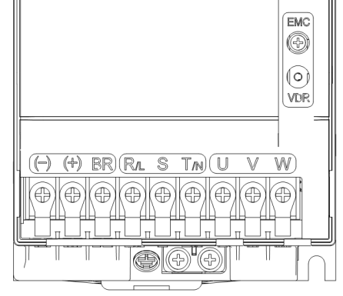
Figure 2-7 11~15kW Main Circuit Terminal Wiring Diagram
Figure 2-8 18.5~30kW Main Circuit Terminal Wiring Diagram
Figure 2-9 37~45kW Main Circuit Terminal Wiring Diagram
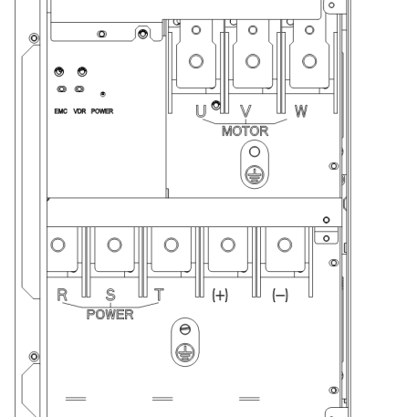
Figure 2-10 55~185kW Main Circuit Terminal Wiring Diagram
Figure 2-11 200~450kW Main Circuit Terminal Wiring Diagram

Table 2-2 Three-Phase Inverter Main Circuit Terminal Description
Terminal Marking | Name | Description
R, S, T | Three-Phase Power Input Terminals | AC Input Three-Phase Power Connection Points
(+), (-) | DC Bus Positive and Negative Terminals | Common DC Bus Input Point
(+), BR | Braking Resistor Connection Terminals | No Braking Option for 160kW~450kW
U, V, W | Inverter Output Terminals | Connecting Three-Phase Motor
 | Grounding Terminal | Grounding Terminal

Selection of Main Circuit Cable
For the selection of power cable size, please comply with the regulations and requirements of each country or region. IEC cable selection reference principles are as follows:
a. Comply with IEC60034-17 and IEC 60364-552 standards or equivalent national standards;--
b. Use PVC or other copper conductor cables with higher temperature resistance.
Note: 1. The operating environment temperature for power cables should be ≤40°C, and the surface temperature of the cable should be ≤70°C. (If the operating environment temperature exceeds 40°C, or the cable surface temperature is below the minimum rated value of the cable, please contact the manufacturer.)
2. It is recommended to use symmetrical cables with copper mesh shielding.
3. If the recommended cable specifications for peripheral devices or options exceed the cable specifications applicable to the product, please contact our company.
To meet EMC standards requirements, it is strongly recommended to use cables with a shielding layer. Common shielded cables come in three-conductor and four-conductor types. When using a three-conductor shielded cable, an additional separate PE line is required, and the shielding layer must be grounded. The requirements for shielded cables are as follows:
a. The shielding layer of the shielded cable should consist of coaxial copper braiding.
To enhance the shielding effectiveness and conductivity, the shielding layer's weave density should be greater than 90%.

Table 2-3 Recommended Wires and Terminal Lugs for Inverters
Inverter Model | RST/UVW Recommended  Wires and Terminal Lugs |  | Recommended Grounding Wires and Terminal Lugs |  | Screw Specifications | Torque  （Nm）
Inverter Model | Wire  （mm²） | Terminal Lug Model | Wire  （mm²） | Terminal Lug Model | Screw Specifications | Torque  （Nm）
CM680-4T4R0GB | 2.5 | TNR24M- | 2.5 | TNR24M- | M4 | 1.2
CM680-4T5R5GB | 2.5 | TNR24M- | 2.5 | TNR24M- | M4 | 1.2
CM680-4T7R5GB | 4 | RV3.5-4 | 4 | RV3.5-4 | M4 | 1.2
CM680-4T011GB | 6.0 | TNR5.5-5 | 6 | TNR5.5-5 | M5 | 2.8
CM680-4T015GB | 10 | RNB8-4 | 10 | RNB8-4 | M5 | 2.8
CM680-4T018GB | 10 | GTNR10-6 | 10 | GTNR10-6 | M6 | 4.8
CM680-4T022GB | 16 | GTNR16-6 | 16 | GTNR16-6 | M6 | 4.8
CM680-4T030GB | 16 | GTNR16-6 | 16 | GTNR16-6 | M6 | 4.8
CM680-4T037G(B) | 25 | GTNR25-6 | 25 | GTNR25-6 | M6 | 4.8
CM680-4T045G(B) | 35 | GTNR35-8 | 25 | GTNR25-6 | M8/M6 | 13/4.8
CM680-4T055G(B) | 50 | GTNR50-8 | 25 | GTNR25-6 | M8/M6 | 13/4.8
CM680-4T075G(B) | 70 | GTNR70-12 | 35 | GTNR35-8 | M12/M8 | 35/13
CM680-4T093G(B) | 95 | GTNR95-12 | 50 | GTNR50-8 | M12/M8 | 35/13
CM680-4T110G(B) | 120 | GTNR120-12 | 70 | GTNR70-12 | M12 | 35
CM680-4T132G(B) | 150 | GTNR150-12 | 95 | GTNR95-12 | M12 | 35
CM680-4T160G | 185 | GTNR185-12 | 95 | GTNR95-12 | M12 | 35
CM680-4T185G | 185 | GTNR185-12 | 95 | GTNR95-12 | M12 | 35
CM680-4T200G | 2×120 | GTNR120-12 | 120 | GTNR120-12 | M12 | 35
CM680-4T220G | 2×150 | GTNR150-12 | 150 | GTNR150-12 | M12 | 35
CM680-4T250G | 2×150 | GTNR150-12 | 150 | GTNR150-12 | M12 | 35
CM680-4T280G | 2×150 | GTNR150-12 | 150 | GTNR150-12 | M12 | 35
CM680-4T315G | 2×150 | GTNR150-12 | 185 | GTNR185-12 | M12 | 35
CM680-4T355G | 2×185 | GTNR185-12 | 185 | GTNR185-12 | M12 | 35
CM680-4T400G | 2×240 | GTNR240-16 | 240 | GTNR240-16 | M16 | 85
CM680-4T450G | 2×240 | GTNR240-16 | 240 | GTNR240-16 | M16 | 85

Main Circuit Wiring Requirements
MainCircuit Wiring Requirements
a. The ground wire must be securely connected to the grounding terminal.
b. BR, ()、(+) terminals are for specific functions and cannot be used for other purposes.-
c. The control circuit is a safety extra low voltage circuit, isolated from other circuits with reinforced insulation. Ensure that the control circuit does not connect to other circuits.
d. Be careful not to allow foreign objects to enter the wiring section of the terminal block.
e. Control wires must not be soldered.
f. Tighten the screws according to the specified torque.
g. If using an electric tool to tighten the terminal screws, set a reasonable torque; otherwise, the terminal screws may be damaged.
h. Do not tighten the terminal screws at an angle greater than 5 degrees, as this may damage the terminal screws.
MainCircuit Wiring Requirements
The power input lines and motor cables of the inverter can generate strong electromagnetic interference, and strong electromagnetic interference to the control signals of the inverter may cause malfunction. Therefore, it is recommended that the input and output power cables and control circuits do not run parallel over long distances. If it is unavoidable for them to run parallel, the distance between the main circuit cables and the signal cables should be more than 50 cm.
Note: Common main circuit cables include input RST lines, output UVW lines, DC bus, and braking cables;
Signal cables include IO signal lines, communication lines, and encoder lines.
Cable trays must maintain good bonding between them, and the cable tray enclosures must be well grounded. A well-grounded metal cable tray can ensure equipotentiality of the equipment.
The inverter, motor, and any optional filters or reactors should all be well bonded with the system (mechanical or apparatus). At the grounding points, paint removal treatment is required, and after installation, anti-corrosion spraying should be applied; non-grounded installation parts should be protected with spray coating and should make good contact with the cabinet.

Figure 2-12 Cable Layout Diagram

Wiringin IT or Delta Power Grids
In IT power grids or delta power grid systems, disconnect the optional EMC grounding screw; otherwise, it may cause equipment damage or even personal injury.
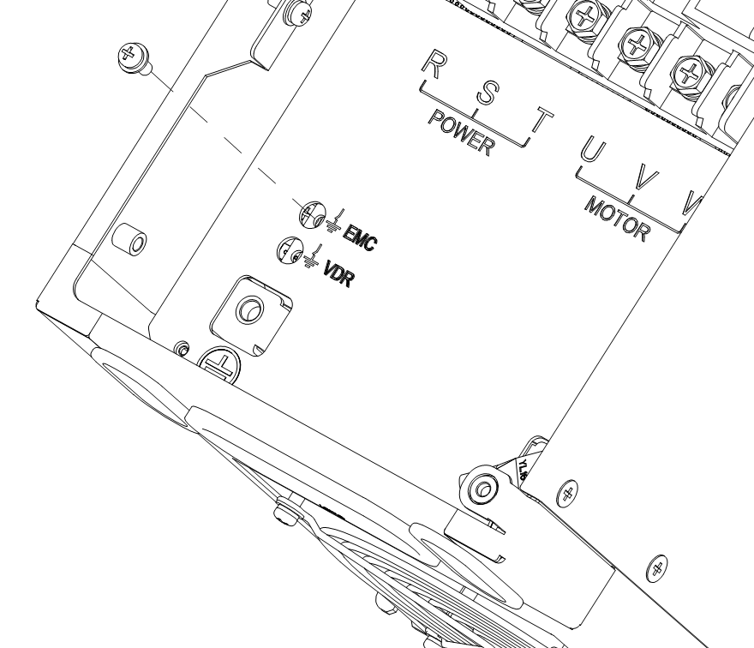
Figure 2-13 Disconnecting the EMC Optional Grounding Screw
Requirements for Shielded Cable Shielding Layer
It is recommended to use shielded cables for power cables, and the shielding layer must be connected to the PE terminal with 360° grounding. Do not twist the cable end shielding layer into a small tail that is exposed outside.
Requirements for Motor Cable Length
When the inverter operates, due to the rapid switching of power transistors, a significant du/dt is generated at the output end. When the motor cable is too
Long-term high du/dt can lead to motor insulation breakdown and bearing damage. To avoid this risk, please refer to the following recommendations:
a. Use motors that meet the IEC6003425 IVIC B technical specifications, or use motors with higher insulation voltage.-
b. The cable length between the inverter and the motor must not exceed the requirements listed in Table 2-4.
c. An output reactor may be required in some applications.
Please select cables of appropriate length according to the cable length requirements specified in this table.

Table 2-4 Cable Length Table
Inverter Model | Rated Output Current (A) | Without Output AC Reactor |  | With Output AC Reactor Installed
Inverter Model | Rated Output Current (A) | Shielded Cable (m) | Unshielded Cable (m) | Shielded Cable (m) | Unshielded Cable (m)
CM680-4T4R0GB | 9.0 | 50 | 75 | 75 | 115
CM680-4T5R5GB | 13.0 | 50 | 75 | 75 | 115
CM680-4T7R5GB | 17.0 | 50 | 75 | 75 | 115
CM680-4T011GB | 25.0 | 50 | 75 | 75 | 115
CM680-4T015GB | 32.0 | 50 | 75 | 75 | 115
CM680-4T018GB | 37.0 | 50 | 75 | 75 | 115
CM680-4T022GB | 45.0 | 50 | 75 | 75 | 115
CM680-4T030GB | 60.0 | 50 | 75 | 75 | 115
CM680-4T037G(B) | 75.0 | 50 | 75 | 75 | 115
CM680-4T045G(B) | 90.0 | 50 | 75 | 75 | 115
CM680-4T055G(B) | 110.0 | 50 | 75 | 75 | 115
CM680-4T075G(B) | 152.0 | 50 | 75 | 75 | 115
CM680-4T093G(B) | 176.0 | 50 | 75 | 75 | 115
CM680-4T110G(B) | 210.0 | 50 | 75 | 75 | 115
CM680-4T132G(B) | 253.0 | 50 | 75 | 75 | 115
CM680-4T160G | 304.0 | 50 | 75 | 75 | 115
CM680-4T185G | 340.0 | 50 | 75 | 75 | 115
CM680-4T200G | 380.0 | 50 | 75 | 75 | 115
CM680-4T220G | 426.0 | 50 | 75 | 75 | 115
CM680-4T250G | 465.0 | 50 | 75 | 75 | 115
CM680-4T280G | 520.0 | 50 | 75 | 75 | 115
CM680-4T315G | 585.0 | 50 | 75 | 75 | 115
CM680-4T355G | 650.0 | 50 | 75 | 75 | 115
CM680-4T400G | 725.0 | 50 | 75 | 75 | 115
CM680-4T450G | 820.0 | 50 | 75 | 75 | 115

Terminal Lug Selection
The terminal lugs recommended in the table below are the GTNR series and BC series from Suzhou Yuanli.

Table 2-5 Appearance Diagrams of Various Series Terminal Lugs
Series | Appearance Diagram
GTNR Series | 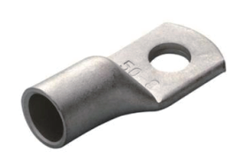
TNR Series | 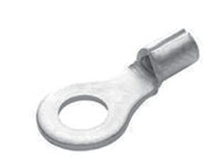
RV Series | 
RNB Series | 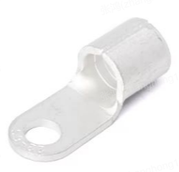

Control Circuit Wiring

Control Circuit Terminal Description
The control circuit terminal layout is shown below:
Figure 2-14 Control Panel Terminal Layout Diagram

Figure 2-15 Control Circuit Terminal Layout Diagram

Control Terminal Function Description:
Table 2-6 CM680 Inverter Control Terminal Function Description
Category Category | Terminal Symbol | Terminal Name | Function Description
Power Supply | +24V-DCM | External +24V  Power Supply | Provides +24V power supply, generally used as the working power supply for digital input/output terminals and external sensors,  Maximum Output Current: 200mA
Analog  Input | AI1-GND | Analog Input Terminal 1 | 1. Input Range: DC 0～10V/0～20mA/4～20mA, configured by the customer.  2. Input Impedance: 10kΩ when voltage input, 500Ω when current input.
Analog  Input | AI2-GND | Analog Input Terminal 2
Analog  Input | AI3-GND | Analog Input Terminal 3
Digital  Input | DI1-COM | Digital Input 1 | 1. Optocoupler isolation, compatible with bipolar input  2. Input impedance: 3kΩ  3. Voltage range for DI1～DI7 level inputs: 9～30V;  Voltage range for HDI8 level input: 15～30V;  4. HDI8 can be used as a high-speed input port.  Default built-in power supply, NPN type (Sink)
Digital  Input | DI2-COM | Digital Input 2
Digital  Input | DI3-COM | Digital Input 3
Digital  Input | DI4-COM | Digital Input 4
Digital  Input | DI5-COM | Digital Input 5
Digital  Input | DI6-COM | Digital Input 6
Digital  Input | DI7-COM | Digital Input 7
Digital  Input | HDI8-COM | Digital Input 8
Analog  Output | AO1-GND | Analog Output 1 | Software Configuration for Current Output or Voltage Output  Output Voltage Range: 0～10V  Output Current Range: 0～20mA
Analog  Output | AO2-GND | Analog Output 2
Digital  Output | DO1-CME | Digital Output 1 | Optocoupler Isolation, Bipolar Open Collector Output  Output Voltage Range: 0～48V  Output Current Range: 0～50mA
Digital  Output | DO2-CME | Digital Output 2
High Speed  Digital  Output | FM-DCM | High-Speed Digital Output | Optocoupler Isolated Output  Output Voltage Range: 0～24V  Output Current Range: 0～30mA  Maximum Output Frequency: 100KHz
Function  Safety | STO1 | STO1 | S1～DCM / S2～DCM  Rated Input Voltage: +24 VDC ± 10%;  Maximum Input Voltage: +30 VDC  Rated Input Current: 6.8mA ± 10%  Note: When the STO function is not used, S1 and S2 can be short-circuited with +24V to disable the STO function
Function  Safety | STO2 | STO2
Communication  Interface | 485+ -485- | Modbus Communication Interface | Modbus Communication Interface
Communication  Interface | EGND | 485GND | 485GND
PE | PE | PE | Signal Wire Shield Ground Terminal
Relay  Output 1 | TA-TB | Normally Closed Terminal | Single Channel Relay Output Capability:  250Vac/3A(NO);  250Vac/3A(NC);  250Vac/2A(NO)estimate cosφ=0.4;  250Vac/1.2A(NC)estimate cosφ=0.4;  30Vdc/3A(NO)  30Vdc/2A(NC)
Relay  Output 1 | TA-TC | Normally Open Terminal
Relay  Output 2 | RA-RB | Normally Closed Terminal
Relay  Output 2 | RA-RC | Normally Open Terminal
Keyboard Extension  Wiring Interface | J6 | External Keyboard Interface | Supports external keyboard, the keyboard can support function copying, using standard network cable for extension.
Note:
● When ambient temperature exceeds 23°C, derating is required; for every 1°C increase in ambient temperature, output current decreases by 1.8mA. At 40°C
ambient temperature, the maximum output current is 170mA. When the user shorts COM and 24V, the current on the DI terminal must also be considered.
● Users need to select 500Ωor 250Ωimpedance based on the load capability of the signal source, the selection basis is the maximum output
of the signal source.
Voltage, for example, using 500Ωimpedance, it is necessary to ensure that the maximum output voltage of the signal source is not less than 10V, to ensure that AI2 can
measure 20mA of current.

Control Loop Terminal Wiring Instructions
Signal Input Terminal Wiring Instructions:
AI Analog Input Terminals:
Due to weak analog voltage signals being particularly susceptible to external interference, shielded cables are generally required, and the wiring distance should be as short as possible, not exceeding 20m, as shown in Figure 2-16. In cases where analog signals are severely interfered with, a filter capacitor or ferrite core should be added on the side of the analog signal source.

Figure 2-16 Schematic Diagram of Analog Input Terminal Wiring

DI Digital Input Terminals:
Figure 2-17 Wiring Diagrams for Digital Input Terminals in Four Different Modes
Note: When using an external power supply, the voltage range for standard IO ports (DI1～DI7) should be 9～30V, and for high-speed IO ports (HDI8), it should be 15～30V.
Generally, shielded cables should be used, and the wiring distance should be as short as possible, not exceeding 20 meters.
When using active drive mode, necessary filtering measures should be taken to prevent power supply crosstalk.
It is recommended to use contact control method.
DO Digital Output Terminals:
When the digital output terminal needs to drive a relay, an absorption diode should be installed across the relay coil, with a driving capability not exceeding 50mA. Otherwise, it can easily cause damage to the DC 24V power supply.
Note: The polarity of the absorption diode must be correctly installed as shown in Figure 2-18. Otherwise, when the digital output terminal has an output, it will immediately damage the DC 24V power supply.

Figure 2-18 Schematic Diagram of Digital Output Terminal DO Wiring
Relay Output Terminal Wiring:
Inductive loads (relays, contactors, and motors) will cause voltage spikes when the current is cut off. For relay contacts,
use a varistor for protection and install an absorption circuit on the inductive load, such as a varistor, RC absorption circuit, or diode.
etc., to ensure the interference is minimized when turned off, as shown in Figure 2-19.
Figure 2-19 Recommended Circuit for Relay Inductive Load

Control Circuit Wiring Requirements
Description
Control circuit wiring should comply with the requirements of EN 60204-1 standard.-
Selection Requirements
Toensure that the control circuit is not affected by strong interference noise around it, it is recommended to use shielded cables with shielding layers for signal cables, and to achieve a reliable 360° connection between the equipment and the signal shielding bracket at both ends of the shielding layer. Different analog signals should use separate shielded cables, and digital signal lines are recommended to use shielded twisted pairs.

Figure 3-24Figure 220 Schematic of Shielded Twisted Pair Cable-
Grounding Requirements for the Shielding Layer of Analog Terminals
Analog voltage signals are susceptible to external interference, so shielded cables are generally required, and the wiring distance should be as short as possible, not exceeding 20m. In cases where analog signals are severely interfered with, a filter capacitor or ferrite core should be added at the analog signal source side, and it is recommended that the shielding layer of the shielded cable be grounded 360°.
Wiring Requirements for Encoder Signal Lines
When installing the PG card and performing encoder wiring, simply connect the shielding layer of the encoder signal line to the PE terminal on the PG card to achieve the connection between the shielding layer of the signal line and the PE grounding point of the inverter, thus completing the grounding of the signal line's shielding layer. The requirements for connecting the encoder cable are as follows:
1. During on-site installation and commissioning, the encoder cables and power cables must be routed in separate conduits; it is strictly prohibited to bundle the encoder cables with the power cables, as this will cause encoder interference issues.
2. It is recommended to use twisted pair shielded cable. For differential encoders, the twisted pairs must be wired differentially, and the shielding layer should be 360° connected to the inverter's grounding terminal (PE terminal).
3. For some large equipment where the inverter is far from the motor (motor cable length 10m), due to the influence of parasitic inductance in the cable, the grounding impedance of the encoder cable shield will increase. In this case, the encoder shield can be left unconnected to the inverter's grounding terminal (PE terminal).
IO Signal Wiring Requirements
IO signals include analog input AI, analog output AO, digital input DI, digital output DO, and relay output signals. Please disconnect the main power supply and ensure that the inverter's power indicator light is off before operating or wiring the IO terminals.
Note: If the inverter's enclosure has a lightning warning symbol (as shown in Figure 2-21), wait for the longer of the warning time or the time it takes for the light to go out.
Toavoid interference with IO signals, keep the IO signal wires at least 50cm away from the main circuit wiring (RST, UVW) and other power lines (or electrical lines).
Keepthe relay output terminal wiring at least 30cm away from other IO signal wires; otherwise, it may cause the inverter and machine to malfunction.
Figure 2-21 Lightning Warning Sign

Communication Connection

CANopen Communication
2.5.1.1 Overview
The EMH-OP module expansion card is a CANopen fieldbus adapter card that complies with CiA standards. This card is installed on the CM680 inverter to enable communication with CANopen master devices, making the inverter a slave node of the CANopen network, accepting control from the master station.
2.5.1.2 Electrical Connection
The hardware layout of the EMH-OP module expansion card is shown in Figure 2-22. Connector X2 is used for connecting to the inverter and is located on the back of the EMH-OP module expansion card. The EMH-OP module expansion card provides spring-type terminal blocks for communication connections. For detailed descriptions of each hardware component, refer to Table 2-7.
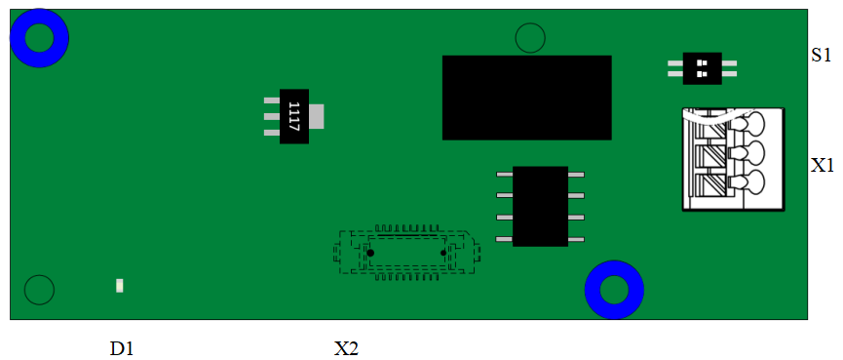
Figure 2-22EMH-OPModule Expansion Card Interface Layout

Table 2-7EMH-OPModule Expansion Card Interface Description
Figure Name | Hardware Name | Function Description
X1 | CAN Socket | For module connection to the CANopen network, refer to Figure 1.3 description
X2 | Board-to-Board Socket | For connection to the inverter (located on the back of the board)
D1 | LED Indicator Light | For indicating power status, refer to Table 1.2 description
S1 | Termination Resistor Setting | For setting the CAN bus termination resistor, refer to Table 1.6 description
Terminal Wiring Description
The EMH-OP module expansion card uses a spring-type terminal block X1 to connect to the CAN bus as shown in the figure below:
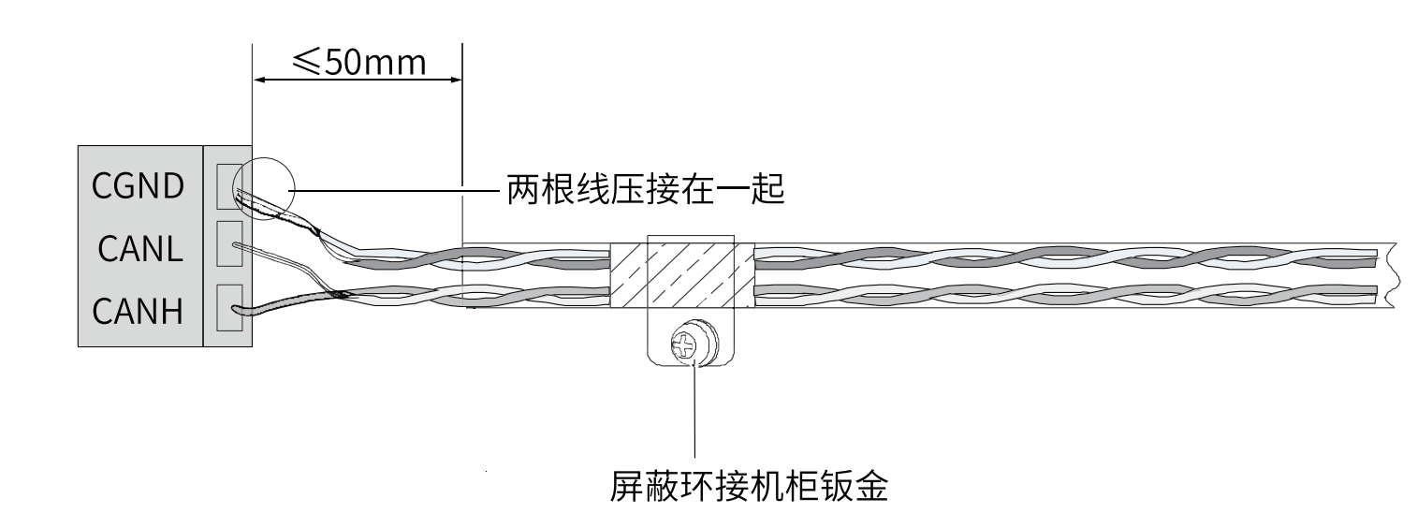
Figure 2-23 Explanation of the CAN Communication Interface for the EMH-OP Module Expansion Card
LED Indicator Light
Table 2-8 Explanation of the LED Indicator Lights on the EMH-OP Module Expansion Card
Figure Name | Indicator Light | Indicator Light Status |  | Function Description
D1 | Hardware Power Indicator Light | Green Light | Constantly On | Module is Normally Powered On
D1 | Hardware Power Indicator Light | Green Light | Off | Module Not Powered On
Termination Resistance
The DIP switch S1 on the EMH-OP module expansion card consists of a 2-bit DIP switch used to configure the CAN bus termination resistor. It is recommended to set the termination resistor at both ends of the network topology. Switching to “ON” represents “1”, and switching down represents “0”. For detailed information, refer to Table 2-9.
Table 2-9 Setting of Termination Resistors for the EMH-OP Module Expansion Card
DIP Switch Number |  | Baud Rate
1 | 2 | Baud Rate
0 | 0 | Do Not Use Termination Resistor
1 | 1 | Use Termination Resistor
Bus Topology
The wiring diagram for the CAN bus is shown in Figure 2-24. It is recommended to use shielded twisted pair cables for CAN bus connections, and termination resistors should be connected at both ends of the bus. The DIP switch should be set according to the terminal block diagram. Failing to connect or connecting insufficient termination resistors can affect communication quality, leading to unstable communication.
Figure 2-24 Wiring Diagram for the CAN Bus

Profibus DP Communication
2.5.2.1 Overview
The EMH-DP module expansion card is a PROFIBUS fieldbus adapter card that complies with the international standard for PROFIBUS-DP fieldbus. This card is installed on the CM680 inverter to enable communication with PROFIBUS Master devices, making the inverter a slave station of PROFIBUS DP, accepting control from the master station.
2.5.2.2 Electrical Connections
The hardware layout of the EMH-DP module expansion card is shown in Figure 2-25. Pin Header X3 is used for connecting to the inverter and is located on the back of the EMH-DP module expansion card. The EMH-DP module expansion card provides a 9-pin D-type connector for PROFIBUS communication. Detailed descriptions of each hardware component are provided in Table 2-10.
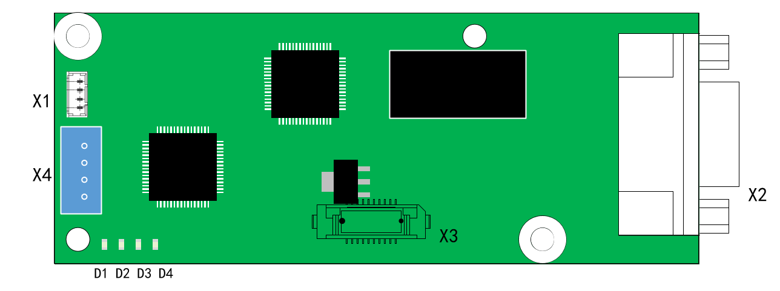
Figure 2-25 EMH-DP Module Expansion Card Interface Layout

Table 2-10 EMH-DP Module Expansion Card Interface Description
Figure Name | Hardware Name | Function Description
X1 | Socket | Print Operation Information
X2 | 9-pin D-type Connector | For connecting modules to the PROFIBUS network, see Figure 1.3 for details
X3 | Board-to-Board Socket | For connecting to the inverter
X4 | Socket | For downloading firmware and commissioning
D1, D2, D3, D4 | LED Indicator Light | For indicating operating status, see Table 1.2 for details
PROFIBUS-DP Communication Interface
The EMH-DP module expansion card uses a standard DB9 socket to connect to the PROFIBUS master station, with pin signal definitions following SIEMENS' DB9 socket standards. As shown below:
Figure 2-26 Explanation of the EMH-DP Module Expansion Card DP Communication Interface
LED Indicator Light
Table 2-11 Explanation of the EMH-DP Module Expansion Card LED Indicator Lights
Figure Name | Indicator Light | Indicator Light Status |  | Function Description
D1 | PROFIBUS Communication Status Indicator Light | Red Light | Constantly On | Indicates No Communication Between the Module and PROFIBUS Master (Check PROFIBUS Cable Connection and Station Number)
D1 | PROFIBUS Communication Status Indicator Light | Red Light | Off | Indicates Normal Communication Between the Module and PROFIBUS Master
D2 | Inverter Communication Status Indicator Light | Red Light | Constantly On | Communication Timeout with Inverter
D2 | Inverter Communication Status Indicator Light | Red Light | Flashing | Abnormal Communication with Inverter (Interference Exists, Poor Connection, etc.), Communication Format Error (Incorrect Register Address, Data Error, etc.)
D2 | Inverter Communication Status Indicator Light | Red Light | Off | Normal Communication with Inverter
D3 | Program Operation Status Indicator Light | Green Light | Constantly On | Main Program Running Normally
D3 | Program Operation Status Indicator Light | Green Light | Off | Main Program Not Started Properly
D4 | Hardware Power Indicator Light | Green Light | Constantly On | Module is Normally Powered On
D4 | Hardware Power Indicator Light | Green Light | Off | Module Not Powered On
The Wiring Diagram for the PROFIBUS DP Bus is Shown in Figure 2-27. Terminal Matching Resistors Must Be Connected at Both Ends of the PROFIBUS Bus. Adjust the DIP Switch According to the Indications on the Terminal Block. Failing to Connect or Connecting Fewer Terminal Resistors Will Affect Communication Quality and Cause Unstable Communication.
Figure 2-27 Schematic Diagram of PROFIBUS DP Bus Wiring

The communication rate range for PROFIBUS-DP is from 9.6 kbps to 12 Mbps, and the transmission line length depends on the transmission rate, with a transmission distance range of 100m to 1200m. The communication rates supported by the EMH-DP module expansion card and the communication distances at each rate are shown in Table 2-12.
Table 2-12 Maximum Cable Lengths for Different PROFIBUS-DP Transmission Rates
Communication Rate (bps) | 9.6k | 19.2k | 93.75k | 187.5k | 500k | 1.5M | 3M | 6M | 12M
Length (m) | 1200 | 1200 | 1200 | 1000 | 400 | 200 | 100 | 100 | 100
It is recommended to use dedicated PROFIBUS DP bus cables. Cable parameters are shown in the table below.
Table 2-13 Cable Parameters

Parameter | Description
Conductor | 1 pair (2×22AWG) solid copper wire
Insulation Jacket Color | Green, Red
Shielding Layer | Aluminum foil tape + tinned copper braid
Jacket Material | PVC
Appearance | Purple
Figure 2-28 Schematic Diagram of Bus Cable Inner Structure
Bus Terminal Description: It is recommended to use SIEMENS's dedicated PROFIBUS DP connector, model: 6ES7 972-0BB12-0XA0.
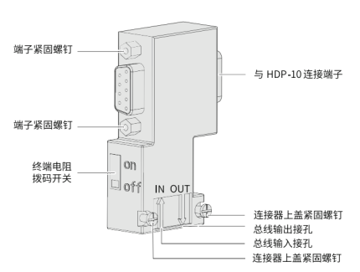
Figure 2-29 Bus Connection Terminal Layout Diagram
Wiring Steps:
1. Remove the outer insulation of the cable and prepare the length according to the dimensions below.
Figure 2-30 Cable Length Reserve Diagram (Unit: mm)
- Use a No. 1 flathead screwdriver to open the bus connector terminal cover.
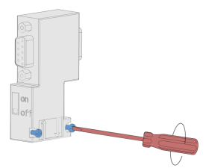
Figure 2-31 Method for Opening the Bus Connector Terminal Cover
- Use a No. 1 flathead screwdriver to secure the cable at the connector installation position, ensuring that the shielding layer is in tight contact with the shielding layer metal plate, connect the green wire to A, and the red wire to B, as shown in Figure 2-32.
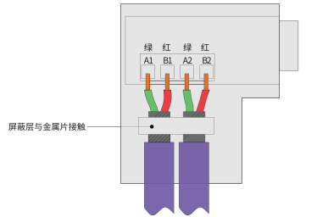
Figure 2-32 Connector Installation Position

4. After covering the connector cover and tightening the screws on the cover, insert it into the corresponding DB9 port of the EMH-DP, and use a screwdriver to tighten the fixing screws on both sides to prevent loosening.
Note:When installing the PROFIBUS DP bus, ensure that the Siemens terminal studs on both sides are securely connected to the EMH-DP module; otherwise, communication may fail or the communication quality may decrease.

Profinet Industrial Ethernet Communication
2.5.3.1 Overview
The EMH-PN module expansion card is a PROFINET fieldbus adapter card that complies with international standard PROFINET Ethernet. This card is installed on the CM680 inverter to enable communication with PROFINET master station devices, making the inverter a PROFINET slave that accepts control from the master station.
2.5.3.2 Electrical Connections
The hardware layout of the EMH-PN module expansion card is shown in Figure 2-33. Pin Header X3 is used for connecting to the inverter and is located on the back of the EMH-PN module expansion card. The EMH-PN module expansion card provides two network ports X2 for communication connections. Detailed descriptions of each hardware component are provided in Table 2-14.
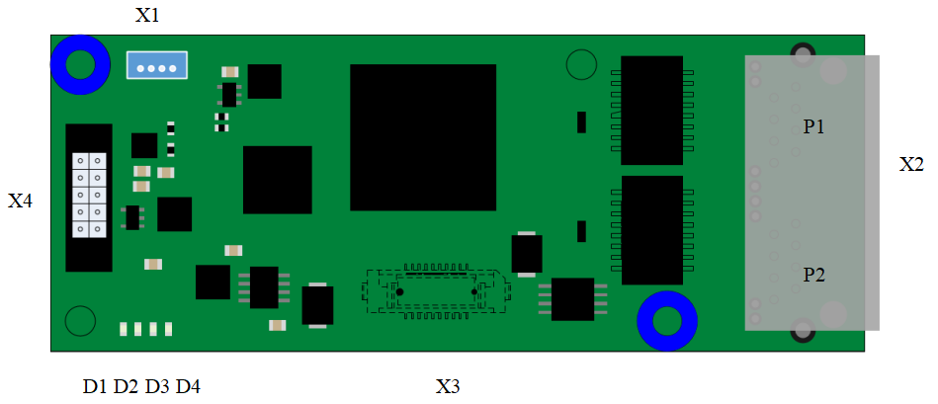
Figure 2-33 EMH-PN Module Expansion Card Interface Layout

Table 2-14 EMH-PN Module Expansion Card Interface Descriptions
Figure Name | Hardware Name | Function Description
X1 | Pin Header Connector | Print Operation Information
X2 | Ethernet Port | For PROFINET Module Connection to Profinet Network
X3 | Pin Header Connector | For connecting to the inverter
X4 | Pin Header Connector | For downloading firmware and commissioning
D1 | PROFINET Communication Status Indicator Light | See Table 2-15 for EMH-PN Module Expansion Card LED Indicator Light Description
D2 | Inverter Communication Status Indicator Light
D3 | Program Operation Status Indicator Light
D4 | Hardware Power Indicator Light

Table 2-15 EMH-PN Module Expansion Card LED Indicator Light Description
Figure Name | Indicator Light | Indicator Light Status |  | Function Description
D1 | PROFINET Communication Status Indicator Light | Red Light | Constantly On | PROFINET Communication Fault
D1 | PROFINET Communication Status Indicator Light | Red Light | Off | PROFINET Communication Normal
D2 | Inverter Communication Status Indicator Light | Red Light | Constantly On | Communication Timeout with Inverter
D2 | Inverter Communication Status Indicator Light | Red Light | Flashing | Inverter Communication Message Fault
D2 | Inverter Communication Status Indicator Light | Red Light | Off | Normal Communication with Inverter
D3 | Program Operation Status Indicator Light | Green Light | Constantly On | Main Program Running Normally
D3 | Program Operation Status Indicator Light | Green Light | Off | Main Program Execution Fault
D4 | Hardware Power Indicator Light | Green Light | Constantly On | Module is Normally Powered On
D4 | Hardware Power Indicator Light | Green Light | Off | Module Not Powered On

Insert the network cable into the Ethernet port of the EMH-PN module expansion card, then connect it to the PLC. You can connect to either the P1 or P2 port according to the TIA Portal network topology. If the network topology is not specified, you can connect to either the P1 or P2 port.
It is recommended to use Cat 5e shielded network cable.
The common network topology diagram is as follows:
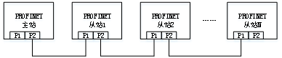
Figure 2-34 Linear Topology
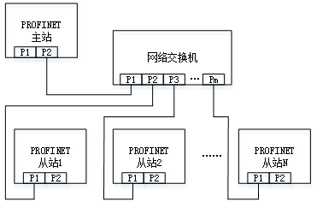
Figure 2-35 Star Topology

Ethernet/IP Industrial Ethernet Communication
2.5.4.1 Overview
The EMH-EN module expansion card is an Ethernet/IP fieldbus adapter card that complies with the general Ethernet/IP fieldbus standard. This card is installed on the CM680 inverter to enable communication with Ethernet/IP master station devices, making the inverter a slave station of Ethernet/IP, accepting control from the master station.
2.5.4.2 Electrical Connections
The hardware layout of the EMH-EN module expansion card is shown in Figure 2-36. Pin Header X3 is used for connecting to the inverter and is located on the back of the EMH-EN module expansion card. The EMH-EN module expansion card provides an Ethernet connector for connecting to Ethernet/IP communication. For detailed descriptions of each hardware component, refer to Table 2-16.
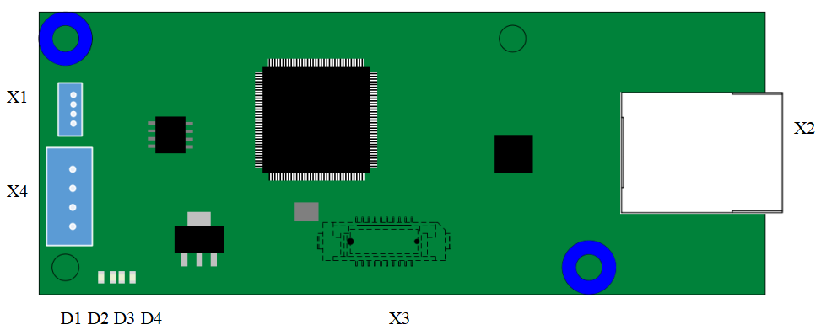
Figure 2-36 EMH-EN Module Expansion Card Interface Layout

Table 2-16 EMH-EN Module Expansion Card Interface Description
Figure Name | Hardware Name | Function Description
X1 | Socket | Print Operation Information
X2 | Ethernet Socket | For module connection to the Ethernet/IP network
X3 | Board-to-Board Socket | For connecting to the inverter
X4 | Socket | For downloading firmware and commissioning
D1, D2, D3, D4 | LED Indicator Light | For indicating operational status, see Table 2-17 for details

Table 2-17 EMH-EN Module Expansion Card LED Indicator Light Description
Figure Name | Indicator Light | Indicator Light Status |  | Function Description
D1 | Ethernet/IP Communication Status Indicator Light | Red Light | Constantly On | Indicates no communication between the module and the Ethernet/IP master station (check Ethernet/IP cable connections and station number)
D1 | Ethernet/IP Communication Status Indicator Light | Red Light | Off | Indicates normal communication between the module and the Ethernet/IP master station
D2 | Inverter Communication Status Indicator Light | Red Light | Constantly On | Communication Timeout with Inverter
D2 | Inverter Communication Status Indicator Light | Red Light | Flashing | Inverter Communication Message Fault
D2 | Inverter Communication Status Indicator Light | Red Light | Off | Normal Communication with Inverter
D3 | Program Operation Status Indicator Light | Green Light | Constantly On | Main Program Running Normally
D3 | Program Operation Status Indicator Light | Green Light | Off | Main Program Not Started Properly
D4 | Hardware Power Indicator Light | Green Light | Constantly On | Module is Normally Powered On
D4 | Hardware Power Indicator Light | Green Light | Off | Module Not Powered On
The wiring diagram for the Ethernet/IP bus is shown in Figure 2-37. Insert the network cable into the network port of the EMH-EN module expansion card, then connect it directly to the PLC or indirectly through a switch. It is recommended to use a Cat 5e shielded network cable.
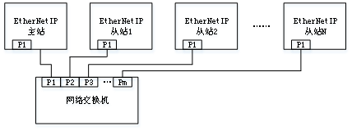
Figure 2-37 CM680-Ethernet/IP Bus Wiring Diagram

EtherCAT Industrial Ethernet Communication
2.5.5.1 Overview
The EMH-EC module expansion card is an EtherCat fieldbus adapter card that complies with international EtherCat fieldbus standards. This card is installed on the CM680 inverter to enable communication with EtherCat master station devices, making the inverter a slave station of the EtherCat network, accepting control from the master station.
2.5.5.2 Electrical Connection
The hardware layout of the EMH-EC module expansion card is shown in Figure 2-38. Pin Header X3 is used for connecting to the inverter and is located on the back of the EMH-EC module expansion card. The EMH-EC module expansion card provides two network ports X1 and X2, which are used for communication between the EMH-EC card and the master station (or the previous slave station) and the next slave station (if any).
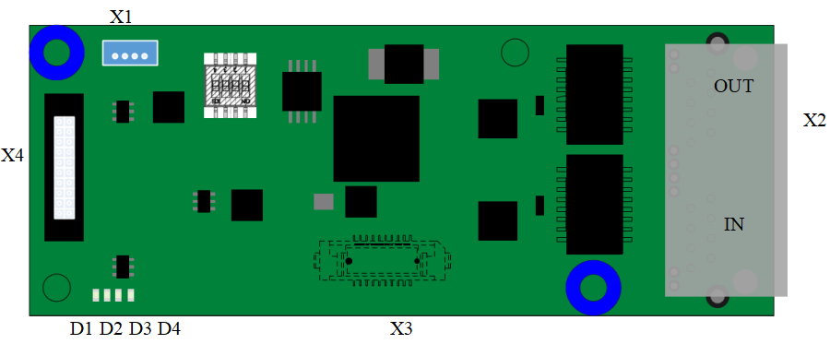
Figure 2-38 Interface Layout Diagram of the EMH-EC Module Expansion Card

Table 2-18 Interface Description of the EMH-EC Module Expansion Card
Figure Name | Hardware Name | Function Description
X1 | IN Network Port | Connects to the master station (or the previous slave station)
X2 | OUT Network Port | Connects to the next slave station (if any)
X3 | Board-to-Board Socket | For connecting to the inverter
X4 | Socket | For downloading firmware and commissioning
X5 | Socket | Print Operation Information
D1, D2, D3, D4 | LED Indicator Light | Used to indicate operating status, see Table 2-19 for details
Table 2-19 EMH-EC Module Expansion Card LED Indicator Light Description
Figure Name | Indicator Light | Indicator Light Status |  | Function Description
D4 | EtherCAT  Communication Status  Indicator Light | Red Light | Constantly On | Indicates the EtherCAT module and EtherCAT master station are in init
D4 | EtherCAT  Communication Status  Indicator Light | Red Light | Blinking (200ms on/off interval) | Indicates normal communication between the module and the EtherCAT master station
D4 | EtherCAT  Communication Status  Indicator Light | Red Light | Single Flash (200ms on, 1000ms off) | Indicates the EtherCAT module and master station are in PreOp
D4 | EtherCAT  Communication Status  Indicator Light | Red Light | Flickering (1200ms on/off interval) | Indicates the EtherCAT module and master station are in SafeOp
D4 | EtherCAT  Communication Status  Indicator Light | Red Light | Double Flash (100ms off, 100ms on, 100ms off, 100ms on, 800ms off) | Indicates communication error between the EtherCAT module and master station
D4 | EtherCAT  Communication Status  Indicator Light | Red Light | Off | Indicates normal communication between the EtherCAT module and master station, in OP
D3 | Inverter Communication Status Indicator Light | Red Light | Constantly On | The EtherCAT module is powered on or communication with the inverter has timed out
D3 | Inverter Communication Status Indicator Light | Red Light | Off | EtherCAT module communicates normally with the inverter
D3 | Inverter Communication Status Indicator Light | Red Light | Blinking (200ms on/off interval) | Indicates that the EtherCAT module and the inverter receive error codes non-periodically
D3 | Inverter Communication Status Indicator Light | Red Light | Double flash (100ms off 100ms on 100ms off 100ms on 800ms off) | Indicates periodic communication errors between the EtherCAT module and the inverter
D2 | Program Operation Status Indicator Light | Green Light | Constantly On | Main Program Running Normally
D2 | Program Operation Status Indicator Light | Green Light | Off | Main Program Not Started Properly
D1 | Hardware Power Indicator Light | Green Light | Constantly On | Module is Normally Powered On
D1 | Hardware Power Indicator Light | Green Light | Off | Module Not Powered On

The topologies supported by EtherCAT include bus, star, tree, etc., as well as combinations of various topologies, making device connection and wiring very flexible and convenient. The bus connection topology is shown in Figure 2-39.
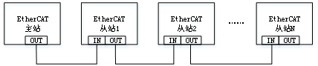
Figure 2-39 EtherCAT Bus Wiring Diagram

Grounding

Main Circuit Grounding Requirements
To ensure the product is properly grounded, please observe the following precautions:
(1)To prevent electric shock, be sure to ground the grounding terminal. For grounding methods, please comply with the relevant electrical regulations of each country or region.
(2)To prevent electric shock, ensure that the protective earthing conductor meets the technical specifications and local safety standards, and keep the earthing lead as short as possible. The leakage current of the product will exceed 3.5 mA, therefore, it should be installed in accordance with EN 61800-5-1 standard,--the cross-sectional area of the protective earthing conductor should refer to 2-20.
- When using multiple devices, follow the instructions for grounding all devices. Incorrect device grounding can cause malfunction.
- This product has an optional VDR grounding screw. When performing dielectric strength tests, make sure to disconnect the VDR grounding screw before testing, otherwise there is a risk of test failure.
- The protective earth conductor must use yellow-green copper cable and must not be connected in series with circuit breakers or other switching devices.
- The grounding terminal must be reliably grounded; otherwise, it may cause the equipment to malfunction or even be damaged. The grounding terminal must not be shared with the power neutral line N terminal.
- It is recommended to install on a conductive metal surface to ensure that the entire conductive bottom of the equipment is in good contact with the installation surface.
- The fixing of the grounding screw must be carried out according to the recommended torque to avoid loose or overly tight fixation of the protective earth conductor.
Table 2-20 Grounding Cable Cross-Sectional Area
Main Cable Cross-sectional Area (mm²) | Minimum Ground Wire Cross-sectional Area (mm²)
S≤16 | S
16＜S≤35 | 16
35＜S | S/2

Control Board Grounding
PE
PE
PE
Figure 2-40 Control Board Grounding Position

Single Equipment Grounding
Main Circuit Grounding Schematic:
Figure 2-41 4.0~7.5kW Grounding Point Schematic

Figure 2-42 11~15kW Grounding Point Schematic
Figure 2-43 18.5~30kW Grounding Point Schematic
Figure 2-44 37~45kW Grounding Point Schematic
Figure 2-45 55~185kW Grounding Point Schematic

Multiple Equipment Grounding
When multiple devices are installed side by side in a cabinet, the grounding diagram is shown below.
Figure 2-46 Grounding Diagram for Multi-unit Installation

Table 2-21 Grounding Instructions for Multi-unit Installation
No. | Wiring Description
① | Connect the PE cable from the input power supply to the grounding busbar in the control cabinet.
② | Connect the main circuit input PE terminal of the product to the grounding busbar in the control cabinet via a protective earthing conductor.
③ | Connect the PE cable and shielding layer of the motor output to the output PE terminal of the product.
④ | Connect the grounding busbar in the control cabinet to the cabinet body and door via a protective earthing conductor.

Cabinet System Grounding
The inverter control system is susceptible to electromagnetic interference. In addition to the EMC design of the inverter, there are a large number of control and other weak electrical signals within the cabinet system, making cabinet layout a key focus area. The cabinet can be divided into multiple EMC zones or multiple cabinets based on the strength of interference signals within the cabinet, and equipment should be installed in the corresponding areas according to the principles listed in the table below.
Table 2-22 Wiring Principles
No. | Wiring Principles
1 | Please place control equipment and variable frequency drive equipment in separate cabinets.
2 | In a multi-cabinet system, cabinets should be connected using grounding wires with a cross-sectional area of at least 16mm² to achieve equipotentiality between cabinets.  to connect and achieve equipotentiality between cabinets.
3 | Within a single cabinet, equipment should be zoned based on signal strength.
4 | Equipment in different areas within the cabinet should be connected for equipotentiality.
5 | All communication cables (e.g., RS485) and signal cables drawn from the electrical cabinet must be properly shielded.
6 | The power input filter in the cabinet should be placed near the cabinet's input interface.
7 | After grounding connections are made at each grounding point in the cabinet, anti-rust and anti-corrosion treatment should be applied to the paint removal areas.
Figure 2-47 Cabinet System Grounding Schematic

STO Safety Design and Wiring
Figure 2-48 STO Wiring

Optional Accessories Selection

List of Optional Accessories
For detailed functions and usage instructions of optional accessories, refer to the relevant accessory documentation.
If any of the following optional accessories are required, please specify when placing your order.
For specific installation methods of the embedded mounting bracket, floor-standing mounting bracket, output reactor base, and push-in tool, refer to the 'CM680 Series General-Purpose Inverter Installation Manual'.
Table 3-1 CM680 Optional Accessories Overview
Name | Model | Function | Notes
Braking Unit | Product model ends with “B” | For energy consumption braking | Braking unit is standard equipment
Braking Unit | Product model ends with “(B)” | For energy consumption braking | Braking unit is optional equipment
C2-C8 Embedded Installation Bracket | / | Embedded installation | Optional equipment
C9-C11 Floor-Mounting Bracket | / | Floor mounting | Optional equipment
C9-C11 Output Reactor Base | / | Reactor base installation | Optional equipment
C9-C11 Push-In Tooling | / | DIN rail mounting | Optional equipment
LCD Keyboard Bracket | CM680-09-01-03 | Cabinet Keyboard Installation | Standard equipment for models above 37kW, optional for models below 30kW.
Incremental Encoder Expansion Card | CM680-PG-INC | Suitable for incremental encoders, compatible with differential and non-differential inputs, DB15 interface. | Available for all models
Resolver Encoder Expansion Card | CM680-PG-R | Suitable for resolvers, excitation frequency 10kHz, DB9 interface. | Available for all series models
CANopen Expansion Card | CM680-CANopen | CANopen Communication Expansion Card | Available for all models
PROFIBUS Expansion Card | CM680-PROFIBUS | PROFIBUS Communication Expansion Card | Available for all models
PROFINET Expansion Card | CM680-PROFINET | PROFINET Communication Expansion Card | Available for all models
Ethernet/IP Expansion Card | CM680-Ethernet/IP | Ethernet/IP Communication Expansion Card | Available for all models
EtherCAT Expansion Card | CM680-EtherCAT | EtherCAT Communication Expansion Card | Available for all models
C2-C4 Sealing Strip | 2mm² O-Ring Sealing Strip | Enhance the sealing capability of the component chamber | Optional equipment

Peripheral Electrical Components

Fuses, Contactors, and Circuit Breakers
To comply with EN 61800-5-1 and UL61800-5-1 standards, it is essential to connect fuses and circuit breakers on the input side to prevent accidents caused by internal circuit short circuits.
For the selection of fuses and circuit breakers, refer to Table 3-2; the recommended fuse manufacturer is Bussmann.
Table 3-2 Selection Table for Fuses and Circuit Breakers
Physical Structure | Inverter Model | Rated Input Current(A) | Recommended Fuse Specifications  Bussmann |  | Contactor | Circuit Breaker
Physical Structure | Inverter Model | Rated Input Current(A) | Rated Current (A) | Model | Rated Current (A) | Rated Current (A)
C2 | CM680-4T4R0GB | 11.4 | 30 | FWP-30B | 20 | 25
C2 | CM680-4T5R5GB | 16.7 | 40 | FWP-40B | 25 | 32
C2 | CM680-4T7R5GB | 21 | 60 | FWP-60B | 38 | 50
C3 | CM680-4T011GB | 32 | 70 | FWP-70B | 50 | 63
C3 | CM680-4T015GB | 41 | 80 | FWH-80B | 50 | 63
C4 | CM680-4T018GB | 47 | 100 | FWH-100B | 65 | 80
C4 | CM680-4T022GB | 56 | 125 | FWH-125B | 80 | 80
C4 | CM680-4T030GB | 72 | 150 | FWH-150B | 95 | 100
C5 | CM680-4T037G(B) | 88 | 175 | FWH-175B | 115 | 160
C5 | CM680-4T045G(B) | 110 | 250 | FWH-250A | 150 | 160
C6 | CM680-4T055G(B) | 106 | 250 | FWH-250A | 150 | 250
C6 | CM680-4T075G(B) | 139 | 275 | FWH-275A | 170 | 250
C6 | CM680-4T093G(B) | 165 | 325 | FWH-325A | 205 | 250
C7 | CM680-4T110G(B) | 190 | 400 | FWH-400A | 245 | 400
C7 | CM680-4T132G(B) | 230 | 500 | FWH-500A | 300 | 400
C8 | CM680-4T160G | 276 | 600 | FWH-600A | 410 | 500
C8 | CM680-4T185G | 314 | 700 | FWH-700A | 475 | 500
C9 | CM680-4T200G | 346 | 800 | FWH-800A | 475 | 630
C9 | CM680-4T220G | 380 | 800 | FWH-800A | 620 | 800
C9 | CM680-4T250G | 435 | 1000 | 170M5016 | 620 | 800
C10 | CM680-4T280G | 478 | 1000 | 170M5016 | 620 | 800
C10 | CM680-4T315G | 534 | 1400 | 170M6017 | 800 | 1000
C10 | CM680-4T355G | 598 | 1400 | 170M6017 | 800 | 1000
C11 | CM680-4T400G | 672 | 1400 | 170M6017 | 1000 | 1250
C11 | CM680-4T450G | 742 | 1600 | 170M6019 | 1000 | 1250

AC Input Reactor
The AC input reactor is mainly used to reduce harmonics in the input current and is configured as an optional accessory. When the application environment has higher harmonic requirements, an external reactor can be added. Models above 55kW in this series come standard with a DC reactor, which also helps to reduce harmonics in the input current. These models are designed to meet IEC61800-3-4 standards. If the application environment has even higher harmonic requirements, an AC input reactor can still be selected.
Table 3-3 Recommended Parameters for Input Reactors (Yingfeng)
Physical Structure | Inverter Model | Rated Input Current(A) | Reactor Model | Inductance (mH)
C2 | CM680-4T4R0GB | 11.4 | ACL-0010-EISC-E1M4E | 1.4
C2 | CM680-4T5R5GB | 16.7 | ACL-0015-EISCL-EM93E | 0.93
C2 | CM680-4T7R5GB | 21 | ACL-0020-EISCL-EM70E | 0.7
C3 | CM680-4T011GB | 32 | ACL-0030-EISCL-EM47E | 0.47
C3 | CM680-4T015GB | 41 | ACL-0040-EISCL-EM35E | 0.35
C4 | CM680-4T018GB | 47 | ACL-0050-EISCL-EM28E | 0.28
C4 | CM680-4T022GB | 56 | ACL-0060-EISCL-EM24E | 0.24
C4 | CM680-4T030GB | 72 | ACL-0090-EISCL-EM16E | 0.16
C5 | CM680-4T037G(B) | 88 | ACL-0090-EISCL-EM16E | 0.16
C5 | CM680-4T045G(B) | 110 | ACL-0120-EISCL-EM12E | 0.12
C6 | CM680-4T055G(B) | 106 | ACL-0150-EISH-E95UE | 0.095
C6 | CM680-4T075G(B) | 139 | ACL-0200-EISH-E70UE | 0.070
C6 | CM680-4T093G(B) | 165 | ACL-0200-EISH-E70UE | 0.070
C7 | CM680-4T110G(B) | 190 | ACL-0250-EISH-E56UE | 0.056
C7 | CM680-4T132G(B) | 230 | ACL-0290-EISH-E48UE | 0.048
C8 | CM680-4T160G | 276 | ACL-0330-EISH-E42UE | 0.042
C8 | CM680-4T185G | 314 | ACL-0390-EISH-E36UE | 0.036
C9 | CM680-4T200G | 346 | ACL-0490-EISH-E28UE | 0.028
C9 | CM680-4T220G | 380 | ACL-0490-EISH-E28UE | 0.028
C9 | CM680-4T250G | 435 | ACL-0530-EISH-E26UE | 0.026
C10 | CM680-4T280G | 478 | ACL-0600-EISH-E23UE | 0.023
C10 | CM680-4T315G | 534 | ACL-0660-EISH-E21UE | 0.021
C10 | CM680-4T355G | 598 | ACL-0800-EISH-E17UE | 0.017
C11 | CM680-4T400G | 672 | ACL-0800-EISH-E17UE | 0.017
C11 | CM680-4T450G | 742 | ACL-1000-EISH-E14UE | 0.014

AC Input Reactor Size Description:
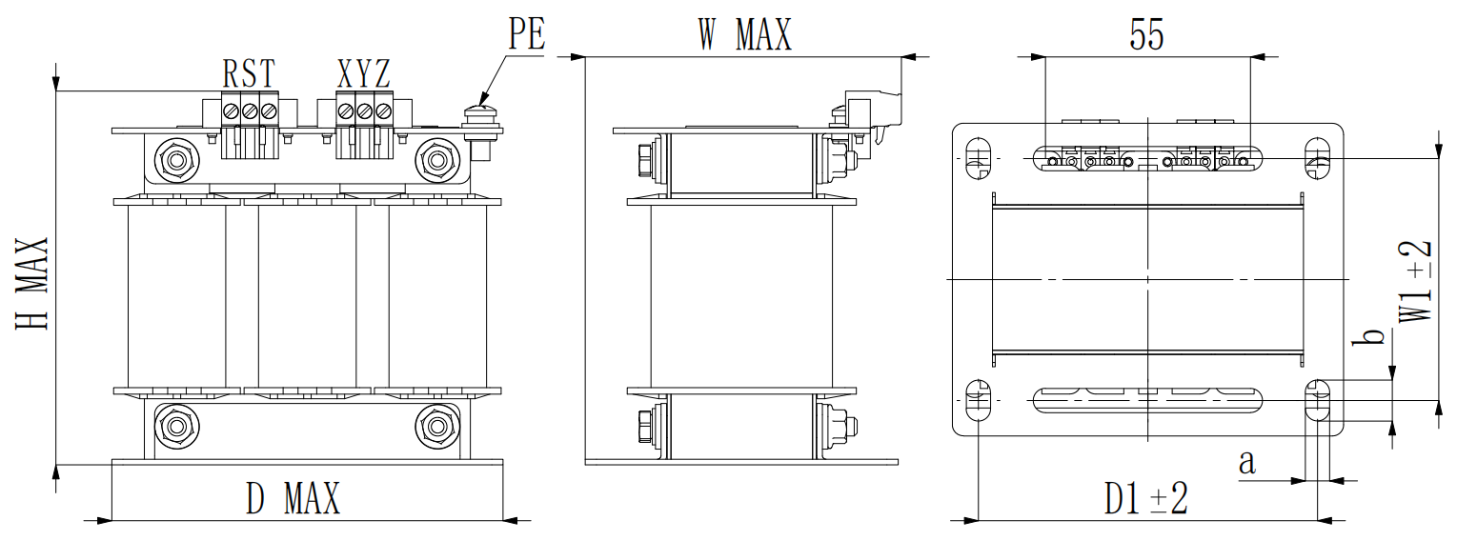
Figure 3-1 10A AC Input Reactor Size Diagram
Table 3-4 AC Input Reactor Size Table
Reactor Model | Reactor Rated Current (A) | D*H*W  (mm) | D1*W1  (mm) | a*b  (mm) | Mounting Hole Diameter (mm) | A*e  (mm)
ACL-0010-EISC-E1M4E | 10 | 110*110*90 | 91*65 | 65*11 | / | /

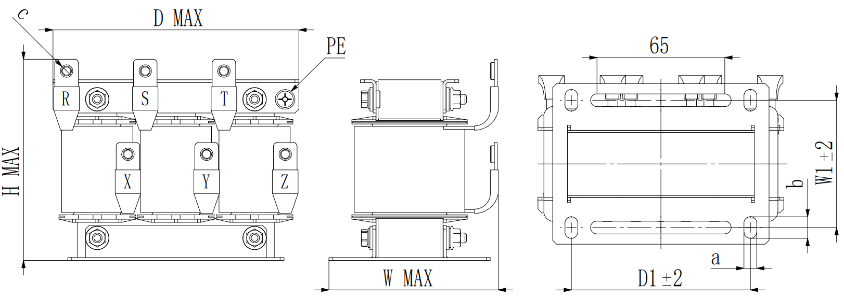
Figure 3-2 15-120A AC Input Reactor Dimensions
Table 3-5 15-120A AC Input Reactor Dimensions
Reactor Model | Reactor Rated Current (A) | D*H*W  (mm) | D1*W1  (mm) | a*b  (mm) | Mounting Hole Diameter (mm) | A*e  (mm)
ACL-0015-EISCL-EM93E | 15 | 130*110*90 | 91*65 | 6.5*11 | M5 | 12*1.5
ACL-0020-EISCL-EM70E | 20 | 130*110*90 | 91*65 | 6.5*11 | M5 | 12*1.5
ACL-0030-EISCL-EM47E | 30 | 140*110*100 | 120*72 | 6.5*11 | M5 | 12*1.5
ACL-0040-EISCL-EM35E | 40 | 140*110*100 | 120*72 | 6.5*11 | M5 | 12*1.5
ACL-0050-EISCL-EM28E | 50 | 140*130*105 | 120*72 | 6.5*11 | M5 | 12*1.5
ACL-0060-EISCL-EM24E | 60 | 140*130*105 | 120*72 | 6.5*11 | M5 | 12*1.5
ACL-0090-EISCL-EM16E | 90 | 200*140*140 | 120*72 | 9*15 | M8 | 20*2
ACL-0120-EISCL-EM12E | 120 | 200*140*140 | 120*72 | 9*15 | M8 | 20*2

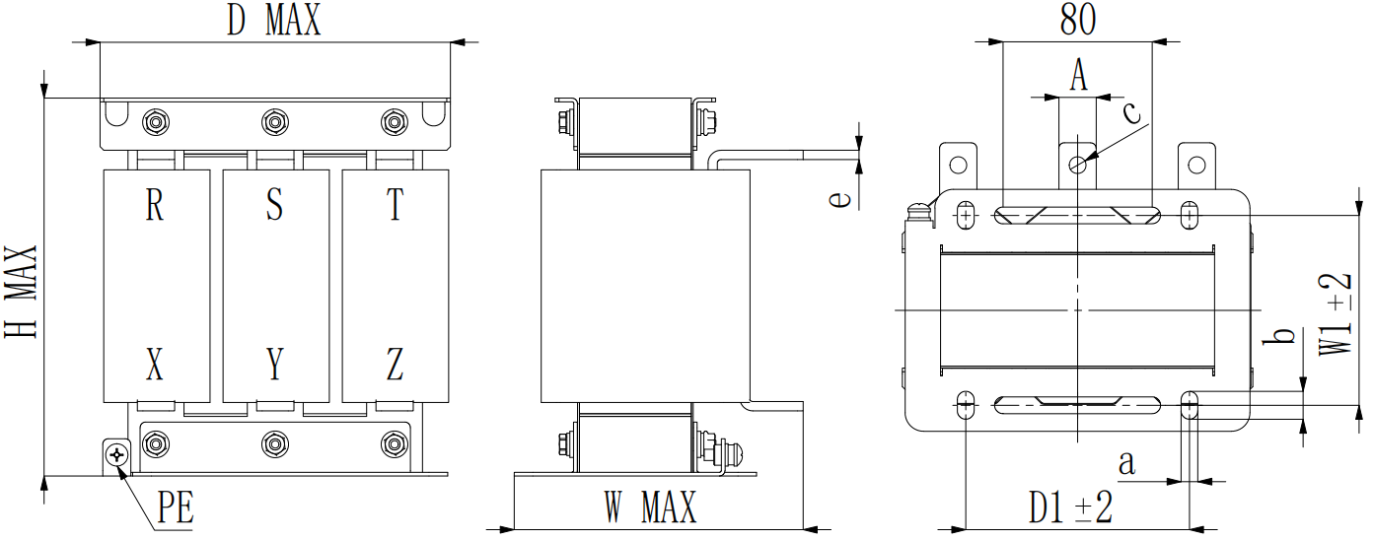
Figure 3-3 150-330A AC Input Reactor Dimensions
Table 3-6 150-330A AC Input Reactor Dimensions
Reactor Model | Reactor Rated Current (A) | D*H*W  (mm) | D1*W1  (mm) | a*b  (mm) | Mounting Hole Diameter (mm) | A*e  (mm)
ACL-0150-EISH-E95UE | 150 | 190*210*160 | 120*102 | 9*15 | 9 | 20*5
ACL-0200-EISH-E70UE | 200 | 190*210*160 | 120*102 | 9*15 | 9 | 20*5
ACL-0250-EISH-E56UE | 250 | 245*230*175 | 182*102 | 11*18 | 11 | 25*5
ACL-0290-EISH-E48UE | 290 | 245*230*175 | 182*102 | 11*18 | 11 | 25*5
ACL-0330-EISH-E42UE | 330 | 245*230*175 | 182*102 | 11*18 | 11 | 25*5
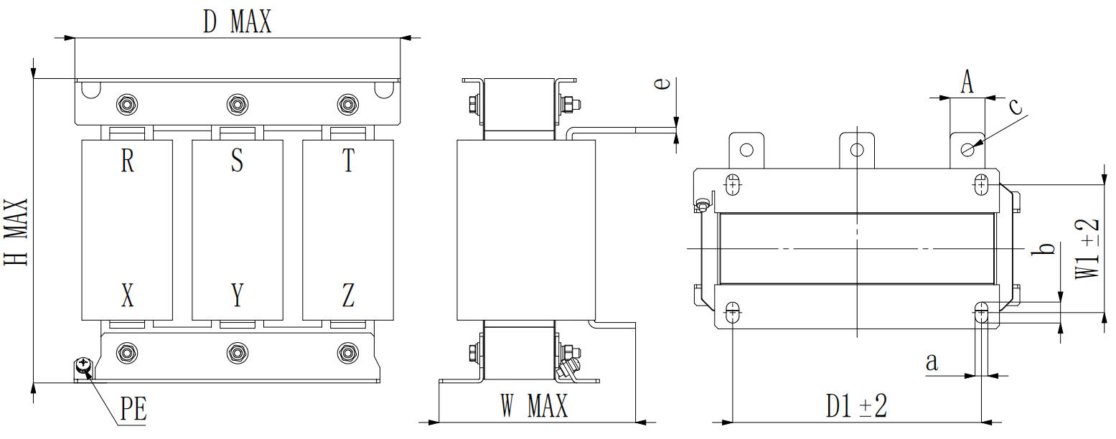
Figure 3-4 390-660A AC Input Reactor Dimensions
Table 3-7 390-660A AC Input Reactor Dimensions
Reactor Model | Reactor Rated Current (A) | D*H*W  (mm) | D1*W1  (mm) | a*b  (mm) | Mounting Hole Diameter (mm) | A*e  (mm)
ACL-0390-EISH-E36UE | 390 | 285*270*180 | 214*110 | 11*18 | 11 | 30*5
ACL-0490-EISH-E28UE | 490 | 285*270*185 | 214*110 | 11*18 | 11 | 30*8
ACL-0530-EISH-E26UE | 530 | 285*270*190 | 214*110 | 11*18 | 11 | 30*8
ACL-0600-EISH-E23UE | 600 | 285*270*225 | 214*140 | 11*18 | 11 | 30*10
ACL-0660-EISH-E21UE | 660 | 285*270*225 | 214*140 | 11*18 | 11 | 30*10
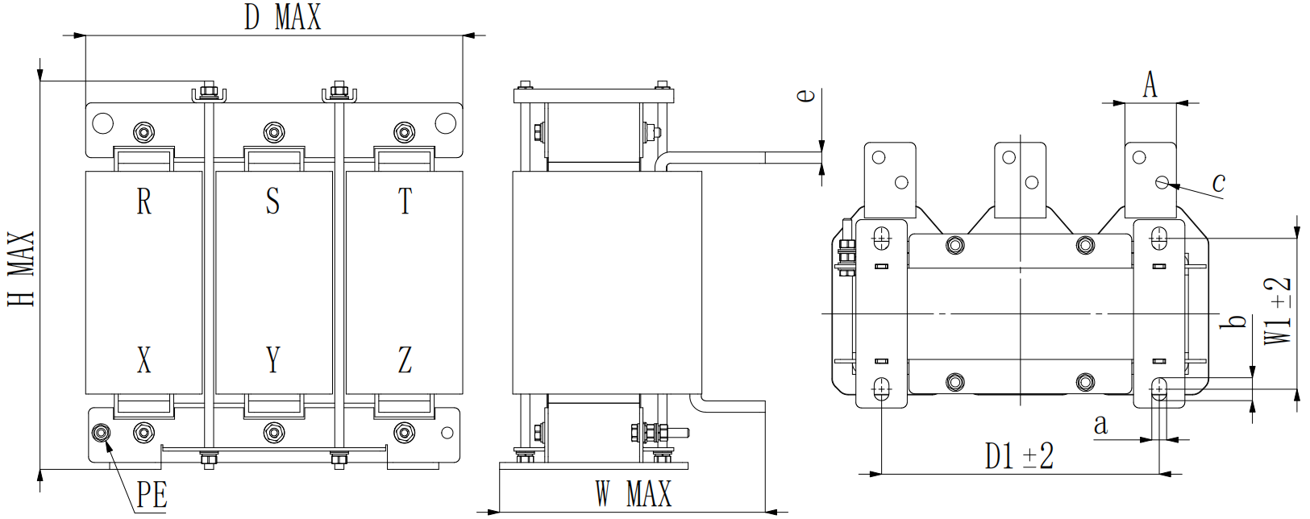
Figure 3-5 Dimensions of 800-1000A AC Input Reactor
Table 3-8 Dimensions of 800-1000A AC Input Reactor
Reactor Model | Reactor Rated Current (A) | D*H*W  (mm) | D1*W1  (mm) | a*b  (mm) | Mounting Hole Diameter (mm) | A*e  (mm)
ACL-0800-EISH-E17UE | 800 | 335*350*235 | 243*132 | 13*20 | 2-11 | 45*10
ACL-1000-EISH-E14UE | 1000 | 335*400*235 | 243*132 | 13*20 | 2-11 | 45*10

EMC Filter
To ensure that this product meets the requirements for radiated and conducted emissions as per EN IEC 61800-3, the EMC filters listed in the table below need to be externally connected. The available EMC filter models for this product are shown in the table below.
Table 3-9 Recommended EMC Filter Selection (Yingfeng)
Physical Structure | Inverter Model | Filter Model | Leakage Current (mA) | Dimensions | Weight (kg)
C2 | CM680-4T4R0GB | NFI0010-SA | < 6 | Figure 3-6 | 0.8
C2 | CM680-4T5R5GB | NFI0020-SA | < 6 | Figure 3-7 | 1.5
C2 | CM680-4T7R5GB | NFI0020-SA | < 6 | Figure 3-7 | 1.5
C3 | CM680-4T011GB | NFI0036-SA | < 6 | Figure 3-7 | 2.8
C3 | CM680-4T015GB | NFI0036-SA | < 6 | Figure 3-7 | 2.8
C4 | CM680-4T018GB | NFI0050-SA | < 6 | Figure 3-7 | 3
C4 | CM680-4T022GB | NFI0050-SA | < 6 | Figure 3-7 | 3
C4 | CM680-4T030GB | NFI0065-SA | < 10 | Figure 3-8 | 3.1
C5 | CM680-4T037G(B) | NFI0080-SA | < 10 | Figure 3-9 | 5
C5 | CM680-4T045G(B) | NFI0100-SA | < 10 | Figure 3-9 | 7.2
C6 | CM680-4T055G(B) | NFI0150-SA | < 10 | Figure 3-9 | 7
C6 | CM680-4T075G(B) | NFI0150-SA | < 10 | Figure 3-9 | 7
C6 | CM680-4T093G(B) | NFI0200-SA | < 30 | Figure 3-10 | 7.7
C7 | CM680-4T110G(B) | NFI0250-BA | < 30 | Figure 3-11 | 5.5
C7 | CM680-4T132G(B) | NFI0250-BA | < 30 | Figure 3-11 | 6.9
C8 | CM680-4T160G | NFI0300-BA | < 30 | Figure 3-11 | 6.9
C8 | CM680-4T185G | NFI0400-BA | < 30 | Figure 3-12 | 12
C9 | CM680-4T200G | NFI0400-BA | < 30 | Figure 3-12 | 12
C9 | CM680-4T220G | NFI0600-BA | < 30 | Figure 3-12 | 12.4
C9 | CM680-4T250G | NFI0600-BA | < 30 | Figure 3-12 | 12.4
C10 | CM680-4T280G | NFI0600-BA | < 30 | Figure 3-12 | 12.4
C10 | CM680-4T315G | NFI0600-BA | < 30 | Figure 3-12 | 12.4
C10 | CM680-4T355G | NFI0900-BA | < 30 | Figure 3-13 | 21.5
C11 | CM680-4T400G | NFI0900-BA | < 30 | Figure 3-13 | 21.5
C11 | CM680-4T450G | NFI0900-BA | < 30 | Figure 3-13 | 21.5

Size Description: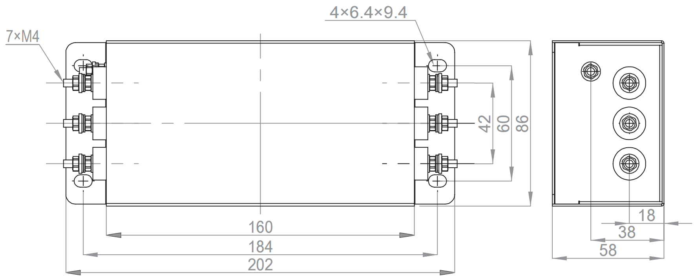
Figure 3-6 Dimensions of NFI0020-SA Model Filter

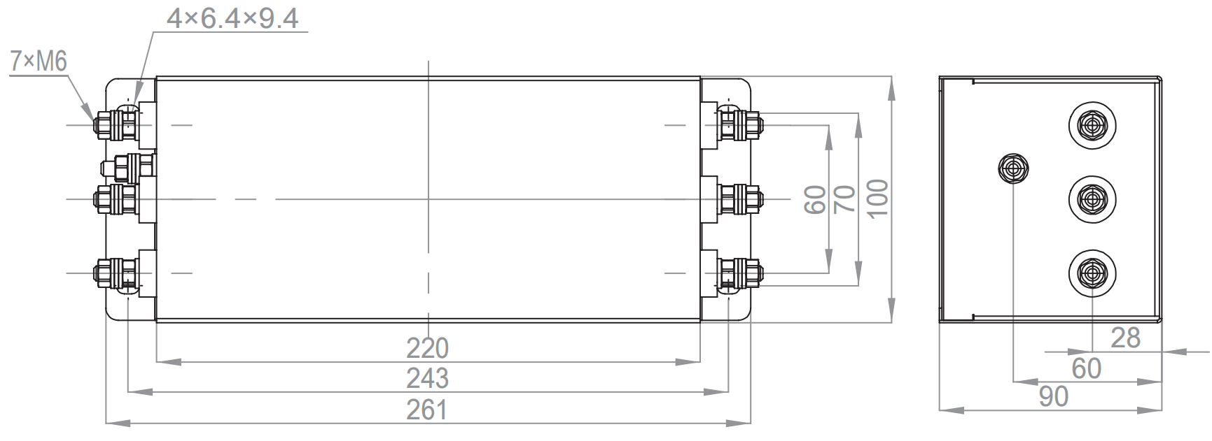
Figure 3-7 Dimensions of NFI0030-SA~NFI0050-SA Model Filters

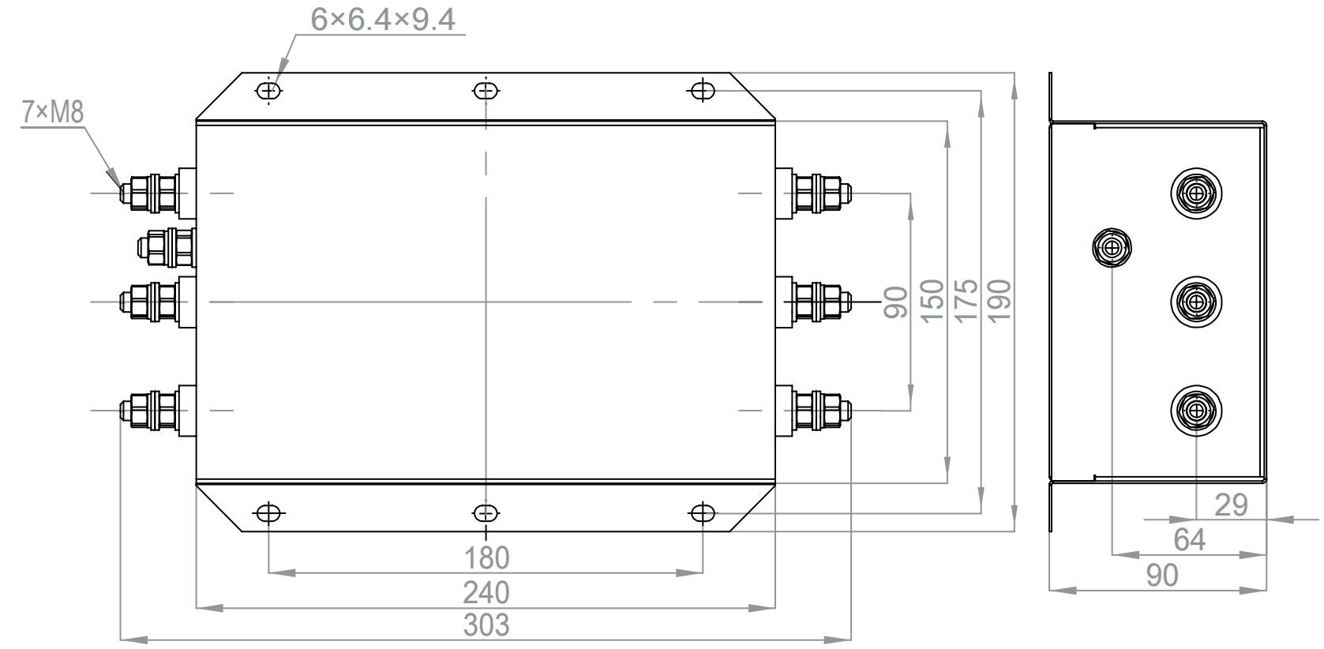
Figure 3-8 Dimensions of NFI0065-SA Model Filter
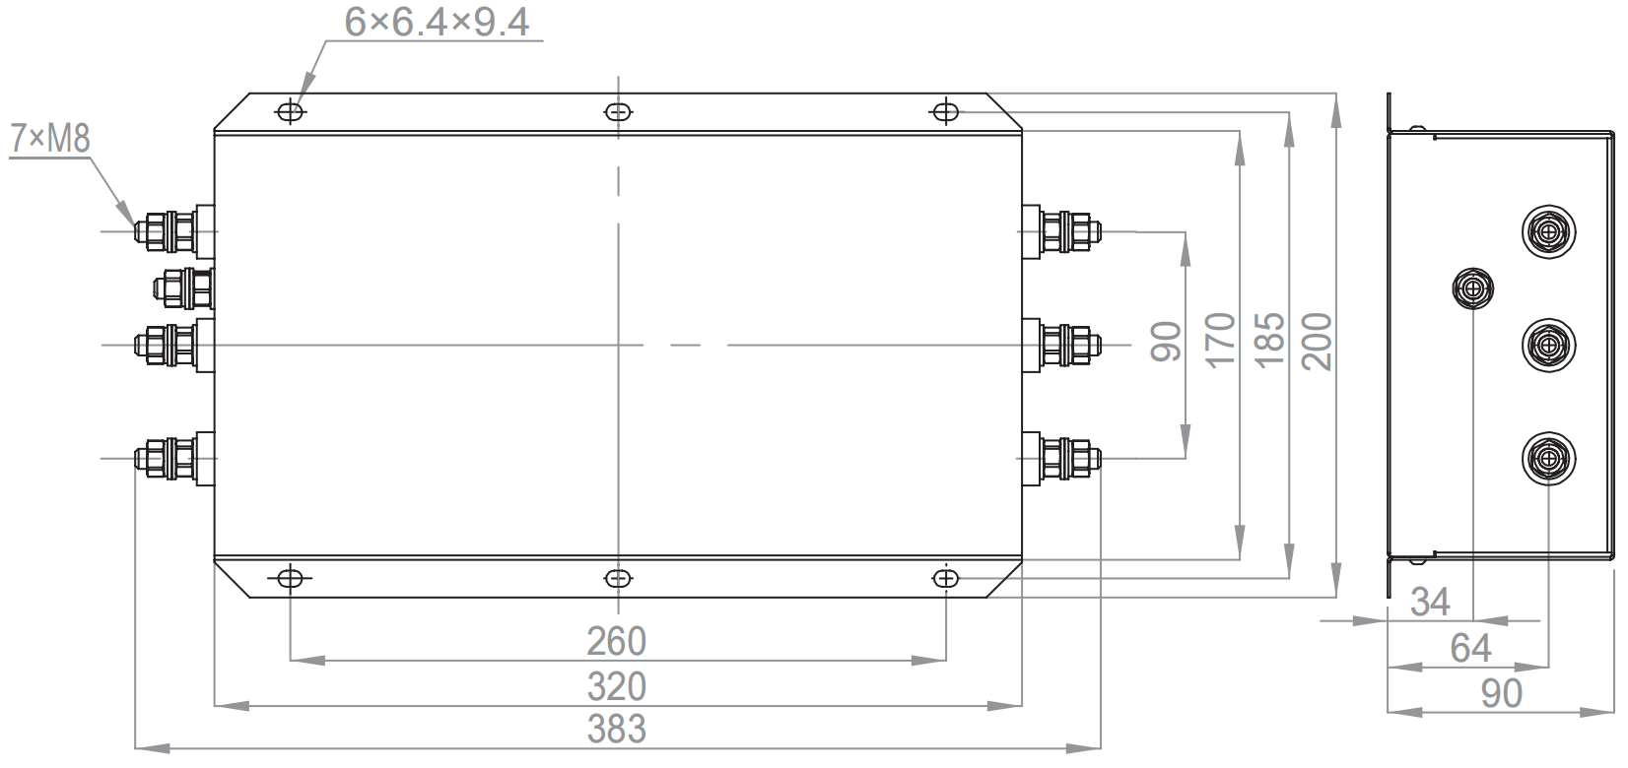
Figure 3-9 Dimensions of NFI0080-SA~NFI0150-SA Model Filters
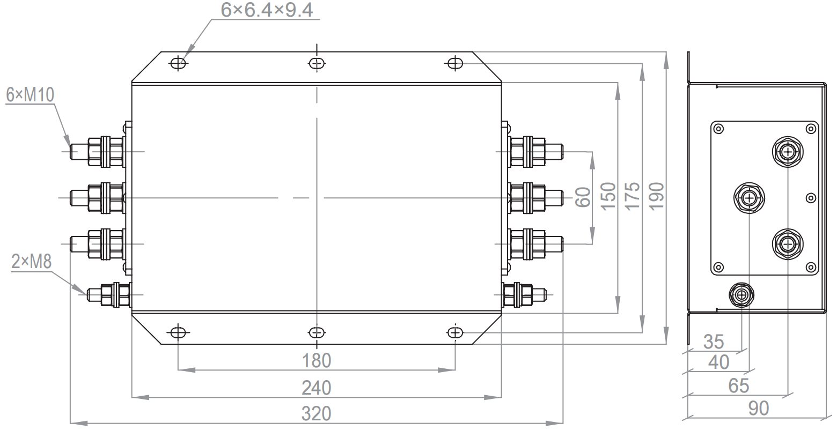
Figure 3-10 Dimensions of NFI0200-SA Model Filter

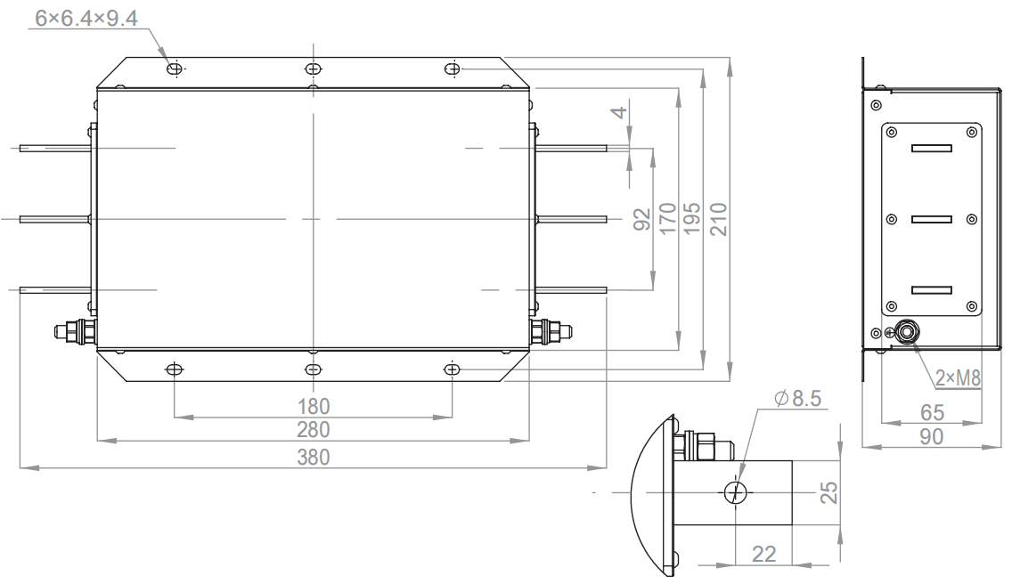
Figure 3-11 Dimensions of NFI0250-BA~NFI0300-BA Model Filters
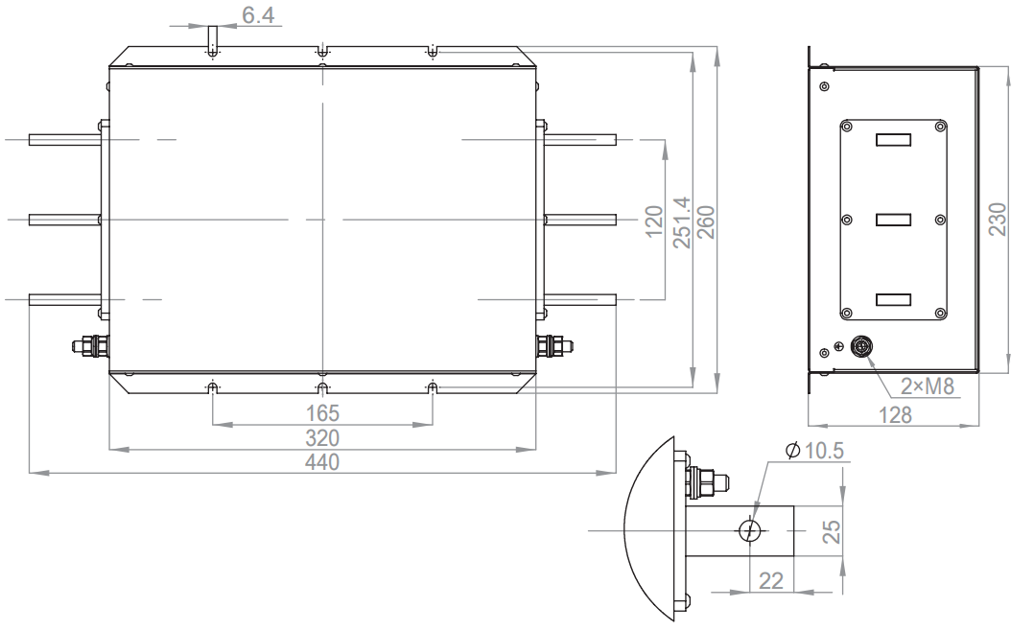
Figure 3-12 Dimensions of NFI0400-BA~NFI0600-BA Model Filters

Figure 3-13 Dimensions of NFI0900-BA Model Filter

Braking Components
The braking unit is standard for 4-30kW models, optional for 55-132kW models. If you need the optional braking unit, please note it before placing your order. The braking unit will be installed inside the complete unit before shipment. There is no braking unit for models above 160kW. When selecting the braking resistor, it must be greater than the minimum braking resistor and power listed in the table below.
Table 3-10 Recommended Braking Resistor Selection Table
Appearance  Structure | Inverter Model | Braking Unit | 125% Braking Torque  (10%, maximum 10s) | Minimum Braking  Resistor (Ω)
C2 | CM680-4T4R0GB | Built-in | 1000W/75Ω | 54.3
C2 | CM680-4T5R5GB | Built-in | 1100W/75Ω | 54.3
C2 | CM680-4T7R5GB | Built-in | 1000W/75Ω | 47.5
C3 | CM680-4T011GB | Built-in | 1500W/43Ω | 42.2
C3 | CM680-4T015GB | Built-in | 2000W/32Ω | 26.2
C4 | CM680-4T018GB | Built-in | 2000W/32Ω | 23
C4 | CM680-4T022GB | Built-in | 3000W/26Ω | 23
C4 | CM680-4T030GB | Built-in | 4000W/16Ω | 14.1
C5 | CM680-4T037G(B) | Optional  Optional | 4800W/15Ω | 12.7
C5 | CM680-4T045G(B) | Optional  Optional | 6000W/13Ω | 12.7
C6 | CM680-4T055G(B) | Optional  Optional | 8000W/10.2Ω | 9.5
C6 | CM680-4T075G(B) | Optional  Optional | 9600W/7.5Ω | 6.3
C6 | CM680-4T093G(B) | Optional  Optional | 12000W/6.5Ω | 6.3
C7 | CM680-4T110G(B) | Optional  Optional | 12000W/6Ω | 6
C7 | CM680-4T132G(B) | Optional  Optional | 18000W/4Ω | 4
C8 | CM680-4T160G | No Braking Option | /
C8 | CM680-4T185G | No Braking Option
C9 | CM680-4T200G | No Braking Option
C9 | CM680-4T220G | No Braking Option
C9 | CM680-4T250G | No Braking Option
C10 | CM680-4T280G | No Braking Option
C10 | CM680-4T315G | No Braking Option
C10 | CM680-4T355G | No Braking Option
C11 | CM680-4T400G | No Braking Option
C11 | CM680-4T450G | No Braking Option

Output Reactor
When the output cable between the inverter and the motor is too long, the distributed capacitance of the cable also becomes too large, leading to excessive higher harmonics current output from the inverter. In this case, an output reactor should be selected. The output reactor can reduce excessive dv/dt, thereby reducing the voltage stress on the motor windings, protecting the motor windings, lowering the motor temperature, and extending the motor's service life. Table 3-11 recommends the cable lengths and reactor models for using an output reactor.
Table 3-11 Recommended Output Reactor Parameters (Yingfeng)
Appearance  Structure | Inverter Model | Rated Output Current (A) | Maximum Wire Length Allowed Without Output Reactor (m) | Reactor Model | Inductance (mH)
C2 | CM680-4T4R0GB | 9.0 | 50 | OCL-0010-EISC-EM70E | 0.7
C2 | CM680-4T5R5GB | 13.0 | 50 | OCL-0015-EISCL-EM47E | 0.47
C2 | CM680-4T7R5GB | 17.0 | 50 | OCL-0020-EISCL-EM35E | 0.35
C3 | CM680-4T011GB | 25.0 | 100 | OCL-0030-EISCL-EM23E | 0.23
C3 | CM680-4T015GB | 32.0 | 100 | OCL-0040-EISCL-EM18E | 0.18
C4 | CM680-4T018GB | 37.0 | 100 | OCL-0050-EISCL-EM14E | 0.14
C4 | CM680-4T022GB | 45.0 | 100 | OCL-0060-EISCL-EM12E | 0.12
C4 | CM680-4T030GB | 60.0 | 100 | OCL-0080-EISCL-E87UE | 0.087
C5 | CM680-4T037G(B) | 75.0 | 100 | OCL-0090-EISCL-E78UE | 0.078
C5 | CM680-4T045G(B) | 90.0 | 100 | OCL-0120-EISCL-E58UE | 0.058
C6 | CM680-4T055G(B) | 110.0 | 100 | OCL-0150-EISH-E47UE | 0.047
C6 | CM680-4T075G(B) | 152.0 | 150 | OCL-0200-EISH-E35UE | 0.035
C6 | CM680-4T093G(B) | 176.0 | 150 | OCL-0200-EISH-E35UE | 0.035
C7 | CM680-4T110G(B) | 210.0 | 150 | OCL-0250-EISH-E28UE | 0.028
C7 | CM680-4T132G(B) | 253.0 | 150 | OCL-0290-EISH-E24UE | 0.024
C8 | CM680-4T160G | 304.0 | 150 | OCL-0330-EISH-E21UE | 0.021
C8 | CM680-4T185G | 340.0 | 150 | OCL-0390-EISH-E18UE | 0.018
C9 | CM680-4T200G | 380.0 | 150 | OCL-0560-EISH-3352A | 0.012
C9 | CM680-4T220G | 426.0 | 150 | OCL-0560-EISH-3352A | 0.012
C9 | CM680-4T250G | 465.0 | 150 | OCL-0560-EISH-3352A | 0.012
C10 | CM680-4T280G | 520.0 | 150 | OCL-0780-EISH-3352A | 0.009
C10 | CM680-4T315G | 585.0 | 150 | OCL-0780-EISH-3352A | 0.009
C10 | CM680-4T355G | 650.0 | 150 | OCL-0780-EISH-3352A | 0.009
C11 | CM680-4T400G | 725.0 | 150 | OCL-1000-EISH-3352A | 0.007
C11 | CM680-4T450G | 820.0 | 150 | OCL-1000-EISH-3352A | 0.007
AC Output Reactor Size Description:
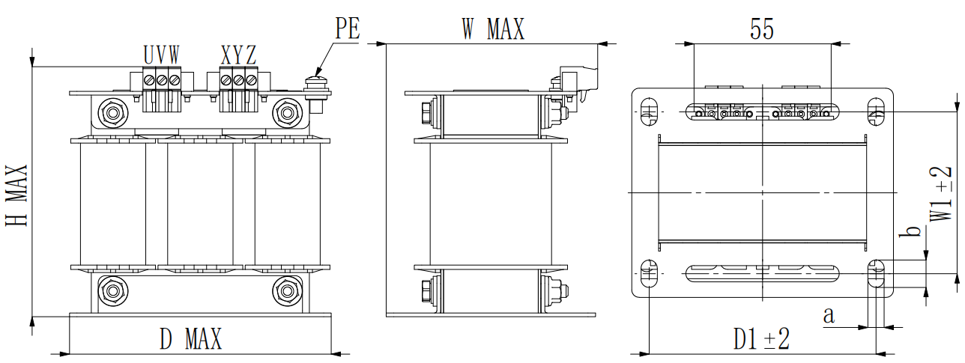
Figure 3-14 10A AC Output Reactor Size Diagram
Table 3-12 10A AC Output Reactor Size Table
Reactor Model | Reactor Rated Current (A) | D*H*W  (mm) | D1*W1  (mm) | a*b  (mm) | Mounting Hole Diameter c (mm) | A*e  (mm)
OCL-0010-EISC-EM70E | 10 | 110*110*90 | 91*65 | 6.5*11 | / | /

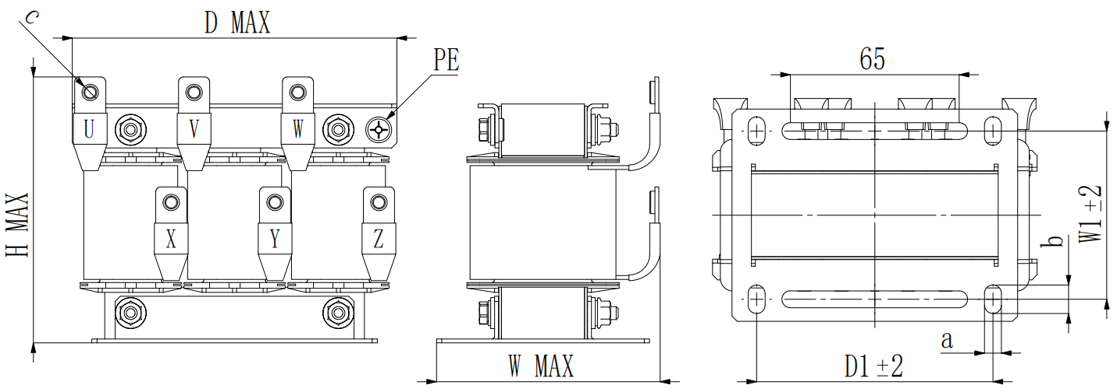
Figure 3-15 15-120A AC Output Reactor Size Diagram
Table 3-13 15-120A AC Output Reactor Size Table
Reactor Model | Reactor Rated Current (A) | D*H*W  (mm) | D1*W1  (mm) | a*b  (mm) | Mounting Hole Diameter c (mm) | A*e  (mm)
OCL-0015-EISCL-EM47E | 15 | 130*110*90 | 91*65 | 6.5*11 | M5 | 12*1.5
OCL-0020-EISCL-EM35E | 20 | 130*110*90 | 91*65 | 6.5*11 | M5 | 12*1.5
OCL-0030-EISCL-EM23E | 30 | 140*110*100 | 120*72 | 6.5*11 | M5 | 12*1.5
OCL-0040-EISCL-EM18E | 40 | 140*110*100 | 120*72 | 6.5*11 | M5 | 12*1.5
OCL-0050-EISCL-EM14E | 50 | 140*130*105 | 120*72 | 6.5*11 | M5 | 12*1.5
OCL-0060-EISCL-EM12E | 60 | 140*130*105 | 120*72 | 6.5*11 | M5 | 12*1.5
OCL-0080-EISCL-E87UE | 80 | 200*140*140 | 120*92 | 9*15 | M8 | 20*2
OCL-0090-EISCL-E78UE | 90 | 200*140*140 | 120*92 | 9*15 | M8 | 20*2
OCL-0120-EISCL-E58UE | 120 | 200*140*140 | 120*92 | 9*15 | M8 | 20*2

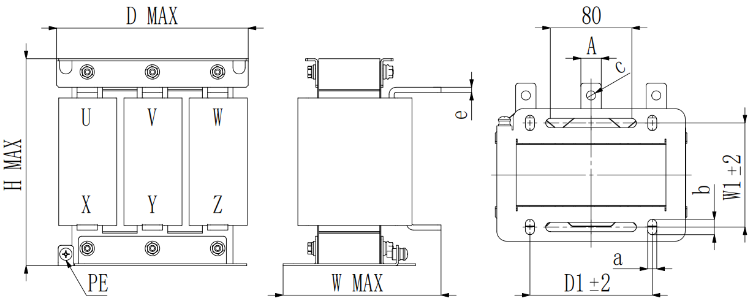
Figure 3-16 150-330A AC Output Reactor Size Diagram
Table 3-14 150-330A AC Output Reactor Dimensions
Reactor Model | Reactor Rated Current (A) | D*H*W  (mm) | D1*W1  (mm) | a*b  (mm) | Mounting Hole Diameter c (mm) | A*e  (mm)
OCL-0150-EISH-E47UE | 150 | 190*210*160 | 120*102 | 9*15 | 9 | 20*5
OCL-0200-EISH-E35UE | 200 | 190*210*160 | 120*102 | 9*15 | 9 | 20*5
OCL-0250-EISH-E28UE | 250 | 245*230*175 | 120*102 | 11*18 | 11 | 25*5
OCL-0290-EISH-E24UE | 290 | 245*230*175 | 182*102 | 11*18 | 11 | 25*5
OCL-0330-EISH-E21UE | 330 | 245*230*175 | 182*102 | 11*18 | 11 | 25*5
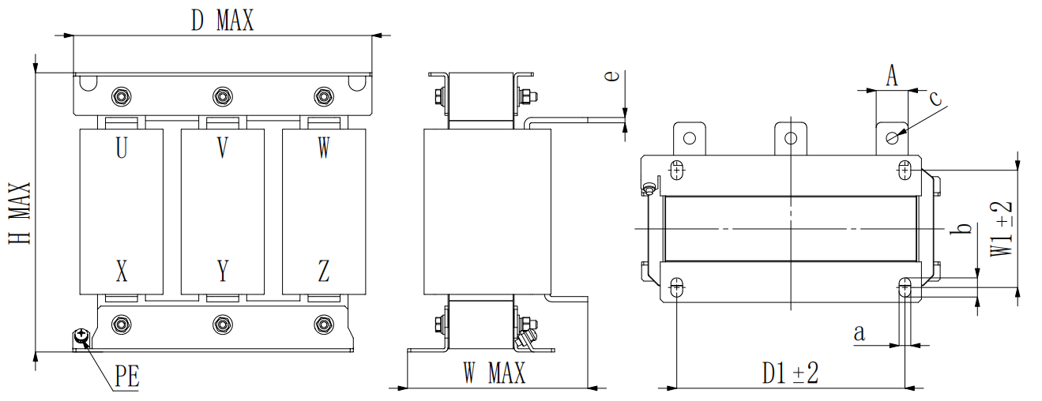
Figure 3-17 390A AC Output Reactor Dimensions
Table 3-15 390A AC Output Reactor Dimensions
Reactor Model | Reactor Rated Current (A) | D*H*W  (mm) | D1*W1  (mm) | a*b  (mm) | Mounting Hole Diameter c (mm) | A*e  (mm)
OCL-0390-EISH-E18UE | 390 | 285*270*180 | 214*110 | 11*18 | 11 | 30*5
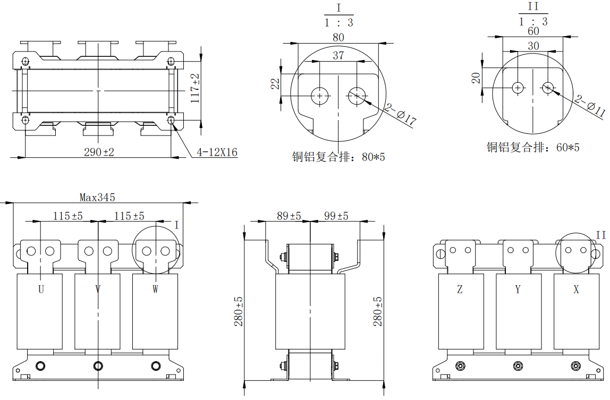
Figure 3-18 560AAC Output Reactor Dimensions
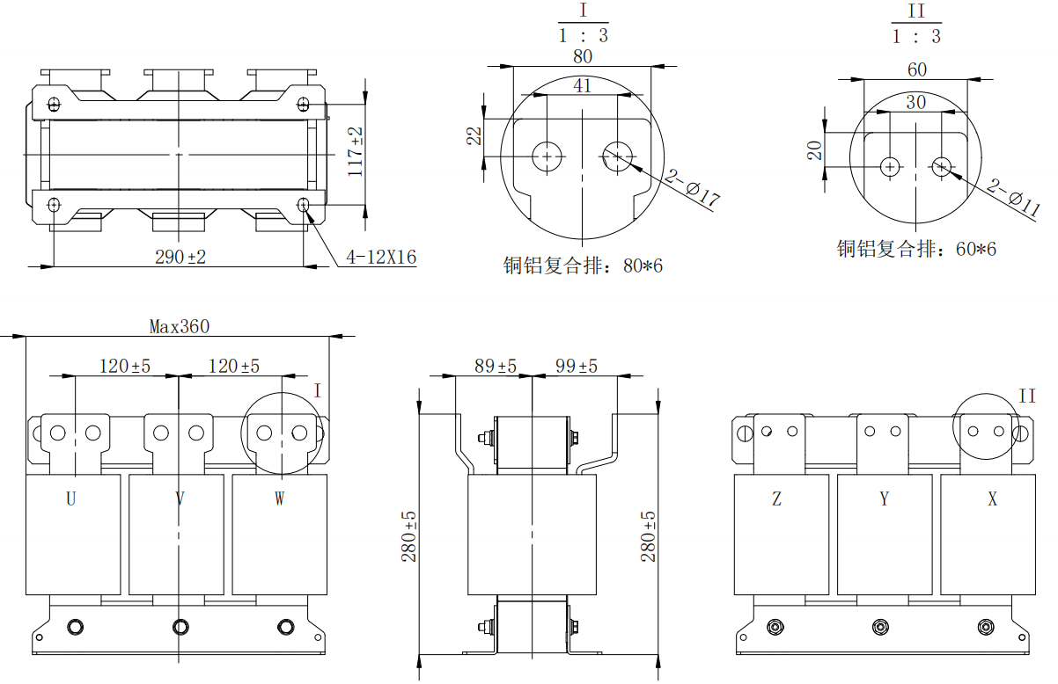
Figure 3-19 730A AC Output Reactor Dimensions
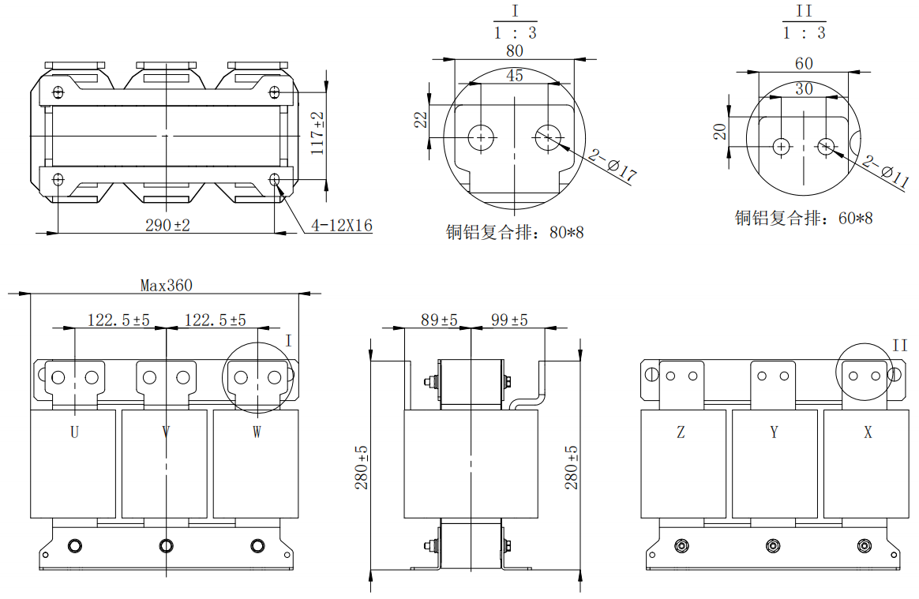
Figure 3-20 1000A AC Output Reactor Dimensions
Table 3-16 560-1000AAC Output Reactor Dimensions
Reactor Model | Reactor Rated Current (A) | D*H*W  (mm) | D1*W1  (mm) | a*b  (mm) | Mounting Hole Diameter c (mm) | A*e  (mm)
OCL-0560-EISH-3352A | 560 | 345*280*188 | 290*117 | 12*16 | 11/17 | 80*5
OCL-0780-EISH-3352A | 780 | 360*280*188 | 290*117 | 12*16 | 11/17 | 80*5
OCL-1000-EISH-3352A | 1000 | 360*280*188 | 290*117 | 12*16 | 11/17 | 80*5

Magnetic Ring and Magnetic Clamp
The magnetic ring is suitable for the input or output side of the inverter's power line. For leakage current issues and other signal interference problems present in some application scenarios, magnetic rings or magnetic clamps can also be selected for suppression. Installing a magnetic ring on the input side can suppress noise in the inverter's input power system. Installing a magnetic ring on the output side is mainly used to reduce interference from the inverter to the outside. When installing magnetic rings and magnetic clamps, please place them as close to the inverter as possible.
Magnetic rings are mainly divided into two types of materials: amorphous magnetic rings and ferrite magnetic clamps. Amorphous material has a very high permeability at frequencies up to 1 MHz, which is very effective for suppressing inverter interference, but it is slightly more expensive. Ferrite materials have better characteristics at frequencies above 1 MHz; for low-power inverters, they effectively suppress interference on various signal lines and are cost-effective.
In applications with significant interference, it is recommended to use amorphous magnetic rings to reduce external interference on the inverter's signal lines. When using them, wind the signal lines near the inverter end around the magnetic ring 4-6 times.

Expansion Card

Overview of Expansion Cards
Table 3-17 Overview of Expansion Cards
Name | Model | Function | Notes
Incremental Encoder Expansion Card | EMH-PG1 | Suitable for incremental encoders, compatible with differential and non-differential inputs, DB15 interface. | Available for all models
Resolver Encoder Expansion Card | EMH-PG2 | Suitable for resolvers, excitation frequency 10 kHz, DB9 interface. | Available for all models
CANopen Expansion Card | EMH-OP | CANopen Communication Expansion Card | Available for all models
PROFIBUS Expansion Card | EMH-DP | PROFIBUS Communication Expansion Card | Available for all models
PROFINET Expansion Card | EMH-PN | PROFINET Communication Expansion Card | Available for all models
Ethernet/IP Expansion Card | EMH-EN | Ethernet/IP Communication Expansion Card | Available for all models
EtherCAT Expansion Card | EMH-EC | EtherCAT Communication Expansion Card | Available for all models
For detailed instructions on the use of communication expansion cards, refer to the 'CM680 Series General-Purpose Inverter Communication Manual'.

Expansion Card Installation
The CM680 inverter is equipped with five types of communication bus cards (Profibus DP, CANopen, Profinet, EtherCAT, Ethernet/IP) and two types of PG cards. The installation positions are shown in the figure below, and the cover plate must be removed during installation.
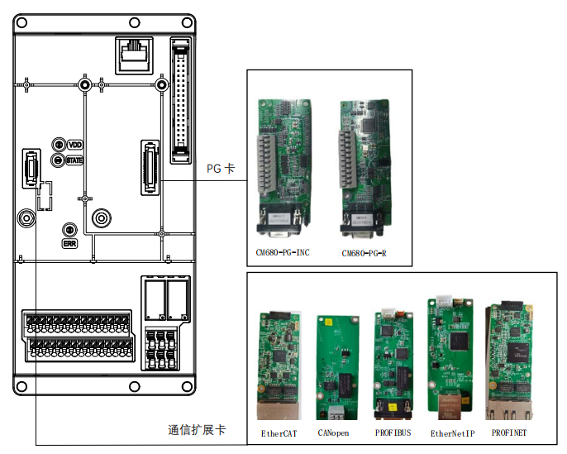
Figure 3-21 Expansion Card Installation Position

PG Card

Incremental Encoder Expansion Card
The incremental encoder expansion card model name for the CM680 is EMH-PG1, which has the following features:
1) Multi-channel signal detection for incremental encoders, A+/-, B+/-, Z+/- or U+/-, V+/-, W+/-;
2) Supports multiple types of signal inputs, including HTL differential, HTL single-ended, OC (Open collector), and OE (Open emitter);
3) Can provide power supply for encoders, 5Vdc±5%, 200mA, or 15Vdc±10%, 200mA;
4) The module can provide synchronous frequency division output, which can be selected as TTL differential or OC signal output;
5) For HTL differential encoder inputs, the module has a wire break detection function;
6) Can detect signals from one KYT84 or PTC temperature sensor to monitor motor temperature;
7) Can detect two digital DI signals, suitable for applications with travel switches;
8) To improve the stability of the module's detection, it is equipped with adaptive filtering and positive interlock functions;
9) Powered by the control board, no external power supply required.
Table 3-18 Terminal Function Specifications for Incremental Encoder Expansion Card
Terminal Item |  | Description
Encoder  PG1 | VP | Power output voltage: +5V/+15V±10%  Maximum output current: 200 mA
Encoder  PG1 | EGND | Common ground for power and signal
Encoder  PG1 | A+/A-  B+/B-  Z+/Z- | Encoder signal input (Line driver or Open collector)  Open collector input voltage: +5V~+24V (Note 1)  Maximum input frequency: 300kHz
Encoder  PG1 | U+/U-  V+/V-  W+/W- | Encoder signal input (Line driver or Open collector)  Open collector input voltage: +5V~+24V (Note 1)  Maximum input frequency: 300kHz
Encoder PG2 | A2+/A2-  B2+/B2- | Pulse Signal Input (Line Driver or Open Collector)  Open collector input voltage: +5V~+24V (Note 1)  Can be Single Phase Input or Two Phase Input  Maximum input frequency: 300kHz
PG-  OUT | AO+/AO-  BO+/BO-  ZO+/ZO-  GND | PG Card Signal Output, Can Be Divided: 1:1  Maximum Output Voltage for Line Driver: +5V  Maximum Output Current: 15 mA  Maximum Output Frequency: 300kHz  GND is the Ground of the PG Card, Shared with the Host Computer or PLC to Ensure a Common Reference Point for the Output Signal
Note 1: For Open Collector Application, Each Group's Input Current is 5~15mA, and Each Group Must Adapt Pull-up Resistors According to Different External Voltages. When the Voltage is 5V, a Pull-up Resistor of 100~220Ω, 1/2W or Higher, Should Be Connected; When the voltage is 12V, connect a pull-up resistor, 510~1350Ω, 1/2W or more; When the voltage is 24V, connect a pull-up resistor, 1.8k~3.3kΩ, 1/2W or more.
Note 2: If the input bandwidth requirement for the application does not exceed 30kHz, it is recommended to use 30kHz instead of 300kHz to avoid unnecessary interference.
Table 3-19 PG1 Encoder Terminal Pin Definition
Terminal Marking | Function | Notes
1 | U- | Encoder Signal Input
2 | U+ | Encoder Signal Input
3 | A- | Encoder Signal Input
4 | A+ | Encoder Signal Input
5 | B+ | Encoder Signal Input
6 | B- | Encoder Signal Input
7 | Z- | Encoder Signal Input
8 | Z+ | Encoder Signal Input
9 | NC | Empty Pin
10 | EGND | Common ground for power and signal
11 | V- | Encoder Signal Input
12 | V+ | Encoder Signal Input
13 | W- | Encoder Signal Input
14 | W+ | Encoder Signal Input
15 | VP | Power output voltage +5V±5% or +15V±10%, jumper cap S1 selects +5V, 3 selects +15V
Terminal distribution | 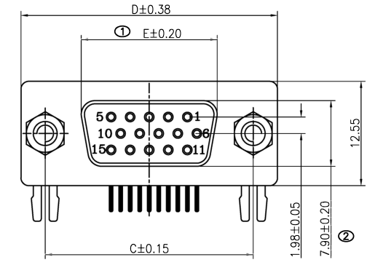
Note:
1. Suitable for line drive output type encoders;
2. Supports multiple signal types input, HTL differential, HTL single-ended, OC (Open collector) and OE (Open emitter);

Table 3-20 PG2 Encoder and PG-OUT Terminal Pin Definition Table
Terminal Marking | Function | Notes | Terminal distribution
1 | A2+ | Pulse signal input, twisted pair | 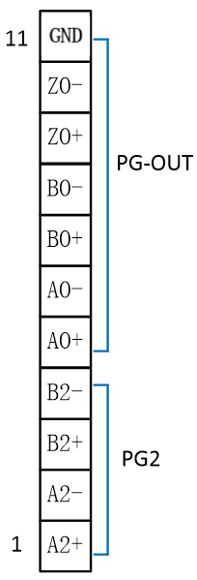
2 | A2- | Pulse signal input, twisted pair
3 | B2+ | Pulse signal input, twisted pair
4 | B2- | Pulse signal input, twisted pair
5 | AO+ | ABZ differential signal output
6 | AO- | ABZ differential signal output
7 | BO+ | ABZ differential signal output
8 | BO- | ABZ differential signal output
9 | ZO+ | ABZ differential signal output
10 | ZO- | ABZ differential signal output
11 | GND | GND is the Ground of the PG Card, Shared with the Host Computer or PLC to Ensure a Common Reference Point for the Output Signal

Resolver Encoder Expansion Card
The model name of the CM680 resolver encoder expansion card is EMH-PG2, which has the following features:
1) Provides synchronous frequency division signal output, TTL differential signal output;
2) Has a resolver feedback signal disconnection detection function;
3) Can be directly installed on the control board without external power supply, making installation convenient;
Table 3-21 Terminal specifications for the resolver encoder expansion card
Terminal Item |  | Description
Encoder PG1 | EXC+  EXC- | Resolver power output voltage: 7Vrms, 10kHz  Maximum output current Ipeak: 120mA
Encoder PG1 | SIN+/SIN-  COS+/COS- | Maximum input frequency of resolver feedback signal: 10kHz  3.5±0.175Vrms
Encoder PG2 | A2+/A2-  B2+/B2- | Pulse Signal Input (Line Driver or Open Collector)  Open collector input voltage: +5V~+24V (requires different pull-up resistors)  Can be Single Phase Input or Two Phase Input  Maximum input frequency: 300kHz
PG- OUT | AO+/AO-  BO+/BO-  ZO+/ZO-  EGND | PG card signal output, can be divided: 1:1  Line driver maximum output voltage: 5Vdc  Maximum output current 15mA  Maximum output frequency: 300kHz  EGND is the ground for the PG card, which shares the ground with the host computer or PLC to ensure the output signal has a common reference point
Note 1: For Open Collector Application, Each Group's Input Current is 5~15mA, and Each Group Must Adapt Pull-up Resistors According to Different External Voltages. When the Voltage is 5V, a Pull-up Resistor of 100~220Ω, 1/2W or Higher, Should Be Connected; When the voltage is 12V, connect a pull-up resistor, 510~1350Ω, 1/2W or more; When the voltage is 24V, connect a pull-up resistor, 1.8k~3.3kΩ, 1/2W or more.
Table 3-22 Resolver Encoder Expansion Card Indicator Light Status Table
No. | Indicator Light | Status Description
1 | Communication indicator light LD3 | Red light flashing: Communication with the control board failed
1 | Communication indicator light LD3 | Red light steady: Normal communication with the control board
2 | ENCODER indicator light LD1 | Off, encoder input signal normal, speed feedback not exceeded upper limit value or no interference
2 | ENCODER indicator light LD1 | On/Blinking, the amplitude of the encoder input signal SIN/COS exceeds the upper limit or the signal feedback is abnormal
2 | ENCODER indicator light LD2 | Off, the encoder input signal is normal, speed feedback has not exceeded the lower limit value or there is no interference
2 | ENCODER indicator light LD2 | On/Blinking, the amplitude of the encoder input signal SIN/COS is too low or the signal is disconnected

Note 1: If the amplitude of the sine wave inputs SIN+/SIN- and COS+/COS- is below or exceeds the specifications of the decoding IC, the red light will be displayed, possible reasons include:
1. The turns ratio of the Resolver encoder is not 1:0.5, causing the sine wave inputs SIN+/SIN- and COS+/COS- to not be 3.5±0.175Vrms.
2. The common-mode noise interference generated during motor operation causes the superimposed voltage to exceed 3.5±0.175Vrms.
Note 2: If the phase angle of the sine wave input at SIN+/SIN- and COS+/COS- compared to the reference sine wave output at R1-R2 exceeds 5°, the red light will be displayed. Possible reasons are as follows:
1. The frequency output by the PG card is incorrect.
2. The specification of the Resolver encoder is not 10kHz.
3. The common-mode noise interference generated during motor operation causes the phase angle of the sine waves induced in the second and third windings to differ significantly from the phase angle of the reference sine wave in the main winding when the motor rotates.

Table 3-23 PG1 Encoder Terminal Pin Definition
Terminal Marking | Function | Notes
1 | EXC- | Resolver Excitation Voltage Negative
2 | EXC+ | Resolver Excitation Voltage Positive
3 | SIN+ | Resolver Feedback SIN Positive
4 | SIN- | Resolver Feedback SIN Negative
5 | COS+ | Resolver Feedback COS Positive
6-8 | -- | --
9 | COS- | Resolver Feedback COS Negative
Terminal distribution | 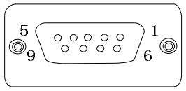
Note:
1. Suitable for line drive output type encoders;
2. PG Card Excitation Frequency: 10kHz, Excitation Voltage VRMS: 7V, Resolution: 12-bit.

Table 3-24 PG2 Encoder and PG-OUT Terminal Pin Definition
Terminal Marking | Function | Notes | Terminal distribution
1 | A2+ | Pulse Signal Input | 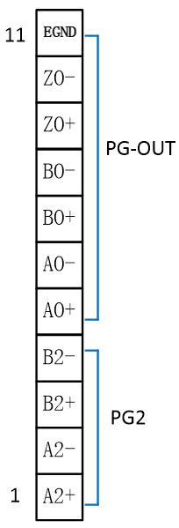
2 | A2- | Pulse Signal Input
3 | B2+ | Pulse Signal Input
4 | B2- | Pulse Signal Input
5 | AO+ | ABZ differential signal output
6 | AO- | ABZ differential signal output
7 | BO+ | ABZ differential signal output
8 | BO- | ABZ differential signal output
9 | ZO+ | ABZ differential signal output
10 | ZO- | ABZ differential signal output
11 | EGND | EGND is the ground for the PG card, which shares the ground with the host computer or PLC to ensure the output signal has a common reference point

Routine Maintenance and Care

Routine Maintenance
To ensure the proper functioning of the equipment and prevent product damage, please confirm the following items daily.
Status | Item | Inspection Content | Fault Countermeasures
Before Powering On | Operating Environment | Whether the operating environment is abnormal | - Whether the ambient temperature is within the allowable range;  - Whether there are any obstructions in the fan ducts.
Before Powering On | Installation Environment | Whether the installation cables are abnormal | - Confirm that the copper bars and cable terminals are not loose or corroded;  - Confirm that the inverter installation cables have no insulation damage;  - Confirm that the grounding of the inverter and motor is normal;  - Confirm that the installation mounting brackets are not vibrating.
After Power-On | Motor | Whether the motor has any abnormal noise or vibration. | - Check if the motor mounting screws are loose;  - Check if the motor is missing any phases.
After Power-On | Fan | Abnormal operation of the inverter and motor cooling fans | - Check if the inverter fan is operating abnormally;  - Check if the motor fan is operating abnormally;  - Check if the cabinet fan is operating abnormally.
After Power-On | Input Voltage | Check if the power voltage between the main circuit and control circuit is abnormal | - Check if the input voltage is within the allowed range;  - Check if there are large load startups or shutdowns from nearby equipment.
Replace  After replacing the motor | Load current | Check if the inverter's operating current exceeds the rated current of the inverter and motor for a certain period | - Check if the motor parameters are set correctly;  - Check if the motor is overloaded;  - Check if mechanical vibration is excessive (normal condition < 1G).

List of Regular Inspection Items
Item | Inspection Content | Fault Countermeasures
Entire Unit | Check for any garbage, dirt, or dust accumulation on the surface. | - Confirm that the inverter cabinet is powered off;  - Use a vacuum cleaner to remove garbage or dust to avoid contact with components;  - If surface dirt cannot be removed, it can be wiped with alcohol and allowed to dry completely.
Cables | Check if the power lines and connections have changed color;  Check if the connection terminals are damaged;  Check if the insulation layer is aged or cracked. | - Replace cables with aged or cracked insulation layers  - Replace damaged connection terminals
Peripheral Devices | Check if the motor has any abnormal noise or vibration; check if the contactor fails to engage firmly or produces unusual sounds when actuated; check for any short circuits, water contamination, swelling, or ruptures in peripheral devices. | - Replace faulty components
Air duct | Whether the air duct and heat sink are blocked;  Whether the fan is damaged; | - Clean the air duct  - Replace the fan
Control circuit | Whether there is poor contact in control components;  Whether terminal screws are loose; whether control cables have insulation cracks. | - Clean foreign objects from the surface of control circuits and connection terminals  - Replace damaged or corroded control cables

Inverter wear parts life
The main wear parts of this product are cooling fans and electrolytic capacitors used for filtering, whose lifespan is closely related to the usage environment and maintenance conditions. The general lifespan times are listed in the table below.
Component Name | Service Life
Cooling Fan | ≥5 years
Electrolytic Capacitor | ≥5 years
The service life of components is based on the following conditions; users can determine the replacement period according to specific operating conditions.
- Ambient Temperature: 40°C
- Load: 80%
- Operating Time: 24 hours/day

Storage of the Inverter
After purchasing the inverter, the following points must be noted for temporary storage and long-term storage:
● When storing, try to pack it back into the original packaging box provided by the company.
● Do not allow the unit to be placed for a long time in damp, high-temperature, or outdoor exposure conditions.
● Long-term storage can lead to degradation of electrolytic capacitors; it is necessary to power the unit at least once every 6 months, with each power-on lasting at least 6 hours. The input voltage must be gradually increased to the rated value using a voltage regulator or consult technical support from inverter professionals.

Compliance with Certifications, Directives, and Standards

Certifications, Directives, and Standards
For the relevant certification categories, directives, and standards, please refer to the table below.
Table 5-1 Relevant Certification Categories, Directives, and Standards
Certification Name | Directive Name | Compliance Standard
CE Certification | EMC Directive | EN 61800-3
CE Certification | LVD Directive | EN 61800-5-1
Note:
The product's CE certification complies with the latest version of directives and standards.

CE Certification

Precautions for Compliance with European Standards

Figure 5-1 CE Mark
● The “CE Mark” is a mark indicating that a product complies with electromagnetic compatibility (EMC), safety (LVD), and other directives when traded commercially (produced, imported, sold) in the European region.
● Commercial trade (production, import, sales) in the European region must have the CE marking.
● This product complies with the Electromagnetic Compatibility (EMC) Directive, Low Voltage Directive (LVD), and bears the CE marking.
● Machinery and equipment installed with this product for sale in the European region must also meet CE requirements.
● When affixing the CE marking to the terminal installed with this product, the responsibility lies with the customer who finally assembles the product, and it is the customer's responsibility to confirm
whether the final product's machinery and equipment comply with CE certification.

Conditions for Compliance with the EMC Directive
This product complies with the European EMC Directive, meeting the requirements of standard EN 61800-3, suitable for Class 1 and Class 2 environments.
Caution:
● If this product is used in a Class 1 environment, it may cause radio interference. In addition to meeting CE compliance requirements, measures should be taken to prevent interference when necessary.
● To ensure that this product complies with EMC directives and standards, an EMC filter must be installed on the input side, and recommended shielded cables must be selected for the output end. It is also necessary to ensure reliable grounding of the filter and a 360° reliable connection of the shielding layer of the output cable.
● The system manufacturer responsible for installing this product must ensure that the system complies with European EMC directives, and according to the application environment of the system, ensure that the system meets the requirements of standard EN 61800-3.

"Introduction to EMC Standards
"Electromagnetic Compatibility (EMC) refers to the ability of electrical and electronic equipment to function properly in an electromagnetic interference environment and not to release excessive electromagnetic interference that could affect the stable operation of other devices or systems. Therefore, EMC includes the following requirements:
"● The electromagnetic interference generated by the equipment during normal operation must not exceed certain limits.
"● The ability to operate normally with a certain degree of immunity to electromagnetic interference present in the environment, i.e., electromagnetic sensitivity.
性。
"EN 61800-3 defines the following two types of environments:
● First Environment: Includes facilities in civilian settings, as well as those directly connected to the low-voltage power grid supplying electricity to civilian buildings without an intermediate transformer.
These facilities are part of the low-voltage power grid that supplies electricity to civilian buildings.
● Second environment: Facilities other than those directly connected to the low-voltage power grid supplying electricity to residential buildings.
According to the expected usage environment, the product is divided into the following four categories:
● Class C1 Equipment: The rated power supply for electrical drive systems is below 1000V, used in Environment 1.
● Class C2 Equipment: The rated voltage for electrical drive systems is below 1000V, and it cannot be plug-in or portable equipment,
which can only be installed and commissioned by professionals when used in Environment 1.
"● Class C3 equipment: The rated voltage of the electrical drive system is below 1000 V, suitable for the second environment, not applicable to the first environment.
境。
"● Class C4 equipment: The rated voltage of the electrical drive system is 1000 V or higher, or the rated current is 400 A or greater, or it is used in complex systems in the second environment.

"Compliance with LVD Low Voltage Directive
"This product has been tested according to EN 61800-5-1 and confirmed to comply with the Low Voltage Directive. To ensure that machinery and installations equipped with this product comply with the Low Voltage Directive, the following requirements must be met.
"Installation Location
"Please install this product in locations with an overvoltage category III and pollution degree 2 or lower as specified in IEC 60664-1.
Installation Environment
For installation environment requirements, please refer to the 'Installation Environment' section in the CM680 Series General-Purpose Inverter Installation Manual.
Installation Protection Requirements
● This product is designed for installation within an enclosure and must be installed in the final system. The final system should provide appropriate fire-resistant casing, electrical protective casing, and mechanical protective casing, etc., and comply with local laws, regulations, and relevant IEC standards.
Shell, electrical protective casing, and mechanical protective casing, etc., and comply with local laws, regulations, and relevant IEC standards.
● When installing cabinet-mounted (IP20) products, please install them in a structure where foreign objects cannot enter from the top and front.
inside.
Main Circuit Terminal Wiring Requirements
For main circuit terminal wiring requirements, refer to the relevant sections on 'Main Circuit Wiring Requirements' in the CM680 Series General-Purpose Inverter Installation Manual.
Protection Device Requirements
To comply with EN 61800-5-1 standard requirements, it is essential to connect a fuse/circuit breaker on the input side to prevent accidents caused by internal circuit shorts.
circuit faults. Matching the product's maximum input value, recommended fuse selection is detailed in section “3.2.1 Fuses, Contactors
and Circuit Breakers.”

