Preface
Introduction to Materials
The CM680 is a high-performance general-purpose inverter, featuring a book-type design across the entire series to meet more installation area requirements. The product is equipped with rich hardware configurations and powerful software performance, supporting a variety of communication protocols and efficient control of various types of motors. It offers excellent drive performance and control functions, enabling the application of automated production equipment in industries such as metallurgy, lifting, machine tools, printing, wire drawing, glass, food, fans, and pumps.
This manual introduces the communication expansion card, including its overview, composition, dimensions, installation, electrical connections, and parameter configuration.
More Information

Document Name | Content Summary
CM680 Series General Purpose Inverter  Quick Installation and Commissioning Manual | Introduces detailed content on product installation, wiring, commissioning, fault handling, function codes, fault codes, etc.
CM680 Series General Purpose Inverter  Hardware Manual | Introduces the system composition, technical specifications, components, dimensions, optional accessories (installation accessories, cables, peripheral electrical components), expansion cards, and detailed content on daily maintenance and care, compliance with certifications and standards, etc.
CM680 Series General Purpose Inverter  Installation Manual | Introduces the installation dimensions, space design, detailed installation steps, wiring requirements, cabling requirements, installation requirements for optional accessories, and detailed content on common EMC issue resolution suggestions, etc.
CM680 Series General Purpose Inverter  Software Manual | Introduces the detailed content of the product's functional applications, communication, fault codes, function codes, etc.
CM680 Series General Purpose Inverter  Communication Manual | Introduces the detailed content of the product communication expansion card's overview, composition, dimensions, installation, electrical connections, communication parameter configuration, fault codes, etc.

Version Change Record

Revision Date | Release Version | Change Content
2023–12 | Ver 1.0 | First release of the manual.
2023–04 | Ver 1.1 | Added methods for reading and writing inverter function codes using CANopen, etc.
2024–09 | Ver 1.2 | Modified some parameters and functions.

About Manual Acquisition
This manual is not shipped with the product. If you need to obtain the electronic PDF version, you can do so through the following methods:
Log in to the Changsha Riye Electric official website (www.cssunye.com), go to the “Download Center,” search for the keyword, and download.

Warranty Statement
Under normal usage conditions, if the product malfunctions or is damaged, we provide warranty service within the warranty period. After the warranty period, repair fees will be charged.
Within the warranty period, the following situations causing product damage will incur repair fees.
● Damage caused by not operating the product according to the manual.
● Damage caused by fire, water, or abnormal voltage.
● Damage caused by using the product for non-standard functions.
● Damage caused by use beyond the specified product usage range.
● Secondary damage caused by force majeure (natural disasters, earthquakes, lightning strikes).
Service fees are calculated according to the manufacturer's unified standards. In case of a contract, the contract takes precedence. For detailed warranty information, please refer to the 'Product Warranty Card'.

Table of Contents
Preface 1
Precautions 6
1. Overview of Communication Protocols 8
2. PROFIBUS DP Communication 9
2.1. Product Information 9
2.1.1. External Dimensions 9
2.1.2. Interface Layout 9
2.2. Installation and Wiring 11
2.2.1. Installation 11
2.2.2. Wiring 11
2.3. Electrical Connections 12
2.4. Communication Description 15
2.4.1. PROFIBUS Communication Key Points Description 15
2.4.2. Periodic Data Format 15
2.4.3. Non-periodic Data Format 15
2.5. Communication Configuration 17
2.5.1. Configuration Settings 17
2.5.2. Configuring Periodic Communication 25
2.5.3. Configuring Non-Periodic Communication 27
2.6. Fault Information 34
2.6.1. Periodic Fault Codes 34
2.6.2. Non-periodic Fault Code 35
2.6.3. Obtaining Diagnostic Information 35
2.6.4. Erasing Fault Codes 38
3. PROFINET Industrial Ethernet Communication 40
3.1. Product Information 40
3.1.1. External Dimensions 40
3.1.2. Interface Layout 40
3.2. Installation and Wiring 41
3.2.1. Installation 41
3.2.2. Wiring 42
3.3. Communication Description 43
3.3.1. Key Points of PROFINET Communication 43
3.3.2. Data Transmission Format 43
3.3.3. PZD Area Data Description 43
3.3.4. Master Station Data Transmission Description 43
3.3.5. Inverter Response Data Description 44
3.4. Communication Configuration 44
3.4.1. Configuration Settings 44
3.4.2. Configuring Periodic Communication 55
3.4.3. Configuring Non-Periodic Communication 57
3.5. Fault Information 58
3.5.1. Periodic Fault Codes 58
3.5.2. Non-periodic Fault Code 59
3.5.3. Module Information 59
3.5.4. Diagnostic Buffer Fault Meaning and Handling 60
3.5.5. Non-periodic Read or Erase Fault Code 60
3.6. MRP Function Description 61
3.6.1. MRP Ring Network 62
3.6.2. MRP Configuration 62
4. EtherNet/IP Industrial Ethernet Communication 64
4.1. Product Information 64
4.1.1. External Dimensions 64
4.1.2. Interface Layout 64
4.2. Installation and Wiring 65
4.2.1. Installation 65
4.2.2. Wiring 66
4.3. Communication Description 66
4.3.1. EtherNet/IP Communication Key Points 66
4.3.2. Data Transmission Format 66
4.3.3. Master Station Data Transmission Description 67
4.3.4. Inverter Response Data Description 67
4.4. Communication Configuration 67
4.4.1. Configuration Settings 68
4.4.2. Configuring Non-Periodic Communication 68
4.5. Fault Information 69
4.5.1. Periodic Fault Codes 69
4.5.2. Reading and Erasing Fault History 70
5. EtherCAT Industrial Ethernet Communication 72
5.1. Product Information 72
5.1.1. External Dimensions 72
5.1.2. Interface Layout 72
5.2. Installation and Wiring 74
5.2.1. Installation 74
5.2.2. Wiring 74
5.3. Communication Description 74
5.3.1. EtherCat Communication Key Points 74
5.3.2. Periodic Data Read/Write Description 75
5.3.3. Non-periodic Data Read/Write Description 76
5.4. Communication Configuration 81
5.4.1. Configuration Settings 82
5.4.2. Configuring Periodic Communication 87
5.4.3. Configuring Non-Periodic Communication 96
5.5. Fault Information 107
5.5.1. Periodic Fault Codes 107
5.5.2. Non-periodic Fault Code 107
5.5.3. Obtaining Diagnostic Information 107
5.5.4. Non-periodic Read or Erase Fault Code 109
6. CANopen Communication 112
6.1. Product Information 112
6.1.1. External Dimensions 112
6.1.2. Interface Layout 112
6.2. Installation and Wiring 113
6.2.1. Installation 114
6.2.2. Wiring 114
6.3. Communication Description 114
6.3.1. Key Points of CANopen Communication 114
6.3.2. CANopen Communication Protocol 115
6.3.3. Communication Sub-Protocol 122
6.3.4. Custom Protocol One 133
6.3.5. Custom Protocol Two 137
6.3.6.CiA 402 138
6.4. CANopen Inverter Function Debugging 140
6.4.1. CANopen Select CiA 402 Protocol 140
6.4.2. CANopen Select Inverter Manufacturer Custom Protocol 141
6.4.3. Analog AIO and DIO 142
6.5. CANopen Fault Codes 144
6.6. Communication Configuration 147
6.6.1. Configuration Settings 147
6.6.2. Configuring Periodic Communication 147
6.6.3. Configuring Non-Periodic Communication 148
7. Appendix: General Periodic Fault Codes 149
8. Appendix: Modbus Communication 152
8.1. Communication Introduction 152
8.2.RS485 Connection Topology 152
8.3.Communication Transmission Methods 152
8.4.Communication Data Frame Structure 153
8.5.Relevant Parameters 154
8.6.Communication Parameter Addresses 155

Precautions
Safety Statement
1. This chapter explains the safety precautions necessary for the proper use of this product. Before using this product, please read the user manual and correctly understand the information related to safety precautions. Failure to comply with the matters specified in the safety precautions may result in death, serious injury, or equipment damage.
2. The 'Danger', 'Warning', and 'Caution' items in the manual do not represent all safety matters that should be observed, but are provided as a supplement to all safety precautions.
3. This product should be used in an environment that meets the design specifications; otherwise, it may cause malfunctions. Any functional abnormalities or component damage caused by non-compliance with these specifications are not covered by the product warranty.
4. Our company will not assume any legal responsibility for personal injuries or property damage caused by non-compliance with the content of this manual or improper operation of the product.
Definition of Safety Levels
In this manual, safety precautions are divided into the following two categories:
Danger: Situations where failure to follow the required procedures can result in serious injury or even death;
Caution: Situations where failure to follow the required procedures can result in moderate injury or minor injury, as well as equipment damage;
Please read this chapter carefully when installing, debugging, and maintaining this system, and strictly follow the safety precautions outlined in this chapter. The company will not be liable for any injuries or losses resulting from non-compliance with the operating procedures.
Safety Precautions
Usage Phase | Safety Level | Matters
Before Installation | Danger | If you find that the control system is waterlogged, parts are missing, or components are damaged upon unpacking, do not install!  If the packing list does not match the actual items, do not install!
Before Installation | Caution | Handle with care when moving to avoid the risk of damaging the equipment!  Do not touch the components of the control system to avoid the risk of static damage!
During installation | Danger | Only trained personnel with knowledge of electrical equipment and electrical expertise should operate. Non-professionals are strictly prohibited from operating!
During installation | Caution | Do not allow wire ends or screws to fall into the drive, as this can cause damage to the drive!  Please install the drive in a location with minimal vibration and avoid direct sunlight.
When wiring | Danger | Installation must be performed by a professional electrical engineer; otherwise, unexpected dangers may occur!  Before wiring, ensure that the power supply is in a zero-energy state to avoid the risk of electric shock!  Please ensure that the inverter is properly and correctly grounded according to standards to avoid the risk of electric shock!
When wiring | Caution | Please follow the steps specified in the Electrostatic Discharge (ESD) prevention measures and wear an ESD wrist strap when performing wiring and other operations to avoid damaging the equipment or internal circuits of the product.  When wiring the control circuit, please use twisted pair shielded wire and connect the shield to the product's grounding terminal for grounding; otherwise, it may cause abnormal operation of the product.
Before Powering On | Danger | Before powering on, please ensure that the product is installed properly, the wiring is secure, and the motor device is allowed to restart.  Before powering on, please confirm that the power supply meets the product requirements to avoid damaging the product or causing a disaster!  Do not open the product cabinet door or protective cover, touch any wiring terminals, or remove any components or parts while the power is on, as there is a risk of electric shock!
Before Powering On | Caution | The inverter must be covered with the cover before power can be applied; otherwise, there is a risk of electric shock!  Wire according to the circuit connection methods provided in this manual; otherwise, accidents may occur!
After power-on | Danger | Do not open the cover after power-on. Otherwise, there is a risk of electric shock!  Do not touch any input or output terminals of the inverter. Otherwise, there is a risk of electric shock!
After power-on | Caution | If parameter identification is required, be aware of the danger of injury from the rotating motor; otherwise, accidents may occur!  Do not arbitrarily change the manufacturer's parameters of the inverter; otherwise, it may cause damage to the equipment!
During operation | Danger | Non-professional technical personnel should not test signals during operation; otherwise, it may cause personal injury or equipment damage!  Do not touch the cooling fan or discharge resistor to test the temperature; otherwise, it may cause burns!
During operation | Caution | During inverter operation, avoid dropping objects into the equipment, as this can cause damage to the device!  Do not use contactors to control the start and stop of the drive, as this can cause damage to the equipment!
During maintenance | Danger | Do not perform repairs or maintenance on the inverter without professional training, as this can result in personal injury or equipment damage!  Do not perform repairs or maintenance on the equipment while it is energized, as this poses an electric shock hazard!  Ensure that the inverter's input power has been disconnected for at least 10 minutes before performing maintenance or repairs on the drive, as residual charges in the capacitors can cause injury!  All pluggable modules must be inserted or removed with the power off!  After replacing the communication module, parameter settings and checks must be performed.

List of Communication Protocols

Supported Communication Protocols | Communication Hardware
PROFIBUS DP Communication | External Communication Expansion Module | EMH-DP Communication Expansion Card
PROFINET Industrial Ethernet Communication | External Communication Expansion Module | EMH-PN Communication Expansion Card
EtherNet/IP Industrial Ethernet Communication | External Communication Expansion Module | EMH-EN Communication Expansion Card
EtherCAT Industrial Ethernet Communication | External Communication Expansion Module | EMH-EC Communication Expansion Card
CANopen Communication | External Communication Expansion Module | EMH-OP Communication Expansion Card

PROFIBUS DP Communication

2.1. Product Information
The EMH-DP Communication Expansion Card is a PROFIBUS fieldbus adapter card that complies with the international standard for PROFIBUS-DP fieldbus. This card is installed on the CM680 Inverter to enable communication with PROFIBUS master station devices, making the inverter a slave station of PROFIBUS DP, accepting control from the master station.

Physical Dimensions
Physical dimensions of the PROFIBUS Communication Expansion Card: PCB length 95mm, width 37mm, mounting hole diameter 3.5mm.
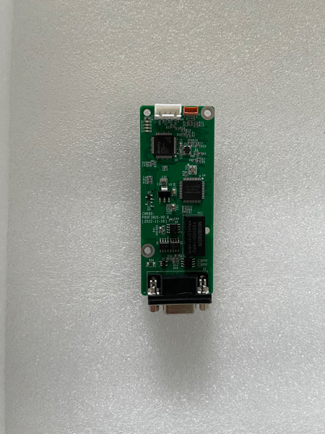
Figure 1 Physical Dimensions of the EMH-DP Communication Expansion Card

Interface Layout
The hardware layout of the EMH-DP Communication Expansion Card is shown in Figure 2. Pin Header X3 is used for connecting to the inverter and is located on the back of the EMH-DP Communication Expansion Card. The EMH-DP Communication Expansion Card provides a 9-pin D-type connector for PROFIBUS communication. Detailed descriptions of each hardware component are provided in Table 1.
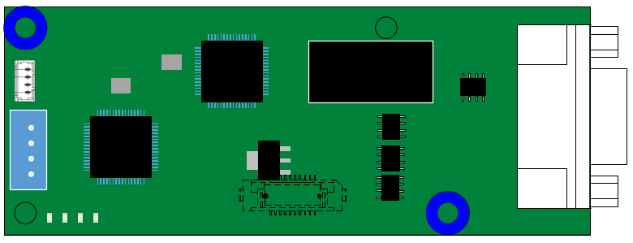

X1
X2

X4

D1 D2 D3 D4 X3

Figure 2 EMH-DP Communication Expansion Card Interface Layout

Table 1 EMH-DP Communication Expansion Card Interface Description
Diagram Name | Hardware Name | Function Description
X1 | Socket | UART Interface: Print Operation Information
X2 | 9-pin D-type Connector | For Module Connection to PROFIBUS Network, Refer to Figure 1.3 Description
X3 | Board-to-Board Socket | For Connection to Inverter
X4 | Socket | For Firmware Download and Debugging
D1, D2, D3, D4 | LED Indicator Light | Used to indicate the operating status, refer to Table 1.2 for details
1. PROFIBUS-DP Communication Interface
The EMH-DP Communication Expansion Card uses a standard DB9 connector to connect with the PROFIBUS master station, and its pin signal definitions follow the SIEMENS DB9 connector standard distribution. As shown in the following figure:
Figure 3 EMH-DP Communication Expansion Card DP Communication Interface Description
2. LED Indicator Light
Table 2 EMH-DP Communication Expansion Card LED Indicator Light Description
Diagram Name | Indicator Light | Indicator Light Status |  | Function Description
D1 | PROFIBUS Communication Status Indicator Light | Red Light | Constantly On | Indicates no communication between the module and the PROFIBUS master station (check PROFIBUS cable connections and station number)
D1 | PROFIBUS Communication Status Indicator Light | Red Light | Off | Indicates normal communication between the module and the PROFIBUS master station
D2 | Inverter communication status indicator light | Red Light | Constantly On | Communication timeout with the inverter
D2 | Inverter communication status indicator light | Red Light | Flashing | Abnormal communication with the inverter (interference exists, poor connection, etc.), communication format error (register address error, data error, etc.)
D2 | Inverter communication status indicator light | Red Light | Off | Normal communication with the inverter
D3 | Program run status indicator light | Green light | Constantly On | Main program running normally
D3 | Program run status indicator light | Green light | Off | Main program not started properly
D4 | Hardware power indicator light | Green light | Constantly On | Module powered on normally
D4 | Hardware power indicator light | Green light | Off | Module not powered on

Installation and Wiring

Installation
The EMH-DP Communication Expansion Card is designed to be embedded in the CM680 Inverter. Before installation, please disconnect the power supply to the inverter, wait for about 10 minutes, and ensure that the inverter's charging indicator light is completely off before proceeding with the installation. After inserting the EMH-DP Communication Expansion Card into the inverter, please secure the corresponding screws to prevent poor contact between the board and the signal socket. The installation diagram is shown in Figure 4.
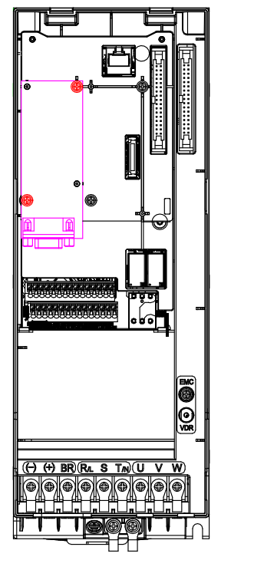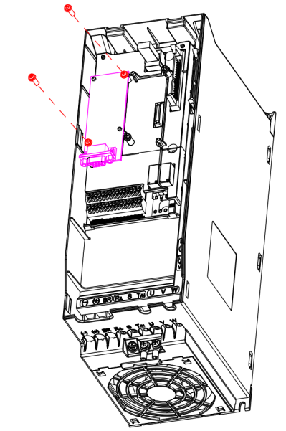
Figure 4 EMH-DP Communication Expansion Card Installation Diagram

Wiring
The wiring diagram for the PROFIBUS DP bus is shown in Figure 5. Terminal matching resistors must be connected at both ends of the PROFIBUS bus. Adjust the DIP switch according to the markings on the terminal block. Failure to connect or insufficient terminal resistors can affect communication quality, leading to unstable communication.
Figure 5 Schematic Diagram of PROFIBUS DP Bus Wiring

The PROFIBUS-DP communication rate ranges from 9.6 kbps to 12 Mbps, and the transmission line length must be determined based on the transmission rate, with a transmission distance range of 100m to 1200m. The communication rates supported by the EMH-DP Communication Expansion Card and the communication distances at each rate are shown in Table 3.
Table 3 Maximum Cable Length for Different PROFIBUS-DP Transmission Rates
Communication Rate (bps) | 9.6k | 19.2k | 93.75k | 187.5k | 500k | 1.5M | 3M | 6M | 12M
Length (m) | 1200 | 1200 | 1200 | 1000 | 400 | 200 | 100 | 100 | 100

Electrical Connection
Bus Cable Description
It is recommended to use dedicated Profibus DP bus cables. Cable parameters are shown in the table below.
Table 4 Cable Parameters
Parameter | Description
Conductor | 1 pair (2×22AWG) solid copper wire
Insulation Jacket Color | Green, Red
Shielding | Aluminum foil tape + tinned copper wire braid
Jacket Material | PVC
Appearance | Purple

Fig. 6 Schematic Diagram of Bus Cable Inner Structure
Bus Terminal Description:
It is recommended to use SIEMENS Profibus DP dedicated connector, model: 6ES7 972-0BB12-0XA
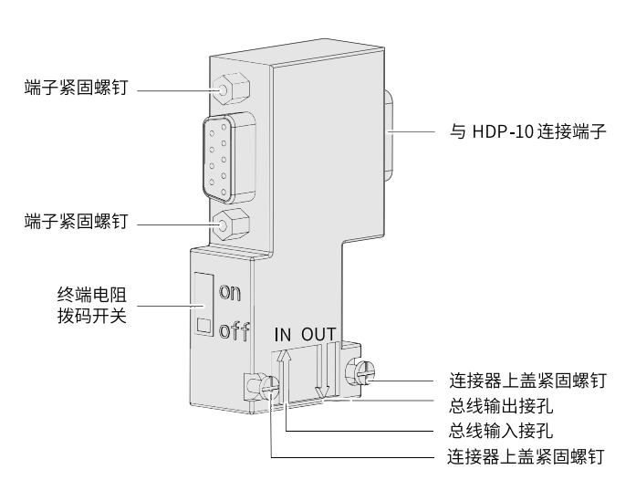
Fig. 7 Schematic Diagram of Bus Connection Terminal Layout

Bus Connection Steps
1. Remove the outer sheath of the cable, and leave the length according to the dimensions below.
Fig. 8 Cable Length Reserve Diagram (Unit: mm)

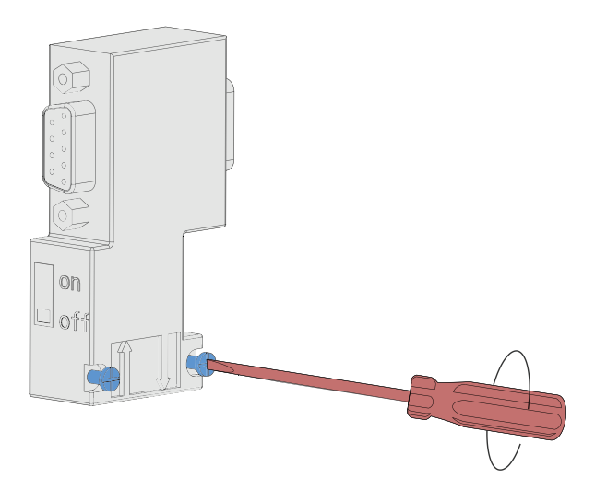
2. Use a No. 1 flathead screwdriver to open the bus connector terminal cover.
Fig. 9 Opening the Bus Connector Terminal Cover
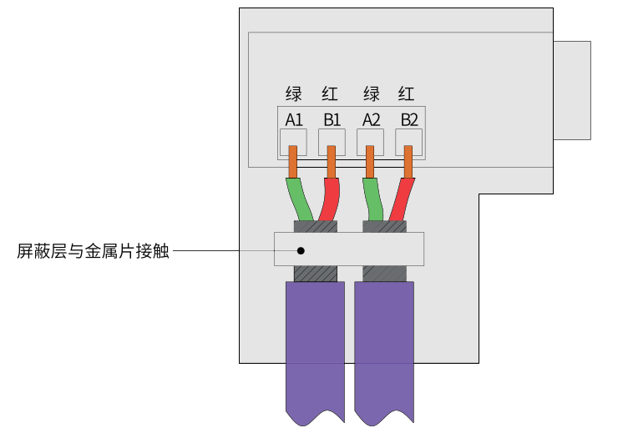
3. Use a No. 1 flathead screwdriver to secure the cable to the connector installation position, ensuring that the shielding layer is in tight contact with the shielding layer metal plate, green cable connects to A, red cable connects to B, as shown in the figure below.
Figure 10 Shield Layer in Contact with Metal Plate
4. After covering the connector cover and tightening the screws on the cover, insert the CM680-PROFIBUS corresponding DB9 port, and use a screwdriver to tighten the fixing screws on both sides to prevent loosening.
Note: When installing the Profibus DP bus, ensure that the screws on both sides of the Siemens terminal are securely connected to the EMH-DP module; otherwise, communication may fail or the communication quality may decrease.

Communication Description

Key Points of PROFIBUS Communication
1. When using the EMH-DP communication expansion card, it is necessary to set the communication decoding method of the CM680. Set the F8-19 register to 0 via the operation panel, and set the F8-07 register to 0 or 1 according to the actual decoding method used.
2. When setting the inverter command, the F0-05 register of the CM680 must be set to 5.
3. When setting the inverter frequency, the F0-06 register of the CM680 must be set to 8.
4. The device address for PROFIBUS communication on the EMH-DP Communication Expansion Card is set in the F8-11 register. After setting, the module must be restarted for the changes to take effect.
5. During non-periodic communication, a new non-periodic read/write operation must not be initiated until the previous one is completed. The interval between two non-periodic communications should be no less than 100ms to avoid affecting the response of periodic communication.

Periodic Data Format
Through PZD area data, the master station can update and read inverter data in real-time and perform periodic data exchange. The communication address is configured by the user during setup.
The EMH-DP Communication Expansion Card provides multiple Modules to transmit PZD data of different lengths. Users select a specific Module for configuration during setup according to their needs. The supported data length for each data format is listed in the table below:
Table 5 Supported Data Length for Each Data Format
Module | Data Length
PZD-2/3 | Cyclic Write (master->slave): PZD1~PZD2  Cyclic Read (slave->master): PZD1~PZD3
PZD-6/6 | Cyclic Write (master->slave): PZD1~PZD6  Cyclic Read (slave->master): PZD1~PZD6
PZD-10/10 | Cyclic Write (master->slave): PZD1~PZD10  Cyclic Read (slave->master): PZD1~PZD10
PZD-16/16 | Cyclic Write (master->slave): PZD1~PZD16  Cyclic Read (slave->master): PZD1~PZD16

When configuring the newly installed communication expansion card, each PZD has a default address, as follows:
● PZD1 (master->slave): 24576 (0x6000), Control Command
● PZD2 (master->slave): 24578 (0x6002), Target Frequency
● PZD1 (slave->master): 8448 (0x2100), Errors and Warnings (Fixed Address)
● PZD2 (slave->master): 24832 (0x6100), Current Status
● PZD3（slave->master）: 24834 (0x6102), actual frequency
● Other addresses: 2096 (0x0830), reserved address, unused PZD should be set to this address to avoid affecting other functions

Non-periodic data format
Non-periodic interaction uses slot-index addressing to determine the format of the message data area. To facilitate user operations on consecutive registers of the inverter, the following non-periodic read/write format is defined, with the index set to 100.
1. Non-periodic write
When executing a non-periodic write command, the data area must include the starting address of the register, length, and value, with the function code fixed at 0x10, indicating a write command. The specific format is as follows:
Table 6 Non-periodic write data format
 | Function Code | Register Address | Register Length | Data
Data Length | 1 Byte | 2 Byte | 1 Byte | (Register Length * 2) Byte
Example | 0x10 | 0x1010 | 0x02 | 0x01020304
The total length of the data area for non-periodic write values is at least 6 Byte and at most 24 Byte.
2. Non-periodic Read Value
In the non-periodic read value request message, the data area is empty and cannot transmit the register address to be read. A non-periodic write value command must be sent first to cache the register address in the module. The function code for this non-periodic write address command is fixed at 0x03, and the data area length is fixed at 3 Byte. The specific format is as follows:
Table 7 Non-periodic Read Data Format
 | Function Code | Register Address
Data Length | 1 Byte | 2 Byte
Example | 0x03 | 0x1010
After executing the non-periodic write address command, send the non-periodic read value command. The read value request message includes the register length to be read, and the data area is empty. The data area of the response message is the register value. The format of the data area in the response message is as follows:
Table 8 Format of the Response Message Data Area
 | Data
Data Length | (Register Length * 2) Byte
Example | 0x01020304

Communication Configuration
Taking the Siemens S7-1200 series PLC as an example, configure the PLC to establish PROFIBUS communication with the module.

Configure Configuration
1. Create a project
Double-click to open the TIA Portal software, select 'Create New Project', and the following interface will appear. Choose the save path and project name, then click 'Create'.
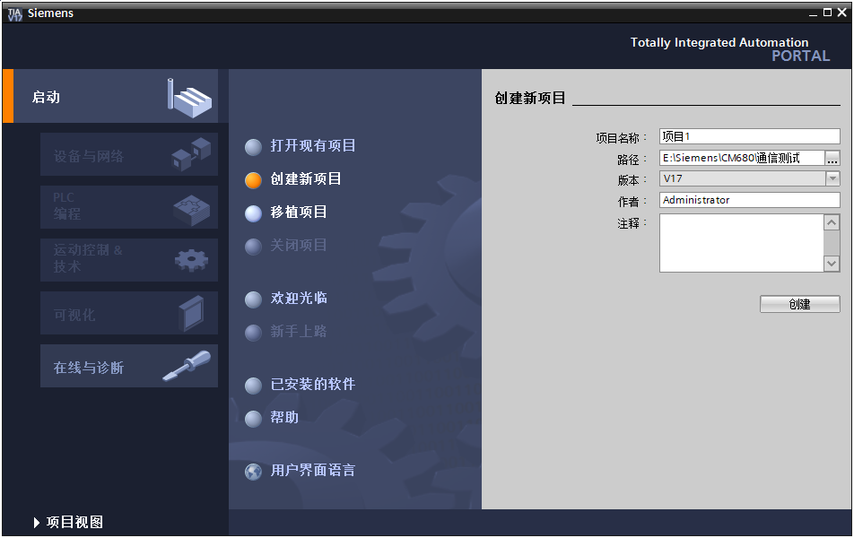
After creation, click 'Project View' to enter the main interface. In the 'Hardware Catalog' on the right, select the actual PLC model being used, for example, S7-1214. Double-click to see the PLC in the configuration page.
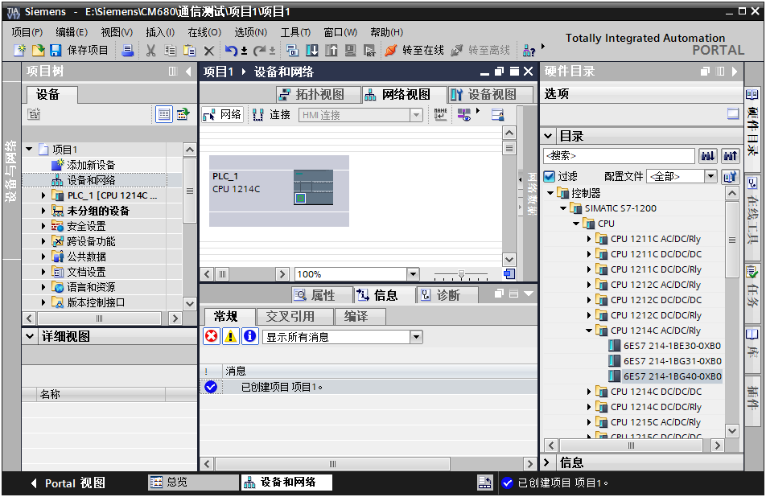
Click on the PLC, enter the 'Device View' page, and in the properties bar, you can configure the IP address and other information of the PLC, which can be modified according to the actual situation.
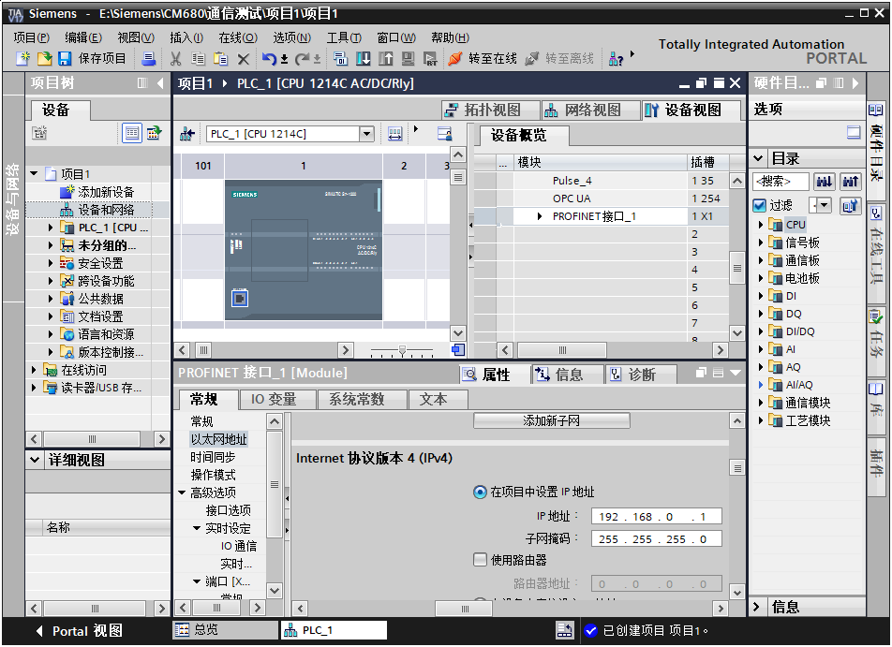

In the hardware catalog, select the CM1243-5 communication module, add it next to the PLC, click on this communication module, and you can configure its PROFIBUS address and other parameters.
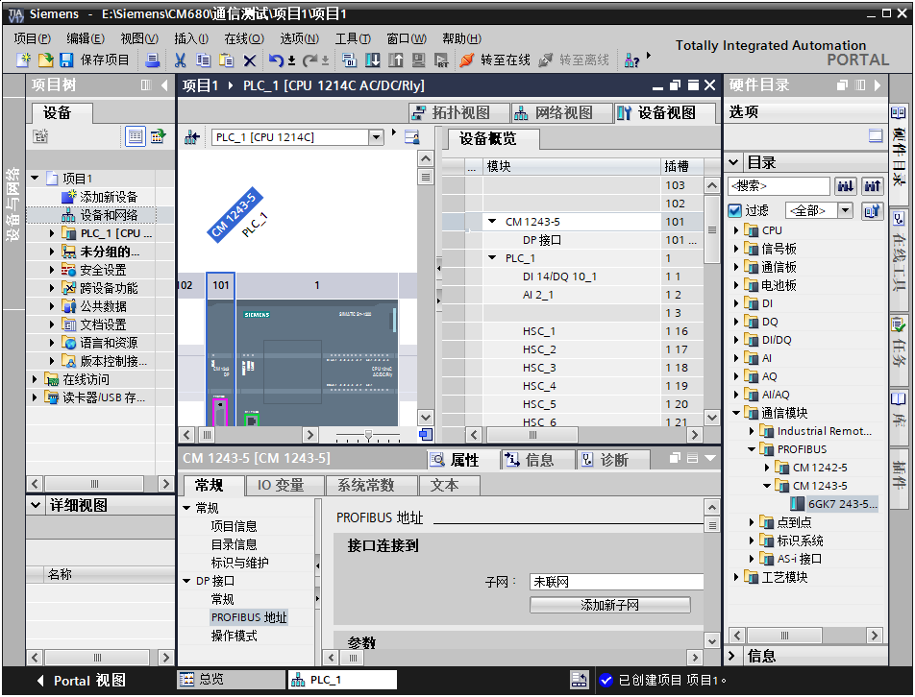
This completes the establishment of the master station.

2. Install GSD File
If the GSD file has not been installed before, it needs to be installed. In 'Options', select 'Manage General Station Description (GSD) Files'.
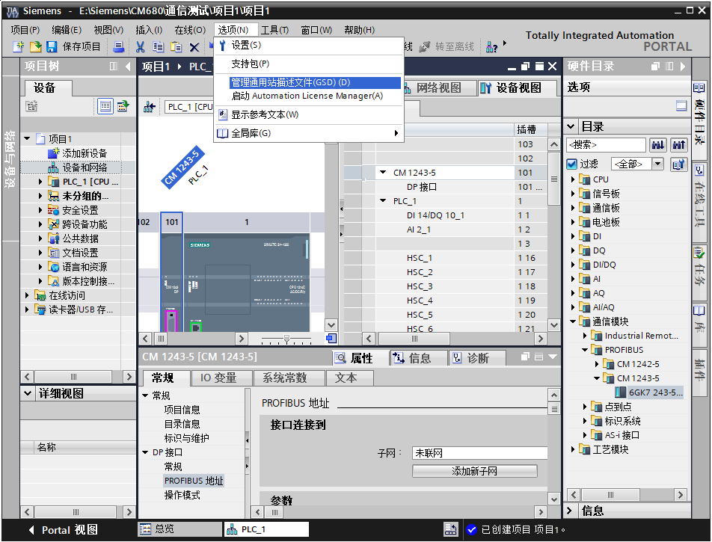

Select the path where the GSD file is stored (Note: Do not store the GSD file in a path with Chinese characters, as this may cause errors), check the GSD file to be installed, click 'Install'. After installation is complete, select 'Close'.
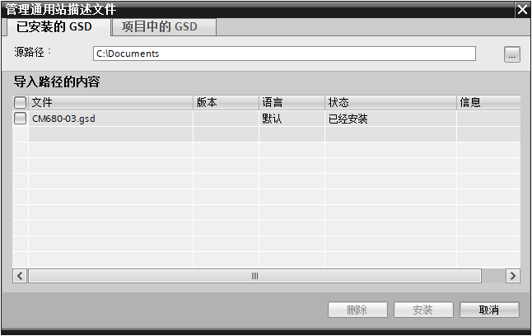

3. Configure Slave Station
Return to the “Device and Network” — “Network View” interface, in the “Hardware Catalog” on the right, find the CM680 position under Other Field Devices — PROFIBUS DP — Drive — SUNYE, and double-click to add the module.
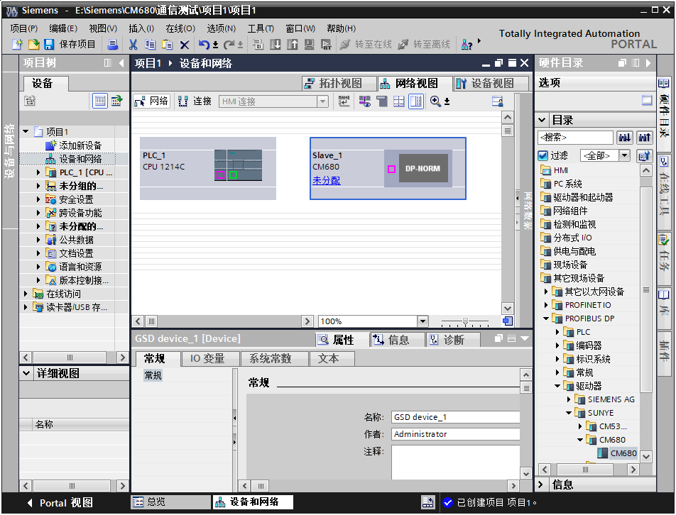

Click on “Unassigned” on the module in the “Device and Network” interface to assign the master station system to the module. Click on the DP connection line to configure parameters such as the DP transmission baud rate.
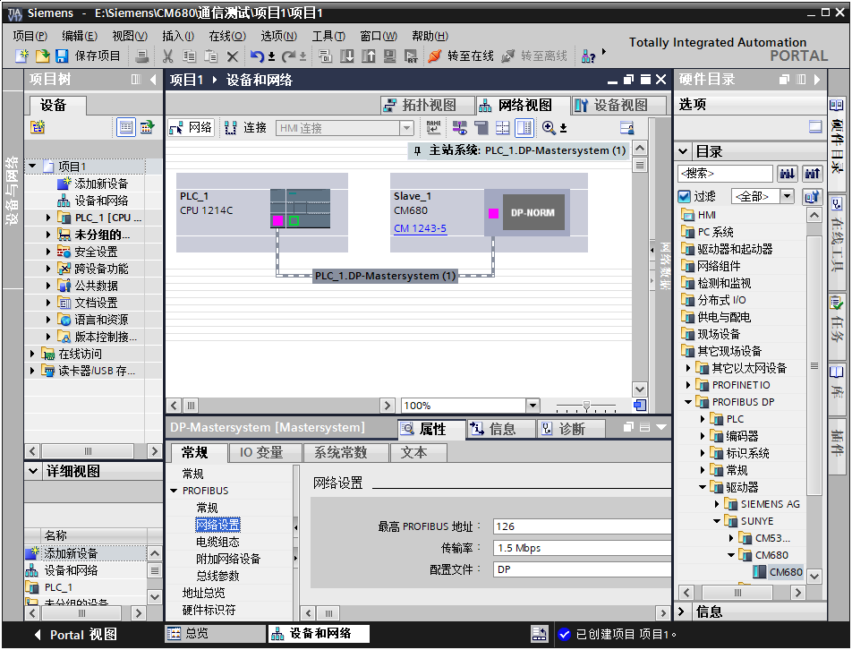

Select the slave station, and in “Properties” -> “General” -> “PROFIBUS Address” -> “Parameters,” set the PROFIBUS device slave address. The slave address must be different from the master address.
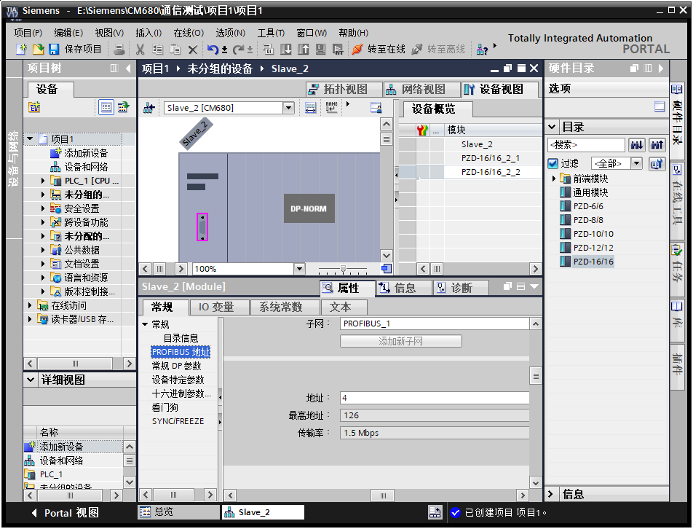

Configure Periodic Communication
1. Configure Module
Select the slave station, switch to the “Device View,” and under “Hardware Catalog” -> “Module,” double-click to select the data length to be configured for the slave station. The configured module will be added in the device view. After adding the module, you can modify the input/output mapping in the PLC by editing the “I Address” and “Q Address”.

2. Configure PZD
Through PZD area data, the master station can real-time modify and read inverter data, and perform periodic data exchange.
Select the slave station, under “Properties” -> “General” select “Device Specific Parameters”, set the register address for user-defined periodic data. PZDx(Master->Slave) indicates the address where the master station writes to the slave station, and PZDx(Slave->Master) indicates the address where the master station reads from the slave station, in decimal format. Refer to section 3.2 for default addresses.
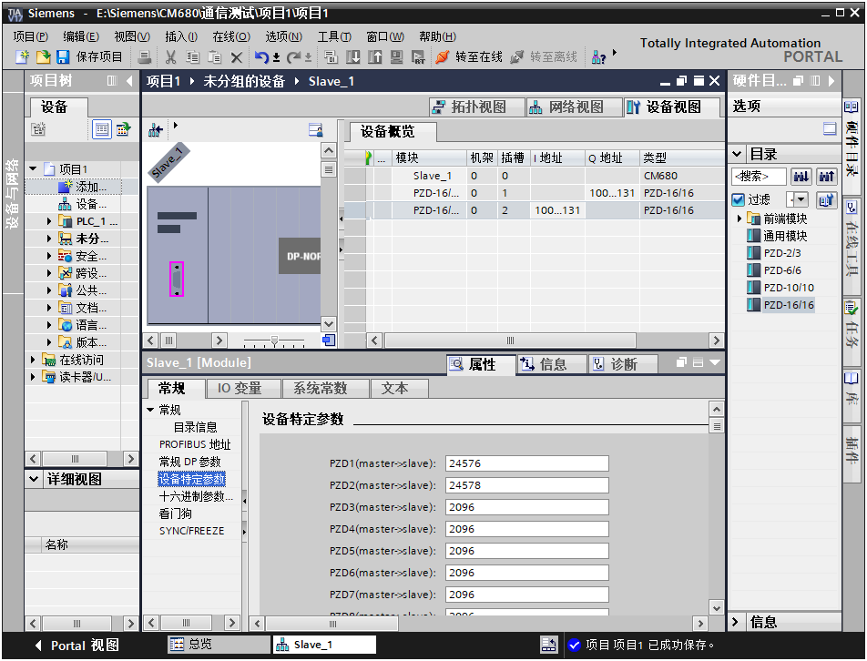
After configuration is complete, download the configuration, and the PLC and module will automatically perform periodic data exchange.

3. Download Configuration and Ladder Diagram
Save the configured network, set the computer's IP address to the same subnet as the PLC (note that it should not conflict with the IP addresses of the slave stations in the configuration, or you can set the PC to automatically obtain an IP address), compile, click download, select the interface, and then click 'Start Search'. Select the detected PLC, and then click download.
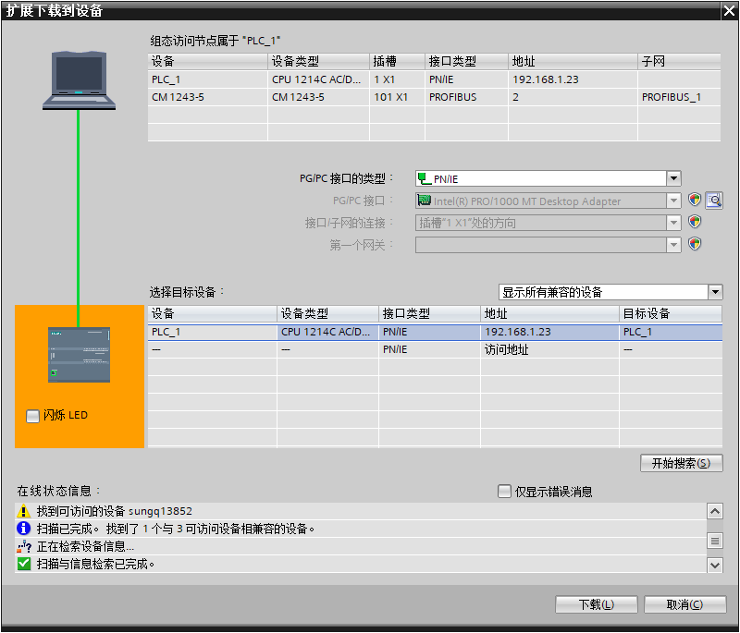

Configure Non-periodic Communication
1. Example of Non-periodic Write
Add a data block FB_control, and allocate some variables as follows:
WR1_LEN represents the byte length of the send array; in the example below, it is 6 bytes.
The WR1_Record array is filled with the corresponding content according to the non-periodic interaction format. In the example below, the WR1_Record array contains the 6 bytes to be sent, with the following meanings:
WR1_Record[0]: Function code 0x10 indicates write.
WR1_Record[1] and WR1_Record[2]: indicate that the starting address of the registers to be written is 0xF00E.
WR1_Record[3]: indicates that the number of consecutive registers to be written is 1.
WR1_Record[4] and WR1_Record[5]: indicate that the data to be written to the starting register address (0xF00E) is 0x1499.
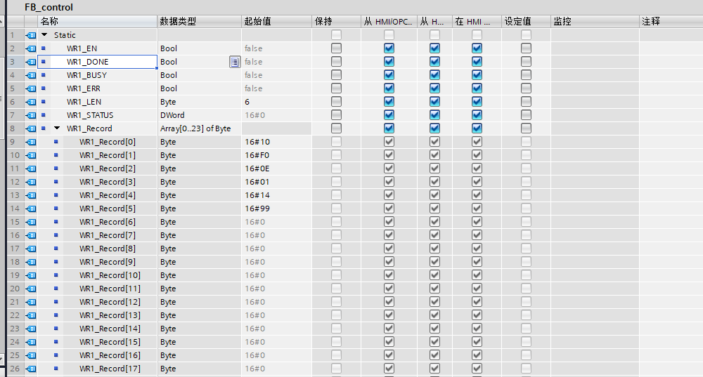
Add the following program in the main program block:
Function block name: WRREC
ID: The ID of the module configured during PROFIBUS module configuration
INDEX: 100
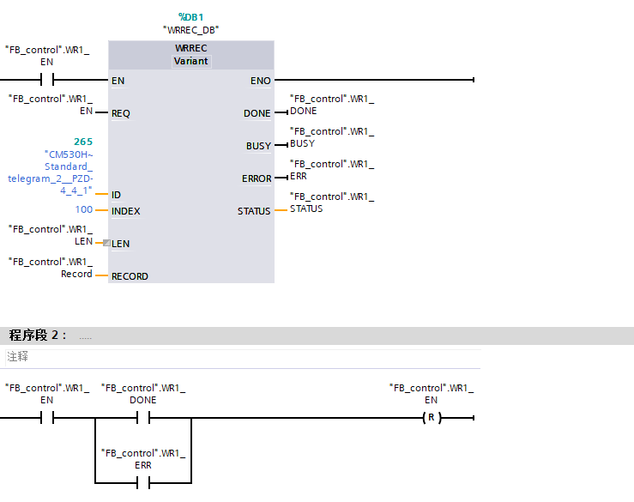
Recompile the PLC program and download it to the PLC. Switch to online mode. Set “FB_control.WR1_EN” to 1, which will trigger a non-periodic write action.
Monitor the FB_control data block online to see the execution results. “FB_control.WR1_Done” being TRUE indicates successful execution, “FB_control.WR1_ERR” being TRUE indicates an execution error, with the error code stored in “FB_control.WR1_STATUS”. Refer to Section 5.2 for specific meanings.
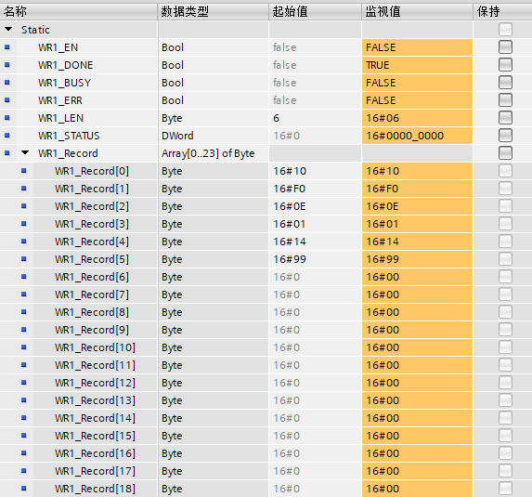

2. Non-periodic Read Value
Add a data block FB_control, and allocate some variables as follows:
WR2_Record array: Enter the function code and address for reading
WR2_Record[0] : Read function code 0x03
WR2_Record[1] and WR2_Record[2]: The register address to be read is 0xF00E
WR2_LEN: The length of the data to be written is 3 bytes, i.e., WR_Record[0]~[2].
RD2_MLEN: The length of the data to be read is 2 bytes, i.e., the data of one register.
RD2_Record array: The data read is stored in this array.
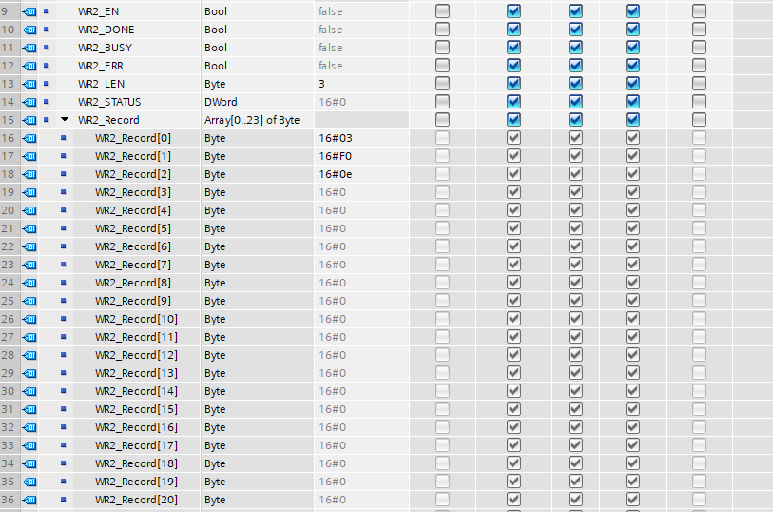
Add the following program in the main program block:
Function block: WRREC is used to write the starting address of the registers to be read
Function Block: RDREC is used to save the data starting from the first address of the read registers.
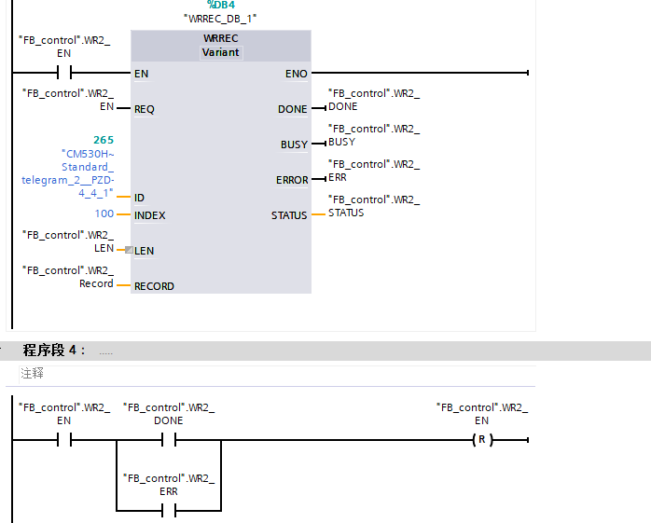
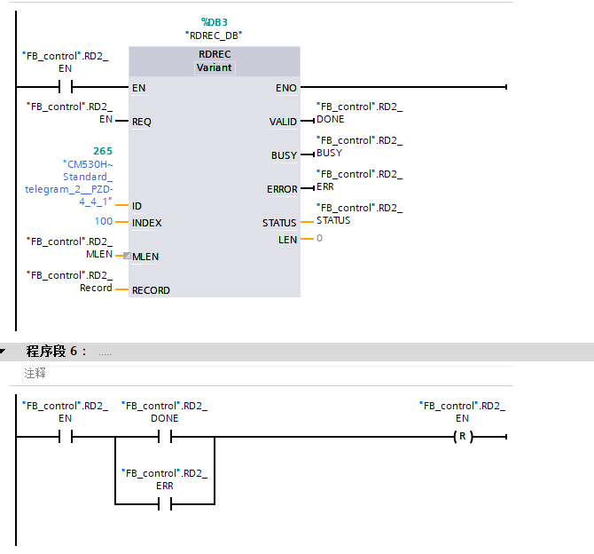
Recompile the PLC program and download it to the PLC. Set 'FB_control.WR2_EN' to 1 to trigger the write read address. When 'FB_control.WR2_Done' is TRUE, it indicates that the write read address was successful. Then set 'FB_control.RD2_EN' to 1, which will trigger the non-periodic read value action. Monitor the 'FB_control' data block online to see the execution results. 'FB_control.RD2_Done' being TRUE indicates successful execution, and 'Error' being TRUE indicates an execution anomaly. The error code is stored in 'FB_control.RD2_STATUS'; refer to Section 5.2 for specific meanings.

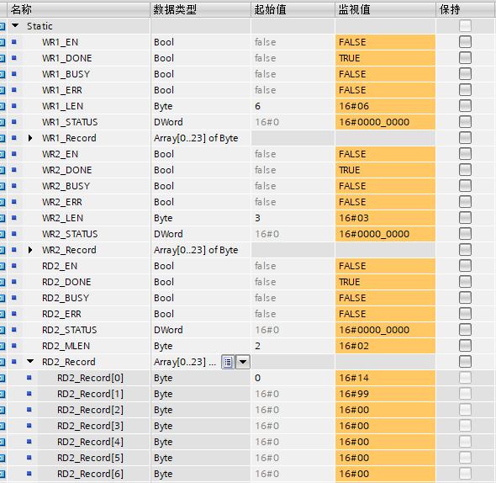
3. Explanation of Encapsulated Non-periodic Read/Write Function Blocks
To allow users to perform non-periodic read/write operations without needing to understand Modbus messages, the manufacturer has encapsulated two non-periodic read/write function blocks for user reference.
DP_WRITE function block: Achieves non-periodic writing, ID: represents the moduleID to be written, ADDR: represents the address of the function code to be written, LEN: represents the number of registers to be written, DATA: array of values to be written to the registers.
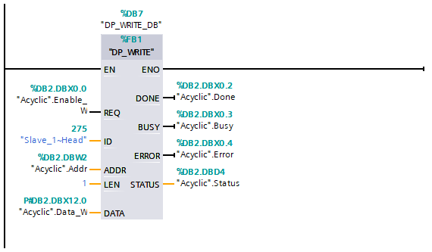
DP_READ function block: A function block to achieve non-periodic reading, ID: represents the moduleID to be written, ADDR: represents the address of the function code to be read, MLEN: represents the number of registers to be read, DATA: array to store the values read from the registers.
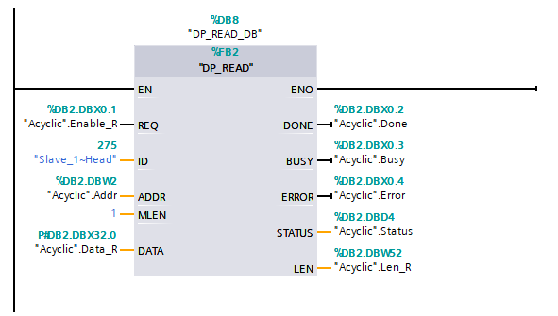

Fault Information

Periodic Fault Code
In the PZD area of periodic communication, the PZD1 sent from the slave station to the master station is fixed to indicate error and alarm information, allowing users to obtain the latest status through periodic communication. In addition to the diagnostic information of the inverter itself, the communication status between the module and the inverter must also be included, allowing users to obtain the cause of errors. Detailed fault status codes are listed in the table below:
Table 9 PROFIBUS Periodic Fault Status Codes
Diagnostic Classification | Status Code
Inverter Body Diagnostic Information (Register Address: 0x2100) | 200 Communication Error (Message Abnormality)  201 Communication Error (Timeout Abnormality)  202 Address Error  203 Parameter Exceeds Threshold

Non-periodic Fault Code
When executing non-periodic communication, the STATUS parameter in the function block is used to return the command execution result, with a data type of DWORD (4 bytes). The data format and meaning are already defined in the TIA software. In addition to the standard definition, the following error codes have the following meanings:
Table 10 PROFIBUS Non-periodic Fault Status Codes
Function_ Num | Error_ Decode | Error_ Code_1 | Error_ Code_2 | Meaning
0xC0 | 0x80 | 0xB8 | 0x01 | Non-periodic Message Function_Num Error (Module only supports 0x5E, 0x5F).
0xC0 | 0x80 | 0xA2 | 0x00 | Non-periodic Data Length Exceeds Limit (0 bytes <= Data Length <= 64 bytes).
0xDE | 0x80 | 0xB0 | 0x00 | Invalid Data Record Number (Index=100, or Index=101).
0xDE | 0x80 | 0xB8 | 0x02 | Non-periodic Read Value Data Length Exceeds Limit (2 bytes <= Data Length <= 24 bytes);  Read Fault History Record Length Exceeds Limit (1 byte <= Data Length <= 64 bytes).
0xDE | 0x80 | 0xB8 | 0x03 | Non-periodic Write Address Invalid (WRREC not run in advance to write read address or address error).
0xDE | 0x80 | 0xB8 | 0x05 | Non-periodic Read Value Failed.
0xDF | 0x80 | 0xB0 | 0x00 | Invalid Data Record Number (Index can only be 100 or 101).
0xDF | 0x80 | 0xB8 | 0x01 | Non-periodic Write Value Function Code Error (Only supports 0x03, 0x10 function codes).
0xDF | 0x80 | 0xB8 | 0x02 | Non-periodic write value data length exceeded (3 bytes <= data length <= 24 bytes);  Clear fault history record length exceeded (data length = 1 byte).
0xDF | 0x80 | 0xB8 | 0x03 | Non-periodic write address is invalid.
0xDF | 0x80 | 0xB8 | 0x04 | Non-periodic write set value out of range;  Clear fault history record set value illegal (set value can only be 0).
0xDF | 0x80 | 0xB8 | 0x05 | Non-periodic write value failure.

Retrieve Diagnostic Information
When communication between the module and the inverter is abnormal, diagnostic information will be sent to the PLC, which can be obtained through the DPNRM_DG function block from the diagnostic information sent by the slave station.
1. Add program block
Add a data block in the program block and include the following variables.
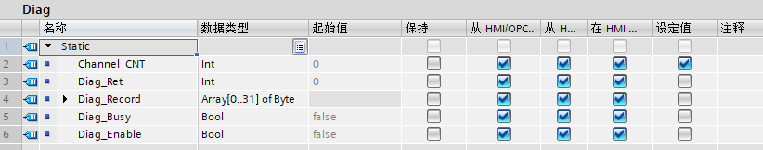
Add the 'Diagnostic error interrupt' organization block in the program block and include the following program in the organization block. This organization block is triggered to execute once each time the PLC receives a diagnostic message from a slave station.
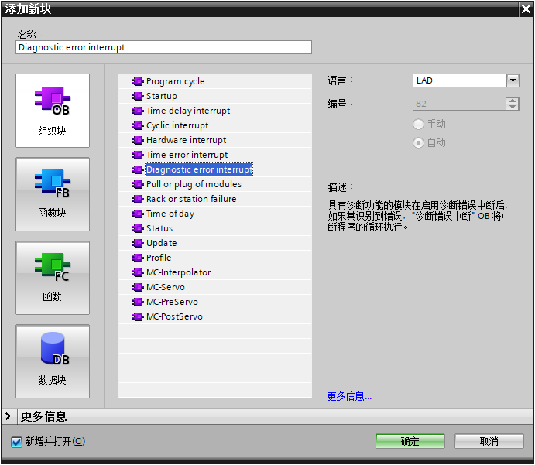
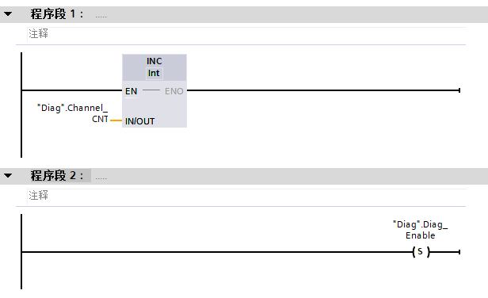

2. Add function block
Add the following program in the Main program block to read diagnostic information when a diagnostic message is received from a slave station.
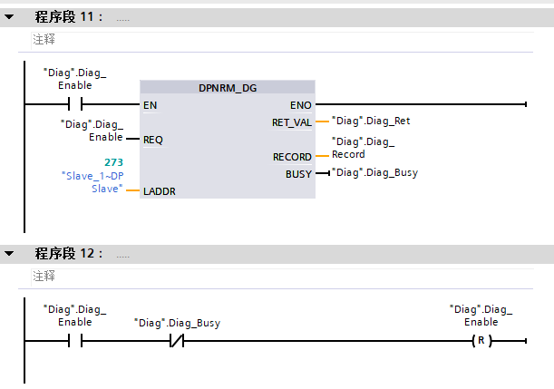
Diagnostic information is stored in the RECORD parameter, consisting of 9 bytes, defined as follows.
Table 11 RECORD parameter
 | Byte 0-Byte 2 | Byte 3 | Byte 4-Byte 5 | Byte 6 | Byte 7-Byte 8
Definition | Slave status | Master address | Ident_Number | Device-specific diagnostic length (fixed at 3) | Device-specific diagnostic code, with the same meaning as the periodic fault code (refer to Section 5.1)

Erase fault code
1. Fault code read
Read fault codes using the RDREC function block provided by TIA Portal. The fault codes are the latest 10 fault records from the last power-up to the current read. The record format is as follows:

Example of using the non-periodic read function block: ID: the ID number of the module, INDEX: 101, MLEN: 61, RECORD: the array for storing the read fault records.
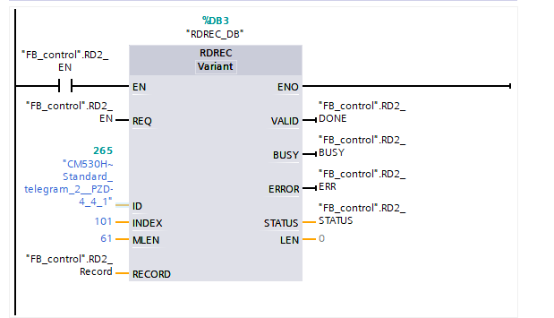
Example of parsing the Record array:
Record[0] = 0x02 indicates there are 2 fault records
Record[1] = 0x00 indicates the high byte of the first fault code is 0
Record[2] = 0x33 indicates the first fault code is 0x33, the specific meaning can be found in the table of 5.1 Periodic Fault Codes.
Record[3] = 0x01
Record[4] = 0x02
Record[5] = 0x03
Record[6] = 0x04 Record[3]~ Record[6] indicates the time of the fault occurrence is 0x01020304, which converts to decimal as 16909060, in seconds. Record[1] ~ Record[6] indicates that a fault code 0x33 occurred 16909060 seconds after startup.
Record[7] = 0x00 indicates the high byte of the second fault code is 0.
Record[8] = 0x32 indicates the second fault code is 0x32, the specific meaning can be found in Table 5.1 of Periodic Fault Codes.
Record[9] = 0x00
Record[10] = 0x00
Record[11] = 0x00
Record[12] = 0x05 Record[9]~ Record[12] indicates the time of the fault occurrence is 0x00000005, which converts to decimal as 5, with the unit being seconds
Record[13] = 0x00 Since there are only 2 fault records, all subsequent no-fault data are 0
Record[14] = 0x00
…
Record[60] =0x00
2. Fault Code Erasure
Use the WRREC function block provided by TIA Portal to erase fault codes, clearing all fault code records (TIA Portal fault records will not be erased).
Example of using the non-cyclic write function block: ID: the ID number of the module, INDEX: 101, MLEN: 1, RECORD: the data setting value for writing is 0.
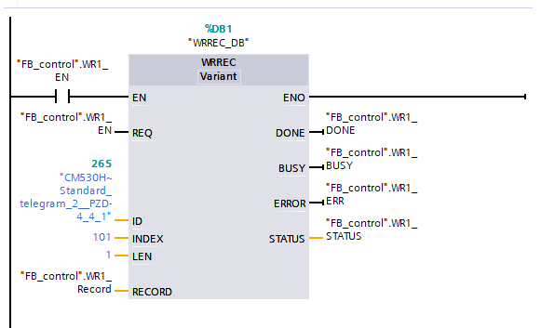

3. PROFINET Industrial Ethernet Communication

Product Information
The EMH-PN Communication Expansion Card is a PROFINET fieldbus adapter card that complies with the international standard for PROFINET Ethernet. This card is installed on the CM680 Inverter to enable communication with PROFINET master station devices, making the inverter a PROFINET slave station that accepts control from the master station.

Physical Dimensions
Physical dimensions of the PROFINET module: PCB length 95mm, width 37mm, network port height 13mm, installation hole spacing 30mm, hole diameter 3.5mm.
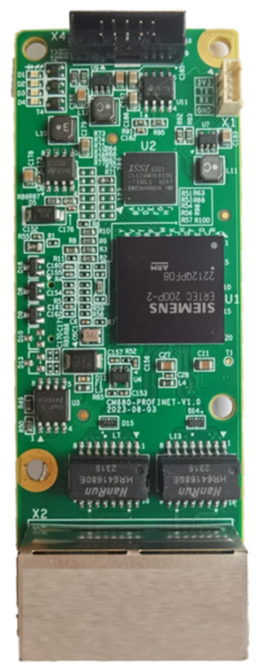
Figure 11 Physical Dimensions of the EMH-PN Communication Expansion Card

Interface Layout
The hardware layout of the EMH-PN Communication Expansion Card is shown in Figure 12. Pin Header X3 is used for connecting to the inverter and is located on the back of the EMH-PN Communication Expansion Card. The EMH-PN Communication Expansion Card provides two network ports X2 for communication connections. Detailed descriptions of each hardware component are provided in Table 12.
X1

P1
X2
X4

P2

D1 D2 D3 D4 X3
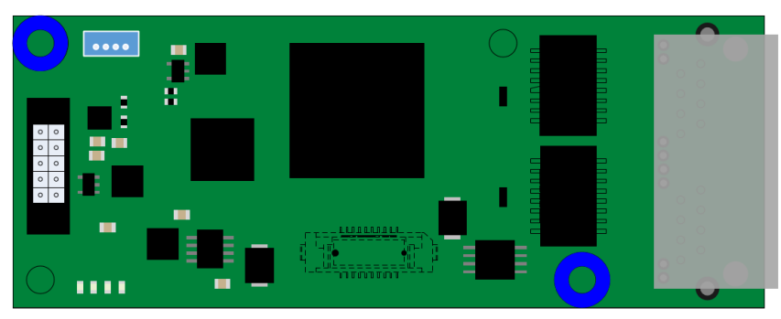

Figure 12 EMH-PN Communication Expansion Card Interface Layout

Table 12 EMH-PN Communication Expansion Card Interface Description
Diagram Name | Hardware Name | Function Description
X1 | Socket | UART Interface: Print Operation Information
X2 | Ethernet Port | For connecting the PROFINET module to the Profinet network
X3 | Board-to-Board Socket | For Connection to Inverter
X4 | Screw Terminal | For Firmware Download and Debugging
D1 | PROFINET Communication Status Indicator Light | See Table 6 EMH-PN Communication Expansion Card LED Indicator Light Description
D2 | Inverter communication status indicator light
D3 | Program run status indicator light
D4 | Hardware power indicator light

Table 13 EMH-PN Communication Expansion Card LED Indicator Light Description
Diagram Name | Indicator Light | Indicator Light Status |  | Function Description
D1 | PROFINET Communication Status  Indicator Light | Red Light | Constantly On | PROFINET Communication Abnormal
D1 | PROFINET Communication Status  Indicator Light | Red Light | Off | PROFINET Communication Normal
D2 | Inverter communication status indicator light | Red Light | Constantly On | Communication timeout with the inverter
D2 | Inverter communication status indicator light | Red Light | Flashing | Inverter Communication Message Abnormal
D2 | Inverter communication status indicator light | Red Light | Off | Normal communication with the inverter
D3 | Program run status indicator light | Green light | Constantly On | Main program running normally
D3 | Program run status indicator light | Green light | Off | Main Program Operation Abnormal
D4 | Hardware power indicator light | Green light | Constantly On | Module powered on normally
D4 | Hardware power indicator light | Green light | Off | Module not powered on

Installation and Wiring

Installation
The EMH-PN Communication Expansion Card is designed for internal installation in the CM680 Inverter. Before installation, please disconnect the power supply to the inverter and wait for about 10 minutes until the charging indicator light is completely off before proceeding with the installation. After inserting the EMH-PN Communication Expansion Card into the inverter, please secure the corresponding screws to prevent poor contact of the board-to-board signal sockets. The installation diagram is shown in Figure 11.
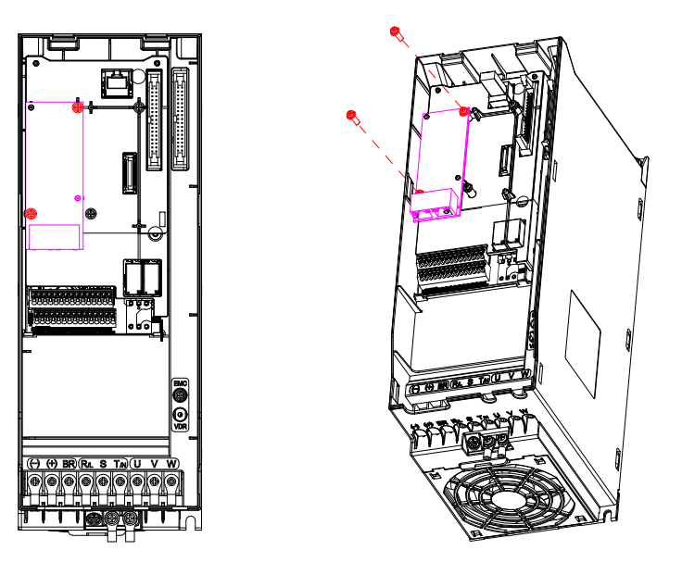
Figure 13 EMH-PN Communication Expansion Card Installation Diagram

Wiring
Insert an Ethernet cable into the network port of the EMH-PN Communication Expansion Card, then connect it to the PLC. You can connect to either the P1 port or the P2 port according to the network topology in TIA Portal. If the network topology is not specified, any network port P1 or P2 can be connected.
It is recommended to use a Cat 5e shielded network cable.
Common network topology diagrams are as follows:
Linear Topology

Star Topology

Figure 14 PROFINET Network Topology

Communication Description

Key Points of PROFINET Communication
- When using the EMH-PN Communication Expansion Card, the communication decoding method of the CM680 needs to be set. Set the F8-19 register to 0 via the operation panel, and set the F8-07 register to 0 or 1 based on the actual decoding method used.
- When setting the inverter command, the F0-05 register of the CM680 needs to be set to 5.
- When setting the inverter frequency, the F0-06 register of the CM680 needs to be set to 8.
- During non-periodic communication, a new non-periodic communication must only be initiated after the completion of the previous non-periodic read/write. The interval between two non-periodic communications should be no less than 100ms to avoid affecting the response to periodic communication.

Data Transmission Format
The EMH-PN Communication Expansion Card can select different PZD lengths for transmission based on requirements. Users can configure the functions of each PZD in the configuration. The supported functions for each data format are listed in the table below.
Table 14 Supported Functions for Each Data Format
Data Type | Data Length | Supported Functions
Standard Telegram 1 | PZD-2/3 | 2 periodic writes, default 0x6000 control command, 0x6002 frequency setting  3 periodic reads,
Standard Telegram 2 | PZD-16/16 | 16 periodic writes of function parameters  Default 0x6000 control command, 0x6002 frequency setting, and other modifiable reserved parameters 0x0830  16 functional parameters read cyclically  Fixed 0x2100 errors and warnings, default 0x6100 inverter status, 0x6102 operating frequency read, and other modifiable reserved parameters 0x0830

PZD area data description
Through PZD area data, the master station can modify and read the inverter data in real time, and perform cyclic data exchange. The communication address is configured by the user during configuration. The specific functions are as follows:
● Real-time setting of inverter control command and target frequency
● Real-time reading of inverter current status, operating frequency, and errors and warnings
● Real-time data exchange of functional parameters and monitoring parameters between the inverter and the Profinet master station
PZD process data mainly completes periodic data exchange between the master station and the inverter, see the table below.
Table 15 Exchange Data
 | Master station sends data to PZD area
Inverter control command | Inverter target frequency | Real-time modification of inverter function parameters
PZD1 | PZD2 | PZD3~PZD16
 | Inverter response data PZD area
Errors and Warnings | Inverter operating status | Inverter operating frequency | Real-time reading of inverter function parameters
PZD1 | PZD2 | PZD3 | PZD4~PZD16

Description of data sent by the master station
Table 16 Description of data sent by the master station to PZD
Master Station Data PZD Description
PZD1 Control Cmd  (Master to Slave) | Inverter Command Word (Command Source Needs to be Set to Communication F0-05 =5)
PZD1 Control Cmd  (Master to Slave) | Bit0: CMD_ACT Bit1: EXT_CMD1 Bit2: EXT_CMD2 Bit3: HALT  Bit4: LOCK Bit5: JOG Bit6: QSTOP Bit7: SERVO_ON  Bit8~Bit11: GEAR Bit12~Bit13: ACC/DEC Bit14: EN_SW Bit15: RST  Modifiable by User.
PZD2 Velocity Cmd  (Master to Slave) | Inverter Target Frequency Command Word (Main Frequency Source Needs to be Set to Communication F0-06 =8), Modifiable by User.
PZD3-PZD16 (Master to Slave) | Default is Address 2096 (Hexadecimal 0x0830), Modifiable by User. Users Can Configure Inverter Function Code Address During Configuration.

Inverter Response Data Description
Table 17 Inverter Response Data Description
Inverter Response Data Description
PZD1 fault code  (Slave to Master) | Current error and warning information of the inverter, detailed definitions refer to Section 5.1.
PZD2 Status  (Slave to Master) | Bit0: ARRIVE Bit1: DIR Bit2: WARN Bit3: ERROR  Bit4: Reserve Bit5: JOG Bit6: QSTOP Bit7: SERVO_ON  Bit8: Ready Bit9~Bit15: Reserve  Modifiable by User.
PZD3  Current Velocity  (Slave to Master) | Current operating frequency of the inverter (unit: 0.01Hz). User modifiable.
PZD4-PZD16  (Slave to Master) | Default is Address 2096 (Hexadecimal 0x0830), Modifiable by User. Users Can Configure Inverter Function Code Address During Configuration.

Communication Configuration
Taking the Siemens S7-1500 series PLC as an example, configure the PLC and module to establish Profinet communication.

Configure Configuration
1. Create a project
Double-click to open the TIA Portal software, select 'Create New Project', and the following interface will appear. Choose the save path and project name, then click 'Create'.

After creation, click 'Project View' to enter the main interface. Connect the PLC and PROFINET module to your computer with an Ethernet cable and power them on. In the TIA Portal project tree, under the Online Access menu, click Update Accessible Devices.
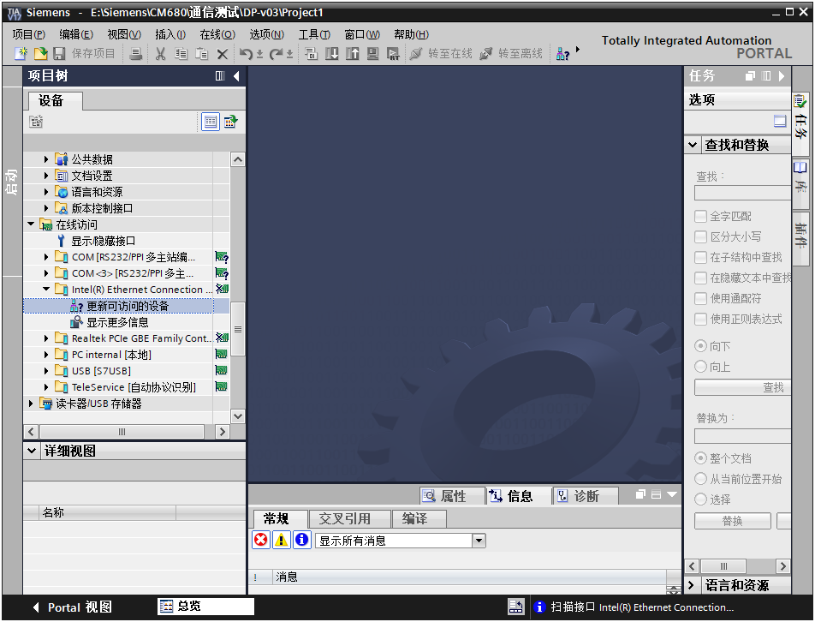
List the devices connected to the computer network.
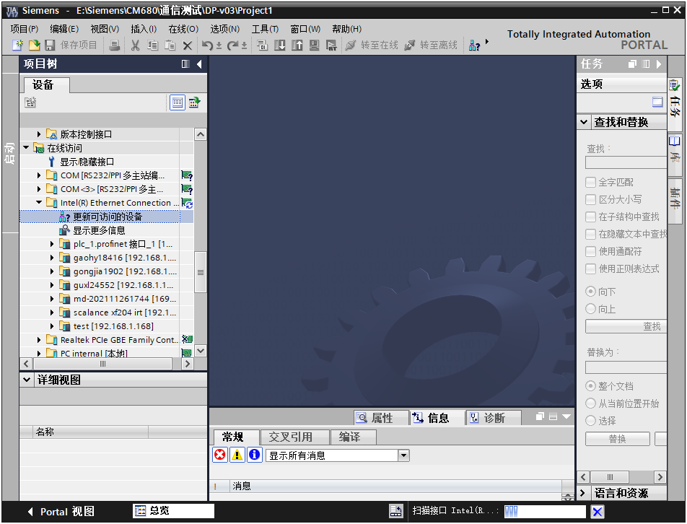

Click on the online and diagnostics of the PLC device to view its model and other information.
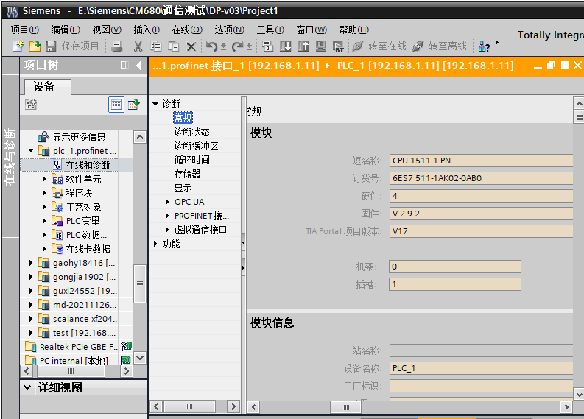
Open the 'Function' tree to modify the PLC's IP address, device name, and other configurations.
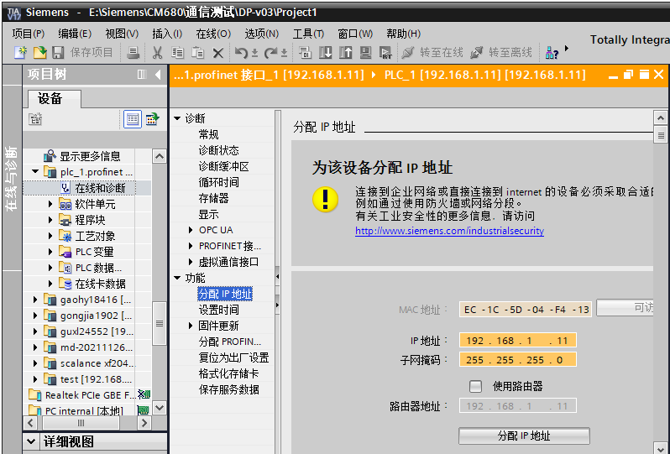

Click on the online and diagnostics of the module to view module information.
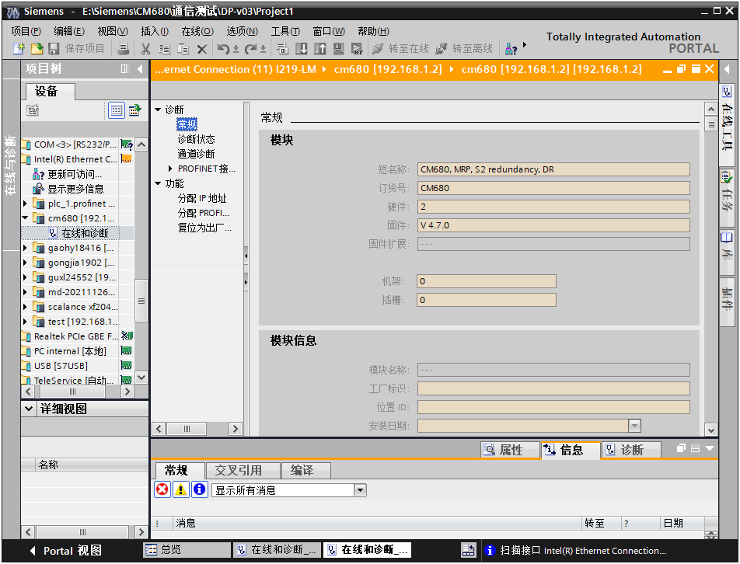
In the function menu, you can modify the device name and IP address. The IP address should be in the same subnet as the PLC's IP address. Click the [Assign IP Address] button to save the modified settings.
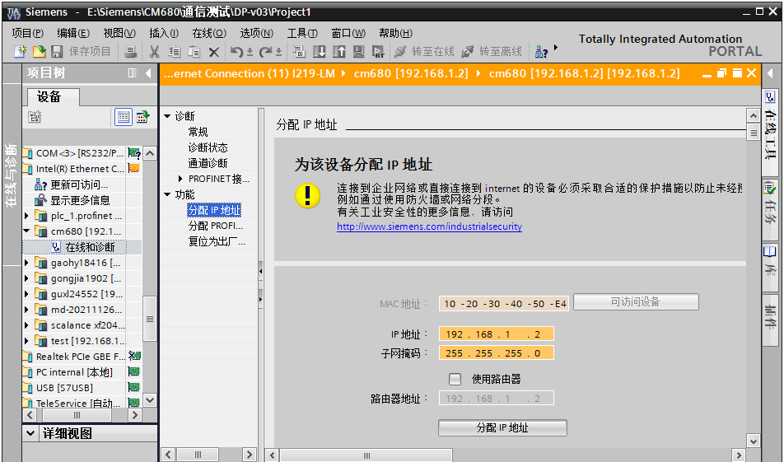

On the 'Assign PROFINET Device Name' page, modify the PROFINET device name. After making changes, click the [Assign Name] button to save the modified settings.
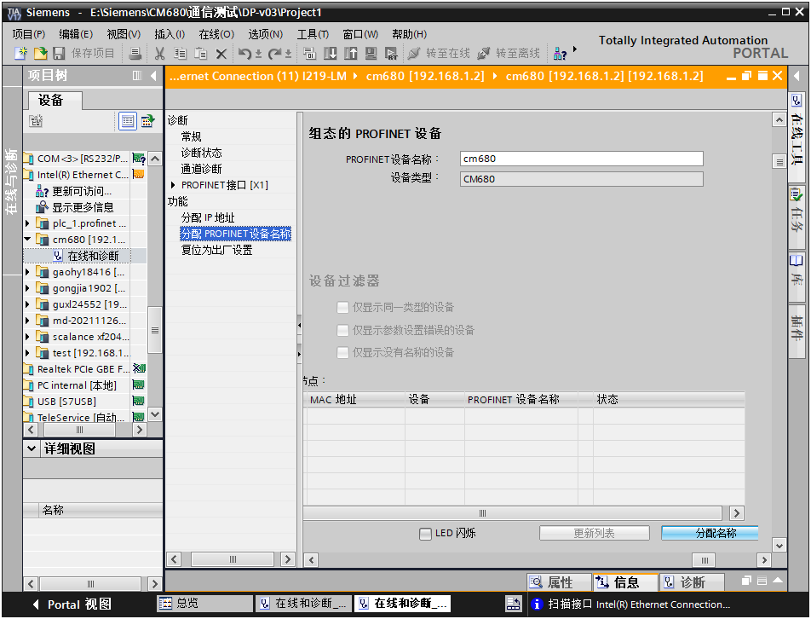

In the 'Hardware Catalog' on the right, select the actual PLC model being used; for example, S7-1511. Double-clicking will display the PLC on the configuration page.
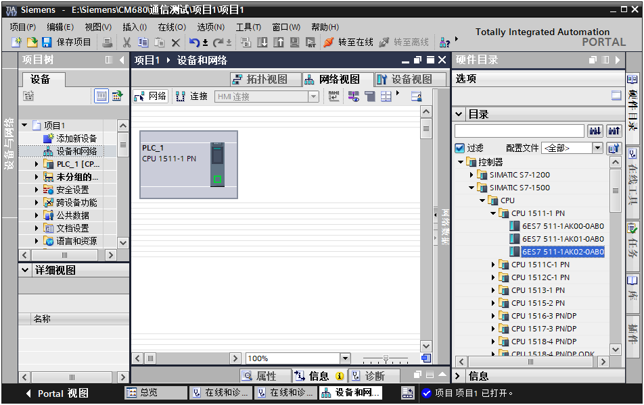
Click on the PLC, in the property bar, you can configure information such as the PLC's IP address, which can be modified according to the actual situation.
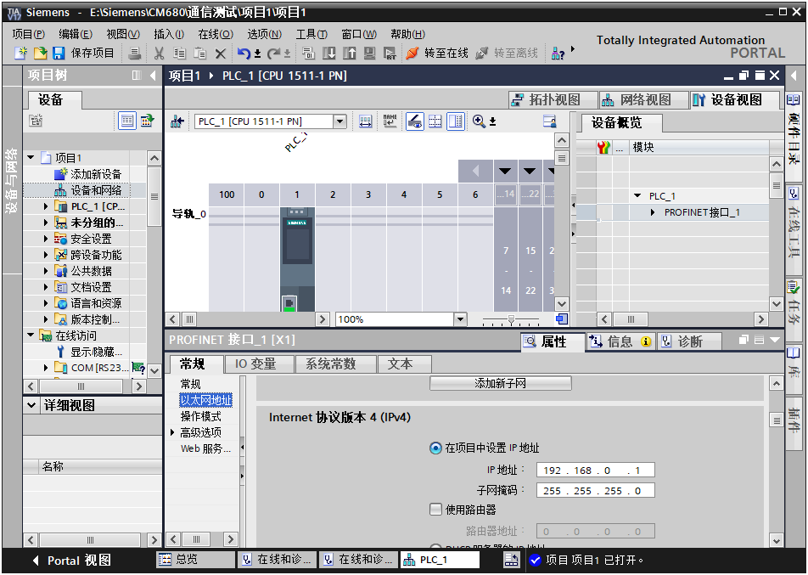
This completes the establishment of the master station.
2. Install GSDML file
If the GSDML has not been installed, it needs to be installed. In 'Options', select 'Manage General Station Description (GSD) Files'.
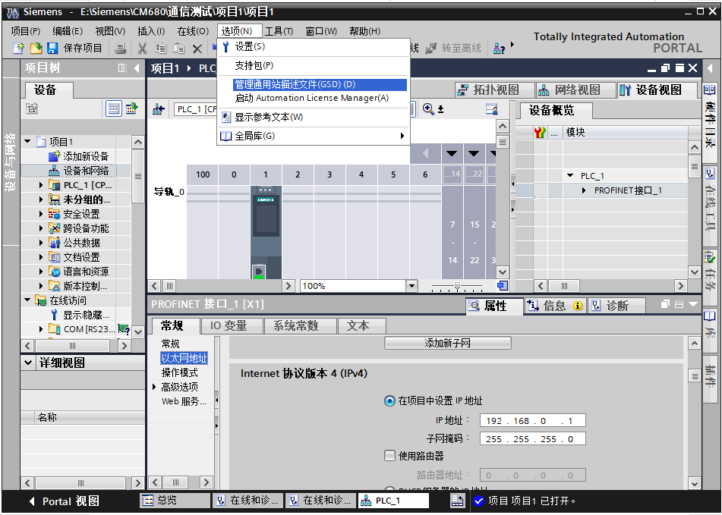
Select the path where the GSDML is stored (Note: Do not store the GSDML file in a path with Chinese characters, as this may cause errors), check the GSDML to be installed, and click 'Install'. After installation, select 'Close'.
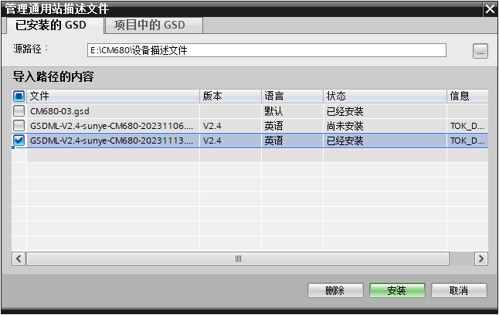
3. Configure Slave Station
Return to the 'Device and Network' — 'Network View' interface, in the 'Hardware Catalog' on the right, find the CM680 position under Other Field Devices — PROFINET IO — Drives — SUNYE, and double-click to add the module.
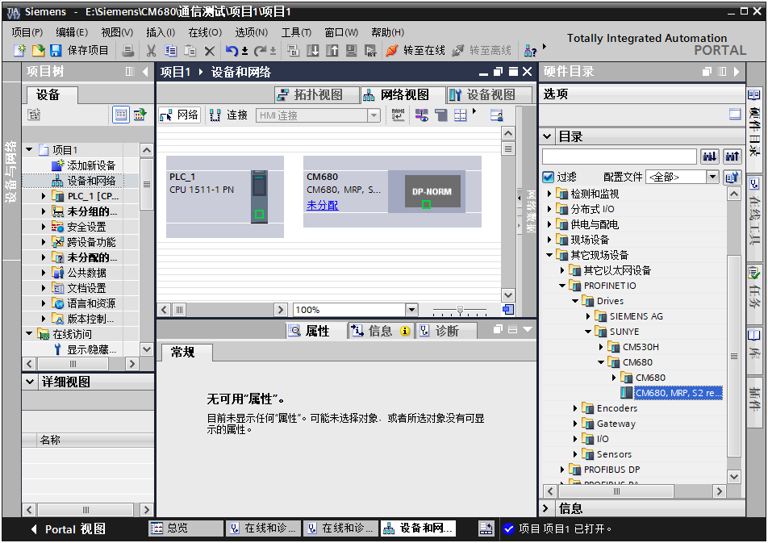

Click on 'Unassigned' on the module in the 'Device and Network' interface to assign the master station system to the module.
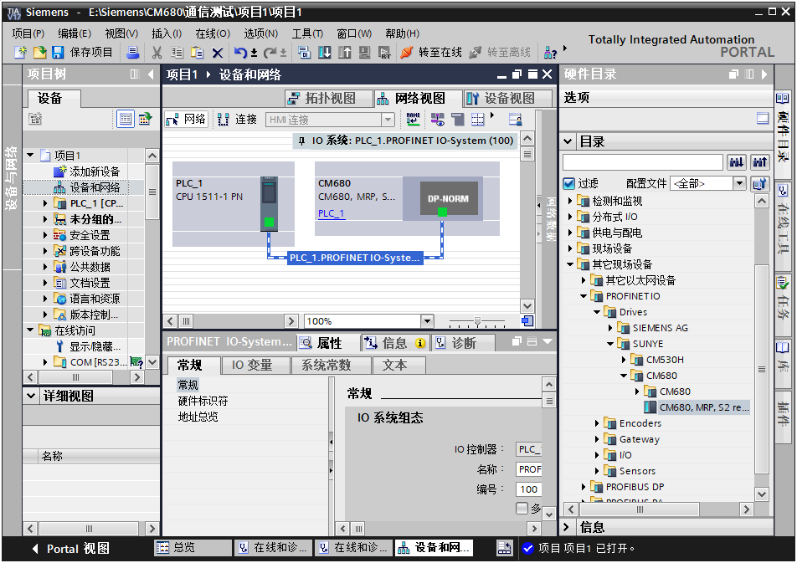

Select the slave station, and set the IP address and device name in 'Properties' -> 'General' -> 'PROFINET Interface [X1]' -> 'Ethernet Address'. The device name must match the device name set in the online access.
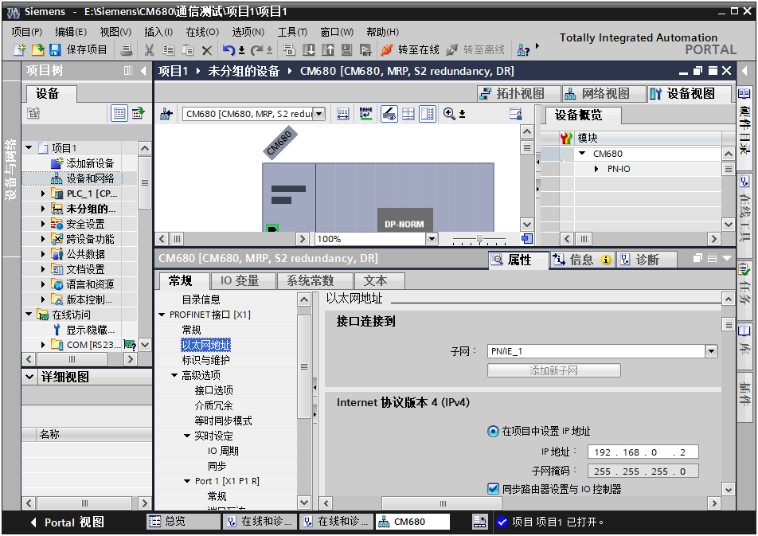

Configure Periodic Communication
1. Configure Module
Select the slave station, switch to the “Device View,” and under “Hardware Catalog” -> “Module,” double-click to select the data length to be configured for the slave station. The configured module will be added in the device view. After adding the module, you can modify the input/output mapping in the PLC by editing the “I Address” and “Q Address”.
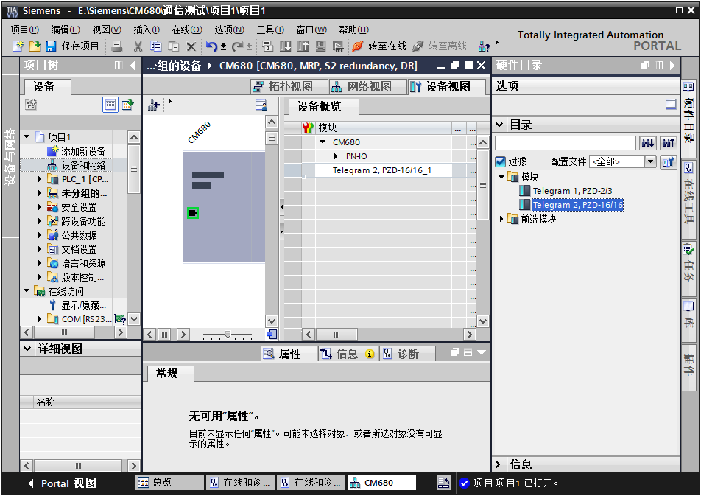
2. Configure PZD
Through PZD area data, the master station can real-time modify and read inverter data, and perform periodic data exchange.
PZD process data mainly completes periodic data exchange between the master station and the inverter, the exchanged data is as follows:
Table 18 PZD Process Data
 | Master station sends data to PZD area
Inverter Command | Inverter target frequency | Real-time modification of inverter function parameters
PZD1 | PZD2 | PZD3~PZD16
 | Inverter response data PZD area
Errors and Warnings | Inverter Status | Inverter operating frequency | Real-time reading of inverter function parameters
PZD1 | PZD2 | PZD3 | PZD4~PZD16
For specific bit definitions, refer to sections 3.4 and 3.5.
PZD3 to PZD12 are user-defined periodic data exchanges, which are set in the hardware configuration.
Select the module added in the previous step, and under 'Properties' -> 'General', choose 'Module Parameters' to set the register address for user-defined periodic data. PZDx(Master to Slave) indicates the address written by the master station to the slave station, and PZDx(Slave to Master) indicates the address read by the master station from the slave station, in decimal format.
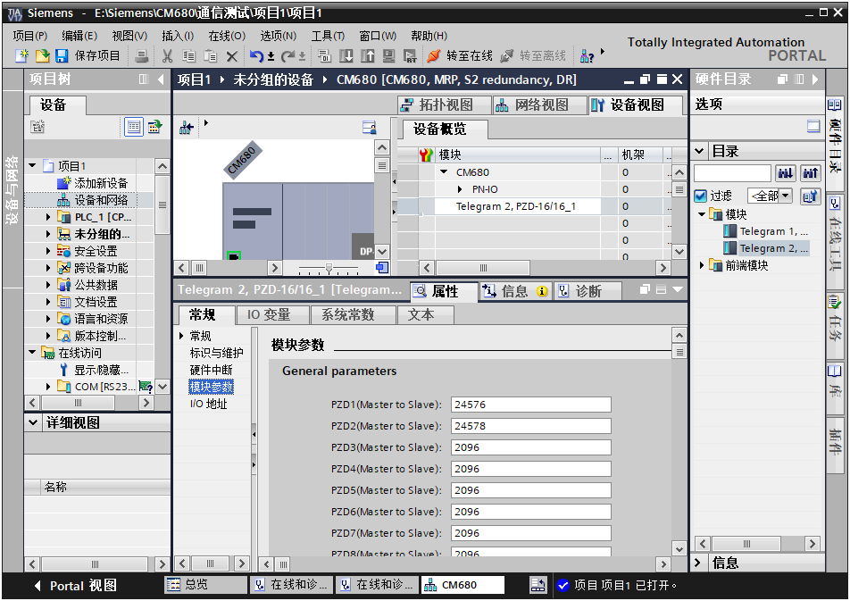
After configuration is complete, download the configuration, and the PLC and module will automatically perform periodic data exchange.

Configure Non-periodic Communication
1. Non-periodic Interaction Data Format
Non-periodic interaction uses the slot-subslot-index method for addressing, thereby determining the format of the message data area. To facilitate user operations on consecutive registers of the inverter, the following non-periodic read/write format is defined, with the index set to 100.
The manufacturer has encapsulated two non-periodic read/write function blocks for user reference.
PN_WRITE function block: implements non-periodic writing, ID: represents the moduleID to be written, ADDR: represents the address of the function code to be written,
LEN: represents the number of registers to be written, DATA: array of values to be written into the registers.
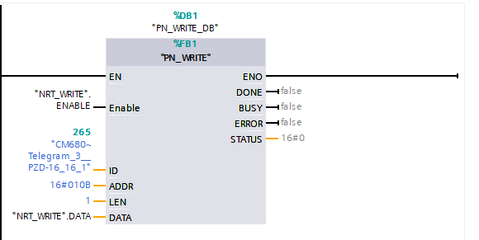

PN_READ function block: a function block for non-periodic reading, ID: represents the moduleID to be written, ADDR: represents the address of the function code to be read, MLEN: represents the number of registers to be read, DATA: array to store the values read from the registers.
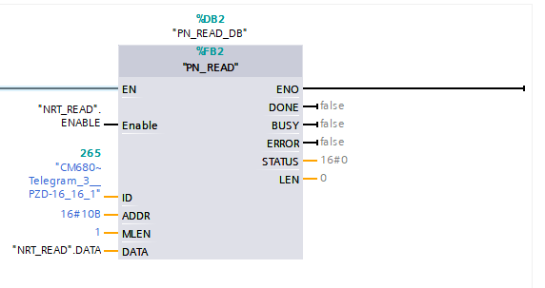

2. Download Configuration and Ladder Diagram
Save the configured network, set the computer's IP address to the same subnet as the PLC (note that it should not conflict with the IP addresses of the slave stations in the configuration, or you can set the PC to automatically obtain an IP address), compile, click download, select the interface, and then click 'Start Search'. Select the detected PLC, and then click download.
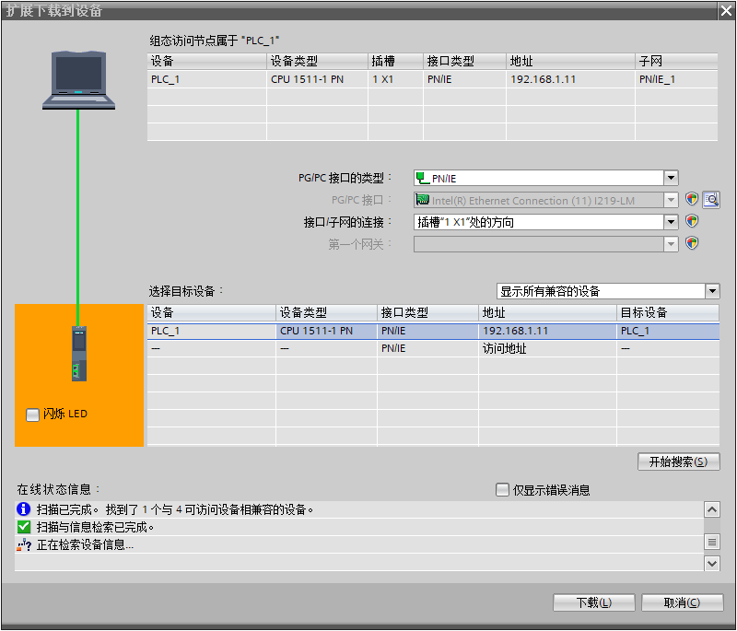

Fault Information

Periodic Fault Code
In the PZD Area for periodic communication, the high byte of the status word indicates alarm information, allowing users to obtain the latest status through periodic communication. In addition to the diagnostic information of the inverter itself, the communication status between the module and the inverter must also be included to help users identify the cause of errors.
Table 19 Periodic Fault Code
Diagnostic Classification | Status Code
Inverter Body Diagnostic Information (Register Address: 0x2100) | 200 Communication Error (Message Abnormality)  201 Communication Error (Timeout Abnormality)  202 Address Error  203 Parameter Exceeds Threshold

Non-periodic Fault Code
When executing non-periodic communication, the STATUS parameter in the function block is used to return the command execution result, with a data type of DWORD (4 bytes). The data format and meaning are already defined in the TIA software. In addition to the standard definition, the following error codes have the following meanings:
Table 20 Non-periodic Fault Code
Function_ Num | Error_ Decode | Error_ Code_1 | Error_ Code_2 | Meaning
0xDE | 0x80 | 0xB8 | 0x00 | Invalid data record number (index can only be 100 or 101)
0xDE | 0x80 | 0xB8 | 0x02 | Non-periodic read value data length exceeds limit (2<=data length<=24), unit: bytes
0xDE | 0x80 | 0xB8 | 0x03 | Non-periodic write read address is invalid (WRREC has not been run in advance to write the read address or the address is incorrect)
0xDE | 0x80 | 0xB8 | 0x05 | Non-periodic read value failed (communication error between module and inverter)
0xDF | 0x80 | 0xB8 | 0x00 | Invalid data record number (index can only be 100 or 101)
0xDF | 0x80 | 0xB8 | 0x01 | Non-periodic write value function code error (only supports 0x03, 0x10 function codes)
0xDF | 0x80 | 0xB8 | 0x02 | Non-periodic Write Value Data Length Exceeded (3<=Data Length<=24), Unit: Bytes
0xDF | 0x80 | 0xB8 | 0x03 | Non-periodic Write Address Invalid
0xDF | 0x80 | 0xB8 | 0x04 | Non-periodic Write Set Value Out of Range
0xDF | 0x80 | 0xB8 | 0x05 | Non-periodic Write Value Failure (Module and Inverter Communication Error)

Module Information
When communication between the module and the inverter is abnormal, diagnostic information will be sent to the PLC. This can be viewed in the TIA Portal software under PLC's [Online & Diagnostics] — [Diagnostics] — [Diagnostic Buffer].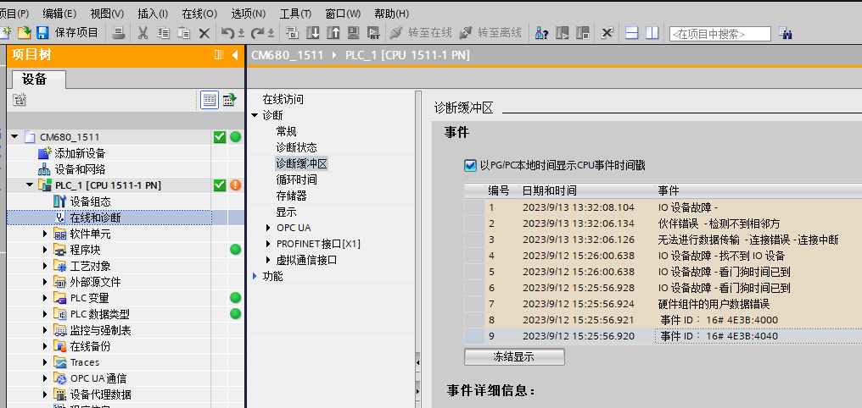

Diagnostic Buffer Fault Meaning and Handling
Table 21 Fault Meaning and Handling
Diagnostic Buffer Events | Error Meaning | Correction Handling
Address Error | Periodic Address or Non-periodic Address Error | Periodic Communication PZD Address Contains Invalid Value, Refer to Function Code Table, Correct the Error Address.
Slave status error | Inverter status error | Check the high byte error code definition of PZD1 and take corresponding actions
Communication error | Communication timeout with the inverter | If the error cannot be eliminated, restart the inverter
Parameters error | Periodic parameters error | Modify the periodic parameters to make them comply with the set range

Non-periodic Read or Erase Fault Code
Fault code reading
Read fault codes using the function block Err_History_Read provided by the manufacturer. The fault codes are the latest 10 fault records from the module's power-on to the current read. The record format is as follows:
Example of using the non-periodic read function block: ID: the ID number of the module, DATA: the array for storing the read fault records.
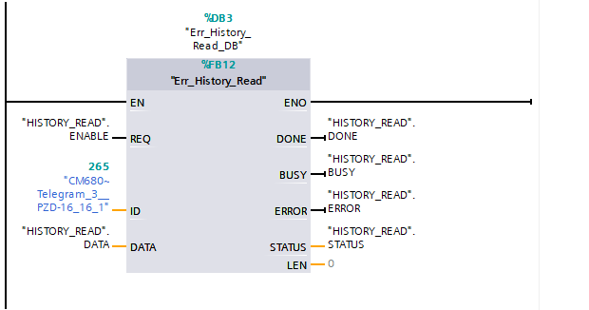
Example of parsing the DATA array:
DATA[0] = 0x02 indicates that there are 2 fault records
DATA[1] = 0x00 indicates the high byte of the first fault code is 0
DATA[2] = 0x33 indicates the first fault code is 0x33, the specific meaning can be found in Table 5.1 Periodic Fault Code.
DATA[3] = 0x01
DATA[4] = 0x02
DATA[5] = 0x03
DATA[6] = 0x04 DATA[3]~ DATA[6] indicate the time of the fault occurrence is 0x01020304, which converts to decimal as 16909060, in seconds. DATA[1] ~ DATA[6] indicate that the fault code 0x33 occurred 16909060 seconds after startup.
DATA[7] = 0x00 indicates the high byte of the second fault code is 0
DATA[8] = 0x32 indicates the second fault code is 0x32, the specific meaning can be found in the table of periodic fault codes in section 5.1.
DATA[9] = 0x00
DATA[10] = 0x00
DATA[11] = 0x00
DATA[12] = 0x05 DATA[9]~ DATA[12] indicate the time of the fault occurrence is 0x00000005, which converts to decimal as 5, with the unit being seconds
DATA[13] = 0x00 Since there are only 2 fault codes, the subsequent no-fault data are all 0
DATA[14] = 0x00

…
DATA[60] =0x00
Fault Code Erase
Use the function block Err_History_Clear provided by the manufacturer to erase fault codes, which will clear all fault code records (will not erase the fault records in TIA Portal).
Example of using the non-cyclic write function block: ID: the ID number of the module.
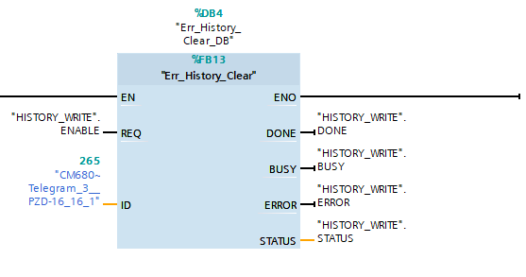

MRP function description
MRP refers to media redundancy (Media Redundancy Protocol). In PROFINET, this function is implemented through an MRP ring network, with only one MRP ring network allowed in a PROFINET network. Configuration is required during setup when using MRP.

MRP ring network
First, an MRP ring network requires an MRP manager, typically a PLC, while PROFINET modules can only act as MRP clients.
Example of ring topology:

MRP configuration
Step one: configure the MRP manager
An MRP manager must exist in the MRP ring network. The EMH-PN card cannot serve as a manager; typically, a PLC is used as the manager. Select the site to be configured as the manager, and in the interface shown below, select the manager from the 'Media Redundancy Function' drop-down menu.
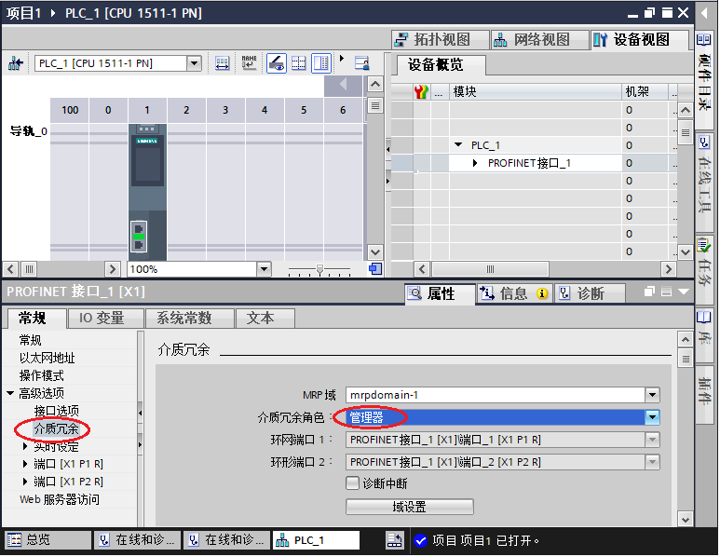

Step Two: Configure MRP client
Select the slave station, in the interface shown below, in the 'Media Redundancy Function' drop-down select 'Client'. Before configuring the client, the manager must be configured first, otherwise, an error will occur.
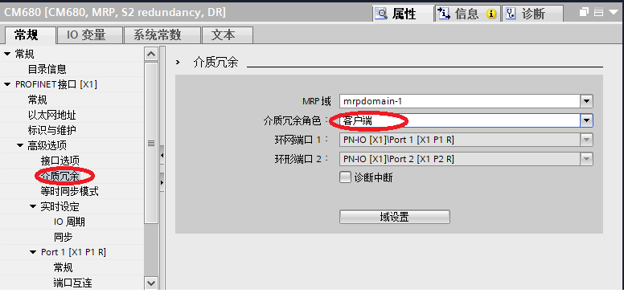

Step Three: Download Configuration
After configuring all devices in the MRP ring network, compile and download to the PLC.
Note:
◆ All devices in the ring network must be configured as MRP manager or MRP client;
◆ MRP configuration does not require setting up a topology diagram; if a topology diagram is needed, it should be set up after completing the MRP configuration;
◆ Devices not configured for MRP should not use the ring network, as this can lead to connection failures or repeated station drops.

EtherNet/IP Industrial Ethernet Communication

Product Information
The EMH-EN Communication Expansion Card is an EtherNet/IP fieldbus adapter card that complies with the general EtherNet/IP fieldbus standard. This card is installed on the CM680 Inverter to enable communication with EtherNet/IP master station devices, making the inverter a slave station of EtherNet/IP, accepting control from the master station.

Physical Dimensions
EtherNet/IP Module Physical Dimensions: PCB length 95mm, width 37mm, mounting hole diameter 3.5mm.
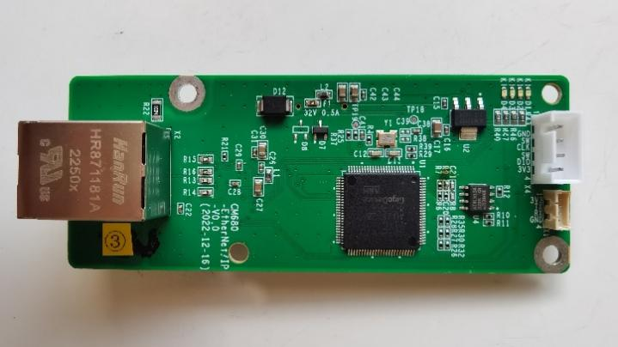
Figure 15 Physical Dimensions of the EMH-EN Communication Expansion Card

Interface Layout
The hardware layout of the EMH-EN Communication Expansion Card is shown in Figure 16. Pin Header X3 is used for connecting to the inverter and is located on the back of the EMH-EN Communication Expansion Card. The EMH-EN Communication Expansion Card provides an Ethernet connector for connecting to EtherNet/IP communication. For detailed descriptions of the hardware, refer to Table 22.

X1
X2

X4

D1 D2 D3 D4 X3
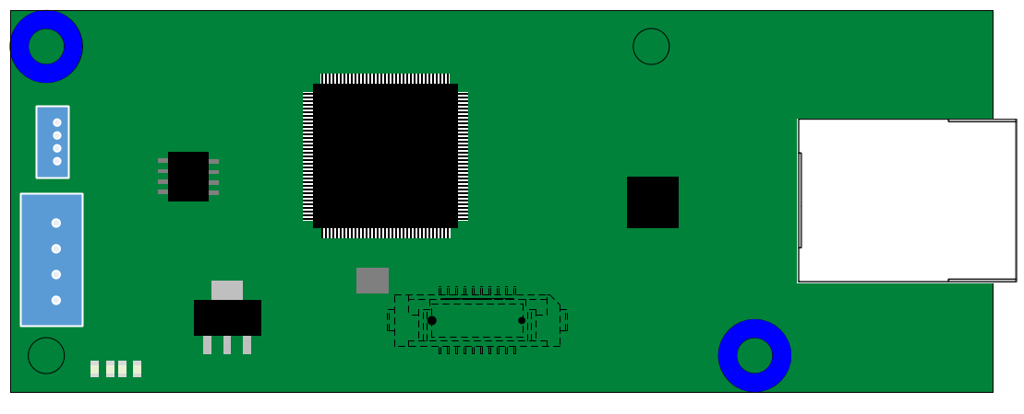
X3
X2
Figure 16 EMH-EN Communication Expansion Card Interface Layout

Table 22 EMH-EN Communication Expansion Card Interface Description
Diagram Name | Hardware Name | Function Description
X1 | Socket | UART Interface: Print Operation Information
X2 | Ethernet Socket | For Module Connection to EtherNet/IP Network
X3 | Board-to-Board Socket | For Connection to Inverter
X4 | Socket | For Firmware Download and Debugging
D1, D2, D3, D4 | LED Indicator Light | Used to indicate the operating status, refer to Table 1.2 for details
LED Indicator Light
Table 23 EMH-EN Communication Expansion Card LED Indicator Light Description
Diagram Name | Indicator Light | Indicator Light Status |  | Function Description
D1 | EtherNet/IP Communication Status Indicator Light | Red Light | Constantly On | Indicates No Communication Between the Module and EtherNet/IP Master Station (Check EtherNet/IP Cable Connection and Station Number)
D1 | EtherNet/IP Communication Status Indicator Light | Red Light | Off | Indicates Normal Communication Between the Module and EtherNet/IP Master Station
D2 | Inverter communication status indicator light | Red Light | Constantly On | Communication timeout with the inverter
D2 | Inverter communication status indicator light | Red Light | Flashing | Inverter Communication Message Abnormal
D2 | Inverter communication status indicator light | Red Light | Off | Normal communication with the inverter
D3 | Program run status indicator light | Green light | Constantly On | Main program running normally
D3 | Program run status indicator light | Green light | Off | Main program not started properly
D4 | Hardware power indicator light | Green light | Constantly On | Module powered on normally
D4 | Hardware power indicator light | Green light | Off | Module not powered on

Installation and Wiring

Installation
The EMH-EN Communication Expansion Card is designed for internal installation in the CM680 Inverter. Before installation, please disconnect the power supply to the inverter and wait approximately 10 minutes until the inverter charging indicator light is completely off before proceeding with the installation. After inserting the EMH-EN Communication Expansion Card into the inverter, please secure the corresponding screws to prevent poor contact between the board signal sockets. The installation diagram is shown in Figure 14.
Figure 17 EMH-EN Communication Expansion Card Installation Diagram

Wiring
The wiring diagram for the EtherNet/IP bus is shown in Figure 15. Insert a network cable into the network port of the EMH-EN Communication Expansion Card, then connect it directly to the PLC, or indirectly through a switch. It is recommended to use a Cat 5e shielded network cable.
Figure 18 EMH-EN Bus Wiring Diagram

Communication Description

Key Points for EtherNet/IP Communication
- When using the EMH-EN Communication Expansion Card, you need to set the communication decoding method for the CM680. Set the F8-19 register to 0 via the operation panel, and set the F8-07 register to 0 or 1 based on the actual decoding method used.
- When setting the inverter command, the F0-05 register of the CM680 needs to be set to 5.
- When setting the inverter frequency, the F0-06 register of the CM680 needs to be set to 8.
- The IP address for EtherNet/IP communication of the EMH-EN Communication Expansion Card is set in registers F8-27 to F8-38. The module must be restarted for the settings to take effect.
- During non-periodic communication, a new non-periodic communication must only be initiated after the completion of the previous non-periodic read/write. The interval between two non-periodic communications should be no less than 100ms to avoid affecting the response to periodic communication.

Data Transmission Format
The EMH-EN Communication Expansion Card supports a maximum of 16 register addresses for input (slave to master) and 16 register addresses for output (master to slave) per cycle.
The first input register addresses are fixed as 0x2100 (Errors and Warnings), the second default is 0x6100 (Current Status), and the third default is 0x6102 (Actual Frequency). The remaining 13 registers are 0x0830 (Reserved Address).
The first two output register addresses are default 0x6000 (Control Word) and 0x6002 (Target Frequency). The remaining 14 registers default to 0x0830 (Reserved Address). For detailed information, see the table below.

Table 24 Cycle Data Table
Master Station Sends Data
OUT ADDR[1] | OUT ADDR[2] | OUT ADDR[3-16]
0x6000  (Control cmd) | 0x6002  （Velocity Cmd） | 0x0830 (reserved)
Slave Station Responds Data
IN ADDR[1] | IN ADDR[2] | IN ADDR[3] | IN ADDR [4-16]
0x2100  (fault warning code) | 0x6100  (Status) | 0x6102  (Current Velocity) | 0x0830 (reserved)

Description of data sent by the master station
Table 25 Master Station Sent Data PZD Description
Master Station Data PZD Description
OUT ADDR[1]  0x6000  (Master to Slave) | Inverter Command Word (Command Source Needs to be Set to Communication F0-05 =5)
OUT ADDR[1]  0x6000  (Master to Slave) | Bit0: CMD_ACT Bit1: EXT_CMD1 Bit2: EXT_CMD2 Bit3: HALT  Bit4: LOCK Bit5: JOG Bit6: QSTOP Bit7: SERVO_ON  Bit8~Bit11: GEAR Bit12~Bit13: ACC/DEC Bit14: EN_SW Bit15: RST
OUT ADDR[2]  0x6002  (Master to Slave) | Inverter Target Frequency Command Word (Main Frequency Source must be set to Communication F0-06 = 8)
OUT ADDR[3-16] (Master to Slave) | Default is address 2096 (Hexadecimal 0x0830), users can configure the inverter function code address during configuration.

Inverter Response Data Description
Table 26 Inverter Response Data Description
Inverter Response Data Description
IN ADDR[1]  0x2100  (Slave to Master) | Current error and warning information of the inverter, detailed definitions refer to Section 4.5.
IN ADDR[2]  0x6100  (Slave to Master) | Bit0: ARRIVE Bit1: DIR Bit2: WARN Bit3: ERROR  Bit4: Reserve Bit5: JOG Bit6: QSTOP Bit7: SERVO_ON  Bit8: Ready Bit9~Bit15: Reserve
IN ADDR[3]  0x6102  (Slave to Master) | Current operating frequency of the inverter (unit: 0.01Hz).
IN ADDR[4-16]  (Slave to Master) | Default is address 2096 (Hexadecimal 0x0830), users can configure the inverter function code address during configuration.

Communication Configuration
Configure the PLC and module to establish EtherNet/IP communication. The configuration process varies for different PLC models; please consult technical support for details.

Configure Configuration
1. Create a project
Open the upper-level computer software, create a new project, and select the device model as AM402‑CPU1608TP/TN.
2. Import the EDS file and add the slave station.
Open the network configuration interface, click on the PLC to select the current communication protocol as EtherNet/IP master station, import the EDS file, and import the EIP expansion card's EDS file. Import the device in the network device list.
- Configure the slave station parameters.
Set the slave station IP address (the slave station IP address can be read and modified via the inverter function code).
Connect the PLC, configure the data, and configure the cyclic input address IN ADDR[1-16] and cyclic output address OUT ADDR[1-16]. The addresses are in decimal, and you need to convert the hexadecimal function codes to decimal.
4. Configure the Master Station
Scan the network to select the master station to be configured.
Assign an IP address to the master station's network port.
Download the project to the PLC.
The upper-level computer can be used to view periodic input and output data.

Configure Non-periodic Communication
Use the Get_Attribute_Single and Set_Attribute_Single function blocks for non-periodic read and write operations.
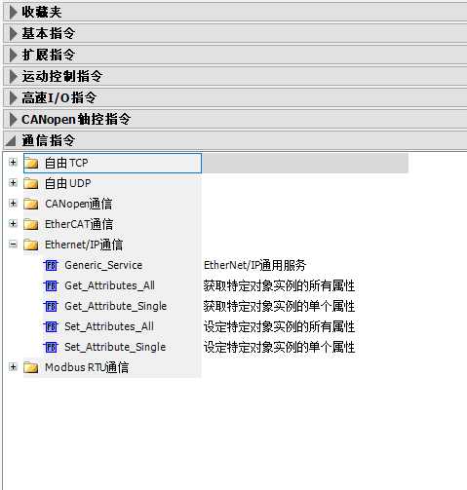
Non-periodic read and write function code parameter configuration
eClass configuration 100
dwInstance configuration 1
wAttribute configuration the address of the function code to be accessed
pData configuration the address for writing parameters or reading parameters
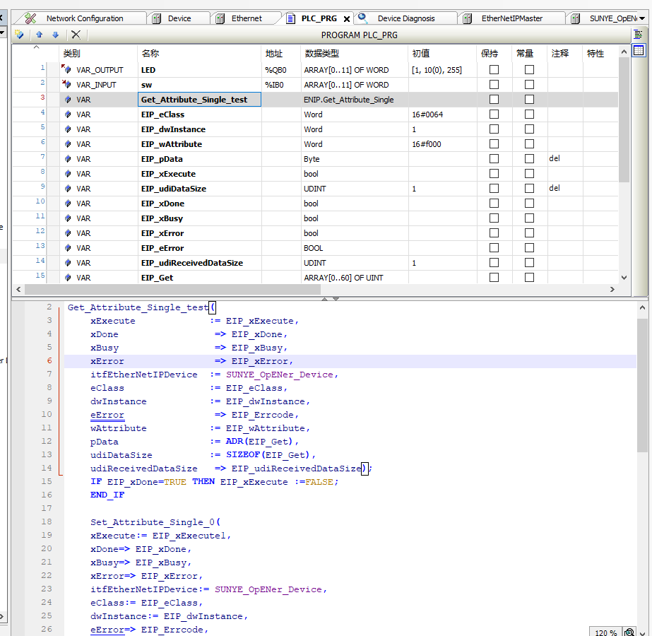

Fault Information

Periodic Fault Code
In the periodic communication PZD area, PZD1 sent from the slave station to the master station indicates error and alarm information, allowing users to obtain the latest status through periodic communication. In addition to the diagnostic information of the inverter itself, the communication status between the module and the inverter must also be included, allowing users to obtain the cause of errors. Detailed fault status codes are listed in the table below:
Table 27 Periodic Fault Codes
Diagnostic Classification | Status Code
Inverter Body Diagnostic Information (Register Address: 0x2100)
  200 Communication Error (Message Abnormality)
  201 Communication Error (Timeout Abnormality)
  202 Address Error
  203 Parameter Exceeds Threshold

Read and clear fault history
1. Use the Get_Attribute_ALL function block for non-periodic reading of historical fault records, and use the Set_Attribute_ALL function block for non-periodic erasing of historical fault records.
eClass Configuration 101
dwInstance configuration 1
pData configuration the address for writing parameters or reading parameters
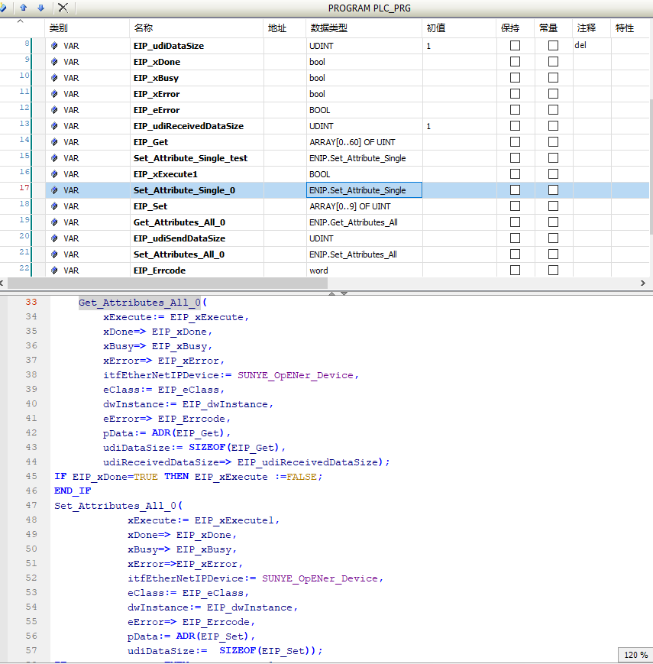

2. The structure of the fault history is: 2 bytes for the number of faults, 2 bytes for the fault code, and 4 bytes for the fault occurrence time, with the unit being seconds.
3. Error Code
Table 28 Error Code Meaning
Error Code | Meaning
201 | Send Error
202 | Communication Timeout
203 | Format Error
204 | Address Error
205 | Data Error
206 | Inverter Error
207 | Message Error

EtherCAT Industrial Ethernet Communication

Product Information
The EMH-EC Communication Expansion Card is an EtherCat fieldbus adapter card that complies with the international standard for EtherCat fieldbus. This card is installed on the CM680 Inverter to enable communication with EtherCat master station devices, making the inverter a slave station of EtherCat, accepting control from the master station.

Physical Dimensions
Physical dimensions of the EtherCat module: PCB length 95mm, width 37mm, mounting hole diameter 3.5mm.
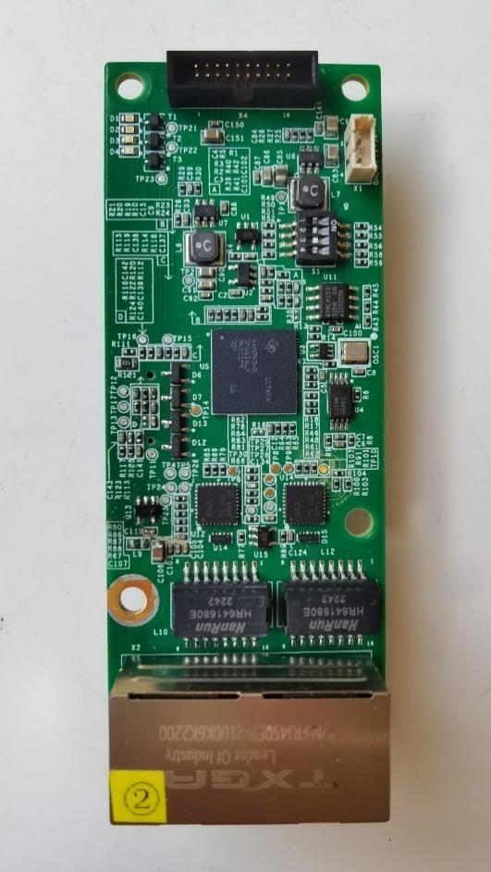
Figure 19 Physical Dimensions of the EMH-EC Communication Expansion Card

Interface Layout
The hardware layout of the EMH-EC Communication Expansion Card is shown in Figure 20. Pin Header X3 is used for connecting to the inverter and is located on the back of the EMH-EC Communication Expansion Card. The EMH-EC Communication Expansion Card provides 2 network ports, used for connecting the CM680-ECAT card to the master station (or the previous slave station) and the next slave station (if any) for communication.
X1

OUT
X2
X4

IN

D1 D2 D3 D4 X3
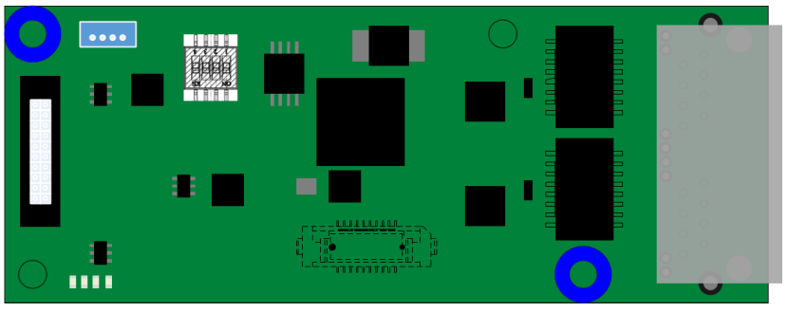

Figure 20 EMH-EC Communication Expansion Card Interface Layout

Table 29 EMH-EC Communication Expansion Card Interface Description
Diagram Name | Hardware Name | Function Description
X1 | Socket | UART Interface: Print operation information, upgrade program
X2 | IN/OUT Network Port | Connect to the master station (or the previous slave station) / connect to the next slave station (if any)
X3 | Board-to-Board Socket | For Connection to Inverter
X4 | Socket | For Firmware Download and Debugging
D1, D2, D3, D4 | LED Indicator Light | Used to indicate the operating status, see Table 30 for details
LED Indicator Light
Table 30 EMH-EC Communication Expansion Card LED Indicator Light Description
Diagram Name | Indicator Light | Indicator Light Status |  | Function Description
D4 | EtherCat Communication Status Indicator Light | Red Light | Constantly On | Indicates that the EtherCat module and EtherCat master station are in init
D4 | EtherCat Communication Status Indicator Light | Red Light | Blinking (200ms on-off interval) | indicates that the module is communicating normally with the EtherCat master station
D4 | EtherCat Communication Status Indicator Light | Red Light | single flash (200ms on, 1000ms off) | indicates that the EtherCat module and the master station are in PreOp
D4 | EtherCat Communication Status Indicator Light | Red Light | flickering (1200ms on-off interval) | indicates that the EtherCat module and the master station are in SafeOp
D4 | EtherCat Communication Status Indicator Light | Red Light | double flash (100ms off 100ms on 100ms off 100ms on 800ms off) | indicates that there is a communication error between the EtherCat module and the master station
D4 | EtherCat Communication Status Indicator Light | Red Light | Off | indicates that the EtherCat module is communicating normally with the EtherCat master station, in OP
D3 | Inverter communication status indicator light | Red Light | Constantly On | the EtherCat module is just powered on or has timed out communication with the inverter
D3 | Inverter communication status indicator light | Red Light | Off | the EtherCat module and the inverter are communicating normally
D3 | Inverter communication status indicator light | Red Light | Blinking (200ms on-off interval) | indicates that the EtherCat module and the inverter have received non-periodic error codes
D3 | Inverter communication status indicator light | Red Light | double flash (100ms off 100ms on 100ms off 100ms on 800ms off) | indicates that the EtherCat module and the inverter have periodic communication errors
D2 | Program run status indicator light | Green light | Constantly On | Main program running normally
D2 | Program run status indicator light | Green light | Off | Main program not started properly
D1 | Hardware power indicator light | Green light | Constantly On | Module powered on normally
D1 | Hardware power indicator light | Green light | Off | Module not powered on

Installation and Wiring

Installation
The EMH-EC Communication Expansion Card is designed to be embedded in the CM680 Inverter. Before installation, please disconnect the power supply to the inverter and wait approximately 10 minutes until the inverter's charging indicator light is completely off before proceeding with the installation. After inserting the EMH-EC Communication Expansion Card into the inverter, please secure the corresponding screws to avoid poor contact of the board-to-board signal sockets. The installation diagram is shown in Figure 18.
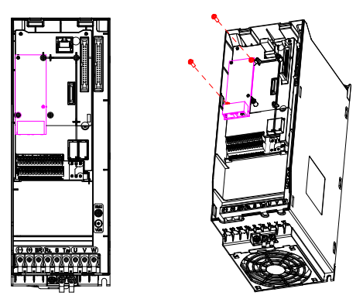
Figure 21 EMH-EC Communication Expansion Card Installation Diagram

Wiring
The topologies supported by EtherCat include bus, star, tree, and combinations of these topologies, making device connection and wiring very flexible and convenient. The bus connection topology diagram is shown in Figure 19.
Figure 22 EtherCat Bus Wiring Diagram

Communication Description

Key Points of EtherCat Communication
- When using the EMH-EC Communication Expansion Card, the communication decoding method of the CM680 needs to be set. When using the CANopen standard DS402 specification, set the F8-19 register to 1 via the operation panel. When using manufacturer-defined command codes, set the F8-19 register to 0 via the operation panel. Additionally, check whether the manufacturer-defined command codes are for the 0x6000 or 0x2000 section. When using the 0x6000 section, set the F8-07 register to 1 via the operation panel. When using the 0x2000 section, set the F8-07 register to 0 via the operation panel.
- When setting the inverter command, the F0-05 register of the CM680 needs to be set to 5.
- When setting the inverter frequency, the F0-06 register of the CM680 needs to be set to 8.
- The alias address for EMH-EC Communication Expansion Card EtherCat communication is set in the F8-11 register, and the module must be restarted for the setting to take effect.
- During non-periodic communication, a new non-periodic communication must only be initiated after the completion of the previous non-periodic read/write. The interval between two non-periodic communications should be no less than 100ms to avoid affecting the response to periodic communication.

Periodic Data Read/Write Description
Periodic data exchange is the basic data interaction method of EtherCat. After the master and slave stations establish a normal connection, they will continuously send periodic interaction messages.
Periodic Interaction Data Format:
Periodic interaction sets up 8 PDO areas, 4 of which are RxPDOs, and the other 4 are TxPDOs. There are some default settings for these 8 PDO areas, as shown in the table below:
Table 31 Periodic Interaction Data
PDO | Explanation | Number of PDOs
RxPDO1 | Default transmission PDO, used for object dictionary 402, such as 0x6040 | Min(16 objects, 32 bytes of data)
RxPDO2 | Default transmitted PDO, used for the object dictionary of standard Modbus addresses, such as 0x3060 | Min(16 objects, 32 bytes of data)
RxPDO3 | Default transmitted PDO, used for the object dictionary of standard Modbus addresses, such as 0x3020 | Min(16 objects, 32 bytes of data)
RxPDO4 | Non-default freely configurable transmitted PDO | Min(16 objects, 32 bytes of data)
TxPDO1 | Default received PDO, used for the object dictionary of 402, such as 0x6041 | Min(16 objects, 32 bytes of data)
TxPDO2 | Default received PDO, used for the object dictionary of standard Modbus addresses, such as 0x3061 | Min(16 objects, 32 bytes of data)
TxPDO3 | Default received PDO, used for the object dictionary of standard Modbus addresses, such as 0x3021 | Min(16 objects, 32 bytes of data)
TxPDO4 | Non-default freely configurable received PDO | Min(16 objects, 32 bytes of data)
The default configured RPDO is 0x1601, and the default configured TPDO is 0x1A01. The first three items of 0x1601 are default mappings, mapping to objects of 402, which are 0x6040, 0x6042, 0x6060, representing control word, set target speed, set mode; the remaining mappings in 0x1601 can be freely configured; The first four items of 0x1A01 are default mappings, with the object at address 402 being 0x603F, 0x6041, 0x6043, 0x6061, representing warning/error, status word, actual operating speed, actual operating mode, respectively. The remaining mappings in 0x1A01 can be freely configured as shown in the table below:
Table 32 Periodic Interaction Data Format 1
Master Station sends RPDO area (0x1601)
Default RPDO |  |  | Variable RPDO
Control Word  （0x6040） | Set Target Speed  （0x6042） | Set Mode  （0x6060） | Real-time modification of inverter function parameters
RPDO1 | RPDO2 | RPDO3 | RPDO4~RPDO16
Inverter Slave Station replies with TPDO area (0x1A01)
Default TPDO |  |  |  | Variable TPDO
Warning/Error  （0x603F） | Status Word  （0x6041） | Actual Running Speed  （0x6043） | Actual Running Mode  （0x6061） | Real-time reading of inverter function parameters
TPDO1 | TPDO2 | TPDO3 | TPDO4 | TPDO5~TPDO16
Another default configuration is 0x1602 and 0x1A02, with a maximum mapping of 16 register addresses. The first two items of 0x1602 are the default RPDO mappings, which are 0x6000, 0x6002, representing control word and set target frequency. The remaining mappings in 0x1602 can be freely configured; The first three items of 0x1A02 are the default mappings, with addresses 0x2100, 0x6100, 0x6102, representing warning/error, status word, and actual frequency. The remaining mappings in 0x1A02 can be freely configured, as shown in the table below:
Table 33 Periodic Interaction Data Format 2
Master Station Sends RPDO Area (0x1602)
Fixed RPDO |  |  |  | Variable RPDO
Control Word  （0x6000） |  | Set Target Frequency  （0x6002） |  |  | Real-time modification of inverter function parameters
RPDO1 |  | RPDO2 |  |  | RPDO3~RPDO16
Inverter Slave Station Responds with TPDO Area (0x1A02)
Fixed TPDO |  |  |  |  | Variable TPDO
Warning/Error  （0x2100） | Status Word  （0x6100） |  | Actual Operating Frequency  （0x6102） |  | Real-time reading of inverter function parameters
TPDO1 | TPDO2 |  | TPDO3 |  | TPDO4~TPDO16
Another default configuration is 0x1603 and 0x1A03, with a maximum mapping of 16 register addresses. The first two items of 0x1603 are the default RPDO mappings, 0x2000, 0x2001, representing control words and set target frequency. The remaining mappings in 0x1603 can be freely configured; The first three items of 0x1A03 are default mappings, with mapping addresses 0x2100, 0x2101, 0x2103, representing warning/error, status word, actual frequency. The remaining mappings in 0x1A03 can be freely configured, as shown in the table below:
Table 34 Periodic Data Exchange Format 3
Master Station sends RPDO area (0x1603)
Fixed RPDO |  |  |  | Variable RPDO
Control Word  （0x2000） |  | Set Target Frequency  （0x2001） |  |  | Real-time modification of inverter function parameters
RPDO1 |  | RPDO2 |  |  | RPDO3~RPDO16
Inverter Slave Station replies with TPDO area (0x1A03)
Fixed TPDO |  |  |  |  | Variable TPDO
Warning/Error  （0x2100） | Status Word  （0x2101） |  | Actual Operating Frequency  （0x2103） |  | Real-time reading of inverter function parameters
TPDO1 | TPDO2 |  | TPDO3 |  | TPDO4~TPDO16
Additionally, 0x1604 and 0x1A04 have no default mapping configurations and are available for user configuration.

Non-periodic Data Read/Write Instructions
Non-periodic data read/write is used for obtaining or writing non-real-time data, interacting only when necessary.
There are two methods of non-periodic interaction, one is to access non-periodic data through the COE-Online method, and the other is to complete non-periodic interaction through custom object dictionary indexes.

Non-periodic COE-Online Acquisition
COE-Online accesses data from all object dictionaries listed in the ESI file in sequence, including data reading and writing. Since the content of the object dictionary is written based on the function codes of the inverter, the sub-indexes under an index are not necessarily continuous. Therefore, using the Complete access method to access data can cause data misalignment, so COE-Online only supports non-Complete access methods to access sub-index objects one by one. As shown in the figure below, the parameters of the inverter are read non-periodically in sequence through the COE-Online method.
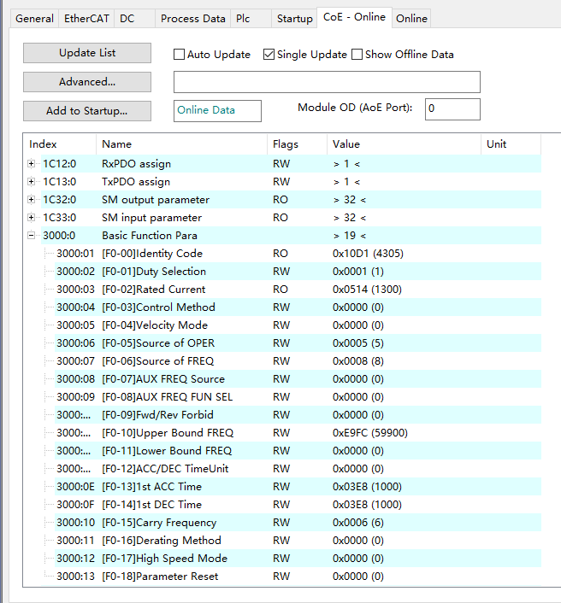

The following figure shows the non-periodic modification of a sub-index value through the COE-Online method to change the inverter parameter value.
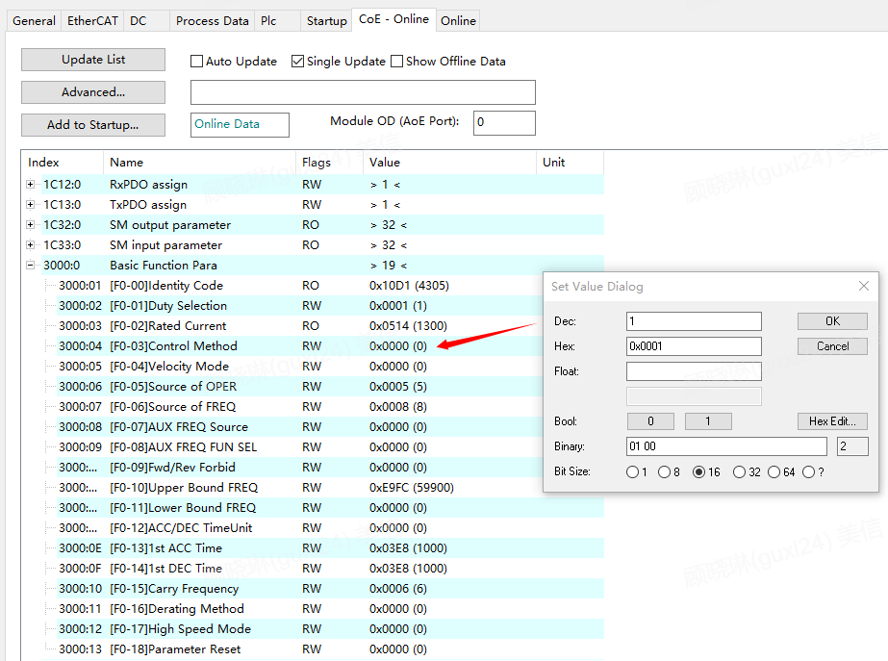

Non-periodic acquisition of custom object dictionary
- Non-periodic interaction data format
Non-periodic interaction is accomplished using specific object dictionary indexes to determine the format of the message data area. To facilitate user operations on continuous registers of the inverter, the following non-periodic read/write formats are defined. Non-periodic reads use a combination of object dictionary indexes 0x5300 and 0x5301, while non-periodic writes use the object dictionary index 0x5600.
- Non-periodic write value (0x5600)
When executing a non-periodic write value command, the data area must include the starting address of the register, length, and value. The data area has a fixed length of 16, and unused data areas are automatically filled with 0. The specific format is as follows:
Table 35 Non-periodic Write Value Format
 | Register Address | Register Length | Data
Data Length | 2 Byte | 2 Byte | Valid Data Area (Register Length * 2) Byte + Invalid Data Area
Example | 0x0400 | 0x10 | 0x0001 0002 0003 0004 0005…

The figure below is an example of an actual object dictionary:
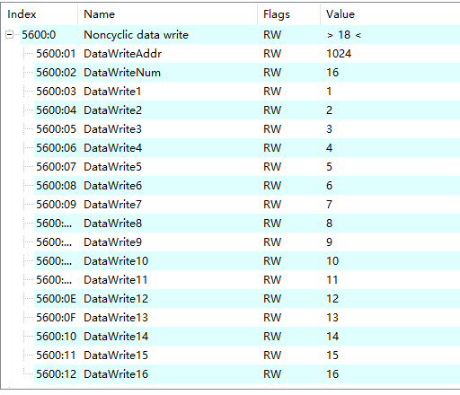
The total length of the non-periodic write value data area is at least 2 Byte and a maximum of 32 Byte.

- Non-periodic Read Value (0x5300 + 0x5301)
In the non-periodic read value request message, the register address and number to be read must first be written to the index 0x5301, as shown in the figure, the address written is 0x0400, reading 16 registers, so it is 0x00 10 04 00, the data read is stored in the index 0x5300, as shown in the figure, the fixed maximum number of non-periodic reads is 16 registers, the values read are sequentially filled into the sub-indexes of 0x5300, for example, the 16 register values read this time are 1~16, if there are unused data areas, they are automatically filled with 0.
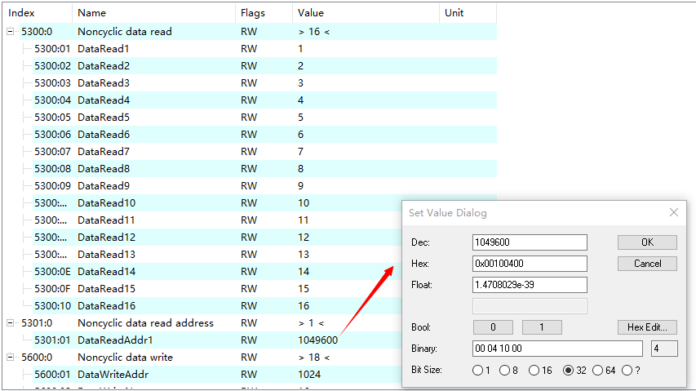
The specific format of the 0x5301 index is as follows
Table 36 0x5301 Index Format
 | Number of Registers | Register Address
Data Length | 2 Byte | 2 Byte
Example | 0x0400 | 0x0010
After sending a non-periodic read value command, the read value is filled into the 0x5300 index, and unused index values are automatically filled with 0. The data area format is as follows:
Table 37 Data Area Format
 | Data
Data Length | (Register Length * 2) Byte
Example | 0x0001 0002 0003 0004 0005…
- Execution Result
If an exception occurs during non-periodic interaction, an error code will be returned. Refer to Table 12 for specific error code definitions.

Table 38 EMH-EC Communication Expansion Card SDO Transmission Error Codes
Error Code | Meaning
0x05030000 | No change in the toggle bit during segmented transfer
0x05040000 | SDO transfer timeout
0x05040001 | Invalid or unknown command code
0x05040005 | Memory overflow
0x06010000 | Operation on a certain object is not supported
0x06010001 | Read a write-only data object
0x06010002 | Write a read-only data object
0x06010003 | The entry cannot be written because sub-index 0 is not 0
0x06010004 | The object cannot be accessed via complete access
0x06020000 | The data object does not exist in the data dictionary
0x06040041 | The data object cannot be mapped to PDO
0x06040042 | The number and length of data objects to be mapped exceed the PDO data length
0x06040043 | Parameter Incompatible
0x06040047 | Device Internal Incompatibility
0x06060000 | Hardware Error
0x06070010 | Parameter Length Mismatch
0x06070012 | Parameter Length Too Long
0x06070013 | Parameter Length Too Short
0x06090011 | Subindex Does Not Exist
0x06090030 | Write Operation: Data Value Out of Range
0x06090031 | Data Value Too Large
0x06090032 | The data value to be written is too small
0x06090033 | 0xF030 and 0xF050 do not match
0x06090036 | The maximum value is less than the minimum value
0x08000000 | General Error
0x08000020 | Data cannot be read or written
0x08000021 | Due to local control reasons, the data cannot be transmitted or saved to the application
0x08000022 | Data cannot be read or written in the current state
0x08000023 | The object cannot be found in the current object dictionary

Communication Configuration
The following describes the simple configuration and usage process of the CM680-ECAT card using Beckhoff's TwinCAT3 master station as an example.
Note: For the network card, an Intel chip-based 100 Mbps Ethernet card must be selected. Network cards from other brands may pose a risk of not supporting EtherCAT operation.

Configure Configuration
1. Install TwinCAT3
2. Copy the CM680 EtherCat configuration file (CM680H_PLUS_IO_V1.5.xml) to the TwinCAT installation directory, TwinCAT3 directory: TwinCAT\3.1\config\IO\EtherCAT.
3. Open TwinCAT
Create a new project, click on 'Create New Project', and the following interface will appear. You can search for TwinCAT templates, select the 'TwinCAT XAE Project (XML format)' template, and click Next.
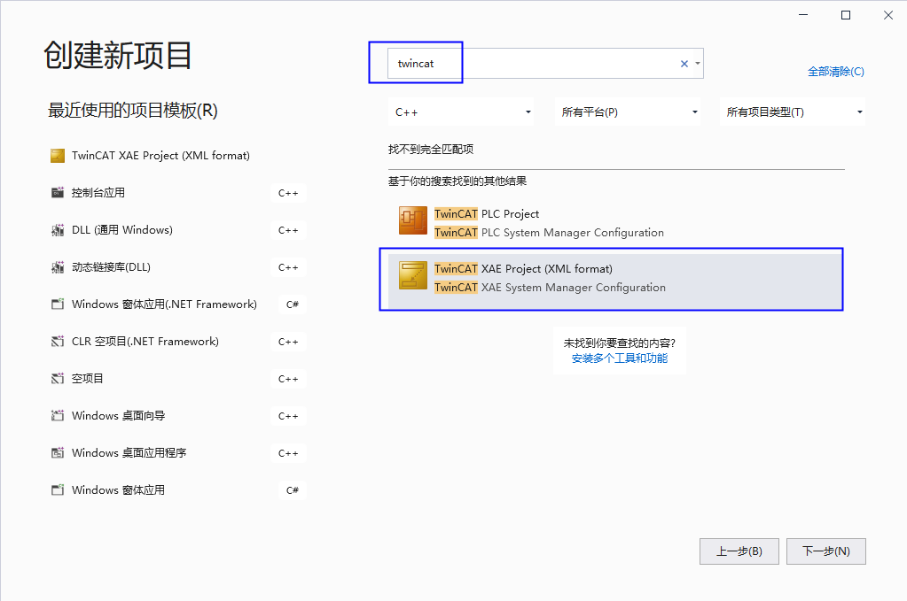

The following interface will appear. After filling in the project name and save location, click Create.
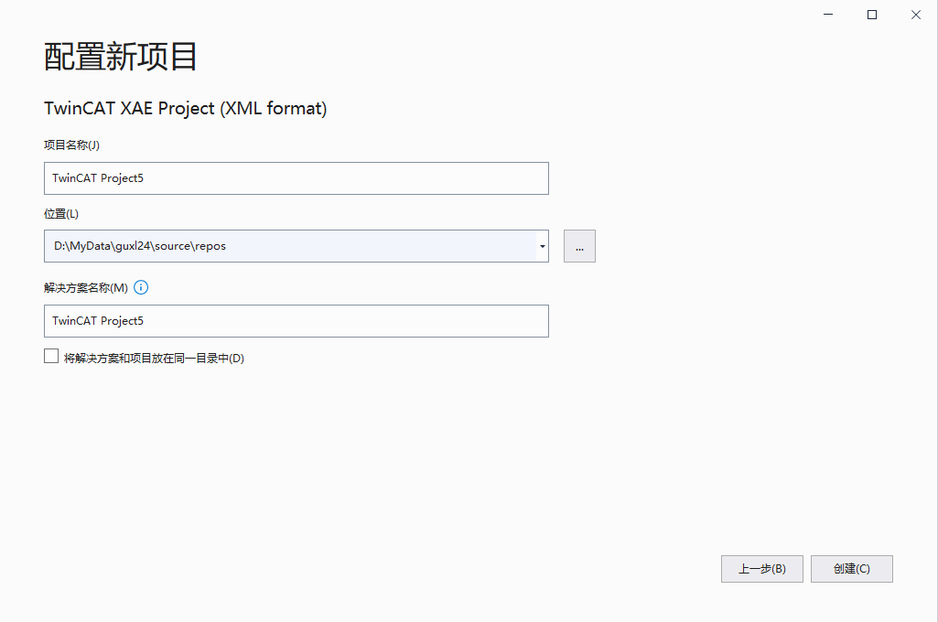
After creation, you need to install the TwinCAT network card driver.
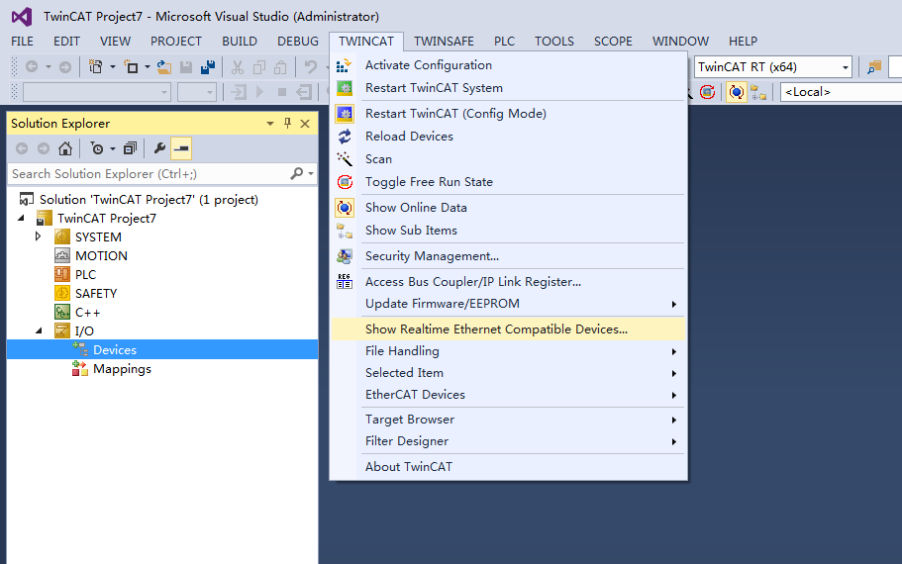
Open the menu 'Show Real Time Ethernet Compatible Devices...', and the following dialog box will appear. In the 'Incompatible devices' section, select the local site and click 'Install'. After installation, the installed network card will appear in the 'Installed and ready to use devices' section as shown in the figure below.
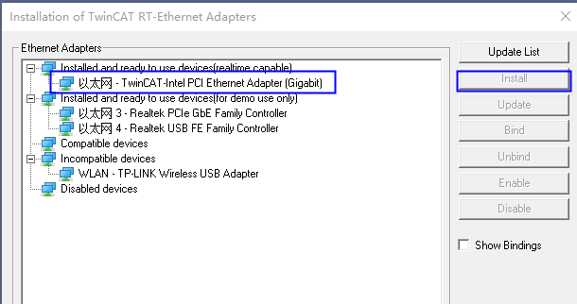
After the driver installation is complete, connect the device and search for it by right-clicking on Device and selecting Scan, as shown in the figure below.
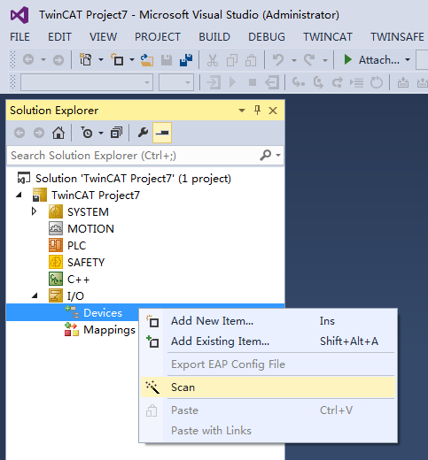
Click OK.
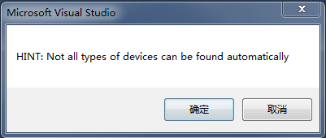
Select the Ethernet that has just installed the Ethercat driver and click OK.
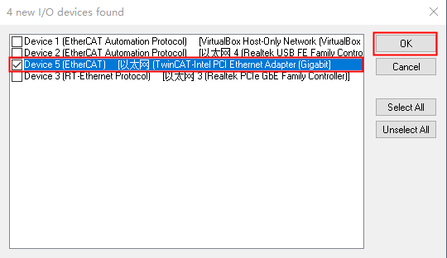
Click Yes.
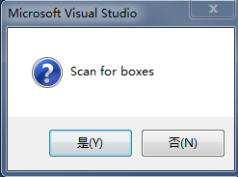
Click OK.
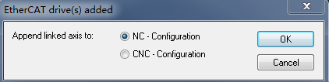

Click Yes. At this point, the device search is complete, as shown in the figure below.
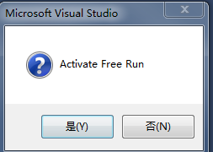

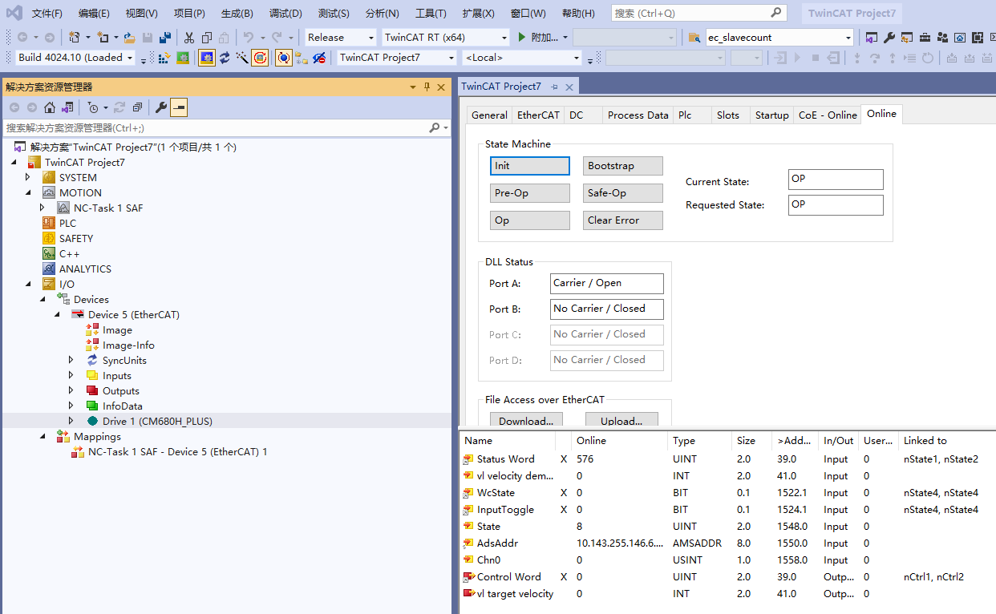

Configure Periodic Communication
1. Configure TPDO
Select the slave station, then select the 'Process Data' item on the right, and choose SM3, which is Inputs. You will see four TPDO options: 0x1A01, 0x1A02, 0x1A03, and 0x1A04. Among these, 0x1A01 is the default configuration for the standard DS402 protocol object dictionary, 0x1A02 and 0x1A03 are default configurations for custom function codes, and 0x1A04 has no default mapping object configuration and is available for user configuration. Users can select one of the four TPDOs according to their needs, and check the box before the selected TPDO. The currently selected TPDO is 0x1A01, as shown in the following steps.
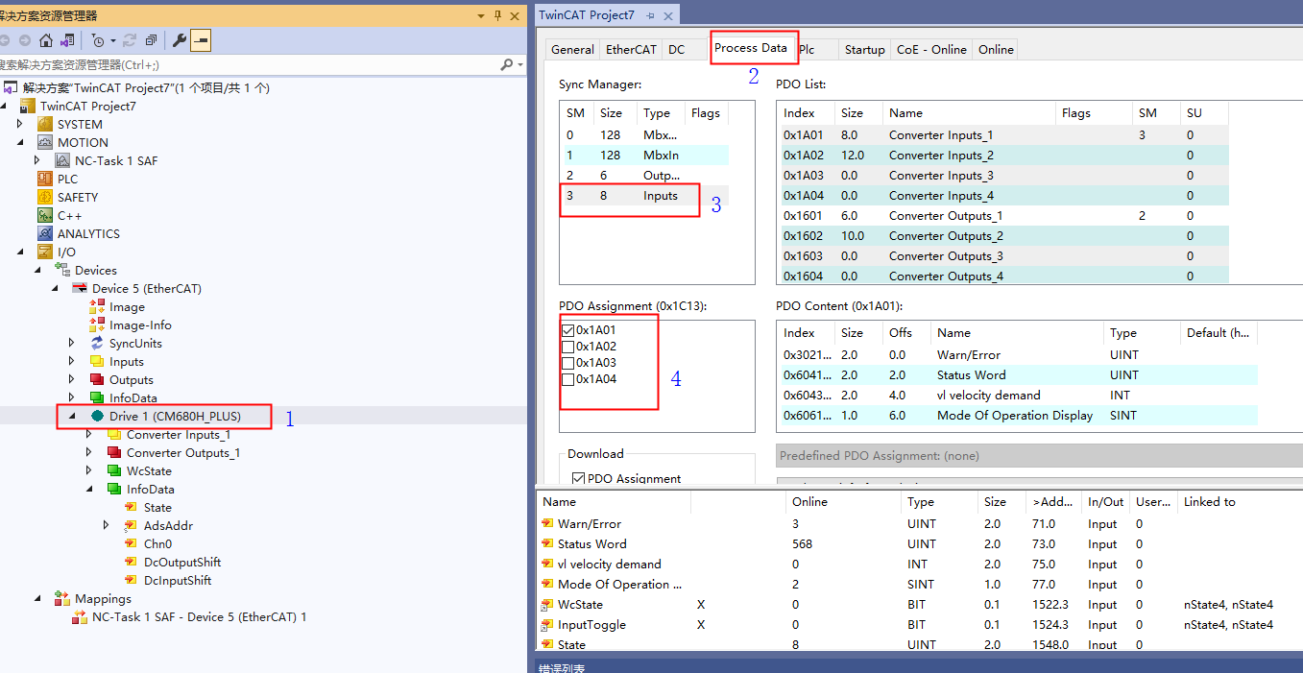
For the default TPDO 0x1A01, the default mapping objects configured are 4, as shown in the following figure: 0x3021:01 Warn/Error, 0x6041:00 Status Word, 0x6043:00 Velocity Demand, 0x6061:00 Mode of Operation Display. Since 0x6061:00 Mode of Operation Display is 1 byte, to align the bytes, an unused empty object needs to be added, as shown in Figure 1.
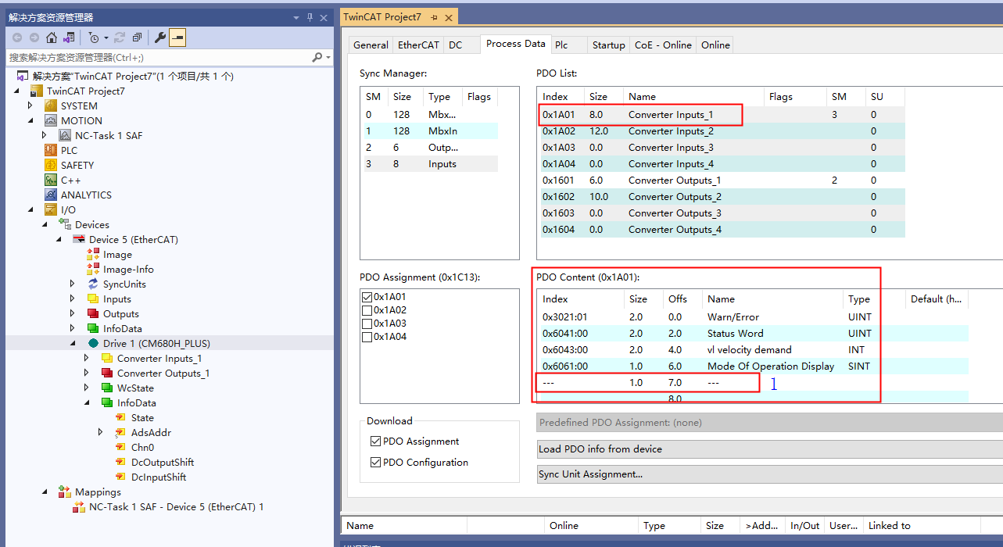
For the default configuration of 0x1A01, it is not recommended that users modify the first (4+1) configured objects. However, users can add new objects after these, as shown in the following figure, by right-clicking and adding a new item after the last object.

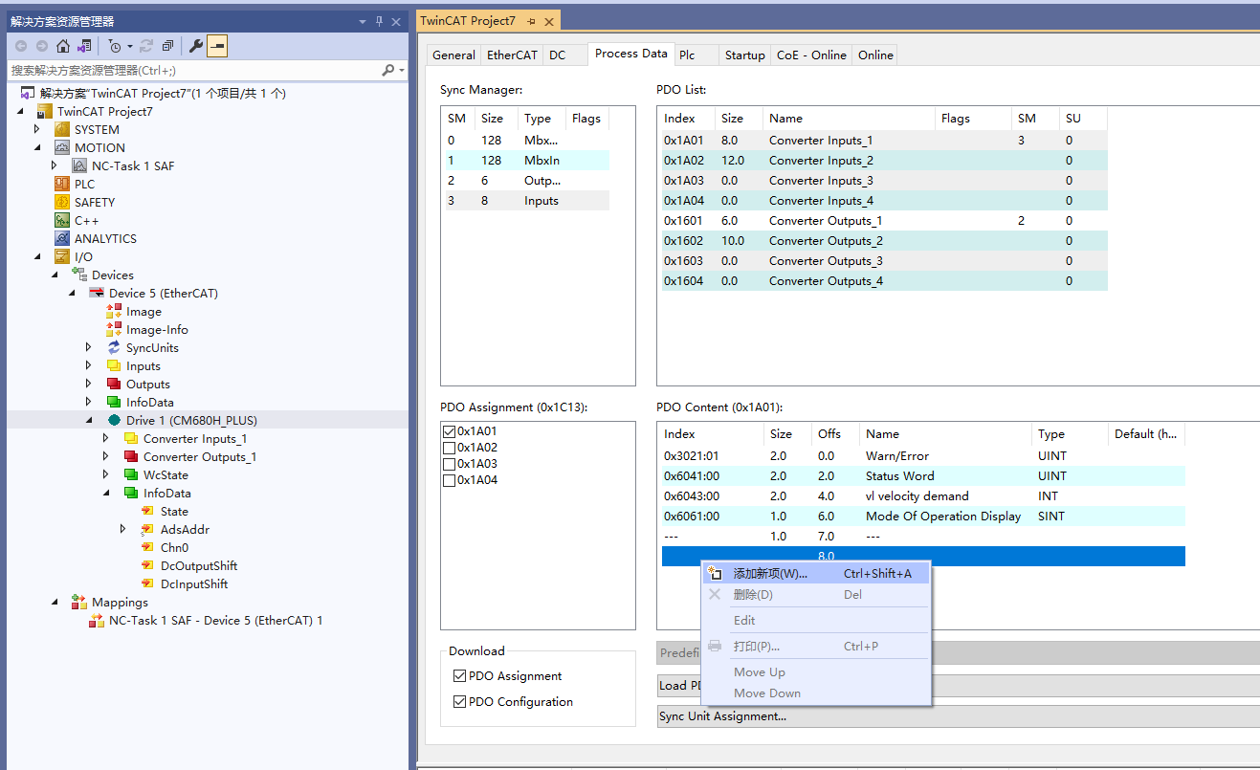
Then, a list of all object dictionaries will pop up, as shown in the figure below, from which you can select the object dictionary you want to add.
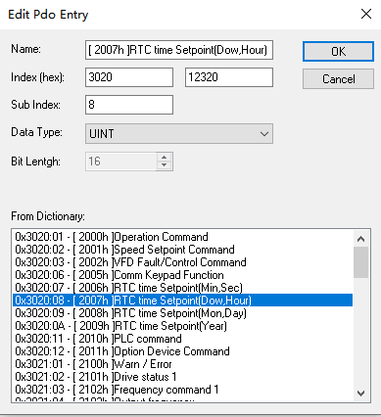
For the object dictionary you want to add that does not appear in the popped-up object dictionary list, you can manually input it, as shown in the figure below, in the red box marked, input the object dictionary you want to add, and also pay attention to the mapping relationship between the object dictionary and the inverter function code as follows:
Object Dictionary Index = 0x3000 + Function Code Group Number;
Object Dictionary Sub-index = Function Code Group Internal Offset in Hexadecimal + 1;
Therefore, as shown in the figure below, the object dictionary 0x3009+2 manually added represents the inverter function code 0x0901.
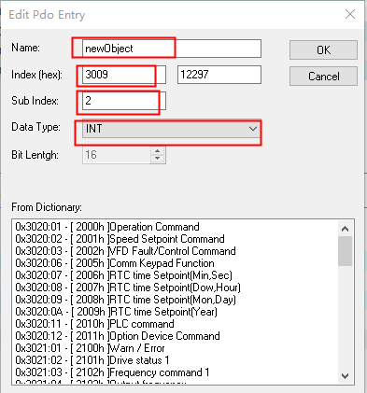
In addition, note that 1) if the length of the object dictionary being added is less than 2 bytes, it must be padded with dummy object dictionaries to achieve 2-byte alignment; 2) the maximum number of object dictionaries that can be added under a single PDO is min(16, the number of objects corresponding to 32 bytes of object dictionary length).

For the default TPDO 0x1A02, the default mapping objects configured are 3, as shown in the figure below, which are 0x3021:01 Warn/Error, 0x3061:01 Inverter State, 0x3061:03 Output Frq.
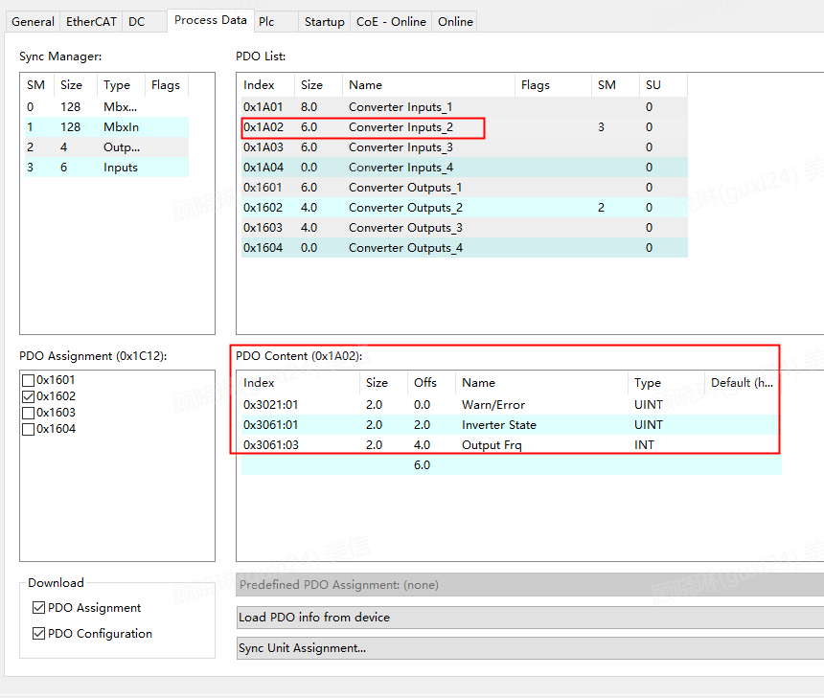

For the default configuration of 0x1A02, it is not recommended that users modify the first three configured objects, but users can add desired objects after these. The method of adding objects is the same as the configuration for 0x1A01. Additionally, if customers want to use 0x1A04 without default configuration, the method of adding objects is also the same.
For the default TPDO 0x1A03, there are 3 default mapped objects, as shown in the figure below, which are 0x3021:01 Warn/Error, 0x3021:02 Inverter State, 0x3021:04 Output Frq.
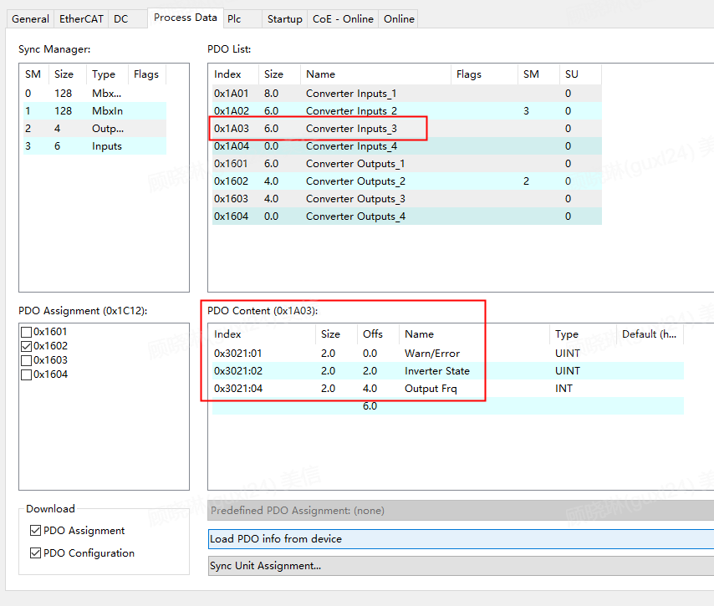
For the default configuration of 0x1A03, it is not recommended that users modify the first 3 configured objects, but users can add objects they wish to include after these, using the same method as configuring 0x1A01.

2. Configure RPDO
Select the slave station, then select the 'Process Data' item on the right, and select SM2, i.e., Outputs. You can see four TPDO options: 0x1601, 0x1602, 0x1603, and 0x1604. Among them, 0x1601 is the standard DS402 protocol object dictionary configured by the manufacturer by default, 0x1602 is the custom function code configured by the manufacturer by default, and 0x1603 and 0x1604 do not have default mapped objects and are available for user configuration. Users can choose one of the four RPDOs according to their needs, and check the box before the selected RPDO. The default selected is 0x1601, as shown in the following steps.
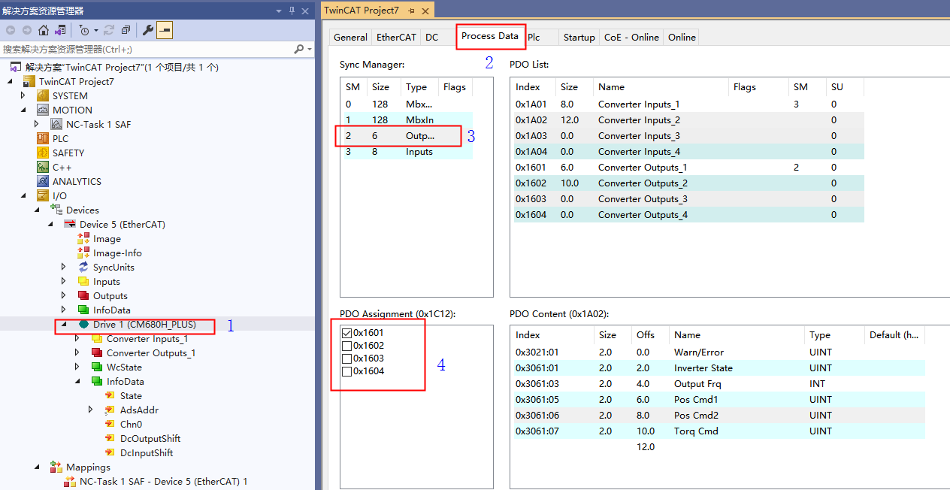
For the default RPDO 0x1601, there are 3 default mapped objects configured, as shown in the following figure: 0x6040:00 Control Word, 0x6042:00 vl target velocity, 0x6060:00 Mode of Operation. Since 0x6060:00 Mode of Operation is 1 byte, to align the bytes, an unused empty object needs to be added, as shown in 1 in the following figure.
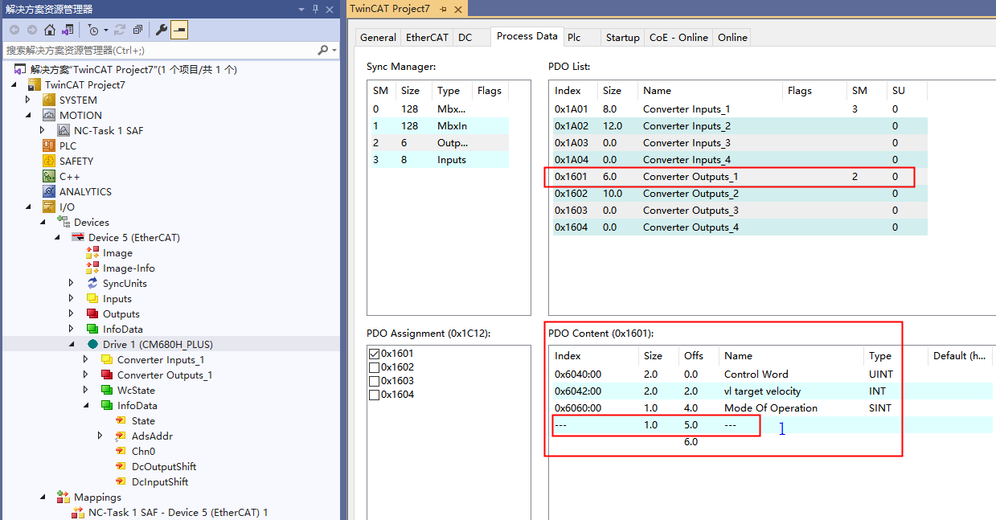
For the default configuration 0x1601, it is not recommended that users modify the first (3+1) configured objects, but users can add objects they wish to include after these, using the same method as configuring 0x1A01.

For the default RPDO 0x1602 configuration, there are 2 default mapped objects, as shown in the figure below, which are 0x3060:01 Control Word, 0x3060:03 vl target velocity.
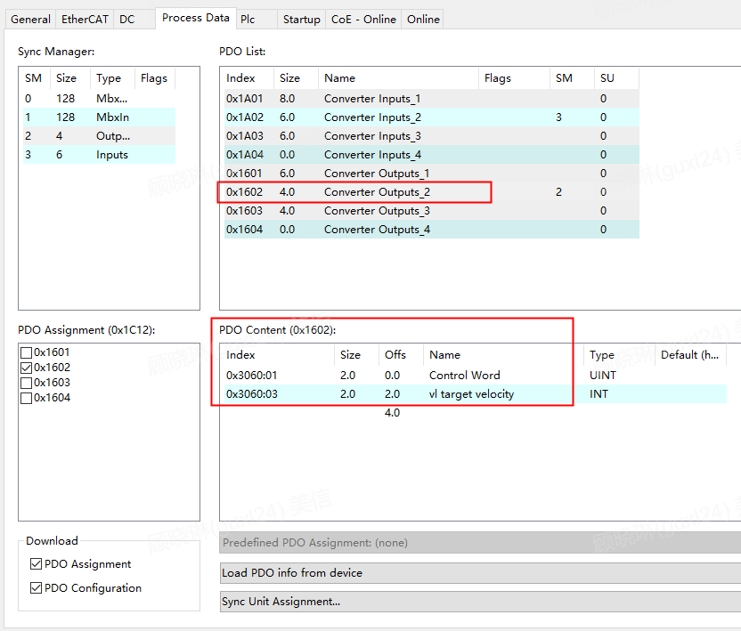
For the 0x1602 with default configuration, it is not recommended that users modify the first 2 configured objects, but users can add objects they wish to increase after these, using the same method as configuring 0x1A01. Additionally, if customers want to use 0x1604 without default configuration, the method of adding objects is the same.

For the default RPDO 0x1603 configuration, there are 2 default mapped objects, as shown in the figure below, which are 0x3020:01 Operation Command, 0x3020:02 Speed Setpoint Command.
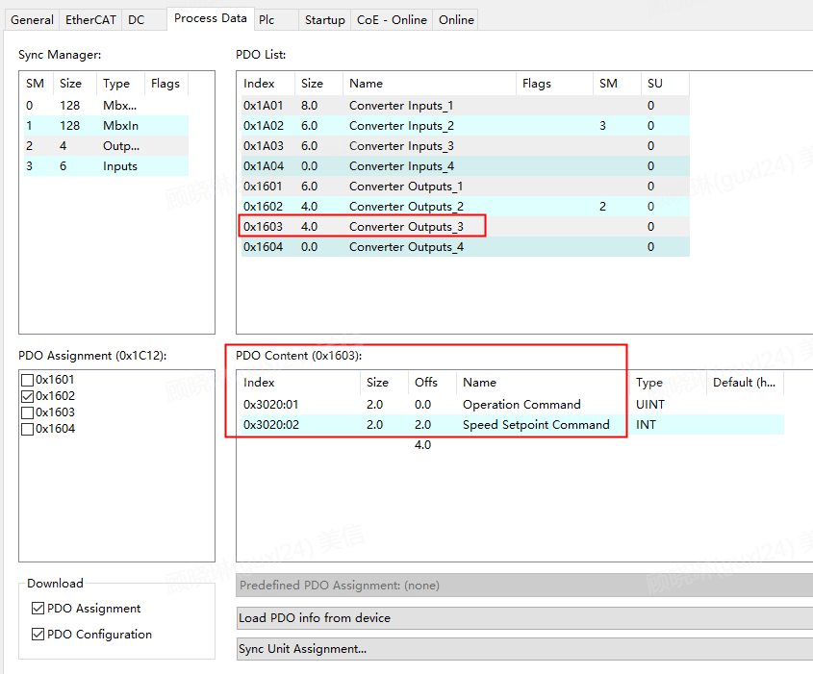
For the 0x1603 with default configuration, it is not recommended that users modify the first 2 configured objects, but users can add objects they wish to increase after these, using the same method as configuring 0x1A01.

Configure Non-periodic Communication

Non-periodic COE-Online Acquisition
After the user activates to PreOP and higher states, they can monitor data in real-time through the COE-Online SDO data list, and can also modify SDO data by double-clicking the object dictionary.
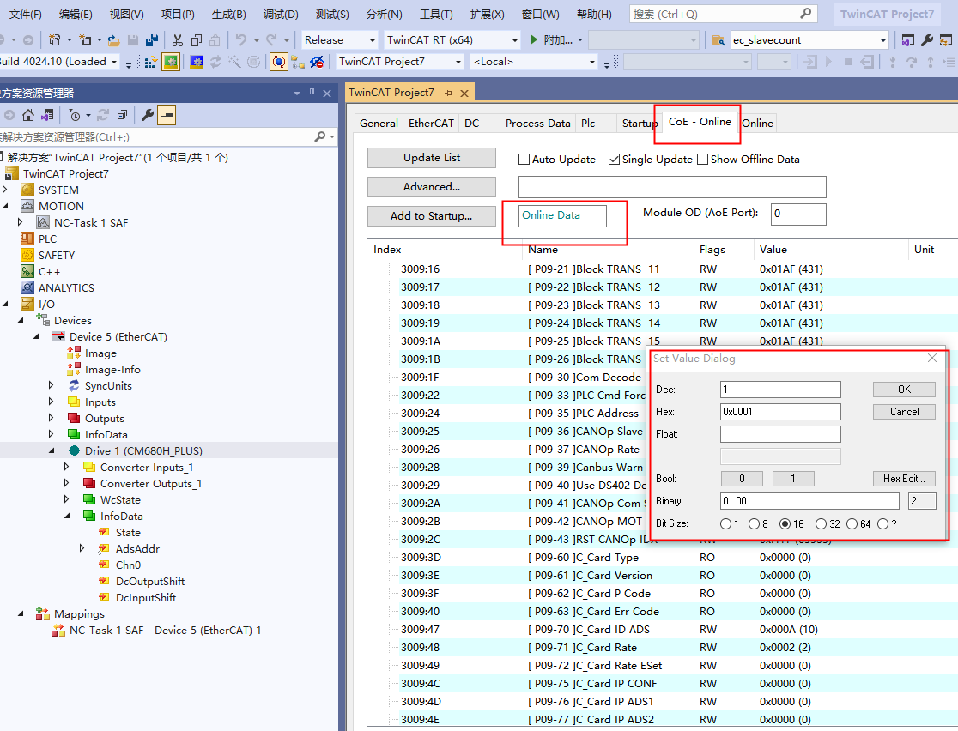

Custom object dictionary for non-cyclic read/write
1. Non-cyclic write
Section 5.3.3.2 has already introduced using a custom object dictionary to operate multiple consecutive registers of the inverter, and now the specific configuration steps are demonstrated.
For the convenience of users, two non-cyclic read/write function blocks that can be used directly are encapsulated: the read function block is Noncyclic_Read2, and the write function block is Noncyclic_Write2. Both function blocks include the capability to obtain SDO transmission error codes. Each execution of a non-cyclic read or write will retrieve an SDO transmission error code, and if there is no error, the error code will return 0. The example code after calling these two function blocks is shown in the figure below, where the red box indicates the instantiation and invocation of the function blocks.
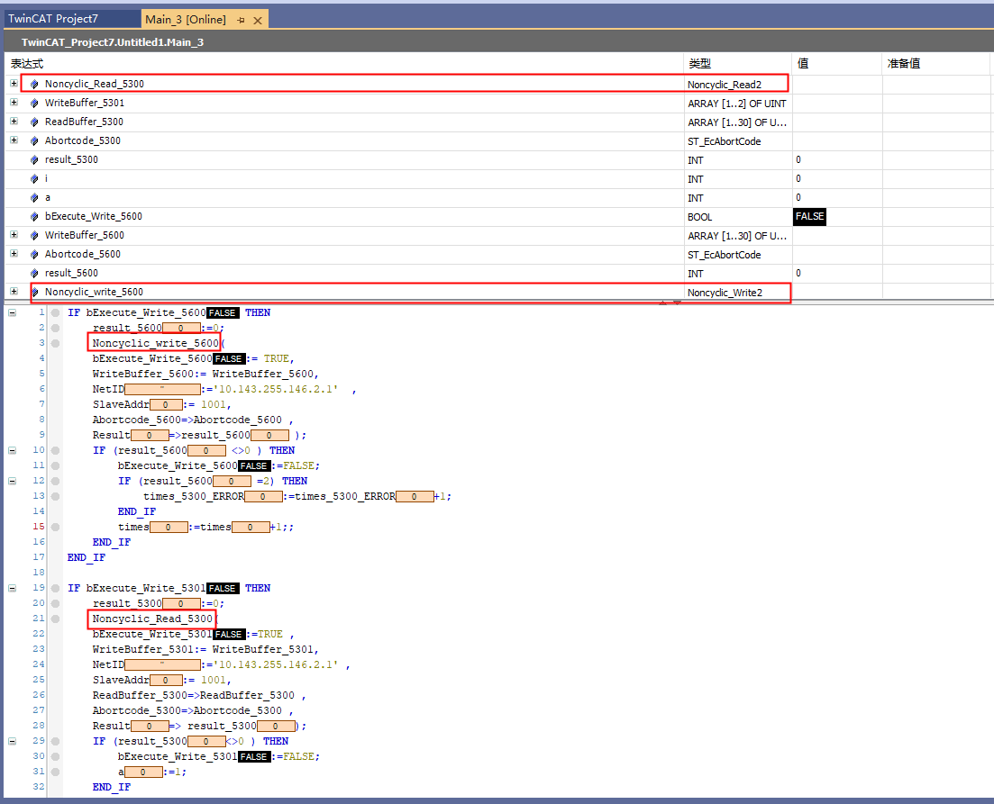

The variables bExecute_Write_5600 and bExecute_Write_5301 indicate whether to perform a non-periodic read. The values of sNetID and nSlaveAddr in the function block need to be entered according to the actual operation of EtherCAT, as shown in the figure below:
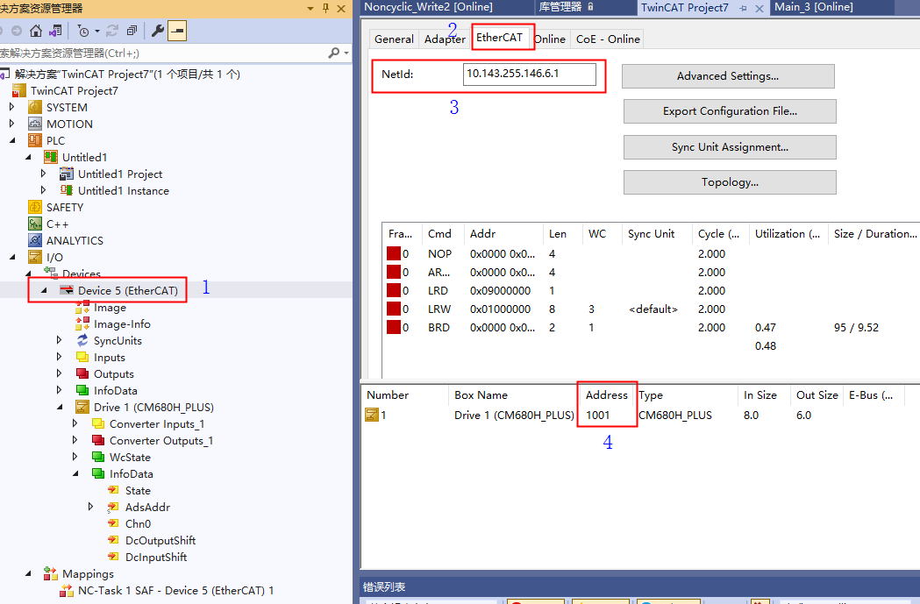

The array WriteBuffer_5600 is used to write the starting address of the Modbus to be written, the number of registers to be written, and the values of each register to be written, as shown in the figure below.
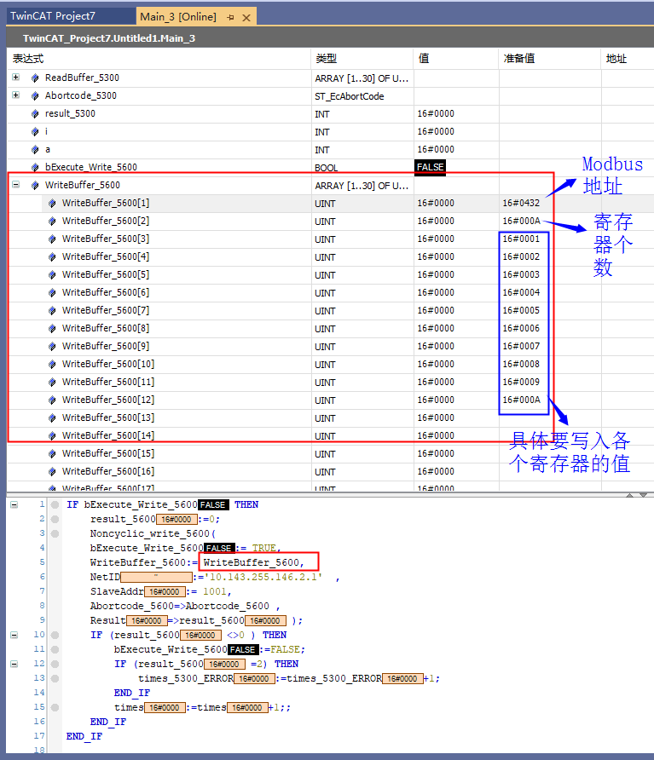
When the values are ready, they are written, and bExecute_Write_5600 is set to True, which will execute a non-periodic write operation. You can check the values returned by the function block's Result and Abortcode_5600, as well as the error list below, to determine if the aperiodic write was successful. If Result equals 1 and nAbortCode under Abortcode_5600 equals 0, then the aperiodic write was successful. If Result equals 2, it indicates that an SDO transfer error code has been obtained. The specific error can be seen in the nAbortCode value under Abortcode_5600, which is explained in Table 3.1. If Result equals 3, it indicates an ADS error. For detailed information on ADS errors, refer to the TwinCAT 3 help documentation.
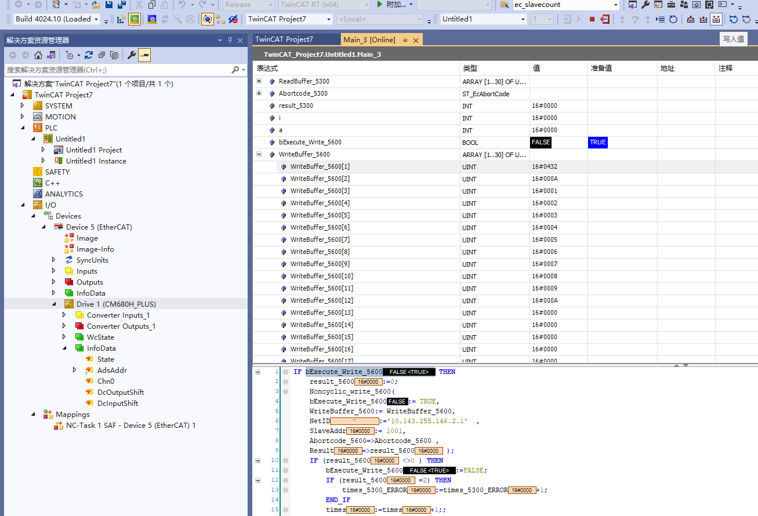
In the example, result_5600 equals 1, nAbortCode equals 0, and there are no errors listed below, so the aperiodic write was successful.
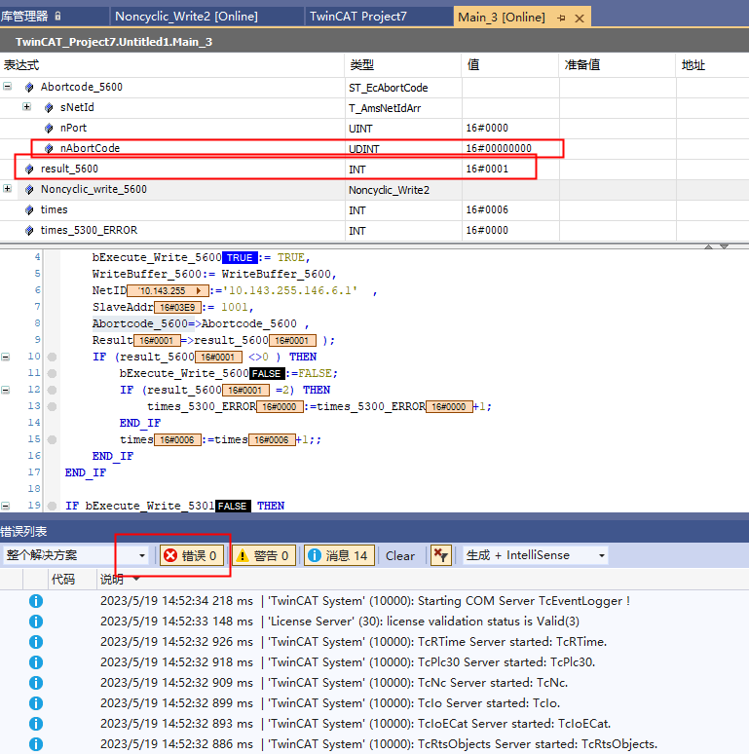
We can also switch to COE-Online to confirm that the values starting from register 0x0432 have indeed been changed to the values 1~10 that we previously wrote.

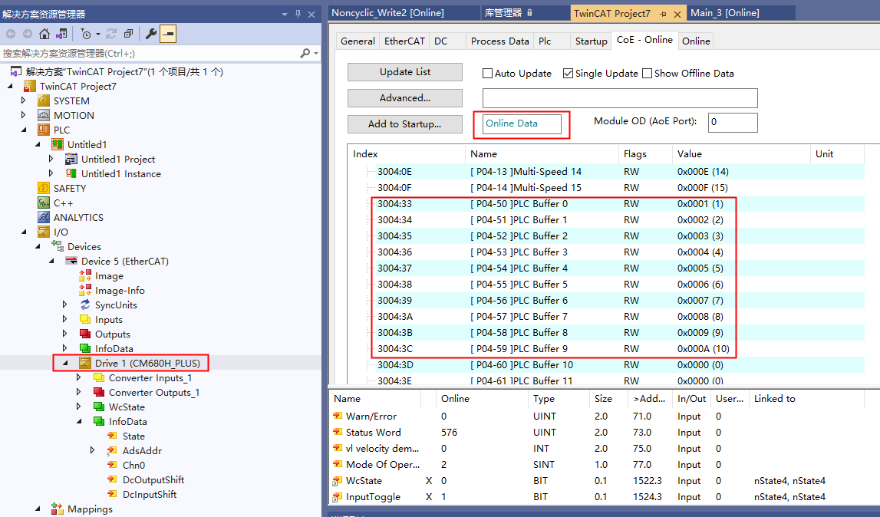
If a non-cyclical write operation is performed on a read-only register address 0x0001, it will return an SDO transfer error code and an Emergency error. As shown in the following two figures.
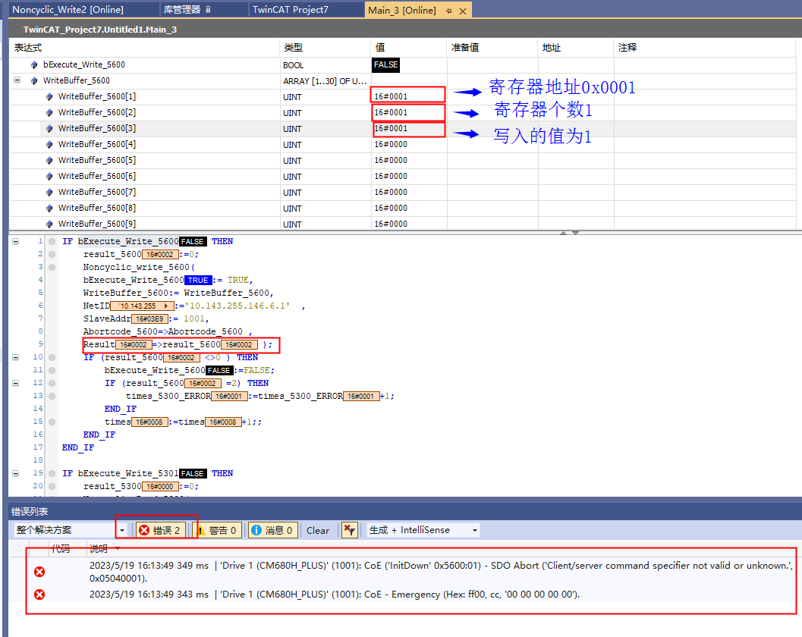
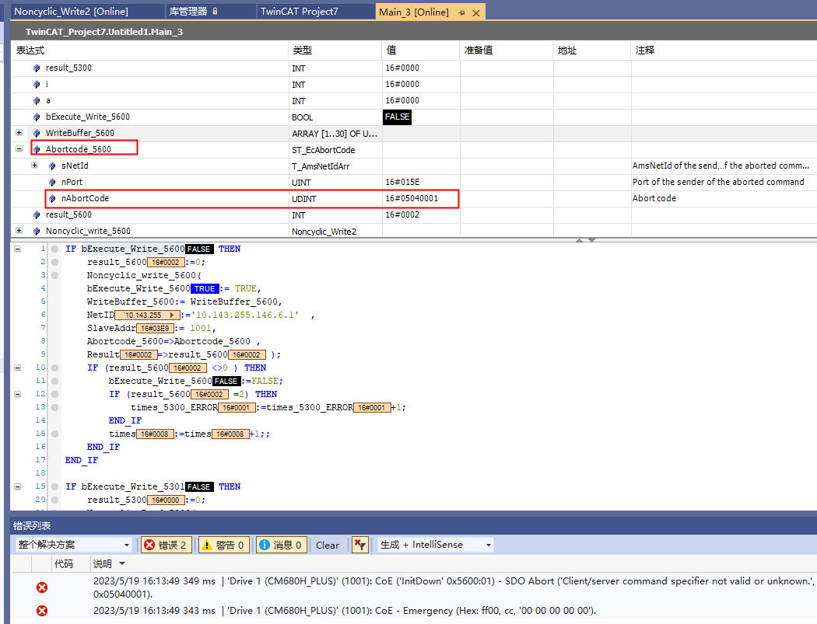

2. Non-cyclical Read
Write the parameters for non-cyclical read into the WriteBuffer_5301 array, as shown in the figure below. The register address to be read is the previously non-cyclical written address 0x0432, and the number of registers to be read is 10. Then set bExecute_Write_5301 to TRUE, write the value, and a non-cyclical read will be executed once.
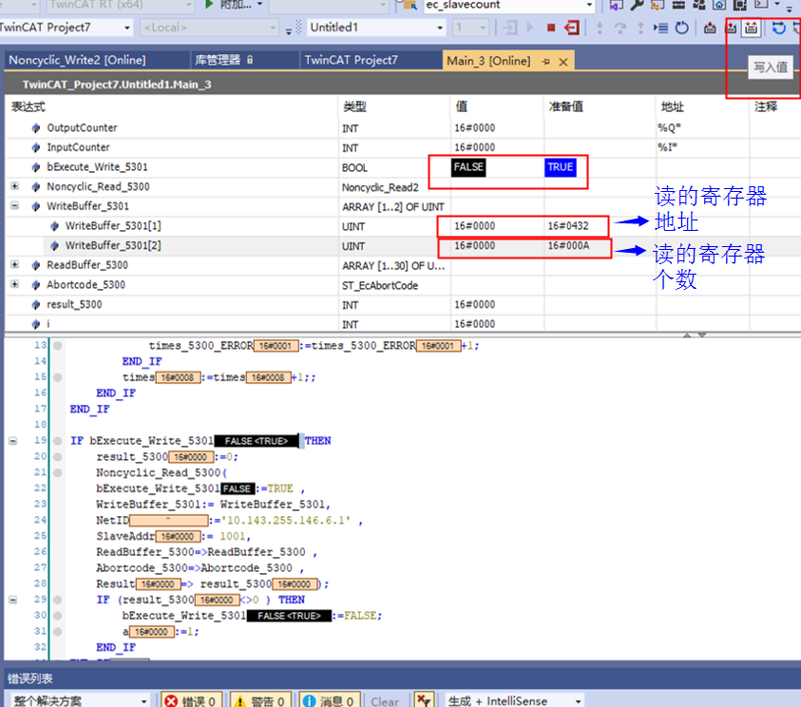

If the non-cyclical read is executed successfully, the values of the 10 read register addresses will be saved in the ReadBuffer_5300 array, as shown in the figure below.
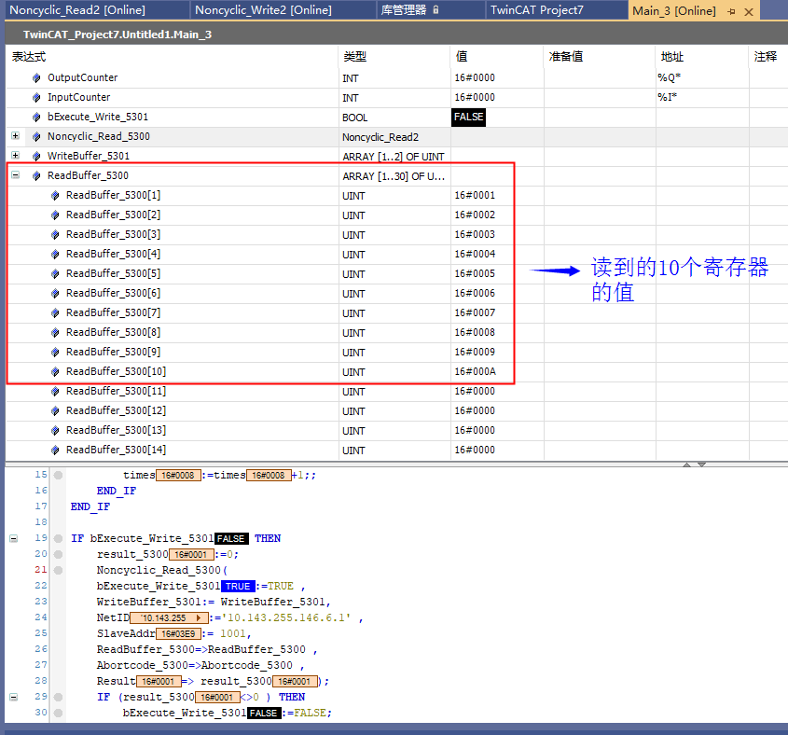
The method to determine whether the non-cyclical read is executed successfully is the same as the method for non-cyclical write, by checking the values of the Result and Abortcode_5300 returned by the function block, as well as the error list below. If there is an SDO transfer error code for non-periodic reads, the method to check it is the same as for non-periodic writes.
3. Explanation of Encapsulated Non-periodic Read/Write Function Blocks
To allow users to perform non-periodic read/write operations without needing to understand Modbus messages, the manufacturer has encapsulated two non-periodic read/write function blocks for user reference.
Noncyclic_Write2 function block: implements non-periodic writing, where bExecute_Write_5600: can always be set to TRUE, WriteBuffer_5600: configures the register, including the register address, number of registers, and the value to be written to the register, NetID: the AMS route of the EtherCAT master station, SlaveAddr: the station address of the slave station, Abortcode_5600: the SDO transfer error code returned, Result: the execution result (1 indicates successful execution, 2 indicates an SDO transfer error code was obtained, 3 indicates an ADS error occurred while obtaining the SDO transfer code).
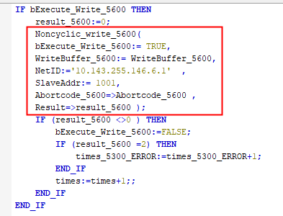

Noncyclic_Read2 function block: a function block that implements non-periodic reading, where bExecute_Write_5301: can always be set to TRUE, WriteBuffer_5301: configures the register, including the register address and number of registers, NetID: the AMS route of the EtherCAT master station, SlaveAddr: the station address of the slave station, ReadBuffer_5300: the value read from the register, Abortcode_5300: the SDO transfer error code returned, Result: the execution result (1 indicates successful execution, 2 indicates an SDO transfer error code was obtained, 3 indicates an ADS error occurred while obtaining the SDO transfer code).
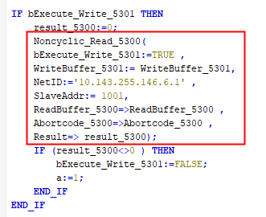

Fault Information

Periodic Fault Code
In the periodic communication PDO area, PDO1 sent from the slave station to the master station indicates error and alarm information. Users can obtain the latest status through periodic communication. In addition to the diagnostic information of the inverter itself, the communication status between the module and the inverter must also be included, allowing users to obtain the cause of errors. Detailed fault status codes are listed in the table below:
Table 39 Periodic Fault Codes
Diagnostic Classification | Status Code
Inverter Body Diagnostic Information (Register Address: 0x2100) | 200 Communication Error (Message Abnormality)  201 Communication Error (Timeout Abnormality)  202 Address Error  203 Parameter Exceeds Threshold  204 Incorrect Slave Station Number  205 Incorrect Periodic Data Value  206 SPI Transmission Without Memory  207 SPI Transmission Error  - Periodic Communication Error

Non-periodic Fault Code
When executing non-periodic communication, the error code of SDO transmission will be returned. For details on error codes, see Table 38.

Retrieve Diagnostic Information
When communication between the module and the inverter is abnormal, diagnostic information is sent to the PLC. Diagnostic information can be obtained through object dictionary 0x10F3. As shown in the figure below, up to the latest 14 diagnostic messages can be displayed.
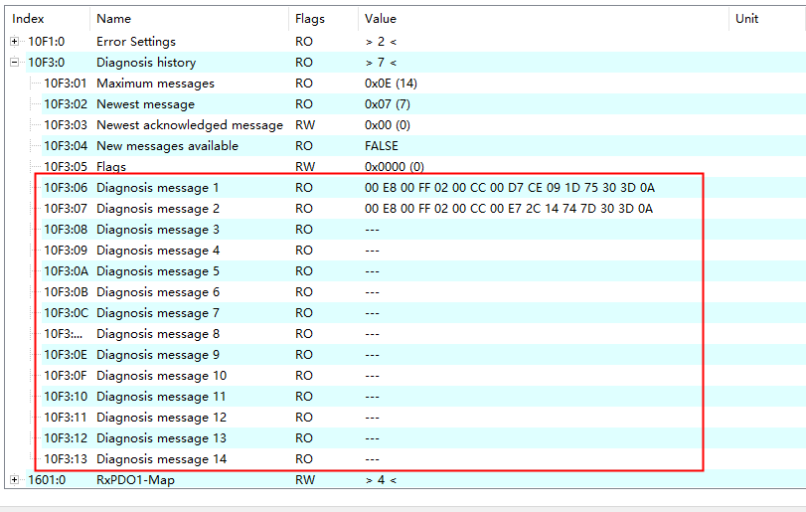

The format of the diagnostic information is as follows:
Table 40 Diagnostic Information Format
Example | 00 | E8 | 10 | FF | 02 | 00 | 00 | 00 | 00 | 00 | 00 | 00 | 00 | 00 | 00 | 00
Purpose | (L) (H)  (Fixed Value) |  | (L) (H)  Error code |  | (L) (H)  (Fixed Value) |  | (L) (H)  Text ID |  | (L) (H)  (Fixed Value)
Purpose | Diag code |  |  |  | Flags |  | Text ID |  | Time stamp
Diag code … diagnostic code for identifying information
Error code diagnostic code as defined.
Flags … value is fixed at 0002h.
Text ID … Returns the Text ID defined for each error code.
Set the upper 8-bit as the main alarm number and the lower 8-bit as the auxiliary alarm number.
Time stamp … The time when the error occurred.

Non-periodic Read or Erase Fault Code
1. Fault code read
Read the 0x10F3 object using the FB_EcCoESdoReadEx function block provided by Twincat3 or obtain it directly via COE-Online. The following figure shows the consistent results obtained through FB_EcCoESdoReadEx and COE-Online. Note that complete access is not supported for operations on 0x10F3.
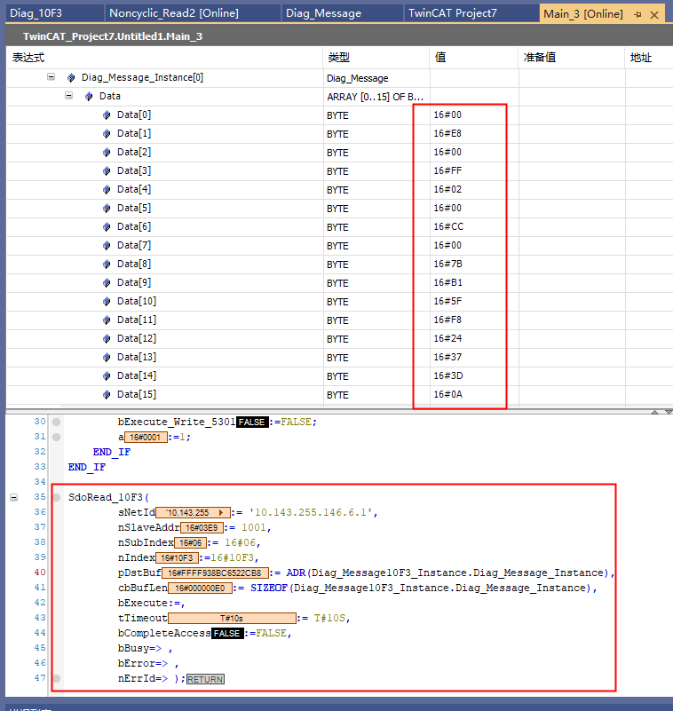
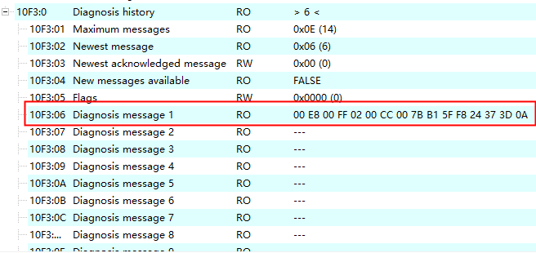

2. Fault Code Erasure
Write 0 to sub-index 3 of 0x10F3 using the FB_EcCoESdoWriteEx function block provided by Twincat3 to clear all diagnostic information, as shown in the following figure:
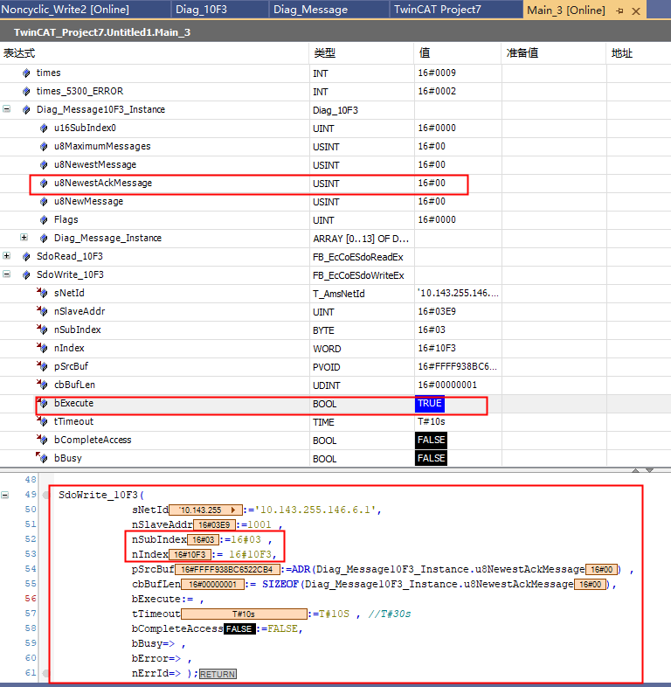

Or write 0 directly to sub-index 3 of 0x10F3 via COE-Online, as shown in the following figure:
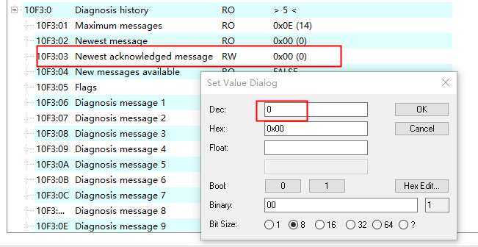

CANopen Communication

Product Information
The EMH-OP Communication Expansion Card is a CANopen fieldbus adapter card that complies with the CiA standard. This card is installed on the CM680 Inverter to enable communication with CANopen master station devices, making the inverter a slave node of the CANopen network, accepting control from the master station.

Physical Dimensions
Physical dimensions of the CANopen module: PCB length 95mm, width 37mm, mounting hole diameter 3.5mm.
Figure 23 Physical Dimensions of the EMH-OP Communication Expansion Card

Interface Layout
The hardware layout of the EMH-OP Communication Expansion Card is shown in Figure 24. Connector X2 is used for connecting to the inverter and is located on the back of the EMH-OP Communication Expansion Card. The EMH-OP Communication Expansion Card provides spring-type terminal blocks for communication connections. Detailed descriptions of each hardware component are provided in Table 41.
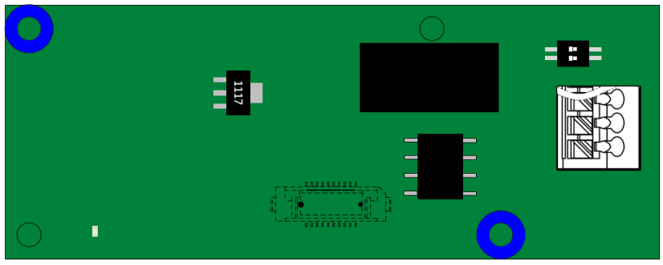
S1

X1

D1 X2

Figure 24 EMH-OP Communication Expansion Card Interface Layout

Table 41 EMH-OP Communication Expansion Card Interface Description
Diagram Name | Hardware Name | Function Description
X1 | CAN Socket | For module connection to the CANopen network, refer to Figure 1.3 for details
X2 | Board-to-Board Socket | For connection to the inverter (located on the back of the board)
D1 | LED Indicator Light | For indicating power status, refer to Table 1.2 for details
S1 | Termination Resistor Setting | For setting the CAN bus termination resistor, refer to Table 1.6 for details

1. CANopen communication interface
The EMH-OP communication expansion card uses a spring-type terminal block X1 to connect to the CAN bus, and the shield is twisted together and connected to the PE (J703-1) of the main control board. If conditions permit, the shield of the communication line can also be connected to the cabinet metalwork. The pin signal definitions are shown in the figure below:
Figure 25 EMH-OP Communication Expansion Card CAN Communication Interface Description

2. LED Indicator Light
Table 42 EMH-OP Communication Expansion Card LED Indicator Light Description
Diagram Name | Indicator Light | Indicator Light Status |  | Function Description
D1 | Hardware power indicator light | Green light | Constantly On | Module powered on normally
D1 | Hardware power indicator light | Green light | Off | Module not powered on

3. Terminal Impedance
The DIP switch S1 on the EMH-OP Communication Expansion Card is a 2-position DIP switch used to configure the CAN bus terminal resistor. It is recommended to set the terminal resistor at both ends of the network topology. Switching to “ON” represents “1”, and switching down represents “0”. For detailed information, see Table 15.
Table 43 EMH-OP Communication Expansion Card Terminal Resistor Settings
DIP Switch Number |  | Terminal Impedance Setting
1 | 2 | Terminal Impedance Setting
0 | 0 | Do Not Use Terminal Resistor
1 | 1 | Use Terminal Resistor

Installation and Wiring

Installation
The EMH-OP Communication Expansion Card is designed to be embedded in the CM680 Inverter. Before installation, please disconnect the power supply to the inverter, wait for about 10 minutes until the charging indicator light is completely off before proceeding with the installation. After inserting the EMH-OP Communication Expansion Card into the inverter, please secure the corresponding screws to prevent poor contact of the board-to-board signal sockets. The installation diagram is shown in Figure 2.1.
Figure 26 Schematic Diagram of EMH-OP Communication Expansion Card Installation

Wiring
The wiring diagram for the CAN bus is shown in Figure 2.2. The CAN bus is recommended to use shielded twisted pair cables. Terminal matching resistors should be connected at both ends of the CAN bus. Adjust the DIP switches according to the indications on the terminal blocks. Failure to connect or insufficiently connect the terminal resistors can affect communication quality and cause unstable communication.
Figure 27 CAN Bus Wiring Diagram

Communication Description

Key Points of CANopen Communication
The CANopen communication sub-protocol CiA 301 (DS 301) includes periodic communication and event-triggered communication.
The CANopen device sub-protocol defines direct access to inverter parameters and key process data.
The inverter's CANopen interface supports the CiA 402 (DS 402, inverter and motion control sub-protocol) specification and the inverter manufacturer's custom specifications.
The maximum transmission distance of CANopen is limited by the transmission speed; the higher the speed, the shorter the communication distance.
Theoretically, up to 127 communication nodes can be connected in a CAN network; in practice, the number of nodes is limited by the transmission capability of the CAN transceiver.
Unless otherwise specified, the inverter is defined as a slave node (Server) in the CAN network.
Table 44 CANopen Protocol
Application layer | CANopen  Application layer | CiA 402  CiA 301
Presentation layer | CANopen  Application layer | CiA 402  CiA 301
Session layer | CANopen  Application layer | CiA 402  CiA 301
Transport layer | CANopen  Application layer | CiA 402  CiA 301
Network layer | CANopen  Application layer | CiA 402  CiA 301
Data link layer |  | CAN2.0A/B
Physical layer |  | ISO 11898

Table 45 CANopen Parameter Settings
Name | Description | Default Value
F8-07 Communication Decoding Method | Select manufacturer-defined protocol, 0 indicates custom protocol one, 1 indicates custom protocol two | 1
F8-14 CANopen Node Address | Set node address, each device in the same network must have a unique node address. 0: Disable CANopen Slave Station, 1~127: Slave Node Address Number, a single CAN network supports up to 127 slave nodes. | 0
F8-15 CAN Bus Communication Speed | User selects CANopen communication speed, all devices in the same network must use the same communication speed. | 0
F8-18 CANopen Warning Record | Displays inverter CANopen warning information | Read-Only
F8-19 CiA402 Protocol Selection | Used to select CiA 402 protocol and manufacturer-defined protocol for CANopen index parsing. 0: Inverter manufacturer-defined protocol, 1: CiA 402 protocol | 1
F8-20 CANopen communication status | Display inverter CANopen node status | Read-Only
F8-21 CiA402 operation status | Display inverter motor operation status | Read-Only
F8-22 CANopen index reset | CANopen index data reset command | 0xFFFF

CANopen communication protocol
The CANopen communication protocol includes NMT (Network Management Object), SYNC (Synchronous Object), SDO (Service Data Object), PDO (Process Data Object, including transmitting TPDO, Tx PDO and receiving RPDO, Rx PDO, transmission and reception are referenced to the CANopen node itself), and EMCY (Emergency Object).
Table 46 Communication Protocol
Communication Object | Function Code (binary) | COB-ID(hex)
NMT | 0000 | 00
SYNC | 0001 | 80
EMCY | 0001 | 81 ... FF
TPDO1 | 0011 | 181 ... 1FF
RPDO1 | 0100 | 201 ... 27F
TPDO2 | 0101 | 281 ... 2FF
RPDO2 | 0110 | 301 ... 37F
TPDO3 | 0111 | 381 ... 3FF
RPDO3 | 1000 | 401 ... 47F
TPDO4 | 1001 | 481 ... 4FF
RPDO4 | 1010 | 501 ... 57F
TSDO | 1011 | 581 ... 5FF
RSDO | 1100 | 601 ... 67F
COB-ID encoding format is as follows:
Table 47 COB-ID (CAN Object ID, 11 or 29 bits)
Function Code |  |  |  | Node ID
10 | 9 | 8 | 7 | 6 | 5 | 4 | 3 | 2 | 1 | 0

NMT
NMT follows the Master/Slave protocol model, where the NMT host can unconditionally control the state transitions of the slave. NMT management involves six states from the start of power-up of a CANopen node, including Initialization, Application Layer Reset, Communication Reset, Pre-Operational Mode, Operational Mode, and Stop Mode. The data field of a CAN communication frame corresponding to an NMT message is 2 bytes long, and the ID field is 0.
Table 48 NMT Message
ID field | Data field (Byte 0) | Data field (Byte 1)
0 | NMT CMD | Node ID
If the Node ID is 0, it indicates that all NMT broadcast frames will be responded to by all slave stations. The NMT CMD list is as follows:
Table 49 NMT CMD
NMT CMD | Meaning
01h | Start Remote Node
02h | Stop Remote Node
80h | Enter Pre-Operation Mode
81h | Node Reset
82h | Communication Reset
The list of node statuses is as follows:
Table 50 Node Status
Node Status Word | Meaning
00h | Boot-up
04h | Stop State
05h | Operation Mode
FFh | Pre-Operation Mode

The CANopen state machine is as follows:
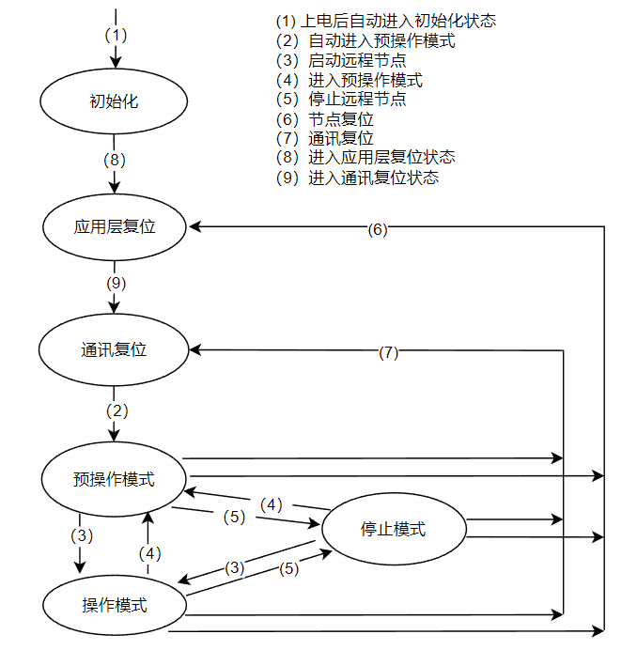
Figure 28 CANopen State Machine
The effective working states of each communication protocol object are shown in the following table:
Table 51 Effective Working States
 | Initialization | Pre-Operation Mode | Operation Mode | Stop State
PDO | \ | \ | Active | \
SDO | \ | Active | Active | \
SYNC | \ | Active | Active | \
EMCY | \ | Active | Active | \
NMT | \ | Active | Active | Active
Boot-up | Active | \ | \ | \

SDO
SDO follows the Client/Server protocol model, used for transmitting data with less stringent timing requirements (parameter setting), data length 0~4 bytes. Common SDO protocol is Fast SDO (SDO command byte bit1 set to 1 indicates Fast SDO), meaning all data is transmitted during initialization (initial SDO upload/download). If the transmission length exceeds 4 bytes, Fast SDO cannot be used, and standard SDO must be used for segmented transmission. The object dictionary is a group object of the CANopen node, each node has its own object dictionary, which contains multiple parameters, describing the supported parameter attributes and values. SDO accesses the device object dictionary through index and sub-index, each object has a single index value, and a single index can have multiple sub-index values. The SDO data frame format is as follows:
Table 52 SDO Data Frame Format
SDO Data Frame Analysis |  |  |  | SDO CMD Analysis
data byte num | Comment |  |  | bit num | Comment
byte0 | SDO CMD |  |  | bit0 | size
byte1 | SDO Index Low Byte |  |  | bit1 | expedited
byte2 | SDO Index High Byte |  |  | bit2 | Number of unused bytes in SDO
byte3 | SDO sub-index |  |  | bit3 | Number of unused bytes in SDO
byte4 | SDO data low word low byte | These 4 bytes are invalid when the SDO client queries the server status |  | bit4 | \
byte5 | SDO data low word high byte |  |  | bit5 | cmd  1: init download (send parameters)  2: init upload (status query)  3: stop SDO transfer
byte6 | SDO data high word low byte |  |  | bit6
byte7 | SDO data high word high byte |  |  | bit7

PDO
PDO follows the Producer/Consumer protocol model, where each network node can receive information from the transmitting node and can also determine whether to process the received information, used for transmitting time-critical process data (reference values, control commands, status information, etc.), which can be transmitted one-to-one or one-to-many. PDO transmission can be initiated by an internal timer (asynchronous communication), upon receiving a synchronization frame (synchronous communication), and through remote requests. The CAN interface supports up to 8 PDOs (including 4 TPDOs and 4 RPDOs), with only TPDO1 and RPDO1 enabled by default. PDO mapping can be used to transmit multiple application objects in a single PDO frame. PDO object mapping can only be modified when the node is in pre-operational mode.
- PDO mapping format CANopen object mapping value is in hexadecimal encoding, PDO mapping data format is as follows:
Table 53 PDO Mapping Data Format
Type | MSB |  | LSB
UINT32 | 31 16 | 15 8 | 7 0
Description | Index (e.g., 6040h) | Sub-Index (e.g., 02h) | Object bit length (e.g., 10h corresponds to 16 bits, 08h corresponds to 8 bits)
Note:
- PDO mapping sub-index starts from 1.
- If the PDO mapping input value is 0, the mapping of the current sub-index and all subsequent sub-indices will be ignored.
PDO transmission type settings and transmission methods correspond as follows:
Table 54 PDO Transmission Type
Transmission type setting value | Cyclic | Non-cyclic | Synchronous | Asynchronous | Remote Request
0 | \ | Active | Active | \ | \
1~240 | Active | \ | Active | \ | \
252 | \ | \ | Active | \ | Active
253 | \ | \ | \ | Active | Active
255 | \ | \ | \ | Active | \
A transmission type value of 0 indicates that two PDOs transmit synchronous non-cyclic information (currently unsupported). A transmission type value of 1~240 indicates the number of SYNCs between two PDO transmissions. A transmission type value of 252 indicates that data is updated immediately after receiving SYNC (currently unsupported). A transmission type value of 253 indicates that data is updated immediately after receiving RTR (currently unsupported). A transmission type value of 255 indicates asynchronous non-cyclic transmission.
- PDO Mapping Configuration via SDO This section provides an example of configuring a slave station's PDO mapping via the CANopen master station's SDO. Other PDO configurations should refer to this example. The slave station's PDO configuration is as follows:
- Node ID = 1;
- RPDO1: 6040h Control Word, 6042h Target Speed;
- TPDO1 : 6041h Status Word, 6043h Actual Target Speed;
- TPDO1 is sent to the master station with a 100ms cycle.
In the pre-operational mode of the CANopen slave node, the object configuration is as shown in the following table: RPDO1 mapping configuration steps:
Table 55 RPDO1 Mapping Configuration Steps
Step | Index  (hex) | sub-Index  (hex) | Name | Write Value  （hex） | Description
1 | 1400 | 01 | RPDO1 Parameter: COB-ID | 80000201 | Disable RPDO1
2 | 1400 | 02 | RPDO1 Parameter: Transmission Type | FF | Transmission Type 255
3 | 1600 | 00 | RPDO1 Mapping: Number of Entries | 0 | Write 0 before Mapping Configuration
4 | 1600 | 01 | RPDO1 Mapping: Mapped Object 1 | 60400010 | 6040h Control Word, Subindex 00, Data Length 16bits
5 | 1600 | 02 | RPDO1 Mapping: Mapped Object 2 | 60420010 | 6042h Target Speed, Subindex 00, Data Length 16bits
6 | 1600 | 00 | RPDO1 Mapping: Number of Entries | 2 | Map 2 Objects
7 | 1400 | 01 | RPDO1 Parameter: COB-ID | 201 | Enable RPDO1
TPDO1 Mapping Configuration Steps:
Table 56 TPDO1 Mapping Configuration Steps
Step | Index  (hex) | sub-Index  (hex) | Name | Write Value  （hex） | Description
1 | 1800 | 01 | TPDO1 Parameter: COB-ID | 80000183 | Disable TPDO1
2 | 1800 | 02 | TPDO1 Parameter: Transmission Type | FF | Transmission Type 255
3 | 1800 | 05 | TPDO1 Parameter: Event Timer | 64 | 100ms
4 | 1A00 | 00 | TPDO1 Mapping: Number of Entries | 0 | Write 0 before Mapping Configuration
5 | 1A00 | 01 | TPDO1 Mapping: Mapped Object 1 | 60410010 | 6041h Status Word, Subindex 00, Data Length 16bits
6 | 1A00 | 02 | TPDO1 Mapping: Mapped Object 2 | 60430010 | 6043h Actual Target Speed, Subindex 00, Data Length 16bits
7 | 1A00 | 00 | TPDO1 Mapping: Number of Entries | 2 | Map 2 Objects
8 | 1800 | 01 | TPDO1 Parameter: COB-ID | 183 | Enable TPDO1

EMCY
The emergency object is triggered when an internal fault occurs in the CANopen device, informing the CANopen master station of the fault code via an emergency frame. The emergency frame is a diagnostic message and does not affect CANopen communication. Refer to 6. CANopen Fault Codes for CANopen fault codes.

Communication Sub-Protocol
The communication sub-protocol specifies the meaning of parameters, control words, status words, and variable values (reference values and actual values) transmitted and received via the CAN bus. The inverter supports two sub-protocols:
- CiA 402. The inverter internally converts the CiA 402 protocol. The inverter defaults to using the CiA 402 protocol.
- Inverter manufacturer protocol. There are two protocols: Protocol One (F8-07=0) can only operate the inverter in speed mode, while Protocol Two (F8-07=1) can operate the inverter in both speed and torque modes. The selection of the sub-protocol standard can be achieved through parameter F8-19.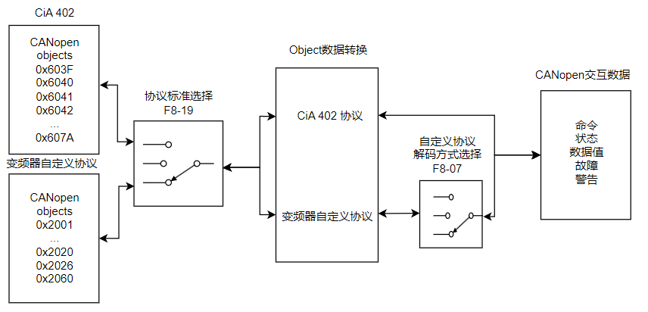Figure 29 Communication Sub-Protocol Selection Diagram
The CANopen control index definitions supported by the inverter are as follows:
Table 57 CANopen Control Index
CANopen Protocol Standard Selection | Speed Mode |  | Torque Mode |  | Operation Control
CANopen Protocol Standard Selection | index-subindex | Meaning | index-subindex | Meaning | index-subindex | Meaning
CiA402 | 0x6042-0x00 | Target Speed (rpm) | 0x6071-0x00 | Target Torque (%) | 0x6040-0x00 | Operation Command
CiA402 | \ | \ | 0x6072-0x00 | Maximum Torque Limit (%) | 0x605A-0x00 | Fast Shutdown Handling Method
CiA402 | \ | \ | \ | \ | 0x605C-0x00 | Prohibited Operation Handling Method
Midea Protocol One | 0x2020-0x02 | Target Frequency (Hz) | \ | \ | 0x2020-0x01 | Operation Command
Midea Protocol Two | 0x2060-0x03 | Target Frequency (Hz) | 0x2060-0x07 | Target Torque (%) | 0x2060-0x01 | Operation Command
Midea Protocol Two | 0x2060-0x04 | Torque Limit (%) | 0x2060-0x08 | Frequency Limit (%) | \ | \

General Indexes Do Not Require Sub-Protocol Selection, All Can Be Used, Relevant Indexes Are as Follows:
- Read-Only (RO) Attribute Indexes.
- Parameter Group Read-Write Indexes (0x2010-0x01 ~ 0x201F-0x64, 0x2070-0x01 ~ 0x20B0-0x64)
- Acceleration/Deceleration Time Setting Indexes (0x604F-0x00, 0x6050-0x00)

Sub-protocol Introduction
CiA 402 protocol is a CANopen application layer protocol specifically designed for inverters and motion control scenarios, built on top of the CiA 301 protocol. Divides the inverter into 9 operating states, including Start, Initialization (Not ready to switch on), Standby (Switch on disable), Ready to Operate (Ready to switch on), Operation (Switch on), Operation Enabled (Operate enable), Quick Stop (Quick stop active), Fault Reaction (Fault reaction active), and Fault. After the inverter is powered on and completes initialization, it will remain in the Ready to Operate state. The inverter can only be controlled to operate when it is in the normal operating state.
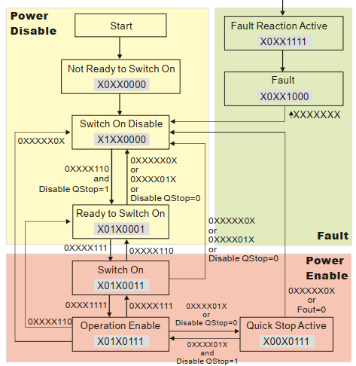
Figure 30 Inverter State Machine
Note: When the setting value of Index 605A is 5~7, the inverter can be controlled to return directly from fast shutdown to operational enable by disabling fast shutdown and control command. Otherwise, the inverter cannot return directly from fast shutdown to operational enable.

Table 58Control Word (Index 6040h)
bits | 15~9 | 8 | 7 | 6~4 | 3 | 2 | 1 | 0
Meaning | Reserved | Halt | Fault Reset | Normal Operation | Operational Enable | Fast Shutdown | Enable Voltage | Running
Note: To start the motor, first send 0xxxx110 (06h) to enter the Ready to Switch ON state under no error conditions, then send 0xxxx111 (07h) to enter the Switch ON state, and the motor will start rotating.

Table 59Status Word (Index 6041h)
bits | 15~14 | 13~12 | 11 | 10 | 9 | 8 | 7 | 6 | 5 | 4 | 3 | 2 | 1 | 0
Meaning | Reserved | Normal Operation | Amplitude Limiting Action | Target Value Reached | Remote Control | Reserved | Warning | Disable Operation | Fast Shutdown | Voltage Enable | Fault | Operation Enable | Running | Operation Preparation Complete
CANopen Object Dictionary
Table 60Standard Object Dictionary (Object Dictionary)
Index | Object
0000h | Reserved
0001h ~ 025Fh | Data Types (Data types)
0260h ~ 0FFFh | Reserved
1000h ~ 1FFFh | 通讯对象子协议区(Communication profile area )
2000h ~ 5FFFh | 制造商特定子协议区(Manufacturer-specific profile area)
6000h ~ 9FFFh | 标准化设备子协议区(Standardized profile area)
A000h ~ AFFFh | Standardized Network variable area, compliant with IEC61131-3
B000h ~ BFFFh | Standardized System variable area for routing gateways
C000h ~ FFFFh | Reserved
Table 61Communication profile area
Index  (hex) | sub-Index  (hex) | Name | Data format | Read/Write | Meaning
1000 | 0 | Device type | unsigned 32 | RO | Device Type Description
1001 | 0 | Fault Register | unsigned 8 | RO | Describe fault type, refer to the fault register description table below for details
1005 | 0 | Synchronous Message COB-ID | unsigned 32 | RW | Synchronous message COB-ID for synchronous transmission
1006 | 0 | Synchronous Communication Cycle Period | unsigned 32 | RW | Set synchronous communication cycle period (us)
100C | 0 | Guard Time | unsigned 16 | RW | Guard time (ms) * Lifetime factor = Node guard protocol lifetime
100D | 0 | Lifetime Factor | unsigned 8 | RW | Guard time (ms) * Lifetime factor = Node guard protocol lifetime
1010 | 1 | Save Parameters | unsigned 32 | RW | Write SDO value 0x65766173 (“evas”) to save all parameters
 | 2 |  |  |  | Write SDO value 0x65766173 (“evas”) to save communication parameters (index 0x1000~0x1FFF)
1011 | 1 | Restore default parameters | unsigned 32 | RW | Write SDO value 0x64616F6C (“daol”) to restore all parameters to default values
 | 2 |  |  |  | Write SDO value 0x64616F6C (“daol”) to restore communication parameters (index 0x1000~0x1FFF) to default values
1014 | 0 | Emergency message COB-ID | unsigned 32 | RW | Define emergency object (EMCY) COB-ID, default value: 0x80 + Node-ID
1016 | 1 | Consumer heartbeat time | unsigned 32 | RW | Value definition: bits 31 ~ 24 reserved, bits 23 ~ 16 Node-ID, bits 15 ~ 0 heartbeat time (ms)
1017 | 0 | Production End Heartbeat Time | unsigned 32 | RW | Define Heartbeat Cycle Time (ms), Write 0 to Disable Heartbeat Function
1018 | 1 | Supplier ID | unsigned 32 | RO | Supplier ID, Inverter Manufacturer Value: 0x476 (Temporary Use)
 | 2 | Product Code |  |  | Product Code
 | 3 | Version Number |  |  | Version Number
1400 | 0 | RPDO1 Communication Parameters | unsigned 8 | RO | Maximum Supported Sub-index Count
 | 1 | COB-ID | unsigned 32 | RW | Default Value: 0x200 + Node-ID
 | 2 | Transmission Type | unsigned 8 | RW | Default Value: 5
1401 | 0 | RPDO2 Communication Parameters | unsigned 8 | RO | Maximum Supported Sub-index Count
 | 1 | COB-ID | unsigned 32 | RW | Default Value: 0x80000300 + Node-ID (Disable RPDO2)
 | 2 | Transmission Type | unsigned 8 | RW | Default Value: 5
1402 | 0 | RPDO3 Communication Parameters | unsigned 8 | RO | Maximum Supported Sub-index Count
 | 1 | COB-ID | unsigned 32 | RW | Default value:0x80000400 + Node-ID (Disable RPDO3)
 | 2 | Transmission Type | unsigned 8 | RW | Default Value: 5
1403 | 0 | RPDO4 Communication Parameters | unsigned 8 | RO | Maximum Supported Sub-index Count
 | 1 | COB-ID | unsigned 32 | RW | Default value:0x80000500 + Node-ID (Disable RPDO4)
 | 2 | Transmission Type | unsigned 8 | RW | Default Value: 5
1600 | 0 | RPDO1 Mapping Parameters | unsigned 8 | RO | Number of Mapped Objects (0~4)
 | 1 | Mapped Object 1 | unsigned 32 | RW | Default value:0x60400010, 0x6040-0x00 indicates the 16-bit control word in CiA 402 protocol
 | 2 | Mapped Object 2 | unsigned 32 | RW | Default value:0x60420010, 0x6042-0x00 indicates the 16-bit status word in CiA 402 protocol
 | 3 | Mapped Object 3 | unsigned 32 | RW
 | 4 | Mapped Object 4 | unsigned 32 | RW
1601 | 0 | RPDO2 Mapping Parameters | unsigned 8 | RO | Number of Mapped Objects (0~4)
 | 1 | Mapped Object 1 | unsigned 32 | RW | Default value:0x20264110, 0x2026-0x41 indicates the 16-bit DO status setting value in Custom Protocol One
 | 2 | Mapped Object 2 | unsigned 32 | RW | Default value:0x2026A110, 0x2026-0xA1 indicates the 16-bit AO1 ratio setting value in Custom Protocol One
 | 3 | Mapped Object 3 | unsigned 32 | RW | Default value:0x2026A210, 0x2026-0xA2 indicates the 16-bit AO2 ratio setting value in Custom Protocol One
 | 4 | Mapped Object 4 | unsigned 32 | RW
1602 | 0 | RPDO3 Mapping Parameters | unsigned 8 | RO | Number of Mapped Objects (0~4)
 | 1 | Mapped Object 1 | unsigned 32 | RW | Default value:0x60400010, 0x6040 indicates the 16-bit control word in CiA 402 Protocol
 | 2 | Mapped Object 2 | unsigned 32 | RW | Default value:0x607A0020, 0x6042 indicates the 32-bit target position in CiA 402 Protocol
 | 3 | Mapped Object 3 | unsigned 32 | RW | Default value:0x60600008, 0x6042 indicates the 8-bit operation mode selection in CiA 402 Protocol
 | 4 | Mapped Object 4 | unsigned 32 | RW
1603 | 0 | RPDO4 Mapping Parameters | unsigned 8 | RO | Number of Mapped Objects (0~4)
 | 1 | Mapped Object 1 | unsigned 32 | RW | Default value:0x60400010, 0x6040 indicates the 16-bit control word in CiA 402 Protocol
 | 2 | Mapped Object 2 | unsigned 32 | RW | Default value:0x60710010, 0x6042 indicates the 16-bit target torque in CiA 402 Protocol
 | 3 | Mapped Object 3 | unsigned 32 | RW | Default value:0x60600008, 0x6042 indicates the 8-bit operation mode selection in CiA 402 Protocol
 | 4 | Mapped Object 4 | unsigned 32 | RW
1800 | 0 | TPDO1 Communication Parameters | unsigned 8 | RO | Maximum Supported Sub-index Count
 | 1 | COB-ID | unsigned 32 | RW | Default value:0x180 + Node-ID
 | 2 | Transmission Type | unsigned 8 | RW | Default Value: 5
 | 3 | Inhibition Time | unsigned 8 | RW | PDO Transmission Minimum Interval, default value:0 (not used)
 | 5 | Event Timer | unsigned 8 | RW | Default value:0 (not used)
1801 | 0 | TPDO2 Communication Parameters | unsigned 8 | RO | Maximum Supported Sub-index Count
 | 1 | COB-ID | unsigned 32 | RW | Default value:0x80000280 + Node-ID (TPDO2 disabled)
 | 2 | Transmission Type | unsigned 8 | RW | Default Value: 5
 | 3 | Inhibition Time | unsigned 8 | RW | PDO Transmission Minimum Interval, default value:0 (not used)
 | 5 | Event Timer | unsigned 8 | RW | Default value:0 (not used)
1802 | 0 | TPDO3 Communication Parameters | unsigned 8 | RO | Maximum Supported Sub-index Count
 | 1 | COB-ID | unsigned 32 | RW | Default value:0x80000380 + Node-ID (TPDO3 disabled)
 | 2 | Transmission Type | unsigned 8 | RW | Default Value: 5
 | 3 | Inhibition Time | unsigned 8 | RW | PDO Transmission Minimum Interval, default value:0 (not used)
 | 5 | Event Timer | unsigned 8 | RW | Default value:0 (not used)
1803 | 0 | TPDO4 Communication Parameters | unsigned 8 | RO | Maximum Supported Sub-index Count
 | 1 | COB-ID | unsigned 32 | RW | Default value:0x80000480 + Node-ID (TPDO4 disabled)
 | 2 | Transmission Type | unsigned 8 | RW | Default Value: 5
 | 3 | Inhibition Time | unsigned 8 | RW | PDO Transmission Minimum Interval, default value:0 (not used)
 | 5 | Event Timer | unsigned 8 | RW | Default value:0 (not used)
1A00 | 0 | TPDO1 Mapping Parameters | unsigned 8 | RW | Number of Mapped Objects (0~4)
 | 1 | Mapped Object 1 | unsigned 32 | RW | Default value:0x60410010, 0x6041-0x00 indicates the 16-bit status word in the CiA 402 protocol
 | 2 | Mapped Object 2 | unsigned 32 | RW | Default value:0x60430010, 0x6043-0x00 indicates the 16-bit real-time target speed (rpm) in the CiA 402 protocol
 | 3 | Mapped Object 3 | unsigned 32 | RW
 | 4 | Mapped Object 4 | unsigned 32 | RW
1A01 | 0 | TPDO2 Mapping Parameters | unsigned 8 | RW | Number of Mapped Objects (0~4)
 | 1 | Mapped Object 1 | unsigned 32 | RW | Default value:0x20260110, 0x2026-0x01 indicates the status of 16-bit DI terminals in Custom Protocol One
 | 2 | Mapped Object 2 | unsigned 32 | RW | Default value:0x20266110, 0x2026-0x61 indicates the 16-bit AI1 ratio value in Custom Protocol One
 | 3 | Mapped Object 3 | unsigned 32 | RW | Default value:0x20266210, 0x2026-0x62 indicates the 16-bit AI2 ratio value in Custom Protocol One
 | 4 | Mapped Object 4 | unsigned 32 | RW | Default value:0x20266310, 0x2026-0x63 indicates the 16-bit AI3 ratio value in Custom Protocol One
1A02 | 0 | TPDO3 Mapping Parameters | unsigned 8 | RW | Number of Mapped Objects (0~4)
 | 1 | Mapped Object 1 | unsigned 32 | RW | Default value:0x60410010, 0x6041-0x00 indicates the 16-bit status word in the CiA 402 protocol
 | 2 | Mapped Object 2 | unsigned 32 | RW | Default value:0x60640020, 0x6064-0x00 indicates the 32-bit actual position in CiA 402 Protocol
 | 3 | Mapped Object 3 | unsigned 32 | RW | Default value:0x60610008, 0x6061-0x00 indicates 8-bit operating mode in CiA 402 protocol
 | 4 | Mapped Object 4 | unsigned 32 | RW
1A03 | 0 | TPDO4 mapping parameters | unsigned 8 | RW | Number of Mapped Objects (0~4)
 | 1 | Mapped Object 1 | unsigned 32 | RW | Default value:0x60410010, 0x6041-0x00 indicates the 16-bit status word in the CiA 402 protocol
 | 2 | Mapped Object 2 | unsigned 32 | RW | Default value:0x60770010, 0x6077-0x00 indicates 32-bit actual torque value in CiA 402 protocol
 | 3 | Mapped Object 3 | unsigned 32 | RW | Default value:0x60610008, 0x6061-0x00 indicates 8-bit operating mode in CiA 402 protocol
 | 4 | Mapped Object 4 | unsigned 32 | RW

Table 62Fault Register Description
Bit | Description
0 | General Fault
1 | Current
2 | Voltage
3 | Temperature
4 | Communication Fault
5 | Device Protocol Specified
6 | Reserved
7 | Vendor Specified

Custom Protocol One
Table 63 Custom Protocol One
Index | Sub-Index | R/W | Data format | Meaning
0x2010+PrGroupNum  0x2070+PrGroupNum-0xE | PrNum+1 | R/W | unsigned 16 | Inverter Parameter Setting and Reading※
0x2020 | 0x01 | R/W | unsigned 16 | Control Command Word
0x2020 | 0x02 | R/W | unsigned 16 | Frequency Command (0.01Hz)
0x2020 | 0x03 | R/W | unsigned 16 | Trigger Command
0x2021 | 0x01 | R | unsigned 16 | Hbyte:warn code  Lbyte:Error code
0x2021 | 0x02 | R | unsigned 16 | Inverter operating status
0x2021 | 0x03 | R | unsigned 16 | Frequency Command (0.01Hz)
0x2021 | 0x04 | R | unsigned 16 | Output Frequency (0.01Hz)
0x2021 | 0x05 | R | unsigned 16 | Output Current (0.1A)
0x2021 | 0x06 | R | unsigned 16 | DC Bus Voltage (0.1V)
0x2021 | 0x07 | R | unsigned 16 | Output Voltage (0.1V)
0x2021 | 0x08 | R | unsigned 16 | Current multi-speed command segment
0x2021 | 0x09 | R | unsigned 16 | Reserved
0x2021 | 0x0A | R | unsigned 16 | Display count value
0x2021 | 0x0B | R | unsigned 16 | Output power factor angle (0.1 degrees)
0x2021 | 0x0C | R | unsigned 16 | Output torque (0.1%)
0x2021 | 0x0D | R | unsigned 16 | Actual motor speed (rpm)
0x2021 | 0x0E | R | unsigned 16 | PG feedback pulse count (0-65535)
0x2021 | 0x0F | R | unsigned 16 | PG2 pulse command count (0-65535)
0x2021 | 0x10 | R | unsigned 16 | Output power (0.001kwh)
0x2021 | 0x11 | R | unsigned 16 | Parameter group number
0x2021 | 0x13 | R | unsigned 16 | Firmware Version (highword)
0x2021 | 0x14 | R | unsigned 16 | Hbyte: Startup Screen Selection F7-20  Lbyte: Multi-function Display Selection F7-21
0x2022 | 0x01 | R | unsigned 16 | Output Current (0.01A), when current exceeds 655.36A, decimal place automatically switches to 1
0x2022 | 0x02 | R | unsigned 16 | Display count value
0x2022 | 0x03 | R | unsigned 16 | Output Frequency (0.01Hz)
0x2022 | 0x04 | R | unsigned 16 | DC Bus Voltage (0.1V)
0x2022 | 0x05 | R | unsigned 16 | Output Voltage (0.1V)
0x2022 | 0x06 | R | unsigned 16 | Output power factor angle (0.1 degrees)
0x2022 | 0x07 | R | unsigned 16 | Three-phase Output Power (kW)
0x2022 | 0x08 | R | unsigned 16 | Actual motor speed (rpm)
0x2022 | 0x09 | R | unsigned 16 | Output torque (0.1%)
0x2022 | 0x0A | R | unsigned 16 | PG feedback pulse count (0-65535)
0x2022 | 0x0B | R | unsigned 16 | After PID Function Activation, Display PID Feedback Value (0.01%)
0x2022 | 0x0C | R | unsigned 16 | AI1 Terminal Input Value (0-100%)
0x2022 | 0x0D | R | unsigned 16 | AI2 Terminal Input Value (0-100%)
0x2022 | 0x0E | R | unsigned 16 | AI3 Terminal Input Value (0-100%)
0x2022 | 0x0F | R | unsigned 16 | Power Module IGBT Temperature (0.1℃)
0x2022 | 0x11 | R | unsigned 16 | Digital Terminal Input Mode Selection (F5—15)
0x2022 | 0x12 | R | unsigned 16 | Digital Terminal Output Mode Direction (F6—04)
0x2022 | 0x13 | R | unsigned 16 | Current multi-speed command segment
0x2022 | 0x14 | R | unsigned 16 | Digital Terminal Input Status (1: on)
0x2022 | 0x15 | R | unsigned 16 | Digital Terminal Output Status (1: on)
0x2022 | 0x16 | R | unsigned 16 | Motor Rotation Count (0—65535), Count Reset on Direction Change or Stop
0x2022 | 0x17 | R | unsigned 16 | Pulse Input Frequency (PG2.0.01Hz)
0x2022 | 0x18 | R | unsigned 16 | Pulse Input Position (PG2, 0—65535)
0x2022 | 0x1A | R | unsigned 16 | Overload Count (0.00-100.00%)
0x2022 | 0x1B | R | unsigned 16 | GFF Percentage Value (0.01%)
0x2022 | 0x1C | R | unsigned 16 | DC Bus Voltage (0.1V)
0x2022 | 0x1E | R | unsigned 16 | Synchronous Motor Pole Segment
0x2022 | 0x1F | R | unsigned 16 | User Physical Quantity Output
0x2022 | 0x20 | R | unsigned 16 | Actual Output Frequency Gain Coefficient (0.01)
0x2022 | 0x21 | R | unsigned 16 | Motor Rotation Count (Stop Hold, Reset Before Operation)
0x2022 | 0x22 | R | unsigned 16 | Motor Running Position (Stop Hold, Reset Before Operation)
0x2022 | 0x25 | R | unsigned 16 | Inverter Carrier Frequency (kHz)
0x2022 | 0x27 | R | unsigned 16 | Inverter Status
0x2022 | 0x28 | R | unsigned 16 | Output torque (0.1%)
0x2022 | 0x29 | R | unsigned 16 | Torque Command (0.1%)
0x2022 | 0x2A | R | unsigned 16 | Energy Display (0.1kWh)
0x2022 | 0x2B | R | unsigned 16 | PG2 Pulse Input (highword)
0x2022 | 0x2C | R | unsigned 16 | PG2 Pulse Input (lowword)
0x2022 | 0x2D | R | unsigned 16 | Actual Motor Position (highword)
0x2022 | 0x2E | R | unsigned 16 | Actual Motor Position (lowword)
0x2022 | 0x2F | R | unsigned 16 | PID Reference Target (0.01%)
0x2022 | 0x30 | R | unsigned 16 | PID Offset (0.01%)
0x2022 | 0x31 | R | unsigned 16 | PID Output Frequency (0.01Hz)
0x2026 | 0x01 | R | unsigned 16 | DI Terminal Input Status
0x2026 | 0x02 | R | unsigned 16 | Extended DI Terminal Input Status
0x2026 | 0x03-0x40 | R | \ | Reserved
0x2026 | 0x41 | R/W | unsigned 16 | DO Terminal Output Status
0x2026 | 0x42-0x60 | R | unsigned 16 | Reserved
0x2026 | 0x61 | R | unsigned 16 | AI1 Proportional Value
0x2026 | 0x62 | R | unsigned 16 | AI2 Ratio Value
0x2026 | 0x63 | R | unsigned 16 | AI3 Ratio Value
0x2026 | 0x64-0x6A | R | unsigned 16 | Reserved
0x2026 | 0x6B | R | unsigned 16 | Expansion Card AI10 Input Ratio Value
0x2026 | 0x6C | R | unsigned 16 | Expansion Card AI11 Input Ratio Value
0x2026 | 0xA1 | R/W | unsigned 16 | AO1 Output Ratio Value
0x2026 | 0xA2 | R/W | unsigned 16 | AO2 Output Ratio Value
0x2026 | 0xA3-0xAA | R/W | unsigned 16 | Reserved
0x2026 | 0xAB | R/W | unsigned 16 | Expansion Card AO10 Output Ratio Value
0x2026 | 0xAC | R/W | unsigned 16 | Expansion Card AO11 Output Ratio Value
※Note the mapping relationship between object dictionary and inverter function codes is as follows:
Object Dictionary Index = 0x2010 + Function Code Group Number (F0-FF Function Group);
or 0x2070 + Function Code Group Number (U0-L8 Function Group) - 0xE
Object Dictionary Sub-index = Function Code Group Internal Offset in Hexadecimal + 1;
Table 64Control Command Word Bit Definition:
Control Command Word
bit 1-0 | 0: No Function
bit 1-0 | 1: Stop
bit 1-0 | 2: Start
bit 1-0 | 3: JOG Start
bit 3-2 | Reserved
bit 5-4 | 0: No Function
bit 5-4 | 1: Forward Command
bit 5-4 | 2: Reverse Command
bit 5-4 | 3: Change Direction
bit 7-6 | 0: First Ramp
bit 7-6 | 1: Second Ramp
bit 7-6 | 2: Third Ramp
bit 7-6 | 3: Fourth Ramp
bit 11-8 | 0: Main Speed
bit 11-8 | 1-15: First to Fifteenth Segment Speed Selection
bit 12 | 1: Enable bit6-bit11 function
bit 15-13 | Reserved
Table 65Trigger Command Word Bit Definition
Trigger Command
bit 0 | 1: External Fault (EF)
bit 1 | 1: Reset Command
bit 2 | 1: External Interrupt (BB)
bit 15-3 | Reserved
Table 66Inverter Operation Status Word Bit Definition
Inverter operating status
bit 1-0 | 0: Stop
bit 1-0 | 1: Accelerating
bit 1-0 | 2: Standby
bit 2 | JOG operation
bit 4-3 | 0: Forward
bit 4-3 | 1: Reverse to forward
bit 4-3 | 2: Forward to reverse
bit 4-3 | 3: Reverse
bit 7-5 | Reserved
bit 8 | 1: Main frequency source is communication interface
bit 9 | 1: Main frequency source is analog input
bit 10 | 1: Main command source is communication interface
bit 11 | 1: Parameter lock
bit 12 | 1: Enable keypad parameter copy function
bit 15-13 | Reserved
Table 67Inverter status word bit definition
Inverter Status
bit 1-0 | 0: No direction
bit 1-0 | 1: Forward
bit 1-0 | 2: Reverse
bit 3-2 | 0: Inverter Ready
bit 3-2 | 1: Inverter Fault
bit 4 | 1: Inverter Output 0: No Output
bit 5 | 1: Warning 0: No Warning
For the mapping relationship between terminal inputs/outputs and CANopen index, refer to 5.3 CANopen Analog AIO and DIO Description.
6.3.5 Custom Protocol Two
Table 68 Custom Protocol Two
Index | Sub-Index | R/W | Data format | Bit Definition |  | Speed Mode |  | Torque Mode
 |  |  |  | bit | Meaning |  |  | Torque Mode
0x2060 | 0x01 | R/W | unsigned 16 | 0 | Ack | 0: fcmd = 0  1: fcmd = fset |  | \
 |  |  |  | 1 | Dir | 0: Forward Command  1: Reverse Command |  | \
 |  |  |  | 2 | Move | \ |  | \
 |  |  |  | 3 | Halt | 0: Continue Running to Target Speed  1: Temporarily Stop According to Deceleration Settings |  | \
 |  |  |  | 4 | Hold | 0: Continue Running to Target Speed  1: Maintain Current Frequency |  | \
 |  |  |  | 5 | JOG | 0: OFF 1: RUN |  | \
 |  |  |  | 6 | Qstop | Fast Shutdown
 |  |  |  | 7 | RUN | 0: Shutdown 1: Startup
 |  |  |  | 8 | Multi-Speed Selection Bit | Multi-Speed Selection Bit 0 |  | \
 |  |  |  | 9 | Multi-Speed Selection Bit | Multi-Speed Selection Bit 1 |  | \
 |  |  |  | 10 | Multi-Speed Selection Bit | Multi-Speed Selection Bit 2 |  | \
 |  |  |  | 11 | Multi-Speed Selection Bit | Multi-Speed Selection Bit 3 |  | \
 |  |  |  | 12 | Acceleration and Deceleration Time Selection Bit | Acceleration and Deceleration Time Selection Bit 0 |  | \
 |  |  |  | 13 | Acceleration and Deceleration Time Selection Bit | Acceleration and Deceleration Time Selection Bit 1 |  | \
 |  |  |  | 14 | Software Terminal Function Enable | Software Multi-Speed and Acceleration/Deceleration Time Switching Enable |  | \
 |  |  |  | 15 | Reset | Clear Fault Code
0x2060 | 0x02 | R/W | unsigned 16 | 0-15 | Run Mode Command | 0: Speed Mode |  | 2: Torque Mode
0x2060 | 0x03 | R/W | unsigned 16 | 0-15 |  | Frequency Command (0.01Hz) |  | \
0x2060 | 0x04 | R/W | unsigned 16 | 0-15 |  | Torque Limit Value (0.01pu)
0x2060 | 0x05 | R/W | signed 32 | 0-31 | Reserved | Reserved
0x2060 | 0x06 | R/W | unsigned 16 | 0-15 | Reserved | Reserved
0x2060 | 0x07 | R/W | signed 16 | 0-15 |  | \ |  | Torque Command
0x2060 | 0x08 | R/W | unsigned 16 | 0-15 |  | \ |  | Speed Limit
0x2061 | 0x01 | R | unsigned 16 | 0 | Arrive | Frequency Command Arrival | Torque Command Arrival
 |  |  |  | 1 | Dir | 0: Forward 1: Reverse
 |  |  |  | 2 | Warn | Warning Occurred
 |  |  |  | 3 | Error | Fault Occurred
 |  |  |  | 4 | Reserved | Reserved
 |  |  |  | 5 | JOG | JOG operation
 |  |  |  | 6 | Qstop | Fast Shutdown
 |  |  |  | 7 | PowerOn | Excitation
 |  |  |  | 15-8 | Reserved | Reserved
0x2061 | 0x02 | R | unsigned 16 | 0-15 | Reserved | Reserved
0x2061 | 0x03 | R | unsigned 16 | 0-15 | Frequency | Actual Output Frequency
0x2061 | 0x04 | R | unsigned 16 | 0-15 | Reserved | Reserved
0x2061 | 0x05 | R | signed 32 | 0-31 | Reserved | Reserved
0x2061 | 0x06 | R | unsigned 16 | 0-15 | Reserved | Reserved
0x2061 | 0x07 | R | signed 16 | 0-15 | Torque | Actual Torque

6.3.6 CiA 402
Table 69 CiA 402 Supported Index
Index | Sub-Index | Definition | Default Value | R/W | Data format | Unit | PDO Mapping
0x6007 | 00h | Communication Exception Action Selection | 2 | R/W | signed 16 | \ | Yes
0x603F | 00h | CANopen Fault Code | 0 | RO | unsigned 16 | \ | Yes
0x6040 | 00h | Control Word | 0 | R/W | unsigned 16 | \ | Yes
0x6041 | 00h | Status Word | 0 | RO | unsigned 16 | \ | Yes
0x6042 | 00h | Target Speed (vl) | 0 | R/W | signed 16 | rpm | Yes
0x6043 | 00h | Actual Target Speed (vl) | 0 | RO | signed 16 | rpm | Yes
0x6044 | 00h | Actual Speed (vl) | 0 | RO | signed 16 | rpm | Yes
0x604F | 00h | First Acceleration Time (vl) | 10000 | R/W | unsigned 32 | ms | Yes
0x6050 | 00h | First Deceleration Time (vl) | 10000 | R/W | unsigned 32 | ms | Yes
0x6051 | 00h | Rapid Stop Time (vl) | 0 | R/W | unsigned 32 | ms | Yes
0x605A | 00h | Rapid Stop Option | 2 | R/W | signed 16 | \ | No
0x605C | 00h | Stop Option | 1 | R/W | signed 16 | \ | No
0x6060 | 00h | Operation Mode Selection | 2 | R/W | signed 8 | \ | Yes
0x6061 | 00h | Operation Mode Display | 2 | RO | signed 8 | \ | Yes
0x6064 | 00h | Actual Position Value (pp) | 0 | RO | signed 32 | \ | Yes
0x 6071 | 00h | Target Torque (tq) | 0 | R/W | signed 16 | 0.001 | Yes
0x 6072 | 00h | Maximum Torque (tq) | 150 | R/W | unsigned 16 | 0.001 | No
0x 6075 | 00h | Motor Rated Current (tq) | 0 | RO | unsigned 32 | mA | No
0x 6077 | 00h | Actual Torque Value (tq) | 0 | RO | signed 16 | 0.1%* | Yes
0x 6078 | 00h | Actual Current Value (tq) | 0 | RO | signed 16 | 0.1%* | No
0x 6079 | 00h | DC bus voltage (tq) | 0 | RO | unsigned 32 | mV | Yes
0x 607A | 00h | Target position (PP) | 0 | R/W | signed 32 | \ | Yes
*: Motor rated values are 100%
Control word (6040h-00h) bit definitions are as follows:
15 11 |  |  |  |  | 10 | 9 | 8 | 7 | 6 4 |  |  | 3 | 2 | 1 | 0
ms |  |  |  |  | r | oms | h | fr | oms |  |  | eo | qs | ev | so
MSB |  |  |  |  |  |  |  |  |  |  |  |  |  |  | LSB
Note: ms = manufacture-specific; r = reserved; oms = operation mode specific; h = halt;
fr = fault reset; eo = enable operation; qs = quick stop; ev = enable voltage; so = switch on

Status word (6041h-00h) bit definitions are as follows:
15 | 14 | 13 | 12 | 11 | 10 | 9 | 8 | 7 | 6 | 5 | 4 | 3 | 2 | 1 | 0
ms |  | oms |  | ila | tr | rm | ms | w | sod | qs | ve | f | oe | so | rtso
MSB |  |  |  |  |  |  |  |  |  |  |  |  |  |  | LSB
Note:ms = manufacture-specific; oms = operation mode specific; lia = internal limit active; tr = target reached; rm = remote; w = warning; sod = switch on disable; qs = quick stop;
ve = voltage enable; f = fault; oe = operation enable; so = switch on; rtso = ready to switch on
Status word encoding mapping table is as follows:
Table 70 Status Word Encoding Table
statusword | PDS FSA state
xxxx xxxx x0xx 0000b | Not ready to switch on
xxxx xxxx x1xx 0000b | Switch not disabled
xxxx xxxx x01x 0001b | Ready to switch on
xxxx xxxx x01x 0011b | Switched on
xxxx xxxx x01x 0111b | Operation enabled
xxxx xxxx x00x 0111b | Quick stop active
xxxx xxxx x0xx 1111b | Fault reaction active
xxxx xxxx x0xx 1000b | Fault

CANopen Control Inverter Function Debugging
Preparations for Controlling the Inverter via CANopen are as follows:
- Wiring, refer to 2.2 CAN Wiring Method
- Set the frequency command source, parameter F0-06 = 6, select the frequency command source as CANopen setting.
- Set the operation command source, parameter F0-05 = 3, select the operation command source as CANopen setting.
- Set the CANopen slave station node address, parameter F8-14 sets the slave station address (default value is 0, indicating the slave station function is disabled, 1~127 are valid slave station node addresses). After setting the slave station node address, if a station number error or CANopen memory error is reported, the CANopen can be reset by setting parameter F0-18 = 7.
- Set the CAN communication speed, parameter F8-15 sets the CANopen communication speed, parameter value setting range 0 (1Mbps), 1 (500kbps), 2 (250kbps), 3 (125kbps), 4 (100kbps), 5 (50kbps).
- The master station uses NMT to control the slave station to enter the operational mode.

CANopen selects the CiA 402 protocol.
Under the CiA 402 protocol, speed mode and torque mode are supported. Setting parameter F8-19 = 1 enables the CiA 402 protocol. To enable the fast shutdown function with external terminals, set one of the parameters F5-00~F5-07 or LC-00~LC-02 to 53.

Speed Mode
The debugging steps are as follows:
- Set the operation mode at index 6060h-00h to 2, configuring the inverter to speed mode.
- The control command word controls the inverter to enter the operational enable state; send the control command word 0x0E at index 6040h-00h, then send 0x0F to enable the inverter to enter the operational enable state. Note the control of the bits 6~4 of the control command word, defined as follows:

Table 71 Control Command Word Bits 6~4
Bit 6 | bit 5 | bit 4 | Function
1 | 0 | 1 | Run at the current frequency
1 | 1 | 1 | Run to target
x | x | x | Decelerate to 0Hz
- Set the target speed, set the target speed at index 6042h-00h, unit is rpm, set a positive value for forward rotation, a negative value for reverse rotation. Note the relationship between motor speed and frequency (information on the number of motor pole pairs).
- Set acceleration and deceleration time, set the inverter acceleration and deceleration time at indices 604Fh-00h and 6050h-00h, unit is ms.
- Get the current operating speed, read index 6043h-00h to obtain the current operating speed, unit is rpm.

Torque Mode
The debugging steps are as follows:
- Set index 6060h-00h to 4, setting the inverter to torque mode, at this time 6042h-00h is used to set the speed limit.
- The control command word controls the inverter to enter the operational enable state; send the control command word 0x0E at index 6040h-00h, then send 0x0F to enable the inverter to enter the operational enable state.
- Set the target torque, index 6071h-00h sets the target torque, index 6072h-00h sets the maximum torque.
- Get the current torque, read index 6077h-00h to obtain the current torque, unit 0.1%.

CANopen selects the inverter manufacturer's custom protocol
Parameter F8-19 = 0 enables the inverter manufacturer's custom protocol.

Custom Protocol One
The custom protocol only supports speed mode. Debugging steps are as follows:
- Parameter F8-07 = 0 enables custom protocol one.
- Set target frequency, index 2020h-02 sets the target frequency, unit is 0.01Hz, for example, 5000 represents 50Hz.
- Operation control, index 2020h-01h set to 2 for operation, index 2020h-01h set to 1 for shutdown.

Custom Protocol Two
Custom Protocol Two supports speed mode and torque mode.
- Speed Mode Debugging Steps are as follows:
- Parameter F8-07 = 1 enables Custom Protocol Two.
- Set target frequency, index 2060h-03 sets the target frequency, unit is 0.01Hz, for example, 5000 represents 50Hz.
- Operation control, index 2060h-01h set to 80h for excitation, index 2060h-01h set to 81h for operation.
- Torque Mode Debugging Steps:
- Parameter F8-07 = 1 enables Custom Protocol Two.
- Set the target torque, index 2060h-07 sets the target torque, unit is 0.1%, for example, 1000 represents 100%.
- Operation Control, set index 2060h-01h to 80h for excitation, after the inverter is excited, it automatically runs to the target torque.
- Get Current Torque, read index 2061h-07h to obtain the current torque, unit is 0.1%.
Note: In Torque Mode, if the speed reaches the limit value, the inverter may reduce the output torque to ensure the speed remains within the limit.

Analog AIO and DIO
The inverter can simulate the status of IO ports through CANopen data, achieving software simulation of AO (Analog Output) and DO (Digital Output) functions, and can obtain the status of AI (Analog Input) and DI (Digital Input) and send it to the CAN bus. CANopen index and DIO (Digital input and output) and AIO (Analog input and output) mapping table as follows: DI terminal (physical terminal name MI, Multi-function input) and CANopen index (2026h-01h) data bit mapping table:
Table 72 DI terminal and CANopen index data bit mapping table
Terminal Name | Attribute | bit
FWD | RO | bit 0
REV | RO | bit 1
MI 1 | RO | bit 2
MI 2 | RO | bit 3
MI 3 | RO | bit 4
MI 4 | RO | bit 5
MI 5 | RO | Bit 6
MI 10 | RO | bit 10
MI 11 | RO | bit 11
MI 12 | RO | bit 12

DO terminal (physical terminal name MO, Multi-function output) and CANopen index (2026h-41h) data bit mapping table:
Table 73 DO terminal and CANopen index data bit mapping table
Terminal Name | Parameter Setting | Attribute | bit
RY 1 | 02-13 = 50 | RW | bit 0
RY 2 | 02-14 = 50 | RW | bit 1
MO 1 | 02-16 = 50 | RW | bit 3
MO 2 | 02-17 = 50 | RW | bit 4
MO 10 | 02-36 = 50 | RW | bit 5
MO 11 | 02-37 = 50 | RW | Bit 6
MO 12 | 02-38 = 50 | RW | bit 7
AI Terminal (Physical Terminal Names AI1, AI2, AI3, Analog Input) and CANopen Index (2026h) Data Bit Mapping Table:
Table 74 AI Terminal and CANopen Index Data Bit Mapping Table
Terminal Name | Attribute | sub-index
AI1 | RO | 61h
AI2 | RO | 62h
AI3 | RO | 63h
AI 10 | RO | 64h
AI 11 | RO | 65h
AO Terminal and CANopen Index (2026h) Data Bit Mapping Table:
Table 75 AO Terminal and CANopen Index Data Bit Mapping Table
Terminal Name | Parameter Setting | Attribute | sub-index
AO 1 | 03-20 = 20 | RW | A1h
AO 2 | 03-23 = 20 | RW | A2h
AO 10 | 14-12 = 20 | RW | A3h
AO 11 | 14-13 = 20 | RW | A4h
Taking CANopen control of AO and DO as an example, the parameter configuration steps are as follows:
- Set parameter F6-14 = 20, AO1 is defined as controlled by CANopen index 2026h-A1h, controlling the data of index 2026h-A1h can control the output voltage value of AO1. If you want to control AO1 to output 6V voltage (duty = 60%), you need to set index 2026h-A1h to 6000.
- Set parameter F6-00 = 50, RY1 is defined as controlled by bit 0 of CANopen index 2026h-41h, controlling the bit 0 of index 2026h-41h data can control the ON/OFF state of RY1. If you want to control RY1 to output ON, you need to set bit 0 of index 2026h-41h to 1.

CANopen Fault Code
Fault codes can be read through object 0x603F, and fault types can be read through object 0x1001. Fault codes xx80h~xxFFh and FF00h ~ FFFFh are manufacturer-defined.
Table 76 CANopen Fault Codes
Fault Code | Meaning
2213h | Overcurrent during acceleration and deceleration
2240h | Ground fault
2250h | Short circuit fault
2310h | Continuous overcurrent
2314h | Overcurrent at constant speed
2331h | U phase output missing
2332h | V phase output missing
2333h | W Phase Output Phase Loss
3130h | Input Phase Loss
3210h | DC Bus Overvoltage
3220h | DC Bus Undervoltage
3330h | Motor Connection Switching Error
4310h | Inverter Overtemperature
5530h | EEPROM Abnormal
7301h | PG Feedback Abnormal
7320h | Position Out of Limit
7500h | Modbus Communication Fault
8100h | CANopen Software Fault
8130h | CANopen Communication Timeout
8140h | CANopen Disconnection
8311h | Over Torque Fault
8321h | Current Underflow
8A00h | Low Frequency Overload Protection
9000h | External Trigger Fault
FF00h | IGBT Temperature Detection Abnormal (th1o)
FF01h | Capacitor temperature detection abnormal (th2o)
FF04h | U phase current detection error (cd1)
FF05h | V phase current detection error (cd2)
FF06h | W phase current detection error (cd3)
FF07h | CBC hardware circuit abnormal (hd0)
FF08h | OC hardware circuit abnormal (hd1)
FF20h | Motor overheating (oh3)
FF21h | Motor auto-identification error (AUE)
FF22h | PID feedback disconnection
FF25h | AI Disconnection (ACE)
FF26h | Password Input Incorrect Three Times (Pcod)
FF27h | Deceleration Energy Regeneration Action (dEb)
FF28h | Over Slip (oSL)
FF29h | PG Card Hardware Error (PGF5)
FF2Bh | U Phase Short Circuit Detected Before Operation (Aoc)
FF2Ch | V Phase Short Circuit Detected Before Operation (boc)
FF2Dh | W Phase Short Circuit Detected Before Operation (coc)
FF30h | S1 Internal Loop Diagnosed with Abnormality (STL1)
FF31h | STO (STO)
FF32h | S2 Internal Loop Diagnostics Detected an Abnormality (STL2)
FF33h | Internal Loop Diagnostics Detected an Abnormality (STL3)
FF3Dh | Motor Auto-Identification Error (DC Test Phase) (AuE1)
FF3Eh | Motor Auto-Identification Error (High-Frequency Stall Phase) (AuE2)
FF3Fh | Motor Auto-Identification Error (Rotation Test Phase) (AuE3)
Fault Type Data Bit Definitions Are as Follows:
bit | Meaning
0 | General Fault
1 | Current
2 | Voltage
3 | Temperature
4 | Communication Fault
5 | Device Sub-Protocol Specified
6 | Reserved
7 | Vendor Specified

Communication Configuration
For Example, to Configure the Module to Establish CANopen Communication with the PLC. The configuration process varies for different PLC models; please consult technical support for details.

Configure Configuration
1. Create a project
Double-Click to Open the Host Computer Programming Software, Click on 'New Project'. Select the PLC Device Type and Programming Language, Change the Save Path and Project Name, Then Click 'OK'.
Enter the 'Network Configuration' interface, click the PLC icon, and check 'CANopen Master Station'.
2. Install EDS File
If the EDS file has not been installed before, it needs to be installed first. Enter the 'Network Configuration' interface, click 'Import EDS File', find the path where the EDS file is stored, and click 'Open'.
After the EDS file is successfully installed, you can find the CANopen device in the network device list — CANopen port — third-party manufacturers — SUYNE.
3. Configure Slave Station
In the network device list, find the CANopen module, double-click to add the module.
In the 'Device' list, under 'CANopen', find the module device, double-click to enter the configuration interface. In the 'Slave Parameter Configuration' page, check 'Enable Expert Mode' to open more configuration options.
In the 'Slave Station Parameter Configuration' page, the node ID can be configured, and the value must be consistent with the inverter F8-14 setting.
In the 'CANopen Master Station' page, the baud rate can be configured, and the value must be consistent with the inverter F8-15 setting.

Configure Periodic Communication
1. Configure RPDO
The EMH-OP Communication Expansion Card supports 4 RPDO transmissions, with a maximum of 16 register data transmissions.
2. Configure TPDO
The EMH-OP Communication Expansion Card supports 4 TPDO transmissions, with a maximum of 16 register data transmissions.
After configuration is complete, download the configuration, and the PLC and module will automatically perform periodic data exchange.

Configure Non-periodic Communication
1. SDO Read Operation
The module supports the fast SDO transfer mechanism, with each data transmission length being 0~4 bytes. The SDO_READ4 function block of the PLC can achieve SDO read operations.
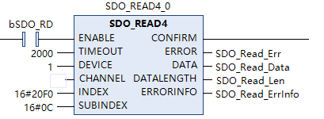
2. SDO Write Operation
The SDO_WRITE4 function block of the PLC can achieve SDO write operations.

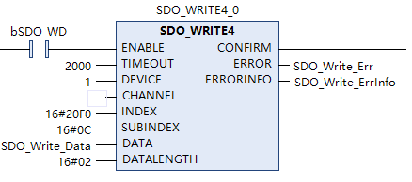

Appendix Periodic General Fault Codes
Table 77 Periodic General Fault Codes
Diagnostic Classification | Status Code
Inverter Body Diagnostic Information (Register Address: 0x2100) | Low Byte (Fault Error Code):  High Byte (Warn Warning Code):
  0 No Abnormal Record  1 Overcurrent During Acceleration  2 Overcurrent During Deceleration  3 Overcurrent During Constant Speed  4 Ground Short Circuit  5 IGBT Upper and Lower Bridge Short Circuit  6 Overcurrent During Stop  7 Overvoltage During Acceleration  8 Overvoltage During Deceleration  9 Overvoltage During Constant Speed  10 Overvoltage During Stop  11 Undervoltage During Acceleration  12 Undervoltage During Deceleration  13 Undervoltage During Constant Speed  14 Undervoltage during Stop  15 Input Phase Loss Protection  16 IGBT Overtemperature  17 Ambient Overtemperature  21 Inverter Overload  22 Motor 1 Overload Protection  23 Motor 2 Overload Protection  24 Motor Overheat  26 Over Torque 1  27 Over Torque 2  28 Low Current  29 Limit Reached  31 Memory Read Error  33 U Phase Current Detection Error  34 V Phase Current Detection Error  35 W Phase Current Detection Error  36 cc Hardware Circuit Abnormality  37 oc Hardware Circuit Abnormality  38 ov Hardware Circuit Abnormality  40 Motor Parameter Identification Error  41 PID Disconnection  42 PG Feedback Setting Error  43 PG Feedback Disconnection  44 PG Feedback Stall  45 PG Slip Abnormality  48 AI Current Signal Disconnection  49 External Fault  50 External Terminal Emergency Stop  51 External Interruption  52 Password Input Incorrect Three Times (Pcod)  54 Illegal Communication Command | 55 Illegal Communication Address  56 Communication Data Error  57 Communication Write to Read-Only Address  58 Modbus Transmission Timeout  62 Deceleration Regenerative Braking Action  63 Excessive Slip  64 Please Reset Machine Code  65 PG Card Hardware Error  69 Feedback Speed Divergence  70 Feedback Speed Deviation Excessive  72 STO1 Fault  76 STO  77 STO2 Fault  79 U Phase Overcurrent  80 V Phase Overcurrent  81 W Phase Overcurrent  82 U Phase Output Phase Loss  83 V Phase Output Phase Loss  84 W Phase Output Phase Loss  87 Low Frequency Overload Protection  101 CANopen Disconnection 1  102 CANopen Disconnection 2  104 CANopen Hardware Disconnection  105 CANopen Index Error  106 CANopen Station Number Error  107 CANopen Memory Error  120 EMS Overcurrent  128 Over Torque 3  129 Over Torque 4  134 Motor 3 Overload Protection  135 Motor 4 Overload Protection  141 Ground Fault Before Operation  142 Parameter Identification Error 1  143 Parameter Identification Error 2  144 Tension Band Break  147 Tension PID Deviation Too Large
  0 No Abnormal Record
  1 Communication Command Error
  2 Communication Address Error
  3 Communication Data Error
  4 Inverter Unable to Process
  5 Communication Transmission Timeout
  7 Parameter Copy Error
  8 Parameter Copy Error
  9 IGBT Overheat Warning
  11 PID Feedback Signal Warning
  12 AI Current Signal Disconnection
  15 PG Feedback Error
  17 Overspeed Warning
  18 Speed Deviation Too Large
  19 Input Phase Loss
  20 Over Torque 1
  21 Over Torque 2
  22 Motor Overheat
  24 Over Slip
  25 Parameter Identification In Progress
  28 Output Phase Loss Warning
  30 Different Model Parameter Copy Error
  31 Over Torque 3
  32 Over Torque 4
  36 CANopen Software Disconnection 1
  37 CANopen Software Disconnection 2
  39 CANopen Hardware Disconnection
  40 CANopen Index Error
  41 CANopen Station Number Error
  42 CANopen Memory Error

Appendix Modbus Communication

Communication Introduction
The CM680 series inverter uses an RS485 communication interface to connect with a PC/PLC for communication, forming a single-master multiple-slave PC/PLC communication network. Each communication slave must have a unique slave address, with the setting range for the slave address being 1 to 254, and 0 being the broadcast communication address. Users can control slaves (inverters) centrally through the master (usually a PC or PLC), achieving functions such as setting inverter operation commands, modifying and reading parameters, and reading inverter operating status and fault information through the Modbus communication protocol.
The CM680 series inverter supports Modbus-ASCII and Modbus-RTU slave station communication protocols. This communication protocol is a serial communication protocol that defines the content and format of information transmitted in serial communication. If the slave station encounters an error during information reception or cannot execute the command issued by the master station, the slave station will send a fault information back to the master station.

RS485 Connection Topology
The RS485 bus typically uses a daisy chain topology, where the 485+ interfaces of the master station and multiple slave stations are connected in sequence, and the 485- interfaces are connected similarly. The daisy chain topology of the RS485 bus is shown in Figure 1. The daisy chain topology has advantages such as low signal reflection, high communication success rate, and no need for additional equipment. To reduce the impact of interference on the output signal, it is recommended to use shielded twisted pair cables for RS485 bus transmission.
Figure 1 Daisy Chain RS485 Bus Topology

Communication Transmission Method
The RS485 communication protocol supports both half-duplex and full-duplex modes. In most cases, we use the half-duplex mode, where at any given time, only one device (master or slave) can transmit data while the other can only receive data. The RS485 communication transmission method is shown in Figure 3. Data is transmitted in the form of messages as specified in the Modbus-RTU protocol. One frame of data is sent at a time, and a new communication frame begins when the idle time on the communication line exceeds the transmission time of 3.5 bytes.

Figure 2 RS485 Communication Transmission Method
The CM680 Inverter is equipped with Modbus-RTU and Modbus-ASCII communication protocols, allowing users to choose which protocol to use. In the network, only one device (the master) can establish the protocol, that is, issue a “query/command.”Other devices (slaves) can only respond to the master’s “query/command” and provide data, or perform the corresponding operations as directed by the master. The master can be a PC, PLC, etc., and the slave refers to the inverter. The master can communicate independently with a specific slave or broadcast information to all slaves. When the master sends a “query/command,” the slave must return a response, but if the master sends a broadcast message, the slave does not need to respond.

Communication Data Frame Structure
The Modbus-RTU protocol communication data format is shown in Figure 4, the inverter only supports read or write operations for Word-type parameters, the corresponding communication read command is 03; the write command is 06, the multiple write command is 10, and byte or bit read/write operations are not supported.
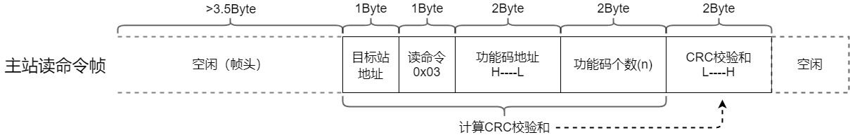
Figure 3(a) Master Station Read Command Frame
Note: Theoretically, the host can read multiple consecutive parameters at once (i.e., n can be up to 12), but it should be noted that it cannot exceed the last parameter of the current parameter group, otherwise, an error response will be returned.
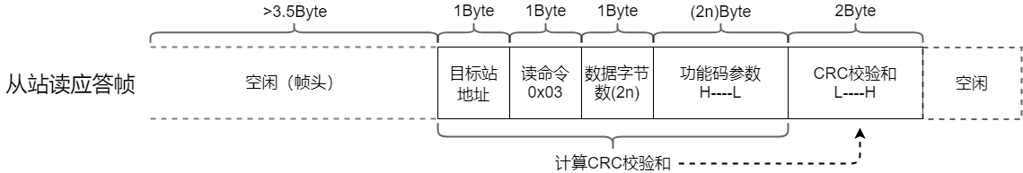
Figure 3(b) Slave Station Read Response Frame

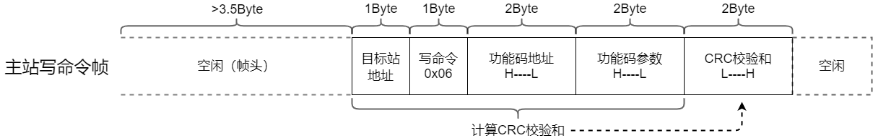
Figure 3(c) Master Station Write Command Frame
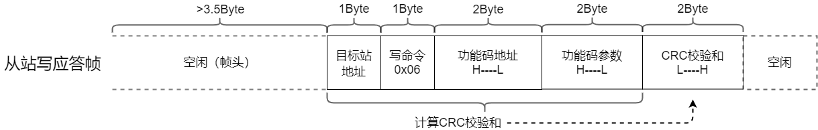
Figure 3(d) Slave Station Write Response Frame

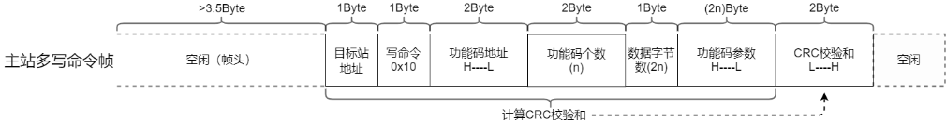
Figure 3(e) Master Station Multiple Write Command Frame
Note: Multiple writes and multiple reads are the same, with a maximum of 12 parameters that can be operated.
Figure 3(f) Slave Station Multiple Write Response Frame
The read response error command for the slave station is 0x83, the write response error command is 0x86, the multiple write response error command is 0x90, and CRC check errors do not respond. In addition, in the error types, 0x01 indicates command code error, 0x02 indicates address error, 0x03 indicates data error, and 0x04 indicates the command cannot be processed.
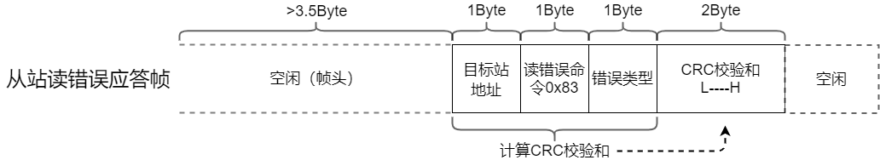
Figure 3(g) Slave Station Read Error Response Frame
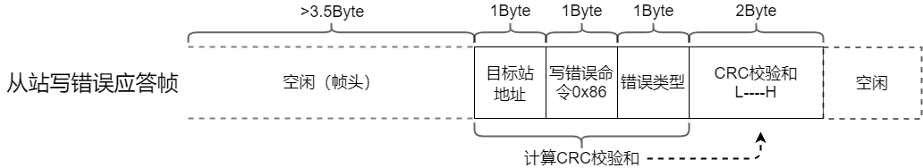
Figure 3(h) Slave Station Write Error Response Frame
Figure 3(i) Slave Station Multiple Write Error Response Frame

Related Parameters
Function Code | Name | Content | Default Value | Parameter Description
F8-00 | Baud Rate Setting | 4.8～115.2 kb/s | 115.2 | Used to set the data transfer rate between the host computer and the inverter. The higher the baud rate, the faster the communication. Note: The baud rate set on the host computer and the inverter must be the same, otherwise communication cannot be performed.
F8-01  F8-01 | Communication Data Format  Communication Data Format | 0: 7,N,1 for ASCII  1: 7,N,2 for ASCII  2: 7,E,1 for ASCII  3: 7,O,1 for ASCII  4: 7,E,2 for ASCII  5: 7,O,2 for ASCII  6: 8,N,1 for ASCII  7: 8,N,2 for ASCII  8: 8,E,1 for ASCII  9: 8,O,1 for ASCII  10: 8,E,2 for ASCII  11: 8,O,2 for ASCII  12: 8,N,1 for RTU  13:8,N,2 for RTU  14:8,E,1 for RTU  15:8,O,1 for RTU  16:8,E,2 for RTU  17:8,O,2 for RTU | 12  12 | The data format set by the master station and the inverter must be consistent; otherwise, communication cannot proceed.  The data format set by the master station and the inverter must be consistent; otherwise, communication cannot proceed.
F8-02 | Communication Address | 1～254 | 1 | Used to set the communication address of the inverter.
F8-03 | Response Delay | 0.0～200.0ms | 2.0 | The interval time between the end of data reception by the inverter and the sending of data to the master station.  If the response delay is less than the system processing time, the response delay will be based on the system processing time;  If the response delay is greater than the system processing time, the system will delay sending data to the master station until the response delay time is reached.
F8-04 | Communication Timeout Time | 0.0～100.0s | 0.0 | When this parameter is set to a non-zero value, if the interval between one communication and the next exceeds the communication timeout time, the system will report a Modbus transmission timeout (E058) fault. In most cases, it is set to zero, which means it is invalid.

Communication Parameter Address
This section contains the communication content, used for controlling the inverter's operation, inverter status, and related parameter settings. R indicates read-only, and RW indicates read-write.
The parameter address is indicated by the function code group number and label:
High Byte: F0～FF groups are 0x00～0x0F, U0～U1 are 0x10～0x11, H1～H3 are 0x12～0x15, L0～L8 are 0x16～0x1E.
Low Byte: 0x00～0xFF
For example, address F0-11 is represented as 0x000B
Note:
FF Group: Neither readable nor writable parameters; U Group: Read-only, not writable parameters.
Some parameters cannot be modified when the inverter is in operation; some parameters cannot be modified regardless of the inverter's state. When changing function code parameters, pay attention to the parameter range, unit, and related notes.
Function Code Group Number | Communication Access Address
F0～FE Groups | 0x0000～0x0FFF
U0～U1 Groups | 0x1000～0x11FF
H1～H3 Groups | 0x1200～0x15FF
L0～L8 Groups | 0x1600～0x1EFF

20xx Definition:

Address | Parameter Description | Address | Parameter Description
2102H | Given Frequency (Unit: 0.01Hz) | 2210H | DI Switch Status, Read-Only
2103H | Output Frequency (Unit: 0.01Hz), Read-Only | 2211H | DO Switch Status, Read-Only
2200H | Output Current (Unit: A), Read-Only | 2212H | Multi-Speed, Read-Only
2201H | Count Value, Read-Only | 2213H | DI CPU Pin Status, Read-Only
2202H | Actual motor speed (unit: rpm), read-only | 2214H | DO CPU pin status, read-only
2203H | Bus voltage (unit: V), read-only | 2215H | PG1 encoder pulse count, read-only
2204H | Output voltage (unit: V), read-only | 2216H | Pulse input frequency (unit: Hz), read-only
2205H | Power factor angle (unit: deg), read-only | 2217H | Pulse input position, read-only
2206H | Output power (unit: kW), read-only | 221AH | GFF Detection Percentage (Unit: %)
2207H | Actual Feedback Speed (Unit: rpm), Read-Only | 221EH | User-Defined Display
2208H | Output Torque (Unit: Nm), Read-Only | 2223H | Speed Mode, Read-Only
2209H | PG Position, Read-Only | 2224H | Carrier Frequency (Unit: Hz), Read-Only
220AH | PID Feedback Value, Read-Only | 222CH | PG1 Pulse Low Byte (Unit: 1Hz), Read-Only
220BH | AI1, read-only | 222DH | PG1 pulse high word (unit: 0.01Hz), read-only
220CH | AI2, read-only | 222EH | PID setpoint, read-only
220DH | AI3, read-only | 222FH | PID compensation, read-only
220EH | IGBT temperature (unit: °C), read-only | 2230H | PID output frequency (unit: Hz), read-only
220FH | Bus capacitor temperature (unit: °C), read-only
Stop/Run Parameters Section:
Type | Command  Address | Command Content
Control Command Input  (Write Only) | 2000H | xx12: Forward Operation xx22: Reverse Operation xx13: Forward Jog  xx23: Reverse Jog xxx1: Stop Operation
Set Frequency (Read/Write) | 2001H | Set Frequency (Unit: 0.01Hz)
External Signal (Read/Write) | 2002H | 0001: External Fault Signal 0002: Fault Reset Signal 0004: Base Fault Signal
Inverter Fault  Address (Read Only)  Inverter Fault  Address (Read Only) | 2100H  2100H | xx01: Overcurrent During Acceleration xx33: External Interrupt  xx02: Overcurrent During Deceleration xx34: Password Entered Incorrectly Three Times  xx03: Overcurrent During Constant Speed xx36: Invalid Communication Command  xx04: Ground Protection xx37: Invalid Communication Address  xx05: IGBT Upper and Lower Bridge Short Circuit xx38: Communication Data Error  xx06: Overcurrent During Stop xx39: Communication Write to Read-Only Address  xx07: Overvoltage During Acceleration xx3A: Modbus Transmission Timeout  xx08: Overvoltage During Deceleration xx3E: Regenerative Braking Action During Deceleration  xx09: Overvoltage During Constant Speed xx3F: Excessive Slip  xx0A: Overvoltage During Stop xx40: Please reset the machine type code  xx0B: Undervoltage during acceleration xx41: PG card hardware error  xx0C: Undervoltage during deceleration xx45: Feedback speed divergence  xx0D: Undervoltage during constant speed xx46: Feedback speed deviation too large  xx0E: Undervoltage during stop xx48: STO1 fault  xx0F: Input phase loss protection xx4C:STO  xx10: IGBT temperature too high xx4D: STO2 fault  xx11: Ambient temperature too high xx4F: U phase overcurrent  xx15: Inverter overload xx50: V phase overcurrent  xx16: Motor 1 overload protection xx51:W Phase Overcurrent  xx17:Motor 2 Overload Protection xx52:U Phase Output Under  xx18:Motor Overheat PTC xx53:V Phase Output Phase Loss  xx1A:Over Torque 1 xx54:W Phase Output Phase Loss  xx1B:Over Torque 2 xx57:Low Frequency Overload Protection  xx1C:Low Current xx65:CANopen Disconnection  xx1D:Limit Reached xx66:CANopen Disconnection  xx1F:Memory Read Error xx68:CANopen Hardware Disconnection  xx21:U Phase Current Detection Error xx69:CANopen Index Error  xx22:V Phase Current Detection Error xx6A:CANopen Station Number Error  xx23:W Phase Current Detection Error xx6B:CANopen Memory Error  xx24:cc Hardware Circuit Abnormality xx78:EMS Overcurrent  xx25:oc Hardware Circuit Abnormality xx80:Over Torque 3  xx26:ov Hardware Circuit Abnormality xx81:Over Torque 4  xx28:Motor Parameter Identification Error xx86:Motor 3 Overload Protection  xx29:PID Disconnection AI2 xx87:Motor 4 Overload Protection  xx2A:PG Feedback Setting Error xx8D:Pre-Operation Ground Fault  xx2B:PG Feedback Disconnection xx8E:Parameter Identification Error 1  xx2C:PG Feedback Stall xx8F: Parameter Identification Error 2  xx2D: PG Slip Abnormality xx92: Broken Belt Detection  xx31: External Terminal Abnormality xx93: Tension PID Feedback Error Detection  xx32: External Terminal Emergency Stop
 | 2100H  2100H | 01xx: Communication Command Error 16xx: Motor Overheating  02xx: Communication Address Error 18xx: Over Slip  03xx: Communication Data Error 19xx: Parameter Identification In Progress  04xx: Inverter Unable to Process 1Cxx: Output Phase Loss Warning  05xx: Communication Transmission Timeout 1Exx: Different Model Copy Error  07xx: Parameter Copy Error 1Fxx: Over Torque 3  08xx: Parameter Copy Error 20xx: Over Torque 4  09xx:IGBT Overheat Warning 24xx:CANopen Software Disconnection  0Axx:Environmental Overheat Warning 25xx:CANopen Software Disconnection  0Bxx:PID Feedback Signal Warning 27xx:CANopen Hardware Disconnection  0Dxx:Low Current Warning 28xx:CANopen Index Error  0Fxx:PG Feedback Error 29xx:CANopen Node Address Error  11xx:Overspeed Warning 2Axx:CANopen Memory Error  12xx:Excessive Speed Deviation 2Bxx:CANopen SDO Transmission Timeout  13xx:Input Phase Loss 2Cxx:CANopen SDO Reception Overflow  14xx:Over Torque 12Dxx:CANopen Initialization Error  15xx:Over Torque 22Exx:CANopen Format Error

60xx definition
command address | bit | bit name | value | Parameter Description
6000h  （RW） | 0 | CMD_ACT | 0 | fcmd =0
6000h  （RW） | 0 | CMD_ACT | 1 | fcmd = Fset(Fpid)
6000h  （RW） | 1 | EXT_CMD1 | 0 | forward direction command
6000h  （RW） | 1 | EXT_CMD1 | 1 | reverse direction command
6000h  （RW） | 2 | - | - | -
6000h  （RW） | 3 | HALT | 0 | continue to target speed
6000h  （RW） | 3 | HALT | 1 | temporarily stop according to deceleration settings
6000h  （RW） | 4 | LOCK | 0 | continue to target speed
6000h  （RW） | 4 | LOCK | 1 | Maintain Current Frequency
6000h  （RW） | 5 | JOG | 0 | JOG OFF
6000h  （RW） | 5 | JOG | Pulse  1 | JOG RUN
6000h  （RW） | 6 | QSTOP | 0 | None
6000h  （RW） | 6 | QSTOP | 1 | Quick Stop
6000h  （RW） | 7 | SERVO_ON | 0 | Servo OFF
6000h  （RW） | 7 | SERVO_ON | 1 | Servo ON
6000h  （RW） | 11~8 | GEAR | 0000 | Main Speed
6000h  （RW） | 11~8 | GEAR | 0001~  1111 | 1~15 Segment Speed Frequency Switching
6000h  （RW） | 13~12 | ACC/DEC | 00 | First Segment Acceleration/Deceleration Time
6000h  （RW） | 13~12 | ACC/DEC | 01 | Second Segment Acceleration/Deceleration Time
6000h  （RW） | 13~12 | ACC/DEC | 10 | Third Segment Acceleration/Deceleration Time
6000h  （RW） | 13~12 | ACC/DEC | 11 | Fourth Segment Acceleration/Deceleration Time
6000h  （RW） | 14 | EN_SW | 0 | Do Not Allow Multi-Segment Command and Acceleration/Deceleration Time Switching
6000h  （RW） | 14 | EN_SW | 1 | Allow Multi-Segment Command and Acceleration/Deceleration Time Switching
6000h  （RW） | 15 | RST | Pulse  1 | Clear Error Code
6002h  （RW） | 15-0 | Velocity Cmd |  | Frequency Command (0.01Hz)
6100h (R) | 0 | ARRIVE | 0 | Frequency Command Not Reached
6100h (R) | 0 | ARRIVE | 1 | Frequency Command Arrival
6100h (R) | 1 | DIR | 0 | Forward
6100h (R) | 1 | DIR | 1 | Reverse
6100h (R) | 2 | WARN | 0 | No Warning
6100h (R) | 2 | WARN | 1 | Warning Occurred
6100h (R) | 3 | ERROR | 0 | No Error
6100h (R) | 3 | ERROR | 1 | Error Occurred
6100h (R) | 5 | JOG | 0 | None
6100h (R) | 5 | JOG | 1 | On JOG
6100h (R) | 6 | QSTOP | 0 | None
6100h (R) | 6 | QSTOP | 1 | On Quick Stop
6100h (R) | 7 | SERVO_ON | 0 | PWM OFF
6100h (R) | 7 | SERVO_ON | 1 | PWM ON
6100h (R) | 8 | Ready | 0 | Ready OFF
6100h (R) | 8 | Ready | 1 | Ready ON
6100h (R) | 15-9 | - | - | -
6102h  （R） | 15-0 | Velocity cmd |  | Actual Output Frequency

